## What is SQL?

SQL (Structured Query Language) is a[programming language](https://www.simplilearn.com/best-programming-languages-start-learning-today-article) used as an interface to manage databases.Various organizations use SQL systems to view and manipulate the information and data contained in their files, as well as to create and modify new tables.

A [database](https://www.simplilearn.com/tutorials/sql-tutorial/create-mysql-database) is a tool for gathering and storing records. Databases can hold data about individuals, goods, orders, and everything else. Many datasets begin with a word processing application or spreadsheet, but as they grow in size, many companies will find it beneficial to move them to a database generated by a [database management system.](https://www.simplilearn.com/what-is-database-management-article)

SQL is an open-source data management system. The SQL query is used to retrieve and manipulate the data from the table. With the help of SQL command we can query, filter, sort, join, group and modify the data in the database.

**SQL** is a database language designed for the retrieval and management of data in a relational database.

All the RDBMS systems like MySQL, MS Access, Oracle, Sybase, Postgres, and SQL Server use SQL as their standard database language.

## Why Use SQL?

* It helps users to access data in the RDBMS system.
* It helps you to describe the data.
* It allows you to define the data in a database and manipulate that specific data.
* With the help of SQL commands in DBMS, you can create and drop databases and tables.
* SQL offers you to use the function in a database, create a view, and stored procedure.
* You can set permissions on tables, procedures, and views.

## Types of SQL

Here are five types of widely used SQL queries.

* Data Definition Language (DDL)
* Data Manipulation Language (DML)
* Data Control Language(DCL)
* Transaction Control Language(TCL)
* Data Query Language (DQL)

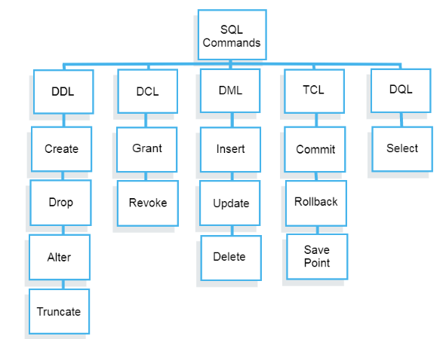

## What is DDL?

Data Definition Language helps you to define the database structure or schema.

Five types of DDL commands in SQL are: