## Foreign Key Constraint

A foreign key is a column or a group of columns in a table that reference the [primary key](https://www.postgresqltutorial.com/postgresql-tutorial/postgresql-primary-key/) of another table.

The table that contains the foreign key is called the referencing table or child table. And the table referenced by the foreign key is called the referenced table or parent table.

A table can have multiple foreign keys depending on its relationships with other tables.

In PostgreSQL, you define a foreign key using the foreign key constraint. The foreign key constraint helps maintain the referential integrity of data between the child and parent tables.

A foreign key constraint indicates that values in a column or a group of columns in the child table equal the values in a column or a group of columns of the parent table.

## PostgreSQL foreign key constraint syntax

The following illustrates a foreign key constraint syntax:

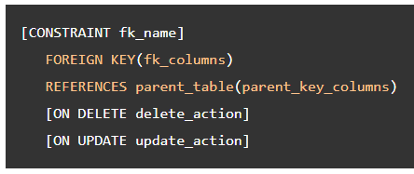

In this syntax:

* First, specify the name for the foreign key constraint after the CONSTRAINT keyword. The CONSTRAINT clause is optional. If you omit it, PostgreSQL will assign an auto-generated name.
* Second, specify one or more foreign key columns in parentheses after the FOREIGN KEY keywords.
* Third, specify the parent table and parent key columns referenced by the foreign key columns in the REFERENCES clause.
* Finally, specify the delete and update actions in the ON DELETE and ON UPDATE clauses.

The delete and update actions determine the behaviors when the primary key in the parent table is deleted and updated. Since the primary key is rarely updated, the ON UPDATE action is not often used in practice. We’ll focus on the ON DELETE action.

PostgreSQL supports the following actions:

* SET NULL
* SET DEFAULT
* RESTRICT
* NO ACTION
* CASCADE

PostgreSQL foreign key constraint examples

The following statements create the customers and contacts tables:

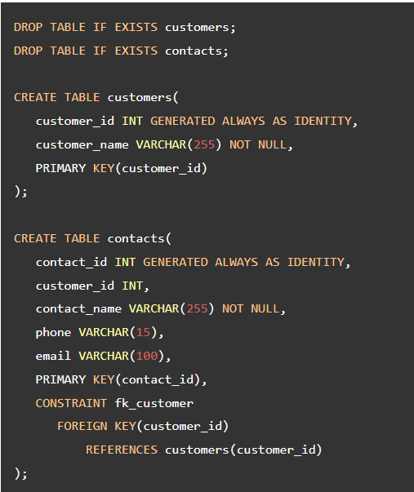

In this example, the customers table is the parent table and the contacts table is the child table.

Each customer has zero or many contacts and each contact belongs to zero or one customer.

The customer_id column in the contacts table is the foreign key column that references the primary key column with the same name in the customers table.

The following foreign key constraint fk_customer in the contacts table defines the customer_id as the foreign key:

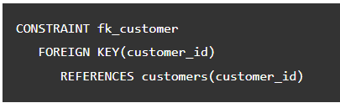

Because the foreign key constraint does not have the ON DELETE and ON UPDATE action, they default to NO ACTION.

### **NO ACTION**

The following inserts data into the customers and contacts tables:

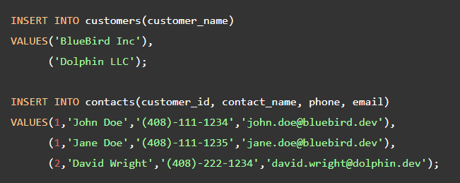

The following statement deletes the customer id 1 from the customers table:

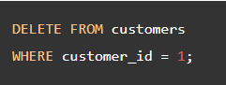

Because of the ON DELETE NO ACTION, PostgreSQL issues a constraint violation because the referencing rows of the customer id 1 still exist in the contacts table:

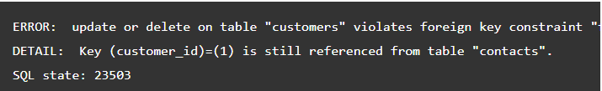

The RESTRICT action is similar to the NO ACTION. The difference only arises when you define the foreign key constraint as DEFERRABLE with an INITIALLY DEFERRED or INITIALLY IMMEDIATE mode. We’ll discuss more on this in the subsequent tutorial.

### **SET NULL**

The SET NULL automatically sets NULL to the foreign key columns in the referencing rows of the child table when the referenced rows in the parent table are deleted.

The following statements drop the sample tables and re-create them with the foreign key that uses the SET NULL action in the ON DELETE clause:

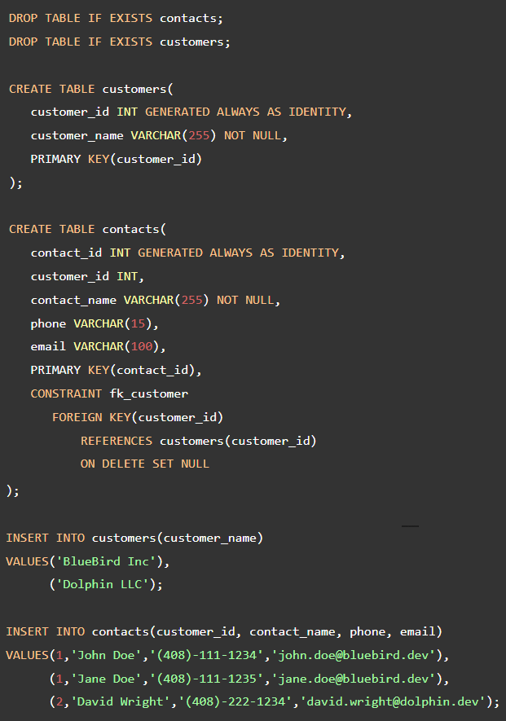

The following statements insert data into the customers and contacts tables:

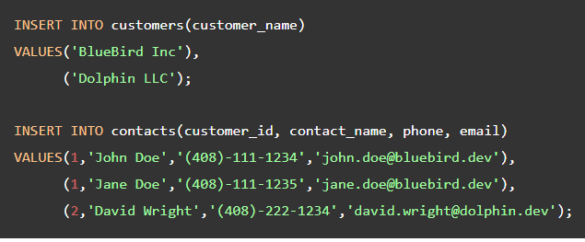

To see how the SET NULL works, let’s delete the customer with id 1 from the customers table:

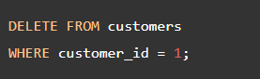

Because of the ON DELETE SET NULL action, the referencing rows in the contacts table set to NULL. The following statement displays the data in the contacts table: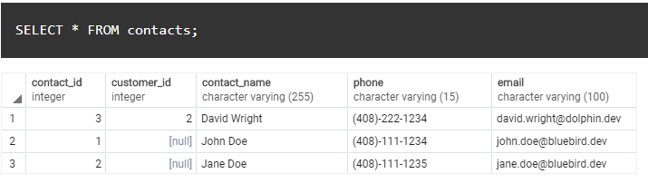

As can be seen clearly from the output, the rows that have the customer_id 1 now have the customer_id sets to NULL

### **CASCADE**

The ON DELETE CASCADE automatically deletes all the referencing rows in the child table when the referenced rows in the parent table are deleted. In practice, the ON DELETE CASCADE is the most commonly used option.

The following statements recreate the sample tables. However, the delete action of the fk_customer changes to CASCADE:

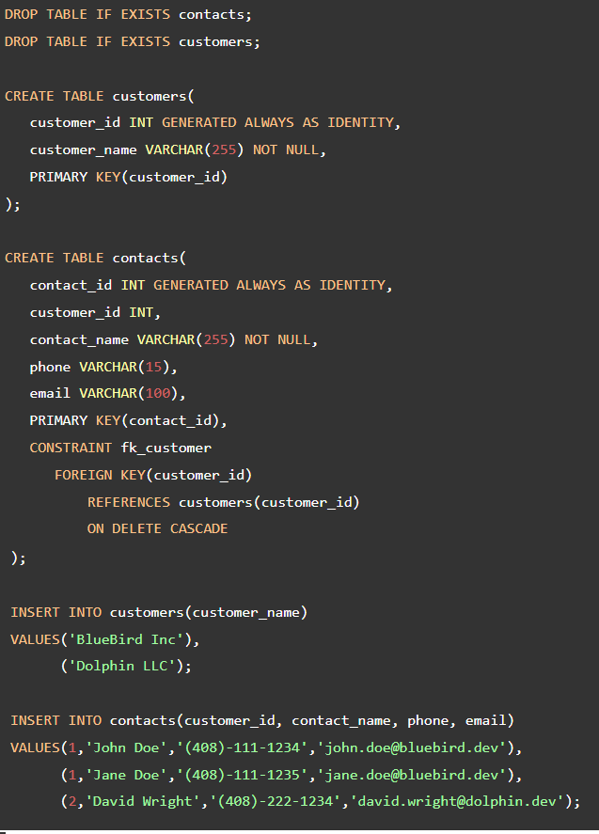

The following statement deletes the customer id 1:

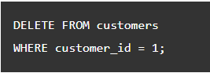

Because of the ON DELETE CASCADE action, all the referencing rows in the contacts table are automatically deleted:

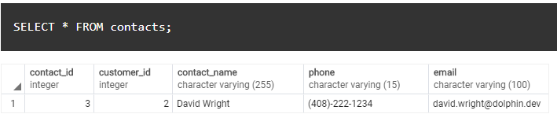

### **SET DEFAULT**

The ON DELETE SET DEFAULT sets the default value to the foreign key column of the referencing rows in the child table when the referenced rows from the parent table are deleted.

## Add a foreign key constraint to an existing table

To add a foreign key constraint to the existing table, you use the following form of the [ALTER TABLE](https://www.postgresqltutorial.com/postgresql-tutorial/postgresql-alter-table/)statement:

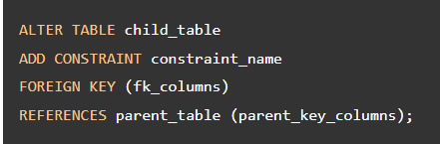

When you add a foreign key constraint with ON DELETE CASCADE option to an existing table, you need to follow these steps:

First, drop existing foreign key constraints:

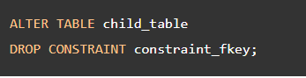

First, add a new foreign key constraint with  ON DELETE CASCADE action:

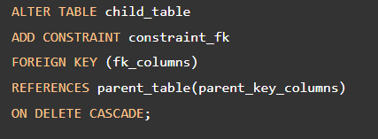

References

https://www.postgresqltutorial.com/postgresql-tutorial/postgresql-foreign-key/