Unit-I

Chapter-1

Human Geography
Nature and Scope
You have already studied ‘Geography as a Discipline’ in Chapter I of the book, Fundamentals of Physical Geography (NCERT, 2006). Do you recall the contents? This chapter has broadly covered and introduced you to the nature of geography. You are also acquainted with the important branches that sprout from the body of geography. If you re-read the chapter you will be able to recall the link of human geography with the mother discipline
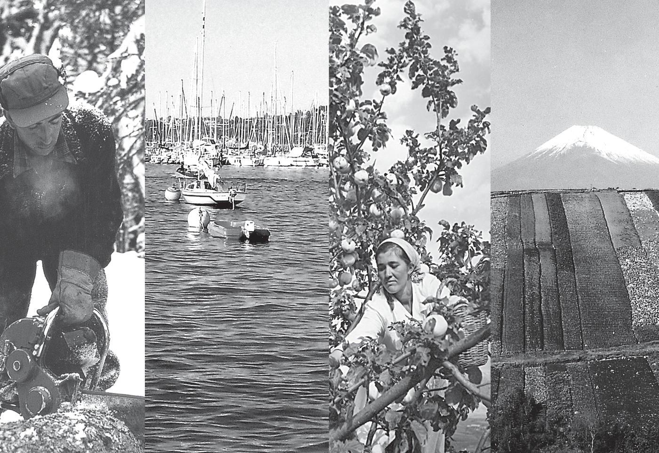

i.e. geography. As you know geography as a field of study is integrative, empirical, and practical. Thus, the reach of geography is extensive and each and every event or phenomenon which varies over space and time can be studied geographically. How do you see the earth’s surface? Do you realise that the earth comprises two major components: nature (physical environment) and life forms including human beings? Make a list of physical and human components of your surroundings. Physical geography studies physical environment and human geography studies “the relationship between the physical/natural and the human worlds, the spatial distributions of human phenomena and how they come about, the social and economic differences between different parts of the world”.¹
You are already aware of the fact that the
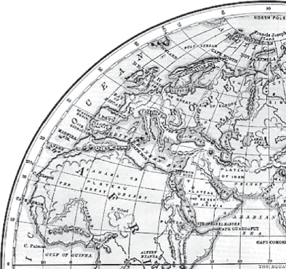
core concern of geography as a discipline is to understand the earth as home of human beings and to study all those elements which have sustained them. Thus, emphasis is on study of nature and human beings. You will realise that geography got subjected to dualism and the wide-ranging debates started whether geography as a discipline should be a law making/theorising (nomothetic) or descriptive (idiographic). Whether its subject matter should be organised and approach of the study should be regional or systematic? Whether geographical phenomena be interpreted theoretically or through historic-institutional approach? These have been issues for intellectual exercise but finally you will appreciate that the dichotomy between physical and human is not a very valid one because nature and human are inseparable elements and should be seen holistically. It is interesting to note that both physical and human

¹ Agnew J. Livingstone, David N. and Rogers, A.; (1996) Blackwell Publishing Limited, Malden, U.S.A. p. 1 and 2.

phenomena are described in metaphors using symbols from the human anatomy.
We often talk of the ‘face’ of the earth, ‘eye’ of the storm, ‘mouth’ of the river, ‘snout’ (nose) of the glacier, ‘neck’ of the isthmus and ‘profile’ of the soil. Similarly regions, villages, towns have been described as ‘organisms’. German geographers describe the ‘state/country’ as a ‘living organism’. Networks of road, railways and water ways have often been described as “arteries of circulation”. Can you collect such terms and expressions from your own language? The basic questions now arises, can we separate nature and human when they are so intricately intertwined?
Human Geography Defined
- “Human geography is the synthetic study of relationship between human societies and earth’s surface”. Ratzel
Synthesis has been emphasised in the above definition.
- “Human geography is the study of the changing relationship between the unresting man and the unstable earth.”
Ellen C. Semple
Dynamism in the relationship is the keyword in Semple’s definition.
- “Conception resulting from a more synthetic knowledge of thephysical laws governing our earth and of the relations between the living beings which inhabit it”.
Paul Vidal de la Blache
Human geography offers a new conception of the interrelationships between earth and human beings.

NATURE OF HUMAN GEOGRAPHY
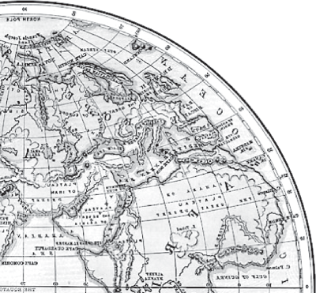
Human geography studies the inter-relationship between the physical environment and socio-cultural environment created by human beings through mutual interaction with each other. You
have already studied the elements of physical environment in class XI in the book entitled Fundamentals of Physical Geography (NCERT 2006). You know that these elements are landforms, soils, climate, water, natural vegetation and diverse flora and fauna. Can you make a list of elements which human beings have created through their activities on the stage provided by the physical environment? Houses, villages, cities, road-rail networks, industries, farms, ports, items of our daily use and all other elements of material culture have been created by human beings using the resources provided by the physical environment. While physical environment has been greatly modified by human beings, it has also, in turn, impacted human lives.

Naturalisation of Humans and Humanisation of Nature
Human beings interact with their physical environment with the help of technology. It is not important what human beings produce and create but it is extremely important ‘with the help of what tools and techniques do they produce and create’.
Technology indicates the level of cultural development of society. Human beings were able to develop technology after they developed better understanding of natural laws. For example, the understanding of concepts of friction and heat helped us discover fire. Similarly, understanding of the secrets of DNA and genetics enabled us to conquer many diseases. We use the laws of aerodynamics to develop faster planes. You can see that knowledge about Nature is extremely important to develop technology and technology loosens the shackles of environment on human beings. In the early stages of their interaction with their natural environment humans were greatly influenced by it. They adapted to the dictates of Nature. This is so because the level of technology was very low and the stage of human social development was also primitive. This type of interaction between primitive human society and strong forces of nature was termed as environmental determinism. At that stage of very low technological development we can imagine the presence of a naturalised human, who listened to Nature, was afraid of its fury and worshipped it.

2 Fundamentals of Human Geography

human beings on nature for resources which sustain them. The physical environment for such societies becomes the “Mother Nature”.
The Naturalisation of Humans
Benda lives in the wilds of the Abujh Maad area of central India. His village consists of three huts deep in the wilds. Not even birds or stray dogs that usually crowd villages can be seen in these areas. Wearing a small loin cloth and armed with his axe he slowly surveys the penda (forest) where his tribe practices a primitive form of agriculture called shifting cultivation. Benda and his friends burn small patches of forest to clear them for cultivation. The ash is used for making the soil fertile. Benda is happy that the Mahua trees around him are in bloom. How lucky I am to be a part of this beautiful universe, he thinks as he looks up to see the Mahua, Palash and Sal trees that have sheltered him since childhood. Crossing the penda in a gliding motion, Benda makes his way to a stream. As he bends down to scoop up a palmful of water, he remembers to thank Loi-Lugi, the spirit of the forest for allowing him to quench his thirst. Moving on with his friends, Benda chews on succulent leaves and roots. The boys have been trying to collect Gajjhara and Kuchla, from the forest. These are special plants that Benda and his people use. He hopes the spirits of the forest will be kind and lead him to these herbs. These are needed to barter in the madhai or tribal fair coming up the next full moon. He closes his eyes and tries hard to recall what the elders had taught him about these herbs and the places they are found in. He wishes he had listened more carefully. Suddenly there is a rustling of leaves. Benda and his friends know it is the outsiders who have come searching for them in the wilds. In a single fluid motion Benda and his friends disappear behind the thick canopy of trees and become one with the spirit of the forest.
The people begin to understand their environment and the forces of nature with the passage of time. With social and cultural development, humans develop better and more efficient technology. They move from a state of necessity to a state of freedom. They create possibilities with the resources obtained from the environment. The human activities create cultural landscape. The imprints of human activities are created everywhere; health resorts on highlands, huge urban sprawls, fields, orchards and pastures in plains and rolling hills, ports on the coasts, oceanic routes on the oceanic surface and satellites in the space. The earlier scholars termed this as possibilism. Nature provides opportunities and human being make use of these and slowly nature gets humanised and starts bearing the imprints of human endeavour.

The story in the box represents the direct relationship of a household belonging to an economically primitive society with nature. Read about other primitive societies which live in complete harmony with their natural environment. You will realise that in all such cases nature is a powerful force, worshipped, revered and conserved. There is direct dependence of
Humanisation of Nature
Winters in the town of Trondheim mean fierce winds and heavy snow. The skies are dark for months. Kari drives to work in the dark at 8 am. She has special tyres for the winter and keeps the headlights of her powerful car switched on. Her office is artificially heated at a comfortable 23 degrees Celsius. The campus of the university she works in is built under a huge glass dome. This dome keeps the snow out in winter and lets in the sunshine in the summer. The temperature is controlled carefully and there is adequate lighting. Even though fresh vegetables and plants don’t grow in such harsh weather, Kari keeps an orchid on her desk and enjoys eating tropical fruits like banana and kiwi. These are flown in from warmer areas regularly. With a click of the mouse, Kari can network with colleagues in New Delhi. She frequently takes a morning flight to London and returns in the evening in time to watch her favourite television serial. Though Kari is fifty-eight years old, she is fitter and looks younger than many thirty-year- olds in other parts of the world.
Human Geography: Nature and Scope 3

Can you imagine what has made such a life style possible? It is technology that has allowed the people of Trondheim and others to overcome the constraints imposed by nature. Do you know about some other such instances? Such examples are not difficult to find.
A geographer, Griffith Taylor introduced another concept which reflects a middle path (Madhyam Marg) between the two ideas of environmental determinism and possibilism. He termed it as Neodeterminism or stop and go determinism. Those of you who live in cities and those who have visited a city, might have seen that traffic is regulated by lights on the cross-roads. Red light means ‘stop’, amber light provides a gap between red and green lights ‘to get set’ and green light means ‘go’. The concept shows that neither is there a situation of absolute necessity (environmental determinism) nor is there a condition of absolute freedom (possibilism). It means that human beings can conquer nature by obeying it. They have to respond to the red signals and can proceed in their pursuits of development when nature permits the modifications. It means that possibilities can be created within the limits which do not damage the environment and there is no free run without accidents. The free run which the developed economies attempted to take has already resulted in the green house effect, ozone layer depletion, global warming, receding glaciers and degrading lands. The neo-determinism conceptually attempts to bring a balance nullifying the ‘either’ ‘or’ dichotomy.

- Welfare or humanistic school of thought in human geography was mainly concerned with the different aspects of social well-being of the people. These included aspects such as housing, health and education. Geographers have already introduced a paper as Geography of Social well-being in the Post Graduate curriculum’.
- Radical school of thought employed Marxian theory to explain the basic cause of poverty, deprivation and social inequality. Contemporary social problems were related to the development of capitalism.
- Behavioural school of thought laid great emphasis on lived experience and also on the perception of space by social categories based on ethnicity, race and religion, etc.

Fields and Sub-fields of Human Geography
Human geography, as you have seen, attempts to explain the relationship between all elements of human life and the space they occur over. Thus, human geography assumes a highly inter-disciplinary nature. It develops close interface with other sister disciplines in social sciences in order to understand and explain human elements on the surface of the earth. With the expansion of knowledge, new sub-fields emerge and it has also happened to human geography. Let us examine these fields and sub-fields of Human Geography (Table 1.2).

Table 1.1: Broad Stages and Thrust of Human Geography

Period | Approaches | Broad Features
Early Colonial period | Exploration and description | Imperial and trade interests prompted the discovery and exploration of new areas. An encyclopaedic description of the area formed an important aspect of the geographer’s account.
Later Colonial period | Regional analysis | Elaborate description of all aspects of a region were undertaken. The idea was that all the regions were part of a whole, i.e. (the earth); so, understanding the parts in totality would lead to an understanding of the whole.

4 Fundamentals of Human Geography

1930s through the inter-War period | Areal differentiation | The focus was on identifying the uniqueness of any region and understanding how and why it was different from others.
Late 1950s to the late 1960s | Spatial organisation | Marked by the use of computers and sophisticated statistical tools. Laws of physics were often applied to map and analyse human phenomena. This phase was called the quantitative revolution. The main objective was to identify mappable patterns for different human activities.
1970s | Emergence of humanistic, radical and behavioural schools | Discontentment with the quantitative revolution and its dehumanised manner of doing geography led to the emergence of three new schools of thought of human geography in the 1970s. Human geography was made more relevant to the socio-political reality by the emergence of these schools of thought. Consult the box below to know a little bit more about these schools of thought.
1990s | Post-modernism in geography | The grand generalisations and the applicability of universal theories to explain the human conditions were questioned. The importance of understanding each local context in its own right was emphasised.
Table 1.2: Human Geography and Sister Disciplines of Social Sciences

Fields of Human Geography | Sub-fields | Interface with Sister Disciplines of Social Sciences
Social Geography | — | Social Sciences – Sociology
Social Geography | Behavioural Geography | Psychology
Social Geography | Geography of Social  Well-being | Welfare Economics
Social Geography | Geography of Leisure | Sociology
Social Geography | Cultural Geography | Anthropology
Social Geography | Gender Geography | Sociology, Anthropology, Women’s Studies
Social Geography | Historical Geography | History
Social Geography | Medical Geography | Epidemology
Urban  Geography | — | Urban Studies and Planning
Political Geography | — | Political Science
Political Geography | Electoral Geography | Psephology
Political Geography | Military Geography | Military Science
Population  Geography | — | Demography
Settlement  Geography | — | Urban/Rural Planning

Human Geography: Nature and Scope 5

Economic Geography | — | Economics
Economic Geography | Geography of Resources | Resource Economics
Economic Geography | Geography of Agriculture | Agricultural Sciences
Economic Geography | Geography of Industries | Industrial Economics
Economic Geography | Geography of Marketing | Business Studies, Economics, Commerce
Economic Geography | Geography of Tourism | Tourism and Travel Management
Economic Geography | Geography of International  Trade | International Trade



EXERCISES
- Choose the right answer from the four alternatives given below.
  - Which one of the following statements does not describe geography?
    - an integrative discipline
    - study of the inter-relationship between humans and environment
    - subjected to dualism
    - not relevant in the present time due to the development of technology.
  - Which one of the following is not a source of geographical information?
    - traveller’s accounts
    - old maps
    - samples of rock materials from the moon
    - ancient epics
  - Which one of the following is the most important factor in the interaction between people and environment?
    - human intelligence (c) technology
    - people’s perception (d) human brotherhood
  - Which one of the following is not an approach in human geography?
    - Areal differentiation (c) Quantitative revolution
    - Spatial organisation (d) Exploration and description
- Answer the following questions in about 30 words.
  - Define human geography.
  - Name some sub-fields of human geography.
  - How is human geography related to other social sciences?
- Answer the following questions in not more than 150 words.
  - Explain naturalisation of humans.
  - Write a note on the scope of human geography.

6 Fundamentals of Human Geography

Unit-II


Chapter-2

The World Population Distribution, Density and Growth
The people of a country are its real wealth. It is they, who are the actual resources and make use of the country’s other resources and decide its policies. Ultimately a country is known by its people.
It is important to know how many women and men a country has, how many children are born each year, how many people die and how? Whether they live in cities or villages, can they read or write and what work do they do? These are what you will study about in this unit.

The world at the beginning of 21st century recorded the presence of over 6 billion population. We shall discuss the patterns of their distribution and density here.

Why do people prefer to live in certain regions and not in others?
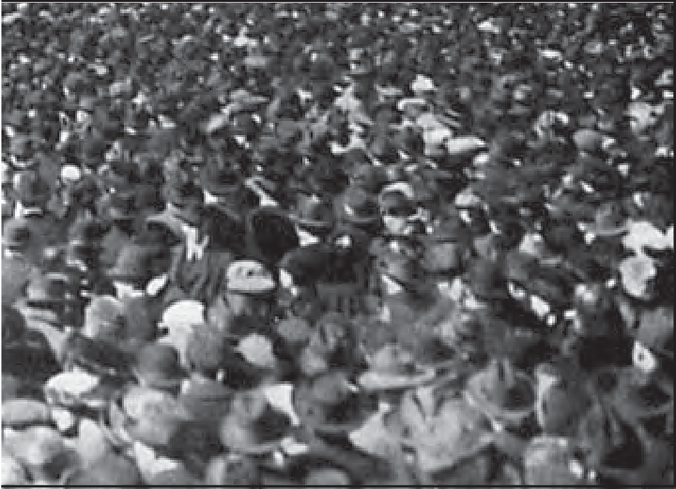
The population of the world is unevenly distributed. The remark of George B. Cressey about the population of Asia that “Asia has many places where people are few and few place where people are very many” is true about the pattern of population distribution of the world also.

PATTERNS OF POPULATION DISTRIBUTION IN THE WORLD
Patterns of population distribution and density help us to understand the demographic characteristics of any area. The term population distribution refers to the way people are spaced over the earth’s surface. Broadly, 90 per cent of the world population lives in about 10 per cent of its land area.

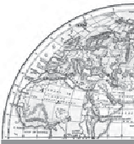
The 10 most populous countries of the world contribute about 60 per cent of the world’s population. Of these 10 countries, 6 are located in Asia. Identify these six countries of Asia.

Not gold but only (Wo)men can make a people great and strong.
(Wo)men who for truth and honour’s sake, stand fast and suffer long (Wo)men who toil while others sleep – who dare while others flee – they build a nation’s pillars deep and lift it to the sky.
Ralph Waldo Emerson
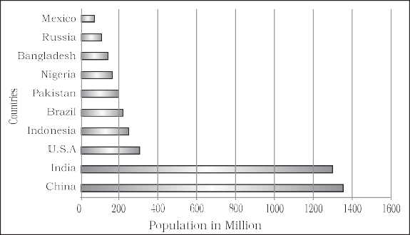
Fig. 2.1: Most Populous Countries

DENSITY OF POPULATION
Each unit of land has limited capacity to support people living on it. Hence, it is necessary to understand the ratio between the numbers of people to the size of land. This ratio is the density of population. It is usually measured in persons per sq km
Density of Population = Population
Area
For example, area of Region X is 100 sq km and the population is 1,50,000 persons. The density of population is calculated as:
1,50,000
  - Climate: An extreme climate such as very hot or cold deserts are uncomfortable for human habitation. Areas with a comfortable climate, where there is not much seasonal variation attract more people. Areas with very heavy rainfall or extreme and harsh climates have low population. Mediterranean regions were inhabited from early periods in history due to their pleasant climate.
  - Soils: Fertile soils are important for agricultural and allied activities. Therefore, areas which have fertile loamy soils have more people living on them as these can
support intensive agriculture. Can you

Density =

100
name some areas in India which are thinly

= 1,500 person/sq km
What does this tell you about Region X?
FACTORS INFLUENCING THE DISTRIBUTION OF POPULATION

Geographical Factors
  - Availability of water: Water is the most important factor for life. So, people prefer to live in areas where fresh water is easily available. Water is used for drinking, bathing and cooking – and also for cattle, crops, industries and navigation. It is because of this that river valleys are among the most densely populated areas of the world.
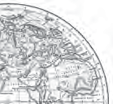
  - Landforms: People prefer living on flat plains and gentle slopes. This is because such areas are favourable for the production of crops and to build roads and industries. The mountainous and hilly areas hinder the development of transport network and hence initially do not favour agricultural and industrial development. So, these areas tend to be less populated. The Ganga plains are among the most densely populated areas of the world while the mountains zones in the Himalayas are scarcely populated.
populated due to poor soils?

Economic Factors
  - Minerals: Areas with mineral deposits attract industries. Mining and industrial activities generate employment. So, skilled and semi–skilled workers move to these areas and make them densely populated. Katanga Zambia copper belt in Africa is one such good example.
  - Urbanisation: Cities offer better employment opportunities, educational and medical facilities, better means of transport and communication. Good civic amenities and the attraction of city life draw people to the cities. It leads to rural to urban migration and cities grow in size. Mega cities of the world continue to attract large number of migrants every year.


Yet city life can be very taxing…. think of some of the unpleasant aspects of city life.
  - Industrialisation: Industrial belts provide job opportunities and attract large numbers of people. These include not just factory workers but also transport operators, shopkeepers, bank employees, doctors, teachers and other service providers. The Kobe-Osaka region of

8 Fundamentals of Human Geography

Japan is thickly populated because of the presence of a number of industries.

Social and Cultural Factors
Some places attract more people because they have religious or cultural significance. In the same way – people tend to move away from places where there is social and political unrest. Many a times governments offer incentives to people to live in sparsely populated areas or move away from overcrowded places. Can you think of some examples from your region?

POPULATION GROWTH
The population growth or population change refers to the change in number of inhabitants of a territory during a specific period of time. This change may be positive as well as negative. It can be expressed either in terms of absolute numbers or in terms of percentage. Population change in an area is an important indicator of economic development, social upliftment and historical and cultural background of the region.

Positive Growth of Population: This happens when the birth rate is more than the death rate between two points of time or when people from other countries migrate permanently to a region.
Negative Growth of Population: If the population decreases between two points of time it is known as negative growth of population. It occurs when the birth rate falls below the death rate or people migrate to other countries.

Components of Population Change
There are three components of population change – births, deaths and migration.
The crude birth rate (CBR) is expressed as number of live births in a year per thousand of population. It is calculated as:
CBR = B × 1000 P
Here, CBR = Crude Birth Rate; B = live births during the year; P= Estimated mid year population of the area.
Death rate plays an active role in population change. Population growth occurs not only by increasing births rate but also due to decreasing death rate. Crude Death Rate (CDR) is a simple method of measuring mortality of any area. CDR is expressed in terms of number of deaths in a particular year per thousand of population in a particular region.
CDR is calculated as:
CDR = D × 1000 P
Here, CDR=Crude Death Rate; D= Number of deaths; P=Estimated mid-year population of that year.
By and large mortality rates are affected by the region’s demographic structure, social advancement and levels of its economic development.

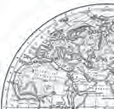
Migration
Apart from birth and death there is another way by which the population size changes.

The World Population: Distribution, Density and Growth 9
Some Basic Concepts of Population Geography
Growth of Population : Change of population in particular area between two points of time is known as growth of population. For example, if we deduct the population of India 2001 (102.70 crore) from population of 2011 (121.02 crore) then we shall get the growth of population (18.15 crores) in actual numbers.
Growth Rate of Population : This is the change of population expressed in percentage.
Natural Growth of Population: This is the population increased by difference between births and deaths in a particular region between two points of time.
Natural Growth = Births – Deaths Actual Growth of Population : This is
Births – Deaths + In Migration – Out Migration

When people move from one place to another, the place they move from is called the Place of Origin and the place they move to is called the Place of Destination. The place of origin shows a decrease in population while the population increases in the place of destination. Migration may be interpreted as a spontaneous effort to achieve a better balance between population and resources.
Migration may be permanent, temporary or seasonal. It may take place from rural to rural areas, rural to urban areas, urban to urban areas and urban to rural areas.
Do you realise that the same person is both
an immigrant and an emigrant?
Immigration: Migrants who move into a new place are called Immigrants.

Emigration: Migrants who move out of a place are called Emigrants.

Can you think of reasons why people migrate?

People migrate for a better economic and social life. There are two sets of factors that influence migration.
The Push factors make the place of origin seem less attractive for reasons like unemployment, poor living conditions, political turmoil, unpleasant climate, natural disasters, epidemics and socio-economic backwardness.
The Pull factors make the place of destination seem more attractive than the place of origin for reasons like better job opportunities and living conditions, peace and stability, security of life and property and pleasant climate.
CBR/CDR
Human population increased more than ten times in the past 500 hundred years.

DEMOGRAPHIC TRANSITION
Demographic transition theory can be used to describe and predict the future population of any area. The theory tells us that population of any region changes from high births and high deaths to low births and low deaths as society progresses from rural agrarian and illiterate to urban industrial and literate society. These changes occur in stages which are collectively known as the demographic cycle.
Rural,
Agrarian
Demographic
Transition
Urban,
Industrial

Fig. 2.2 explains the three-staged model of Demographic Transition Theory:
The first stage has high fertility and high mortality because people reproduce more to compensate for the deaths due to epidemics and variable food supply. The population growth is slow and most of the people are engaged in agriculture where large families are an asset. Life expectancy is low, people are mostly illiterate and have low levels of technology. Two hundred years ago all the countries of the world were in this stage.

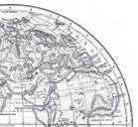
Fig. 2.2: Demographic Transition Theory
In the twentieth century itself the population has increased four times.
High Fluctuating
Stage Stage
I II
Stage
III
Expanding
BR
35
Natural Increase in Population
Low Fluctuating
DR
15
Present
World examples
Bangladesh Peru
Rainforest tribes
Sri Lanka Canada
Kenya Japan USA
Time

10 Fundamentals of Human Geography

Fertility remains high in the beginning of second stage but it declines with time. This is accompanied by reduced mortality rate. Improvements in sanitation and health conditions lead to decline in mortality. Because of this gap the net addition to population is high.
In the last stage, both fertility and mortality decline considerably. The population is either stable or grows slowly. The population becomes urbanised, literate and has high technical know- how and deliberately controls the family size.
This shows that human beings are extremely flexible and are able to adjust their fertility.
In the present day, different countries are at different stages of demographic transition.

POPULATION CONTROL MEASURES
Family planning is the spacing or preventing the birth of children. Access to family planning services is a significant factor in limiting population growth and improving women’s health. Propaganda, free availability of contraceptives and tax disincentives for large families are some of the measures which can help population control.
Thomas Malthus in his theory (1798) stated that the number of people would increase faster than the food supply. Any further increase would result in a population crash caused by famine, disease and war. The preventive checks are better than the physical checks. For the sustainability of our resources, the world will have to control the rapid population increase.

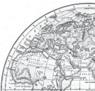
EXERCISES
- Choose the right answer from the four alternatives given below.
  - Which one of the following continents has the highest growth of population?
    - Africa (c) Asia
    - South America (d) North America
  - Which one of the following is not an area of sparse population?
    - The Atacama (c) Equatorial region
    - South-east Asia (d) Polar regions
  - Which one of the following is not a push factor ?
    - Water shortage (c) Unemployment
    - Medical/educational facilities (d) Epidemics
  - Which one of the following is not a fact ?
    - Human population increased more than ten times during the past 500 years.
    - Population growth is high in the first stage of demographic transition?
- Answer the following questions in about 30 words.
  - Name three geographical factors that influence the distribution of population.
The World Population: Distribution, Density and Growth 11

  - There are a number of areas with high population density in the world. Why does this happen?
  - What are the three components of population change?
- Distinguish between:
  - Birth rate and death rate.
  - Push factors and pull factors of migration.
- Answer the following questions in about 150 words.
  - Discuss the factors influencing the distribution and density of population in the
world.
(ii) Discuss the three stages of demographic transition.
On the outline map of the world, show and name the following.
(i) Countries of Europe and Asia with negative growth rate of population.
- Has someone in your family migrated? Write about her/his place of
destination. What made her/him migrate?
- Write a brief report on the distribution and density of population in your
state.
Map Skill
Project/Activity

12 Fundamentals of Human Geography

Unit-II

Chapter-3

Human Development

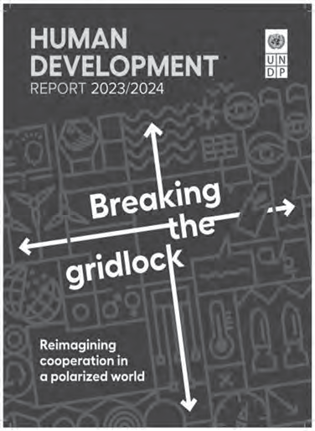
The words ‘growth’ and ‘development’ are not new to you. Look around you, almost everything that you can see (and many that you cannot) grows and develops. These may be plants, cities, ideas, nations, relationships or even you yourself! What does this mean?


This chapter discusses the concept of human development as it pertains to nations and communities.

Do growth and development mean the same thing?
Do they accompany each other?

GROWTH AND DEVELOPMENT
Both growth and development refer to changes over a period of time. The difference is that growth is quantitative and value neutral. It may have a positive or a negative sign. This means that the change may be either positive (showing an increase) or negative (indicating a decrease). Development means a qualitative change which is always value positive. This means that development cannot take place unless there is an increment or addition to the existing conditions. Development occurs when positive growth takes place. Yet, positive growth does not always lead to development. Development occurs when there is a positive change in
quality.
For example, if the population of a city grows from one lakh to two lakhs over a period of time, we say the city has grown. However, if a facilities like housing, provision of basic services and other characteristics remain the same, then this growth has not been accompanied by development.
Can you think of a few more examples to differentiate between growth and development?
Write a short essay or draw a set of pictures illustrating growth without development and growth with development.

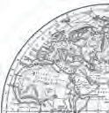
For many decades, a country’s level of development was measured only in terms of its

Band Aceh, June, 2004 Band Aceh, December, 2004
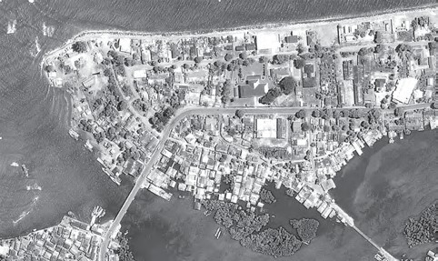
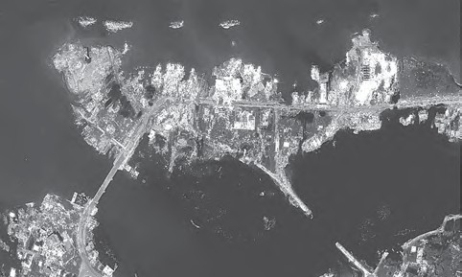
Do you know that cities can also grow negatively? Look at the photographs of this tsunami affected city. Are natural disasters the only reasons for negative growth in a city’s size?

economic growth. This meant that the bigger the economy of the country, the more developed it was considered, even though this growth did not really mean much change in the lives of most people.
The idea that the quality of life people enjoy in a country, the opportunities they have and freedoms they enjoy, are important aspects of development, is not new.
These ideas were clearly spelt out for the first time in the late eighties and early nineties. The works of two South Asian economists, Mahbub-ul-Haq and Amartya Sen are important in this regard.
The concept of human development was introduced by Dr Mahbub-ul-Haq. Dr Haq has described human development as development that enlarges people’s choices and improves their lives. People are central to all development under this concept. These choices are not fixed but keep on changing. The basic goal of development is to create conditions where people can live meaningful lives.
A meaningful life is not just a long one. It must be a life with some purpose. This means that people must be healthy, be able to develop their talents, participate in society and be free to achieve their goals.

Dr Mahbub-ul-Haq and Prof Amartya Sen were close friends and have worked together under the leadership of Dr Haq to bring out the initial Human Development Reports. Both these South Asian economists have been able to provide an alternative view of development.
A man of vision and compassion, Pakistani economist Dr Mahbub-ul-Haq created the Human Development Index in 1990. According to him, development is all about enlarging people’s choices in order to lead long, healthy lives with dignity. The United Nations Development Programme has used his concept of human development to publish the Human Development Report annually since 1990.

Dr Haq’s flexibility of mind and ability to think out of the box can be illustrated from one of his speeches where he quoted Shaw saying, “‘You see things that are, and ask why? I dream of things that never were, and ask why not?’
Nobel Laureate Prof Amartya Sen saw an increase in freedom (or decrease in unfreedom) as the main objective of development. Interestingly, increasing freedoms is also one of the most effective ways of bringing about development. His work explores the role of social and political institutions and processes in increasing freedom.

The works of these economists are path breaking and have succeeded in bringing people to the centre of any discussion on development.

14 Fundamentals of Human Geography






What is a Meaningful Life?

The Government of India has introduced Beti Bachao Beti Padhao programme to address the issue of decline in child sex ratio. Discuss with your peers how it will lead to more meaningful life for girls.

Which of these lives is a meaningful life?

Who do you think leads more meaningful life? What makes one of these more meaningful than the other?
Human Development 15

Leading a long and healthy life, being able to gain knowledge and having enough means to be able to live a decent life are the most important aspects of human development.
Therefore, access to resources, health and education are the key areas in human development. Suitable indicators have been developed to measure each of these aspects. Can you think of some?
Very often, people do not have the capability and freedom to make even basic choices. This may be due to their inability to acquire knowledge, their material poverty, social discrimination, inefficiency of institutions and other reasons. This prevents them from leading healthy lives, being able to get educated or to have the means to live a decent life.
Building people’s capabilities in the areas of health, education and access to resources is therefore, important in enlarging their choices. If people do not have capabilities in these areas, their choices also get limited.
For example, an uneducated child cannot make the choice to be a doctor because her choice has got limited by her lack of education. Similarly, very often poor people cannot choose to take medical treatment for disease because their choice is limited by their lack of resources.
Enact a five-minute play with your classmates showing how choices are limited due to lack of capability in the areas of either income, education or health.

THE FOUR PILLARS OF HUMAN DEVELOPMENT
Just as any building is supported by pillars, the idea of human development is supported by the concepts of equity, sustainability, productivity and empowerment.
Equity refers to making equal access to opportunities available to everybody. The opportunities available to people must be equal irrespective of their gender, race, income and in the Indian case, caste. Yet this is very often not the case and happens in almost every society.
For example, in any country, it is interesting to see which group the most of the school dropouts belong to. This should then lead to an understanding of the reasons for such behaviour. In India, a large number of women and persons belonging to socially and economically backward groups drop out of school. This shows how the choices of these groups get limited by not having access to knowledge.
Sustainability means continuity in the availability of opportunities. To have sustainable human development, each generation must have the same opportunities. All environmental, financial and human resources must be used keeping in mind the future. Misuse of any of these resources will lead to fewer opportunities for future generations.
A good example is about the importance of sending girls to school. If a community does not stress the importance of sending its girl children to school, many opportunities will be lost to these young women when they grow up. Their career choices will be severely curtailed and this would affect other aspects of their lives. So each generation must ensure the availability of choices and opportunities to its future generations.
Productivity here means human labour productivity or productivity in terms of human work. Such productivity must be constantly enriched by building capabilities in people. Ultimately, it is people who are the real wealth of nations. Therefore, efforts to increase their knowledge, or provide better health facilities ultimately leads to better work efficiency.
Empowerment means to have the power to make choices. Such power comes from increasing freedom and capability. Good governance and people-oriented policies are required to empower people. The empowerment of socially and economically disadvantaged groups is of special importance.
Talk to the vegetable vendor in your neighbourhood and find out if she has gone to school. Did she drop out of school? Why? What does this tell you about her choices and the freedom she has? Note how her opportunities were limited because of her gender, caste and income.

16 Fundamentals of Human Geography

APPROACHES TO HUMAN DEVELOPMENT
There are many ways of looking at the problem of human development. Some of the important approaches are: (a) The income approach; (b) The welfare approach; (c) Minimum needs approach; and (d) Capabilities approach (Table 3.1).

MEASURING HUMAN DEVELOPMENT
The human development index (HDI) ranks the countries based on their performance in the key areas of health, education and access to resources. These rankings are based on a score between 0 to 1 that a country earns from its record in the key areas of human development.
The indicator chosen to assess health is the life expectancy at birth. A higher life expectancy means that people have a greater chance of living longer and healthier lives.
The adult literacy rate and the gross enrolment ratio represent access to knowledge. The number of adults who are able to read and
write and the number of children enrolled in schools show how easy or difficult it is to access knowledge in a particular country.
Access to resources is measured in terms of purchasing power (in U.S. dollars).
Each of these dimensions is given a weightage of 1/3. The human development index is a sum total of the weights assigned to all these dimensions.
The closer a score is to one, the greater is the level of human development. Therefore, a score of 0.983 would be considered very high while 0.268 would mean a very low level of human development.
The human development index measures attainments in human development. It reflects what has been achieved in the key areas of human development. Yet it is not the most reliable measure. This is because it does not say anything about the distribution.
The human poverty index is related to the human development index. This index measures the shortfall in human development.

Table 3.1: Approaches to Human Development

(a) Income Approach | This is one of the oldest approaches to human development. Human development is seen as being linked to income. The idea is that the level of income reflects the level of freedom an individual enjoys. Higher the level of income, the higher is the level of human development.
(b) Welfare Approach | This approach looks at human beings as beneficiaries or targets of all development activities. The approach argues for higher government expenditure on education, health, social secondary and amenities. People are not participants in development but only passive recipients. The government is responsible for increasing levels of human development by maximising expenditure on welfare.
(c) Basic Needs Approach | This approach was initially proposed by the International Labour Organisation (ILO). Six basic needs i.e.: health, education, food, water supply, sanitation, and housing were identified. The question of human choices is ignored and the emphasis is on the provision of basic needs of defined sections.
(d) Capability Approach | This approach is associated with Prof. Amartya Sen. Building human capabilities in the areas of health, education and access to resources is the key to increasing human development.

Human Development 17


Since 1990, the United Nations Development Programme (UNDP) has been publishing the Human Development Report every year. This report provides a rank-wise list of all member countries according to the level of human development. The Human Development index and the Human Poverty index are two important indices to measure human development used by the UNDP.
It is a non-income measure. The probability of not surviving till the age of 40, the adult illiteracy rate, the number of people who do not have access to clean water, and the number of small children who are underweight are all taken into account to show the shortfall in human development in any region. Often the human poverty index is more revealing than the human development index.
Looking at both these measures of human development together gives an accurate picture of the human development situation in a country.
The ways to measure human development are constantly being refined and newer ways of capturing different elements of human development are being researched. Researchers have found links between the level of corruption or political freedom in a particular region. There is also a discussion regarding a political freedom index and, a listing of the most corrupt countries. Can you think of other links to the level of human development?

Bhutan is the only country in the world to officially proclaim the Gross National Happiness (GNH) as the measure of the country’s progress. Material progress and technological developments are approached more cautiously taking into consideration the possible harm they might bring to the environment or the other aspects of cultural and spiritual life of the Bhutanese. This simply means material progress cannot come at the cost of happiness. GNH encourages us to think of the spiritual, non-material and qualitative aspects of development.

INTERNATIONAL COMPARISONS
International comparisons of human development are interesting. Size of the territory and per capita income are not directly related to human development. Often smaller countries have done better than larger ones in human development. Similarly, relatively poorer nations have been ranked higher than richer neighbours in terms of human development.
For example, Sri Lanka, Trinidad and Tobago have a higher rank than India in the human development index despite having smaller economies. Similarly, within India, Kerala performs much better than Punjab and Gujarat in human development despite having lower per capita income.
Countries can be classified into four groups on the basis of the human development scores earned by them (Table 3.2).

Table 3.2: Human Development: Categories, Criteria and Countries

Level of Human Development | Score in Development Index | Number of Countries
Very High | above 0.800 | 69
High | between 0.700  up to 0.799 | 49
Medium | between 0.550  up to 0.699 | 42
Low | below 0.550 | 33
Source: Human Development Report, 2023-24

18 Fundamentals of Human Geography

Countries with very high human development index are those which have a score of over 0.800. According to the Human Development Report of 2023-24, this group includes 69 countries. Table
3.3 shows the top ten countries in this group.
Table 3.3: Top Ten Ranked Countries with High Value Index
Rank | Country | Rank | Country
1. | Switzerland | 7. | Germany
2. | Norway | 7. | Ireland
3. | Iceland | 9. | Singapore
4. | Hongkong, China (SAR) | 10. | Australia
5. | Denmark | 10. | Netherlands
5. | Sweden

Source: Human Development Report, 2023-24
Try to locate these countries on a map. Can you see what these countries have in common? To find out more visit the official government websites of these countries.
High level of human development group has 49 countries. Providing education and healthcare is an important government priority. Countries with higher human development are those where a lot of investment in the social sector has taken place. Altogether, a higher investment in people and good governance has set this group of countries apart from the others. Try to find out the percentage of the country’s income spent on these sectors. Can you think of some other characteristics that
these countries have in common?
You will notice that many of these countries have been the former imperial powers. The degree of social diversity in these countries is not very high. Many of the countries with a high human development score are located in Europe and represent the industrialised western world. Yet there are striking numbers of non-European countries also who have made it to this list.
Countries with medium levels of human development form the largest group. There are 42 countries in the medium level of human development. Most of these are countries which have emerged in the period after the Second World War. Some countries from this group were former colonies while many others have emerged
after the break up of the erstwhile Soviet Union in 1990. Many of these countries have been rapidly improving their human development score by adopting more people-oriented policies and reducing social discrimination. Most of these countries have a much higher social diversity than the countries with higher human development scores. Many in this group have

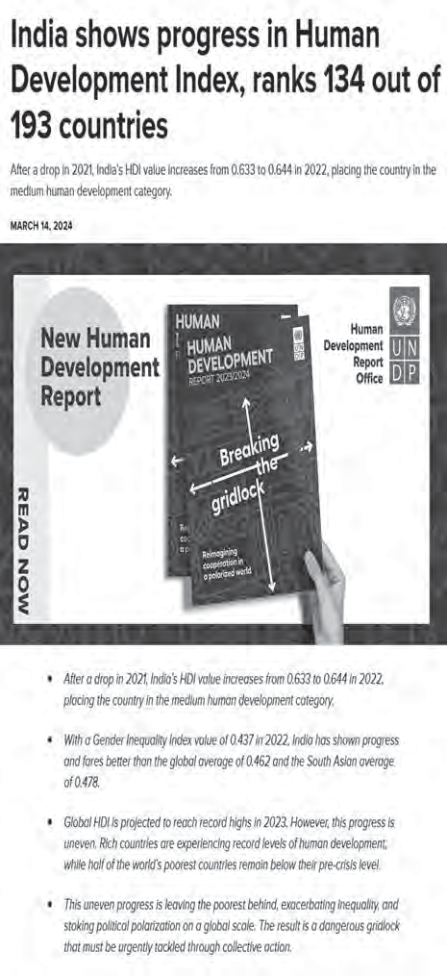
Human Development 19

faced political instability and social uprisings at some point of time in their recent history.
As many as 33 countries record low levels of human development. A large proportion of these are small countries which have been going through political turmoil and social instability in the form of civil war, famine or a high incidence of diseases. There is an urgent need to address the human development requirements of this group through well thought out policies.
International comparisons of human development can show some very interesting results. Often people tend to blame low levels of human development on the culture of the people. For example, X country has lower human development because its people follow Y religion, or belong to Z community. Such statements are misleading.
To understand why a particular region keeps reporting low or high levels of human development it is important to look at the pattern of government expenditure on the social sector. The political environment of the country and the amount of freedom people have is also important. Countries with high levels of human development invest more in the social sectors and are generally free from political turmoil and instability. Distribution of the country’s resources is also far more equitable.
On the other hand, places with low levels of human development tend to spend more on defence rather than social sectors. This shows that these countries tend to be located in areas of political instability and have not been able to initiate accelerated economic development.



EXERCISES
- Choose the right answer from the four alternatives given below.
  - Which one of the following best describes development?
    - an increase in size (c) a positive change in quality
    - a constant in size (d) a simple change in the quality
  - Which one of the following scholars introduced the concept of Human Development?
    - Prof. Amartya Sen (c) Dr Mahabub-ul-Haq
    - Ellen C. Semple (d) Ratzel
- Answer the following questions in about 30 words.
  - What are the three basic areas of human development?
  - Name the four main components of human development?
  - How are countries classified on the basis of human development index?
- Answer the following questions in not more than 150 words.
  - What do you understand by the term human development?
  - What do equity and sustainability refer to within the concept of human development?

20 Fundamentals of Human Geography

Project/Activity
Make a list of the ten most corrupt countries and ten least corrupt countries. Compare their scores on the human development index. What inferences can you draw?
Consult the latest Human Development Report for this.

Human Development 21

Unit-III

Chapter-4

Primary Activities
Human activities which generate income are known as economic activities. Economic activities are broadly grouped into primary, secondary, tertiary and quaternary activities. Primary activities are directly dependent on environment as these refer to utilisation of earth’s resources such as land, water, vegetation, building materials and minerals. It, thus includes, hunting and gathering, pastoral activities, fishing, forestry, agriculture, and mining and quarrying.


Why are the inhabitants of coastal and plain regions engaged in fishing and agriculture respectively? What are the physical and social factors which affect the type of primary activities in different regions?

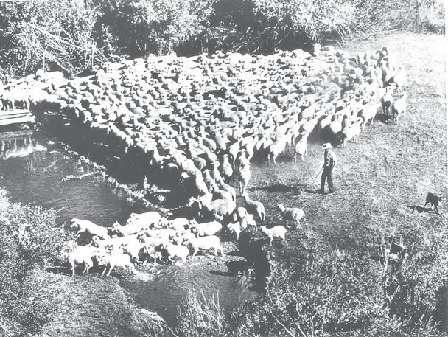
People engaged in primary activities are called red-collar workers due to the outdoor nature of their work.

HUNTING AND GATHERING
The earliest human beings depended on their immediate environment for their sustenance. They subsisted on: (a) animals which they hunted; and (b) the edible plants which they gathered from forests in the vicinity.
Primitive societies depended on wild animals. People located in very cold and extremely hot climates survived on hunting. The people in the coastal areas still catch fish though fishing has experienced modernisation due to technological progress. Many species, now have become extinct or endangered due to illegal hunting (poaching). The early hunters used primitive tools made of stones, twigs or arrows so the number of animals killed was limited. Why has hunting been banned in India?
Gathering and hunting are the oldest economic activity known. These are carried out at different levels with different orientations.
Gathering is practised in regions with harsh climatic conditions. It often involves primitive societies, who extract, both plants and
22 Fundamentals of Human Geography

animals to satisfy their needs for food, shelter and clothing. This type of activity requires a small amount of capital investment and operates at very low level of technology. The yield per person is very low and little or no surplus is produced.
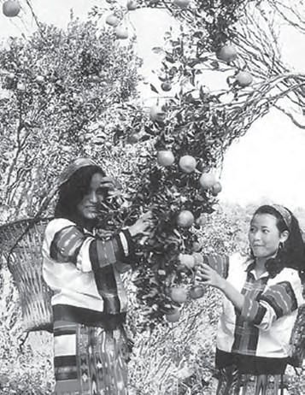
Fig. 4.1: Women Gathering Oranges in Mizoram
Gathering is practised in: (i) high latitude zones which include northern Canada, northern Eurasia and southern Chile; (ii) Low latitude zones such as the Amazon Basin, tropical Africa, Northern fringe of Australia and the interior parts of Southeast Asia (Fig. 4.2).
In modern times some gathering is market-oriented and has become commercial. Gatherers collect valuable plants such as leaves, barks of trees and medicinal plants and after simple processing sell the products in the market. They use various parts of the plants, for example, the bark is used for quinine, tanin extract and cork— leaves supply materials for beverages, drugs, cosmetics, fibres, thatch and fabrics; nuts for food and oils and tree trunk yield rubber, balata, gums and resins.
The name of the part of the chewing gum after the flavour is gone? It is called Chicle — it is made from the milky juice of zapota tree.

Gathering has little chance of becoming important at the global level. Products of such an

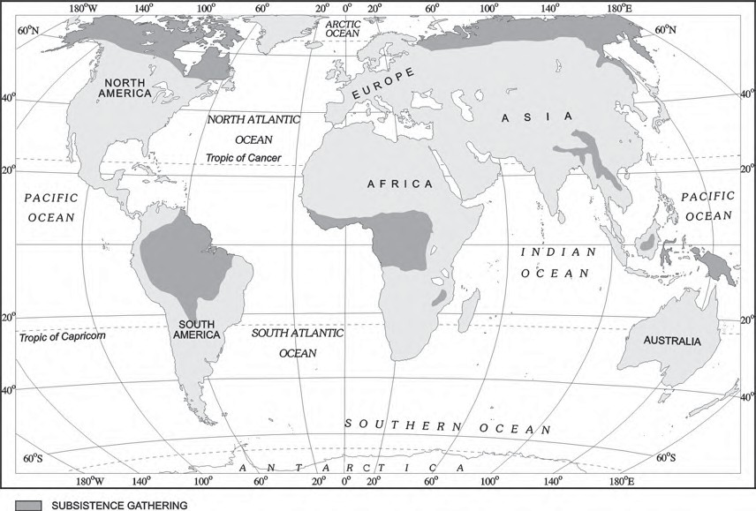
Fig. 4.2: Areas of Subsistence Gathering
Primary Activities 23

activity cannot compete in the world market. Moreover, synthetic products often of better quality and at lower prices, have replaced many items supplied by the gatherers in tropical forests.

PASTORALISM
At some stage in history, with the realisation that hunting is an unsustainable activity, human beings might have thought of domestication of animals. People living in different climatic conditions selected and domesticated animals found in those regions. Depending on the geographical factors, and technological development, animal rearing today is practised either at the subsistence or at the commercial level.

Nomadic Herding
Nomadic herding or pastoral nomadism is a primitive subsistence activity, in which the herders rely on animals for food, clothing, shelter, tools and transport. They move from one place to another along with their livestock, depending on the amount and quality of pastures and water. Each nomadic community occupies a well-identified territory as a matter of tradition.
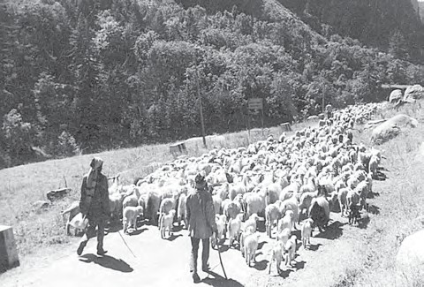
Fig. 4.3: Nomads taking their sheep up to the Mountains at the onset of summer
A wide variety of animals is kept in different regions. In tropical Africa, cattle are the most important livestock, while in Sahara and Asiatic deserts, sheep, goats and camel are reared. In the mountainous areas of Tibet and Andes, yak and llamas and in the Arctic and sub Arctic areas, reindeer are the most important animals.
Pastoral nomadism is associated with three important regions. The core region extends from the Atlantic shores of North Africa eastwards across the Arabian peninsula into Mongolia and Central China. The second region extends over the tundra region of Eurasia. In the southern hemisphere there are small areas in South-west Africa and on the island of Madagascar (Fig. 4.4)
Movement in search of pastures is undertaken either over vast horizontal distances or vertically from one elevation to another in the mountainous regions. The process of migration from plain areas to pastures on mountains during summers and again from mountain pastures to plain areas during winters is known as transhumance. In mountain regions, such as Himalayas, Gujjars, Bakarwals, Gaddis and Bhotiyas migrate from plains to the mountains in summers and to the plains from the high altitude pastures in winters. Similarly, in the tundra regions, the nomadic herders move from south to north in summers and from north to south in winters.
The number of pastoral nomads has been decreasing and the areas operated by them shrinking. This is due to (a) imposition of political boundaries; (b) new settlement plans by different countries.

Commercial Livestock Rearing
Unlike nomadic herding, commercial livestock rearing is more organised and capital intensive. Commercial livestock ranching is essentially associated with western cultures and is practised on permanent ranches. These ranches cover large areas and are divided into a number of parcels, which are fenced to regulate the grazing. When the grass of one parcel is grazed, animals are moved to another parcel. The number of animals in a pasture is kept according to the carrying capacity of the pasture.
This is a specialised activity in which only one type of animal is reared. Important animals include sheep, cattle, goats and horses. Products such as meat, wool, hides and skin are processed and packed scientifically and
exported to different world markets.
Rearing of animals in ranching is organised on a scientific basis. The main

24 Fundamentals of Human Geography

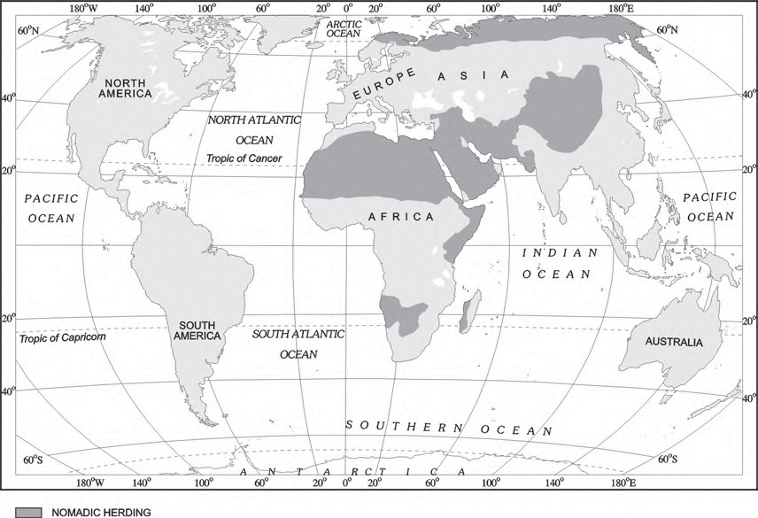
Fig. 4.4: Areas of Nomadic Herding

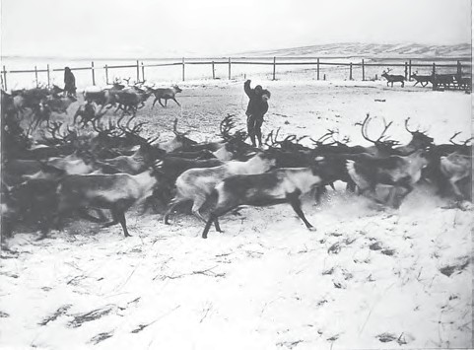
AGRICULTURE
Agriculture is practised under multiple combinations of physical and socio-economic conditions, which gives rise to different types of agricultural systems.
Based on methods of farming, different types of crops are grown and livestock raised. The following are the main agricultural systems.

Fig. 4.5: Commercial Livestock Rearing

Reindeer rearing in the northern regions of Alaska where most of the Eskimos own about two-third of the stock.
emphasis is on breeding, genetic improvement, disease control and health care of the animals. New Zealand, Australia, Argentina, Uruguay and United States of America are important countries where commercial livestock
rearing is practised (Fig. 4.6).

Subsistence Agriculture
Subsistence agriculture is one in which the farming areas consume all, or nearly so, of the products locally grown. It can be grouped in two categories — Primitive Subsistence Agriculture and Intensive Subsistence Agriculture.

Primitive Subsistence Agriculture
Primitive subsistence agriculture or shifting cultivation is widely practised by many tribes in the tropics, especially in Africa, south and central America and south east Asia (Fig. 4.7).

Primary Activities 25

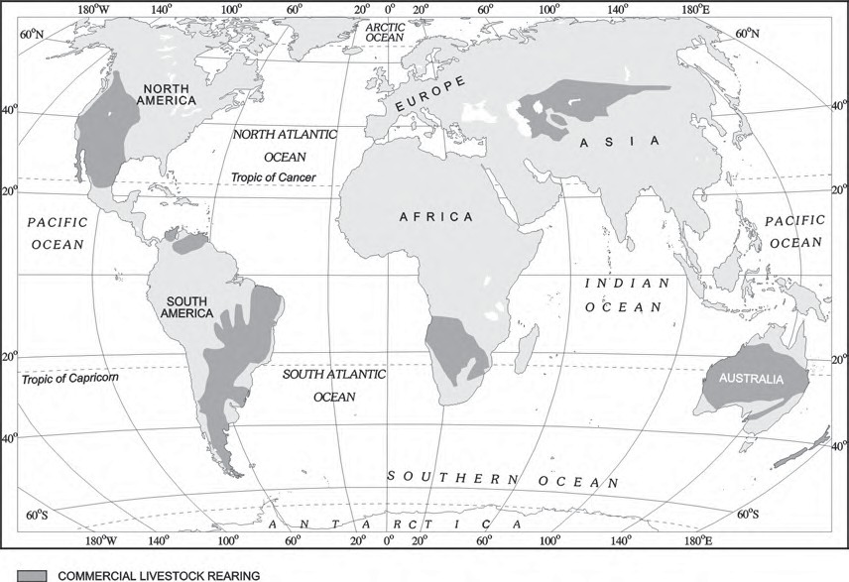
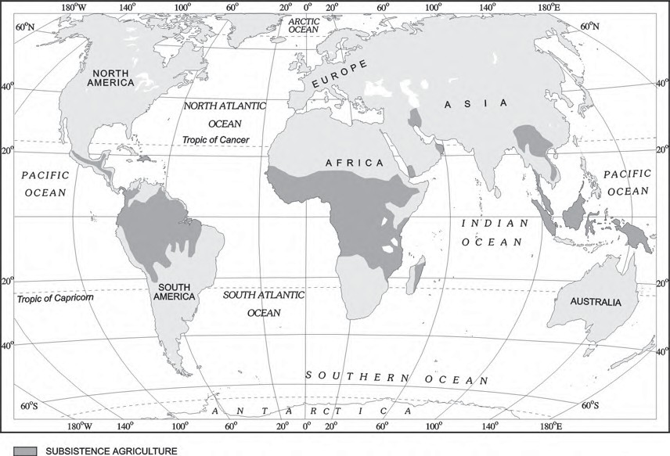
Fig. 4.6: Areas of Commercial Livestock Rearing

Fig. 4.7: Areas of Primitive Subsistence Agriculture

26 Fundamentals of Human Geography

The vegetation is usually cleared by fire, and the ashes add to the fertility of the soil. Shifting cultivation is thus, also called slash and burn agriculture. The cultivated patches are very small and cultivation is done with very primitive tools such as sticks and hoes. After sometime (3 to 5 years) the soil looses its fertility and the farmer shifts to another parts and clears other patch of the forest for cultivation. The farmer may return to the earlier patch after sometime. One of the major problems of shifting cultivation is that the cycle of jhum becomes less and less due to loss of fertility in different parcels. It is prevalent in tropical region in different names, e.g. Jhuming in North eastern states of India, Milpa in central America and Mexico and Ladang in Indonesia and Malaysia. Find out other areas and the names with which shifting cultivation is done.

Intensive Subsistence Agriculture
This type of agriculture is largely found in densely populated regions of monsoon Asia.
Basically, there are two types of intensive subsistence agriculture.
- Intensive subsistence agriculture dominated by wet paddy cultivation: This type of agriculture is characterised by dominance of the rice crop. Land holdings are very small due to the high density of population. Farmers work with the help of family labour leading to intensive use of land. Use of machinery is limited and most of the agricultural operations are done by manual labour. Farm yard manure is used to maintain the fertility of the soil. In this type of agriculture, the yield per unit area is high but per labour productivity is low.
- Intensive subsistence agriculture dominated by crops other than paddy: Due to the difference in relief, climate, soil and some of the other geographical factors, it is not practical to grow paddy in many parts of monsoon Asia. Wheat, soyabean, barley and sorghum are grown in northern China, Manchuria, North Korea and North Japan. In India wheat is grown in western

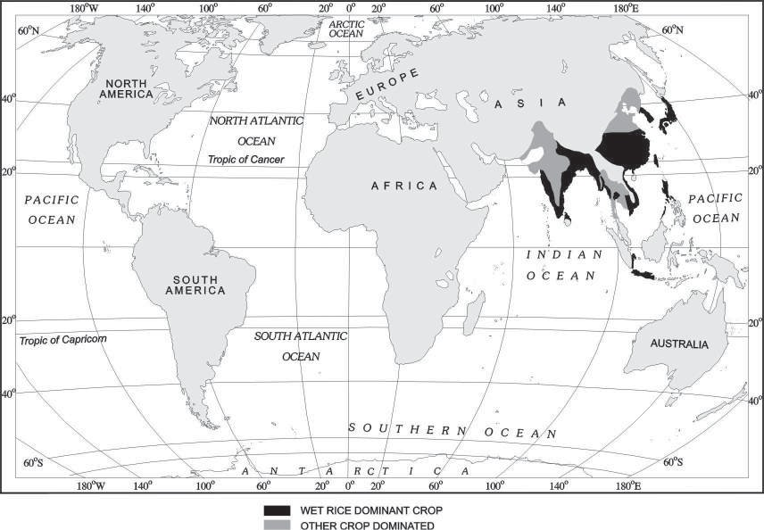

Fig. 4.8: Areas of Intensive Subsistence Farming
Primary Activities 27

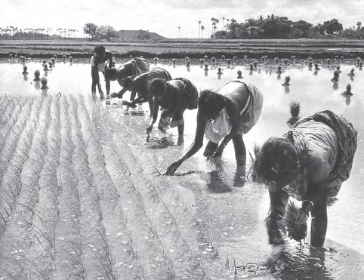
sugarcane plantations in the Philippines. The Dutch once had monopoly over sugarcane plantation in Indonesia. Some coffee fazendas (large plantations) in Brazil are still managed by Europeans.
Today, ownership of the majority of plantations has passed into the hands of the government or the nationals of the countries concerned.

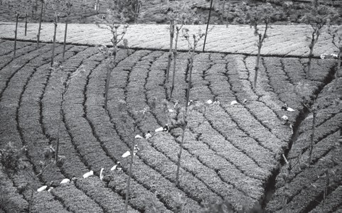
Fig. 4.9: Rice Transplantation

parts of the Indo-Gangetic plains and millets are grown in dry parts of western and southern India. Most of the characteristics of this type of agriculture are similar to those dominated by wet paddy except that irrigation is often used.
The Europeans colonised many parts in the world and they introduced some other forms of agriculture such as plantations which were mainly profit-oriented large scale production systems.

Plantation Agriculture
Plantation agriculture as mentioned above was introduced by the Europeans in colonies situated in the tropics. Some of the important plantation crops are tea, coffee, cocoa, rubber, cotton, oil palm, sugarcane, bananas and pineapples.
The characteristic features of this type of farming are large estates or plantations, large capital investment, managerial and technical support, scientific methods of cultivation, single crop specialisation, cheap labour, and a good system of transportation which links the estates to the factories and markets for the export of the products.
The French established cocoa and coffee plantations in west Africa. The British set up large tea gardens in India and Sri Lanka, rubber plantations in Malaysia and sugarcane and banana plantations in West Indies. Spanish and Americans invested heavily in coconut and

Fig. 4.10: Tea Plantation
The slopes of hills are used for tea plantations because of favourable geographical conditions.

Extensive Commercial Grain Cultivation
Commercial grain cultivation is practised in the interior parts of semi-arid lands of the mid-latitudes. Wheat is the principal crop, though other crops like corn, barley, oats and rye are also grown. The size of the farm is very large, therefore entire operations of cultivation from
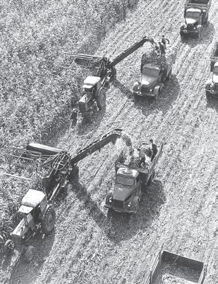
ploughing to harvesting are mechanised (Fig. 4.11). There is low yield per acre but high yield per person. Why does this happen?

Fig. 4.11:
Mechanised Grain Farming
Combine crews are capable of harvesting grain over many hectares in a single day.

28 Fundamentals of Human Geography

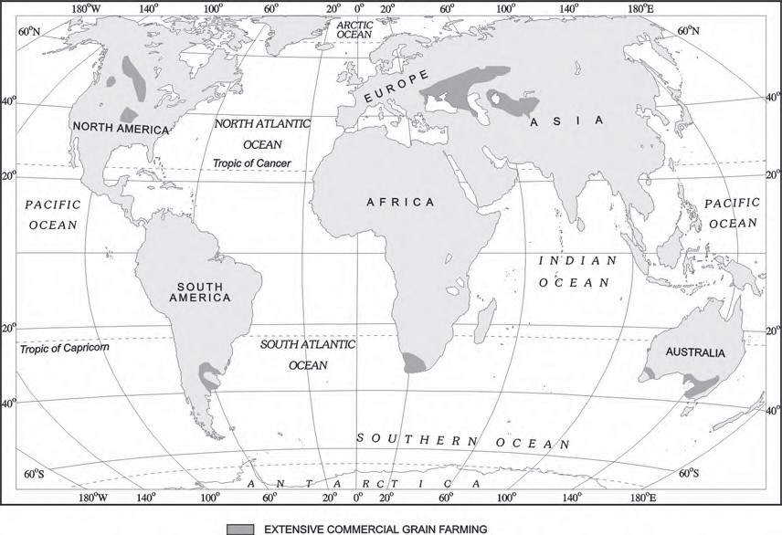
Fig. 4.12: Areas of Extensive Commercial Grain Farming

This type of agriculture is best developed in Eurasian steppes, the Canadian and American Prairies, the Pampas of Argentina, the Velds of South Africa, the Australian Downs and the Canterbury Plains of New Zealand. (Locate these areas on the world map).

Mixed Farming
This form of agriculture is found in the highly developed parts of the world, e.g. North-western Europe, Eastern North America, parts of Eurasia and the temperate latitudes of Southern continents (Fig. 4.14).
Mixed farms are moderate in size and usually the crops associated with it are wheat, barley, oats, rye, maize, fodder and root crops. Fodder crops are an important component of mixed farming. Crop rotation and intercropping play an important role in maintaining soil fertility. Equal emphasis is laid on crop cultivation and animal husbandry. Animals like cattle, sheep, pigs and poultry provide the main income along with crops.
Mixed farming is characterised by high capital expenditure on farm machinery and
building, extensive use of chemical fertilisers and green manures and also by the skill and expertise of the farmers.

Dairy Farming
Dairy is the most advanced and efficient type of rearing of milch animals. It is highly capital intensive. Animal sheds, storage facilities for fodder, feeding and milching machines add to the cost of dairy farming. Special emphasis is laid on cattle breeding, health care and veterinary services.

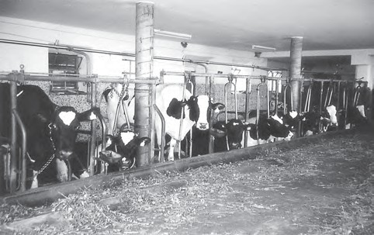
Primary Activities 29

Fig. 4.13: A Dairy Farm in Austria

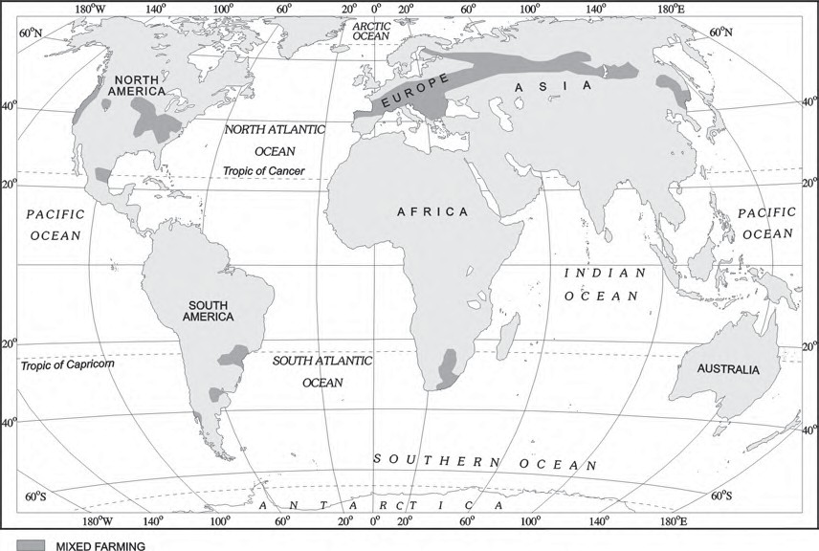
Fig. 4.14: Areas of Mixed Farming

It is highly labour intensive as it involves rigorous care in feeding and milching. There is no off season during the year as in the case of crop raising.
It is practised mainly near urban and industrial centres which provide neighbourhood market for fresh milk and dairy products. The development of transportation, refrigeration, pasteurisation and other preservation processes have increased the duration of storage of various dairy products.
There are three main regions of commercial dairy farming. The largest is North Western Europe the second is Canada and the third belt includes South Eastern Australia, New Zealand and Tasmania (Fig. 4.16).

Mediterranean Agriculture
Mediterranean agriculture is highly specialised commercial agriculture. It is practised in the countries on either side of the Mediterranean

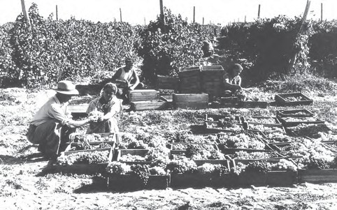
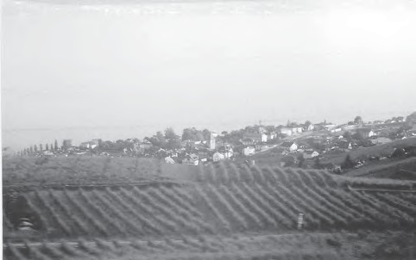
Fig. 4.15 (b): Collection of

Fig. 4.15 (a): A vineyard in Switzerland
grapes in a collective farm of Kazakhstan

30 Fundamentals of Human Geography

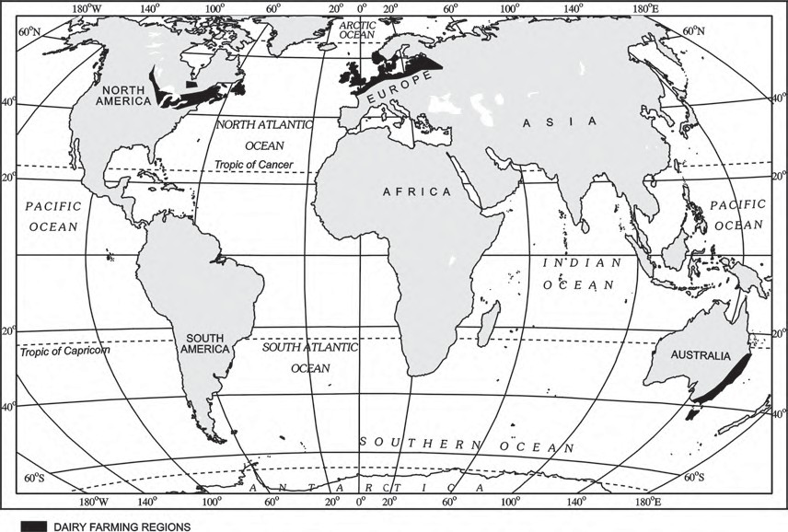
Fig. 4.16: Areas of Dairy Farming

sea in Europe and in north Africa from Tunisia to Atlantic coast, southern California, central Chile, south western parts of South Africa and south and south western parts of Australia. This region is an important supplier of citrus fruits.
Viticulture or grape cultivation is a speciality of the Mediterranean region. Best quality wines in the world with distinctive flavours are produced from high quality grapes in various countries of this region. The inferior grapes are dried into raisins and currants. This region also produces olives and figs. The advantage of Mediterranean agriculture is that more valuable crops such as fruits and vegetables are grown in winters when there is great demand in European and North American markets.

Market Gardening and Horticulture
Market gardening and horticulture specialise in the cultivation of high value crops such as vegetables, fruits and flowers, solely for the urban markets. Farms are small and are
located where there are good transportation links with the urban centre where high income group of consumers is located. It is both labour and capital intensive and lays emphasis on the use of irrigation, HYV seeds, fertilisers, insecticides, greenhouses and artificial heating in colder regions.
This type of agriculture is well developed in densely populated industrial districts of north west Europe, north eastern United States of America and the Mediterranean regions. The Netherlands specialises in growing flowers and horticultural crops especially tulips, which are flown to all major cities of Europe.
The regions where farmers specialise in vegetables only, the farming is know as truck farming. The distance of truck farms from the market is governed by the distance that a truck can cover overnight, hence the name truck farming.
In addition to market gardening, a modern development in the industrial regions of Western Europe and North America is factory farming. Livestock, particularly poultry and cattle

Primary Activities 31

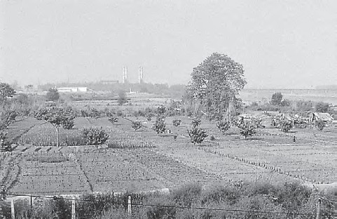
Figure 4.17 (a): Vegetables being grown in the vicinity of the city

rearing, is done in stalls and pens, fed on manufactured feedstuff and carefully supervised against diseases. This requires heavy capital investment in terms of building, machinery for various operations, veterinary services and heating and lighting. One of the important features of poultry farming and cattle rearing is breed selection and scientific breeding.
Types of farming can also be categorised according to the farming organisation. Farming organisation is affected by the way in which farmers own their farms and various policies of the government which help to run these farms.

Co-operative Farming
A group of farmers form a co-operative society by pooling in their resources voluntarily for more efficient and profitable farming. Individual farms remain intact and farming is a matter of cooperative initiative.
Co-operative societies help farmers, to procure all important inputs of farming, sell the products at the most favourable terms and help in processing of quality products at cheaper rates.
Co-operative movement originated over a century ago and has been successful in many western European countries like Denmark, Netherlands, Belgium, Sweden, Italy etc. In Denmark, the movement has been so successful that practically every farmer is a member of a co-operative.

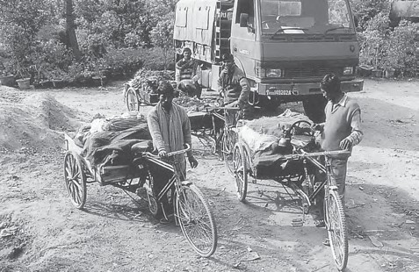
Figure 4.17 (b): Vegetables being loaded into a truck and cycle carts for transporting to city markets

Collective Farming
The basic principle behind this types of farming is based on social ownership of the means of production and collective labour. Collective farming or the model of Kolkhoz was introduced in erstwhile Soviet Union to improve upon the inefficiency of the previous methods of agriculture and to boost agricultural production for self-sufficiency.
The farmers used to pool in all their resources like land, livestock and labour. However, they were allowed to retain very small plots to grow crops in order to meet their daily requirements.

MINING
The discovery of minerals in the history of human development, is reflected in many stages in terms of copper age, bronze age and iron age. The use of minerals in ancient times was largely confined to the making of tools, utensils and weapons. The actual development of mining began with the industrial revolution and its importance is continuously increasing.

Factors Affecting Mining Activity
The profitability of mining operations thus, depends on two main factors:
- Physical factors include the size, grade and the mode of occurrence of the deposits.
- Economic factors such as the demand for the mineral, technology available and used, capital to develop infrastructure and the labour and transport costs.

32 Fundamentals of Human Geography

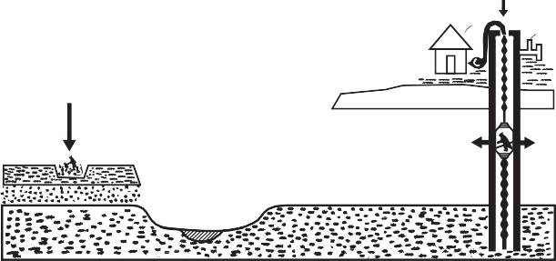
OPEN-CAST OR
(STRIP MINING)
SHAFT MINING
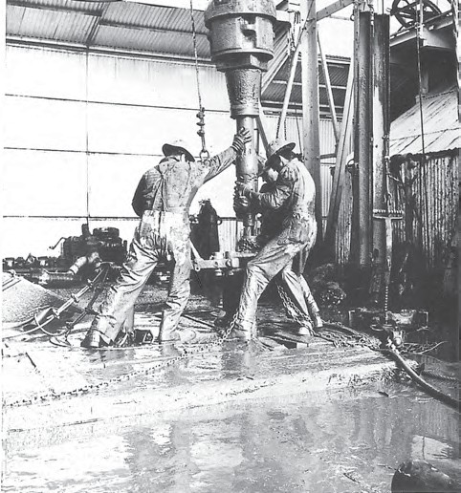
Fig. 4.19: Methods of Mining

Fig. 4.18: Oil drilling operation in the Gulf of Mexico

Methods of Mining
Depending on the mode of occurrence and the nature of the ore, mining is of two types: surface and underground mining. The surface mining also known as open-cast mining is the easiest and the cheapest way of mining minerals that occur close to the surface. Overhead costs such as safety precautions and equipment is relatively low in this method. The output is both large and rapid.
When the ore lies deep below the surface,
underground mining method (shaft method)
has to be used. In this method, vertical shafts have to be sunk, from where underground galleries radiate to reach the minerals. Minerals are extracted and transported to the surface through these passages. It requires specially designed lifts, drills, haulage vehicles, ventilation system for safety and efficient movement of people and material. This method is risky. Poisonous gases, fires, floods and caving in lead to fatal accidents. Have you ever read about mine fires and flooding of coal mines in India?
The developed economies are retreating from mining, processing and refining stages of production due to high labour costs, while the developing countries with large labour force and striving for higher standard of living are becoming more important. Several countries of Africa and few of south America and Asia have over fifty per cent of the earnings from minerals alone.

Primary Activities 33


EXERCISES
- Choose the right answer from the four alternatives given below.
  - Which one of the following is not a plantation crop?
    - Coffee (c) Wheat
    - Sugarcane (d) Rubber
  - In which one of the following countries co-operative farming was the most successful experiment?
    - Russia (c) India
    - Denmark (d) The Netherlands
  - Growing of flowers is called:
    - Truck farming (c) Mixed farming
    - Factory farming (d) Floriculture
  - Which one of the following types of cultivation was developed by European colonists?
    - Kolkoz (c) Mixed farming
    - Viticulture (d) Plantation
  - In which one of the following regions is extensive commercial grain cultivation not practised?
    - American Canadian prairies (c) Pampas of Argentina
    - European Steppes (d) Amazon Basin
  - In which of the following types of agriculture is the farming of citrus fruit very important?
    - Market gardening (c) Mediterranean agriculture
    - Plantation agriculture (d) Co-operative farming
  - Which one type of agriculture amongst the following is also called ‘slash and burn agriculture’?
    - Extensive subsistence agriculture
    - Primitive subsistence agriculture
    - Extensive commercial grain cultivation
    - Mixed farming
  - Which one of the following does not follow monoculture?
    - Dairy farming (c) Plantation agriculture
    - Mixed farming (d) Commercial grain farming
- Answer the following questions in about 30 words.
  - Future of shifting cultivation is bleak. Discuss.
  - Market gardening is practised near urban areas. Why?
  - Large scale dairy farming is the result of the development of transportation and refrigeration.

34 Fundamentals of Human Geography

- Answer the following questions in not more than 150 words.
  - Differentiate between Nomadic Herding and Commercial Livestock Rearing.
  - Discuss the important characteristic features of plantation agriculture. Name a few important plantation crops from different countries.
Project/Activity
Visit a nearby village and observe the cultivation of some crops. Ask the farmers and list the various operations.

Primary Activities 35

Unit-III

Chapter-5

Secondary Activities
All economic activities namely primary, secondary, tertiary and quaternary, revolve around obtaining and utilising resources necessary for survival.
Secondary activities add value to natural resources by transforming raw materials into valuable products. Cotton in the boll has limited use but after it is transformed into yarn, becomes more valuable and can be used for making clothes. Iron ore, cannot be used; directly from the mines, but after being converted into steel it gets its value and can be used for making many valuable machines, tools, etc. The same is true of most of the materials from the farm, forest, mine and the sea. Secondary activities, therefore, are concerned with manufacturing, processing and construction (infrastructure) industries.

MANUFACTURING
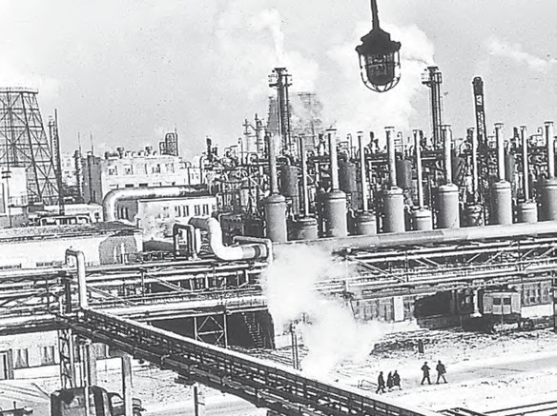
Manufacturing involves a full array of production from handicrafts to moulding iron and steel and stamping out plastic toys to assembling delicate computer components or space vehicles. In each of these processes, the common characteristics are the application of power, mass production of identical products and specialised labour in factory settings for the production of standardised commodities. Manufacturing may be done with modern power and machinery or it may still be very primitive. Most of the Third World countries still ‘manufacture’ in the literal sense of the term. It is difficult to present a full picture of all the manufacturers in these countries. More emphasis is given to the kind of ‘industrial’ activity which involves less complicated systems of production.

Characteristics of Modern Large Scale Manufacturing
Modern large scale manufacturing has the following characteristics:

Specialisation of Skills/Methods of Production
Under the ‘craft’ method factories produce only a few pieces which are made-to-order. So the costs are high. On the other hand, mass
36 Fundamentals of Human Geography

production involves production of large quantities of standardised parts by each worker performing only one task repeatedly.
‘Manufacturing’ Industry and ‘Manufacturing Industry’
Manufacturing literally means ‘to make by hand’. However, now it includes goods ‘made by machines’. It is essentially a process which involves transforming raw materials into finished goods of higher value for sale in local or distant markets. Conceptually, an industry is a geographically located manufacturing unit maintaining books of accounts and, records under a management system. As the term industry is comprehensive, it is also used as synonymous with ‘manufacturing’ When one uses terms like ‘steel industry’ and ‘chemical industry’ one thinks of factories and processes. But there are many secondary activities which are not carried on in factories such as what is now called the ‘entertainment industry’ and Tourism industry, etc. So for clarity the longer expression ‘manufacturing industry’ is used.

Mechanisation
Mechanisation refers to using gadgets which accomplish tasks. Automation (without aid of human thinking during the manufacturing process) is the advanced stage of mechanisation. Automatic factories with feedback and closed-loop computer control systems where machines are developed to ‘think’, have sprung up all over the world.

Technological Innovation
Technological innovations through research and development strategy are an important aspect of modern manufacturing for quality control, eliminating waste and inefficiency, and combating pollution.

Organisational Structure and Stratification
Modern manufacturing is characterised by a complex machine technology and extreme specialisation and division of labour for producing more goods with less efforts and low costs. It also requires vast capital, large organisations and executive bureaucracy for a large scale manufacturing industry.

Uneven Geographic Distribution

Major concentrations of modern manufacturing have flourished in a few number of places. These cover less than 10 per cent of the world’s land area. These nations have become the centres of economic and political power. However, in terms of the total area covered, manufacturing sites are much less conspicuous and concentrated on much smaller areas than that of agriculture due to greater intensity of processes. For example, 2.5 sq km of the American corn belt usually includes about four large farms employing about 10-20 workers supporting 50-100 persons. But this same area could contain several large integrated factories and employ thousands of workers.

Why do Large-scale Industries choose different locations?
Industries maximise profits by reducing costs. Therefore, industries should be located at points where the production costs are minimum. Some of the factors influencing industrial locations are as under:

Access to Market
The existence of a market for manufactured goods is the most important factor in the location of industries. ‘Market’ means people who have a demand for these goods and also have the purchasing power (ability to purchase) to be able to purchase from the sellers at a place. Remote areas inhabited by a few people offer small markets. The developed regions of Europe, North America, Japan and Australia provide large global markets as the purchasing power of the people is very high. The densely populated regions of South and South-east Asia also

Secondary Activities 37

provide large markets. Some industries, such as aircraft manufacturing, have a global market. The arms industry also has global markets.

Access to Raw Material
Raw material used by industries should be cheap and easy to transport. Industries based on cheap, bulky and weight-losing material (ores) are located close to the sources of raw material such as steel, sugar, and cement industries. Perishability is a vital factor for the industry to be located closer to the source of the raw material. Agro-processing and dairy products are processed close to the sources of farm produce or milk supply respectively.

Access to Labour Supply
Labour supply is an important factor in the location of industries. Some types of manufacturing still require skilled labour. Increasing mechanisation, automation and flexibility of industrial processes have reduced the dependence of industry upon the labours.

Access to Sources of Energy
Industries which use more power are located close to the source of the energy supply such as the aluminium industry.
Earlier coal was the main source of energy, today hydroelectricity and petroleum are also important sources of energy for many industries.

Access to Transportation and Communication Facilities
Speedy and efficient transport facilities to carry raw materials to the factory and to move finished goods to the market are essential for the development of industries. The cost of transport plays an important role in the location of industrial units. Western Europe and eastern North America have a highly developed transport system which has always induced the concentration of industries in these areas. Modern industry is inseparably tied to transportation systems. Improvements in transportation led to integrated economic development and regional specialisation of manufacturing.
Communication is also an important need for industries for the exchange and management of information.

Government Policy
Governments adopt ‘regional policies’ to promote ‘balanced’ economic development and hence set up industries in particular areas.

Access to Agglomeration Economies/ Links between Industries
Many industries benefit from nearness to a leader-industry and other industries. These benefits are termed as agglomeration economies. Savings are derived from the linkages which exist between different industries.
These factors operate together to determine industrial location.

Foot Loose Industries
Foot loose industries can be located in a wide variety of places. They are not dependent on any specific raw material, weight losing or otherwise. They largely depend on component parts which can be obtained anywhere. They produce in small quantity and also employ a small labour force. These are generally not polluting industries. The important factor in their location is accessibility by road network.

Classification of Manufacturing Industries
Manufacturing industries are classified on the basis of their size, inputs/raw materials, output/products and ownership (Fig. 5.1).

Industries based on Size
The amount of capital invested, number of workers employed and volume of production determine the size of industry. Accordingly, industries may be classified into household or cottage, small-scale and large-scale.

38 Fundamentals of Human Geography

Fig. 5.1 : Classification of Industries
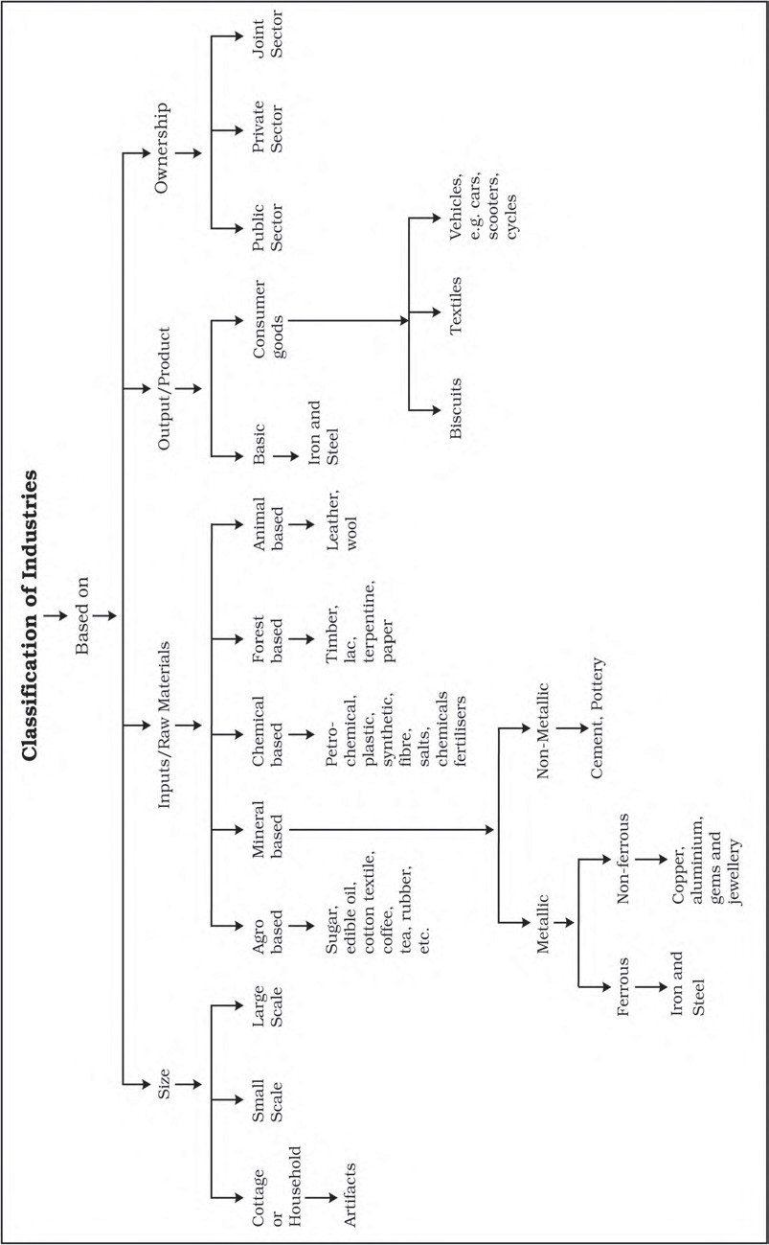

Secondary Activities 39

HOUSEHOLD INDUSTRIES OR COTTAGE MANUFACTURING
It is the smallest manufacturing unit. The artisans use local raw materials and simple tools to produce everyday goods in their homes with the help of their family members or part-time labour. Finished products may be for consumption in the same household or, for sale in local (village) markets, or, for barter. Capital and transportation do not wield much influence as this type of manufacturing has low commercial significance and most of the tools are devised locally.
Some common everyday products produced in this sector of manufacturing include foodstuffs, fabrics, mats, containers, tools, furniture, shoes, and figurines from wood lot and forest, shoes, thongs and other articles from leather; pottery and bricks from clays and stones. Goldsmiths make jewellery of gold, silver and bronze. Some artefacts and crafts are made out of bamboo, wood obtained locally from the forests.

Small Scale Manufacturing
Small scale manufacturing is distinguished from household industries by its production techniques and place of manufacture (a workshop outside the home/cottage of the producer). This type of manufacturing uses local raw material, simple power-driven machines and semi-skilled labour. It provides employment and raises local purchasing power. Therefore, countries like India, China, Indonesia and Brazil, etc. have developed labour-intensive small scale manufacturing in order to provide employment to their population.

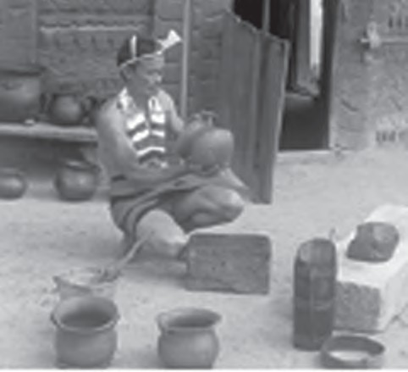
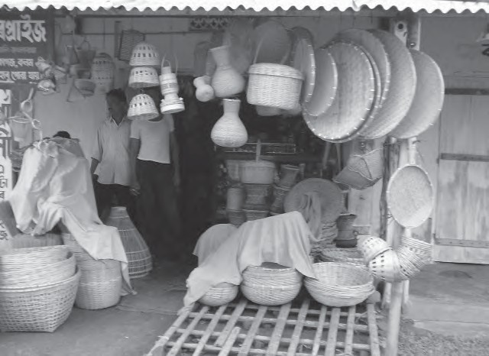
Fig. 5.2 (a) : A man making pots in his courtyard-example of household industry in Nagaland

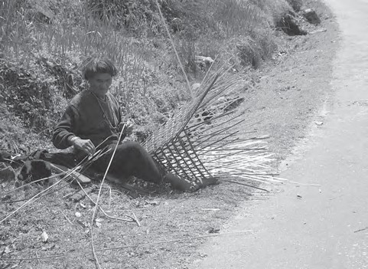
Fig. 5.3: Products of cottage industry on sale in Assam

Fig. 5.2 (b) : A man weaving a bamboo basket by the roadside in Arunachal Pradesh

Large Scale Manufacturing
Large scale manufacturing involves a large market, various raw materials, enormous energy, specialised workers, advanced technology, assembly-line mass production and large capital. This kind of manufacturing developed in the last 200 years, in the United Kingdom, north-eastern U.S.A. and Europe. Now it has diffused to almost all over the world.

40 Fundamentals of Human Geography

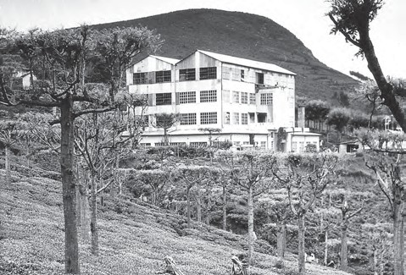
On the basis of the system of large scale manufacturing, the world’s major industrial regions may be grouped under two broad types, namely
- traditional large-scale industrial regions which are thickly clustered in a few more developed countries.
- high-technology large scale industrial regions which have diffused to less developed countries.

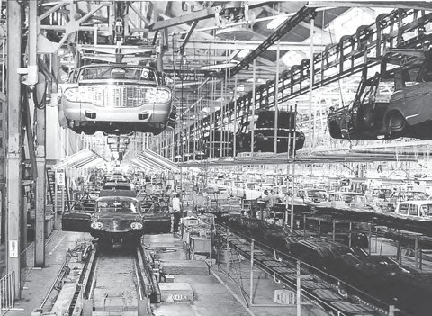
Fig. 5.5: Tea Garden and a Tea Factory in the Nilgiri Hills of Tamil Nadu

Fig. 5.4 : Passenger car assembly hires at a plant of the Motor Company in Japan

Industries based on Inputs/Raw Materials
On the basis of the raw materials used, the industries are classified as: (a) agro-based; (b) mineral based; (c) chemical based; (d) forest based: and (e) animal based.

Agro based Industries
Agro processing involves the processing of raw materials from the field and the farm into finished products for rural and urban markets. Major agro-processing industries are food processing, sugar, pickles, fruits juices, beverages (tea, coffee and cocoa), spices and oils fats and textiles (cotton, jute, silk), rubber, etc.
Food Processing
Agro processing includes canning, producing cream, fruit processing and confectionery. While some preserving techniques, such as drying, fermenting and pickling, have been known since ancient times, these had limited applications to cater to the pre-Industrial Revolution demands.

Mineral based Industries
Agri-business is commercial farming on an industrial scale often financed by business whose main interests lie outside agriculture, for example, large corporations in tea plantation business. Agri-business farms are mechanised, large in size, highly structured, reliant on chemicals, and may be described as ‘agro-factories’.
These industries use minerals as a raw material. Some industries use ferrous metallic minerals which contain ferrous (iron), such as iron and steel industries but some use non-ferrous metallic minerals, such as aluminium, copper and jewellery industries. Many industries use non-metallic minerals such as cement and pottery industries.

Chemical based Industries
Such industries use natural chemical minerals,
e.g. mineral-oil (petroleum) is used in petro-chemical industry. Salts, sulphur and potash industries also use natural minerals. Chemical industries are also based on raw materials obtained from wood and coal. Synthetic fibre, plastic, etc. are other examples of chemical based industries.

Secondary Activities 41

Forest based Raw Material using Industries
The forests provide many major and minor products which are used as raw material. Timber for furniture industry, wood, bamboo and grass for paper industry, lac for lac industries come from forests.
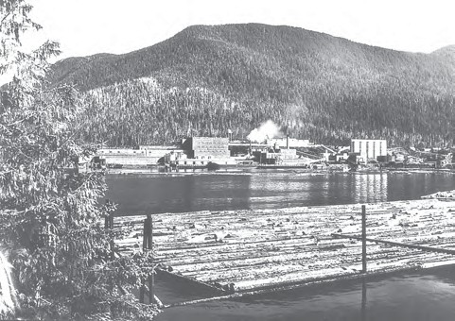
Fig. 5.6: A pulp mill in the heart of the Ketchikan’s timber area of Alaska

Animal based Industries
Leather for leather industry and wool for woollen textiles are obtained from animals. Besides, ivory is also obtained from elephant’s tusks.

Industries Based On Output/Product
You have seen some machines and tools made of iron or steel. The raw material for such machines and tools is iron and steel. Which is itself an industry. The industry whose products are used to make other goods by using them as raw materials are basic industries. Can you identify the links? Iron/steel machines for textile industry clothes for use by consumers.
The consumer goods industries produced goods which are consumed by consumers directly. For example, industries producing breads and biscuits, tea, soaps and toiletries, paper for writing, televisions, etc. are consumer goods or non-basic industries.

INDUSTRIES BASED ON OWNERSHIP
- Public Sector Industries are owned and managed by governments. In India, there were a number of Public Sector Undertakings (PSUs). Socialist countries have many state owned industries. Mixed economies have both Public and Private sector enterprises.
- Private Sector Industries are owned by individual investors. These are managed by private organisations. In capitalist countries, industries are generally owned privately.
- Joint Sector Industries are managed by joint stock companies or sometimes the private and public sectors together establish and manage the industries. Can you make a list of such industries?

Concept of High Technology Industry
High technology, or simply high-tech, is the latest generation of manufacturing activities. It is best understood as the application of intensive research and development (R and D) efforts leading to the manufacture of products of an advanced scientific and engineering character. Professional (white collar) workers make up a large share of the total workforce. These highly skilled specialists greatly outnumber the actual production (blue collar) workers. Robotics on the assembly line, computer-aided design (CAD) and manufacturing, electronic controls of smelting and refining processes, and the constant development of new chemical and pharmaceutical products are notable examples of a high-tech industry.
Neatly spaced, low, modern, dispersed, office-plant-lab buildings rather than massive assembly structures, factories and storage areas mark the high-tech industrial landscape. Planned business parks for high-tech start-ups have become part of regional and local development schemes.
High-tech industries which are regionally concentrated, self-sustained and highly specialised are called technopolies.

42 Fundamentals of Human Geography

The Silicon Valley near San Francisco and Silicon Forest near Seattle are examples of technopolies. Are some technopolies developing in India?
Manufacturing contributes significantly to the world economy. Iron and steel, textiles, automobiles, petrochemicals and electronics are some of the world’s most important manufacturing industries.

EXERCISES
- Choose the right answer from the four alternatives given below.
  - Which one of the following statements is wrong?
    - Cheap water transport has facilitated the jute mill industry along the Hugli.
    - Sugar, cotton textiles and vegetable oils are footloose industries.
    - The development of hydro-electricity and petroleum reduced, to a great extent, the importance of coal energy as a locational factor for industry.
    - Port towns in India have attracted industries.
  - In which one of the following types of economy are the factors of production owned individually ?
    - Capitalist (c) Socialist
    - Mixed (d) None
  - Which one of the following types of industries produces raw materials for other industries?
    - Cottage Industries (c) Basic Industries
    - Small-scale Industries (d) Footloose Industries
  - Which one of the following pairs is correctly matched ?
    - Automobile industry … Los Angeles
    - Shipbuilding industry … Lusaka
    - Aircraft industry … Florence
- Write a short note on the following in about 30 words.
  - High-Tech industry
  - Manufacturing
  - Footloose industries
Secondary Activities 43

- Answer the following in not more than 150 words.
  - Differentiate between primary and secondary activities.
  - Discuss the major trends of modern industrial activities especially in the developed countries of the world.
  - Explain why high-tech industries in many countries are being attracted to the peripheral areas of major metropolitan centres.
  - Africa has immense natural resources and yet it is industrially the most backward continent. Comment.
Project/Activity
- Carry out a survey in your school premises of the factory-made goods used by students and the staff.
- Find out the meaning of the terms bio-degradable and non-biodegradable. Which kind of material is better to use? Why?
- Look around and make a list of the global brands, their logos and products.

44 Fundamentals of Human Geography

Unit-III

Chapter-6

Tertiary and Quaternary Activities
When you fall ill you go to your family doctor or you call a doctor. Sometimes your parents take you to a hospital for treatment. While in school, you are taught by your teachers. In the event of any dispute, legal opinion is obtained from a lawyer. Likewise, there are many professionals who provide their services against payment of their fee. Thus, all types of services are special skills provided in exchange of payments. Health, education, law, governance and recreation etc. require professional skills. These services require other theoretical knowledge and practical training. Tertiary activities are related to the service sector. Manpower is an important component of the service sector as most of the tertiary activities are performed by skilled labour, professionally trained experts and consultants.
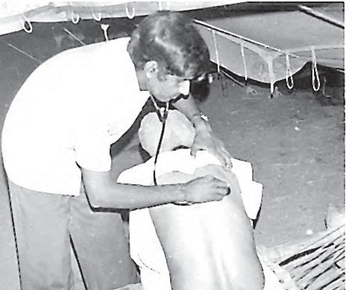
In the initial stages of economic development, larger proportion of people worked in the primary sector. In a developed economy, the majority of workers get employment in tertiary activity and a moderate proportion is employed in the secondary sector.
Tertiary activities include both production and exchange. The production involves the ‘provision’ of services that are ‘consumed’. The output is indirectly measured in terms of wages and salaries. Exchange, involves trade, transport and communication facilities that are used to overcome distance. Tertiary activities, therefore, involve the commercial output of services rather than the production of tangible goods. They are not directly involved in the processing of physical raw materials. Common examples are the work of a plumber, electrician, technician, launderer, barber, shopkeeper, driver, cashier, teacher, doctor, lawyer and publisher etc. The main difference between secondary activities and tertiary activities is that the expertise provided by services relies more heavily on specialised skills, experience and knowledge of the workers rather than on the production techniques, machinery and factory processes.

TYPES OF TERTIARY ACTIVITIES
By now you know that you purchase your books, stationery from traders shop, travel by











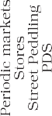

Fig. 6.1: Service Sector

46 Fundamentals of Human Geography

bus or rail, send letters, talk on telephone and obtain services of teachers for studies and doctors at the time of illness.
Thus, trade, transport, communication and services are some of the tertiary activities discussed in this section. The chart provides the basis for classifying the tertiary activities.

Trade and commerce
Trade is essentially buying and selling of items produced elsewhere. All the services in retail and wholesale trading or commerce are specifically intended for profit. The towns and cities where all these works take place are known us trading centres.
The rise of trading from barter at the local level to money-exchange of international scale has produced many centres and institutions such as trading centres or collection and distribution points.
Trading centres may be divided into rural and urban marketing centres.
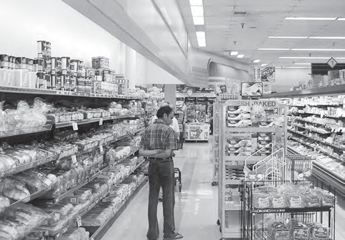
Rural marketing centres cater to nearby settlements. These are quasi-urban centres. They serve as trading centres of the most rudimentary type. Here personal and professional services are not well-developed. These form local collecting and distributing centres. Most of these have mandis (wholesale markets) and also retailing areas. They are not urban centres per se but are significant centres for making available goods and services which are most frequently demanded by rural folk.
Periodic markets in rural areas are found where there are no regular markets and local periodic markets are organised at different temporal intervals. These may be weekly, bi-weekly markets from where people from the surrounding areas meet their temporally accumulated demand. These markets are held on specified dates and move from one place to another. The shopkeepers thus, remain busy on all the days while a large area is served by them.
Urban marketing centres have more widely specialised urban services. They provide ordinary goods and services as well as many of the specialised goods and services required by people. Urban centres, therefore, offer manufactured goods as well as many specialised markets develop, e.g. markets for labour, housing, semi or finished products. Services of educational institutions and professionals such as teachers, lawyers, consultants, physicians, dentists and veterinary doctors are available.

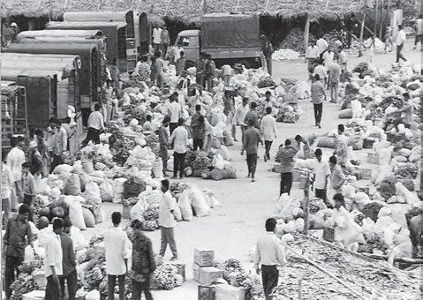
Fig. 6.3: Packed Food Market in U.S.A.

Fig. 6.2: A Wholesale Vegetable Market

Retail Trading
This is the business activity concerned with the sale of goods directly to the consumers. Most of the retail trading takes place in fixed establishments or stores solely devoted to selling. Street peddling, handcarts, trucks, door-to-door, mail-order, telephone, automatic vending machines and internet are examples of non-store retail trading.

Tertiary and Quaternary Activities 47

particular route; and cost distance or the expense of travelling on a route. In selecting the mode of transport, distance, in terms of time or cost, is the determining factor. Isochrone lines are drawn on a map to join places equal in terms of the time taken to reach them.
More on Stores
Consumer cooperatives were the first of the large-scale innovations in retailing.
Departmental stores delegate the responsibility and authority to departmental heads for purchasing of commodities and for overseeing the sale in different sections of the stores.
Chain stores are able to purchase merchandise most economically, often going so far as to direct the goods to be manufactured to their specification. They employ highly skilled specialists in many executive tasks. They have the ability to experiment in one store and apply the results to many.

Wholesale Trading
Wholesale trading constitutes bulk business through numerous intermediary merchants and supply houses and not through retail stores. Some large stores including chain stores are able to buy directly from the manufacturers. However, most retail stores procure supplies from an intermediary source. Wholesalers often extend credit to retail stores to such an extent that the retailer operates very largely on the wholesaler’s capital.

Transport
Transport is a service or facility by which people, materials and manufactured goods are physically carried from one location to another. It is an organised industry created to satisfy man’s basic need of mobility. Modern society requires speedy and efficient transport systems to assist in the production, distribution and consumption of goods. At every stage in this complex system, the value of the material is significantly enhanced by transportation.
Transport distance can be measured as: km distance or actual distance of route length; time distance or the time taken to travel on a

Network and Accessibility
As transport systems develop, different places are linked together to form a network. Networks are made up of nodes and links. A node is the meeting point of two or more routes, a point of origin, a point of destination or any sizeable town along a route, Every road that joins two nodes is called a link. A developed network has many links, which means that places are well-connected.

Factors Affecting Transport
Demand for transport is influenced by the size of population. The larger the population size, the greater is the demand for transport.
Routes depend on: location of cities, towns, villages, industrial centres and raw materials, pattern of trade between them, nature of the landscape between them, type of climate, and funds available for overcoming obstacles along the length of the route.

Communication
Communication services involve the transmission of words and messages, facts and ideas. The invention of writing preserved messages and helped to make communication dependent on means of transport. These were actually carried by hand, animals, boat, road, rail and air. That is why all forms of transport are also referred to as lines of communication. Where the transport network is efficient, communications are easily disseminated. Certain developments, such as mobile telephony and satellites, have made communications independent of transport. All forms are not fully disassociated because of the cheapness of the older systems. Thus, very

48 Fundamentals of Human Geography

large volumes of mail continue to be handled by post offices all over the world.
Some of the communication services are discussed below.

Telecommunications
The use of telecommunications is linked to the development of modern technology. It has revolutionised communications because of the speed with which messages are sent. The time reduced is from weeks to minutes. Besides, the recent advancements like mobile telephony have made communications direct and instantaneous at any time and from anywhere. The telegraph, morse code and telex have almost become things of the past.
Radio and television also help to relay news, pictures, and telephone calls to vast audiences around the world and hence they are termed as mass media. They are vital for advertising and entertainment. Newspapers are able to cover events in all corners of the world. Satellite communication relays information of the earth and from space. The internet has truly revolutionised the global communication system .

Services
Services occur at many different levels. Some are geared to industry, some to people, and some to both industry and people, e.g. the transport systems. Low-order services, such as grocery shops and laundries, are more common and widespread than high-order services or more specialised ones like those of accountants, consultants and physicians. Services are provided to individual consumers who can afford to pay for them. For example, the gardener, the launderers and the barber do primarily physical labour. Teacher, lawyers, physicians, musicians and others perform mental labour.
Many services have now been regulated. Making and maintaining highways and bridges, maintaining fire fighting departments and supplying or supervising education and customer-care are among the important services most often supervised or performed by governments or companies. State and union
legislation have established corporations to supervise and control the marketing of such services as transport, telecommunication, energy and water supply. Professional services are primarily health care, engineering, law and management. The location of recreational and entertainment services depends on the market. Multiplexes and restaurants might find location within or near the Central Business District (CBD), whereas a golf course would choose a site where land costs are lower than in the CBD. Personal services are made available to the people to facilitate their work in daily life. The workers migrate from rural areas in search of employment and are unskilled. They are employed in domestic services as housekeepers, cooks, and gardeners. This segment of workers is generally unorganised. One such example in India is Mumbai’s dabbawala (Tiffin) service provided to about
1,75,000 customers all over the city.
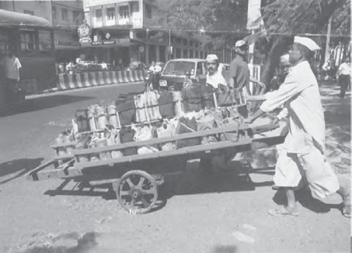
Fig. 6.4: Dabbawala Service in Mumbai

PEOPLE ENGAGED IN TERTIARY ACTIVITIES
Today most people are service workers. Services are provided in all societies. But in more developed countries a higher percentage of workers is employed in providing services as compared to less developed countries. The trend in employment in this sector has been

Tertiary and Quaternary Activities 49

increasing while it has remained unchanged or decreasing in the primary and secondary activities.
are scattered. Historic towns also attract tourists, because of the monument, heritage sites and cultural activities.

SOME
SELECTED
EXAMPLES

Tourist Attractions

Tourism
Tourism is travel undertaken for purposes of recreation rather than business. It has become the world’s single largest tertiary activity in total registered jobs (250 million) and total revenue (40 per cent of the total GDP). Besides, many local persons, are employed to provide services like accommodation, meals, transport, entertainment and special shops serving the tourists. Tourism fosters the growth of infrastructure industries, retail trading, and craft industries (souvenirs). In some regions, tourism is seasonal because the vacation period is dependent on favourable weather conditions, but many regions attract visitors all the year round.

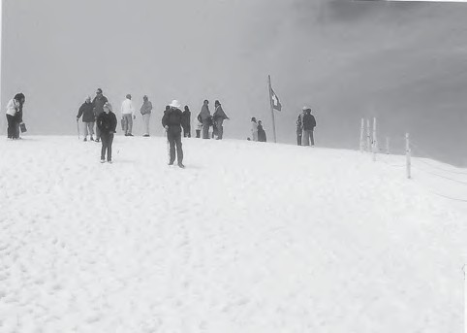

Fig. 6.5: Tourists skiing in the snow capped mountain slopes of Switzerland

Tourist Regions
The warmer places around the Mediterranean Coast and the West Coast of India are some of the popular tourist destinations in the world. Others include winter sports regions, found mainly in mountainous areas, and various scenic landscapes and national parks, which
Climate: Most people from colder regions expect to have warm, sunny weather for beach holidays. This is one of the main reasons for the importance of tourism in Southern Europe and the Mediterranean lands. The Mediterranean climate offers almost consistently higher temperatures, than in other parts of Europe, long hours of sunshine and low rainfall throughout the peak holiday season. People taking winter holidays have specific climatic requirements, either higher temperatures than their own homelands, or snow cover suitable for skiing.
Landscape: Many people like to spend their holidays in an attractive environment, which often means mountains, lakes, spectacular sea coasts and landscapes not completely altered by man.
History and Art: The history and art of an area have potential attractiveness. People visit ancient or picturesque towns and archaeological sites, and enjoy exploring castles, palaces and churches.
Culture and Economy: These attract tourists with a penchant for experiencing ethnic and local customs. Besides, if a region provides for the needs of tourists at a cheap cost, it is likely to become very popular. Home-stay has emerged as a profitable business such as heritage homes in Goa, Madikere and Coorg in Karnataka.

Medical Services for Overseas Patients in India
About 55,000 patients from U.S.A. visited India in 2005 for treatment. This is still a small number compared with the millions of surgeries performed each year in the U.S. healthcare system. India has emerged as the leading country of medical tourism in the world. World class hospitals located in metropolitan cities cater to patients all over the world. Medical tourism brings abundant benefits to developing countries like India, Thailand, Singapore and Malaysia. Beyond medical tourism, is the trend

50 Fundamentals of Human Geography

of outsourcing of medical tests and data interpretation. Hospitals in India, Switzerland and Australia have been performing certain medical services – ranging from reading radiology images, to interpreting Magnetic Resonance Images (MRIs) and ultrasound tests. Outsourcing holds tremendous advantages for patients, if it is focused on improving quality or providing specialised care.

QUINARY ACTIVITIES
The highest level of decision makers or policy makers perform quinary activities. These are subtly different from the knowledge based industries that the quinary sector in general deals with.
Quinary activities are services that focus on the creation, re-arrangement and interpretation of new and existing ideas; data interpretation and the use and evaluation of new technologies. Often referred to as ‘gold collar’ professions, they represent another subdivision of the tertiary sector representing special and highly paid skills of senior business executives, government officials, research scientists, financial and legal consultants, etc. Their importance in the structure of advanced economies far outweighs their numbers.

Medical Tourism
When medical treatment is combined with international tourism activity, it lends itself to what is commonly known as medical tourism.

QUATERNARY ACTIVITIES
What do a CEO of an MNC in Copenhagen, at New York and a medical transcriptionist at Bangalore have in common? All these people work in a segment of the service sector that is knowledge oriented. This sector can be divided into quaternary and quinary activities.
Quaternary activities involve some of the following: the collection, production and dissemination of information or even the production of information. Quaternary activities centre around research, development and may be seen as an advanced form of services involving specialised knowledge and technical skills.
The Quaternary Sector The Quaternary Sector along with the Tertiary Sector has replaced most of the primary and secondary employment as the basis for economic growth. Over half of all workers In
developed economies are in the ‘Knowledge Sector’ and there has been a very high growth in demand for and consumption of information-based services from mutual fund managers to tax consultants, software developers and statisticians. Personnel working in office buildings, elementary schools and university classrooms, hospitals and doctors’ offices, theatres, accounting and brokerage firms all belong to this category of services.
Like some of the tertiary functions, quaternary activities can also be outsourced. They are not tied to resources, affected by the environment, or necessarily localised by market.

Outsourcing has resulted in the opening up of a large number of call centres in India, China, Eastern Europe, Israel, Philippines and Costa Rica. It has created new jobs in these countries. Outsourcing is coming to those countries where cheap and skilled workers are available. These are also out-migrating countries. With the work available though outsourcing, the migration in these countries may come down. Outsourcing countries are facing resistance from job-seeking youths in their respective countries. The comparative advantage is the main reason for continuing outsourcing. New trends in quinary services include knowledge processing outsourcing (KPO) and ‘home shoring’, the latter as an alternative to outsourcing. The KPO industry is distinct from Business Process Outsourcing (BPO) as it involves highly skilled workers. It is information driven knowledge outsourcing. KPO enables companies to create additional business opportunities. Examples of KPOs include research and development (R and D) activities, e-learning, business research, intellectual property (IP) research, legal profession and the banking sector.

Tertiary and Quaternary Activities 51

European and African countries, In these
countries IT skilled staff with good English language skills are available at lower wages than those in the developed countries. Thus, a company in Hyderabad or Manila does work on a project based on GIS techniques for a country like U.S.A or Japan. Overhead costs are also much lower making it profitable to get job-work carried out overseas, whether it is in India, China or even a less populous country like Botswana in Africa.

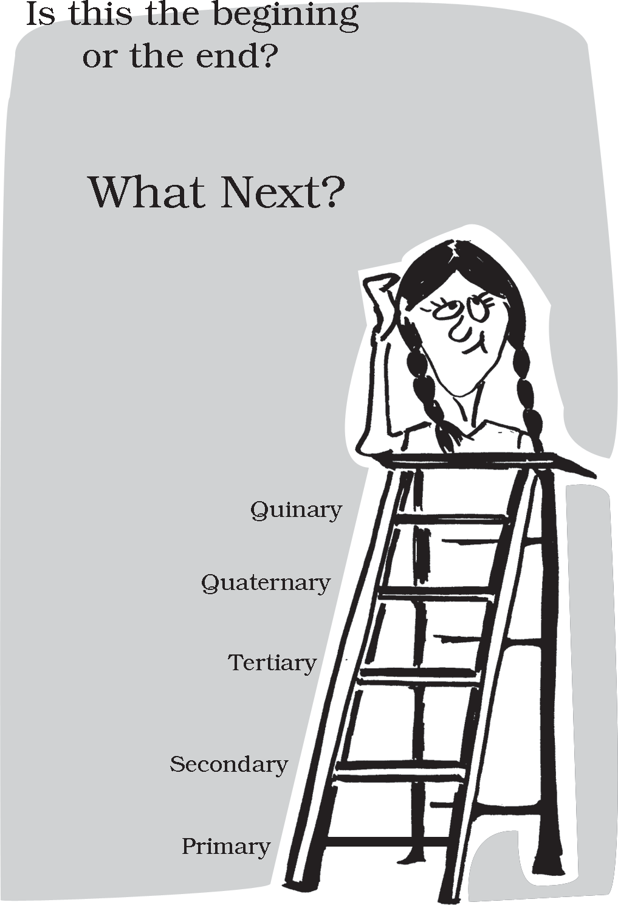
Describe the nature of work against each colour-name
Where Will it All Lead to?
Colour of the collar | Nature of work
Red | ?
Gold | ?
White | ?
Grey | ?
Blue | ?
Pink | ?

THE DIGITAL DIVIDE
Opportunities emerging from the Information and Communication Technology based development is unevenly distributed across the globe. There are wide ranging economic, political and social differences among countries. How quickly countries can provide ICT access and benefits to its citizens is the deciding factor. While developed countries in general have surged forward, the developing countries have lagged behind and this is known as the digital divide. Similarly digital divides exist within countries. For example, in a large country like India or Russia, it is inevitable that certain areas like metropolitan centres possess better connectivity and access to the digital world versus peripheral rural areas.

Outsourcing
Outsourcing or contracting out is giving work to an outside agency to improve efficiency and to reduce costs. When outsourcing involves transferring work to overseas locations, it is described by the term off - shoring, although both off - shoring and outsourcing are used together. Business activities that are outsourced include information technology (IT), human resources, customer support and call centre services and at times also manufacturing and engineering.
Data processing is an IT related service easily be carried out in Asian, East

52 Fundamentals of Human Geography

EXERCISES
  - Choose the right answer from the four alternatives given below.
    - Which one of the following is a tertiary activity?
      - Farming (c) Weaving
      - Trading (d) Hunting
    - Which one of the following activities is NOT a secondary sector activity?
      - Iron Smelting (c) Making garments
      - Catching fish (d) Basket Weaving
    - Which one of the following sectors provides most of the employment in Delhi, Mumbai, Chennai and Kolkata.
      - Primary (c) Secondary
      - Quaternary (d) Service
    - Jobs that involve high degrees and level of innovations are known as:
      - Secondary activities (c) Quinary activities
      - Quaternary activities (d) Primary activities
    - Which one of the following activities is related to quaternary sector?
      - Manufacturing computers (c) University teaching
      - Paper and Raw pulp production (d) Printing books
    - Which one out of the following statements is not true?
      - Outsourcing reduces costs and increases efficiency.
      - At times engineering and manufacturing jobs can also be outsourced.
      - BPOs have better business opportunities as compared to KPOs.
      - There may be dissatisfaction among job seekers in the countries that outsource the job.
  - Answer the following questions in about 30 words.
    - Explain retail trading service.
    - Describe quaternary services.
    - Name the fast emerging countries of medical tourism in the world.
    - What is digital divide?
  - Answer the following questions in not more than 150 words.
    - Discuss the significance and growth of the service sector in modern economic development.
    - Explain in detail the significance of transport and communication services.
Project/Activity

- Find out the activities of BPO.
- Find out from a travel agent the documents you need to travel abroad.
Tertiary and Quaternary Activities 53

Unit-III

Chapter-7

Transport and Communication
Natural resources, economic activities and markets are rarely found in one place. Transport, communication and trade establish links between producing centres and consuming centres. The system of mass production and exchange is complex. Each region produces the items for which it is best suited. Trade or the exchange of such commodities relies on transportation and communication. Likewise, the high living standards and quality of life depend on efficient transportation, communications and trade. In earlier days, the means of transport and communication were the same. But today both have acquired distinct and specialised forms. Transport provides the network of links and carriers through which trade takes place.

TRANSPORT
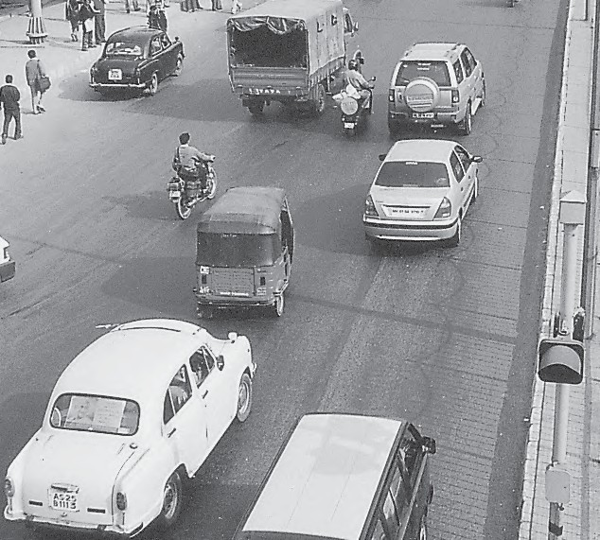
Transport is a service or facility for the carriage of persons and goods from one place to the other using humans, animals and different kinds of vehicles. Such movements take place over land, water and air. Roads and railways form part of land transport; while shipping and waterways and airways are the other two modes. Pipelines carry materials like petroleum, natural gas, and ores in liquidified form.
Moreover, transportation is an organised service industry created to satisfy the basic needs of society. It includes transport arteries, vehicles to carry people and goods, and the organisation to maintain arteries, and to handle loading, unloading and delivery. Every nation has developed various kinds of transportation for defence purposes. Assured and speedy transportation, along with efficient communication, promote cooperation and unity among scattered peoples.

What is a Transport Network ?
Several places (nodes) joined together by a series of routes (links) to form a pattern.

MODES OF TRANSPORTATION
The principal modes of world transportation, as already mentioned are land, water, air and
54 Fundamentals of Human Geography

pipelines. These are used for inter-regional and intra-regional transport, and each one (except pipelines) carries both passengers and freight. The significance of a mode depends on the type of goods and services to be transported, costs of transport and the mode available. International movement of goods is handled by ocean freighters. Road transport is cheaper and faster over short distances and for door-to-door services. Railways are most suited for large volumes of bulky materials over long distances within a country. High-value, light and perishable goods are best moved by airways. In a well-managed transport system, these various modes complement each other.

Land Transport
Most of the movement of goods and services takes place over land. In early days, humans themselves were carriers. Have you ever seen a bride being carried on a palanquin (palki/doli) by four persons (Kahars in north India). Later animals were used as beasts of burden. Have you seen mules, horses and camels, carrying loads of cargo in rural areas? With the invention of the wheel, the use of carts and wagons became important. The revolution in transport came about only after the invention of the steam engine in the eighteenth century. Perhaps the first public railway line was opened in 1825 between Stockton and Darlington in northern England and then onwards, railways became the most popular and fastest form of transport in the nineteenth century. It opened up continental interiors for commercial grain farming, mining and manufacturing in U.S.A. The invention of the internal combustion engine revolutionised road transport in terms of road quality and vehicles (motor cars and trucks) plying over them. Among the newer developments in land transportation are pipelines, ropeways and cableways. Liquids like mineral oil, water, sludge and sewers are transported by pipelines. The great freight carriers are the railways, ocean vessels, barges, boats and motor trucks and pipelines.
In general, the old and elementary forms like the human porter, pack animal, cart or wagon are the most expensive means of

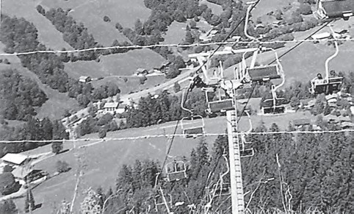
Fig. 7.1: Ropeway and Cable cars in Austria
This means of transport is usually found on steep mountain slopes and mines which are not suitable for building roads.

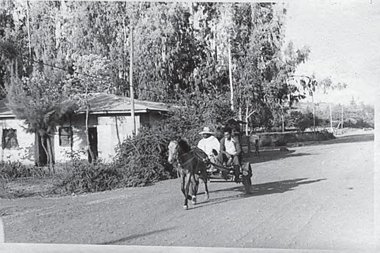
transportation and large freighters are the cheapest. They are important in supplementing modern channels and carriers which penetrate the interiors in large countries. In the densely populated districts of India and China, overland transport still takes place by human porters or carts drawn or pushed by humans.
Pack Animals
Horses are used as a draught animal even in the Western countries. Dogs and reindeer are used in North America, North Europe and Siberia to draw sledges over snow-covered ground. Mules are preferred in the mountainous regions; while camels are used for caravan movement in deserts. In India, bullocks are used for pulling carts.

Fig. 7.2: A horse cart in a village Tefki, in Ethiopia

Transport and Communication 55

Roads
Road transport is the most economical for short distances compared to railways. Freight transport by road is gaining importance because it offers door-to-door service. But unmetalled roads, though simple in construction, are not effective and serviceable for all seasons. During the rainy season these become unmotorable and even the metalled ones are seriously handicapped during heavy rains and floods. In such conditions, the high embankment of rail-tracks and the efficient maintenance of railway transport service, is an effective solution. But the rail kilometrage being small cannot serve the needs of vast and developing countries at a low cost. Roads, therefore, play a vital role in a nation’s trade and commerce and for promoting tourism.
The quality of the roads varies greatly between developed and developing countries because road construction and maintenance require heavy expenditure. In developed countries good quality roads are universal and provide long-distance links in the form of motorways, autobahns (Germany), and inter–state highways for speedy movement. Lorries, of increasing size and power to carry heavy loads, are common. But unfortunately, the world’s road system is not well developed.
The world’s total motorable road length is only about 15 million km, of which North America accounts for 33 per cent. The highest road density and the highest number of vehicles are registered in this continent compared to Western Europe.
Traffic Flows: Traffic on roads has increased dramatically in recent years. When the road network cannot cope with the demands of traffic, congestion occurs. City roads suffer from chronic traffic congestion. Peaks (high points) and troughs (low points) of traffic flow can be seen on roads at particular times of the day, for example, peaks occurring during the rush hour before and after work. Most of the cities in the world have been facing the problem of congestion.

Think on these lines for a better tomorrow . . .
URBAN TRANSPORT SOLUTIONS
Higher Parking Fee Mass Rapid Transit (MRT)
Improved Public Bus Service Expressways

Highways
Highways are metalled roads connecting distant places. They are constructed in a manner for unobstructed vehicular movement. As such these are 80 m wide, with separate traffic lanes, bridges, flyovers and dual carriageways to facilitate uninterrupted traffic flow. In developed countries, every city and port town is linked through highways.
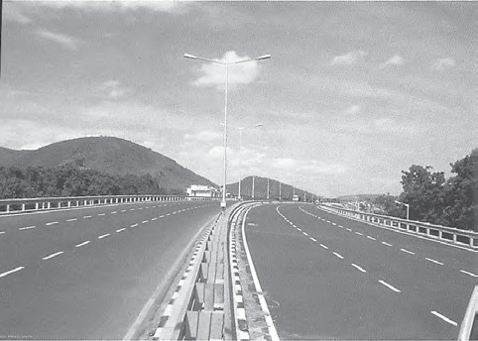

Fig. 7.3 : Dharmavaram Tuni National Highway, India
In North America, highway density is high, about 0.65 km per sq km. Every place is within 20 km distance from a highway. Cities located on the Pacific coast (west) are well-connected with those of the Atlantic Coast (east). Likewise, the cities of Canada in the north are linked with those of Mexico in the south. The Trans-

56 Fundamentals of Human Geography

Canadian Highway links Vancouver in British Columbia(west coast) to St. John’s City in Newfoundland (east coast) and the Alaskan Highway links Edmonton (Canada) to Anchorage (Alaska).
The Pan-American Highway, a large portion of which has been constructed, will connect the countries of South America, Central America and U.S.A.-Canada. The Trans-Continental Stuart Highway connects Darwin (north coast) and Melbourne via Tennant Creek and Alice Springs in Australia.
Europe has a large number of vehicles and a well-developed highway network. But highways face a lot of competition from railways and waterways.
In Russia, a dense highway network is developed in the industrialised region west of the Urals with Moscow as the hub. The important Moscow-Vladivostok Highway serves the region to the east. Due to the vast geographical area, highways in Russia are not as important as railways.
In China, highways criss-cross the country connecting all major cities such as Tsungtso (near Vietnam boundary), Shanghai (central China), Guangzhou (south) and Beijing (north). A new highway links Chengdu with Lhasa in Tibet.
In India, there are many highways linking the major towns and cities. The Golden Quadrilateral (GQ) or Super Expressway connect the four metropolitan cities — New Delhi, Mumbai, Chennai and Kolkata.
In Africa, a highway joins Algiers in the north to Conakry in Guinea. Similarly, Cairo is also connected to Cape Town.

Border Roads
Roads laid along international boundaries are called border roads. They play an important role in integrating people in remote areas with major cities and providing defence. Almost all
countries have such roads to transport goods to border villages and military camps.

Railways
Railways are a mode of land transport for bulky goods and passengers over long distances. The railway gauges vary in different countries and are roughly classified as broad (more than 1.5 m), standard (1.44 m), metre gauge (1 m) and smaller gauges. The standard gauge is used in the U.K.
Commuter trains are very popular in U.K., U.S.A, Japan and India. These carry millions of passengers daily to and fro in the city. There are about 13 lakh km of railways open for traffic in the world.

Fig. 7.4: Tube Train in Vienna
Europe has one of the most dense rail networks in the world. There are about 4,40,000 km of railways, most of which is double or multiple-tracked. Belgium has the highest density of 1 km of railway for every 6.5 sq kms area. The industrial regions exhibit some of the highest densities in the world. The important rail heads are London, Paris, Brussels, Milan, Berlin and Warsaw. Passenger transport is more important than freight in many of these countries. Underground railways are important in London and Paris. Channel Tunnel, operated by Euro Tunnel Group through England, connects London with Paris. Trans-continental railway lines have now lost

Transport and Communication 57

their importance to quicker and more flexible transport systems of airways and roadways.
In Russia, railways account for about 90 per cent of the country’s total transport with a very dense network west of the Urals. Moscow is the most important rail head with major lines radiating to different parts of the country’s vast geographical area. Underground railways and commuter trains are also important in Moscow. North America has one of the most extensive rail networks accounting for nearly 40 per cent of the world’s total? In contrast to many European countries, the railways are used more for long-distance bulky freight like ores, grains, timber and machinery than for passengers. The most dense rail network is found in the highly industrialised and urbanised region of East Central U.S.A. and
adjoining Canada.
In Canada, railways are in the public sector and distributed all over the sparsely populated areas. The transcontinental railways carry the bulk of wheat and coal tonnage.
Australia has about 40,000 km of railways, of which 25 per cent are found in New South Wales alone. The west-east Australian National Railway line runs across the country from Perth to Sydney. New Zealand’s railways are mainly in the North Island to serve the farming areas.
In South America, the rail network is the most dense in two regions, namely, the Pampas of Argentina and the coffee growing region of Brazil which together account for 40 per cent of South America’s total route length. Only Chile, among the remaining countries has a considerable route length linking coastal centres with the mining sites in the interior. Peru, Bolivia, Ecuador, Colombia and Venezuela have short single-track rail-lines from ports to the interior with no inter-connecting links.
There is only one trans-continental rail route linking Buenos Aires (Argentina) with Valparaiso (Chile) across the Andes Mountains through the Uspallatta Pass located at a height of 3,900 m.
In Asia, rail network is the most dense in the thickly populated areas of Japan, China and India. Other countries have relatively few rail routes. West Asia is the least developed in rail
facilities because of vast deserts and sparsely populated regions.
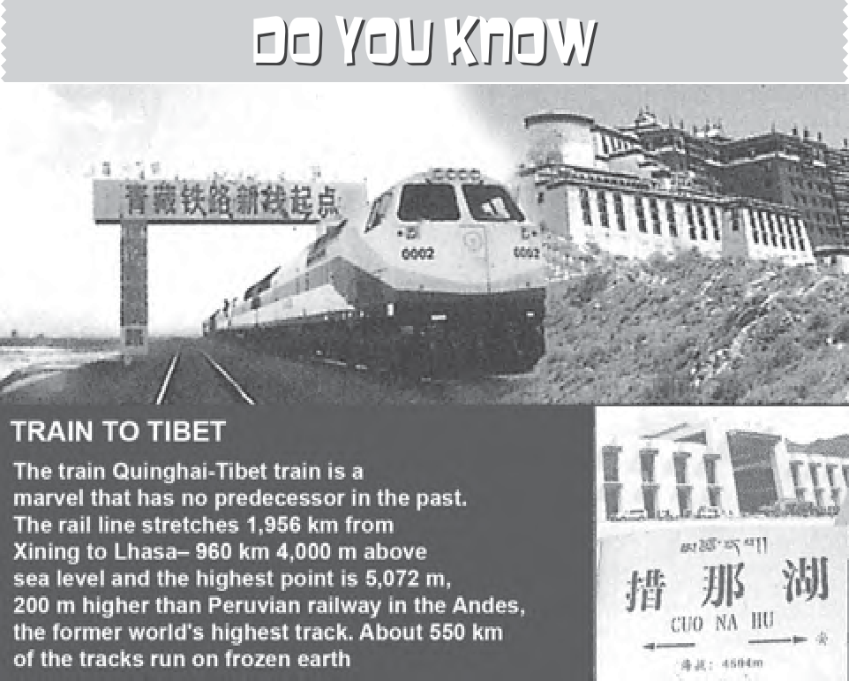
Africa continent, despite being the second largest, has only 40,000 km of railways with South Africa alone accounting for 18,000 km due to the concentration of gold, diamond and copper mining activities. The important routes of the continent are: (i) the Benguela Railway through Angola to Katanga-Zambia Copper Belt; (ii) the Tanzania Railway from the Zambian Copper Belt to Dar-es-Salaam on the coast; (iii) the Railway through Botswana and Zimbabwe linking the landlocked states to the South African network; and (iv) the Blue Train from Cape Town to Pretoria in the Republic of South Africa. Elsewhere, as in Algeria, Senegal, Nigeria, Kenya and Ethiopia, railway lines connect port cities to interior centres but do not form a good network with other countries.

Trans–Continental Railways
Trans–continental railways run across the continent and link its two ends. They were constructed for economic and political reasons to facilitate long runs in different directions. The following are the most important of these:

Trans–Siberian Railway
This is a trans–siberian Railways major rail route of Russia runs from St. Petersburg in the west to Vladivostok on the Pacific Coast in the east passing through Moscow, Ufa, Novosibirsk, Irkutsk, Chita and Khabarovsk. It is the most important route in Asia and the longest (9,332 km)

58 Fundamentals of Human Geography

double-tracked and electrified trans–continental railway in the world. It has helped in opening up its Asian region to West European markets. It runs across the Ural Mountains Ob and Yenisei rivers Chita is an important agro-centre and Irkutsk, a fur centre. There are connecting links to the south, namely, to Odessa (Ukraine), Baku on the Caspian Coast, Tashkent (Uzbekistan), Ulan Bator (Mongolia), and Shenyang (Mukden) and Beijing in China.

Trans–Canadian Railways
This 7,050 km long rail-line in Canada runs from Halifax in the east to Vancouver on the Pacific Coast passing through Montreal, Ottawa, Winnipeg and Calgary (Fig. 7.6). It was constructed in 1886, initially as part of an agreement to make British Columbia on the west coast join the Federation of States. Later on, it
gained economic significance because it connected the Quebec-Montreal Industrial Region with the wheat belt of the Prairie Region and the Coniferous Forest region in the north. Thus each of these regions became complementary to the other. A loop line from Winnipeg to Thunder Bay (Lake Superior) connects this rail-line with one of the important waterways of the world. This line is the economic artery of Canada. Wheat and meat are the important exports on this route.

The Union and Pacific Railway
This rail-line connects New York on the Atlantic Coast to San Francisco on the Pacific Coast passing through Cleveland, Chicago, Omaha, Evans, Ogden and Sacramento. The most valuable exports on this route are ores, grain, paper, chemicals and machinery.

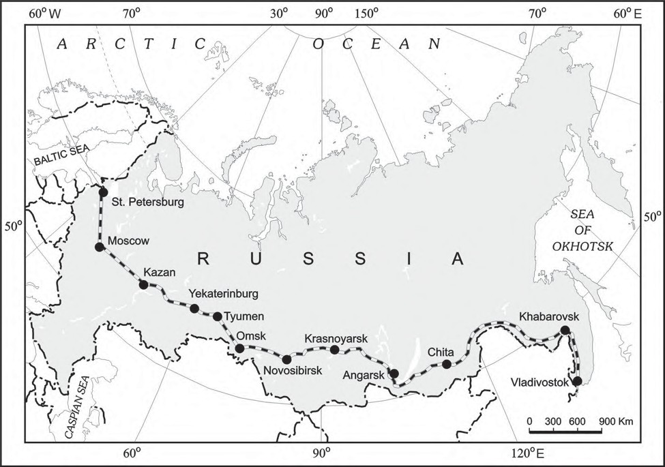

Fig. 7.5: Trans–Siberian Railway
Transport and Communication 59

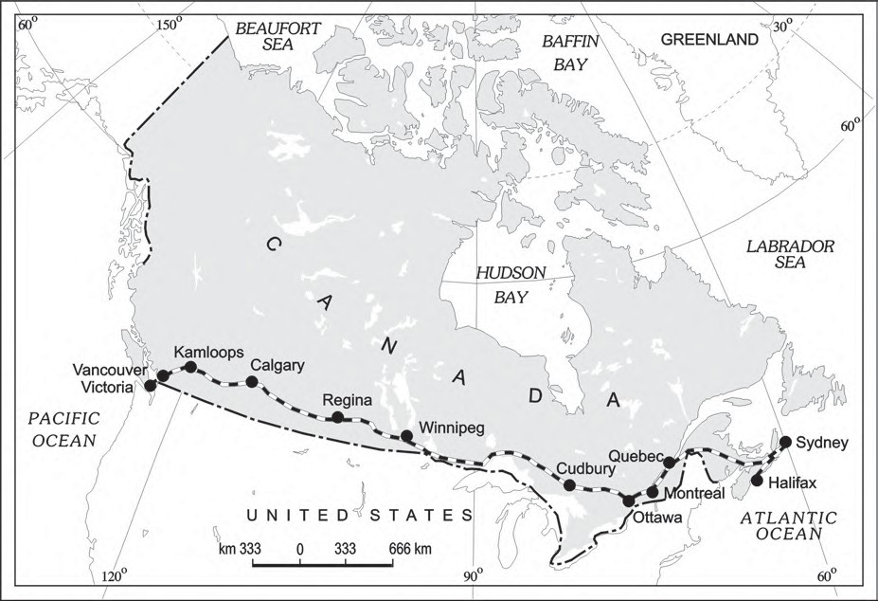

Fig. 7.6: Trans–Canadian Railway

The Australian Trans–Continental Railway
This rail-line runs west-east across the southern part of the continent from Perth on the west coast, to Sydney on the east coast. passing through Kalgoorlie, Broken Hill and Port Augusta (Fig. 7.7).
Another major north-south line connects Adelaide and Alice Spring and to be joined further to the Darwin–Birdum line.

The Orient Express
This line runs from Paris to Istanbul passing through Strasbourg, Munich, Vienna, Budapest and Belgrade. The journey time from London to Istanbul by this Express is now reduced to 96 hours as against 10 days by the sea-route. The chief exports on this rail-route
are cheese, bacon, oats, wine, fruits, and machinery.
There is a proposal to build a Trans–Asiatic Railway linking Istanbul with Bangkok via Iran, Pakistan, India, Bangladesh and Myanmar.

WATER TRANSPORT
One of the great advantages of water transportation is that it does not require route construction. The oceans are linked with each other and are negotiable with ships of various sizes. All that is needed is to provide port facilities at the two ends. It is much cheaper because the friction of water is far less than that of land. The energy cost of water transportation is lower. Water transport is divided into sea routes and inland waterways.

60 Fundamentals of Human Geography

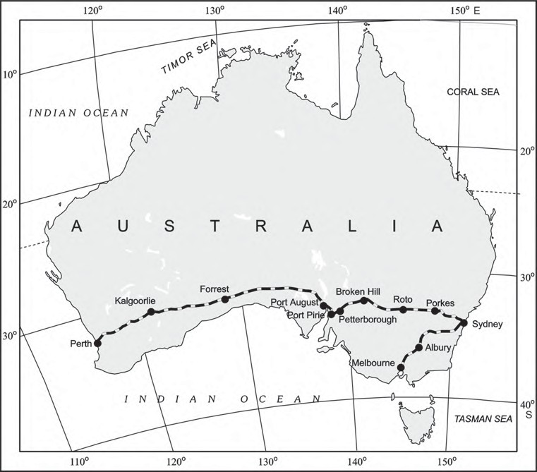
Fig. 7.7: Australian Trans–Continental Railway

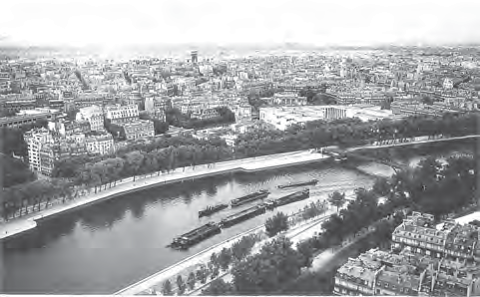
Fig. 7.8: The view of Seine River from the Eiffel Tower (One can see how the river has become an important Inland waterway)

Sea Routes
The oceans offer a smooth highway traversable in all directions with no maintenance costs. Its transformation into a routeway by sea-going vessels is an important development in human
adaptation to the physical environment. Compared to land and air, ocean transport is a cheaper means of haulage (carrying of load) of bulky material over long distances from one continent to another.
Modern passenger liners (ships) and cargo ships are equipped with radar, wireless and other navigation aids. The development of refrigerated chambers for perishable goods, tankers and specialised ships has also improved cargo transport. The use of containers has made cargo handling at the world’s major ports easier.

Important Sea Routes
Major sea routes are shown in the Fig. 7.9. Some important routes have been discussed in the following pages.

The Northern Atlantic Sea Route
This links North-eastern U.S.A. and North-western Europe, the two industrially developed

Transport and Communication 61

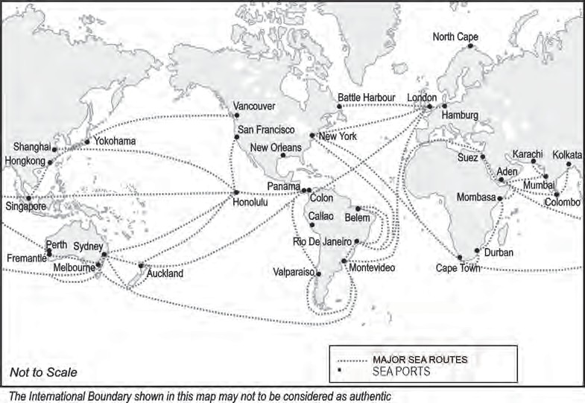
Fig. 7.9: Major Sea Routes and Sea Ports

regions of the world. The foreign trade over this route is greater than that of the rest of the world combined. One fourth of the world’s foreign trade moves on this route. It is, therefore, the busiest in the world and otherwise, called the Big Trunk Route. Both the coasts have highly advanced ports and harbour facilities.
Find out some of the important ports on the coast of
U.S.A. and Western Europe in your atlas.

The Mediterranean–Indian Ocean Sea Route
This sea route passes through the heart of the Old World and serves more countries and people than any other route. Port Said, Aden, Mumbai, Colombo and Singapore are some of the important ports on this route. The construction of Suez Canal has greatly reduced the distance and time as compared to the earlier route through the Cape of Good Hope, which was longer than the route through Suez Canal.

The Cape of Good Hope Sea Route
This trade route connects the highly industrialised Western European region with West Africa, South Africa, South-east Asia and the commercial agriculture and livestock economies of Australia and New Zealand. The volume of trade and traffic between both East and West Africa is on the increase due to the development of the rich natural resources such as gold, diamond, copper, tin, groundnut, oil palm, coffee and fruits.

The Southern Atlantic Sea Route
This sea route is another important one across the Atlantic Ocean which connects West European and West African countries with Brazil, Argentina and Uruguay in South America. The traffic is far less on this route because of the limited development and population in South America and Africa. Only southeastern Brazil and Plata estuary and parts of South Africa have large-scale industries. There is also little traffic on the route between Rio de Janeiro and Cape Town because both South America and Africa have similar products and resources.

62 Fundamentals of Human Geography

The North Pacific Sea Route
Trade across the vast North Pacific Ocean moves by several routes which converge at Honolulu. The direct route on the Great Circle links Vancouver and Yokohama and reduces the travelling distance (2,480 km) by half.
This sea route links the ports on the west-coast of North America with those of Asia. These are Vancouver, Seattle, Portland, San Francisco and Los Angeles on the American side and Yokohama, Kobe, Shanghai, Hong Kong, Manila and Singapore on the Asian side.

The South Pacific Sea Route
This sea route connects Western Europe and North America with Australia, New Zealand and the scattered Pacific islands via the Panama Canal. This route is also used for reaching Hong Kong, Philippines and Indonesia. The distance covered between Panama and Sydney is 12,000 km. Honolulu is an important port on this route.

Coastal Shipping
It is obvious that water transport is a cheaper mode. While oceanic routes connect different countries, coastal shipping is a convenient mode of transportation with long coastlines,
e.g. U.S.A, China and India. Shenzhen States in Europe are most suitably placed for coastal shipping connecting one member’s coast with the other. If properly developed, coastal shipping can reduce the congestion on the land routes.

Shipping Canals
The Suez and the Panama Canals are two vital man-made navigation canals or waterways which serve as gateways of commerce for both the eastern and western worlds.

The Suez Canal
This canal had been constructed in 1869 in Egypt between Port Said in the north and Port Suez in the south linking the Mediterranean Sea and the Red Sea. It gives Europe a new gateway to the Indian Ocean and reduces direct
sea-route distance between Liverpool and Colombo compared to the Cape of Good Hope route. It is a sea-level canal without locks which is about 160 km and 11 to 15 m deep. About 100 ships travel daily and each ship takes 10-12 hours to cross this canal. The tolls are so heavy that some find it cheaper to go by the longer Cape Route whenever the consequent delay is not important. A railway follows the canal to Suez, and from Ismailia there is a branch line to Cairo. A navigable fresh-water canal from the Nile also joins the Suez Canal in Ismailia to supply fresh-water to Port Said and Suez.
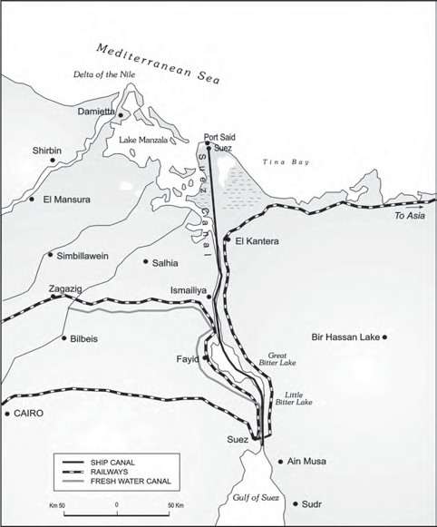
Fig. 7.10 : Suez Canal

The Panama Canal
This canal connects the Atlantic Ocean in the east to the Pacific Ocean in the west. It has been constructed across the Panama Isthmus between Panama City and Colon by the U.S. government which purchased 8 km of area on either side and named it the Canal Zone. The Canal is about 72 km. long and involves a very

Transport and Communication 63

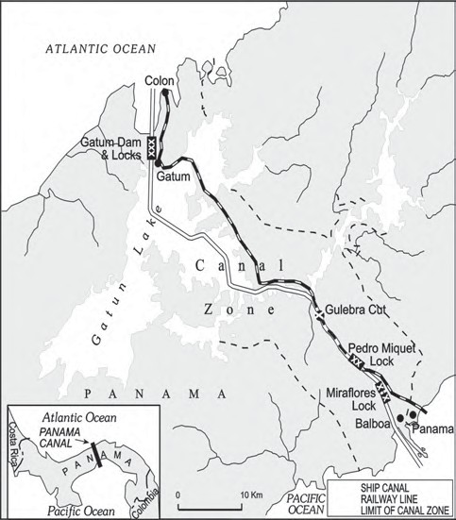
Fig. 7.11 : The Panama Canal
deep cutting for a length of 12 km. It has a six-lock system and ships cross the different levels (26 m up and down) through these locks before entering the Gulf of Panama.
It shortens the distance between New York and San Francisco by 13,000 km by sea. Likewise the distance between Western Europe and the West-coast of U.S.A.; and North-eastern and Central U.S.A. and East and South-east Asia is shortened. The economic significance of this Canal is relatively less than that of the Suez. However, it is vital to the economies of Latin America.

Inland Waterways
Rivers, canals, lakes and coastal areas have been important waterways since time immemorial. Boats and steamers are used as means of transport for cargo and passengers. The development of inland waterways is dependent on the navigability width and depth of the channel, continuity in the water flow, and transport technology in use. Rivers are the only means of transport in dense forests. Very heavy cargo like coal, cement, timber and metallic ores can be transported through inland waterways. In ancient times, riverways were the main highways of transportation as in the case of India. But they lost importance because of competition from railways, lack of water due to diversion for irrigation, and their poor maintenance.
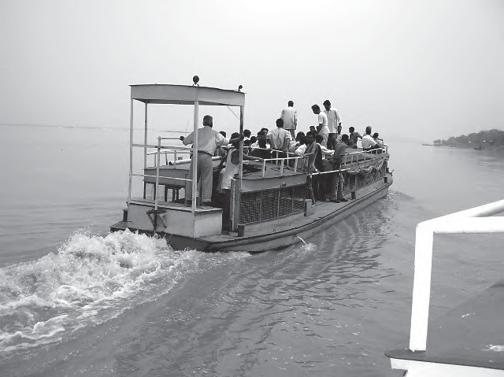
Fig. 7.12: Inland waterways are a major source of transport wherever the river is wide, deep and free of silt
The significance of rivers as inland waterways for domestic and international

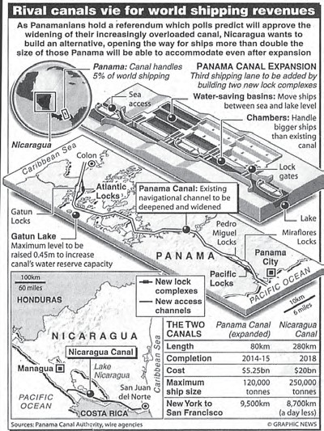
64 Fundamentals of Human Geography

Can you think of the impact on traffic in Panama canal after the Nicaraguan canal opens up?

transport and trade has been recognised throughout the developed world. Despite inherent limitations, many rivers have been modified to enhance their navigability by dredging, stabilising river banks, and building dams and barrages for regulating the flow of water. The following river waterways are some of the world’s important highways of commerce.

The Rhine Waterways
The Rhine flows through Germany and the Netherlands. It is navigable for 700 km from Rotterdam, at its mouth in the Netherlands to Basel in Switzerland. Ocean-going vessels can reach up to Cologne. The Ruhr river joins the Rhine from the east. It flows through a rich coalfield and the whole basin has become a prosperous manufacturing area. Dusseldorf is the Rhine port for this region. Huge tonnage moves along the stretch south of the Ruhr. This waterway is the world’s most heavily used. Each year more than 20,000 ocean-going ships and 2,00,000 inland vessels exchange their cargoes. It connects the industrial areas of Switzerland, Germany, France, Belgium and the Netherlands with the North Atlantic Sea Route.
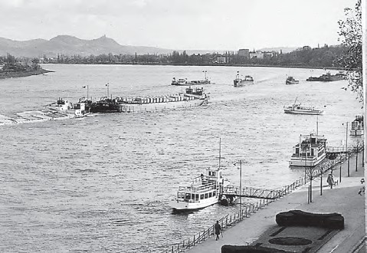
Fig. 7.13: The Rhine Waterway

The Danube Waterway
This important inland waterway serves Eastern Europe. The Danube river rises in the Black Forest and flows eastwards through many countries. It is navigable up to Taurna Severin. The chief export items are wheat, maize, timber, and machinery.

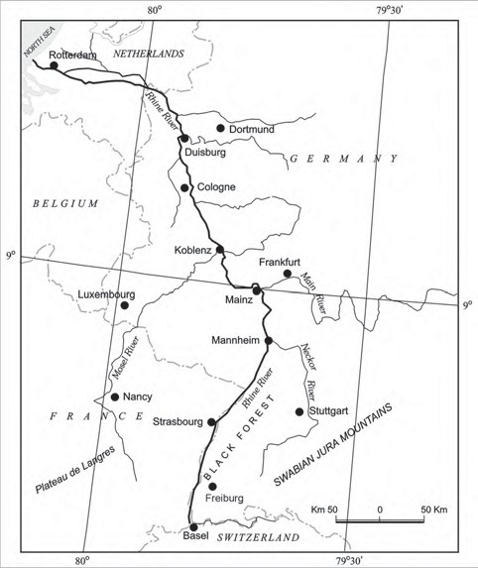
Fig. 7.14 : Rhine Waterway

The Volga Waterway
Russia has a large number of developed waterways, of which the Volga is one of the most important. It provides a navigable waterway of 11,200 km and drains into the Caspian Sea. The Volga-Moscow Canal connects it with the Moscow region and the Volga-Don Canal with the Black Sea.

The Great Lakes – St. Lawrence Seaway
The Great Lakes of North America Superior, Huron Erie and Ontario are connected by Soo Canal and Welland Canal to form an inland waterway. The estuary of St. Lawrence River, along with the Great Lakes, forms a unique commercial waterway in the northern part of North America. The ports on this route like Duluth and Buffalo are equipped with all facilities of ocean ports. As such large ocean-going vessels are able to navigate up the river deep inside the continent to Montreal. But here goods have to be trans-shipped to smaller vessels due to the presence of rapids. Canals have been constructed up to 3.5 m deep to avoid these.

Transport and Communication 65

The Mississippi Waterways
The Mississippi-Ohio waterway connects the interior part of U.S.A. with the Gulf of Mexico in the south. Large steamers can go through this route up to Minneapolis.

AIR TRANSPORT
Air transport is the fastest means of transportation, but it is very costly. Being fast, it is preferred by passengers for long-distance travel. Valuable cargo can be moved rapidly on a world-wide scale. It is often the only means to reach inaccessible areas. Air transport has brought about a connectivity revolution in the world. The frictions created by mountainous snow fields or inhospitable desert terrains have been overcome. The accessibility has increased. The airplane brings varied articles to the Eskimos in Northern Canada unhindered by the frozen ground. In the Himalayan region, the routes are often obstructed due to landslides, avalanches or heavy snow fall. At such times, air travel is the only alternative to reach a place. Airways also have great strategic importance. The air strikes by U.S. and British forces in Iraq bears testimony to this fact. The airways network is expanding very fast.
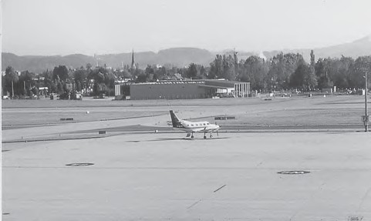
Fig. 7.15: An Aeroplane at Salsburg Airport
The manufacturing of aircrafts and their operations require elaborate infrastructure like hangars, landing, fuelling, and maintenance facilities for the aircrafts. The construction of airports is also very expensive and has developed more in highly industrialised countries where there is a large volume of traffic.
At present no place in the world is more than 35 hours away. This startling fact has been made possible due to people who build and fly airplanes. Travel by air can now be measured by hours and minutes instead of years and months. Frequent air services are available to many parts of the world. Although, U.K. pioneered the use of commercial jet transport,
U.S.A. developed largely post-War international civil aviation. Today, more than 250 commercial airlines offer regular services to different parts of the world. Recent developments can change the future course of air transport. Supersonic aircraft, cover the distance between London and New York within three and a half hours.

Inter-Continental Air Routes
In the Northern Hemisphere, there is a distinct east-west belt of inter-continental air routes. Dense network exists in Eastern U.S.A., Western Europe and Southeast Asia. U.S.A. alone accounts for 60 per cent of the airways of the world. New York, London, Paris, Amsterdam, Frankfurt Rome, Moscow, Karachi, New Delhi, Mumbai, Bangkok, Singapore, Tokyo, San Francisco, Los Angeles and Chicago are the nodal points where air routes converge or radiate to all continents.
Africa, Asiatic part of Russia and South America lack air services. There are limited air services between 10-35 latitudes in the Southern hemisphere due to sparser population, limited landmass and economic development.

PIPELINES
Pipelines are used extensively to transport liquids and gases such as water, petroleum and natural gas for an uninterrupted flow. Water supplied through pipelines is familiar to all. Cooking gas or LPG is supplied through pipelines in many parts of the world. Pipelines can also be used to transport liquidified coal. In New Zealand, milk is being supplied through pipelines from farms to factories.
In U.S.A. there is a dense network of oil pipelines from the producing areas to the

66 Fundamentals of Human Geography

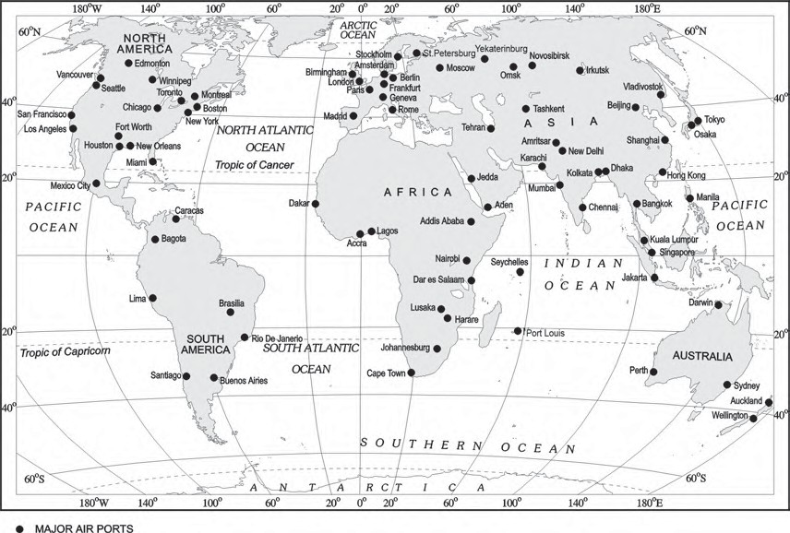
Fig. 7.16: Major Airports

consuming areas. Big Inch is one such famous pipeline, which carries petroleum from the oil wells of the Gulf of Mexico to the North-eastern States. About 17 per cent of all freight per tonne-km. is carried through pipelines in U.S.A.
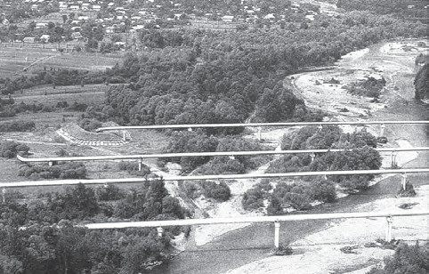

Fig. 7.17: Pipelines transporting natural gas in Ukraine
In Europe, Russia, West Asia and India pipelines are used to connect oil wells to refineries, and to ports or domestic markets. Turkmenistan is central Asia has extended pipelines to Iran and also to parts of China.
The proposed Iran-India via Pakistan international oil and natural gas pipeline will be the longest in the world.

COMMUNICATIONS
Human beings have used different methods long-distance communications of which the telegraph and the telephone were important. The telegraph was instrumental in the colonisation of the American West. During the early and mid-twentieth century, the American Telegraph and Telephone Company (AT&T) enjoyed a monopoly over U.S.A.’s telephone industry. In fact, the telephone became a critical factor in the urbanisation of America. Firms centralised their functioning at city-headquarters and located their branch offices in smaller towns. Even today, the telephone is the most commonly used mode. In developing countries, the use of cell phones, made possible by satellites, is important for rural connectivity. Today there is a phenomenal pace of development. The first major breakthrough is the use of optic fiber cables (OFC). Faced with mounting competition, telephone companies all

Transport and Communication 67

over the world soon upgraded their copper cable systems to include optic fiber cables. These allow large quantities of data to be transmitted rapidly, securely, and are virtually error-free. With the digitisation of information in the 1990s, telecommunication slowly merged with computers to form integrated networks termed as Internet.

Satellite Communication
Today Internet is the largest electronic network on the planet connecting about 1,000 million people in more than 100 countries.
Satellites touch human lives in many ways. Every time you use a cell phone to call a friend, send an SMS or watch a popular programme on cable television. You are using satellite communication.
Communication through satellites emerged as a new area in communication technology since the 1970s after U.S.A. and former U.S.S.R. pioneered space research. Artificial satellites, now, are successfully deployed in the earth’s orbit to connect even the remote corners of the globe with limited on-site verification. These have rendered the unit cost and time of communication invariant in terms of distance. This means it costs the same to communicate over 500 km as it does over 5,000 km via satellite.
India has also made great strides in satellite development. Aryabhatt was launched on 19 April 1975, Bhaskar-I in 1979 and
Rohini in 1980. On 19 June 1981, APPLE (Arian Passenger Payload Experiment) was launched through Arian rocket. Bhaskar,
Challenger and INSAT I-B have made long-distance communication, television and radio very effective. Today weather forecasting through television is a boon.

Cyber Space – Internet
Cyberspace is the world of electronic computerised space. It is encompassed by the Internet such as the World Wide Web (www). In simple words, it is the electronic digital world for communicating or accessing information over computer networks without physical movement of the sender and the receiver... It is also referred to as the Internet. Cyberspace exists everywhere. It may be in an office, sailing boat, flying plane and virtually anywhere.
The speed at which this electronic network has spread is unprecedented in human history. There were less than 50 million Internet users in 1995, about 400 million in 2000, over two billion in 2010 and about 5.4 billion in 2023. In the last few years there has been a shift among global users from U.S.A. to the developing countries. The percentage share of U.S.A. has dropped from 66 in 1995 to only 25 in 2005. Now the majority of the world’s users are in U.S.A., U.K., Germany, Japan, China and India.
As billions use the Internet each year, cyberspace will expand the contemporary economic and social space of humans through e-mail, e-commerce, e-learning and e-governance. Internet together with fax, television and radio will be accessible to more and more people cutting across place and time. It is these modern communication systems, more than transportation, that has made the concept of global village a reality.

68 Fundamentals of Human Geography

EXERCISES
- Choose the right answer from the four alternatives given below.
  - The Trans–Continental Stuart Highway runs between
    - Darwin and Melbourne
    - Edmonton and Anchorage
    - Vancouver and St. John’s City
    - Chengdu and Lhasa
  - Which country has the highest density of railway network?
    - Brazil (c) Canada
    - U.S.A (d) Russia
  - The Big Trunk Route runs through
    - The Mediterranean – Indian ocean
    - The North Atlantic Ocean
    - The South Atlantic Ocean
    - The North Pacific Ocean
  - The Big Inch pipeline transports
    - Milk (c) Water
    - Liquid petroleum gas (LGP) (d) Petroleum
  - Which one pair of the following places is linked by Channel Tunnel?
    - London – Berlin (c) Berlin – Paris
    - Paris – London (d) Barcelona – Berlin
- Answer the following questions in about 30 words.
  - What are the problems of road transport in mountainous, desert and flood prone regions?
  - What is a trans–continental railway?
  - What are the advantages of water transport?
- Answer the following questions in not more than 150 words.
  - Elucidate the statement– “In a well managed transport system, various modes complement each other”.
  - Which are the major regions of the world having a dense network of airways.
  - What are the modes by which cyber space will expand the contemporary economic and social space of humans.

Transport and Communication 69

Unit-III

Chapter-8

International Trade
You are already familiar with the term “trade” as a tertiary activity which you have studied in Chapter 7 of this book. You know that trade means the voluntary exchange of goods and services. Two parties are required to trade. One person sells and the other purchases. In certain places, people barter their goods. For both the parties trade is mutually beneficial.
Trade may be conducted at two levels: international and national. International trade is the exchange of goods and services among countries across national boundaries. Countries need to trade to obtain commodities, they cannot produce themselves or they can purchase elsewhere at a lower price.
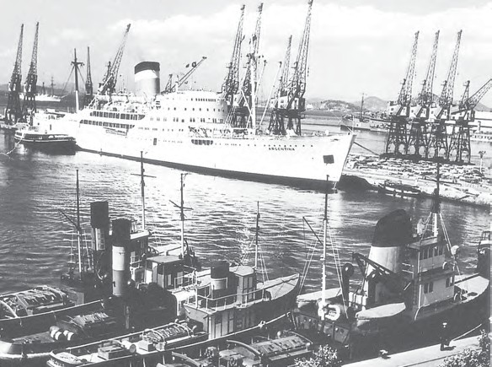
The initial form of trade in primitive societies was the barter system, where direct exchange of goods took place. In this system if you were a potter and were in need of a plumber, you would have to look for a plumber who would be in need of pots and you could exchange your pots for his plumbing service.

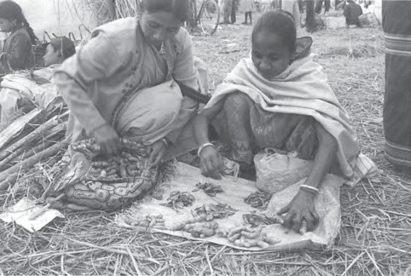

Fig. 8.1: Two women practising barter system in Jon Beel Mela

Every January after the harvest season Jon Beel Mela takes place in Jagiroad, 35 km away from Guwahati and it is possibly the only fair In India, where barter system is still alive. A big market is organised during this fair and people from various tribes and communi-ties exchange their products.

The difficulties of barter system were overcome by the introduction of money. In the olden times, before paper and coin currency
70 Fundamentals of Human Geography


came into being, rare objects with very high intrinsic value served as money, like, flintstones, obsidian, cowrie shells, tiger’s paws, whale’s teeth, dogs teeth, skins, furs, cattle, rice, peppercorns, salt, small tools, copper, silver and gold.
The word salary comes from the Latin word Salarium which means payment by salt. As in those times producing salt from sea water was unknown and could only be made from rock salt which was rare and expensive. That is why it became a mode of payment.

HISTORY OF INTERNATIONAL TRADE
In ancient times, transporting goods over long distances was risky, hence trade was restricted to local markets. People then spent most of their resources on basic necessities – food and clothes. Only the rich people bought jewellery, costly dresses and this resulted in trade of luxury items.
The Silk Route is an early example of long distance trade connecting Rome to China – along the 6,000 km route. The traders transported Chinese silk, Roman wool and precious metals and many other high value commodities from intermediate points in India, Persia and Central Asia.
After the disintegration of the Roman Empire, European commerce grew during twelfth and thirteenth century with the development of ocean going warships trade between Europe and Asia grew and the Americas were discovered.
Fifteenth century onwards, the European colonialism began and along with trade of exotic commodities, a new form of trade emerged which was called slave trade. The Portuguese, Dutch, Spaniards, and British captured African natives and forcefully transported them to the newly discovered Americas for their labour in the plantations. Slave trade was a lucrative business for more than two hundred years till it was abolished in Denmark in 1792, Great Britain in 1807 and United States in 1808.

Figure 8.2 : Advertisement for Slave Auction, 1829
This American slave auction advertised slaves for sale or temporary hire by their owners. Buyers often paid as much as $2,000 for a skilled, healthy slave. Such auc-tions often separated family members from one another, many of whom never saw their loved ones again.
After the Industrial Revolution the demand for raw materials like grains, meat, wool also expanded, but their monetary value declined in relation to the manufactured goods.
The industrialised nations imported primary products as raw materials and exported the value added finished products back to the non-industrialised nations.
In the later half of the nineteenth century, regions producing primary goods were no more important, and industrial nations became each other’s principle customers.
During the World Wars I and II, countries imposed trade taxes and quantitative restrictions for the first time. During the post-war period, organisations like General Agreement for Tariffs and Trade (which later became the World Trade Organisation), helped in reducing tariff.

Why Does International Trade Exist?
International trade is the result of specialisation in production. It benefits the world economy if

International Trade 71

different countries practise specialisation and division of labour in the production of commodities or provision of services. Each kind of specialisation can give rise to trade. Thus, international trade is based on the principle of comparative advantage, complimentarity and transferability of goods and services and in principle, should be mutually beneficial to the trading partners.
In modern times, trade is the basis of the world’s economic organisation and is related to the foreign policy of nations. With well-developed transportation and communication systems, no country is willing to forego the benefits derived from participation in international trade.

Basis of International Trade
- Difference in national resources: The world’s national resources are unevenly distributed because of differences in their physical make up i.e. geology, relief soil and climate.
  - Geological structure: It determines the mineral resource base and topographical differences ensure diversity of crops and animals raised. Lowlands have greater agricultural potential. Mountains attract tourists and promote tourism.
  - Mineral resources: They are unevenly distributed the world over. The availability of mineral resources provides the basis for industrial development.
  - Climate: It influences the type of flora and fauna that can survive in a given region. It also ensures diversity in the range of various products, e.g. wool production can take place in cold regions, bananas, rubber and cocoa can grow in tropical regions.
- Population factors: The size, distribution and diversity of people between countries affect the type and volume of goods traded.
  - Cultural factors: Distinctive forms of art and craft develop in certain
cultures which are valued the world over, e.g. China produces the finest porcelains and brocades. Carpets of Iran are famous while North African leather work and Indonesian batik cloth are prized handicrafts.
  - Size of population: Densely populated countries have large volume of internal trade but little external trade because most of the agricultural and industrial production is consumed in the local markets. Standard of living of the population determines the demand for better quality imported products because with low standard of living only a few people can afford to buy costly imported goods.
- Stage of economic development: At different stages of economic development of countries, the nature of items traded undergo changes. In agriculturally important countries, agro products are exchanged for manufactured goods whereas industrialised nations export machinery and finished products and import food grains and other raw materials.
- Extent of foreign investment: Foreign investment can boost trade in developing countries which lack in capital required for the development of mining, oil drilling, heavy engineering, lumbering and plantation agriculture. By developing such capital intensive industries in developing countries, the industrial nations ensure import of food stuffs, minerals and create markets for their finished products. This entire cycle steps up the volume of trade between nations.
- Transport: In olden times, lack of adequate and efficient means of transport restricted trade to local areas. Only high value items, e.g. gems, silk and spices were traded over long distances. With expansions of rail, ocean and air transport, better means of refrigeration and preservation, trade has experienced spatial expansion.

72 Fundamentals of Human Geography

Balance of Trade
Balance of trade records the volume of goods and services imported as well as exported by a country to other countries. If the value of imports is more than the value of a country’s exports, the country has negative or unfavourable balance of trade. If the value of exports is more than the value of imports, then the country has a positive or favourable balance of trade.
Balance of trade and balance of payments have serious implications for a country’s economy. A negative balance would mean that the country spends more on buying goods than it can earn by selling its goods. This would ultimately lead to exhaustion of its financial reserves.

Types of International Trade
International trade may be categorised into two types:
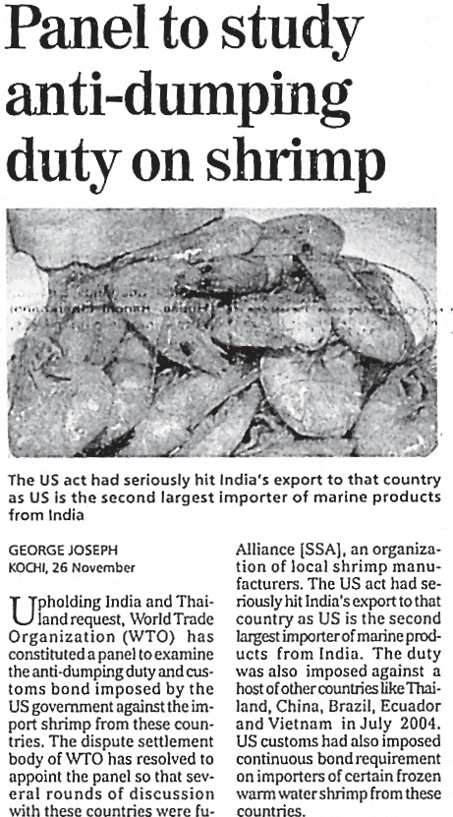
  - Bilateral trade: Bilateral trade is done by two countries with each other. They enter into agreement to trade specified commodities amongst them. For example, country A may agree to trade some raw material with agreement to purchase some other specified item to country B or vice versa.
  - Multi-lateral trade: As the term suggests multi-lateral trade is conducted with many trading countries. The same country can trade with a number of other countries. The country may also grant the status of the “Most Favoured Nation” (MFN) on some of the trading partners.

Case for Free Trade
The act of opening up economies for trading is known as free trade or trade liberalisation. This is done by bringing down trade barriers like tariffs. Trade liberalisation allows goods and services from everywhere to compete with domestic products and services.
Globalisation along with free trade can adversely affect the economies of developing countries by not giving equal playing field by imposing conditions which are unfavourable. With the development of transport and communication systems goods and services can travel faster and farther than ever before. But free trade should not only let rich countries enter the markets, but allow the developed countries to keep their own markets protected from foreign products.
Countries also need to be cautious about dumped goods; as along with free trade dumped goods of cheaper prices can harm the domestic producers.
Dumping
The practice of selling a commodity in two countries at a price that differs for reasons not related to costs is called dumping.

International Trade 73

Think of some reasons why dumping is becoming a serious concern among trading nations?

World Trade Organisation
In1948, to liberalise the world from high customs tariffs and various other types of restrictions, General Agreement for Tariffs and Trade (GATT) was formed by some countries. In 1994, it was decided by the member countries to set up a permanent institution for looking after the promotion of free and fair trade amongst nation and the GATT was transformed into the World Trade Organisation from 1st January 1995.
WTO is the only international organisation
dealing with the global rules of trade between nations. It sets the rules for the global trading system and resolves disputes between its member nations. WTO also covers trade in services, such as telecommunication and banking, and others issues such as intellectual rights.
The WTO has however been criticised and opposed by those who are worried about the effects of free trade and economic globalisation. It is argued that free trade does not make ordinary people’s lives more prosperous. It is actually widening the gulf between rich and poor by making rich countries more rich. This is because the influential nations in the WTO focus on their own commercial interests. Moreover, many developed countries have not fully opened their markets to products from developing countries. It is also argued that issues of health, worker’s rights, child labour and environment are ignored.
WTO Headquarters are located in Geneva, Switzerland. 166 countries were members of WTO as on December

Regional Trade Blocs
Regional Trade Blocs have come up in order to encourage trade between countries with geographical proximity, similarity and complementarities in trading items and to curb restrictions on trade of the developing world. Today, 120 regional trade blocs generate 52 per cent of the world trade. These trading blocs developed as a response to the failure of the global organisations to speed up intra-regional trade.
Though, these regional blocs remove trade tariffs within the member nations and encourage free trade, in the future it could get increasingly difficult for free trade to take place between different trading blocs.

Concerns Related to International Trade
Undertaking international trade is mutually beneficial to nations if it leads to regional specialisation, higher level of production, better standard of living, worldwide availability of goods and services, equalisation of prices and wages and diffusion of knowledge and culture. International trade can prove to be detrimental to nations of it leads to dependence on other countries, uneven levels of development, exploitation, and commercial rivalry leading to wars. Global trade affects many aspects of life; it can impact everything from the environment to health and well-being of the people around the world. As countries compete to trade more, production and the use of natural resources spiral up, resources get used up faster than they can be replenished. As a result, marine life is also depleting fast, forests are being cut down and river basins sold off to private drinking water companies. Multi-national corporations trading in oil, gas mining, pharmaceuticals and agri-business keep expanding their operations at all costs creating more pollution – their mode of work does not follow the norms of sustainable development. If organisations are geared only towards profit making, and environmental and health concerns are not addressed, then it could lead
to serious implications in the future.

74 Fundamentals of Human Geography
2024.

India has been one of the founder member of WTO.

GATEWAYS OF INTERNATIONAL TRADE

Ports
The chief gateways of the world of international trade are the harbours and ports. Cargoes and travellers pass from one part of the world to another through these ports.
The ports provide facilities of docking, loading, unloading and the storage facilities for cargo. In order to provide these facilities, the port authorities make arrangements for maintaining navigable channels, arranging tugs and barges, and providing labour and managerial services. The importance of a port is judged by the size of cargo and the number of ships handled. The quantity of cargo handled by a port is an indicator of the level of development of its hinterland.
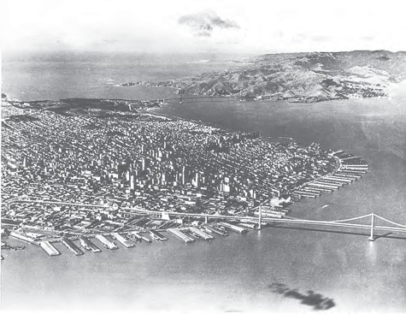
Fig. 8.3: San Francisco, the largest land-locked harbour in the world

Types of Port
Generally, ports are classified according to the types of traffic which they handle.
Types of port according to cargo handled:
- Industrial Ports: These ports specialise in bulk cargo-like grain, sugar, ore, oil, chemicals and similar materials.
- Commercial Ports: These ports handle general cargo-packaged products and manufactured good. These ports also handle passenger traffic.

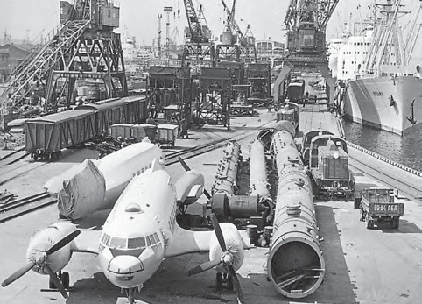

Fig. 8.4: Leningrad Commercial Port

- Comprehensive Ports: Such ports handle bulk and general cargo in large volumes. Most of the world’s great ports are classified as comprehensive ports.
Types of port on the basis of location:
- Inland Ports: These ports are located away from the sea coast. They are linked to the sea through a river or a canal. Such ports are accessible to flat bottom ships or barges. For example, Manchester is linked with a canal; Memphis is located on the river Mississippi; Rhine has several ports like Mannheim and Duisburg; and Kolkata is located on the river Hoogli, a branch of the river Ganga.
- Out Ports: These are deep water ports built away from the actual ports. These serve the parent ports by receiving those ships which are unable to approach them due to their large size. Classic combination, for example, is Athens and its out port Piraeus in Greece.
Types of port on the basis of specialised functions:
- Oil Ports: These ports deal in the processing and shipping of oil. Some of these are tanker ports and some are refinery ports. Maracaibo in Venezuela, Esskhira in Tunisia, Tripoli in Lebanon are tanker ports. Abadan on the Gulf of Persia is a refinery port.

International Trade 75

- Ports of Call: These are the ports which originally developed as calling points on main sea routes where ships used to anchor for refuelling, watering and taking food items. Later on, they developed into commercial ports. Aden, Honolulu and Singapore are good examples.
- Packet Station: These are also known as ferry ports. These packet stations are exclusively concerned with the transportation of passengers and mail across water bodies covering short distances. These stations occur in pairs located in such a way that they face each
other across the water body, e.g. Dover in England and Calais in France across the English Channel.
- Entrepot Ports: These are collection centres where the goods are brought from different countries for export. Singapore is an entrepot for Asia. Rotterdam for Europe, and Copenhagen for the Baltic region.
- Naval Ports: These are ports which have only strategic importance. These ports serve warships and have repair workshops for them. Kochi and Karwar are examples of such ports in India.

EXERCISES
  - Choose the right answer from the four alternatives given below.
    - Most of the world’s great ports are classified as:
      - Naval Ports (c) Comprehensive Ports
      - Oil Ports (d) Industrial Ports
    - Which one of the following continents has the maximum flow of global trade?
      - Asia (c) Europe
      - North America (d) Africa
  - Answer the following questions in about 30 words:
    - What is the basic function of the World Trade Organisation?
    - Why is it detrimental for a nation to have negative balance of payments?
    - What benefits do nations get by forming trading blocs?
  - Answer the following questions in not more than 150 words:
    - How are ports helpful for trade? Give a classification of ports on the basis of their location.
    - How do nations gain from International Trade?

76 Fundamentals of Human Geography

