GTA DEM 2002

User Guide

Provincial Mapping Unit

Mapping and Information Resources Branch

Corporate Management and Information Division

Ministry of Natural Resources and Forestry

2020-03-17

Disclaimer

This technical documentation has been prepared by Her Majesty the Queen in right of Ontario as represented by the Ministry of Natural Resources and Forestry (the “Ministry”). No warranties or representations, express or implied, statutory or otherwise shall apply or are being made by the Ministry with respect to the documentation, its accuracy or its completeness. In no event will the Ministry be liable or responsible for any lost profits, loss of revenue or earnings, claims by third parties or for any economic, indirect, special, incidental, consequential or exemplary damage resulting from any errors, inaccuracies or omissions in this documentation; and in no event will the Ministry’s liability for any such errors, inaccuracies or omissions on any particular claim, proceeding or action, exceed the actual consideration paid by the claimant involved to the Ministry for the materials to which this instructional documentation relates. Save and except for the liability expressly provided for above, the Ministry shall have no obligation, duty or liability whatsoever in contract, tort or otherwise, including any liability or negligence. The limitations, exclusions and disclaimers expressed above shall apply irrespective of the nature of any cause of action, demand or action, including but not limited to breach of contract, negligence, strict liability, tort or any other legal theory, and shall survive any fundamental breach or breaches.

Cette publication spécialisée n’est disponible qu’en anglais.

Additional Information

For more information about this document, please contact the Provincial Mapping Unit at [pmu@ontario.ca](mailto:pmu@ontario.ca).

Executive Summary

Key Words

DEM, Digital Elevation Model, WRIP, Water Resources Information Program, Provincial Mapping Unit, PMU, Digital Terrain Model, Terrain, DTM, TIN, Triangulated Irregular Network.

Abstract

A three-dimensional raster data set which represents a continuous elevation surface. This data set encompasses the Greater Toronto Area (GTA) and surrounding area extending from the Niagara region to Port Severn, the Kawartha Highlands and the Bay of Quinte regions.

Table of Contents

Disclaimer 2

Additional Information 2

Executive Summary 3

Key Words 3

Abstract 3

Table of Contents 4

List of Figures 5

List of Acronyms 6

1. Product Description 7

1.1 Geographic Extent 7

1.2 Reference System 8

1.3 Resolution 8

2. Product Details 9

2.1 TIN and DEM Products 9

2.2 Data Delivery Format 11

2.3 Use Restrictions 12

3. References 13

List of Figures

Figure 1: Extent of GTA 2002 Project Area 7

Figure 2: A TIN without breaklines (A) and a TIN with breaklines (B). 9

Figure 3: Three Downloadable Package Areas 11

List of Acronyms

CGVD28: Canadian Geodetic Vertical Datum 1928

DEM: Digital Elevation Model

DTM: Digital Terrain Model

GIS: Geographic Information Systems

GTA: Greater Toronto Area

LIO: Land Information Ontario

NAD83: North American Datum of 1983

PMU: Provincial Mapping Unit

TIN: Triangulated Irregular Network

UTM: Universal Transverse Mercator

1. Product Description

In the spring of 2002, a project was initiated to acquire leaf-off photography for the Greater Toronto Area (GTA) and to generate a highly accurate and precise elevation data set using softcopy photogrammetric techniques. This terrain data was designed to support the generation of a Digital Elevation Model (DEM) and other elevation data product derivatives (Regional Municipality of York, 2001).

* 1. Geographic Extent

The elevation data is organized into 20km x 20km tiles that encompass the GTA and the surrounding area from the Niagara region to Port Severn, the Kawartha Highlands and Bay of Quinte regions.

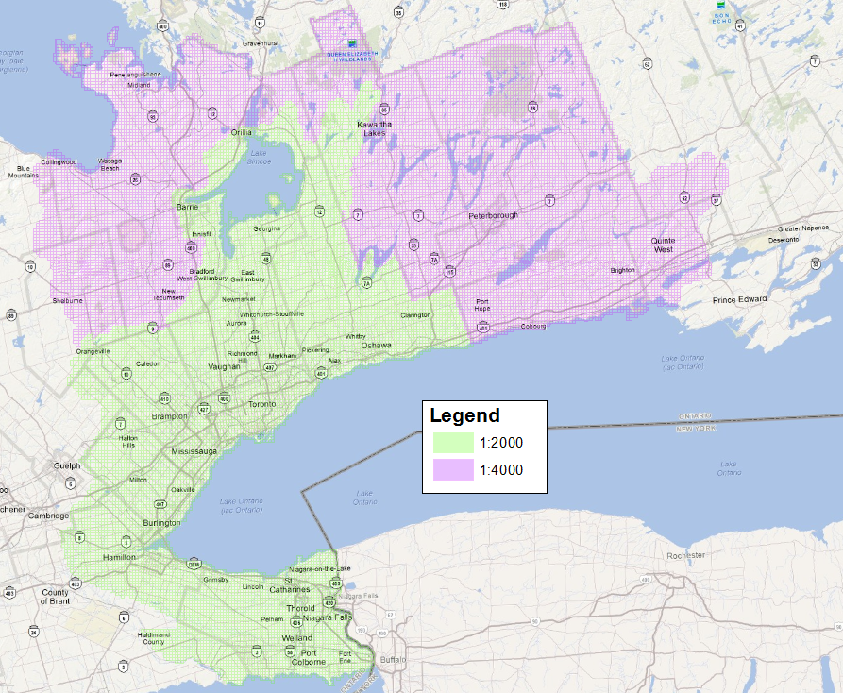

Figure 1: Extent of GTA 2002 Project Area

This data is intended to be used for pre-engineering survey and design as well as the production of planimetric mapping at differing accuracies with the following specifications:

* 1:2000 Scale Mapping: Horizontal and vertical accuracy 0.5m, suitable for 1m contour generation. Final point spacing of Digital Terrain Model (DTM) is 10m.
* 1:4000 Scale Mapping: Horizontal and vertical accuracy 1m, suitable for 2m contour generation. Final point spacing of DTM is 20m.
  1. Reference System

**Horizontal Reference System**

The horizontal coordinate system of the DEM is the Universal Transverse Mercator (UTM) and covers zones 17 and 18. The horizontal datum of the DEM is the North American Datum of 1983 (NAD83).

The horizontal unit of measure (coordinate system axis units) for all raster grid cells in the DEM is meters (m).

**Vertical Reference System**

The vertical coordinate system of the DEM is based on the Canadian Geodetic Vertical Datum 1928 (CGVD28) of the Geodetic Survey Division of Natural Resources Canada and is measured in metres above mean sea level. For more information please see the [Height Reference System Modernization](https://www.nrcan.gc.ca/height-reference-system-modernization/9054#_Canadian_Geodetic_Vertical_1) (https://www.nrcan.gc.ca/height-reference-system-modernization/9054#_Canadian_Geodetic_Vertical_1).

The vertical unit of measure (coordinate system axis units) for all raster grid cells in the DEM is meters (m). One single vertical elevation value represents each raster grid cell in the DEM.

* 1. Resolution

**Spatial Resolution**

The grid spacing is based on Universal Transverse Mercator (UTM) projection with a raster cell resolution of 5 metres.

**Temporal Resolution**

Source elevation data was captured using softcopy photogrammetry in 2002.

1. Product Details
   1. TIN and DEM Products

The GTA 2002 vector elevation data was delivered in a format best modeled using a Triangulated Irregular Network (TIN) data model. A TIN and DEM have been generated to honour the original vector data as much as possible. The DEM has been generated from the vector data by first creating an ArcGIS Terrain using the elevation points, lines and polygons then this Terrain was converted to a DEM using a Natural Neighbours interpolation algorithm.

Breaklines are a key dataset that is used when creating a TIN as they define rapid or sharp changes in elevation. Without the use of breaklines, a TIN will yield a poor representation of the terrain surface. Figure 2 demonstrates the level of detail added within a TIN by including breaklines.

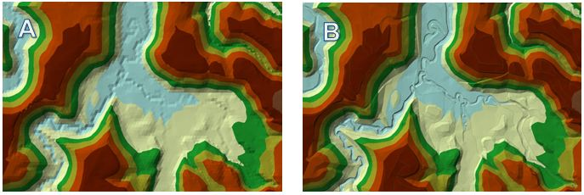

Figure 2: A TIN without breaklines (A) and a TIN with breaklines (B).

Prior to TIN modeling, each coded breakline feature that was captured had to be designated to an appropriate TIN category based on their use as a hard or soft breakline feature before they were used in the TIN modeling process (see Table 1). Decisions were made based on whether the features were coded as approximate or actual and using a basic understanding of hydrology.

Table 1: Breakline classification used to create the GTA TIN model.

| Classification Code | Feature Class | TIN Input | Description |
| --- | --- | --- | --- |
| Ditch C/L | Polyline | Hard Breakline | All major ditch centerlines that will ensure the proper generation of 1.0m contours. |
| Marsh/Swamp | Polygon | Soft Replace | The outline of visible interpretable marshes/swamps. Avoid wet areas that are likely seasonal. |
| Creek/Stream C/L | Polyline | Hard Breakline | The centerline of creeks and streams that are less than 4 meters wide. |
| Creek/Stream C/L approx. | Polyline | Soft Breakline | Where the creek/streams are difficult to accurately compile (i.e. tree cover), or where the path may be uncertain. |
| River/Shoreline | Polygon | Hard Replace | Both sides of rivers greater than 4 meters wide, also contains ponds and reservoirs. |
| River/Shoreline approx. | Polygon | Soft Replace | Where the river/shoreline may be difficult to accurately compile (i.e. tree cover). |
| WaterBody | Polygon | Hard Replace | All identifiable water bodies such as Lake Ontario, Lake Scugog, Lake Wilcox. |
| Headwall/Culv | Polygon | Hard Replace | Outline of all headwalls and culverts to scale (concrete box culverts, not corrugated steel culverts) |
| Dam2Sc. | Polygon | Hard Replace | The outline of all Dams to Scale. |
| AccWay | Polygon | Hard Replace | All major access ways required to ensure the proper generation of 1.0m contours. |
| RoadEdgPv | Polygon | Hard Replace | All paved road edges |
| RoadEdgCb | Polygon | Hard Replace | All curbed road edges. |
| RoadEdgGr | Polygon | Hard Replace | All gravel road edges |
| RailC/L | Polygon | Hard Replace | All rail centerlines |
| Bridge | Polygon | Hard Replace | All bridges which service roads or rails. |
| RetWall | Polygon | Hard Replace | All significant retaining walls. |
| Breakline | Polygon | Soft Replace | Generic breaklines for all pits/piles, top of bluff, gullies etc. to ensure the proper generation of 1.0m contours. |
| Mass Points | Point | Mass Points | Not Applicable |

Once the polygons and lines were divided into their respective layers, a single DTM point layer was generated that was comprised of soft and hard breakline layers and hard and soft polygon layers. These datasets were then used as input for the TIN creation. The final DEM product was created by converting the TIN model to a 5m raster elevation surface using a Natural Neighbours interpolation algorithm (ESRI, 2014).

* 1. Data Delivery Format

The GTA DEM 2002 data is currently distributed through the [Ontario GeoHub](https://geohub.lio.gov.on.ca/search?q=Greater%20Toronto%20Area%20(GTA)%20Digital%20Elevation%20Model%202002) (https://geohub.lio.gov.on.ca/search?q=Greater%20Toronto%20Area%20(GTA)%20Digital%20Elevation%20Model%202002).

The GTA DEM 2002 can be downloaded in three packages NE, NW and SW (see Figure 3). Each package contains multiple DEM tiles in floating point file (.FLT) format.

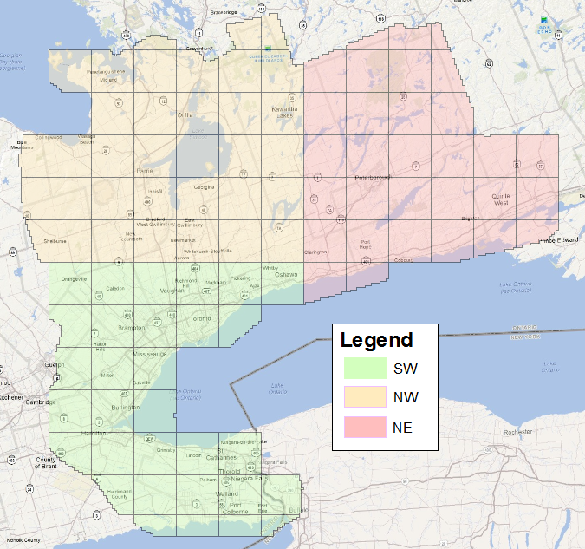

Figure 3: Three Downloadable Package Areas

* 1. Use Restrictions

The GTA DEM 2002 is considered Open Data. You are free to copy, modify, publish, translate, adapt, distribute or otherwise use the Information in any medium, mode or format for any lawful purpose. If you do any of the above, you must use the following attribution statement “Contains information licensed under the Open Government Licence – Ontario.” See [Open Government Licence](https://www.ontario.ca/page/open-government-licence-ontario) (https://www.ontario.ca/page/open-government-licence-ontario).

1. References

Earth Science Research Institute (ESRI). 2014. [Terrain to Raster Function for ArcGIS software](http://resources.arcgis.com/en/help/main/10.1/index.html#//009t00000206000000) (http://resources.arcgis.com/en/help/main/10.1/index.html#//009t00000206000000)

Earth Science Research Institute (ESRI). 2014. [Natural Neighbors Interpolation Algorithm](http://resources.arcgis.com/en/help/main/10.1/index.html#//005v00000027000000) (http://resources.arcgis.com/en/help/main/10.1/index.html#//005v00000027000000)

Regional Municipality of York. 2001. Request for Proposal P-01-71: Greater Toronto and Area Digital Orthophotography and Digital Terrain Data, Finance Department, Supplies and Services Branch, 44p.

Version 1516.1