GATED FEASIBILITY • TURNKEY OEM PATHS • MoE ONLY • SWITCHED E3.S
ATMOS E3.S for MoE Serving — Version 3
Hybrid expert acceleration across rack OEMs • RTX as a development vehicle
Executive summary
This V3 proposal converts the V2 assessment into an evidence-gated feasibility program. The first decision is whether a complete GPU-router-to-ATMOS-expert-to-GPU continuation fits the measured per-layer latency budget; capacity fit alone is not sufficient. A single Qwen3-235B-class FP8 configuration is qualified first on an RTX development vehicle, followed by a four-GPU/four-ATMOS tray emulator and one named turnkey OEM rack path. NVIDIA NVL and AMD Helios remain reference platforms, while additional rack integrators are screened through the same attachment, availability, lifecycle, and measured-ROI gates.
- Product target: Earn a product claim separately on each named OEM/platform; the RTX system is a software and heterogeneous-execution development vehicle.
- Economic thesis: Increase accepted MoE work per unit of GPU infrastructure, then spend the headroom on throughput, KV/concurrency, fewer active GPU units, or lower scale-out traffic while preserving quality, TTFT and TPOT.
- Portability rule: Use stock CUDA/NCCL or ROCm/HIP/RCCL; do not modify proprietary GPU firmware/drivers; keep ATMOS outside NVLink/NVSwitch and UALink. Host staging is the guaranteed transport baseline.
- Validation discipline: Six sequential decision gates cover baseline freeze, primitive latency/service curves, tray-scale routing and faults, full RTX service, named OEM attachment, and independent rack-scale ROI qualification.

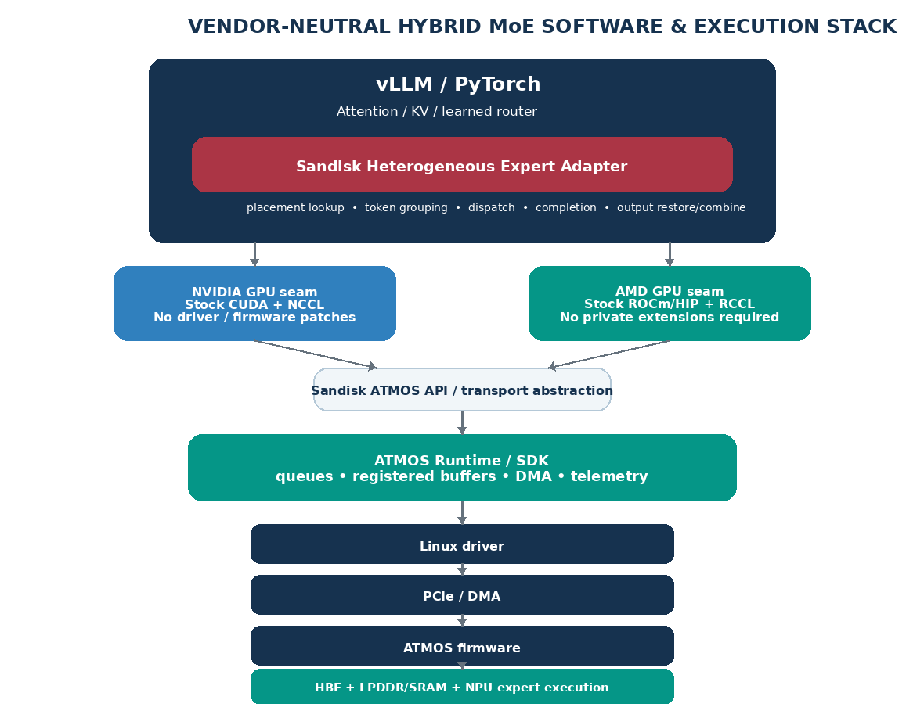

Reading map
Part | Question answered | Outcome
Background | Why an ATMOS expert tier matter? | Value hypothesis, claim boundary and common resource model.
Product target | How does the RTX development vehicle lead to rack scale? | NVIDIA NVL and AMD Helios are the production targets; RTX is the proving ground.
Part I | How does the switched E3.S subsystem attach? | Gen5 baseline, Gen6 path, DMA/peer rules and OEM/rack gates.
Part II | What changes in the serving stack? | One vendor-neutral workstream with explicit NVIDIA and AMD seams.
Part III | What measured economics would justify ATMOS? | Break-even equations; illustrative RTX numbers are not claims.
Part IV | Which turnkey partners should be engaged first? | Preliminary scored shortlist plus a common RFI gate.
Part V | What evidence is needed before product commitment? | Six gated POCs with explicit pass, stop, pivot, owner, and evidence rules.

Background: Why an ATMOS expert tier can matter at rack scale
Large Mixture-of-Experts models create a useful asymmetry: every token activates only a subset of experts, yet the serving system must keep a much larger expert population resident and ready. On GPU systems, those expert tensors compete with attention weights, live KV, graph/workspace and batching headroom. At scale, Expert Parallelism can also add dispatch/combine traffic across GPUs and racks.
ATMOS is not treated as a storage device. Each E3.S worker combines HBF, local LPDDR/SRAM working memory and an NPU. The architectural bet is to keep routed-expert weights beside the NPU that executes them, leaving the native GPU platform to do what it already does well. RTX is used to prove that split first; the production value must then be re-established against the much stronger memory, compute and scale-up fabrics of NVIDIA NVL and AMD Helios.
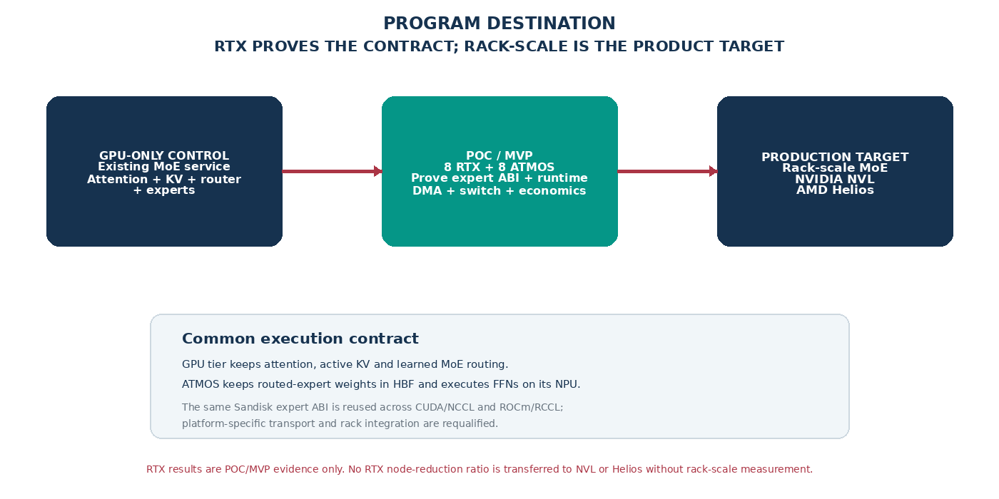

What we can claim — and what we cannot
Expected mechanism | Defensible target | Not assumed
GPU memory relief | ATMOS-owned expert tensors are omitted from GPU residency, creating useful GDDR/HBM headroom. | That every freed GB converts directly into cash savings.
Additional compute | ATMOS NPU performs the expert FFN instead of returning weights to a GPU for execution. | That NPU peak TOPS maps directly to token throughput.
Throughput / node count | At fixed SLO, accepted work per GPU service unit increases enough to serve more demand or reduce required GPU nodes/trays/racks. | A universal node- or rack-reduction ratio, or transfer of the RTX development vehicle result to NVL/Helios.
TTFT / TPOT | Preserve the existing SLO; improve tails if reduced queueing/expert work is on the critical path. | Automatic per-request latency improvement.
Network locality | A larger local expert bank can reduce remote expert edges when the complete execution graph and transport path are actually local. | That an E3.S switch joins NVLink/NVSwitch or UALink, or eliminates scale-out communication by itself.

Rack-scale is the product; RTX is the proving ground
The common Sandisk contract is intentionally independent of one GPU vendor: vLLM selects the same neural experts, the Sandisk adapter maps those experts to ATMOS workers, and the ATMOS runtime executes them. What changes by platform is the GPU framework seam, transport path, host architecture, rack topology and lifecycle integration.
Stage | Concrete reference | Native GPU fabric / software | ATMOS integration rule
RTX development vehicle | 8 × RTX PRO 6000-class server + 8 ATMOS E3.S | CUDA / NCCL on a conventional server topology | Prove expert ABI, switched E3.S, DMA, vLLM integration and economic threshold. Not the final product claim.
NVIDIA target | NVIDIA NVL rack-scale family; GB300 NVL72 and Vera Rubin NVL72 are current concrete references | CUDA / NCCL with NVLink/NVSwitch; Grace/Vera host architecture varies by generation | Preserve the NVLink scale-up domain. Use only an OEM-approved PCIe branch or a separately costed companion ATMOS service/tray.
AMD target | AMD Helios reference architecture with 72 Instinct MI455X GPUs and EPYC Venice hosts | ROCm / HIP / RCCL with UALink-based scale-up | Preserve the UALink scale-up domain. Reuse the logical expert ABI; requalify HIP transport, rack attachment, operator and service economics.
ARCHITECTURE INVARIANT — ATMOS does not become an NVLink/NVSwitch or UALink endpoint, and the product does not require proprietary NVIDIA or AMD GPU firmware/driver modifications. Stock vendor stacks are the supported boundary.

HARDWARE PLATFORM
Part I — Switched E3.S subsystem: one building block from RTX development vehicle to rack scale
Topology | Pros | Cons
Direct E3.S reference | No shared switch/uplink; simple endpoint debugging; useful POC control when host lanes are readily available. | Within an eight-device local design, consumes 32 host lanes; not the production rack-scale baseline; no common managed fabric.
Switched E3.S baseline | One host-facing uplink fans out to eight x4 ATMOS devices; common diagnostics/reset domain; manageable E3.S subsystem for MVP and rack integration. | Adds cost/power and a shared failure domain. It does not place ATMOS in NVLink/NVSwitch or UALink, and the rack OEM must expose a supported host path.
Two balanced switch domains | Contains switch failure; reduces contention; can align to NUMA/root domains. | Uses two upstream x16 paths and more board/power budget; must prove recovery.

Topology 1:- Direct-attached E3.S pool
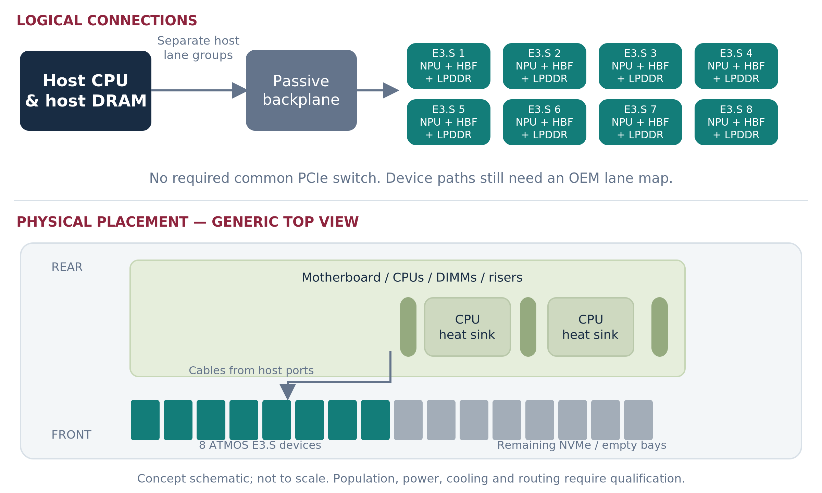

Direct attachment remains useful for early endpoint bring-up because it removes the switch from the debug path. In any local eight-device design, however, eight x4 E3.S endpoints consume 32 host lanes and create eight separately managed paths. The proposed product building block is therefore a switched ATMOS E3.S subsystem with one host-facing uplink and eight x4 downstream endpoints. RTX uses this as the development fixture; NVL and Helios use it only when their OEM exposes an approved local PCIe integration boundary.

ARCHITECTURE DECISION Keep direct attachment only as a bring-up/reference path. The reusable hardware building block is a switched E3.S ATMOS subsystem. RTX is the development host; production requires an independently qualified NVIDIA NVL or AMD Helios integration. The fully integrated eight-module ATMOS card remains out of scope.

Topology 2 :- Switched E3.S pool
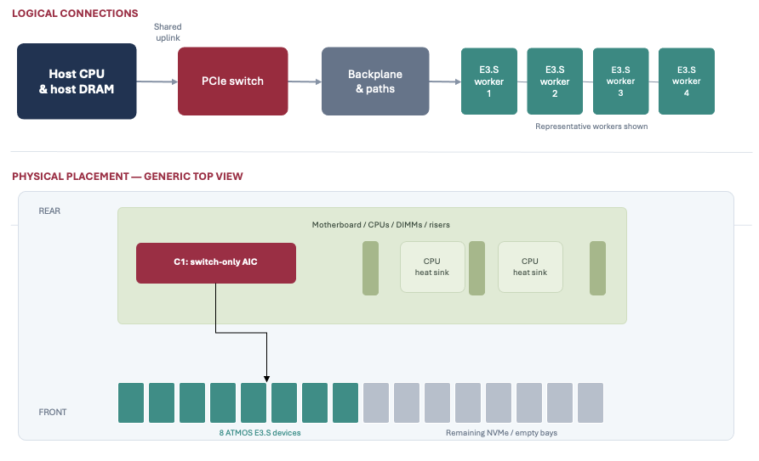

Figure 5. The switch is an ATMOS branch, not a replacement for the GPU platform fabric. The GPU compute domain and NICs remain on their native platform paths. The drawing represents the local-PCIe attachment option; a companion ATMOS tray/service is a separate topology when the rack does not expose a suitable local route.
Gen5 baseline: settle the 48-lane fan-out first
Candidate | Public fit | Role in the program | Adoption gate
Microchip PM50052 | Switchtec PFX Gen5, 52 lanes. Microchip publishes a 52-lane reference design and ChipLink-based enablement path. | Primary engineering-enablement inquiry because the 48-lane target map leaves four lanes of arithmetic margin. | Vendor-confirmed x16 upstream + 8×x4 downstream map, non-NVMe endpoint interoperability, board/firmware support, quote and lifecycle owner.
Broadcom PEX89048 | 48-lane PCIe Gen5 ExpressFabric switch; exact arithmetic for x16 + 8×x4. | Parallel fixed-eight-device alternative to avoid vendor lock-in and compare OEM-supported board availability. | Exact port grouping/configuration, board support, peer/ACS/DPC/reset behavior, diagnostics, quote and support owner.
Microchip PM50100 / larger Gen5 | Up to 100 lanes in the Gen5 Switchtec family. | Only when the actual server port map needs wider uplinks, more endpoints or additional fabrics. | Concrete extra-port requirement; do not pay area/power/cost merely because a larger switch exists.

Gen5 first for the subsystem; Gen6 when the rack path earns it
- A Gen6 x16 host uplink can approximately match the headline line rate of eight Gen5 x4 downstream links, but only when the selected NVL/Helios host path, switch, board/channel and firmware all support the combination. Gen6 is therefore a platform qualification, not a paper upgrade.
- Microchip publicly describes Gen6 Switchtec low-lane-count 48/64-lane families with x2/x4/x8/x16 flexibility. Keep this as the first Gen6 engineering inquiry after the Gen5 subsystem behavior is understood.
- Do not choose Gen6 simply to upgrade a Gen5 endpoint. ATMOS endpoint generation, host/root generation and switch uplink/downlink configuration are independent decisions.
- Treat any larger Gen6 switch as a vendor/OEM roadmap item until an exact orderable part, x4 grouping, board path, firmware profile, supply plan and support owner are returned.
GPU-to-ATMOS DMA qualification: host staging first, peer path optional
The initial MoE architecture does not require ATMOS-to-ATMOS P2P. The critical data path is GPU-to-ATMOS activation dispatch and ATMOS-to-GPU result return. A host-staged path using stock vendor APIs is the mandatory functional baseline. Direct GPU-memory peer DMA is enabled only when documented NVIDIA or AMD interfaces, Linux/IOMMU policy, the ATMOS endpoint and the runtime all support the exact route; lack of that path must never force a proprietary GPU driver or firmware modification.
Gate | What must be proven | Owner(s)
1. ATMOS endpoint | Registered-buffer mechanism; programmable DMA; ordering/completion; reset invalidation; bounded access. Peer-visible aperture only if required by a supported route. | Sandisk silicon/FW + driver
2. Switch fabric | Required x16 + 8×x4 map; diagnostics; ACS/DPC/security policy; containment and firmware profile. ATMOS-to-ATMOS P2P is optional for the first product. | Microchip/Broadcom FAE + OEM
3. OEM / OS | BIOS address windows, IOMMU mapping, NUMA/root reachability, security policy, reset and failure containment for the selected host/rack. | OEM + Linux/platform
4. NVIDIA GPU path | Stock vendor-supported CUDA/driver path. Host-staged pinned memory is sufficient for baseline; optional peer DMA only through documented interfaces. No NVIDIA firmware/driver patch. | Sandisk runtime/driver + OEM
5. AMD GPU path | Stock ROCm/HIP/amdgpu path. Host-staged pinned memory is sufficient for baseline; optional peer path uses documented/open interfaces. No private AMD extension is required. | Sandisk runtime/driver + OEM
6. Runtime semantics | Pinned lifetime, token/expert identity, fences, cancellation, timeout, retry, backpressure and generation-safe cleanup. DMA and NPU completions remain separate. | Sandisk runtime + Tenstorrent
7. Service evidence | Measure producer→expert→continuation latency, bandwidth and queueing under all-eight-device load; compare host-staged and any qualified peer path at identical model/SLO. | Performance + validation

DESIGN RULE The switch is useful for ATMOS fan-out and lifecycle even if no peer DMA is enabled. ATMOS-to-ATMOS P2P is not required for the initial expert architecture. Preserve the native GPU scale-up fabric; if a direct GPU peer route is unavailable, use host staging or change the physical integration rather than modifying proprietary GPU software.

OEM deliverable required before the switch is “settled”
Returned artifact | Required content
Qualified BOM / configuration ID | One exact configuration per stage: RTX development vehicle fixture, then NVIDIA NVL and/or AMD Helios rack integration. Include ATMOS switch/board, cables/retimers, NICs, boot/storage and spare strategy.
Lane + NUMA map | CPU/root path, native GPU scale-up fabric boundary, ATMOS switch uplink, all eight x4 endpoints, generations, oversubscription and any root/rack crossing.
Power / cooling envelope | ATMOS device/switch budget plus simultaneous GPU workload, airflow/liquid-cooling interaction, BMC telemetry, throttling and service access.
BIOS / BMC / reset contract | Enumeration, address windows, IOMMU/ACS, DPC/AER, FLR/reset domains, secure boot/update sequence and failure recovery for the selected platform.
Support boundary | Who owns ATMOS switch board/firmware, field replacement, diagnostics, spares and escalation. Sandisk owns the ATMOS service boundary; native GPU stack ownership stays with its vendor/platform.
Measured route matrix | Host-staged and any qualified peer paths, with payload, latency, queueing, root/rack crossings and unsupported combinations explicitly listed for each target platform.

Production selection rule
- Choose the production Gen5 switch only after POC 2 proves the required port map, fault/reset behavior and sustained DMA behavior, and POC 3 confirms that the subsystem can support the end-to-end development service rate. Lane count alone is not a winner criterion.
- A separate switch AIC is acceptable as the development engineering fixture when it shortens bring-up. For rack-scale deployment, prefer the OEM-integrated or companion-tray path that produces the clearest BOM, lifecycle and support boundary.
- Gen6 is a later platform qualification delta, not an development-vehicle blocker. Promote it when the Gen5 uplink is a measured bottleneck and the selected NVL/Helios integration exposes a supported Gen6 root path.
WHAT “SETTLED” MEANS One exact ATMOS switch/board revision and E3.S population, plus a platform-specific integration record for RTX development vehicle and each rack-scale target: lane/route map, reset/security contract, supported software stack, power/cooling envelope and accountable first-response owner.

Part II — One workstream: Heterogeneous MoE Execution & Infrastructure Efficiency
The proposal intentionally uses one workstream because expert execution, reclaimed GPU memory, locality and infrastructure reduction are one economic chain. The same execution architecture can spend its headroom on more throughput, more KV/concurrency, fewer GPU service units or less remote expert traffic. The software contract is common across NVIDIA and AMD; only the GPU-facing seam and physical platform integration change.
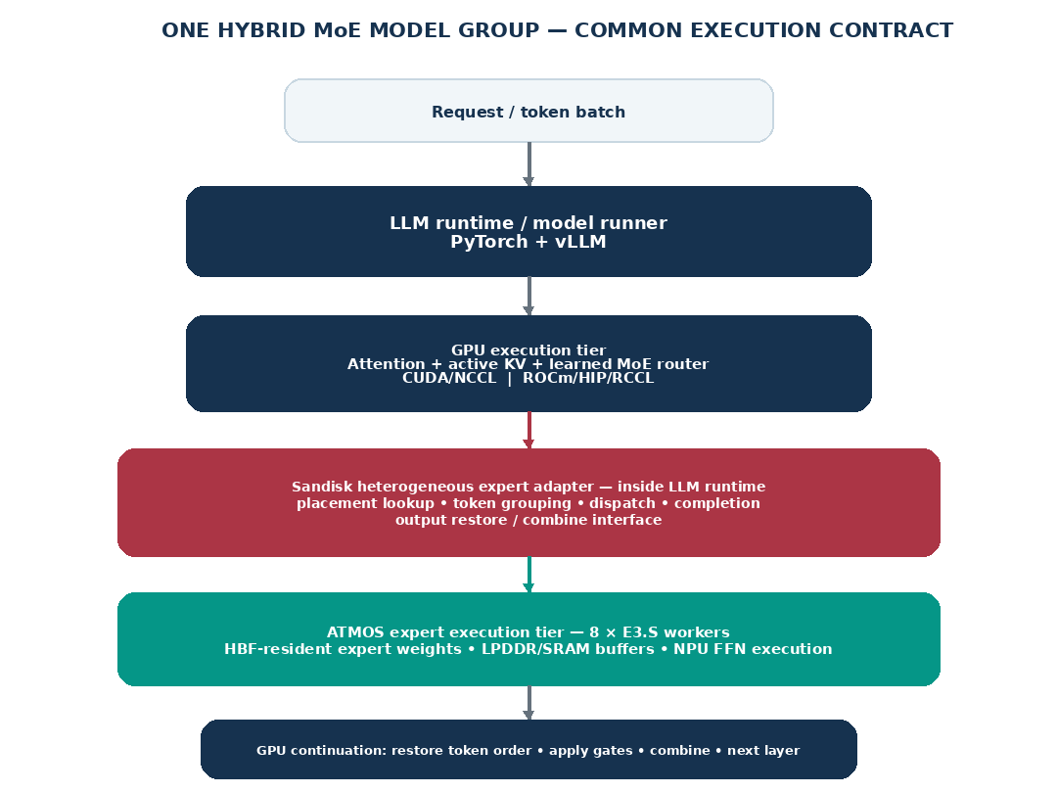

Execution sequence
- 1. vLLM/PyTorch runs the existing attention and shared/non-expert GPU path on the stock platform stack: CUDA/NCCL for NVIDIA or ROCm/HIP/RCCL for AMD. The learned MoE router computes the same top-k expert IDs and gate weights as the GPU-only reference.
- 2. The Sandisk heterogeneous expert adapter, in-process with the LLM runtime, groups routed tokens by model version, layer, expert and physical destination. Placement is deployment-time state; it does not predict future “hot” experts.
- 3. For an ATMOS-owned expert, the adapter submits hidden activations through the Sandisk transport abstraction into registered ATMOS buffers. Host-staged transport is always supported; direct peer DMA is a platform-specific optimization.
- 4. ATMOS moves the required working tiles through HBF/LPDDR/SRAM and the NPU executes the expert FFN. Expert weights stay resident in ATMOS; no request-time weight copy to GPU is required.
- 5. The GPU continuation path restores token order, applies the learned gate exactly once, combines all required top-k contributions and advances to the next dependent layer. The native GPU collective stack remains untouched.
- 6. At deployment scale, complete expert coverage and replica placement are optimized against the actual rack topology, demand and failure policy. RTX development vehicle placement is not assumed to be optimal for NVL or Helios.

Serving-stack impact: common Sandisk core with NVIDIA and AMD platform seams
Source / note: V = verify/reuse; M = configure/modify; N = new Sandisk/partner artifact. The architecture is deliberately built around stock vendor-supported GPU software. No product feature is allowed to depend on a proprietary NVIDIA or AMD firmware/driver modification; if a peer path is unavailable, the system retains host staging or changes the physical integration.

Domain | Artifact | Action | Common Sandisk requirement | GPU-platform path (NVIDIA / AMD) | Primary owner
Software | Model contract / learned router | V | Freeze checkpoint, tokenizer, expert function, top-k and gate normalization. Trace export only; neural expert selection is unchanged. | NVIDIA: unchanged model semantics.  AMD: unchanged model semantics. | Sandisk
Software | ExpertPack compiler | N | Compile every ATMOS-owned (layer, expert) FFN into a versioned NPU pack with weight layout, precision/scales, scratch budget and golden outputs. | Same pack identity and expert ABI for both GPU ecosystems. | Sandisk + Tenstorrent
Software | vLLM MoE integration | M/N | Add one ATMOS-aware prepare/expert/finalize seam. Skip GPU allocation of ATMOS-owned experts and preserve customer APIs. | NVIDIA: pinned vLLM/PyTorch/CUDA build.  AMD: pinned vLLM/PyTorch/ROCm build. No separate model fork. | Sandisk + Tenstorrent
Software | Heterogeneous expert adapter / placement | N | Map (model, layer, expert) to resident ATMOS owners; group tokens; preserve identity, gates, queue bounds and placement epochs. | Vendor-neutral logic; no CUDA/NCCL or HIP/RCCL rank identity for ATMOS. | Sandisk + Tenstorrent
Software | GPU framework seam | M | Implement packing, result restore/combine, async buffers and explicit synchronization in Sandisk code. | NVIDIA: stock PyTorch/CUDA APIs.  AMD: stock PyTorch/ROCm/HIP APIs. No GPU driver/FW patches. | Sandisk + Tenstorrent
Software | GPU collectives | V | Keep ATMOS outside the GPU collective domain; revalidate GPU rank/group configuration after experts move off GPU. | NVIDIA: stock NCCL.  AMD: stock RCCL. No collective-library modification. | Vendor Runtime
Software | ATMOS SDK + Linux driver | N | Discovery, buffer registration, queue/DMA submission, completion, cancel/error, reset invalidation, telemetry and bounded BAR access. | Identical ATMOS API contract; host build may differ (x86-64 vs Arm64) by platform. | Sandisk + Tenstorrent
Software | Kubernetes allocation | M/N | Expose ATMOS as whole-device resources initially; co-allocate qualified GPU+ATMOS groups and publish topology/health. | NVIDIA: preserve NVIDIA GPU Operator.  AMD: preserve AMD GPU Operator. Sandisk operator remains separate. | Sandisk + Tenstorrent
Software | Operator / lifecycle | N | Stage complete ExpertPacks, publish readiness only for a complete generation, drain/update/rollback/recover and fail closed on missing experts. | Common lifecycle contract; package separately for supported distro/CPU architecture. | SRE/release
Software | Telemetry / evidence | N | Correlate request/layer/token IDs across GPU, transport and NPU; expose queue time, bytes, errors, TTFT/TPOT and accepted throughput. | Common schema so RTX, NVL and Helios results can be compared without changing definitions. | Perf/validation
Hardware | ATMOS NPU + HBF/LPDDR path | V/M | Qualify exact routed-FFN shapes, precision, useful HBF delivery, LPDDR contention, tile/ring buffers, thermals and small-batch behavior. | Independent of GPU vendor; service curve must be re-tested under each host/rack traffic pattern. | NPU + memory
Hardware | PCIe endpoint / DMA | V/M | Fix endpoint generation, address widths, MSI-X, registered buffers, DMA descriptors, ordering, completions and errors. | Same endpoint contract; platform-specific root/IOMMU and host architecture are requalified. | Silicon/FW
Hardware | GPU-to-ATMOS transport | V/M | Host-staged pinned-memory path is the required baseline. Direct GPU-memory peer DMA is optional only through documented interfaces. | NVIDIA: public supported CUDA/driver path only.  AMD: public/open ROCm/HIP/amdgpu path only. No proprietary patch dependency. | Sandisk + OEM
Hardware | Native GPU scale-up fabric | V | Preserve the rack GPU fabric; ATMOS does not masquerade as a native GPU-fabric endpoint. | NVIDIA: do not modify NVLink/NVSwitch domain.  AMD: do not modify UALink domain. | OEM/platform
Hardware | Switch / backplane | V/M | Qualify selected Gen5 switch, x16+8×x4 map, cables/retimers, ACS/IOMMU/DPC, diagnostics and reset containment. | Common ATMOS subsystem; exact upstream/root connection is different on RTX, NVL and Helios. | OEM + switch FAE
Hardware | Server / rack envelope | V/M | Preserve GPU/NIC service, account for displaced storage, mixed-load power, cooling, BMC telemetry, serviceability and failure coupling. | NVIDIA: NVL OEM/Grace/Vera host path.  AMD: Helios ORW/EPYC Venice/OEM path. | OEM engineering
Product | Compatibility manifest | N | Bind ATMOS hardware/firmware, switch, OS, vLLM, model/pack hashes, Kubernetes, workload envelope and known limits. | Separate qualified manifests for RTX development vehicle, NVIDIA NVL and AMD Helios. | Sandisk release
Product | Economic / support contract | N | Report qualified service rate, SLO, failure reserve, avoidable GPU/rack cost and one accountable support route. | ROI is earned separately per platform; RTX economics are not transferred to rack scale. | Product + SA

Definition of done for Part II
The common expert ABI, vLLM adapter, ATMOS runtime/driver and switched E3.S subsystem must first operate as a reproducible RTX development vehicle while preserving model quality and the required TTFT/TPOT. Product completion requires the same logical contract to pass on at least one named rack-scale target — NVIDIA NVL or AMD Helios — using the stock GPU stack, a qualified physical route and a measured economic benefit. The two rack platforms are released independently.

Part III — Break-even model: illustrative RTX calibration and rack-scale translation
The following scenario remains intentionally concrete, but it is now used as an RTX development vehicle calibration case rather than the final production sizing. It shows how the heterogeneous expert architecture could create measurable headroom with ~235B and ~671B MoE classes. Once the MVP is measured, the same demand, model quality and latency contract is replayed against NVIDIA NVL and AMD Helios using their own GPU memory, scale-up fabric, rack topology and service rate.
Scenario demand
Input | Assumption
User scale | 60,000 active-user population; assume 40% active on a selected day.
Daily calls | 10 model calls per active user → 240,000 calls/day.
Service window | 8-hour concentrated business window → 8.33 calls/s mean.
Peak factor | 3× mean → 25 calls/s peak.
Traffic mix | 80% claims-assistant traffic (20 RPS peak); 20% complex-claims traffic (5 RPS peak).
Availability | Each independently scalable service class carries one complete replica/group of reserve capacity.
Latency contract | Claims assistant: TTFT ≤2.5 s, TPOT ≤45 ms. Complex claims: TTFT ≤5 s, TPOT ≤70 ms.

Source / note: The user count is an enterprise-scale anchor only. Activity, call count, traffic mix, context/output lengths, model choices, node rates and inventory are scenario assumptions for sizing—not customer disclosures.
Two MoE classes — different expert populations and precision pressure
Model class | Published / chosen geometry | Routed-expert raw size | 8-ATMOS implication
Qwen3-235B-A22B | 235B total / ~22B active; 94 layers; 128 routed experts per MoE layer; top-8. | ~227.1B routed-expert parameters → ~227 GB FP8 or ~454 GB at 16-bit. | Both raw expert sets fit inside the 800-GB application HBF study budget, subject to pack/runtime reserve and per-device placement.
DeepSeek-V3-class | ~671B total / ~37B active; 61 layers, first 3 dense; 256 routed + 1 shared expert; top-8. | ~653.9B routed-expert parameters → ~654 GB FP8 or ~1.308 TB at 16-bit. Shared expert excluded from this routed count. | FP8 routed experts plausibly fit in 8 ATMOS under the 800-GB study budget. 16-bit does not; use mixed placement or at least two hybrid nodes / more devices.

Source / note: Qwen geometry is from the published Qwen3-235B-A22B configuration (128 experts, top-8, 94 layers, hidden 4096, MoE intermediate 1536). DeepSeek-V3 configuration publishes 256 routed experts, 1 shared expert, top-8 and 61 layers with the first three dense. Raw bytes exclude scales, packing, metadata, shared tensors and replicas.
WHY THE 700B-CLASS FP8 CASE IS ESPECIALLY INTERESTING
Eight RTX PRO 6000 GPUs provide 768 GB nominal distributed GDDR. A ~671-GB raw FP8 model leaves little practical room for KV, workspace and fragmentation. If ~654 GB of routed experts can instead live and execute on the eight ATMOS devices, the GPU side keeps a much smaller non-expert working set plus live KV. That changes the service geometry even if per-request latency does not improve.

SAME DEMAND • SAME MODEL QUALITY • SAME LATENCY SLA
Baseline and hybrid sizing
The node rates below are explicit planning assumptions for the RTX calibration case and are replaced by measured complete-service rates. They are useful only to set an development economic threshold. NVIDIA NVL and AMD Helios are not sized by multiplying or reusing these node ratios.
Service class | GPU-only RTX development vehicle baseline | RTX + ATMOS development target case | Peak demand | Nodes incl. one reserve
Claims assistant — Qwen3-235B class | 1 × 8-RTX node per replica; 1.3 accepted RPS/node at the SLO. | 1 × 8-RTX + 8-ATMOS node; 2.2 accepted RPS/node target. | 20 RPS | GPU-only: 1 + ceil(20/1.3) = 17  Hybrid: 1 + ceil(20/2.2) = 11
Complex claims — ~671B FP8 MoE | 2 × 8-RTX nodes per complete replica/group; 0.7 accepted RPS per two-node group. | 1 hybrid node if the FP8 routed-expert pack and non-expert GPU state fit; 0.7 accepted RPS/node target. | 5 RPS | GPU-only: [1 + ceil(5/0.7)] × 2 = 18  Hybrid: 1 + ceil(5/0.7) = 9
TOTAL | 35 RTX servers = 280 RTX GPUs | 20 hybrid servers = 160 RTX GPUs + 160 ATMOS modules | 25 RPS | Illustrative only: 35 vs 20 servers and 280 vs 160 RTX GPUs; not a product claim

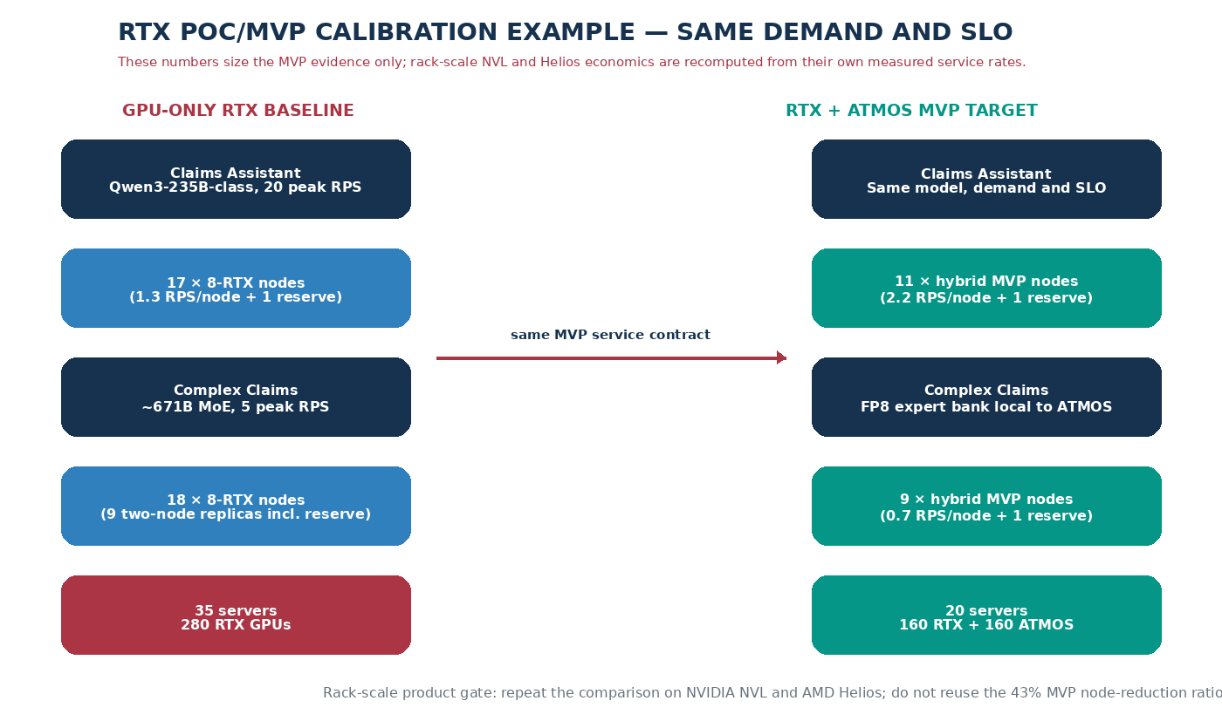

Figure 4. RTX development vehicle calibration only. The large-model benefit comes primarily from changing the complete replica geometry; the Qwen-class benefit also assumes higher accepted rate per hybrid node. Rack-scale NVL/Helios results must be re-measured from their own control configurations.
Sensitivity: how much node improvement is required to justify the hybrid premium?
Normalize a GPU-only node’s comparable three-year cost to 100 units and assume the hybrid node costs 120 units after ATMOS modules, switch, power/support and platform overhead. Integration NRE is accounted separately. The table shows why the program needs service-rate evidence rather than a capacity-only story.
Case | Qwen hybrid qualified rate | Large-MoE hybrid qualified rate | Hybrid fleet | Node reduction | Comparable cost vs GPU-only
Minimum useful | 1.7 RPS/node | 0.55 RPS/node | 24 nodes | 31% | 2,880 vs 3,500 units → ~18% lower
Target planning case | 2.2 RPS/node | 0.70 RPS/node | 20 nodes | 43% | Illustrative only: 2,400 vs 3,500 units; qualification required
Stretch | 2.6 RPS/node | 0.90 RPS/node | 16 nodes | 54% | 1,920 vs 3,500 units → ~45% lower

Source / note: These rates and the 20% hybrid-node premium are scenario inputs, not forecasts. The illustrative dollar translation is an RTX-development calibration only and must not be presented as NVL or Helios TCO. Rack-scale economics use actual GPU-rack quotes, power, networking, availability reserve and measured accepted service rate.
Operational effect beyond server count
- Fewer RTX nodes means fewer GPU/NIC/server firmware combinations to patch, monitor, spare and recover, but each hybrid node adds ATMOS firmware/driver and switch lifecycle that must be supported as one release.
- A complete local expert bank can reduce inter-node EP traffic for the supported group. That may simplify network sizing and tail behavior, but the saving is counted only when ports/bandwidth or service capacity can actually be removed or avoided.
- More free RTX GDDR can be spent on live KV and active sequences. This can reduce admission pressure and queueing; any TTFT/TPOT improvement must be measured at identical offered load and is not included in the node-count arithmetic above.
- The 16-bit ~671B case is a deliberate limit case: the routed expert bank alone is ~1.31 TB raw, so eight ATMOS devices under the 800-GB study budget do not make it a one-node service. Precision and actual pack size determine the valid topology.
RACK-SCALE TRANSLATION RULE Hold the model, request mix, quality, TTFT/TPOT and failure reserve constant. Compare GPU-only NVL with NVL+ATMOS and GPU-only Helios with Helios+ATMOS. Credit only measured gains such as more accepted tokens/requests per rack, more usable KV/concurrency, fewer active GPU trays/racks, or avoidable scale-out traffic. Do not transfer the 43% RTX-development node reduction.

Part IV — V2 assessment disposition
V3 treats every assessment item as a decision obligation. An item is closed only by a versioned artifact and an approved result; prose, capacity arithmetic, or a vendor roadmap does not close a gate.
ID | V2 assessment item | Closure gate(s) | Required evidence
R1 | Per-MoE-layer serial round-trip latency | G1, G3, G5 | Latency decomposition; p50/p95/p99; TPOT budget replay
R2 | 200 GB/s HBF and small-batch expert efficiency | G1 | Measured expert service curves by shape, precision, and tokens/expert
R3 | No exact rack attachment or lifecycle path | G4 | Named OEM design record: lanes, mechanics, power, cooling, BIOS/BMC, service
R4 | RTX results do not transfer to rack scale | G4, G5 | RTX called a development vehicle; each target is requalified independently
R5 | Insufficient failure reserve / incomplete model on loss | G2, G3, G5 | Chosen availability policy; fault injection; capacity and TCO include reserve
R6 | Assumption-driven 43% / 31% economics | G0, G3, G5 | Break-even model populated only with accepted-throughput and quoted TCO evidence
R7 | Top-8 fan-out, skew, and slowest-device tail | G1, G2, G3 | Destination count, co-activation, imbalance, fan-in, and slowest contribution
R8 | One switch is a shared failure domain | G2, G4 | Single-domain versus dual-domain comparison; DPC/reset containment
R9 | vLLM scope and long-term ownership understated | G0, G3 | Three owned software boundaries, conformance tests, release/upstream plan
R10 | Initial model/platform/transport matrix is too broad | G0 | One checkpoint, precision, Gen5 switch, host-staged path, and pinned CUDA stack

CLAIM CONTROL No gate may be marked Pass with simulated timing when real endpoint timing is available. No RTX rate, vendor marketing claim, or capacity-fit result is transferable to a rack product claim.

Part V — Turnkey AI vendor landscape
The ranking is a September 2026 screening hypothesis for ATMOS partnership priority, not a vendor performance benchmark. Public evidence establishes turnkey capability; only a returned RFI, quote, lab route, and POC can establish ATMOS compatibility or ROI.
NVIDIA NVL and AMD Helios are reference accelerator/platform ecosystems and are not ranked here. The table ranks solution providers that could own the physical integration, validation, deployment, and lifecycle boundary around those or other accelerators.

Scoring method
- ROI potential (35%): plausible reduction in accelerator, rack, energy, network, or service cost for the fixed workload.
- Integration ease (30%): supported host PCIe route, mechanical/power/cooling access, firmware ownership, and lab availability.
- Flexibility (25%): form-factor, CPU/GPU, network, cooling, and OEM/ODM co-design choices without a proprietary GPU-stack modification.
- Lifecycle readiness (10%): turnkey rack validation, global deployment/support, spares, firmware, and one accountable escalation path.
Each factor is scored 1–5. Weighted score = (35×ROI + 30×Ease + 25×Flexibility + 10×Lifecycle) / 5. A score is invalidated if the vendor cannot return the mandatory G4 attachment artifacts.

Preliminary ATMOS partner priority
Rank | Vendor / offer | ROI | Ease | Flex | Life | /100 | Conf. | Recommended action
1 | Giga Computing GIGAPOD | 4.5 | 4.5 | 5.0 | 4.0 | 91.5 | Med | Lead: explicit turnkey, NVIDIA/AMD/Intel, ORV3, air/DLC and bespoke facility integration
2 | Supermicro DCBBS / SuperCluster | 4.5 | 4.5 | 4.5 | 4.5 | 90.0 | Med | Lead: broad rack/form-factor portfolio, cooling, rack integration and L11/L12 validation
3 | Penguin Solutions OriginAI | 4.5 | 4.0 | 4.5 | 5.0 | 88.0 | Med | Lead: AMD/NVIDIA and broad component choice; tailored design-build-deploy-manage lifecycle
4 | Lenovo Hybrid AI Factory / Neptune | 4.0 | 3.5 | 4.0 | 4.5 | 78.0 | Med | Control: validated platforms, services and liquid cooling; internal PCIe/E3.S route unproven
5 | Dell AI Factory | 4.0 | 3.5 | 3.5 | 5.0 | 76.5 | Med | Control: NVIDIA turnkey plus AMD open architecture; validated-rack change control may constrain
6 | Cisco Secure AI Factory | 3.5 | 3.5 | 4.0 | 4.5 | 74.5 | Med | Parallel: full-stack AI PODs and Supermicro-enabled racks; tray ownership is shared
7 | HPE Private Cloud AI / AI Factory | 3.5 | 3.0 | 3.0 | 5.0 | 67.5 | Med | Parallel: strongest turnkey operations; appliance validation may limit low-level modification

SHORTLIST DECISION Engage ranks 1–3 for the fastest co-design learning, and one of ranks 4–5 as the enterprise lifecycle control. Run the same RFI and G4 evidence gate for every vendor; do not select a production partner from this paper score.

Alternative full-stack systems
Cerebras, Groq, and SambaNova offer integrated AI systems, but their proprietary accelerator/runtime paths do not currently expose a public, supported ATMOS E3.S layer-synchronous MoE insertion point. Intel Gaudi systems sold through OEMs remain a watchlist route: standard Ethernet and OEM servers may help infrastructure economics, but SynapseAI and serving integration create a new software qualification branch.
Route | ATMOS posture | Decision
Cerebras / Groq / SambaNova appliances | Potential asynchronous retrieval/data service only; synchronous expert offload is unproven and may duplicate native architecture. | Do not fund in the first POC wave; require a vendor-supported device/runtime extension point.
Intel Gaudi through a rack OEM | Potential host-PCIe or companion path, but requires a separate framework, transport, and baseline economics branch. | Revisit after G3 if a customer/OEM supplies a named platform and funded use case.

ODM and regional watchlist
QCT/Quanta, Foxconn/Ingrasys, Wiwynn, and ASUS publicly participate in rack-scale AI infrastructure. They are not scored in V3 because public material reviewed here does not establish all three of: a directly procurable turnkey offer, a named ATMOS co-design owner, and an enterprise field-support boundary. Invite them through the same RFI when commercial reach, geography, customer pull, or an existing relationship justifies it.

Part VI — Gated POC execution plan
Gates are sequential for product claims. G4 vendor discovery begins in parallel after G0, but no custom rack engineering is funded until G1 passes. Every pass requires the named evidence package, independent review, and a compatibility-manifest revision.
Gate / POC | Decision | Assessment coverage | Accountable owner
G0 / POC-A | Freeze model, SLO, oracle, software, hardware, cost inputs | R6, R9, R10 | Baseline owner
G1 / POC-B | Primitive round trip and single-device expert service curves | R1, R2, R7 | Performance + NPU
G2 / POC-C | Four-device tray emulator: placement, fan-out, switch and faults | R5, R7, R8 | Platform validation
G3 / POC-D | 8+8 RTX complete service, maintained vLLM seam, availability, economics | R1, R4–R7, R9 | Runtime + Product
G4 / POC-E | Named turnkey OEM physical/electrical/lifecycle attachment | R3, R4, R8 | OEM + Sandisk
G5 / POC-F | Independent rack service and ROI qualification | All | Joint qualification

G0 / POC-A — Freeze the first qualified configuration
- Entry: one Qwen3-235B-A22B-class checkpoint; one qualified FP8 format; host-staged transport; one Gen5 switch profile; 8 RTX + 8 ATMOS target fixture; one pinned vLLM/PyTorch/CUDA/driver/OS build.
- Execute: capture a reproducible GPU-only oracle and latency decomposition; freeze tokenizer, routing/top-k, quality set, TTFT/TPOT SLO, request mix, accepted-throughput definition, load points, power method, and three-year TCO boundary.
- Software contract: name owners and conformance suites for (1) Expert Execution ABI, (2) ATMOS Transport Runtime, and (3) vLLM Integration Layer; record release cadence and upstream/fork strategy.
- Pass: the baseline reproduces within the predeclared tolerance across three runs; the per-layer ATMOS budget, burst reserve, quality tolerance, and cost hurdle are signed before hybrid measurements.
- Stop/pivot: no reproducible baseline, unsupported FP8/expert operator, or no maintainable integration owner. Narrow operator/precision or select a different checkpoint before hardware fan-out work.
- Evidence: configuration manifest, hashes, baseline traces, numerical oracle, latency-budget worksheet, workload manifest, cost model, and ownership/RACI.

G1 / POC-B — Fundamental latency and expert execution
- Entry: real GPU, real ATMOS endpoint/NPU path, compiled real expert shapes, synchronized clocks/tracing, and G0 budget.
- Execute: measure GPU dispatch through ATMOS execution and GPU continuation for top-1/top-2/top-8; 1/2/4/8 destinations; 1/2/4/8/16/32/64 tokens per expert; warm and loaded queues; host-staged and any documented peer path; p50/p95/p99.
- Service curves: report useful HBF bandwidth, NPU utilization, weight/activation bytes, queue depth, arrival/service rate, power, precision error, and latency by expert shape and tokens/expert.
- Pass: p99 complete continuation fits the signed per-layer budget and replayed end-to-end TPOT stays within SLO at the target accepted load; the service curve sustains trace-derived peak demand plus the G0 burst reserve without unbounded queue growth.
- Stop/pivot: both supported transports miss the budget or small-batch service cannot meet demand. Test layer grouping, router/combine relocation, larger batches, prefill/offline-only use, or GPU-resident hot experts before any rack investment.
- Evidence: raw traces, service-curve dataset, numerical comparison, queue model, synchronization audit, and signed feasibility report.

G2 / POC-C — Four-device tray emulator and fault domains
- Entry: four ATMOS devices behind one balanced x16-to-4×x4 Gen5 domain, representative host/GPU traffic, and G1-qualified primitive.
- Execute: replay router traces under one and four concurrent GPUs; measure average/p95 destinations per token/layer, co-activation, slowest contribution, fan-in, queue imbalance, head-of-line blocking, and placement-epoch changes.
- Fault matrix: endpoint removal, malformed completion, link degradation, DPC/AER, switch firmware/reset, downstream FLR, host re-enumeration, and power/thermal throttling. Compare one eight-device domain with two balanced four-device domains before G3/G4 topology lock.
- Availability rule: select and cost one correctness-preserving policy—two complete service groups by default; N+1 rebuild, GPU fallback, or cross-node replicas only if measured RTO/SLO and retained capacity pass.
- Pass: no silent quality error; bounded p99 and queues at the G0 load; a failed endpoint/domain is contained; unaffected service continues according to the declared policy; reset/rejoin meets the signed RTO/RPO.
- Stop/pivot: tail latency, fan-out, reset blast radius, or reserve cost violates the signed envelope. Re-place/replicate experts, split switch domains, reduce ATMOS destinations, or narrow the service class.
- Evidence: topology/NUMA map, placement report, fault-injection log, recovery trace, availability-capacity calculation, and single-vs-dual-domain decision.

G3 / POC-D — Complete RTX development service
- Entry: G0–G2 pass; 8 RTX + 8 ATMOS development vehicle; complete ExpertPack; versioned vLLM integration; chosen failure policy.
- Execute: A/B GPU-only and hybrid at identical checkpoint, quality, request mix, TTFT/TPOT, failure reserve, and offered-load sweep. Exercise continuous batching, cancellation, timeout, backpressure, rolling update/rollback, prefix caching, speculative decoding policy, and degraded operation.
- Pass: quality is within G0 tolerance; accepted service rate within SLO exceeds the cost-adjusted break-even rate; no unbounded queue; the chosen failure policy preserves correctness; three-run confidence intervals and power are reported.
- Stop/pivot: capacity fits but service rate, SLO, quality, maintainability, or fully burdened economics fail. Do not infer rack value; narrow to prefill/offline/cold-expert service or stop fine-grained offload.
- Evidence: reproducible deployment bundle, compatibility manifest, A/B dataset, fault/upgrade report, software maintenance plan, BOM/quote, and populated break-even workbook.

G4 / POC-E — Named turnkey OEM attachment
- Entry: G1 pass; vendor NDA/RFI; one exact orderable rack/tray; named OEM engineering and support owners. Discovery may start after G0, but custom NRE starts only after G1.
- Execute: choose OEM-integrated local subsystem first, approved companion PCIe tray second; network-attached ATMOS is excluded from layer-synchronous MoE and may be assessed only for asynchronous services.
- Required return: exact connector/root/lanes/NUMA route; module and switch mechanics; cable/retimer budget; power/cooling; BIOS/IOMMU/ACS/DPC; BMC/update/reset; host architecture; peer-DMA status; service procedure; spares; warranty; quote; NRE; roadmap; lab access.
- Pass: OEM signs a supported design record with no proprietary GPU firmware/driver patch, supplies a measurable route and lifecycle owner, and the modeled latency/power/cost remain inside G1/G3 envelopes.
- Stop/pivot: no supported route, inaccessible reset/IOMMU policy, no thermal/mechanical envelope, or no accountable field support. Try companion tray or next ranked vendor; do not treat spare storage bays as compatibility.
- Evidence: signed RFI/design record, CAD/lane/NUMA diagrams, thermal/power model, firmware and service contract, risk register, quote, and qualification schedule.

G5 / POC-F — Independent rack-scale product and ROI qualification
- Entry: G3 and G4 pass for one named platform; production-intent hardware/software; GPU-only control rack; chosen availability reserve deployed on both arms.
- Execute: repeat the complete workload, offered-load sweep, quality, TTFT/TPOT, placement, faults, updates, power, cooling, operations, and cost study. Re-tune only through a documented procedure available to both control and hybrid arms.
- Economic metric: three-year TCO per accepted token/request within SLO includes accelerators, ATMOS, switches, rack/network, energy/cooling, licenses, support, spares, failure reserve, and amortized NRE. Report ROI and sensitivity; do not reuse RTX ratios.
- Pass: hybrid beats the G0 hurdle at the same SLO/quality/availability, with a supported lifecycle, positive sensitivity over approved demand/cost ranges, and no critical unresolved fault or security item.
- Stop/pivot: no product claim on the failing vendor/platform. Preserve any successful platform-specific release or narrow to an asynchronous/prefill workload with a new baseline.
- Evidence: independent qualification report, raw benchmark package, accepted-load curves, three-year TCO/ROI workbook, support readiness review, security review, and release compatibility manifest.

Execution controls
Control | Rule
Gate authority | Architecture, performance, product/finance, and reliability owners sign; the workstream owner cannot self-approve.
Result states | Pass, Conditional Pass with dated closure, Pivot, or Stop. 'Promising' is not a decision state.
Reproducibility | Publish manifests, hashes, raw traces, analysis code, run logs, confidence intervals, and deviations with each result.
Claim hygiene | Label simulation, modeled values, vendor claims, targets, and measurements distinctly in every chart and executive summary.
Change control | Checkpoint, precision, topology, driver, firmware, vLLM, SLO, workload, or failure policy changes invalidate affected gates.

Recommended program decision
RECOMMENDATION Approve G0 and G1 plus parallel no-NRE OEM discovery. Do not approve a production rack direction, eight-device custom switch investment, or headline ROI until the primitive latency/service-curve gate passes.

- Use Qwen3-235B-class FP8, host staging, Gen5, and one pinned NVIDIA software build as the first qualification path.
- Build the four-GPU/four-ATMOS tray emulator after G1; compare one and two switch failure domains before topology lock.
- Treat two complete service groups as the conservative availability baseline until a cheaper N+1/GPU-fallback policy proves correctness and RTO.
- Issue the common G4 RFI first to Giga Computing, Supermicro, Penguin Solutions, and one enterprise OEM control (Lenovo or Dell).
- Qualify each rack vendor/platform independently; publish no aggregate 'NVIDIA', 'AMD', or 'turnkey OEM' ROI claim.

Public source register
Accessed 30 September 2026. Sources establish public product positioning only; they do not establish ATMOS compatibility. Exact product availability, configuration, and commercial terms require vendor confirmation.
Vendor | Source scope | URL
Supermicro | NVIDIA Blackwell systems and Data Center Building Block Solutions | https://www.supermicro.com/en/accelerators/nvidia
Giga Computing | GIGAPOD turnkey rack-scale AI infrastructure | https://www.gigabyte.com/Solutions/gigapod
Penguin Solutions | OriginAI complete AI factory infrastructure | https://www.penguinsolutions.com/solutions/ai/originai
Lenovo | Hybrid AI solutions / Hybrid AI Factory | https://www.lenovo.com/us/en/servers-storage/solutions/ai/
Dell | Dell AI Factory; NVIDIA turnkey and AMD open paths | https://www.dell.com/en-us/dt/solutions/artificial-intelligence/index.htm
Cisco | Secure AI Factory with NVIDIA | https://www.cisco.com/site/us/en/solutions/artificial-intelligence/secure-ai-factory/index.html
HPE | HPE Private Cloud AI and AI Factory solutions | https://www.hpe.com/us/en/ai-factory.html
NVIDIA | DGX GB300 / GB300 NVL72 platform documentation | https://docs.nvidia.com/dgx/dgxgb300-user-guide/introduction-to-dgX-gb300.html
AMD | Helios rack-scale AI architecture | https://www.amd.com/en/corporate/events/advancing-ai.html

V3 revision record
Revision | Date | Material change
V3 | 30 September 2026 | Integrated all V2 assessment items into traceable gates; added failure reserve, dual-domain topology comparison, software ownership, named OEM RFI, and preliminary turnkey-vendor ranking. Removed the appended review narrative.

