ARCHITECTURE • WORKLOADS • SOFTWARE • OEM • ECONOMICS

ATMOS
Program Master Proposal
  - A phased portfolio for near-data retrieval and model serving
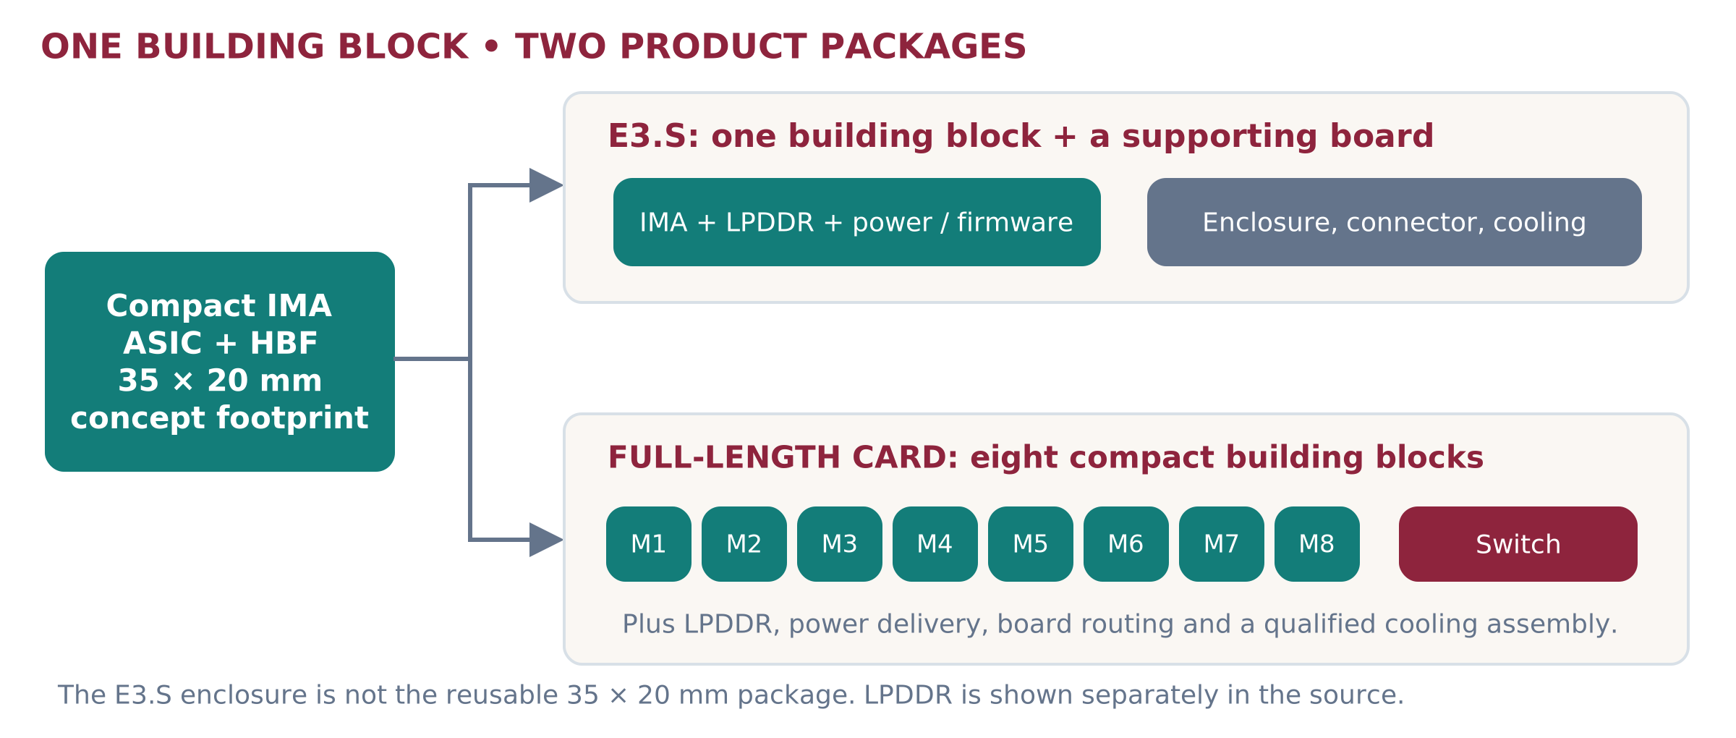
Figure 1. Packaging concept derived from the IMA source. Not a final mechanical drawing. [I2, I3]
THE PROGRAM THESIS
Keep large reusable weights and representations beside useful local compute. Offer a common operating experience across modular E3.S workers and integrated model-serving groups. Qualify each workload before making a performance or savings claim.

Document control | Status
Owner / intended steward | Shailesh Pilare • accountable program sponsor and engineering approvers to confirm
Version / date | v3 • 26 September 2026
Audience | Executives, product, architecture, software, firmware, validation, OEM, field and selected internal account teams
Release state | INTERNAL REVIEW DRAFT — pre-product concept, not an approved product specification or customer commitment

Basis: supplied architecture proposal and 15-slide backup deck; related internal plans; public first-party research; explicitly identified new recommendations and calculations. Images marked conceptual are not photos of shipping ATMOS hardware.

READ FIRST • DECISIONS AND OUTCOMES

Executive summary
Build a portfolio, not a universal accelerator. Prioritize the E3.S path demanded by the current anchor engagement while preserving a bounded integrated-card track and a reusable software foundation. Commercial breadth should grow as qualification evidence grows—not by launching every combination at once.
Offering | Customer job | Initial program treatment
A • Integrated ATMOS card | A complete, qualified cooperating-model group; independent module allocation only when supported. | Protect a parallel architecture and large-model study. Physical release remains gated.
B • Direct E3.S pool | Independent local models or representation shards, with fine purchase and service increments. | Primary simple-device and local data-path reference.
C • Switched E3.S pool | Same modular workers with an explicit shared fabric and practical population plan. | One family: C1 switch AIC; C2 OEM-integrated. Choose the anchor fixture by approved requirements.
E / F • Composition and scale | Hybrid service nodes and replicated multi-node pools built from qualified A/B/C. | Deployment patterns, not additional silicon programs.

What we will deliver first
Within the first approved quarter: a reviewed specification ledger, one reproducible local memory-path study, candidate-refinement evidence, a small dense/MoE control, a bounded software release contract, an exact OEM fixture definition, and a customer-price versus product-cost envelope. Hardware-dependent evidence is delivered only when the relevant component exists.

What makes the program worth funding
A surviving workload must demonstrate useful HBF access during normal operation, local computation that saves a meaningful downstream cost or delay, and acceptable complete-service behavior. Capacity that merely stores unused models does not establish product value. A smaller physical package does not establish a lower fleet cost.
RECOMMENDED MANAGEMENT POSITION
Approve E3.S-first execution plus protected portfolio discovery. Require a supported service contract, strong conventional controls, and explicit no-fit results. Do not endorse the existing colored winner maps as product evidence.

[I1 §§1,9; I2 slides 4–12; I4 §§1–8; I5 executive summary; I6 §11.5]. Google prioritization is user-reported internal context [U1], not verified public customer adoption.

NAVIGATION • SOURCE OF TRUTH

How to use and govern this reference
This document is the master program baseline for review. It can become the single source of truth after the named owners approve it and link it to controlled engineering releases. It does not override a signed silicon specification, customer agreement, or released OEM qualification record.
Portfolio, definitions and specifications · pages 4–13
Workload limits and competitive gaps · pages 14–21
JPMorganChase and Allianz case studies · pages 22–26
Turnkey software and customer operations · pages 27–30
OEM qualification and evidence plan · pages 31–34
Economics, launch, resources and governance · pages 35–40
PPT audit, glossary and calculations · pages 41–44
Source register · pages 45–48

Evidence labels used throughout
Label | Meaning | Allowed interpretation
SOURCE TARGET | Unreleased value shown in supplied architecture material. | A design input requiring owner/revision confirmation.
PUBLIC FACT | Dated company/vendor publication. | Only the specific fact published—not ATMOS adoption.
ANALYTICAL | Reproducible calculation with stated assumptions. | Capacity, a bound, sensitivity or requirement—not achieved performance.
PROPOSED | A new program recommendation or delivery requirement. | To be approved, staffed, built and tested.
MEASURED | Traceable observation from a named physical platform. | No ATMOS-measured workload result is supplied here.

Authority order: controlled device/OEM releases and signed contracts → approved experiment manifests → dated primary publications → supplied planning documents → new assumptions. Conflicts stay visible until an owner resolves them. Each changed assumption invalidates dependent claims until rerun.
The architecture source explicitly describes a pre-product proposal rather than an approved server configuration. [I1, pp.14–15] The Bridge evidence ladder is retained. [I6 §3]

DECISIONS MADE EXPLICIT—NOT SILENT CORRECTIONS

What changed in v3
Prior framing / new input | v3 treatment | Owner to confirm
Separate C and D choices | One switched family C. C1 = switch AIC; C2 = OEM-integrated. Location, ownership, support and topology remain distinct attributes. | Platform + OEM lead
E3.S equals internal IMA module | Separate compact package from finished E3.S enclosure. One A card uses eight building blocks, not eight enclosed drives. | Hardware architect
1 TB versus 1,024 GB; 1.6 TB confusion | Publish physical sum separately from normalized budgets. 1.6 TB/s is aggregate read bandwidth, not capacity. | Memory architect
64 TOPS/TFLOPS and <200 W / 200 W | Retain source wording as unresolved targets. Do not derive effective FP8 operator rate or measured power. | NPU + thermal leads
Inference-first versus retrieval-first documents | One shared foundation. Lead HBF-value proof: memory path and retrieval. Preserve bounded LLM/MoE controls and card discovery. | Product + Raj
Rust/C++ core versus Python/SimPy Bridge | Use reviewed Bridge as initial implementation recommendation. Keep backend contract; compile hot paths only when profiling justifies it. | Software lead
Google driving E3.S priority | Treat as user-reported internal direction; confirm sponsor, workload, interface, schedule and commercial rights in controlled records. | Account + sponsor
20% of future calls need sharding | An optional scenario mix, not market evidence or a universal parameter threshold. | Performance + product

Continuity with the existing proposal
The program retains the original hardware mental model, A/B/C connectivity analysis, hybrid and rack overlays, customer scorecard, qualification ladder and OEM engagement sequence. It broadens these into a phased product and operating plan, adds source-controlled specifications and two sector studies, and removes unsupported platform-winner implications.

Strategic independence without ignoring the anchor
Anchor delivery must have a protected critical path. Sandisk should separately own the reusable runtime contract, workload evidence, qualified alternatives, and commercial model. Confirm what may be reused beyond the anchor engagement; do not presume partner IP or exclusivity terms.
[I1–I9; U1]. The supplied documents do not establish signed Google commitments, final device dimensions, final launch dates, production software, or measured ATMOS throughput.

PART I • ARCHITECTURE AND OFFERING SPECIFICATIONS

Understand the product boundary
Figure 2. The same class of compute-and-memory building block can support two packaging directions. [I3, p.7]
The original IMA image labels a 35 × 20 mm MODULE BGA containing ASIC and HBF. It shows LPDDR beside the modules. The dimension therefore cannot be used as the size of a complete independently operating E3.S device. Nor is it a completed eight-module board layout.
Boundary | What belongs inside it | What must not be inferred
Module/package | NPU/controller logic, HBF and associated local resources as specified by the approved package/board design. | Same physical package is reusable in every SKU; final pinout/power not established.
E3.S product | One module plus working memory, board electronics, connector, enclosure and cooling design. | A normal SSD function, universal bay compatibility or safe live removal.
Full-length A card | Eight building blocks, LPDDR, switch, power and thermal assembly. | One coherent memory pool, eight proven isolated VMs or an RTX drop-in.

CAPACITY EQUIVALENCE IS CONDITIONAL
One eight-module A card and eight E3.S devices can contain the same nominal HBF capacity when the per-module configurations match. Their physical size, sustainable power, connection paths, software exposure and failure behavior may differ.

Physical reference, not ATMOS specification: the Kioxia E3 overview lists an E3.S body of 112.75 × 76 × 7.5 mm and 16.8 mm thickness for E3.S 2T. Exact ATMOS enclosure, connector, retention and cooling remain unapproved. The thicker format does not by itself provide more PCIe lanes. [R23]
[I1 §2; I2 slide 4; I3 pp.7–8]. Diagrams are packaging concepts, not mechanical or electrical sign-off.

SOURCE TARGETS • NO INFERRED PERFORMANCE

Technical baseline and open specifications
Parameter | One module / E3.S direction | Eight-module A card / eight-device sum
HBF capacity | Up to 128 GB nominal; usable budget TBD. | 8 × 128 = 1,024 GB nominal; deck normalizes to ~1,000 GB.
HBF read bandwidth | 200 GB/s source target. | 1.6 TB/s sum only for simultaneous local work.
HBF write / access | Source card table: 64 GB/s writes and 4 KB minimum access. Per-module write allocation not independently qualified. | 64 GB/s aggregate table value; service distributions/endurance TBD.
LPDDR capacity | 8–16 GB, distinct from HBF. | 64–128 GB distributed; upper option is not universal.
LPDDR bandwidth | 50 GB/s per-module direction. Combined-bus versus directional scope unresolved. | 400 GB/s read / write labels in original table; do not assume 800 GB/s simultaneous traffic.
SRAM | Up to 32 MB SoC-local direction; NPU SRAM separately identified. | 256 MB SoC SRAM; 96 MB NPU SRAM in source table. Do not add without ownership/layout confirmation.
Compute | 64 TOPS/TFLOPS mixed INT8/FP8 source label. | 512 TOPS / TFLOPS direction. Datatype, dense/sparse and operator rate must be resolved.
Links | E3.S Gen5/Gen6 x4 candidate; x8 requires a separate supported design. | IMA image: internal Gen6 x4; host Gen5 x16.
Power / mechanics | E3.S vs 2T; final power and dimensions not approved. | 200 W class deck target; full-length label only—slot thickness and exact size TBD.

Three capacity ledgers—never interchangeable
Nominal: what engineering identifies as installed capacity. Usable: what firmware exposes after device reserves. Application allocation: what remains after runtime, metadata, update and safety budgets. Do not subtract the same reserve twice.
For the worked studies, use 100 GB HBF application budget per module unless a case explicitly uses the deck’s 900 GB/card budget. A 100 GB × 8 study is 800 GB, not 900 GB. Working memory is budgeted separately. These are planning allocations, not final SKU values.
Power budget remains unresolved: eight devices each using a hypothetical 25 W would already total 200 W before any separate switch or shared overhead. E3 format power classes cannot validate the card’s 200 W target. Require a component-level, sustained-load power budget for each package. [R23; I2]
[I2 slides 3–4 and notes; I3 original IMA image; I4 §8]. Derived sums are arithmetic. Every specification needs an engineering owner, revision, approved units, confidence and validation method.

INTERNAL ACCELERATOR ASSEMBLY

Offering A — Integrated ATMOS card
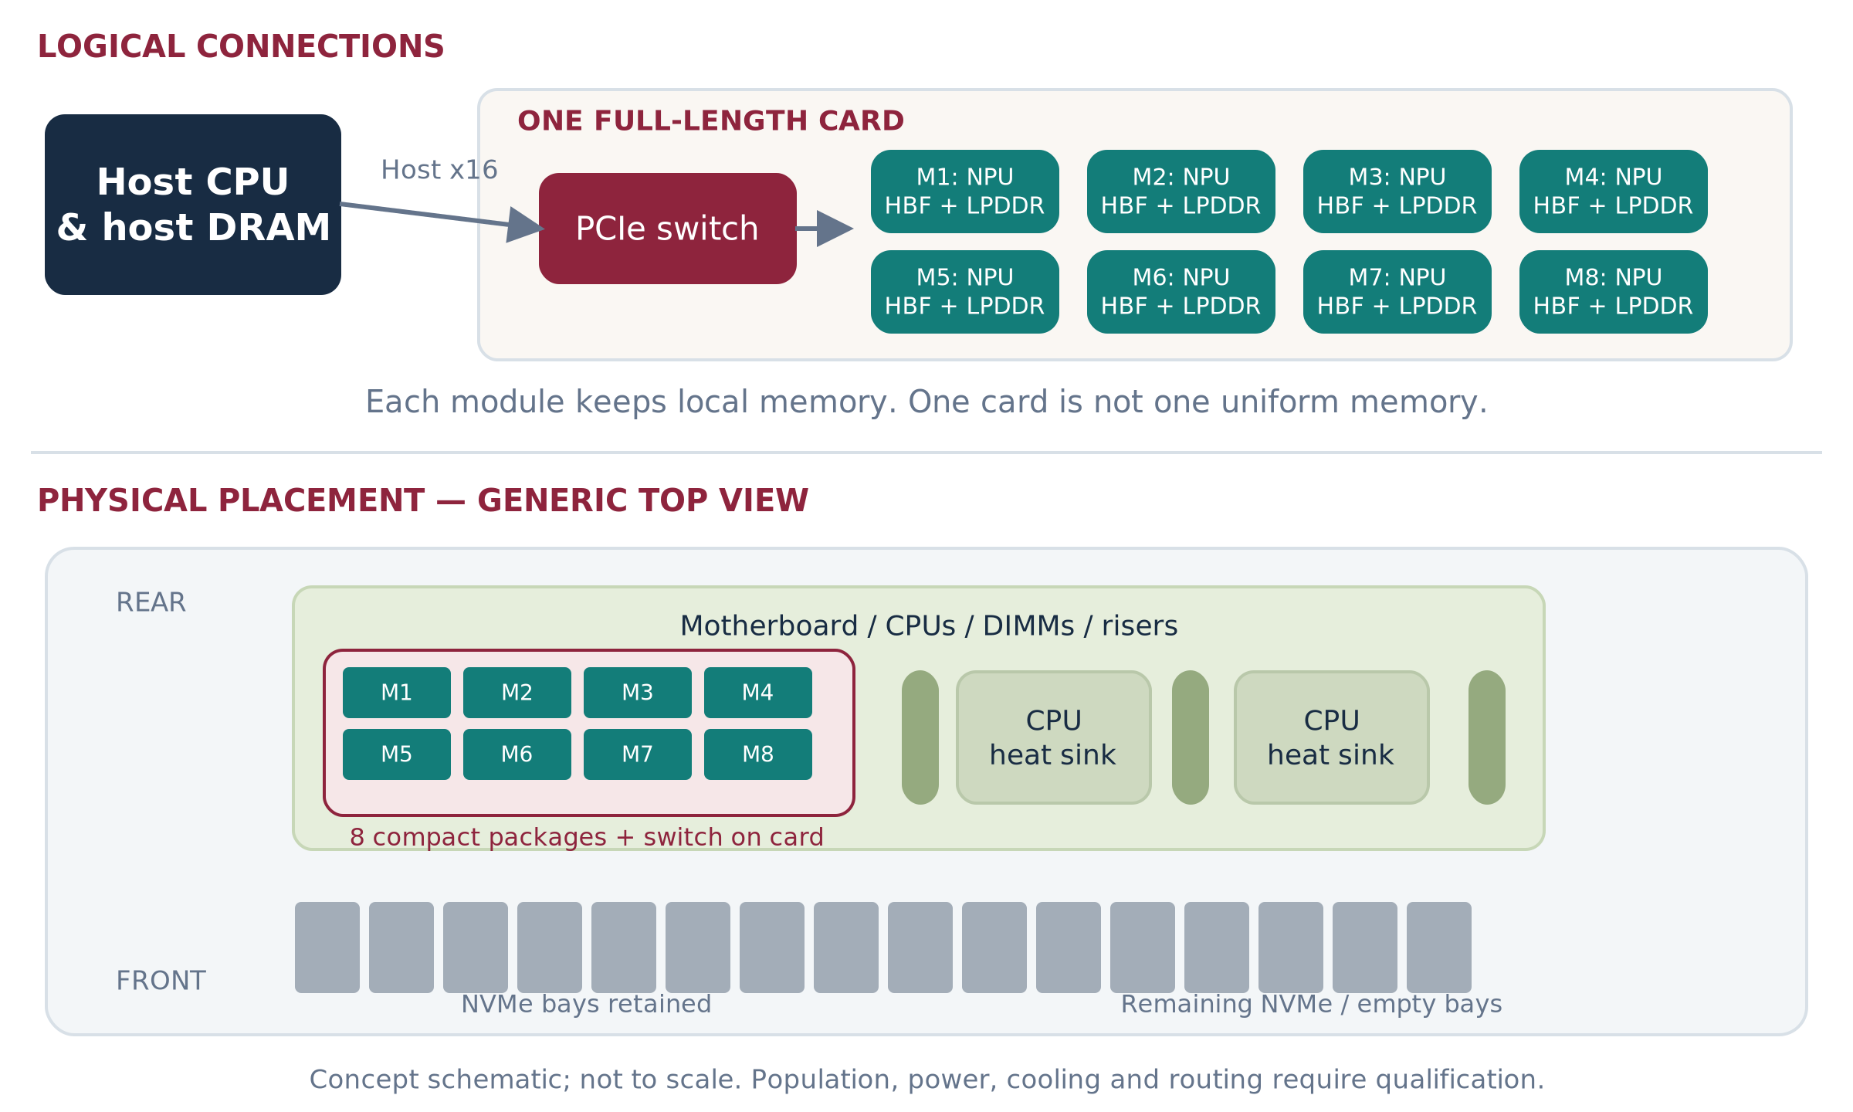
Figure 3. A: compute, HBF and switch are inside one card assembly; front bays are not required for its weights. [I1 §3A]
Profile | Required definition
Composition / capacity | Eight modules. Source target: 1,024 GB nominal HBF and 64–128 GB distributed LPDDR.
Connection / packaging | Host Gen5 x16 and internal Gen6 x4 in source image. Exact length, height, thickness, retention and auxiliary power TBD.
Working service unit | A complete model group, or independent modules only when the runtime exposes and isolates them.
Why keep this offering | Controlled integrated group; preserves front-bay storage opportunity; useful candidate for large-model locality.
Limits to prove | On-card paths can still bottleneck. >one-card models need cross-card coordination. Card-level service may affect multiple modules.

Product acceptance: a complete supported model placement, not simply a capacity sum. Compare against a capable single-host GPU group as well as smaller-host layouts; do not force the GPU control across nodes unnecessarily. Measure sustained grouped execution, partial degradation, reset scope and time to ready.
[I1 pp.3–5; I2 slide 6; I7 §4]. Equal module counts are the controlled comparison; minimum deployable serving-group cost is the customer comparison.

INDEPENDENT LOCAL WORKERS FIRST

Offering B — Direct-attached E3.S pool
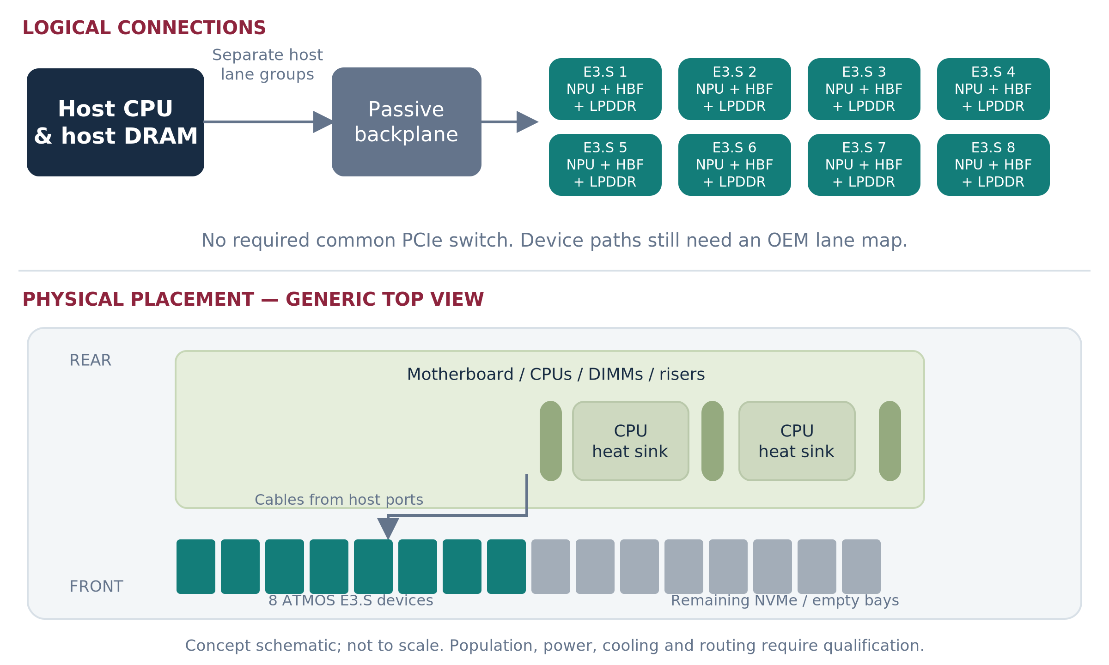
Figure 4. B: one module per bay-mounted device, routed to host ports without a required common switch AIC. [I1 §3B]
Profile | Required definition
Composition / capacity | One NPU/HBF/LPDDR worker per device. N devices provide N × local capacity, not a uniform memory pool.
Connection / packaging | Gen5/Gen6 x4 candidate; E3.S/2T dimensions, cooling and bay support to qualify. Host lane groups and NUMA ownership recorded per bay.
Working service unit | Complete small model replica or local representation shard. Host fan-out and merge allowed; no P2P prerequisite.
Why lead here | Small capacity increments and a clear local-path experiment; avoids switch complexity when not needed.
Limits to prove | Consumes compatible storage bays and host lanes. Direct host attachment does not guarantee fast cross-root peer communication.

Product acceptance: start with one device, then a qualified 4–8-device population. Prove operator support, DMA isolation, sustained thermal behavior, query/model registration, health, drain/reset and recovery. A device physically resembling an SSD is not an SSD software contract.
[I1 pp.5–6; I3 §4; I4 §§7–9]. More devices do not imply proportional end-to-end throughput when every request fans out to all shards.

C1 AND C2 ARE IMPLEMENTATION VARIANTS

Offering C — One switched-E3.S family
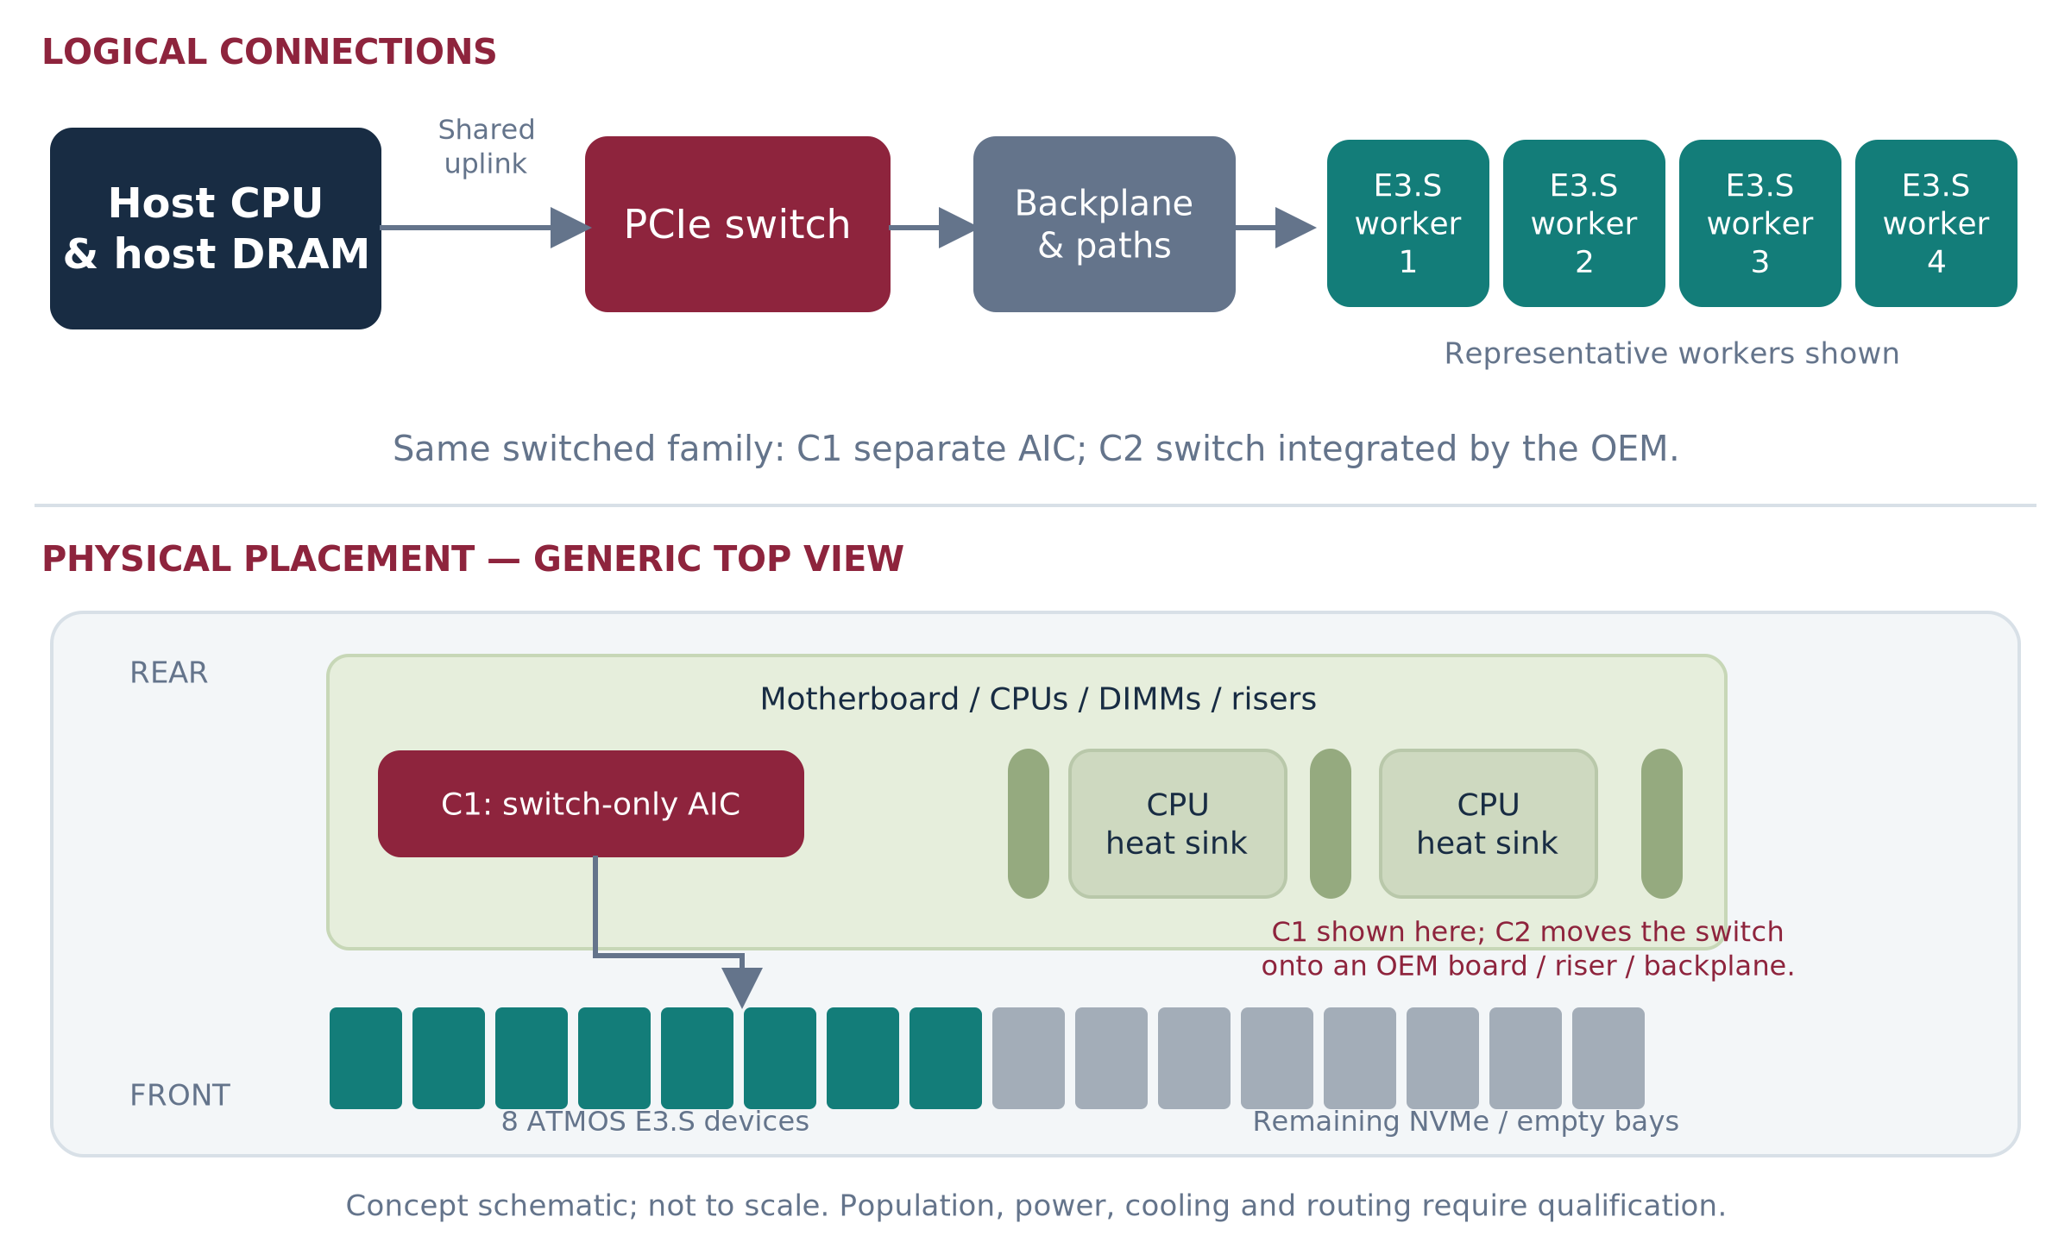
Figure 5. C: front-bay compute-and-memory devices share a defined switch fabric. C1 shown physically; C2 changes switch integration. [I1 §§3C–3D]
Common family contract | Implication
Capacity and compute | Per-device module targets match B only when revision, power and memory configuration match. The switch adds connectivity—not HBF or NPU capacity.
Host links | Document generation/width of each endpoint and uplink, switch ports, routing, queue limits, signal path and oversubscription. The latest photo does not specify the host generation.
Serving role | Independent pools first; cooperating groups only through supported host-mediated or verified peer paths.
Evidence needed | Compare one worker, simultaneous workers, host-bound transfers, peer transfers, updates and recovery separately.

COMBINE THE OFFERING, NOT THE UNKNOWNS
C1 and C2 can expose the same worker API and may have equivalent service performance. Their placement, qualification cost, firmware ownership, service unit and compatibility matrix remain distinct. Neither gets an automatic performance advantage.

[I1 pp.6–9; U1]. Old C maps to C1; old D maps to C2. OEM qualification can also apply to a separate switch AIC.

ONE FAMILY • TWO INTEGRATION CONTRACTS

C1 / C2: ownership and support
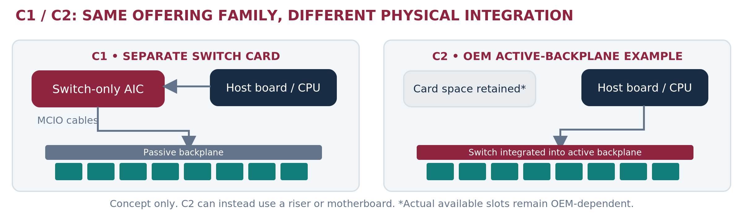
Figure 6. C1 and C2 share the switched-worker concept, but move switching and service ownership. [I1 §§3C–3D]
Responsibility | C1 • Separate switch AIC | C2 • OEM-integrated switch
Physical switch location | Separate board in a supported expansion position; cabled to the backplane. | Motherboard, riser or active backplane designed into the OEM platform.
Who makes the switch silicon? | May be a third-party chip supplier. | May be the same third-party supplier.
Who supplies the board? | Sandisk, partner or OEM—contract must name the provider. | OEM/ODM or its qualified board supplier.
Sandisk owns | ATMOS device requirements, driver/runtime contract, device telemetry and qualification inputs. | Same device/software obligations; coordinated platform lifecycle.
OEM owns | Approved slot, cable/backplane map, full-node power/cooling, BIOS/BMC integration and supported population. | Integrated fabric and node qualification, platform firmware and service configuration.
Service boundary | Devices plus separate switch field-replaceable unit; switch loss can affect the pool. | Devices plus platform-board service scope; precise failure containment must be tested.
Commercial consequence | Potentially faster engineering fixture; extra component/support interfaces. | Deeper platform investment; potentially simpler procurement once qualified.

The contract must name a single escalation owner
For a device-discovery failure after firmware update, the customer should not arbitrate among cable, switch, BIOS and device suppliers. Establish first-response ownership, joint defect triage, compatible-version matrix, regression suite, replacement procedure and a support-data bundle before calling the solution turnkey.

Not a required migration sequence
A qualified C1 configuration may remain the production product. C2 should be pursued when population, serviceability, projected volume or operating cost justify native integration. A C2 release is not a prerequisite for independent B deployments. Launch windows and resource gates are set later in this document.
[I1 pp.7–9,14; I3 §4]. Ownership choices above are requirements for negotiation, not assigned supplier commitments.

E / F REMAIN DEPLOYMENT PATTERNS

Hybrid nodes and rack service pools
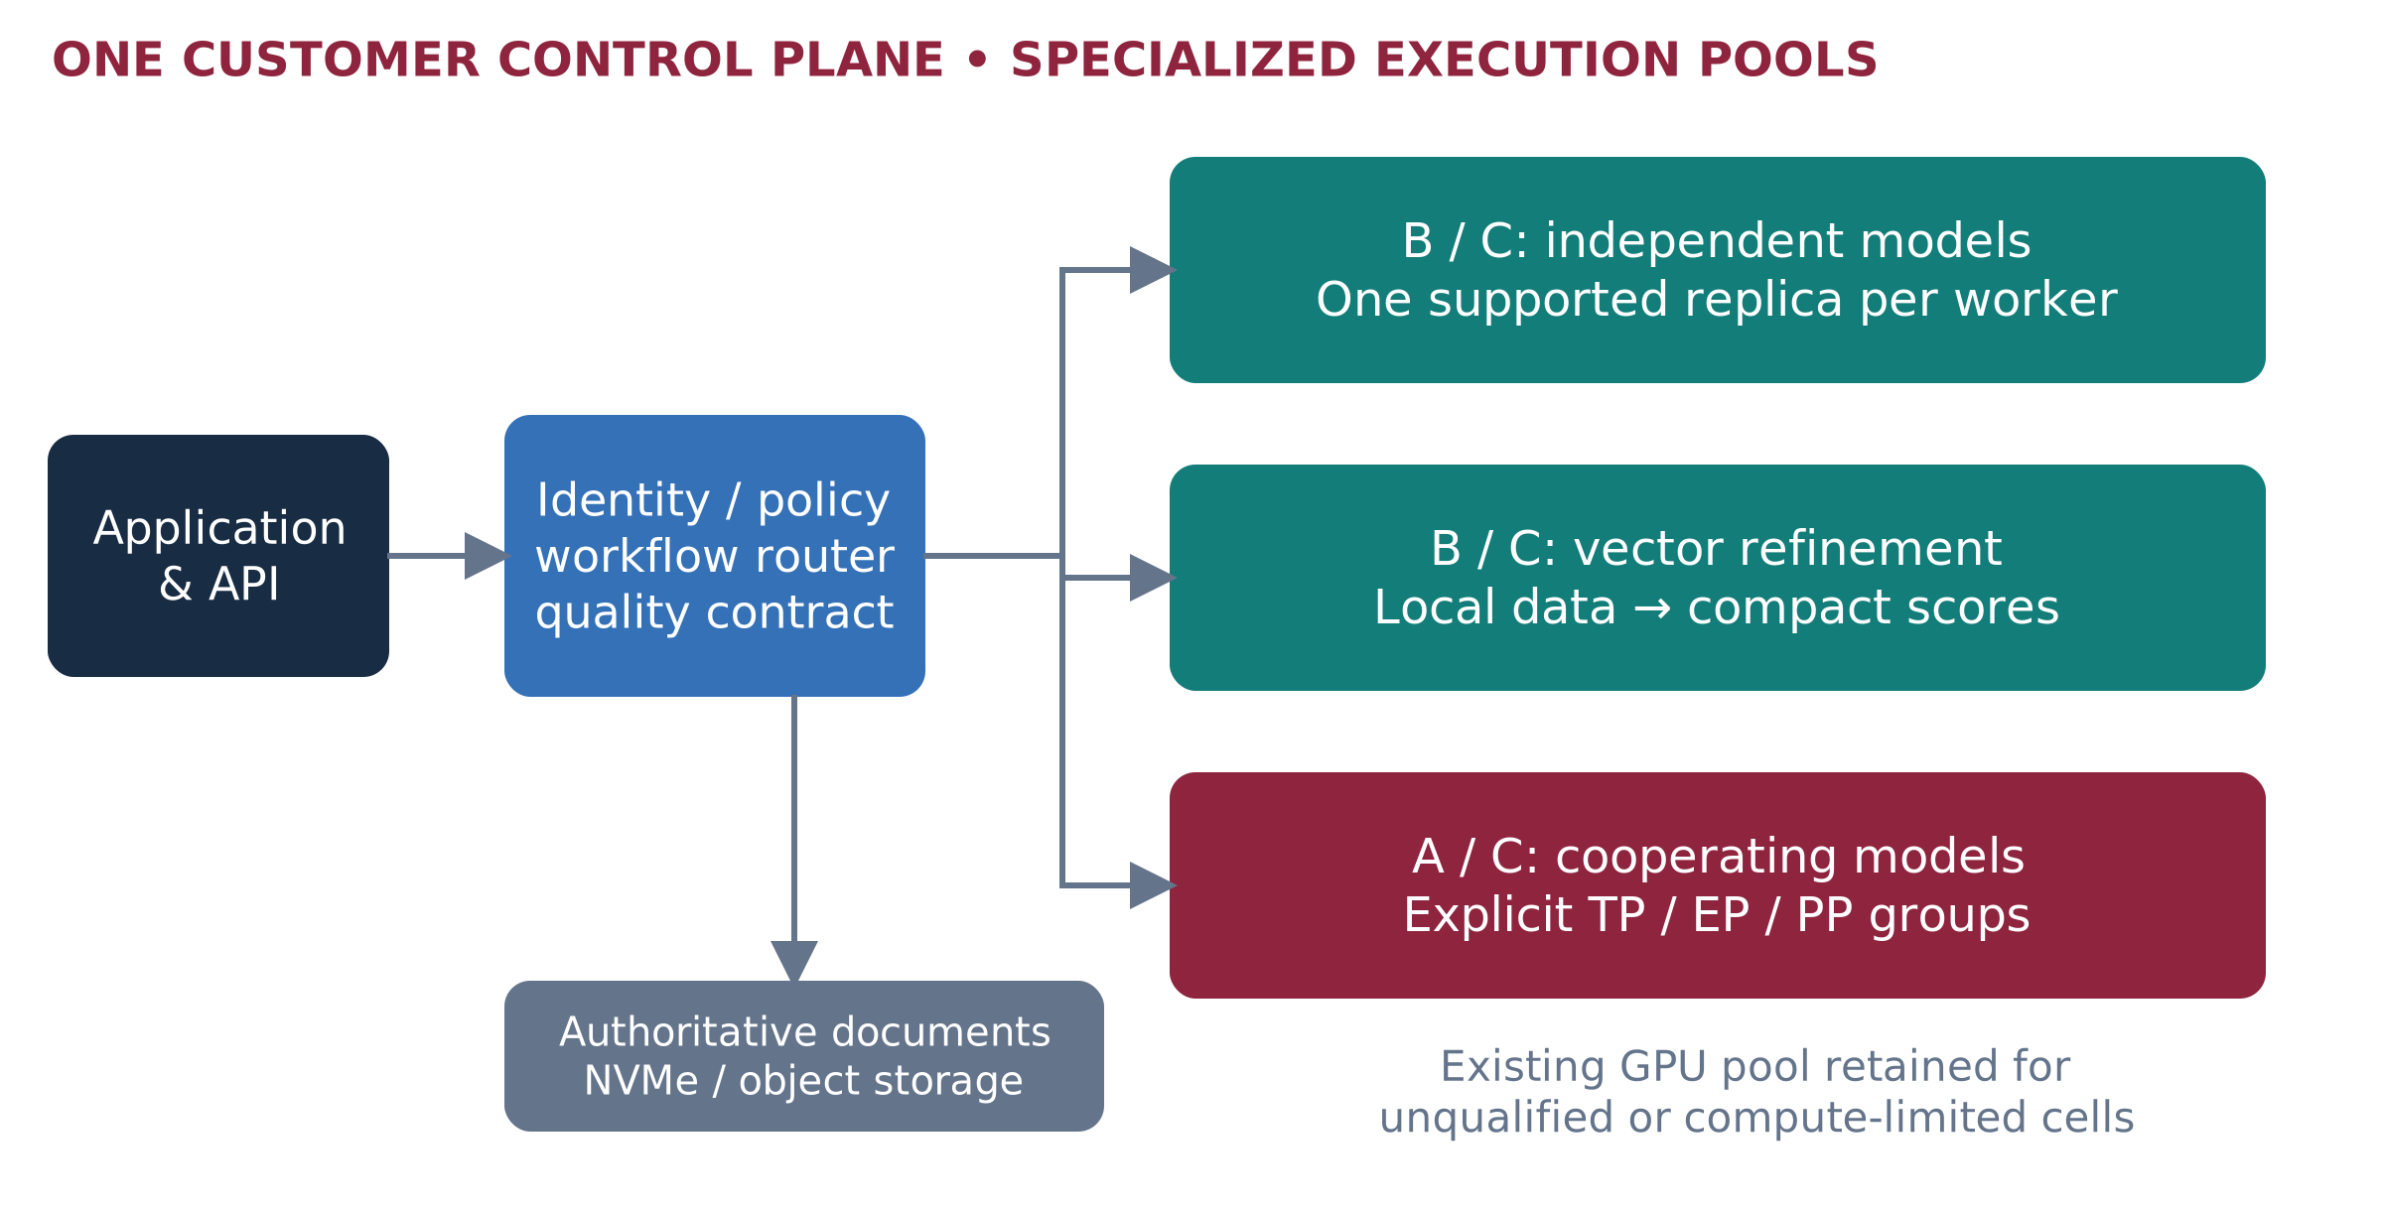
Figure 7. A common customer-facing service can route to different qualified ATMOS pools; placement preserves model and data policy. [I1 §§3E,4]
E, hybrid node: combine an E3.S pool and integrated card only after each is supported separately. The alternative is separate role-specific nodes. Compare interference, failure coupling, usable capacity, maintenance and host overhead—not just cable length.
F, rack pool: compose qualified nodes into replicas or explicit distributed groups. Size for loss of the declared failure domain. Eight shards spread across eight nodes are not eight complete replicas. A unique lost shard can stop the logical service unless recovery or an approved degraded mode exists.
Execution contract | What stays local | What still moves
Complete model replica | All required weights, working state and supported operations. | Requests, tokens, management and artifact refresh.
Expert worker | Weights of assigned experts. | Intermediate activations and dependent dispatch/combine operations.
Vector shard | Assigned representations and local scoring. | Query/IDs and results; host/global merge.

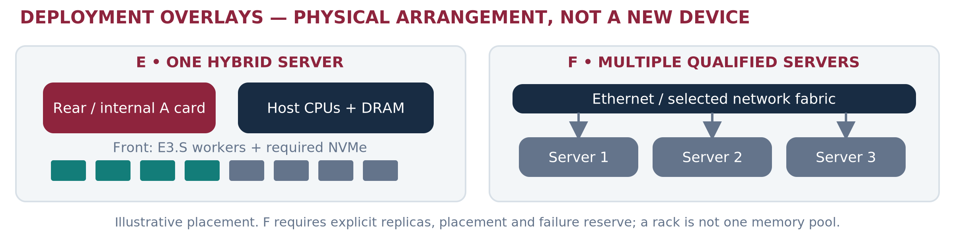
Figure 8. Hybrid co-location and multi-node replication are deployment choices above A/B/C. [I1 §§3E–4]
[I1 §2 and §§3E–4; I4 §7; R18]. A shared API does not make local memory globally coherent or eliminate model dependencies.

KNOW WHAT IS REAL, CONCEPTUAL AND MISSING

Physical reference: source drawings
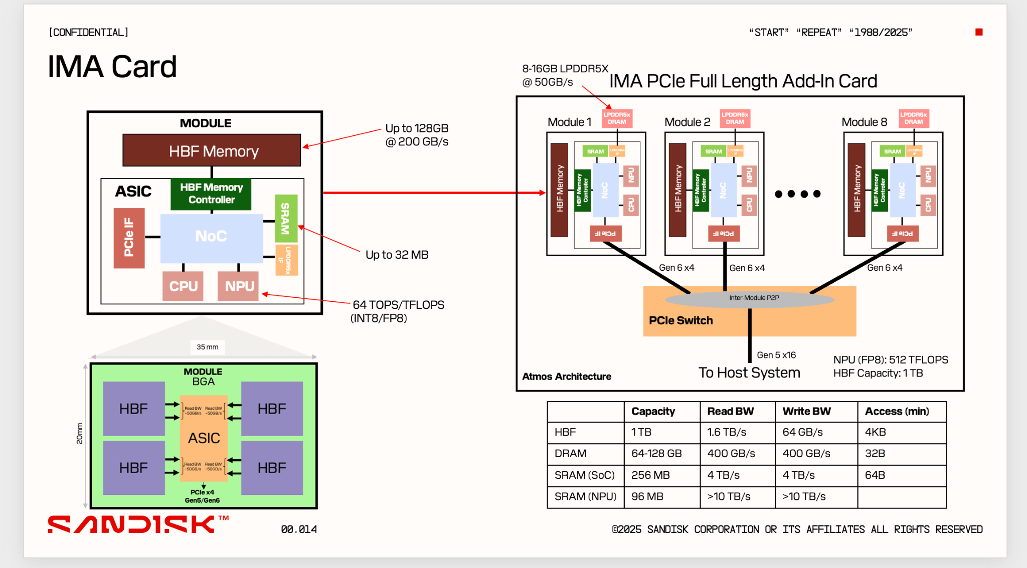
Figure 9. Original IMA concept reproduced from the supplied Product/Workstream proposal. This is an architecture drawing—not final silicon or a qualified card photo. [I3, p.7]
The source establishes the packaging idea and names the target resources. It does not provide a final board-placement drawing, enclosure thickness, connector qualification, heatsink design or manufacturing release. In particular, the 35 × 20 mm footprint does not contain all surrounding LPDDR and support electronics.
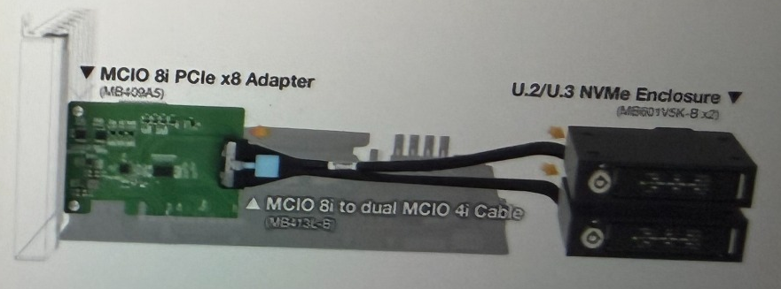
Figure 10. Detail from the user-supplied MCIO slide: a real cabled adapter/enclosure reference. It is not the ATMOS compute card and does not prove the pictured adapter supplies the proposed PCIe switch. [U2]
For customer publication, replace concept illustrations with approved mechanical renderings or qualified prototype photographs. Do not relabel a generic E3.S SSD, a commercial AI module or a GPU photo as ATMOS. OEM sign-off must identify the exact physical build and version.

SYSTEMS TRADE-OFFS BEFORE RACK ARITHMETIC

Host paths and storage displaced
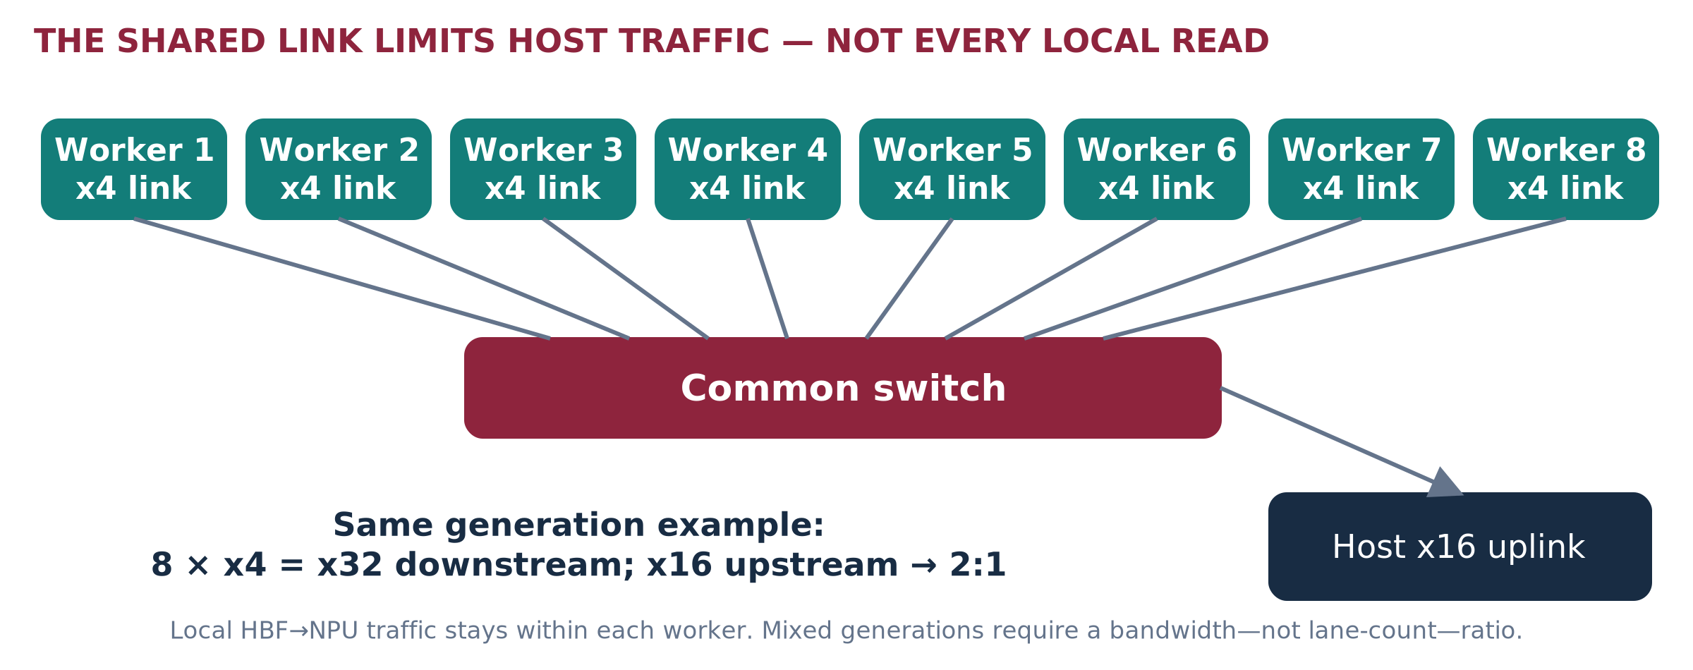
Figure 11. The same-generation 2:1 width illustration concerns host-bound traffic. It is not measured PCIe payload throughput. [A1]
16-bay teaching example | A • one card | B / C • eight E3.S workers
ATMOS front-bay occupancy | 0 | 8 compatible thin-device positions
Positions remaining for SSDs | 16, if otherwise supported | 8, if otherwise supported
At 7.68 TB per SSD | 122.88 TB raw | 61.44 TB raw
Additional opportunity cost | Internal accelerator position, power/cooling and possible lane allocation. | Storage expansion plus per-bay power/lanes; C1 also consumes a card position.

This example is not a qualified mixed population. Empty bays lose expansion potential, not existing stored data. ATMOS HBF is not a general-purpose NVMe volume replacing authoritative documents or database persistence. Price displaced storage, endurance, RAID/replication and network alternatives explicitly. [I3 §4; I4 §§1,9]
Cabled paths and switches do not create more physical bays. At mixed PCIe generations, compare the actual payload-rate ceilings and measured paths rather than lane counts alone. Firmware routing, isolation and CPU/NUMA placement can change which peer paths are usable. [R17]

PART II • WORKLOAD FIT AND LIMITATIONS

Model residency: use published checkpoints
The table is a capacity screen using representative released models, not a ranking of current model quality or a claim of ATMOS compiler support. Each experiment must pin the checkpoint, tokenizer, license, quantizer and compiled ModelPack. Raw arithmetic excludes scales, mixed-precision tensors, layout, duplicates and auxiliaries.
Model / type | Total / active parameters | 8-bit raw | 16-bit raw | 100 GB local budget
Qwen3-30B-A3B • MoE | 30.5B / 3.3B | 30.5 GB | 61 GB | Both raw screens pass
Qwen3-32B • dense | 32.8B / 32.8B | 32.8 GB | 65.6 GB | Both raw screens pass
Qwen3-235B-A22B • MoE | 235B / 22B | 235 GB | 470 GB | Must partition or use other capacity
DeepSeek-V3 • MoE | 671B / 37B | 671 GB | 1,342 GB | Must partition
Kimi K2 • MoE | 1T / 32B | 1,000 GB | 2,000 GB | Must partition

Published architecture/counts: [R6–R11]. These reference checkpoints are chosen for reproducible size classes, not as a comprehensive latest-model inventory.

One card is not one independently executing memory pool
With the deck’s illustrative 900 GB/card weight allocation, a 671B model passes the raw 8-bit screen while a 1T model does not. With 100 GB/application/module, eight modules instead provide 800 GB. A model fitting either aggregate still needs valid per-rank placement and supported internal transfers. [I2 slide 6; A1]

A larger-model stress case
A hypothetical 1.2 TB compiled pack, at 100 GB usable per module, needs at least 12 modules for capacity alone. A uses at least two eight-module cards; B/C could use at least 12 individually installed modules if the OEM supports that population. Runtime partition sizes, duplicate shared layers, workspace or performance may increase either count.
DO NOT MAKE “1T” A UNIVERSAL SHARDING RULE
Precision and artifact size determine weight fit; working memory and service targets determine whether local execution is viable. Replicas duplicate complete weights. Total parameters, active parameters and bytes actually read per step are different quantities.

LOGICAL KV SIZING • PER-RANK VALIDATION STILL REQUIRED

Long context is a working-memory problem
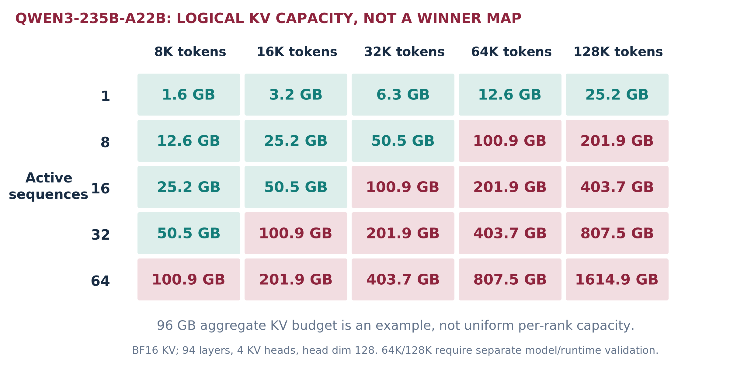
Figure 12. Calculated logical KV requirement using Qwen3-235B-A22B geometry; pink cells exceed the 96 GB aggregate example. [R9; A2]
KV bytes = active sequences × retained tokens × 2 × layers × KV heads × head dimension × bytes/value
Here: 94 layers, four KV heads, head dimension 128, BF16 values. One 32K retained sequence requires 6.31 GB logical KV. A 96 GB aggregate KV allocation holds at most 15 such sequences before layout duplication, block rounding and other constraints. The source deck’s 128-active-job cells therefore cannot be interpreted as this same one-card configuration. [I2 slides 6,8]
For the smaller Qwen3-30B-A3B geometry, the corresponding value is 3.22 GB at 32K. A selected 8 GB KV allocation allows only two such active sequences before other losses. Weights remaining in HBF do not expand LPDDR. Long-context model validation is separate from the arithmetic. [R7; A2]

Mitigate in a controlled order
Use admission and length-aware queues; separate long-context traffic; qualify KV quantization and reusable-prefix sharing; reclaim paused state; then add replicas or supported partitioning. Each changes latency, quality, memory traffic or cost. Cross-tenant cache reuse is prohibited unless explicitly authorized. HBF KV spill is conditional on its restore path, writes and service tails—not a free extension of active memory.

ANALYTICAL BOUNDS, NOT BENCHMARK PREDICTIONS

Dense serving: capacity can fit while speed fails
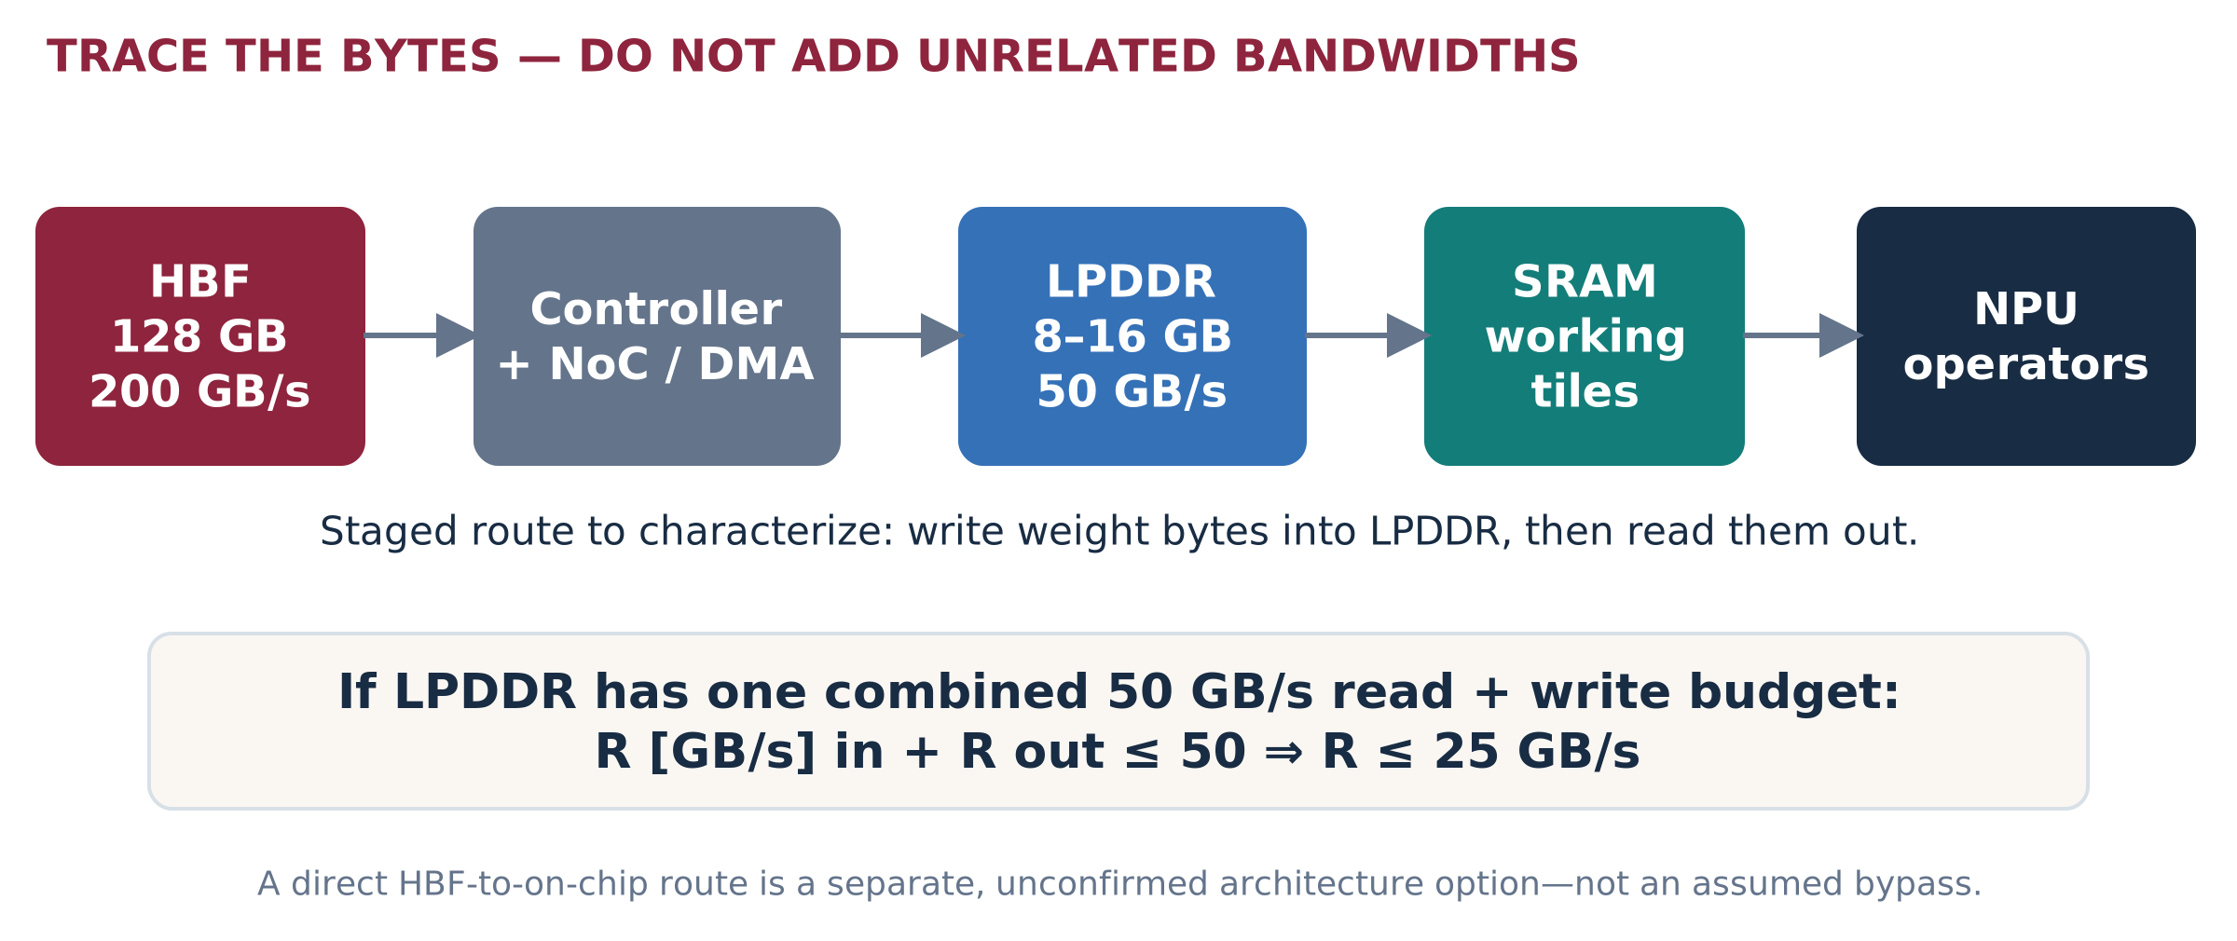
Figure 13. The staged path can constrain useful delivery below media bandwidth. The combined LPDDR-budget interpretation is an explicit assumption. [I3; A3]
32 GB of uncached weights per decode step | Ideal weight-transfer time | Meaning
Direct useful delivery at 200 GB/s | 160 ms / step | At most 6.25 single-sequence output tokens/s from weight delivery alone.
Staged useful delivery at 25 GB/s | 1.28 s / step | At most 0.78 tokens/s from this path alone.
Requested 50 ms step budget | Requires ≥640 GB/s useful delivery | Not feasible under the stated full-streaming 200 GB/s limit.

This is a hypothetical 32 GB delivered weight set, not an exact Qwen artifact. Cached weights reduce those bytes. A microbatch can reuse a weight read across multiple sequences and raise aggregate throughput, but it does not automatically reduce the per-user step time. Computation, attention, KV and scheduling add costs; overlap cannot violate the bottleneck bound. [A3]
Prefill requirement: for a hypothetical 32B-active dense model and 8,192 input tokens, 2 × P × tokens gives about 524 TFLOP of linear-layer work. A two-second processing target requires at least 262 TFLOP/s effective for that work alone, before attention. The mixed “64 TOPS/TFLOPS” source label is insufficient to establish that rate. [A3; I3]

KEEP THE NO-P2P BASELINE HONEST

MoE: residency, routing and grouping
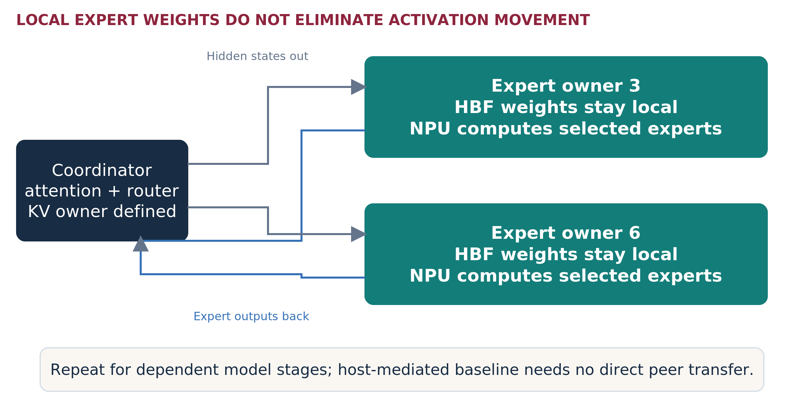
Figure 14. Illustrative host-coordinated expert invocation. Attention/router/KV ownership must be defined; the CPU need not perform all neural math. [I6; R18]
A local expert bank avoids moving expert weights across the host link for each invocation. It does not avoid sending the hidden states and returning expert outputs. Compare host-mediated execution first; enable peer DMA or collectives only as a separately supported path. InfiniBand is not a prerequisite for the local test.
Deployment strategy | What to test | Main risk
Complete replica | Whole model on one worker; load balance independent requests. | Weight fit is insufficient if KV or compute fails.
EP / TP / PP combinations | TP1/EP1 control, supported EP groups, within-card TP alternatives, stage partitioning and replicas. | Communication, synchronization, duplicated state and unsupported shapes.
Advanced placement | Replicate hot experts, balance token demand, colocate frequent routes, prefetch/double buffer. | Extra memory, stale popularity, wasted prefetch and fairness.

For 128 experts and top-8 routing, a purely synthetic independent uniform model touches an expected 8, 51.6, 111.8 and 125.9 distinct experts across batches of 1, 8, 32 and 64 tokens. This explains why a larger batch can increase active weight traffic. It is not a measured routing profile. Replace it with token/layer/expert traces. [A4]

NEAR-DATA SCORING—NOT A REPLACEMENT DATABASE

Vector refinement: prove the useful read path
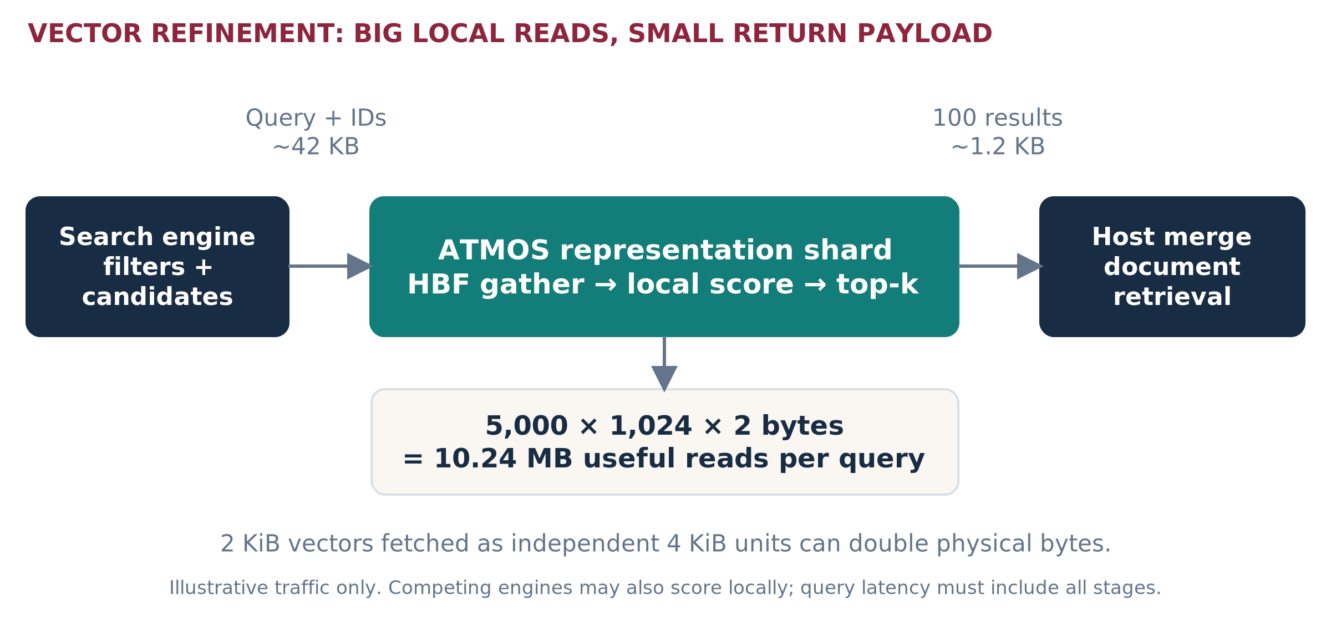
Figure 15. Exact candidate scoring stage with illustrative bytes. Source documents, filters, corpus lifecycle and final assembly remain outside the device. [I4 §§4,7; A5]
A 40-million-vector shard with 1,024 FP16 dimensions contains 81.92 GB of raw vectors. Metadata, update generations and layout reserve are additional. The first mechanism test keeps candidate IDs, filters, precision and scoring identical to the control. Better relevance requires a separately evaluated larger candidate budget or richer representation. [A5; R14]

Small-read concurrency can dominate a large bandwidth target
Assume 4 KiB transfers, 20 µs media-ready time and 32 outstanding requests. The ideal window limit is 32 × 4,096 / 20 µs = 6.55 GB/s, far below 200 GB/s. It omits controller details and is a screening bound, not an HBF specification. Doubling sequential bandwidth alone cannot repair an exhausted request window. [A5]
Mitigations include contiguous candidate packing, locality-aware scheduling, more valid outstanding work, hot-vector caches and reduced read amplification. They need quality/freshness tests and may increase latency or write cost. Exact rescoring cannot recover a relevant item absent from the original candidates. [R14; I4 §4]

A PRACTICAL PORTFOLIO—NOT EVERY USE CASE AT ONCE

Complex workload coverage
Workload | Candidate combination | Qualify / reject boundary
Interactive small dense / complete small MoE | B/C replicas; A module allocation only if supported. | Strict TTFT/TPOT, context and active KV; CPU/GPU resident control can remain best.
Large MoE expert groups | A or supported C group; separate host-coordinated baseline. | Per-rank fit, activation movement, imbalance, shared tensors and recovery.
Long-context / paused agents | Dedicated length class, replicas; optional retained-prefix tier. | Read/write budget, restore-versus-recompute, burst resumes, secure cache keys.
Vector candidate refinement | B/C shard pools; A can also host shards if allocation economics work. | Gather, top-k, masks, index/candidate quality and update behavior.
Late interaction / multi-vector | B/C for selected document features; dedicated reduction kernels. | Variable vector counts, MaxSim, pruning, tail amplification; compressed Vespa control.
Cross-encoder neural reranking | Supported NPU pool or current GPU; keep distinct from vector scoring. | Pairs × token lengths drive compute; HBF may not be the primary value.
Embedding / OCR / VLM | Supported local models or a retained accelerator pool. | Operator coverage, preprocessing/vision components, quality and host payload.
Batch enrichment with interactive traffic | Separate queues or nodes; combine only after interference tests. | Interactive SLO during ingestion; deadlines and bounded backlog.
Multi-tenant model catalog | Versioned packs, whole-worker allocation initially. | Isolation, artifact licensing, swap cost and unutilized capacity.
Cross-node inference / retrieval | F overlay with replicas or explicit groups. | Network/merge, failover capacity, dependency and consistent snapshots.

Do not interpret user workflows as hardware placement. An agent is not one NPU; a premium chatbot instance is not one model; a vector shard is not a complete replica. Define a service contract, then select its physical placement.
Dense/MoE quality comes from a functional reference, not a timing simulator. Retrieval quality comes from ground truth and ranking evaluation, not candidate-byte arithmetic. All meaningful comparisons hold those quality obligations constant. [I4 §§4–5; I6 §3; R15]

NO-FIT REGISTER • MITIGATION DOES NOT WAIVE THE SLO

Where ATMOS may miss the requirement
Observed or bounded problem | ATMOS-side action to test | Limit / escalation
Dense decode needs 32 GB every ≤50 ms | Cache a hot subset; quality-approved lower bits; smaller task model; supported multi-module execution. | Full-streamed 200 GB/s path cannot supply 640 GB/s. More batching may improve aggregate rate but not this user latency.
Long context × active sequences exceeds LPDDR | Length-aware admission, qualified KV compression, prefix reuse, more replicas, separate long-context pool. | Queuing may preserve memory but violate TTFT. HBF spill adds transfer/write costs.
Prefill / cross-encoder compute dominates | Operator fusion, chunked prefill, capped candidate counts, specialized kernels, dedicated prefill group. | Peak TOPS is not effective work. Split prefill/decode only after state-transfer compatibility and cost are proven.
Small scattered vector reads underfill NPU | Pack/gather/layout improvements, trace-based cache, outstanding-depth tuning and controller work. | 4 KB granularity can amplify 2 KB vectors. No unlimited window or absent-media latency assumptions.
MoE coordinator or fabric bottleneck | Batch dispatch, placement by demand, hot-expert replication, valid group sizing; verify P2P alternative. | No-P2P remains valid but not communication-free. Cross-card traffic still exists above card capacity.
Write/update-heavy state | Keep authoritative mutable state in existing store; bounded delta/snapshot pipeline. | HBF write endurance and tail behavior unknown. Do not make a general database or log device promise.

A retention ladder, not vendor lock-in
First optimize supported ATMOS software and placement. Next change the qualified ATMOS configuration or isolate the workload class. Then propose a future hardware improvement with an owner, cost and validation gate. Until it exists, retain the customer’s approved GPU/CPU path for the failing cells. Do not silently reduce quality, remove necessary context, or relax a contractual SLO to retain the account.
Analytical bounds [A2–A5]; source requirements [I2 slides 7–12; I4 §8; I6 §§3,11.5]. No measured platform failure is asserted where only a target-based bound is available.

PUBLISHED PRODUCT SPECIFICATIONS ARE NOT SERVING BENCHMARKS

Strong controls—and when to retain them
Item | ATMOS source direction | RTX PRO 6000 Blackwell Server | AMD Instinct MI350X
Capacity per unit | 128 GB HBF + 8–16 GB LPDDR/module; 8-module A aggregate separate. | 96 GB GDDR7. | 288 GB HBM3E.
Memory bandwidth | 200 GB/s HBF/module; 50 GB/s LPDDR scope to resolve. | 1,597 GB/s published. | 8 TB/s published.
Package / host | E3.S or full-length AIC concept; exact mechanical release TBD. | Air: dual-slot full-height/full-length; PCIe Gen5. | OAM module; PCIe 5.0 x16 protocol is not an AIC form factor.
Power | ~200 W card direction, not measured or complete-node power. | Up to 600 W configurable. | 1,000 W typical board power.
Execution maturity | Supported operator/precision/runtime list must be built and qualified. | Benchmark the supported GPU stack and appropriate partitioning. | Benchmark the supported ROCm/OEM platform separately.

ATMOS [I2–I3]; NVIDIA [R12]; AMD [R13]. Headline memory bandwidths are not equivalent useful application paths. Card/module power is not fleet energy. The AMD fixture is not a drop-in replacement for an E3.S bay or ordinary PCIe card.

Required conventional controls
Use resident GPU execution whenever the model fits; add optimized offload only when justified. GDS can move data into GPU memory without a host-DRAM bounce on supported configurations, but does not eliminate the GPU memory hierarchy. For retrieval, compare in-memory CPU, compressed/disk-based engine paths, and GPU-local/staged scoring where applicable. [R14, R15, R19]

Explicit no-fit outcomes
Retain the incumbent when the required artifact cannot be licensed or executed on ATMOS; when a strict latency bound exceeds the useful delivery/compute envelope; when an unsupported operator forces excessive fallback; when existing compression solves the retrieval problem; or when a secure, recoverable deployment cannot yet be supplied. Training and universal GPU replacement remain outside the initial program.
BRIDGING DOES NOT MEAN HIDING A FAILURE
A smaller model, shorter prompt, different precision, admission cap or asynchronous workflow is a new quality/SLO configuration. Obtain customer approval and remeasure. Existing RTX/AMD capacity remains the honest fallback when no qualified ATMOS configuration meets the unchanged requirement.

PUBLISHED SCALE • PROPOSED INFRASTRUCTURE EXERCISE

Financial case study: JPMorganChase
Named use case: employee research, drafting and evidence-grounded assistance. The public reference is LLM Suite. This is an architecture study inspired by its published scale—not a representation of the bank’s actual models, traffic, infrastructure or interest in ATMOS.
Published fact | Source / date | What it can establish
LLM Suite grew to 200,000 onboarded users within eight months. | JPMorganChase, 3 June 2025. | A historical enterprise-adoption scale. Not daily activity or concurrency.
The service supported idea generation and content drafting. | Same first-party account. | A useful general-assistance workload category.
Additional internal data access and agentic workflows were described as next steps. | Same first-party account. | A direction for the then-future service—not proof of a deployed retrieval fleet.

[R1]. These are the only bank operating facts used in the numerical scenario. Public reporting does not disclose a reproducible RPS/model/context/GPU inventory for this exercise.

Proposed service decomposition—not the bank’s architecture
Service contract | Candidate placement | Acceptance concern
Ordinary drafting/summarization | B/C complete supported replicas; compare current GPU or hosted service. | Factuality, approved input handling, latency and output format.
Evidence/policy retrieval | Existing search engine plus optional B/C refinement. | Entitlements, source versions, relevance, deletions and stage overhead.
Complex analysis | A/C cooperating model group only when a larger model adds judged quality. | Model access, valid partition, communication and full-job time.
Ingestion / document processing | Scheduled supported devices or retained CPU/GPU processing. | Update deadlines and no interactive-service interference.

The customer should keep authoritative records, access controls, workflow approvals and financial decisions in its existing governed systems. The first POC would replace one bounded stage using synthetic or specifically authorized data, while retaining a rollback path. This is a proposed control boundary, not legal-compliance certification.

CALCULATION A6 • EVERY TRAFFIC INPUT IS AN ASSUMPTION

JPMorganChase-scale demand example
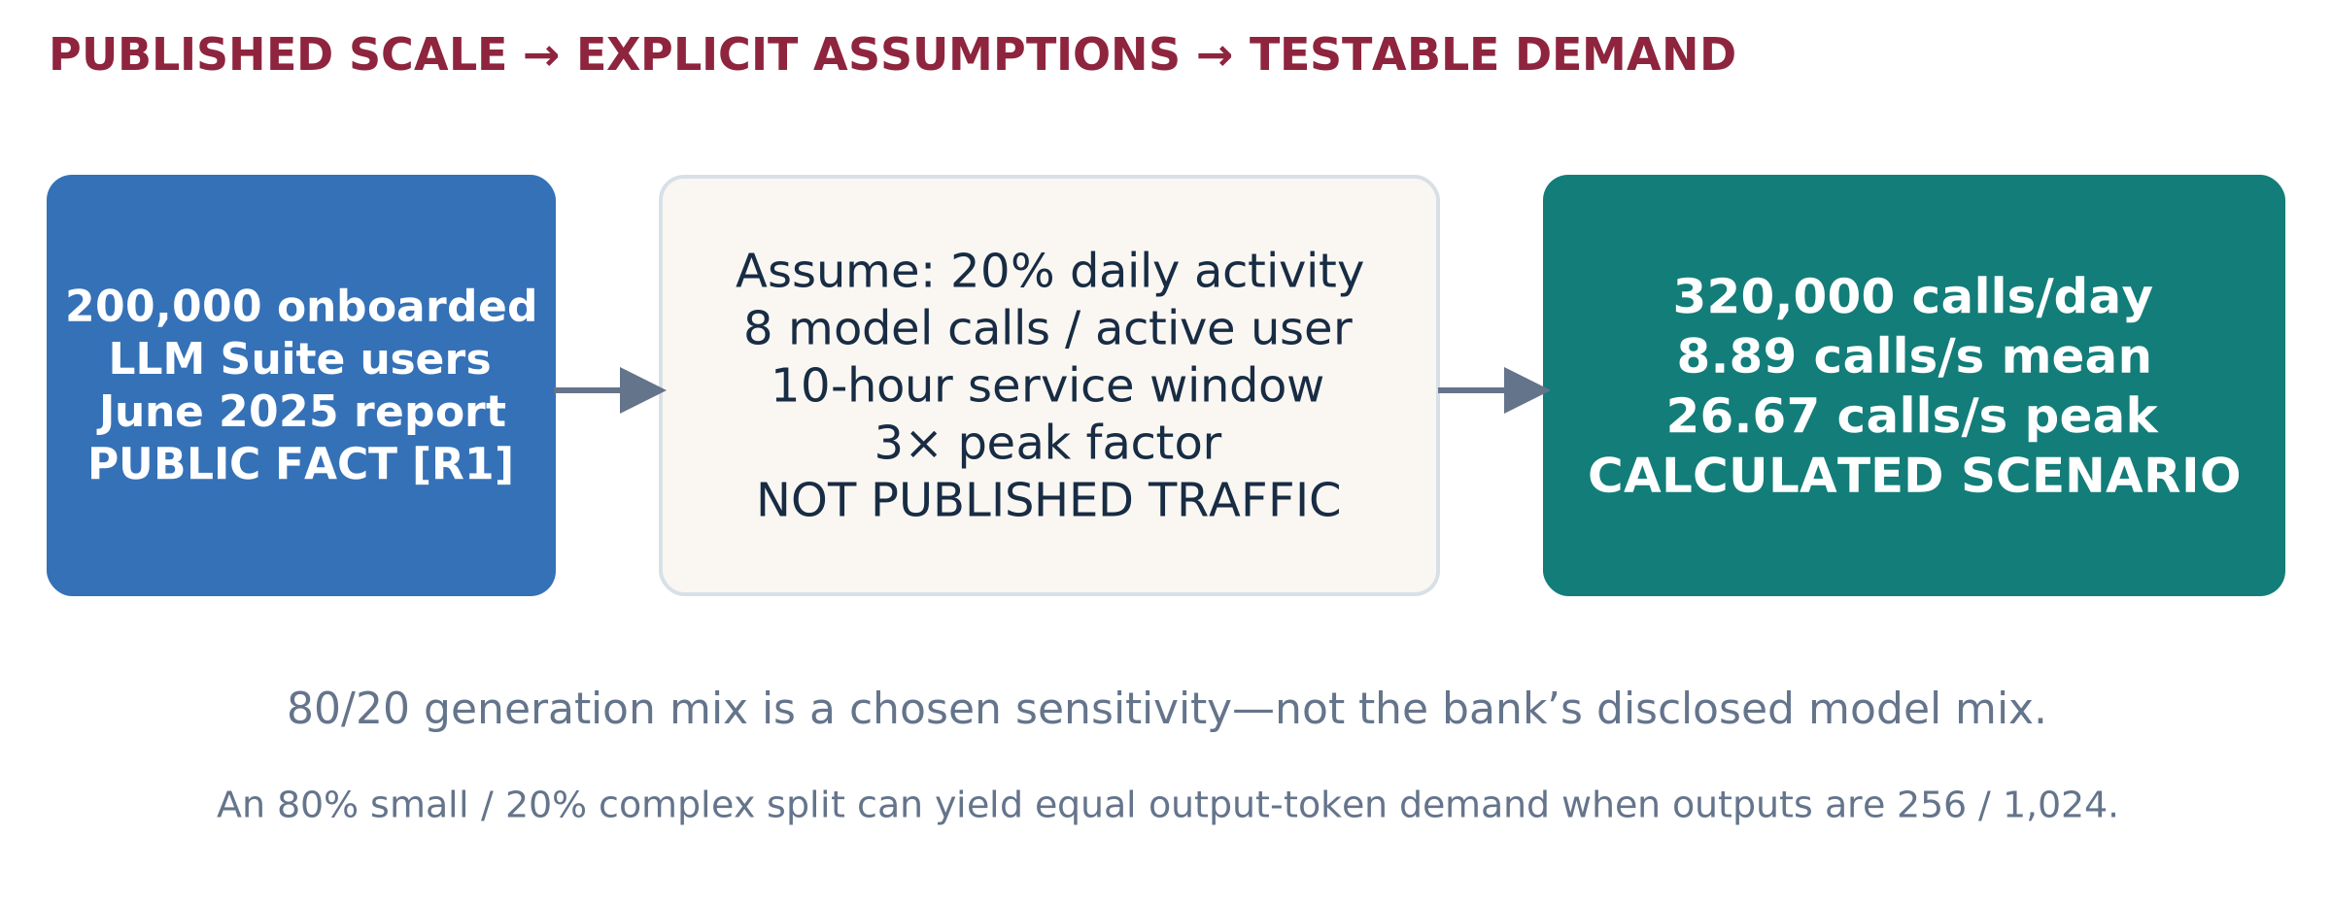
Figure 16. Historical public adoption is the anchor; activity, calls and peaks are selected scenario inputs. No actual JPMC load is inferred. [R1; A6]
Chosen generation class | Share / peak calls per second | Output target | Peak output-token demand
Ordinary service | 80% / 21.33 | 256 tokens | 5,461 tokens/s
Complex service | 20% / 5.33 | 1,024 tokens | 5,461 tokens/s
Combined | 100% / 26.67 | Mixed | 10,923 tokens/s

These are offered demands, not ATMOS rates. The mix is not the bank’s disclosed model mix. If selected stable mean end-to-end times were 20 seconds and 120 seconds, rate × mean time gives about 427 and 640 unfinished requests respectively. Those are service-boundary averages—not active GPU sequences or KV allocations. Do not substitute p99 into this average relationship. [A6]

Size only after measuring each complete service unit
Required identical replicas, tolerating one lost replica = 1 + ceil(peak class demand / qualified usable rate per replica)
Apply the formula per independently replicable service class, with the rate already including the chosen headroom. A cooperating model group is one replica for this calculation, not each expert module. Node/rack correlated failures require a placement-specific availability model rather than blindly adding one device.

TURN AN ADOPTION STORY INTO A QUALIFIED OPPORTUNITY

Financial deployment and buying decision
Start with an authorized business unit or workload slice, not a hypothetical replacement of every employee-facing AI call. Determine which work may move from the existing cloud or on-prem service, which models can legally and technically run locally, and what deployment cost can actually disappear.
Proposed configuration | Why the customer might adopt it | Evidence before buying
B local-service pool | Independent models/refinement with incremental growth; retain existing generation for unqualified cells. | Same business quality; model/shard registration; device health and steady-state economics.
C switched E3.S | Same services with a qualified larger population or a better host connectivity plan. | Switch earns its cost under real demand, updates and failover; no assumed P2P benefit.
A complex-analysis pool | Several modules execute the approved larger model with useful local capacity. | End-to-end time, per-rank KV/weights, communication and group recovery.
E / F combinations | Separate pools by interactive/complex/retrieval workload; replicate across node boundaries. | Resource ratios, failure reserve and mixed workload cost justify the added pools.

A deliberate negative-control case
Assume only 60% of the example model calls need one retrieval. Peak retrieval demand is then about 16 queries/s. Assume ten million chunks: one 1,024-dimensional FP16 vector/chunk is 20.48 GB. That representation can be a strong conventional memory-resident control. The public employee count does not by itself create a need for HBF. [A6]
A richer assumed representation—128 vectors/chunk, 128 FP16 dimensions—would be 327.68 GB, before indexes and replicas. B/C becomes more interesting only if that representation improves judged relevance at the required cost and query mix. Richer storage alone is not evidence; compressed late-interaction controls remain mandatory. [A5; R15]

Partner approach
Ask the account sponsor for one service owner, one incumbent baseline, a permitted trace and a buying decision. Run a joint 60-minute discovery, freeze the service boundary, then propose a two-stage evaluation: incumbent bottleneck confirmation followed by ATMOS threshold/physical-path testing. No supplied source establishes a JPMC POC commitment.

PUBLISHED WORKFLOWS • NOT AN ATMOS CUSTOMER CLAIM

Insurance case study: Allianz
Named use case: claims evidence assistance with employee AI and bounded agent workflows. Allianz offers public examples of multiple AI service shapes. The proposed ATMOS placement below is new analysis, not its disclosed hardware design.
Public anchor | Date | What it means—and does not mean
AllianzGPT: over 60,000 active users, 60 premium instances, and over 10 million prompts to date. | 18 Feb 2025 | Historical cumulative prompts, not peak QPS. Active-user interval unspecified; instances are not device counts. Data stays in Allianz Azure Cloud. [R2]
Insurance Copilot introduced for Austrian automotive claims in 2024. | 5 Feb 2025 | Document/contract assistance with human decisions. No accelerator inventory or request trace is disclosed. [R3]
Project Nemo: seven specialized agents, launched in Australia in July 2025; final human payout decision. | 3 Nov 2025 | A workflow reference. Seven agents do not imply seven LLM calls or seven NPUs per case. [R4]
More than 900 AI use cases internally registered worldwide. | 18 Mar 2026 | Portfolio breadth; not 900 production LLM deployments. [R5]

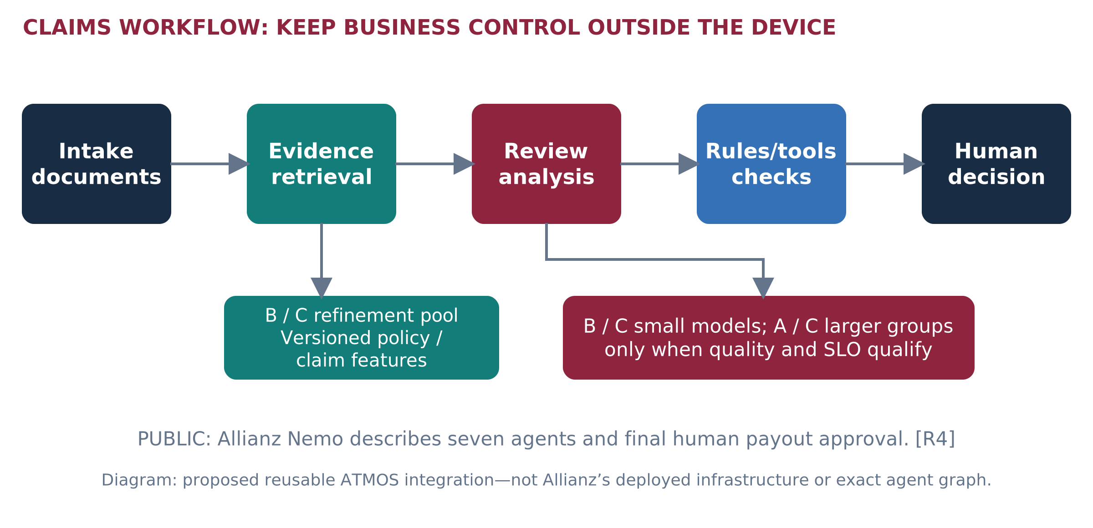
Figure 17. Proposed placement of retrieval and neural execution inside a claims workflow. The customer retains rules, tools and the final decision. [R3–R4; proposed design]
No hardware-performance gain or business-time reduction reported by Allianz is attributed to ATMOS. Public reports do not supply complete prompt distributions, model packs, actual claim rates or corpus size.

CALCULATION A7 • NO INVENTED ACTUAL CLAIMS VOLUME

Insurance sizing and adoption example
Explicit scenario assumption | Calculated demand | Boundary
60,000 reported active users as anchor; assume 25% active on a selected day, six model calls each, eight hours and 3× peak. | 90,000 calls/day; 3.125 calls/s mean; 9.375 peak. | Daily fraction, call count, window and peak are not public Allianz data.
Catastrophe test: 10,000 claim workflows in a four-hour window; four neural calls/workflow. | 40,000 calls; 2.78 calls/s mean; test bursts separately. | 10,000 and four are synthetic inputs, not a report about Nemo. Do not multiply by seven agents again.
Representation study: 30 million single FP16 vectors, dimension 1,024. | 61.44 GB raw representations. | A plausible conventional-memory control; HBF benefit may be weak.
Alternative: 32 token vectors/chunk, 128 FP16 dimensions. | 245.76 GB raw; at least three 100 GB shards before metadata. | Quality-approved richer retrieval plus reserve may require more.

How the portfolio could be adopted
Phase 1: a B/C refinement service for a versioned policy/claim-feature snapshot, plus one supported small-model worker. Keep the current claims system and existing model endpoints. Measure full workflow impact, not only the accelerated stage.
Phase 2: when complex claims demonstrably benefit from a supported larger model, add an A/C cooperating group and route only the approved class. A premium app instance is not an automatic reason for dedicated hardware. Share or isolate only under the agreed data and service policy.
Phase 3: use C2 or a qualified C1 deployment when sustained population and operating economics justify it. Replicate complete logical shard sets or ensure every required shard survives the declared failure. The simple three-shard example is not available after losing a unique shard without a copy.

Contract, quality and cloud boundary
Existing proprietary model services cannot simply be loaded onto ATMOS. A local supported open-weight substitute is a new quality/migration decision. Where the service is Azure-hosted, the operator and approved deployment path must participate in hardware changes. Do not promise cloud avoidance or closed-model equivalence. Use human-reviewed evidence and preserve the original business authorization boundary.
[R2–R5; A7]. The numbers are a test design, not an estimate of Allianz’s installed fleet or purchasing requirement.

PART III • SOFTWARE, OPERATIONS AND OEM DELIVERY

What “turnkey” must include
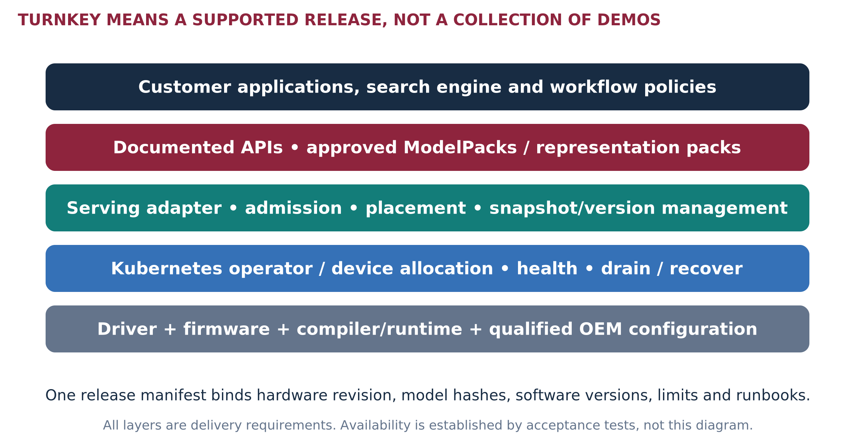
Figure 18. Required delivery stack across A, B and C. The program is not claiming these components currently exist as a released ATMOS product.
Package | What the customer receives | Release condition
Evaluation kit | Pinned simulator/profiles, reference datasets, current GPU controls, CLI/reports, assumptions and limitations. | Reproducible by an engineer other than the author; no ATMOS performance claim.
Device developer kit | Supported physical device, firmware/driver, runtime primitives, sample ModelPack/scorer, diagnostics and API contract. | Functional and physical-path tests; disclosed unsupported operations.
Turnkey service release | Qualified OEM configuration, signed software bundle, maintained adapters/operator, model registry, telemetry, recovery and support matrix. | Customer acceptance on deployment, quality, SLO, failure and lifecycle—not a demo.

A turnkey release must bind the exact hardware revision, model/shard formats, supported context and batch envelope, software versions, known limitations and operational tests in one release manifest. “Install a container” alone does not supply a compiler, device driver, secure DMA or an operator-quality backend.
Expanded program requirement based on [I3 §§6–7; I4 §7; I6 §1.2]. The Bridge explicitly excludes production driver/Kubernetes implementation; those are separate funded deliverables here.

OUT-OF-BOX WORKFLOW • TARGET, NOT AN ELAPSED-TIME PROMISE

Customer onboarding and service contracts
Step | Automated or documented action | Proof / owner
Preflight | Validate OEM/BOM, OS/kernel, BIOS/BMC, IOMMU policy, links, population and firmware compatibility. | Signed configuration report; OEM + Sandisk.
Install | Install approved driver/runtime and signed container/operator bundle from permitted registry or offline media. | Version/checksum and health checks; platform team.
Register | Verify model or shard hash, license, datatype, operator coverage, bounds and reserve; reject unsupported packs. | Capability report; compiler/runtime.
Deploy | Allocate worker/group, load/register data, expose API, set admission/SLO/tenant policy. | Readiness only after correctness smoke test.
Validate | Run matched representative samples and load trace; publish output/quality and timing separately. | Acceptance report; customer + validation.
Operate | Monitor, roll updates, drain, restore, sanitize and support cases through one runbook. | Recovery drills and escalation contract.

Proposed common APIs
describe_capabilities()
register_pack(hash, type, version, limits)
submit(request, model_or_shard_version, deadline)
health() / drain() / reset_under_policy()
report_metrics() / collect_support_bundle()
These are logical contract examples, not shipping API names. LLM requests must bind tokenizer, sampling, output caps, context and safety policy. Vector requests must bind query representation, candidate IDs, authorization mask, snapshot version, score semantics and merge rules. Unsupported datatypes/operators fail preflight or use an explicitly measured approved fallback.
Keep the integration narrow: choose one maintained retrieval boundary and one supported model-serving adapter first. The customer retains identity, data lifecycle, search query planning and business workflow. A REST-compatible endpoint is not proof of model/backend compatibility. [I4 §7]

SOFTWARE RESPONSIBILITIES THE FORM FACTOR DOES NOT SOLVE

Kubernetes, isolation and recovery
Initial allocation: whole independently supported workers or explicit complete model groups. Expose capacity and topology metadata without claiming fractional hardware isolation that has not been proven. An eight-module A card need not enumerate as eight allocatable devices. [I1 §3A]
Requirement | Implementation target | Acceptance test
Discovery and allocation | Device plugin or approved resource-allocation integration; NUMA/group/health metadata. | Correct count and grouping after reboot, partial failure and replacement.
Scheduling / admission | Placement honors per-worker KV/weight fit, supported kernels and complete-group readiness. | Reject oversubscription visibly; no late off-device fallback surprise.
Model/shard lifecycle | Immutable hashes, atomic activation, compatible versions, rollback and bounded staging. | No mixed snapshots or unready models serve live traffic.
Security | Least-privilege device access, DMA/IOMMU policy, signed firmware/images, secrets handling and scrubbed telemetry. | Cross-tenant boundary, malicious request bounds and reset sanitization tests.
Resilience | Drain and reschedule policies aware of card/switch/node dependencies. | Recover complete service under the declared fault; measure RTO and work lost.
Observability | Per-stage timing, errors, bytes, queues, temperatures, throttling and versions. | A slow request links to a reproducible resource trace.

Kubernetes device-plugin health reporting does not automatically migrate pods already using a failed device. The application/operator must supply workload-aware recovery. A pod restart is not a new model replica or recovered vector shard. [R16]

No safety bypass as a tuning step
Do not disable security isolation or permit unsupported live removal to obtain a faster benchmark. Fault tests run only on approved lab hardware with disposable data. Front access supports serviceability, but safe compute hot removal depends on outstanding work, reset behavior, firmware and the replication plan. [I7 §5]

BUILD WHAT MAKES THE HARDWARE ADOPTABLE

Software workstreams and release ownership
Workstream | First deliverable | Next delivery gate | Accountable role
Firmware + driver | Versioned commands, queues, DMA/buffer ownership, errors, reset and telemetry specification. | Prototype driver and functional smoke suite; physical path validated. | FW/driver lead
Compiler + kernels | Supported operator/precision matrix; tiled matrix, attention and gather/reduction microtests. | Signed ModelPacks or scorer packs with numerical tolerances and declared fallback. | NPU/compiler lead
Serving integration | One LLM adapter, request timing and admission; one retrieval interface spike. | End-to-end fixed workload passes with maintained dependency versions. | Runtime lead
Platform operator | Inventory/readiness, allocation, health, drain and upgrade design. | Two-node lifecycle and loss-of-device tests pass. | Platform/SRE lead
Quality + security | Reference datasets, tolerances, retrieval labels, sensitive-data rules and supply-chain inventory. | No silent corruption; authorization and rollback tests pass. | Validation/security
Field/release tooling | Installer/preflight, support bundle, sizing inputs, README and example configurations. | New user reproduces result; first-response and escalation owners assigned. | Release + solution architect

Software reuse across offerings
Reuse the driver contract, model/shard packaging, telemetry schema, admission rules and evidence runner where hardware permits. Keep topology, reset domain, usable capacity and power envelope as explicit capabilities. A and C may share grouped execution primitives; B and C share modular device operations. Compatibility is tested, not assumed from identical API names.

Two things the program must not confuse
Simulation adapter versus production backend: a timing callback does not execute the model. KV-cache connector versus weight/operator backend: a cache layer such as LMCache does not implement the NPU compiler, expert execution or device memory semantics. Those require separate engineering and qualification. The prior document’s optional runtime paths remain options, not already completed integrations. [I6; I7]
General-purpose training, arbitrary PyTorch compatibility, universal CUDA/ROCm binary support and unrestricted fractional multi-tenancy remain outside the first release. Every extension needs demand, an owner and a test contract.

PARALLEL ENGAGEMENT WITH ONE PRIMARY AND ONE ALTERNATE OEM

OEM integration: choose fixtures, not logos
The preferred lab is reconfigurable, but not every configuration belongs in one chassis. Keep a small family of matched, qualified fixtures when E3.S, accelerator power, riser layout or AMD OAM packaging prevents a single-host comparison. Cloud is useful for controls, not physical ATMOS qualification. [I7 §§2–4]
Fixture | Candidate reference | What the OEM must confirm
F1 • E3.S host | Dell PowerEdge R770 family: published E3.S/internal layout reference. | Exact backplane, per-bay lanes/CPU affinity, sustained accelerator power, cooling, management and supported mixed population.
F2 • Integrated card / GPU | Dell PowerEdge XE7740 or a documented alternate accelerator server. | Card size, spacing, retention, auxiliary power, partial populations, RTX/ATMOS revisions and support for the proposed modifications.
F3 • Switched E3.S | Qualified C1 reference BOM or C2 OEM engineering platform. | Switch part, uplink/device generations, port map, cables/retimers, firmware, isolation and service responsibility.
F4 • AMD control | OEM-supported MI350X OAM platform. | Complete platform and ROCm versions. Not a swap into an ordinary card fixture.

Public investigation basis [R12–R13, R20–R21]; private platform plan [I7]. None is identified here as an ATMOS-qualified server or purchase recommendation.

First OEM workshop: requested output
Bring the device envelope, A/B/C layouts, target service contracts and priority microtraces. Request a returned lane map, bill of materials, power/cooling allocation, BIOS/BMC requirements, management/reset matrix, qualification scope, engineering access conditions and a priced configuration. End with a configuration ID and unresolved-owner list.

Protect the storage plan
Price the authoritative store, spare/update capacity, boot drives and networking after ATMOS devices occupy bays. Preserve the required SSD capacity and I/O service; do not move a hidden cost to network storage. For 2T devices, count occupied width and cooling, not merely the printed bay count. [I3 §4; A1]

EVIDENCE CHECKLIST USED BY HARDWARE AND SOFTWARE TEAMS

OEM qualification and collaboration gates
Gate | Sandisk provides | OEM/customer provides | Exit evidence
O0 • Requirements | Approved device envelope, host interface, power range, command/runtime requirements. | Exact chassis, CPU/riser/backplane map and operating constraints. | Versioned feasibility and unknowns.
O1 • Engineering build | Device/sample, FW/driver, microtraces and diagnostics. | Supported lab modification, fixtures, cables, BIOS/BMC and safe access. | Repeatable boot, enumeration, mapping and local DMA.
O2 • Paths / population | Transfer workload, NUMA/P2P tests, read/write/load interference. | Topology observability, approved security settings, full population. | Measured path map; limits and unsupported routes.
O3 • Sustained operation | Reference service trace, temperatures, firmware update and failure tests. | Airflow/inlet/PSU conditions, fan policy, service procedure. | No unaccounted throttling; recoverable update/reset behavior.
O4 • Service acceptance | Qualified runtime/packs, node/shard recovery and installer. | Customer quality/SLO targets and authorized datasets. | Matched service report, operational gaps closed.
O5 • Release/support | Compatibility matrix, diagnostics, release notes, incident ownership. | Supported SKU/BOM, supply, spares, escalation and change control. | Signed release readiness, pricing and lifecycle agreement.

A switch’s P2P capability is not an application guarantee. Measure endpoint, driver and route support. Host-root traversal does not necessarily mean a host-DRAM copy; record the real payload path. Never disable isolation just to produce a preferred peer result. [R17; I7 §5]

A future generation is a new qualification
Changing PCIe generation, package power, HBF/LPDDR revision or GPU model is not a software setting that creates missing hardware support. Requalify affected links, thermals, memory mappings, model packs, recovery and service results. Maintain compatibility by configuration ID, not an unqualified server-family claim. [I7 §4]

ONE EVIDENCE SYSTEM • NOT ONE INTERCHANGEABLE TRUTH

Simulation, prototypes and real execution
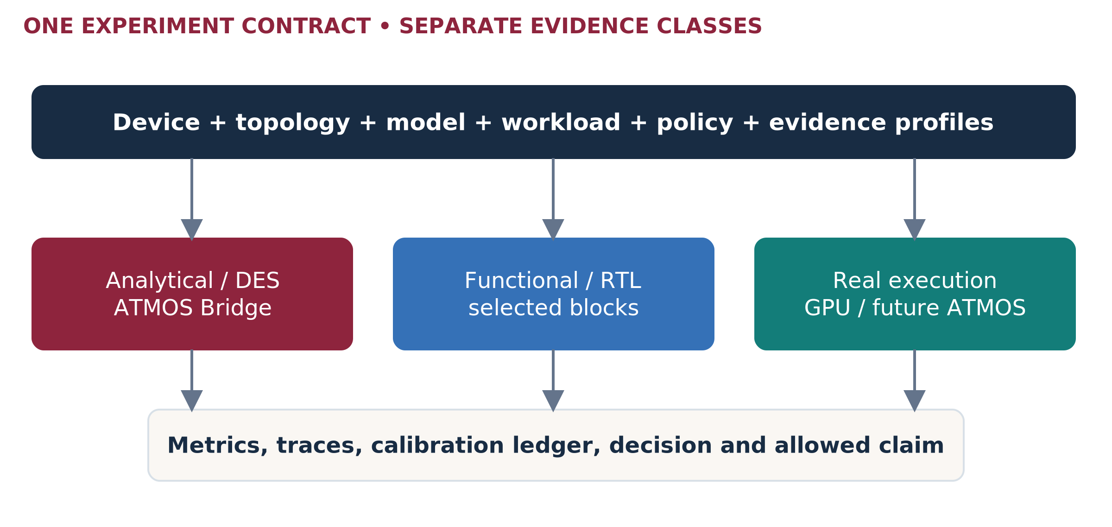
Figure 19. The common runner accepts multiple evidence backends. Their results remain visibly different classes. [I6 §§2–3]
Use the reviewed Python/SimPy Bridge recommendation for rapid resource modeling. TokenSim is an optional serving adapter; search traces need their own workload adapter. C++/Rust is an optimization option for measured hot paths, not a second parallel core to build by default. The prior Rust/C++ design remains a source of contracts and questions. [I6 §6; I9]
Environment | What we can learn | What we cannot claim
Capacity / analytical model | Fit, traffic, bounds and required performance. | Achieved tokens/s, p99 or model correctness.
Discrete-event model | Queues, contention, scheduling and sensitivity. | Silicon timing simply because the code is deterministic.
Selected partner/RTL model | Supported command/kernel behavior and bounded calibration. | Full ATMOS memory/controller/platform functionality unless supplied.
Physical reference / ATMOS | Observed service and operational behavior of the tested configuration. | Untested scale, models or future revisions.

The February 2027 partner milestone in the source is an internal assumption to reconfirm. Existing reviewed partner material is block-level evidence, not a complete ATMOS replacement. Keep restricted details under approved access and preserve release IDs; this reference does not redistribute internal RTL constants. [I6 §11]

TEST THE THESIS, NOT THE PRESENTATION

POC ladder and acceptance method
POC | Question / first scope | Go / no-fit evidence
P0 • Local memory path | Size, alignment, sequential/random, outstanding depth, staged/bypass variants, simultaneous working-memory traffic. | Useful NPU-consumed bytes/s and service tails; isolate the limiting resource.
P1 • Candidate refinement | One representation; fixed candidate IDs, filters, scores and local top-k. | Numerical/ordering equivalence; p99 and cost threshold against strong resident and disk controls.
P2 • Multi-vector | One MaxSim/reduction pipeline over precomputed features. | Judged relevance, variable document size, compression control, tail and capability coverage.
L1 • Small dense / MoE | One complete supported model on one worker; fixed trace. | Real quality first, then TTFT/TPOT, KV, bytes and sustained goodput.
L2 • Cooperating model | Valid EP/TP/PP combination; no-P2P baseline plus supported alternate path. | Complete-group service, imbalance, per-rank memory and recovery.
O1 • Node / fleet | A/B/C population, background traffic, restart and node loss. | Service remains within the declared degraded-state contract.
V1 • Customer workflow | One finance and one insurance stage, then authorized composition. | Joint continue/iterate/stop decision; no extrapolated fleet claim.

Rules for every run
Freeze data/model/precision, business quality, SLO and evidence class. Record arrivals separately from completions, active sequences separately from API concurrency, and logical bytes separately from physical transfers. Test low/target/burst/saturation loads, mixed traffic and negative controls. Show errors, timeouts, rejected requests and backlog; do not hide difficult requests.
Measure full-service distributions directly; never sum component p99 values into an end-to-end p99. Critical-path waiting is distinct from the sum of overlapping resource waits. A small deterministic toy trace can validate causality but cannot establish a production p99. [R22; I6 §8; I2 slide 5 notes]

Initial sweep—not one promised operating envelope
LLM inputs: 4K / 8K / 16K / 32K tokens; outputs: 128 / 256 / 1,024 tokens; active sequences: 1 / 4 / 8 / 16 / 32 / 64. Independently sweep fixed outstanding-client load and offered requests/s. Add 64K/128K only with a qualified model/runtime. Batch size and client concurrency are different variables. Vector candidates: 1K / 5K / 10K; query batches: 1 / 8 / 32. Start with screening and promote decision-critical cells rather than exhaust the Cartesian product. These are proposed test points, not supported ATMOS specifications. [I7 §6; R22]
Prior two-scenario outputs are teaching-only replay results, not completed TokenSim/C++ or physical ATMOS benchmarks. Reuse schemas and tests—not their latency numbers. [I10]

PART IV • INVESTMENT, LAUNCH AND PROGRAM OPERATION

Customer economics: show a feasible region
Use complete service cost at equal quality, latency and availability. The following reproduces the supplied executive proposal’s illustrative retrieval scenario, not quotes or ATMOS benchmarks: 800 GB representations, 4,000 peak QPS, 1,000 average accepted QPS; at least three complete copies normally and two after one node fails. [I4 §§11–12; A8]
Input | Conventional reference | ATMOS candidate
Assumed qualified rate/node | 2,500 QPS | 3,500 QPS
Sizing rate after 70% admission factor | 1,750 QPS | 2,450 QPS
Fleet meeting one-node-loss constraint | 4 nodes | 3 nodes / 24 devices
Hardware price | 4 × $60,000 | 3 × ($20,000 host + 8 × $2,000 devices)
Mean complete-node power | 1.2 kW | 0.8 kW
Incremental one-time integration | $0 | $60,000

Three-year undiscounted cost | Reference | Candidate
Hardware | $240,000 | $108,000
Support: 12% of hardware/year | $86,400 | $38,880
Electricity: PUE 1.3, $0.12/kWh | $19,678 | $9,839
Operations + non-energy facilities | $144,000 | $138,000
Common retrieval/source services | $180,000 | $180,000
Integration | $0 | $60,000
Total | $670,078 | $534,719

The conditional reduction is 20.2%. It is narrow: lower candidate rate, extra replicas, storage displaced, integration effort or a better incumbent can erase it. Generation, taxes, financing and unlisted corporate overhead are outside this specific boundary; add real differences before purchase.
COUNT ONLY COST THAT CHANGES
Freed but still purchased GPU memory is not immediate cash saving. For a deployed fleet, compare incremental spending and genuinely avoidable operating cost—not sunk purchase cost. For a new purchase, use full lifecycle costs. [I4 §10]

SENSITIVITY IS MORE USEFUL THAN ONE FAVORABLE CELL

Price, rate and supplier viability
Candidate QPS/node → fleet | At $1K/device | At $2K/device | At $4K/device | At $8K/device
1,000 → 7 nodes | −3.2% | −14.6% | −37.3% | −82.8%
2,000 → 4 nodes | +18.0% | +11.5% | −1.5% | −27.5%
3,500 → 3 nodes | +25.1% | +20.2% | +10.5% | −9.0%
5,000 → 3 nodes | +25.1% | +20.2% | +10.5% | −9.0%

Reduction in the illustrative three-year TCO on p.35. Positive = cheaper; negative = more expensive. Rates/prices are assumptions, not confidence intervals or forecasts. [I4 §12; A8]
A faster node does not reduce fleet count below the complete-copy/failure requirement. Under this scenario, candidate rate must exceed about 2,857 QPS/node before the 70% factor to meet peak demand on two surviving nodes. At the three-node point, an approximately $2,041/device ceiling retains a 20% cost reduction; exact quotes must replace the assumptions.

The supplier floor must fit below the customer ceiling
Required end-customer price = fully burdened unit cost / [(1 − channel discount) × (1 − hardware margin)]
For illustration only, $800 variable unit cost, 20% channel discount and 40% hardware margin imply a $1,667 price floor. At a $2,000 end price, supplier revenue is $1,600 and contribution is $800 before fixed costs. A hypothetical $5M development investment needs 6,250 such units before ongoing fixed costs, financing and taxes. These are not Sandisk policy, BOM or NRE estimates. [I4 §13; A8]

What changes by offering
Quote A as a complete card, B per device plus required host configuration, C as devices plus qualified fabric/management, and C2 with platform engineering amortization. E/F include mixed-pool utilization, network, spare capacity and recovery. Do not assume equal module count implies equal price or equivalent revenue.
A funded POC, a technically successful demo, a design win and booked revenue are separate milestones. The program needs repeatable deployment volume and service ownership beyond the anchor account. [I4 §§3,13]

RELATIVE WINDOWS, WITH EXPLICIT READINESS GATES

Phased portfolio launch
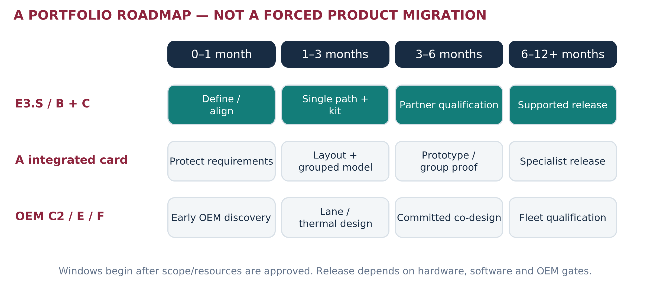
Figure 20. Proposed planning windows from an approved T0; hardware and commercial delivery dates are not established. [Proposed roadmap]
Milestone | E3.S-first output | Protected portfolio output
Month 1 | Confirm anchor requirements, device envelope, approved profile and local-path/SDK scope. | A/C1/C2 mappings, bay opportunity cost and model-group requirements.
Month 3 | Reproducible P0/P1, maintained integration spike, prototype capability and conventional controls. | Small dense/MoE control; A mechanical/timing feasibility; OEM alternative map.
Month 6 | Physical E3.S service qualification if hardware exists; otherwise calibrated requirements and explicit blockers. | A/C group experiments, turnkey operating tests, price/rate envelope and committed OEM path.
Month 12+ | Release supported configurations that pass gates; expand volume and supported workloads selectively. | Specialist A offering, C2 co-design or E/F deployment when economics and support qualify.

Not a mandatory B → C1 → C2 migration. The anchor may require C1 first. B may remain the best independent-worker offering. A should not wait for C2, and C2 should not become a product simply to complete a diagram. OEM discovery starts early; expensive platform commitments remain gated.
E3.S anchor priority [U1]; original multi-offering direction [I1 §9]. Google’s signed scope, dates, reuse rights and purchase commitment are not supplied. No public partnership or hardware adoption is asserted.

SUGGESTED FIRST-QUARTER ENVELOPE—NOT APPROVED STAFFING

Resource plan and ownership
Use one cross-functional delivery team rather than one team per form factor. The following 12-week planning envelope funds evidence and integration definition; it does not fund a complete NPU, production firmware, full compiler, silicon program or OEM NRE. FTE is full-time-equivalent effort, not necessarily a separate person per row.
Role | FTE | Accountability
Program / solution architect | 1.0 | Service contracts, architecture baseline, customer/OEM alignment and decision reports.
Performance/modeling | 1.0 | Resource model, benchmark controls, arithmetic, calibration and tails.
Runtime/compiler integration | 1.5 | Supported primitives/packs, reference execution and maintained adapters.
Firmware/driver liaison | 0.5 | Commands, DMA, reset, safety and device visibility requirements.
Hardware/OEM engineering | 0.5 | Envelope, topology, mechanics, power/thermal and fixture approval.
Validation/security | 0.75 | Correctness, failure, isolation and acceptance evidence.
Build/release/SRE | 0.25 | CI, manifests, packaging and operational tests.
Product/account coordination | 0.25 | Priority, partner path, pricing inputs and release scope.
Total | 5.75 | 69 FTE-weeks over 12 weeks.

Illustrative loaded labor at $4K–$6K/FTE-week gives $276K–$414K, plus $25K–$75K direct study spend: $301K–$489K total planning envelope. Actual pay, quotes, licenses, hardware purchase, tapeout and platform NRE are not supplied. This is a new phased estimate, not the earlier proposal’s budget. [A9]

Protect priorities
Suggested effort split: 35% shared foundation, 45% E3.S/anchor path, 20% integrated-card and independent-market investigation. Shared foundations directly support E3.S. Product/sponsor must approve changes; no workload adds a separate stack without a reuse decision.
With only the solution architect and periodic reviewers, narrow the quarter to a ledger, one local-path model, one measured control and one reviewed customer/OEM charter. Do not promise multiple production adapters or a qualified release on a solo schedule.

MAKE THIS A MAINTAINED SOURCE OF TRUTH

Program governance and first 30 days
Record | Required fields | Accountable role
Specification ledger | Value, units, scope, source, owner, release, confidence, approval and replaced values. | Architecture
Requirement / decision register | Need, option, workload impact, dependencies, decision, owner, due date, affected artifacts. | Program + product
Experiment manifest | Hardware/topology/model/trace hashes, policy, evidence class, versions, raw data and conclusion. | Performance
Claim register | Exact wording, supporting results, limitations, approval and allowed audience. | Product / legal / communications
Compatibility matrix | Qualified device/server/firmware/software/model combination and known limits. | Release + OEM
Risk / partner action log | Trigger, impact, mitigation, external dependency, owner and next decision. | Program / account

First month commitments
Week | Output | Review
1 | Confirm C-family naming, anchor scope, source priority, three service contracts and named specification owners. | Raj + architecture + product
2 | Approved topology candidates; source/assumption ledger; bounded P0 and real-control experiment; software gap map. | Hardware + runtime + performance
3 | Reproducible path/capacity artifacts; customer fact-versus-assumption packs; OEM requirements workshop. | Validation + OEM + account
4 | Evidence review: top five constraints, no-fit results, month-3 scope, resource decision and publication boundaries. | Cross-functional decision review

Use weekly engineering reviews, biweekly architecture decisions and monthly portfolio reviews. Freeze a release baseline for every POC. When a value changes, update affected equations, diagrams, tests, economics and approved wording together; archive superseded winner charts and duplicated specification tables.
The master remains usable only if another engineer can find the current value and reproduce the decision. The author is not the sole approval authority. Restricted partner details and customer traces stay in controlled repositories, linked by ID rather than copied into broadly shared versions.

A PROGRAM RESULT CAN BE “NOT A FIT”

Risks, gates and definition of done
Risk / trigger | Response | Decision owner
Anchor requirements consume all capacity | Protect shared interfaces and a bounded alternate-market track; confirm reusable IP and scope. | Sponsor/product
HBF delivery path cannot feed useful compute | Reprofile staging/window/NoC limits; change requirements or stop the workload. | Memory/NPU
Weight fit mistaken for latency readiness | Run per-rank KV and actual operator path; no TOPS-to-token conversion. | Performance/runtime
E3.S displaces required storage or overheats | Revise population/form factor or separate nodes; price the additional infrastructure. | OEM/hardware
Driver/compiler maturity blocks turnkey | Fund separate deliverables, keep evaluation-only label, and retain incumbent production path. | Software/product
Simulation appears as a measured claim | Automated evidence labels; no unsupported winner maps in field material. | Validation/claims
Partner/silicon delivery slips | Continue controls and sensitivity; change calendar commitments, not evidence labels. | Program/partner
No repeatable customer economics | Stop broad SKU investment; retain useful tooling and narrowly justified services. | Product/finance

Release gates
G1: definition — owners, source envelope, interface and bounded workload agreed. G2: function — numerical/operator and data-safety tests pass. G3: service — sustained workload meets quality/SLO under the named topology. G4: operations — update, reset, failure and recovery pass. G5: economics/support — quote-backed model, support owner and supply plan. G6: release — new users reproduce installation and operation from the package.
DEFINITION OF DONE
A customer can deploy the named configuration, run a supported model or representation service, understand its limits, observe it, recover it and receive support. The matched evidence explains why it was selected and where it should not be used. This is the standard for “turnkey,” not slide completeness.

ACTUAL SLIDE POSITIONS IN THE ATTACHED 15-SLIDE FILE

Appendix A — Backup PPT audit, slides 1–7
The attachment contains 15 actual slides; several printed footers refer to older deck positions. The source PowerPoint is not modified by this Word proposal. The following dispositions preserve source intent while preventing unsupported conclusions.
Slide / content | What the source supports | Required treatment
1 • ATMOS positioning | Capacity-led inference and POC narrative. | Retain, but define the three offering families and evidence state.
2 • Enterprise constraints | Model/context, distributed software, movement and deployment limits. | Retain as questions to measure; not all workloads are capacity-limited.
3 • Hierarchy and targets | Generic LPDDR/HBM–HBF–host hierarchy and source targets. | ATMOS diagram uses LPDDR; do not claim HBM is fitted. Clarify <200 W vs 200 W, mixed precision units and revision.
4 • Eight-module card | Modular capacity and source notes: 128 GB/200 GB/s HBF per module, 8–16 GB/50 GB/s LPDDR. | Keep distributed memory warning. Distinguish 1,024 GB nominal from 1,000/900 GB example budgets; add E3.S packaging.
5 • 16 / 40 / 120 s bars | Chosen means: prefill, decode and exposed-tier/launch components. | Not RTX/ATMOS forecasts, TTFT or p99. Input 32K plus output exceeds a 32K total retained budget; do not combine labels silently.
6 • 250 GB MoE group | Provisional model-pack and logical memory-placement comparison. | Four RTX cards vs one ATMOS card is not a throughput replacement ratio. Include a strong same-host GPU control and per-rank limits.
7 • Analytical break-even | R=(1−f)c+f/4+0.05 with f eligible exposed wait. | Keep as sensitivity. 4× wait reduction and 5% overhead are assumptions; 117 cell is 117.5 before rounding.

What the new program adds
Instead of converting those illustrations into more convincing graphics, the master defines the configuration, exact traffic, numerical/function test, device path and observation needed to replace each assumption. It retains the useful capacity example and conditional break-even equation without inheriting their use as proof of a platform winner.
[I2 native slide text, embedded chart series, notes and rendered visuals; I8 review as supporting context]. Printed footers are not used for this audit.

THE FIGURES ARE RESEARCH QUESTIONS UNTIL EVIDENCE EXISTS

Appendix A — Backup PPT audit, slides 8–15
Slide / content | Risk in current presentation | v3 disposition
8 • Context × concurrency map | Platform colors imply measured winners without a fixed model, active-state definition, topology or per-cell result. | Replace with a test matrix or calculated KV heatmap. No universal long-context ATMOS region.
9 • Parameter levers | Reuse, tools, random reads and “blocks all” mix fit conditions with unrelated limits. | Record locality and incumbent residence. Slow tools reduce addressable benefit, not necessarily all platform fitness.
10 • TP / EP / HBF placement | Expert “churn” can be misread as weight reload; tiers look mutually exclusive with parallelism. | Separate activation dispatch, expert residency and transfer. HBF placement can coexist with TP/EP/PP.
11 • Nonresident bytes × reuse | Stored working set and per-request transfer bytes are conflated; reuse categories not a numerical scale. | Preserve source ambiguity in audit. New tests record each quantity separately; remove winner assignments.
12 • Capacity curve | No numeric axes or measured series; p95 latency and queue pressure share a label. | Plot offered rate vs measured latency; report backlog, rejection and goodput separately.
13 • Customer value | “Watts/token” and “tokens/rack” lack the right dimensional/service boundary. | Use joules/accepted token or tasks/kWh; accepted output tokens/s/rack.
14 • Discovery | Useful questions, but retains internal editing-history text. | Keep workload/platform/decision questions; remove editing commentary and secure a signed service contract.
15 • POC | Good baseline→simulate→validate→decide sequence; energy metric ambiguous. | Keep with evidence labels, strong controls, correct energy units and operational/recovery gates.

CXL treatment: the source contains RTX+CXL controls. v3 does not launch a CXL offering or treat it as another ATMOS option. A real CXL fixture can remain an optional research control if it answers a specific customer question; its hardware and staging path must be real and separately qualified. [I2; I7]
Critical consistency check: slide 5 assigns 12.5%, 15% and 16.7% of its assumed totals to the additional-wait category. Slide 7’s +25% other-work case needs 30% eligible wait to break even under its assumptions. These are independent illustrations; one does not establish the favorable region of the other. [A10]

NAME THE LAYER BEFORE COMPARING ITS NUMBERS

Appendix B — Terminology for customers and SAs
Term | Plain meaning | Do not confuse with
Module / package | Compact compute/memory building block. | An entire E3.S enclosure or an accelerator card.
E3.S / E3.S 2T | EDSFF packaging variants; 2T is thicker. | PCIe generation, guaranteed lanes, an SSD protocol, or hot-removal safety.
AIC / riser / bay | Expansion board / mounting-connection assembly / removable-device position. | One interchangeable physical space.
Backplane / MCIO | Board behind bays / connector-and-cable system. | An automatic PCIe switch or added bandwidth.
PCIe switch / root port | Device transaction routing / host PCIe connection. | One coherent memory or CPU copying every payload.
Bifurcation / retimer | Split a supported host port / regenerate link signals. | Switch routing or creating unsupported lanes.
NPU / SoC / NoC | Neural processing unit / system on chip / network on chip. Compute block, integrated chip and internal interconnect. | An entire server or one globally shared memory.
HBF / LPDDR / SRAM | High-bandwidth flash / low-power DDR DRAM / static RAM. Capacity tier, active memory and immediate working storage. | A unified memory budget or equal bandwidth.
GB vs GB/s | Capacity versus data rate. | 1.6 TB/s being 1.6 TB of model storage.
Total / active parameters | All model weights / selected parameters per token. | Unique physical bytes fetched or token throughput.
Replica / EP / TP / PP | Complete copy / expert placement / tensor split / layer-stage split. | Same failure behavior or same communication.
ISL / OSL / retained context | Input tokens / generated tokens / retained input plus output state. | A single unspecified “document size.”
RPS / concurrency / batch | Arrival or completion rate / unfinished requests / work grouped at execution. | Interchangeable axes.
TTFT / TPOT / ITL | First-token time / average subsequent-token cost / individual token gaps. | Full-answer time or the same tail statistic.
Goodput / quality / SLO | Accepted useful rate / correctness-relevance requirement / service objective. | Peak throughput from all completions regardless of errors.
NUMA / P2P / DMA | Host locality / supported direct peer transfers / data-transfer engine. | Automatic routing, isolation or zero-copy on every path.
FRU / BMC / RAS | Replaceable unit / server management / reliability-availability-serviceability. | The logical service recovery boundary.

Source terminology [I1–I7]; industry metric/P2P/device concepts [R16–R18,R22]. Definitions here are condensed for the program, not a replacement for interface specifications.

ANALYTICAL INPUTS AND FORMULA REGISTER

Appendix C — Reproducible calculations
ID | Formula / numerical example | Qualification
A1 • Capacity / lanes / bays | 8×128=1,024 GB; 8×200=1.6 TB/s. Same-gen (8×4)/16=2. 16×7.68=122.88 TB; 8×7.68=61.44 TB. | Nominal sums; not accessible by one NPU or proof of supported population.
A2 • KV | N×T×2×L×Hkv×D×bytes. Qwen235: 192,512 B/token; at 32K =6.308 GB; 96 GB budget ⇒ floor(96/6.308)=15. | GQA logical KV; duplication, placement and layout reduce feasibility. Not MLA/hybrid formula.
A3 • Dense / staging | Tstep≥Wmiss/Buseful. 32/200=.16 s; Bstage≤50/2=25 GB/s. Linear prefill work≈2P×ISL. | Workload-specific bytes; batching/cache and attention are separate; not NPU measured time.
A4 • Expert union | Expected union=E×[1−(1−k/E)^B]; E128,k8, B1/8/32/64. | Independent uniform synthetic selection; not observed model routing.
A5 • Vectors / window | Bytes=Nvec×D×bytes/value. Q×transfer_size/service_time gives an ideal outstanding-window bound. | Physical read amplification and actual controller credit policy required.
A6 • Bank demand | 200,000×.20×8=320,000 calls/day; /36,000×3=26.667 peak calls/s. | Only 200,000 historical onboarded users is published; rest assumed.
A7 • Insurer demand | 60,000×.25×6=90,000; /28,800×3=9.375 peak calls/s. 10,000×4/14,400=2.778 burst-window mean. | Only 60,000 historical active-user anchor is published; claims volume/call count assumed.
A8 • TCO | N=max(3,1+ceil(4,000/(.7q))). TCO=hardware+support+energy+ops+common+integration. | Replica formula specific to the chosen full-corpus-node scenario.
A9 • Resources | 5.75×12=69 FTE-weeks; 69×$4K–$6K plus $25K–$75K. | Planning labor/direct-study envelope, not approved costs or hardware NRE.
A10 • Break-even | R=(1−f)c+f/4+.05; c1.25 gives R=1.30−f; break-even f=.30. | f eligible exposed wait, not cold-expert share or cache-miss percentage.

This document reports arithmetic and research—not a newly executed ATMOS simulation or benchmark. Before a POC, turn these into versioned test inputs with units, source IDs, owners and an assumption-expiry rule. Do not promote a sensitivity input to a specification.

APPENDIX D • SOURCE HIERARCHY AND TRACEABILITY

Source register — controlled internal material
I1 ATMOS_E3S_Server_Architecture_Options_Proposal(2).docx
15 pages. Main architecture baseline; A/B/C/D and E/F definitions, adoption and OEM qualification. Superseded as the master narrative only after v3 approval.
I2 SNDK-ATMOS-Customer-Backup.pptx
15 actual slides. Reviewed native text, notes, chart values and renders. Targets and hypotheses retained; winner charts not accepted as results.
I3 ATMOS_E3S_Product_and_Workstream_Proposal(1).docx
28 pages. IMA source image p.7, module/card packaging, device directions, software/OEM readiness. Mixed TOPS/TFLOPS, units and power require confirmation.
I4 ATMOS_E3S_Executive_Product_and_Partner_Proposal(1).docx
29 pages. Retrieval product boundary, partner route, economics and supporting calculations.
I5 ATMOS_E3S_HBF_Use_Case_Strategy_and_POC_Roadmap(1).docx
25 pages. HBF-active retrieval thesis, no-fit controls, candidate workloads and local-versus-aggregate distinction.
I6 ATMOS_Bridge_Emulator_Implementation_Proposal.docx
22 pages. Reviewed Bridge plan, Python/SimPy, optional serving adapters, partner/RTL boundaries, memory-first POC requirements. Prior pre-review version is not the preferred baseline.
I7 ATMOS_HBF_OEM_Platform_and_LLM_Evaluation_Plan_Draft.docx
21 pages. Cloud/OEM boundaries, hardware replacement, topology/NUMA, controls, safe lab procedures and serving tests.
I8 README_ATMOS_Final_Deck_Review_and_Slides_04-12(1).md
Supporting historical deck review. Actual positions in the new 15-slide backup take precedence.
I9 PROPOSAL.md — ATMOS Digital Twin Emulator
Earlier Rust/C++-centered architecture. Interface and causality ideas retained; stack decision differs from reviewed Bridge.
I10 ATMOS_Two_Worked_Scenarios.md and package
Teaching examples. Not TokenSim/C++ production implementation or physical ATMOS performance.
U1 User direction in current discussion
E3.S/Google priority, combined C/D, phased offerings and program scope. Internal assertion; signed sponsor/SOW/reuse rights not provided.
U2 User MCIO/E3.S/switch slide photograph
Source of separate switch-AIC physical concept and adapter photo. Does not establish the host generation or final switch part.

DATED PUBLICATIONS • NO IMPLIED ATMOS ADOPTION

Public sources — enterprise workloads
R1 JPMorganChase — LLM Suite: Innovation of the Year
3 June 2025. 200,000 onboarded-user anchor; drafting and planned internal-data/agent direction. Does not disclose workload traces or fleet sizing.
R2 Allianz — The impact of AllianzGPT
18 February 2025. Active-user/instance anchors and cloud operating context; no hardware purchase inference.
R3 Allianz — Smarter claims management, smoother settlements
5 February 2025. Insurance Copilot workflow, automotive claims and human role; no published prompt/QPS inventory used.
R4 Allianz — When the storm clears, so should the claim queue
3 November 2025. Nemo workflow, seven agents and human payout decision. Workflow design is not a per-layer accelerator specification.
R5 Allianz — Responsible use of AI
18 March 2026. More than 900 internally registered use cases. Registered does not mean production LLM deployment.

Research boundary
The named organizations are reference cases, not confirmed prospects or customers. Employee counts, app instances, agent counts and reported business improvements cannot supply missing model-call rates, token lengths, HBF bytes or device prices. Those remain explicit scenario choices or customer data requests.

Partner data needed to replace assumptions
Obtain a sanctioned trace with timestamps, service classes, input/output lengths, representation dimensions, candidate IDs/locality, version/freshness, failure expectations and incumbent cost. Include the approved model/license and quality target. Use redacted or synthetic data until handling permission is established.
Public sources reviewed 26 September 2026. Publication dates are retained so historical anchors are not presented as current headcounts.

PIN ACTUAL REVISIONS BEFORE EXECUTION

Public sources — models and hardware
R6 Qwen3-30B-A3B — published model card
30.5B total / 3.3B active reference model; counts are not a final compiled pack.
R7 Qwen3-30B-A3B — config.json
48 layers, four KV heads, head dimension 128 for the logical KV example.
R8 Qwen3-32B — published model card
32.8B dense reference; model/native/extended-context behavior requires exact configuration.
R9 Qwen3-235B-A22B — configuration
94 layers, four KV heads, head dimension 128, 128 experts and top-eight selection. 235B/22B model class also appears in source deck [I2].
R10 DeepSeek-V3 — publisher model card
671B total / 37B active reference. Complete model and mixed precision require artifact audit.
R11 Kimi K2 Instruct — publisher model card
1T total / 32B active reference, MLA attention. Do not use the GQA KV formula blindly for this model.
R12 NVIDIA RTX PRO 6000 Blackwell Server Edition
96 GB GDDR7; 1,597 GB/s; up to 600 W; air dual-slot FHFL. Product specifications, not the measured control.
R13 AMD Instinct MI350X
288 GB HBM3E; 8 TB/s; 1,000 W TBP; OAM packaging. Requires a supported OAM server fixture.
These are representative released references, not a complete current-model leaderboard. Recheck artifact sizes, licensing, firmware, support and URLs at experiment freeze.

PRIMARY DOCUMENTATION AND PRACTICAL REFERENCE LINKS

Public sources — serving and integration
R14 OpenSearch — Disk-based vector search
Quantized selection and full-precision rescoring reference; configure a strong incumbent.
R15 Vespa — ColBERT embedder and compressed late interaction
Reference for data-local multi-vector scoring and compression; not ATMOS integration.
R16 Kubernetes — Device plugins
Discovery, allocation and health boundaries. Pin the customer-supported Kubernetes version.
R17 Linux kernel — PCI peer-to-peer DMA support
Topology and host-bridge constraints. A switch alone does not certify an application peer path.
R18 vLLM — Expert parallel deployment
Expert execution and communication reference. Existing vLLM support does not establish an ATMOS backend.
R19 NVIDIA — GPUDirect Storage overview
Supported direct storage-to-GPU-memory paths; GDS is not MoE cache policy.
R20 Dell — PowerEdge R770 inside view
Physical server reference; no ATMOS qualification implied.
R21 Dell — PowerEdge XE7740
Accelerator-server investigation candidate; exact modified BOM and support remain to be agreed.
R22 NVIDIA — LLM inference benchmarking fundamentals
Definitions of service load and token/latency metrics; use a workload-specific acceptance contract.
R23 Kioxia — EDSFF E3 form-factor overview
Physical format context; form factor alone does not establish accelerator compatibility.
R24 TokenSim — public repository
Audit and pin the implementation used. Public simulator capabilities do not supply an ATMOS component model automatically.
Cited technical sources support general mechanisms. The new architecture, phased plan, thresholds and delivery requirements remain program recommendations unless an approved evidence record says otherwise.

