STRATEGIC PRODUCT PROPOSAL

ATMOS E3.S Persistent-Model Inference Module
  - A single reference document for management, product, architecture, hardware, firmware, software, OEM, marketing and field teams
Decision requested: authorize a cross-functional discovery and feasibility workstream to define an E3-class ATMOS product that combines neural compute, persistent model capacity and local active memory in a modular, serviceable device.

Field | Proposal
Proposal owner | Technology Development / ATMOS-HBF evaluation
Audience | Executive management, product management, architecture, silicon, platform software, OEM engineering, marketing and sales
Planning horizon | Quarter 1: feasibility and definition; 2027: prototype and partner qualification target, subject to gates
Status | Pre-product concept. No performance, capacity, power, pricing or availability commitment.
Primary decision | Should Sandisk create a modular E3-class ATMOS product in addition to, or ahead of, the full-length ATMOS accelerator card?

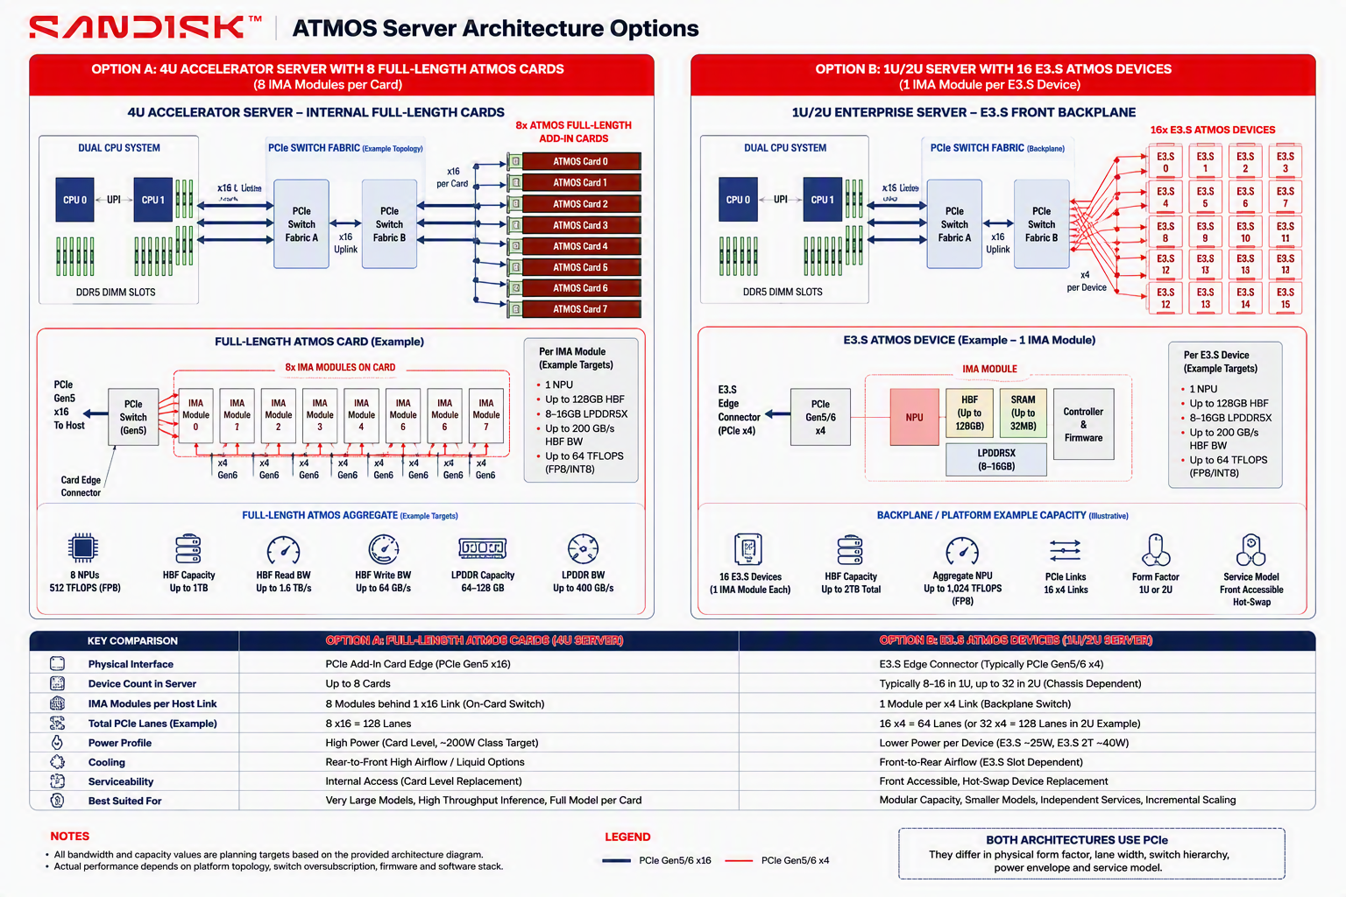
Figure 1. Conceptual server comparison: full-length ATMOS accelerator versus modular E3.S ATMOS devices. Values are illustrative planning targets.

Executive Summary
Recommendation: pursue ATMOS E3.S as a modular product track for independently scalable neural services and medium-size model serving. Preserve the full-length ATMOS card as the preferred architecture for very large dense and MoE models that benefit from keeping multiple IMA modules within one accelerator boundary.

The proposed ATMOS E3.S device is not an SSD with an AI feature, and it is not simply a smaller GPU. It is a persistent-model inference module that combines one IMA compute module, up to 128 GB of HBF model capacity, 8–16 GB of local active memory, local SRAM, controller and firmware, and a PCIe/CXL host interface. The product objective is to make qualified neural inference deployable in the same modular, serviceable infrastructure model that enterprises and OEMs already understand for EDSFF devices.
Management question | Recommended answer
Why now? | E3-class AI modules are appearing in the market, while CXL memory modules demonstrate OEM acceptance of high-capacity non-SSD devices in E3 form factors. HBF standardization strengthens the capacity-side opportunity.
Where does ATMOS differentiate? | More persistent model capacity than current low-power E3 AI modules, plus local NPU execution and a separate active-memory tier.
What is the primary target? | Embeddings, neural reranking, domain-specific dense models, guard/classification models, VLM/speech workloads, long-tail model hosting and private on-prem inference.
What is not the primary target? | One enormous MoE sharded across many E3.S devices, generic HNSW traversal, raw document storage, training or universal GPU replacement.
What must be true? | The device must meet power/thermal constraints, expose a credible programming model, run supported ModelPacks, integrate with Kubernetes and OEM management, and show SLO-qualified performance and economics.
What should management authorize? | A gated 12-week definition workstream leading to an architecture selection, prototype plan, OEM engagement package and continue/hold/stop decision.

Proposed product in one page
Dimension | Initial proposal | Qualification required
Product category | ATMOS E3.S Persistent-Model Inference Module | Customer terminology and category testing
Core module | One IMA module per device | Confirm compute, package, power and pinout
Model capacity | Up to 128 GB HBF planning target | Usable capacity, ECC, overprovisioning and packaging
Active memory | 8–16 GB LPDDR5X planning target | KV/workspace fit and bandwidth
Compute | Approximately 64 TOPS/TFLOPS INT8/FP8 planning target | Operator throughput and utilization
Host link | PCIe Gen5/Gen6 x4 baseline; evaluate x8/E3.S 2T | Lane budget, protocol and OEM backplane support
Form factor | Evaluate E3.S and E3.S 2T; do not commit before thermal analysis | 25 W versus 40 W class feasibility
Deployment | One independently schedulable device or a homogeneous pool | Driver, orchestration, isolation and P2P
First software target | One active model per device | Later multi-model time-sharing only if justified
Security/operations | Secure boot, signed firmware, telemetry, health, reset and upgrade | OEM/BMC and enterprise qualification

Document Map
Section | Purpose
1 | Strategic context and product thesis
2 | Target architecture and form-factor choices
3 | Use cases and workload qualification
4 | System and OEM integration
5 | Hardware, firmware and silicon readiness
6 | Software and platform readiness
7 | ModelPack and performance validation
8 | Competitive landscape and positioning
9 | Commercial, marketing and ecosystem readiness
10 | Quarterly workstreams, deliverables and governance
11 | Risks, decision gates and rejection criteria
12 | Appendices: requirements, RACI, evidence ledger and references

1. Strategic Context and Product Thesis

1.1 Customer problem
- Enterprises want private and on-premises inference but frequently cannot justify a large GPU for every embedding, reranking, domain-model, safety or departmental workload.
- Current E3 AI modules show demand for low-power, hot-swappable inference capacity, but their local memory is generally sized for edge-class or smaller GenAI models.
- CXL memory modules provide modular capacity but do not execute neural models locally, leaving the host CPU or accelerator responsible for every compute operation.
- A full-length accelerator offers more aggregate compute and capacity, but requires x16 slots, higher power, internal service access and a larger acquisition unit.
- ATMOS E3.S can potentially occupy the gap: more model capacity than current modular accelerators, integrated NPU compute, and a serviceable device-level deployment model.

1.2 Product thesis
ATMOS E3.S wins when one qualified model or neural service fits within one modular device, stays locally available, meets its latency/throughput SLO, and avoids assigning an expensive full-size GPU or sharding the workload across multiple devices.

1.3 Product boundaries
In scope | Out of scope for first product
Inference for qualified dense neural models | Training and large-scale fine-tuning
Embedding generation and neural reranking | Generic vector database or HNSW engine
Domain-specific LLM/VLM/speech models | Raw document or object storage replacement
Device-per-model and homogeneous device pools | One giant model spanning many E3.S devices as the lead use case
Containerized serving with OEM management | Universal PyTorch/CUDA replacement on day one
Optional pipeline participation in RAG | Complete RAG application platform

2. Target Architecture and Form-Factor Choices

2.1 Logical device architecture
Layer | Proposed function | Why required
NPU compute | Run supported attention, FFN, embedding, reranking, classification, VLM and speech operators | Creates local neural execution and differentiates from CXL memory
HBF model capacity | Persist model weights and read-mostly model objects | Provides the principal capacity differentiation
LPDDR active memory | Hold activations, KV state, workspace, current tiles and temporary buffers | Supports writable low-latency execution state
SRAM / local cache | Hold immediate tensor tiles and command metadata | Reduces latency and supports streaming execution
Controller and firmware | Queue management, DMA, integrity, health, firmware lifecycle and recovery | Turns the module into a manageable enterprise device
PCIe/CXL host interface | Discovery, commands, data ingress/egress, management and optional memory semantics | Enables OEM server integration and software control

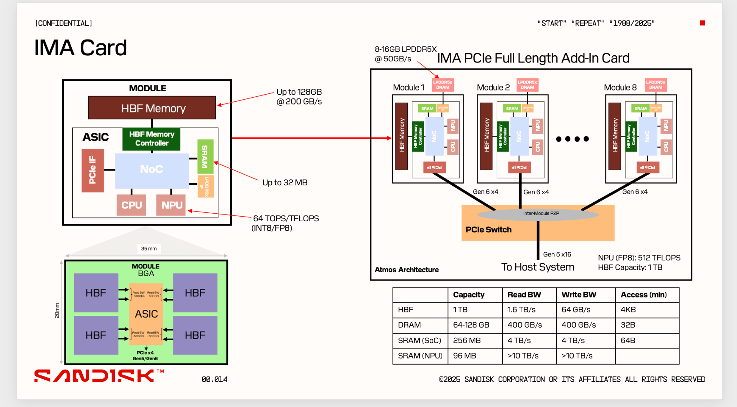
Figure 2. Existing IMA concept: one module as the building block and eight modules on a full-length add-in card. The E3.S proposal packages one module as an independent device; it is not the full-length card shown.

2.2 E3.S versus E3.S 2T selection
Attribute | E3.S baseline | E3.S 2T alternative | Decision implication
Thickness / cooling | Thinner, highest bay density | Double-thickness, more board and thermal volume | Select only after module thermal model
Power class | Typically storage-oriented and more constrained | Supports higher-power memory/compute use cases | Likely safer starting point if 25 W is insufficient
Link width | Commonly x4 | Can support wider x8/x16 configurations | Wider link helps host data movement, not internal model bandwidth
Server density | Higher | Approximately half thin-device bay count | Trade deployment density against power and link width
Target role | Lowest-power independent services | Higher-performance inference and memory device | Potential two-SKU strategy later

2.3 Relationship to full-length ATMOS card
Decision axis | ATMOS E3.S | Full-length ATMOS card
IMA modules per device | One, initially | Eight in current concept
Host interface | Likely x4, potentially x8 in 2T | x16
Service unit | One front-accessible device | One internal accelerator card
Best model topology | One small/medium model per device or replicated pool | One large dense/MoE model per card
Inter-device communication | Server/backplane PCIe fabric | On-card switch among modules
Primary value | Modularity, isolation, incremental scaling | Large-model locality and aggregate capacity
Key risk | Power/thermal and sharding across many devices | Higher integration and acquisition unit

3. Use Cases and Workload Qualification

3.1 Prioritized use-case portfolio
Priority | Use case | Why ATMOS E3.S fits | Primary KPI | Initial disposition
P0 | Embedding generation | Independent, highly batchable, stable model, horizontal pool scaling | Embeddings/s, p99 latency, W/1M vectors | Launch workload
P0 | Neural reranking | Transformer scoring over candidate batches; dedicated devices avoid LLM interference | Pairs/s, NDCG/MRR, p99 latency | Launch workload
P0 | Private domain LLM | One model per device; local data control and persistent model availability | TTFT, TPOT, sessions at SLO | Launch workload
P1 | Guard/classification model | Small, high-QPS model that benefits from physical workload isolation | Requests/s, p99, power | Early ModelPack
P1 | VLM and document understanding | Qualified multimodal models with moderate capacity and private data | Images/s, quality, latency | Operator-dependent
P1 | Speech / text-to-speech | Independent neural service with local data and predictable batching | Real-time factor, p99 | Operator-dependent
P1 | Long-tail model hosting | One device per tenant/domain/model avoids partitioning a large GPU | Models/rack, utilization, cold-start | Platform value
P2 | RAG neural preprocessing pool | Embedding + reranking + guard stages around a separate LLM engine | Pipeline latency, prompt-token reduction | Solution integration
P2 | Small/medium MoE | Possible if complete model fits one device and routing kernels are supported | TPOT, expert locality, cache hit | Research
Reject initially | Massive MoE across many E3 devices | Recreates PCIe sharding and collective complexity | Not applicable | Use full-length ATMOS

3.2 RAG placement
RAG stage | ATMOS E3.S role | Value level | System owner
Query embedding | Primary inference pool | High | ATMOS device pool
ANN/HNSW traversal | Not a primary target | Low | CPU/DRAM or specialized vector engine
IVF-PQ scoring | Conditional accelerator kernel | Medium | Qualified NPU backend
Raw chunk retrieval | Not a target | Low | E3.S NVMe or object store
Neural reranking | Primary inference pool | High | ATMOS device pool
Prompt assembly | Not a target | Low | CPU/application
Large LLM generation | Only when model fits and compute meets SLO | Medium to high | ATMOS E3.S or full-length ATMOS
Very large MoE generation | Use full-length ATMOS architecture | High for ATMOS, not E3.S | Full-length ATMOS pool

Product discipline: ATMOS E3.S should be sold around one-device or homogeneous-pool workloads. Avoid leading with a single model sharded across many E3.S devices until direct P2P, collectives, topology and fault recovery are proven.

3.3 Workload qualification checklist
- Model artifact fits within usable persistent capacity with at least 10–20% operational reserve.
- Active state, activations and workspace fit within usable LPDDR/SRAM capacity.
- Operator graph is supported without excessive CPU fallback or graph breaks.
- One device or a replicated pool meets TTFT, TPOT, throughput and p99 SLOs.
- Host-link traffic is not on the per-layer critical path for model weights.
- Device power, thermals and sustained workload behavior meet the selected E3 profile.
- The workload has enough volume to justify acceleration over CPU and lower-cost alternatives.
- The value persists after software, OEM qualification, availability reserve and operational overhead.

4. System and OEM Integration

4.1 Reference server deployment modes
Mode | Example topology | Best use | Critical dependency
Independent device pool | 8–16 E3.S devices in 1U or 16–32 in 2U, chassis-dependent | Embedding, reranking and model replicas | Full-bandwidth lanes, power and cooling per bay
Mixed E3 server | ATMOS E3.S plus NVMe E3.S plus CXL E3.S 2T | RAG preprocessing, chunks and host memory | Backplane protocol and lane planning
Hybrid ATMOS server | E3.S ATMOS devices plus full-length ATMOS card | Small-model services plus very large LLM | Unified runtime and routing
Scale-out pool | Multiple servers with device-level scheduling | Hyperscaler or shared enterprise inference | Network, placement and fleet telemetry

4.2 OEM hardware responsibilities
- Choose E3.S or E3.S 2T bay design and confirm connector, power, cooling and hot-plug capability.
- Provide PCIe Gen5/Gen6 lane width per bay, backplane switch topology, uplink bandwidth and oversubscription map.
- Validate peer-to-peer routing among devices and whether traffic remains within a switch or traverses CPU root complexes.
- Integrate BIOS enumeration, ACPI, IOMMU, BMC inventory, health, firmware update and service workflows.
- Qualify sustained accelerator thermal load rather than assuming an SSD duty cycle.
- Define acceptable device count under CPU, DRAM, NIC, fan and power-supply budgets.
- Validate shock, vibration, airflow impedance, EMC, regulatory and service requirements.

4.3 Sandisk deliverables to OEM
Deliverable | Minimum content | Owner
Device design guide | Mechanical, electrical, SI, power, thermal, airflow and connector requirements | Hardware/platform
Host integration guide | PCIe/CXL enumeration, reset, hot-plug, IOMMU, P2P and firmware lifecycle | Firmware/driver
Management guide | BMC telemetry, health, fault codes, inventory, secure update and recovery | Platform software
Qualification package | Golden server list, BIOS versions, OS/kernel matrix and device limits | OEM enablement
Performance guide | Qualified ModelPacks, measured SLOs, load curves and no-fit boundaries | Performance engineering
Service guide | FRU replacement, data sanitization, rollback, RMA and diagnostics | Operations/quality

5. Hardware, Firmware and Silicon Readiness

5.1 Required hardware definition
Area | Questions to close | Gate output
Form factor | E3.S or 2T? One or two boards? Required heat sink and airflow? | Mechanical concept and thermal feasibility
Power | Typical, sustained and peak power by workload and ambient? | Power budget and SKU class
NPU | Supported precision, operators, utilization, batching and independent queues? | Operator performance table
HBF | Usable capacity, bandwidth, latency, granularity, endurance, ECC and bad-block reserve? | Model-capacity specification
LPDDR | Capacity, bandwidth, topology and contention with weight delivery? | Active-memory budget
SRAM | Capacity, banking and tile-buffer usage? | Compiler/runtime constraints
PCIe/CXL | Generation, width, protocol, DMA, ATS/PASID, SR-IOV and P2P? | Host-interface specification
Security | Secure boot, roots of trust, signed firmware and tenancy boundaries? | Security architecture
Reliability | Reset, isolation, watchdog, telemetry, ECC, retries and data retention? | RAS specification

5.2 Firmware requirements
- Boot, attestation, firmware update, rollback and recovery.
- Independent command and completion queues with bounded latency.
- DMA scheduling, buffer ownership, backpressure and timeout handling.
- Model registration, validation, integrity checks and secure erasure.
- Health, temperature, power, errors, wear/endurance and throughput telemetry.
- Device reset and recovery behavior compatible with container and Kubernetes restart semantics.
- Hot-plug or planned-service behavior, depending on the selected OEM platform.
- Debug trace and performance counters sufficient to attribute bottlenecks.

5.3 Critical feasibility prototypes
Prototype | Purpose | Exit criterion
Thermal dummy / power vehicle | Prove continuous accelerator operation in E3 chassis airflow | No throttling at target ambient and duty cycle
PCIe FPGA/firmware vehicle | Prove enumeration, queues, reset, DMA and telemetry | Stable host integration under load and recovery
Memory-path emulator | Measure or model HBF-to-NPU delivery and LPDDR contention | Credible component timing distributions
NPU functional model | Validate supported operators, precision and model correctness | Golden-output equivalence within tolerance
System emulator | Predict queueing, batching, model fit and SLO-qualified throughput | Calibrated against reference hardware where possible

6. Software and Platform Readiness

6.1 Required software stack
Layer | Required capability | First-release scope
Model import | ONNX/PyTorch export, graph validation and unsupported-op report | Curated model path, not arbitrary models
Compiler | Quantization, tiling, kernel selection, memory layout and fusion | FP8/INT8 plus approved formats
Kernel library | Attention, FFN, embedding, pooling, top-k, normalization and selected VLM/speech ops | ModelPack-driven
Runtime | Contexts, command queues, memory allocation, model lifecycle, priorities and metrics | One active model per device
Linux driver | Discovery, DMA, mmap, IOMMU, reset, firmware and error handling | Supported enterprise distributions
Serving adapter | OpenAI-compatible embeddings/rerank/generation endpoints; batching and admission | Triton/ONNX Runtime or focused custom service first
Kubernetes device plugin | Whole-device allocation, health and topology | One device resource; no fractional device initially
Operator/daemon | Firmware, health, ModelPack deployment and lifecycle | OEM-certified control plane
Observability | Prometheus metrics, logs, traces and model/device attribution | Production minimum set
Security | Signed artifacts, tenant isolation, secrets, audit and sanitization | Enterprise baseline

6.2 Recommended software ownership boundary
Layer | Owns
Kubernetes / cluster scheduler | Node placement, whole-device allocation, replica count, health and failure-domain awareness
Serving framework | Request queues, dynamic batching, model endpoint, admission, SLO policy and request-level metrics
ATMOS backend/runtime | Model binding, compiled graph execution, memory capacity, prefetch, device queues and NPU dispatch
ATMOS compiler | Tensor tiling, operator mapping, layout, precision and transfer-compute schedule
Firmware | DMA, queue execution, buffer state, health, recovery and data integrity
Hardware | NPU, HBF, LPDDR, SRAM, fabric, PCIe/CXL interface and RAS mechanisms

6.3 First-release simplifications
- Expose the whole E3.S device as the Kubernetes allocation unit.
- Run one active model per device; use multiple devices for replicas or separate services.
- Use curated ModelPacks rather than promising broad framework compatibility.
- Prioritize embeddings, reranking and one dense generative model before MoE or multi-device sharding.
- Defer dynamic fractional NPU allocation, multi-tenant sharing and cross-device expert parallelism.
- Provide stable APIs and telemetry before optimizing every framework integration.

7. ModelPack and Performance Validation

7.1 Initial ModelPack portfolio
ModelPack class | Candidate profile | Validation
Embedding | Modern multilingual or domain embedding model | Recall/quality, embeddings/s, batch scaling, p99
Neural reranker | Cross-encoder or late-interaction reranker | NDCG/MRR, pairs/s, input-length scaling
Guard/classifier | Small dense classification model | Accuracy, p99, throughput and concurrency
Dense LLM | 7B–32B quantized target, subject to operator support | TTFT, TPOT, context, quality and memory fit
VLM/document | Compact VLM or document-understanding model | Image/document quality, latency and memory
Speech | ASR or TTS model if kernels support the graph | Real-time factor, quality and concurrency

7.2 Performance scorecard
Metric group | Measurements
User experience | p50/p95/p99 latency, TTFT, TPOT, timeout and completion rate
Throughput | Requests/s, pairs/s, embeddings/s, input tokens/s and output tokens/s
Capacity | Packaged model size, usable HBF occupancy, LPDDR occupancy, maximum concurrent sequences
Efficiency | Accepted work/W, accepted work/$, utilization and host CPU overhead
Data movement | Host ingress/egress, internal weight goodput, LPDDR traffic, PCIe traffic and stalls
Reliability | Error rate, recovery time, thermal throttling, firmware stability and long-run variance
Operations | Provisioning time, model activation time, replacement time and upgrade rollback

7.3 Competitive benchmark profiles
Control | Reason
CPU inference | Determines whether acceleration is economically necessary
Unigen Amaretti-class E3 AI module | Closest modular GenAI compute reference
Unigen Poptart-class E3 visual AI module | Operational and form-factor precedent
RTX PRO with MIG/MPS | Small-model packing and mature ecosystem reference
Full-length ATMOS card | Shows which workloads should move to the larger ATMOS product
CXL memory module plus CPU/GPU | Separates capacity-only value from integrated compute value

8. Competitive Landscape and Positioning

8.1 Market reference set
Reference | Public profile | What it validates | ATMOS differentiation
Unigen Amaretti | E1.S/E3.S; 60 TOPS; 10 W; up to 32 GB; marketed for up to 20B LLM/VLM | Modular, low-power on-prem GenAI | Higher persistent model capacity and separate active memory
Unigen Poptart | E3.S; dual Hailo-8; 52 TOPS; 10 W; visual inference and VMS integration | Hot-swappable E3 AI and scale-out visual processing | LLM/reranking focus and much larger model capacity
SMART CMM-E3S | E3.S CXL 2.0; 64/96/128 GB DDR5; PCIe Gen5 x8 | OEM acceptance of E3 memory expansion | Local neural compute and nonvolatile model capacity
Innodisk CXL E3.S 2T | 64/96/128 GB; PCIe Gen5 x8; about 32 GB/s stated bandwidth | 2T packaging and higher link width | Integrated compute and model-oriented internal path
Samsung CXL memory module | 512 GB CXL DRAM development in E3.S | Very high modular capacity | Persistent HBF and NPU in same device
Full-size GPU/AIC | High compute, mature software and large ecosystem | Performance and software benchmark | Modularity, service unit, potential model capacity/W

Competitive positioning must remain capability-based. Avoid directly comparing TOPS across different precisions, sparsity assumptions, models or utilization levels. Customer claims should use measured workload results and qualified ModelPacks.

8.2 Positioning statement
ATMOS E3.S is a modular persistent-model inference device for enterprises and OEMs that need more model capacity than current low-power E3 AI modules, but want a smaller, serviceable and incrementally deployable product than a full-length accelerator card. The product is optimized for qualified inference services rather than training or universal GPU replacement.

8.3 Messaging pillars
- Persistent model capacity: keep qualified models locally available without repeated external loading.
- Modular inference: add, replace and scale devices in enterprise E3 infrastructure.
- Physical workload granularity: map one model, tenant or service pool to one or more devices.
- Integrated execution: combine model capacity and neural compute within the device boundary.
- Private AI: support on-prem workflows with enterprise lifecycle, security and observability.
- Portfolio complement: use E3.S for small/medium services and full-length ATMOS for very large dense/MoE models.

9. Commercial, Marketing and Ecosystem Readiness

9.1 Target buyers and stakeholders
Stakeholder | Problem | ATMOS E3.S value
OEM platform team | Needs differentiated AI capability without a custom accelerator motherboard | Qualified modular device and design guide
Enterprise infrastructure | Needs private AI with predictable deployment and serviceability | Device-level procurement, replacement and scaling
Application owner | Needs a stable endpoint for embedding, reranking or domain inference | Curated ModelPack and standard API
Managed service provider | Needs physical workload allocation and simple fleet expansion | Device pools and operational telemetry
Storage/server product manager | Wants higher-value use of E3 infrastructure | AI module plus SSD/CXL coexistence story
Security/compliance | Requires controlled data, signed software and auditability | On-prem execution and device lifecycle controls

9.2 Marketing readiness checklist
- Final product name, category and one-sentence value proposition.
- Qualified specifications with precision, model, workload and test conditions.
- Clear relationship among HBF, ATMOS E3.S and full-length ATMOS products.
- Use-case guides for embedding, reranking, domain LLM and RAG preprocessing.
- OEM reference architecture and validated server list.
- Competitive battlecards against modular E3 AI, CXL memory and GPU partitioning.
- Customer evidence, model quality, performance curves and no-fit boundaries.
- Pricing model, warranty, support, RMA, firmware lifecycle and supply commitments.
- Demonstration system and repeatable executive demo script.
- Partner program for system integrators, ISVs and OEMs.

9.3 Commercial model options
Option | Description | Pros | Cons
Device sale | Sell ATMOS E3.S as a qualified component | Simple channel and OEM motion | Requires strong software/support package
OEM platform SKU | Co-market a validated server configuration | Clear customer outcome | Longer qualification cycle
Solution bundle | Device + ModelPack + runtime + support | Higher value and differentiation | Greater support responsibility
Capacity subscription | License software/ModelPacks per device or model | Recurring revenue | Operational and metering complexity
Design-partner program | Early systems with selected customers | Fast feedback and evidence | Needs strict claims governance

10. Quarterly Workstreams, Deliverables and Governance
Quarter objective: convert the concept into an evidence-backed product definition, not a broad research portfolio. End the quarter with a selected form-factor direction, frozen first workloads, a software architecture, an OEM requirements package and a prototype recommendation.

10.1 Workstreams
WS | Workstream | Quarter deliverables | Lead
1 | Product and customer definition | MRD, use-case priorities, target buyer, product boundary, pricing hypotheses | Product management
2 | Device architecture | E3.S/2T trade study, block diagram, power/thermal model, memory and NPU budgets | Hardware architecture
3 | Host and OEM platform | Reference server topology, lane/power/cooling requirements, BMC/BIOS integration plan | Platform/OEM
4 | Firmware and driver | Command model, lifecycle, health, reset, security, telemetry and API definition | Firmware/driver
5 | Compiler/runtime | Model import, operator matrix, memory planner, runtime interface and framework adapter | Software architecture
6 | ModelPack and benchmarks | Embedding, reranking and dense LLM candidates, quality gates and scorecards | AI performance
7 | Emulation and validation | TokenSim/system model, component calibration, workload traces and bottleneck analysis | Performance modeling
8 | Market and competitive | Positioning, battlecard, competitive evidence, partner map and launch narrative | Marketing
9 | Program and quality | Risks, schedule, RACI, design reviews, evidence ledger and decision gates | Program management

10.2 Twelve-week plan
Phase | Weeks | Objectives | Exit artifacts
Define | 1–3 | Freeze product boundary, target workloads, form-factor candidates, assumptions and owners | MRD v1, architecture choices, approved evidence ledger
Model | 4–6 | Build thermal/power, memory, NPU, PCIe and software architecture models | Feasibility report, emulator profile, API draft
Evaluate | 7–9 | Run workload sizing, ModelPack bring-up, OEM topology and competitive comparisons | Scorecards, fit/no-fit map, prototype requirements
Decide | 10–12 | Close critical risks, prepare partner package and management recommendation | PRD v0.5, prototype plan, budget and continue/hold/stop decision

10.3 Management decisions requested now
- Approve ATMOS E3.S as a formal discovery and feasibility workstream.
- Name one accountable product owner and one accountable architecture owner.
- Authorize engagement with two OEM platform teams and two design-partner customers.
- Freeze the first three workload classes: embedding, neural reranking and one quantized dense LLM.
- Allow E3.S 2T to remain an equal candidate until thermal and power studies complete.
- Protect the quarter from expansion into giant cross-device MoE, generic vector database, training or full RAG implementation.
- Require Week 6 and Week 12 decision gates with explicit stop criteria.

11. Risks, Decision Gates and Rejection Criteria

11.1 Top risks
Risk | Impact | Mitigation / decision
Power exceeds E3.S envelope | Invalidates thin-device concept | Evaluate 2T, reduced clock/NPU, or stop E3 product
Active memory too small | Limits context, batching or model graph | Increase LPDDR, narrow workloads, or move to full-length card
NPU operator gaps | Model fallback destroys value | ModelPack-first compiler plan and explicit unsupported-op report
Host x4 link bottleneck | High ingress/egress or multi-device communication stalls | Keep weights local, choose independent workloads, evaluate x8 2T
OEM backplane oversubscription | Aggregate throughput below device sum | Publish qualified topology and device-count limits
Software ecosystem delay | Hardware unavailable to applications | Prioritize simple APIs and one production framework path
Market confusion | E3.S competes with full ATMOS or SSD portfolio | Define portfolio roles and qualification guide
Competitor catches capacity | Modular AI modules add more DRAM | Differentiate persistence, model capacity, ModelPacks and operations
Economics fail | CPU, GPU MIG or current modules are cheaper | Use workload-specific SLO and TCO gates; stop weak uses
Unproven hot-plug compute | Service expectations exceed reality | Define cold-plug or planned-service mode if necessary

11.2 Gate criteria
Gate | Advance | Hold / redesign | Stop
G1: Product fit | At least two named customers and two OEMs validate the problem | Interest exists but workload or form factor is unclear | No differentiated demand
G2: Device feasibility | Target compute, capacity and active memory fit a supported E3 profile | 2T or reduced SKU required | Power/thermal or packaging infeasible
G3: Software feasibility | Three launch ModelPacks compile and run in functional model | One major operator/runtime gap remains | Required models need broad fallback
G4: Performance | At least one launch workload shows material SLO-qualified value | Value depends on one unresolved hardware parameter | CPU/GPU/current module remains clearly superior
G5: OEM readiness | Qualified topology and integration plan agreed | One platform-specific blocker remains | No practical lane/power/cooling configuration
G6: Business case | Credible price, margin, volume and support model | Economic sensitivity remains wide | No viable ASP/TCO position

12. Appendices

12.1 Minimum product requirements
ID | Requirement | Priority
PR-01 | One independently discoverable and resettable E3-class ATMOS device | Must
PR-02 | Usable persistent capacity sufficient for launch ModelPacks plus reserve | Must
PR-03 | Local active memory sufficient for launch workloads and runtime | Must
PR-04 | Measured sustained inference without thermal throttling | Must
PR-05 | Linux driver, firmware lifecycle and production telemetry | Must
PR-06 | Containerized embedding, reranking and generation services | Must
PR-07 | Kubernetes whole-device allocation and health reporting | Must
PR-08 | Secure boot, signed firmware and model integrity | Must
PR-09 | OEM-qualified reference platform and service guide | Must
PR-10 | P2P and multi-device collectives | Should, not launch blocker
PR-11 | Fractional NPU partitioning and concurrent multi-model sharing | Future
PR-12 | CXL memory semantics in addition to accelerator commands | Option

12.2 RACI summary
Deliverable | Management | PM | Architecture | HW/FW | Software | OEM | Marketing
MRD / product boundary | A | R | C | C | C | C | C
Device architecture | I | C | A/R | R | C | C | I
Software stack | I | C | C | C | A/R | C | I
Reference server | I | C | C | C | C | A/R | I
ModelPack / benchmark | I | C | C | C | A/R | I | C
Competitive positioning | I | A | C | I | C | C | R
Prototype funding | A/R | C | C | C | C | C | I
Launch decision | A/R | R | C | C | C | C | C

12.3 Evidence and claim ledger
Claim class | Allowed evidence | Customer wording
Public market fact | Vendor or standards body source | State with date and source
Internal architecture target | Approved architecture document | Use “target” or “proposed”
Emulated result | Calibrated model with documented assumptions | Use “modeled” or “projected”
Prototype result | Controlled measured system | State configuration and test conditions
Production claim | Qualified product and repeatable benchmark | Use only after formal approval
Economic claim | Approved pricing, utilization and TCO assumptions | Present range and sensitivity

12.4 Open questions for the first architecture review
- Is the first device E3.S or E3.S 2T, and what continuous power can the target OEM bays sustain?
- What is the usable HBF capacity after ECC, bad-block management, firmware and reserve?
- What is the sustainable NPU-consumed weight-delivery goodput, not only media bandwidth?
- How much LPDDR is required by the first three ModelPacks under peak batching and context?
- Does the NPU execute one graph at a time, or are independent contexts and queues supported?
- What are the first supported precisions and operator classes?
- Will the host interface be accelerator-command PCIe, CXL.io + CXL.mem, or a hybrid?
- What is the required server switch topology and acceptable oversubscription?
- Is hot-plug a launch requirement, or is planned service acceptable?
- Which software framework is the single production path for first customer evaluation?
- Which OEM and customer will serve as design partners?
- What measured advantage is sufficient to justify a product: performance/W, model capacity, rack density, deployment cost, or serviceability?

References and Source Notes
Public references are included for market orientation. Vendor claims are not independently verified and should not be repeated as ATMOS claims. Internal product values remain planning assumptions until approved and measured.
[1] SNIA, “SSD Form Factors / EDSFF,” updated June 2026. EDSFF provides standardized PCIe-based mechanics, connector/pinout, serviceability and CXL ecosystem support.
[2] SNIA, SFF-TA-1008 and SFF-TA-1009 specifications for the E3 family and enterprise/datacenter pin and signal definitions.
[3] Unigen, “Amaretti AI Module,” accessed September 2026. Vendor states E1.S/E3.S availability, 60 TOPS at 10 W, up to 32 GB and support for models up to 20B parameters.
[4] Unigen, “Poptart E3.S AI Module,” accessed September 2026. Vendor states 52 TOPS at 10 W, dual Hailo-8, hot-swap E3.S deployment and visual analytics/VMS use cases.
[5] SMART Modular / Penguin Solutions, “CMM-E3S,” accessed September 2026. CXL 2.0 E3.S memory module with 64/96/128 GB DDR5 and PCIe Gen5 x8.
[6] Innodisk, “CXL Memory Module E3.S 2T,” accessed September 2026. 64/96/128 GB, PCIe Gen5 x8, approximately 32 GB/s stated bandwidth.
[7] Samsung Semiconductor, “Industry’s First 512GB CXL Memory Module,” May 9, 2022. Development announcement for 512 GB DDR5 CXL memory in an E3.S form factor.
[8] SK hynix, “First HBF Standard Specifications with Sandisk,” August 4, 2026. Public specification describes up to 512 GB and bandwidth grades from approximately 0.4 TB/s to 3.0 TB/s.
[9] Internal source: IMA Card architecture slide supplied with this proposal. Values such as one module, up to 128 GB HBF, 8–16 GB LPDDR5X and approximately 64 TOPS/TFLOPS are planning targets, not product commitments.
[10] Internal source: ATMOS HBF OEM Platform and LLM Evaluation Plan Draft. Used for workload, stack, OEM and evidence-framework context.
[11] Internal source: SNDK-ATMOS-Customer presentation. Used for ATMOS positioning and architecture narrative.

Management Decision Page
Proposed decision: create a cross-functional ATMOS E3.S definition program with embedding, neural reranking and a quantized dense LLM as the first workload targets. Maintain E3.S 2T as an equal form-factor candidate and defer giant cross-device MoE until the full-length ATMOS architecture is mature.

Decision | Approve | Owner / date
Authorize 12-week feasibility workstream | ☐
Name product owner and architecture owner | ☐
Approve first three workload classes | ☐
Engage two OEM design partners | ☐
Engage two customer design partners | ☐
Approve E3.S and E3.S 2T parallel trade study | ☐
Approve Week 6 and Week 12 gates | ☐
Confirm out-of-scope list | ☐

Quarter-end success definition
- A product boundary and target customer are agreed.
- A feasible E3 mechanical, power, thermal and link configuration is selected.
- The first ModelPack set is frozen and modeled or functionally demonstrated.
- The software and OEM integration architecture is documented with named owners.
- At least one workload shows a credible, measurable reason to choose ATMOS E3.S.
- A prototype plan, budget, schedule and partner list are ready for approval.
- Weak workload claims are explicitly rejected rather than carried forward.

