TECHNICAL APPENDIX / SCOPE

SanDisk ATMOS
Turnkey Technical Design
Companion appendix to the V3 Private AI Appliance Strategy and executive presentation.
One qualified stack. Local policy. Signed delivery.
This appendix turns the V3 product responsibilities into an implementable reference design: a hardened appliance platform, native certified services, tenant admission, local data governance, a SanDisk release backend, signed distribution and controlled model/platform upgrades.
STATUS Design for review—not a shipping product, certified reference architecture, final component selection or performance commitment. V3 remains the portfolio and business baseline.

What stays fixed
Preserve W4, D8, E8, E16 and gated E24; the nine software products; the Enterprise Knowledge Agent and retrieval-only mode; seven API families; four-device allocation domains; complete-model readiness; and SanDisk prime support. Do not reintroduce per-layer GPU-attention / ATMOS-FFN offload.

Reading guide
Topic | Design sections / slide
Appliance stack and isolation | A1–A3 / slides 2–4
Request path, APIs, quotas and runtime | A4–A6 / slides 5–7
HA, backend, repositories and delivery | A7–A11 / slides 8–12
Model, index and platform lifecycle | A12–A15 / slides 13–16
Operations, ownership and acceptance | A16–A18 / slides 17–19
Schemas, terms and evidence | Technical annexes / slide 20

Open the editable technical appendix presentation
Basis: V3 PRD §§7–14 [B1] and executive deck [B2]. New implementation choices below are proposals. Public documentation [R1–R16] supports mechanisms, not ATMOS compatibility. Sources reviewed 6 October 2026.

TECHNICAL APPENDIX / DECISIONS

Design decisions and source boundaries
V3 defines responsibilities but does not choose a Linux distribution, Kubernetes distribution, hypervisor, database, registry implementation or quota transaction protocol. The choices below fill those gaps explicitly; they are not silently attributed to V3.
Decision | Proposed reference | Why / status
D01 Base OS | Ubuntu Server 24.04 LTS engineering base; kernel and driver pinned together. | New choice. Revisit at production hardware freeze; align contracted support with distro coverage.
D02 Container platform | RKE2 with bundled containerd; one qualified CNI/CSI profile. | New choice. Same appliance contract across single-node and enterprise profiles.
D03 Virtualization | Bare metal by default; optional qualified KVM whole-device/group passthrough. | New choice. No SR-IOV, vGPU, migration or fractional NPU claim.
D04 Device allocation | Preferred DRA/CDI implementation; device-plugin fallback only in a named release profile. | V3 allocation requirement; concrete mode needs ATMOS driver and integration proof.
D05 Serving | SanDisk Serving Manager; Envoy gateway and KServe components where qualified. | V3 component candidates retained; no generic upstream ATMOS support assumed.
D06 Hard quotas | Gateway rate checks + durable quota reservations + runtime memory admission. | New mechanics. Response-only token accounting is not a hard concurrent budget.
D07 Repositories | Reviewed Git; digest-pinned OCI registry; release blobs; catalog/evidence store. | New packaging design. Customer data and secrets remain separate.
D08 Update trust | Protected signing; signed compatibility manifest; local verification; offline metadata policy. | V3 signing/offline requirements made concrete. No mandatory Internet verifier.
D09 Data services | PostgreSQL-compatible local metadata/budget ledger; protected object/file storage; qualified index service. | Candidate implementations. HA and backup are separate obligations.
D10 External models | Explicit policy-approved API endpoint only. | Retained V3 role. No hidden fallback or GPU runtime changes.

Inherited requirements: [B1] §§7–14. Public mechanism references: [R1–R16]. No version number or diagram establishes a commercially supported ATMOS configuration.

TECHNICAL APPENDIX / A1

A1. End-to-end turnkey architecture
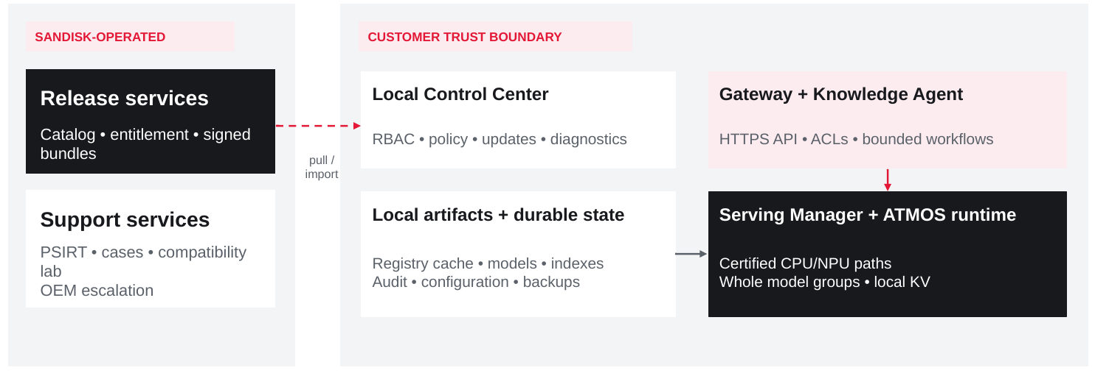
Figure A1. Release/support services are separated from customer-local control and inference.
The customer receives one local system of record for appliance configuration and one approved inference endpoint. SanDisk operates product distribution and support, but it is not in the request-critical path. A disconnected site can continue to run its installed, entitled service without a cloud callback.
Boundary | Responsibilities | Must not happen
SanDisk backend | Build, certify, sign, catalog, entitlement, advisories, support and OEM escalation. | No default ingestion of customer prompts, documents, private weights or KV.
Customer control plane | Identity mapping, policy, model deployment, local catalog cache, quotas, updates and audit. | No invisible remote command authority from the release repository.
Customer data/execution | CPU knowledge pipeline; certified ATMOS inference; versioned data/indexes; approved external model connector. | No bypass of tenant policy or treating an arbitrary model as NPU-compatible.

CONTRACT Cloud unavailability is different from local policy failure. Local inference may continue without the vendor backend; it must not bypass missing authorization or hard-budget controls.

Source baseline: [B1] §§7, 10–12, 14. Diagram and plane separation are proposed technical detail.

TECHNICAL APPENDIX / A2

A2. Base OS and immutable appliance platform
Proposed default: a SanDisk-composed image based on Ubuntu Server 24.04 LTS, running directly on the qualified OEM host. AI OS is a supported distribution and lifecycle contract—not a new kernel or an unmodified Ubuntu installer.
Layer | Reference design / obligations
Boot and trust | UEFI secure boot, TPM-backed identity or measured-boot record where qualified, signed kernel/modules, documented recovery keys. Preserve OEM trust for BIOS/BMC firmware.
Kernel and ATMOS driver | Pin kernel, device driver and runtime ABI as one release tuple. Use IOMMU-enforced bounded DMA. No production customer kernel, switch-policy or firmware patches.
Host hardening | Minimal packages; scoped services; audit; firewall; seccomp/AppArmor policy; encrypted configuration/data where supported; time synchronization; no permanent shared bootstrap password.
A/B root images | Separate known-good and candidate root images plus boot-health decision. SanDisk must implement image composition, installation and rollback; this is not a standard RKE2 feature.
Persistent host volumes | Keep configuration, database, model/cache artifacts, source/index data and audit separate from root slots. Disk mirrors do not replace node-level replication and backups.
Container runtime | Use the distribution-bundled containerd and a pinned OCI image set. No interactive package installs or unreviewed image pulls in the production path.
Support train | Pin an engineering baseline now; at launch select a support train covering the product term. Ubuntu base OS maintenance does not automatically cover the ATMOS driver, NPU runtime or third-party containers.

OS lifecycle decision
Ubuntu 24.04 LTS is a concrete engineering candidate, not a claim that the future device driver is supported today. Canonical documents standard and extended maintenance windows; a five-year appliance contract may require extended coverage or a controlled base-OS migration. Exact package, kernel and firmware levels belong in ProductRelease—not slide text that will become stale. [R1]
RELEASE RULE The appliance boots only a compatible, authorized release. A security-revoked generation is not an acceptable automatic rollback target.

V3 AI OS and security requirements: [B1] §§10, 12, 14. Proposed OS selection: [R1, R2, R4].

TECHNICAL APPENDIX / VIRTUALIZATION

A2.1 Virtualization: optional, not the default
Start with bare-metal device workers. Virtualization is a separate supported profile only when customer isolation or platform policy justifies its performance and qualification cost.
Deployment | Proposed treatment | Qualification boundary
Bare-metal appliance | Default. Containers share a hardened host kernel; the runtime accesses assigned ATMOS devices through the driver. | Still requires tenant, DMA, memory-scrub, network and process isolation.
Dedicated physical nodes | Preferred hard separation for high-trust tenants or regulated model/data pools. | Complete model/data replicas and cost of dedicated reserve are explicit.
KVM / VFIO guest | Optional. Assign the entire qualified IOMMU isolation unit; prefer a complete four-device logical domain in one guest. | An IOMMU group and a switch-local allocation group are not necessarily identical. Verify reset scope, DMA isolation, NUMA and guest driver ABI.
Existing enterprise hypervisor | Separate OEM/hypervisor compatibility project. | No generic VMware/KVM/Nutanix passthrough certification is claimed.
Shared virtual NPU / live migration | Not part of the initial contract. | No assumed SR-IOV, vGPU, fractional allocation, cross-guest P2P, snapshots of live KV or live migration.

Guest execution stack
Application APIs / gateway
→ guest Kubernetes / containerd
→ certified model worker + ATMOS runtime
→ guest ATMOS driver
→ assigned PCIe device / qualified IOMMU group
→ ATMOS firmware + NPU
The host uses the supported assignment mechanism; the guest owns the device driver and its model state. The host must not also allocate those devices to another Pod or guest. Test guest teardown, device reset, crash, stale DMA, group reassignment and data sanitization before a tenant boundary changes.
NO FALSE SHORTCUT Putting a second Kubernetes cluster on the same physical devices does not create isolation or independent failure domains.

V3 hard tenant separation and bounded DMA: [B1] §12. VFIO mechanism: [R5]. All ATMOS passthrough behavior remains unqualified.

TECHNICAL APPENDIX / A3

A3. Container platform and service topology
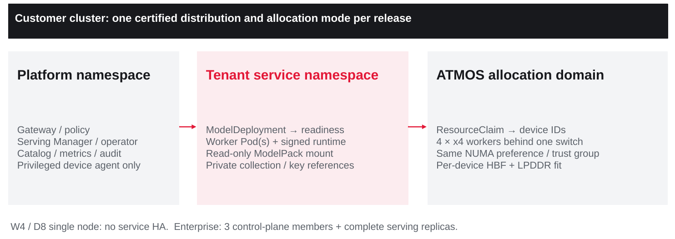
Figure A3. Kubernetes orchestrates complete services; the NPU runtime performs model execution.
Use one RKE2/containerd release for the appliance family as a proposed simplification. A W4 or single D8 may run control and worker services on one host without claiming HA. Enterprise deployments use three control-plane members, colocated with reserved CPU/DRAM or on separate management nodes. [R2–R4]
Logical namespace | Processes and state | Boundary
platform-system | Serving Manager, catalog controller, policy/entitlement adapter, update operator. | Privileged change authority; tightly scoped RBAC.
gateway-system | Envoy-based gateway, identity validation and quota/admission client. | Only approved public/API ingress.
atmos-system | ATMOS device agent, DRA/CDI or approved plugin, health/reset telemetry. | Only the device services receive required host privileges.
tenant / service | Certified Model Services, read-only packs, collection references and scoped credentials. | Non-root where supported; no host access; model access must be authorized.
knowledge / operations | Controlled connector jobs, parsers, index services, metrics and audit collectors. | CPU/storage quotas; network allow-lists; separate raw-content retention.

Namespace names are illustrative. V3 product roles: [B1] §§7–12. Public allocation/container mechanisms: [R2, R6–R8].

TECHNICAL APPENDIX / ALLOCATION

A3.1 Allocate devices and publish readiness
The Serving Manager resolves a certified service profile into a complete model deployment. It does not expose a random E3.S Pod as an independently serving LLM.
Step | Required implementation
Discover | Device Service reports immutable device identity, firmware/NPU revision, per-device budgets, link/root/NUMA map, group membership, health and reset generation.
Resolve | Select exact runtime and ModelPack digests, model shape/context limits and a topology that passed qualification. Validate both per-device fit and complete expert/layer coverage.
Reserve | DRA driver reserves qualified devices under ResourceClaims. A plugin fallback uses one separately qualified resource contract. Do not let two allocators own the same device.
Prepare | Map only assigned handles/buffers, bind CPU threads and host buffers to the correct NUMA domain, stage packs and establish driver/runtime ownership.
Warm up | Load all required model artifacts; allocate LPDDR/KV/scratch; run golden outputs and health checks; ensure every required worker is alive.
Publish | Mark the complete service generation ready and register its endpoint. Gateway routes only compatible work to that generation.
Drain / reset | Stop new work, cancel or complete outstanding operations, fence stale DMA/completions, sanitize tenant state, unprepare claims and revalidate before reuse.

Illustrative deployment intent—not an existing CRD
kind: ModelDeploymentIntent # proposed SanDisk schema
tenant: claims-team
modelPackDigest: sha256:<approved-pack>
runtimeDigest: sha256:<approved-image>
allocation:
groupCount: 1
devicesPerGroup: 4
locality: qualified-switch-and-numa-domain
sharing: exclusive-trust-group
readiness: complete-pack-plus-golden-warmup
failurePolicy: withdraw-entire-invalid-service-group
DRA can represent device attributes and claims, but SanDisk must implement ATMOS-specific allocation and lifecycle. A whole group is a scheduling boundary—not a coherent memory pool, a guaranteed speedup or a high-availability replica. [R6, R7]
Source model/readiness/HA contract: [B1] §§3, 6–7, 9–10. Schema is new design and not copy-paste deployment YAML.

TECHNICAL APPENDIX / A4

A4. API and request execution contract
Retain the seven API families from V3. Every endpoint documents its supported models, parameters, limits, authorization and failure behavior. API resemblance is not a promise of all features of another provider.
Family | Surface / example | Contract
Chat / responses / models | /v1/chat/completions; /v1/responses; /v1/models | Only certified parameters, stream behavior, schemas and tools. Model generation is resolved and pinned.
Embeddings | /v1/embeddings; batch embedding | Token/input batch limits; declared embedding version and dimensionality.
Retrieval | /v1/retrieve; collections / filters | Tenant/ACL filtering, bounded candidate count, index generation and citation metadata.
Reranking | /v1/rerank; batch rerank | Certified candidate count and length; model identity and quality profile.
Documents | Ingest / status / delete / reindex | Asynchronous job IDs, size/type controls, lineage, quarantine and deletion state.
Agents | Sessions / runs / tools / status | Bounded steps/calls/tokens/time; scoped tools; explicit human approval for actions.
Administration | Projects / keys / quotas / models / updates / support | Separate RBAC and audit; no unrestricted cluster-admin or firmware access.

Request sequence
Authenticate → authorize → reserve budget → admit resources → retrieve authorized evidence → execute certified service → stream/return → settle usage and audit. The gateway strips spoofable identity headers. Only verified user/service claims establish tenant, project and allowed models. Retrieval augments the prompt, so exact model-context and remaining budget are checked again before inference.

Failure behavior
Use 401/403 for authentication/authorization, 400 for invalid model/context parameters, 413 for supported upload size/type policy where applicable, 429 for exhausted quota, and 503 for no safe serving capacity. Streaming failures require a documented event/termination contract. No blind retry of completed tool actions; clients use idempotency keys for asynchronous jobs/actions where supported.
V3 API families and governance: [B1] §§8, 12. Gateway mechanism reference: [R9]. Exact error and API schemas here are proposed design detail.

TECHNICAL APPENDIX / A5

A5. Quotas, limits and resource admission
A gateway request-rate limit, a Kubernetes ResourceQuota and an NPU memory limit protect different resources. The product needs all three plus a durable tenant/project budget when a hard usage cap is promised.
Enforcement point | Checks | Owner
Gateway | Authenticated identity; model/API allow-list; request rate and burst; upload/body size; endpoint timeout. | Serving/gateway team
Quota service | Atomic tenant/project/model usage reservations; daily/monthly budget; actual-use settlement; agent child-call attribution. | SanDisk policy service
Serving Manager | In-flight requests, bounded queues, interactive/batch fairness, ready replica, deadline feasibility and tenant priority. | Serving/control plane
Runtime | Exact prompt/context/output cap; supported batch shapes; per-device KV/scratch; cancellation and generation pinning. | Native runtime team
Kubernetes | CPU/host-memory/storage quotas, Pod counts and device claims. Not tokens, active KV or business spend. | Platform team
Knowledge / agents | Collection/storage/ingestion limits; retrieved bytes/candidates; planner steps, tool count and elapsed-time budget. | Knowledge/policy team

Hard-budget design
Propose a customer-local quota authority with an atomic ledger in a protected PostgreSQL-compatible store. Stateless gateway replicas request a bounded reservation. At higher rates, validated bounded sub-leases can reduce contention, but total issued allowances must remain within the tenant budget. A response-only token meter is useful accounting, not proof that concurrent requests cannot overshoot. [R9, R16]
For each model call, reserve exact admitted input tokens + maximum allowed output tokens against the available budget. Meter actual model work on the server; release unused allowance only after terminal completion or confirmed cancellation. An agent reserves bounded child calls and inherits the parent request’s tenant/deadline; it cannot create fresh unbounded budgets.
FAILURE POLICY When authoritative quota/ACL state is unavailable, reject new work unless an approved, bounded local grant and still-valid authorization explicitly permit it. Never fail open to unlimited generation.

V3 multi-tenancy and budgets: [B1] §§8, 10, 12. Upstream quotas/accounting: [R8, R9, R16]. Transaction/reservation semantics are a new proposal.

TECHNICAL APPENDIX / QUOTA_EXAMPLE

A5.1 Example tenant policy and accounting
The following is an illustrative product-policy schema—not a shipping SanDisk CRD, Envoy resource or measured D8 service profile. Actual limits are clamped to the certified ModelPack and the deployment’s tested capacity.
kind: TenantServicePolicy # illustrative only
identity:
tenantFrom: verified-oidc-claim
project: claims-team
models:
allowedAliases: [knowledge-generation-approved]
usage:
requestsPerMinute: 30
totalTokensPerMinute: 60000
totalTokensPerDay: 500000
accounting: server-metered-input-plus-output
hardBudget: reserve-before-model-call
admission:
maxInFlightPerProject: 4
maxQueuedPerProject: 8
maxQueueWaitSeconds: 2
modelLimits:
maxTotalContextTokens: 8192
maxOutputTokens: 512
agentLimits:
maxPlannerSteps: 4
maxToolCalls: 6
maxElapsedSeconds: 60
externalGeneration: denied
policyFailure: reject-new-work
usageExport: metadata-only

Worked example
A request reaches inference with 2,048 admitted input tokens and a 512-token output cap. It needs a 2,560-token reservation. If the project has only 2,400 tokens remaining, reject it before model execution. If it produces 300 output tokens, settle 2,348 actual tokens and release the unused 212. Record hidden reasoning/model-generated tokens when the certified runtime produces and meters them; do not bill only user-visible text.
Context limits include chat templates, system text, retrieved evidence and tool messages. The request/minute control does not establish a throughput SLA. If the device cannot meet the admitted workload, runtime/Serving Manager caps take precedence. Retrieval and generation maxima from V3 are not assumed to hold together.
Numerical values and schema: proposed policy example. V3 service profile limits remain controlling [B1] §5.

TECHNICAL APPENDIX / A6

A6. Native runtime and memory ownership
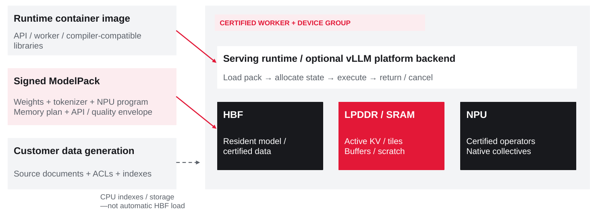
Figure A6. The runtime container, ModelPack and customer-data generation remain separate.
A generation-enabled ATMOS service requires the complete qualified model path: attention, active KV, router, FFNs, output/sampling and native multi-device communication where used. A vLLM platform plugin can wrap that backend; it does not create NPU operators. Tenstorrent’s public plugin is precedent for its hardware, not ATMOS certification. [R10, R11]
Resource | Proposed placement | Lifecycle
HBF | Resident weights and explicitly certified large representations. | Verify pack generation and load completeness; reconstruct from trusted artifacts after a fault.
LPDDR / SRAM | Active KV, activations, NPU tiles, queues and scratch. | Bound admission per device; sanitize before trust-group reassignment; no generic live-state migration.
Host ECC DRAM | API/orchestration, metadata, CPU indexes and certified host operators. | Not transparent NPU working memory without a qualified transport.
NVMe / protected storage | OS data partitions, artifact cache, source/rebuild inputs, collection generations and audit. | Separate authoritative data and re-creatable cache; backup and retention policies differ.

Baseline: [B1] §§6–7, 10. Public plugin mechanisms: [R10, R11]. Exact kernel/operator and memory mapping are partner qualification deliverables.

TECHNICAL APPENDIX / NETWORK

A6.1 Data, network and trust boundaries
Use a customer-local knowledge pipeline: approved source → scan/parse → versioned chunks and ACL lineage → CPU shortlist/index → certified ATMOS scoring/reranking → local or expressly approved external generation. Source ACLs are enforced before evidence leaves retrieval; failed or partially ingested items remain quarantined.
Connection / state | Proposed control | Notes
User API / UI | TLS on approved HTTPS ingress; identity from OIDC/service keys; rate and payload policy. | No raw worker/API port exposed outside the service network.
Admin / cluster / BMC | Segregated management path, least privilege, audited break-glass. Kubernetes API and BMC not public. | RKE2 registration/API ports are allowed only on the internal control network; exact matrix is release-specific.
Pod / service traffic | Default-deny network policy; explicit service identities and TLS/mTLS where qualified. | Choose one CNI/certificate profile; do not assume a service mesh is mandatory.
Registry / release pull | Allow-listed HTTPS egress to site mirror or signed offline import. | No arbitrary container/model downloads or automatic remote code execution.
Data sources | Scoped read-only credentials, allowed paths/prefixes, change/delete handling. | Database ingestion uses approved exports/connectors, not broad production SQL access.
Model runtime / devices | Only assigned device handles, IOMMU buffers and qualified peer domains. | No cross-tenant P2P; logical allocation and physical isolation both tested.
Durable data / indexes | Encrypted protected source-of-truth data; versioned indexes; separate backups. | Host mirror survives a disk loss, not node loss. HBF is not the sole authoritative corpus.
Support export | Opt-in redacted inventory, versions, errors and metrics. | Exclude prompts, documents, raw KV, secret values and private weights by default.

IDENTITY FAILURE An offline-capable deployment needs a local identity path or bounded still-valid cached credentials. “No cloud required” does not mean new users can authenticate when every identity authority is unreachable.

V3 governance/security/offline baseline: [B1] §§8, 12, 14. Network choices are proposed details; product compliance requires its own assessment.

TECHNICAL APPENDIX / A7

A7. Enterprise HA and scale-out
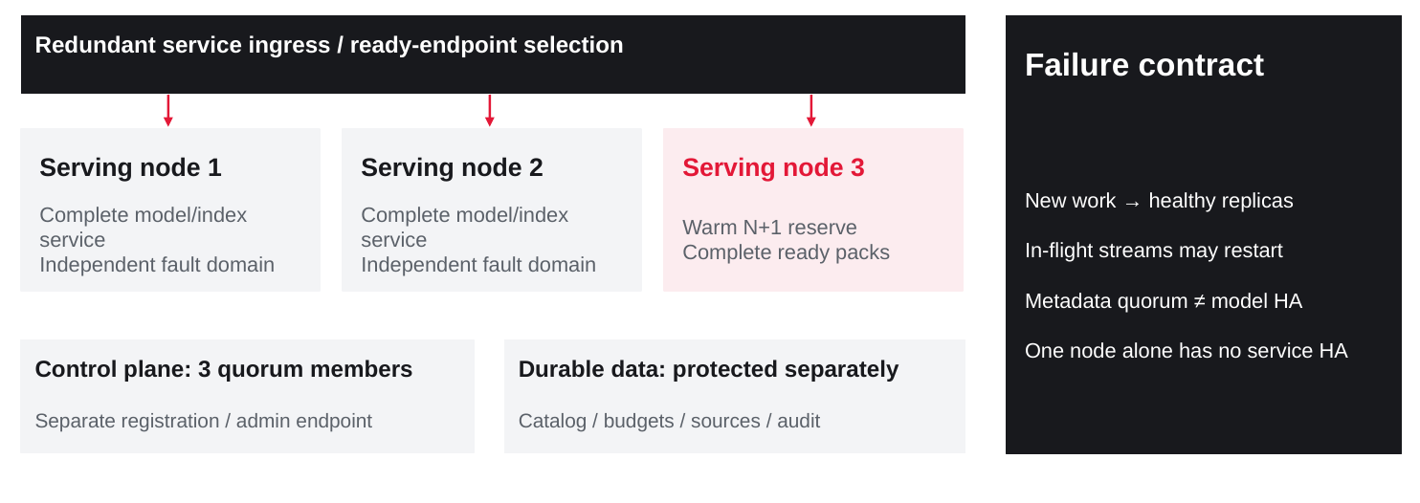
Figure A7. Serving capacity, control quorum and durable data are separate availability systems.
The first scale-out unit is a complete service replica, not an isolated expert shard. For a measured rate q and peak R, N = ceil(R/q) + 1 provides one-node reserve only when one node is a complete ready service unit. A model distributed across two nodes needs reserve at that complete-group boundary.
Failure | Required behavior | Boundary
Worker/device loss | Withdraw invalid endpoint; route new work to a complete warm replica. | In-flight KV/stream may be lost; do not silently substitute another expert.
One control member loss | Retain tested three-member quorum and admission/control behavior. | RKE2 etcd HA does not make the application database durable automatically.
Local mirror/repository loss | Use pre-staged validated artifacts; continue installed service. | Block new deployment when artifacts or trust cannot be verified.
Source/index service loss | Use a valid replica or fail the dependent request. | No silently stale/unauthorized evidence; rebuild only within agreed RTO.

Retain V3 recovery targets as qualification goals, not guarantees: unhealthy endpoint withdrawal within 10 seconds; new-request service on a warm replica within 30 seconds; acknowledged metadata RPO 0 only under a validated synchronous durable design. Hardware-fault rate and long-term availability require more evidence than a soak test.
Controlling targets: [B1] §9. RKE2 three-server control-plane mechanism: [R3].

TECHNICAL APPENDIX / A8

A8. SanDisk backend: release and support factory
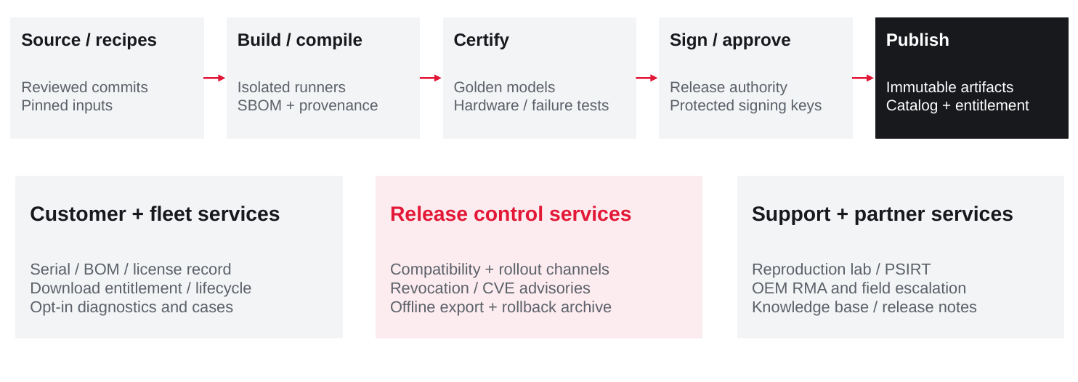
Figure A8. Production publication is separated from ordinary builds and customer inference.
Implement the backend as a product system with controlled source intake, builds, physical qualification, signing, publication and support. The appliance consumes its output under local customer approval; it does not trust a repository to execute arbitrary commands.
Backend service | Required artifacts / authority
Engineering intake and CI | Reviewed source, dependency locks, isolated build recipes, model preparation recipes, compiled outputs, software bill of materials and provenance.
Compatibility / certification lab | Golden model/task suites; supported BOM/kernel/runtime matrices; per-device memory; soak, security, failure and upgrade results.
Release authority / signing | Approved immutable digest set; protected keys/identities; multi-party production approval; revocation and recovery procedures.
Customer/catalog services | Product serial and contract, model license scope, entitlement, release channel, advisory feed and offline export.
Support / OEM / PSIRT | Case workflow, reproduction environment, secure diagnostics, component escalation, replacement/spares and signed remedies.

V3 backend/support ownership: [B1] §§10–11. Repository/signing mechanisms: [R12–R15]. Candidate backend components do not imply an existing SanDisk deployment.

TECHNICAL APPENDIX / A9

A9. Repositories and immutable release records
Use different repositories for engineering source, executable images, large artifacts and customer state. A shared filename or a mutable “latest” tag is not a version contract.
Repository | Contents | Release rule
Engineering Git | OS/image recipes; Helm/manifests; device/platform/runtime source; model certification recipes. | Reviewed immutable source commit; no credentials or private signing keys.
OCI registry / site mirror | Container images, charts, model manifest artifacts; Harbor-compatible candidate. | Digest-pinned deployment; immutable release tags; retain active/rollback references.
Release object repository | OS/recovery images; approved firmware bundles; large model blobs; offline archives. | Authenticated delivery and independently verified digests/signatures.
Catalog / evidence database | Compatibility, license, channel, advisory, evaluation and certification records. | Catalog alias resolves to immutable digest set before deployment.
Customer-local stores | Documents, metadata, indexes, private model packs, secrets and local audit. | Tenant policy and private retention; not the public product catalog.

ProductRelease record—illustrative fields
releaseId: atmos-platform-<approved-version>
trustMetadataVersion: <signed-version>
hardwareProfiles: [D8-<BOM>, E16-<BOM>]
osImageDigest: sha256:<image>
kernelDriverAbi: <qualified-tuple>
oemFirmwarePolicy: <approved-versions-and-recovery>
runtimeImages: [{arch: amd64, digest: sha256:<runtime>}]
modelPackDigests: [sha256:<certified-pack>]
solutionGeneration: <solution-index-api-contract>
rollbackPolicy: <approved-compatible-nonrevoked-targets>
evidenceRefs: [<quality>, <security>, <upgrade>, <hardware>]
The customer DeploymentRecord additionally records site configuration and policy revisions without embedding secret values. The same runtime image can serve multiple compatible ModelPacks; updating weights alone need not rebuild every container. Conversely, a runtime update must revalidate its affected model/driver matrix.
V3 signed-release/compatibility requirement: [B1] §§10–11, 14. Artifact immutability and trust mechanisms: [R12–R15]. Fields are proposed, not an existing schema.

TECHNICAL APPENDIX / A10

A10. Image delivery: factory, connected and offline
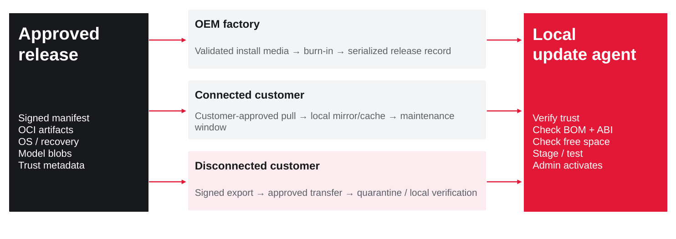
Figure A10. Delivery channels converge on the same customer-local verification and activation contract.
Route | Proposed workflow
OEM factory | Approved signed installer/recovery and runtime bundle → install on named BOM → hardware burn-in → factory DeploymentRecord → shipment without customer secrets.
Connected site | Local admin sees signed catalog → selects approved channel/version → pulls through site mirror/cache → validates all dependencies → stages for a maintenance/canary window.
Air-gapped site | Authorized export on connected staging system → customer-approved media/transfer → quarantine → local trust/digest check → mirror/import all dependencies → administrator activation.

Verify artifact identity, signer authorization, BOM, NPU revision, OS/driver ABI, runtime compatibility, topology, entitlement and free space before exposing any new endpoint. Bundles include all required images and verification material; an offline install must not fetch missing packages from the Internet. OCI images and signed OS/firmware payloads remain distinct artifact types.
OFFLINE TRUST Stage signed root/rotation/advisory metadata on a defined cadence. Expired metadata blocks new release activation until refreshed; installed, authorized service follows its contracted offline policy. Air-gapped revocation is not instantaneous.

V3 offline/platform lifecycle: [B1] §14. RKE2 offline images: [R4]. Verification and metadata: [R13–R15].

TECHNICAL APPENDIX / A11

A11. Factory delivery and first-service setup
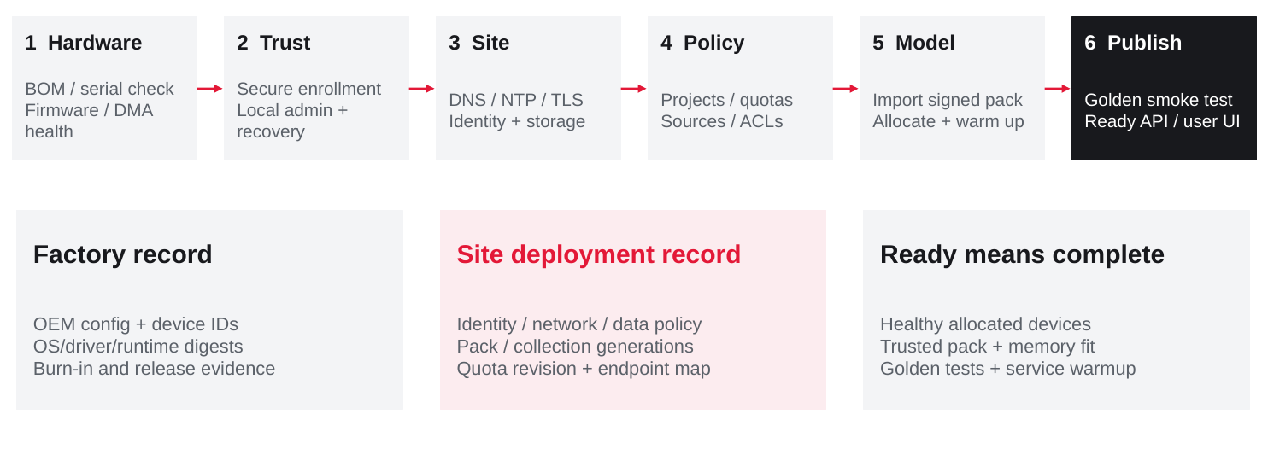
Figure A11. Enrollment and readiness produce a reproducible site DeploymentRecord.
Stage | Completion condition
Factory | Approved BOM serials, firmware/OS/runtime digests, boot recovery and burn-in evidence are recorded. OEM signing/branding/support rights are contractual deliverables.
Site enrollment | Customer administrator establishes trusted local access, recovery procedure and entitlement; temporary bootstrap secrets are rotated or removed.
Site services | DNS/NTP, TLS, identity, data storage, service/management networks and backup destinations pass preflight. Offline identity is addressed explicitly.
Project setup | Tenant membership, API keys, quotas, collection credentials, retrieval policy and approved model aliases are configured and audited.
First service | Signed pack fits assigned devices, runtime warmup and golden tests pass, ACL-safe sample collection works, and endpoint is published only then.

An endpoint’s readiness is a conjunction of model generation, allocated devices, health, memory reserve, trusted code, policy and warmup. A running process or a green Pod alone is not sufficient. After reset or partial-model failure, invalidate readiness before accepting another request.
V3 first-service target and customer/OEM ownership: [B1] §§7–8, 11, 13–14. Workflow details are proposed.

TECHNICAL APPENDIX / A12

A12. Workflow for adding an LLM or model service
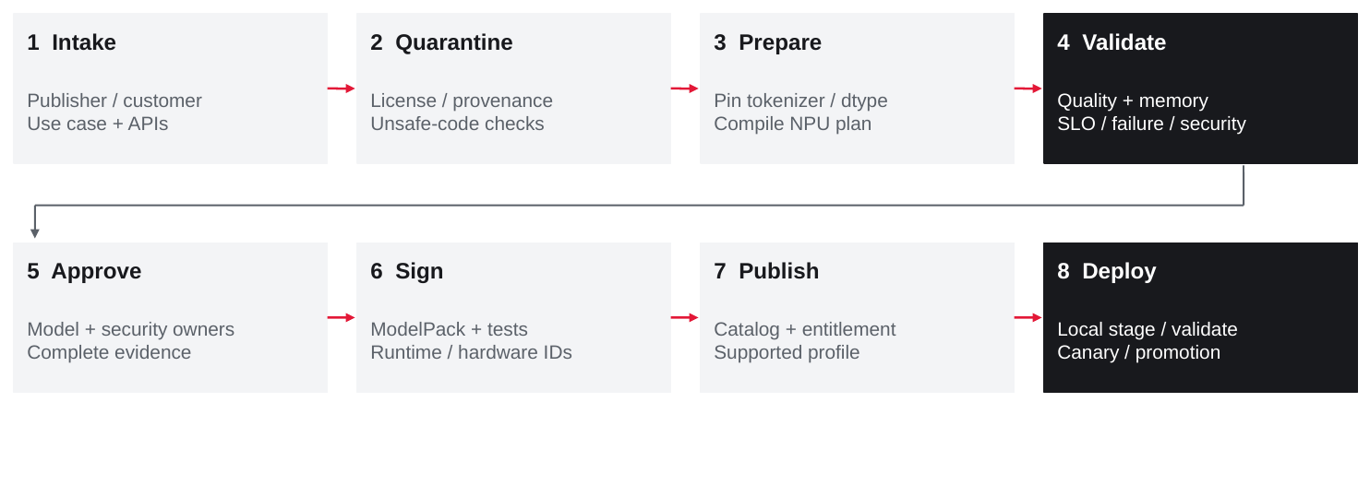
Figure A12. Model intake, compilation, qualification and release are controlled product steps.
Gate | Evidence before signing
Identity / rights | Publisher checkpoint hash; tokenizer/chat template; license and redistribution scope; private-customer restrictions.
Safe intake | No unreviewed remote-code execution; inspect model serialization and inputs; isolate preparation from production secrets.
Native execution | Supported graph/operators; precision/scales; NPU program; per-device weights, KV, scratch and communication plan.
Correctness / quality | Golden expert/operator outputs and full-model/task results; approved tolerance; no hidden GPU/external fallback.
Service envelope | Exact hardware/runtime, prompt/output distribution, context, batch, cache state, concurrent workload, latency tails and failure handling.
Product behavior | Documented APIs/tools/structured-output/streaming limits; cancellation, readiness and upgrade compatibility.
Security / release | Tenant/ACL/tool abuse tests, SBOM/CVE disposition, signature identities, reviewer approvals and rollback record.

The catalog advertises only certified combinations. Customer fine-tunes and quantization changes follow the same path. Private weights stay customer-local or enter a separately authorized isolated build environment; no default upload. Developer-only models cannot be promoted by changing a label.
V3 ModelPack and supported-catalog contract: [B1] §§6–8, 10, 12, 14. Plugin mechanisms: [R10, R11]; signing: [R13].

TECHNICAL APPENDIX / A13

A13. Updating a deployed model generation
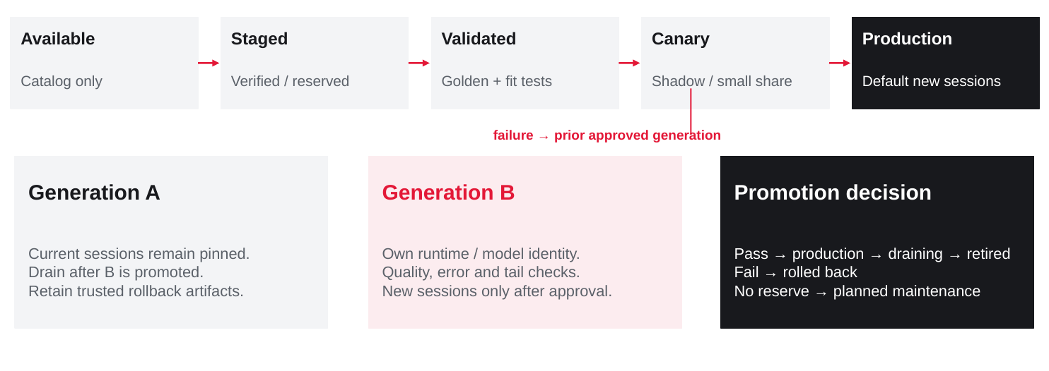
Figure A13. Existing sessions remain pinned; the new generation receives traffic only after its gates pass.
State | Operational meaning
Available / Staged | Catalog advertises metadata; staged bytes are verified and required capacity is reserved.
Validated / Canary | Compatibility/golden tests pass; shadow or bounded traffic compares quality, errors and tails.
Production | Alias points new sessions to the new generation under customer-approved rollout.
Draining / Retired | Old generation takes no new sessions; retire only after in-flight work and retention obligations finish.
Rolled back | Return eligible new work to a prior approved compatible generation. Preserve audit and declare failed-session behavior.

Pin session/model/tokenizer/runtime identity. Where a workflow spans retrieval and tools, record solution and collection generations too, but current authorization and deletion policy always override stale permissions. Do not mutate weights, scales or tokenizer under live sessions.
Canary requires spare compute, memory and storage—not merely two files in a registry. On a constrained single-node appliance, use a declared maintenance window if full old/new readiness cannot coexist. A same-embedding generator/reranker update normally preserves the active index, but quality and interface compatibility must still be evaluated.
RELEASE CONDITION No new-generation promotion below the customer’s quality/security gate. Rollback is limited to approved, compatible and non-revoked artifacts.

Eight V3 lifecycle states and generation pinning retained [B1] §14. Detailed reservation and session rules are proposed extensions.

TECHNICAL APPENDIX / A14

A14. Embedding, index and knowledge updates
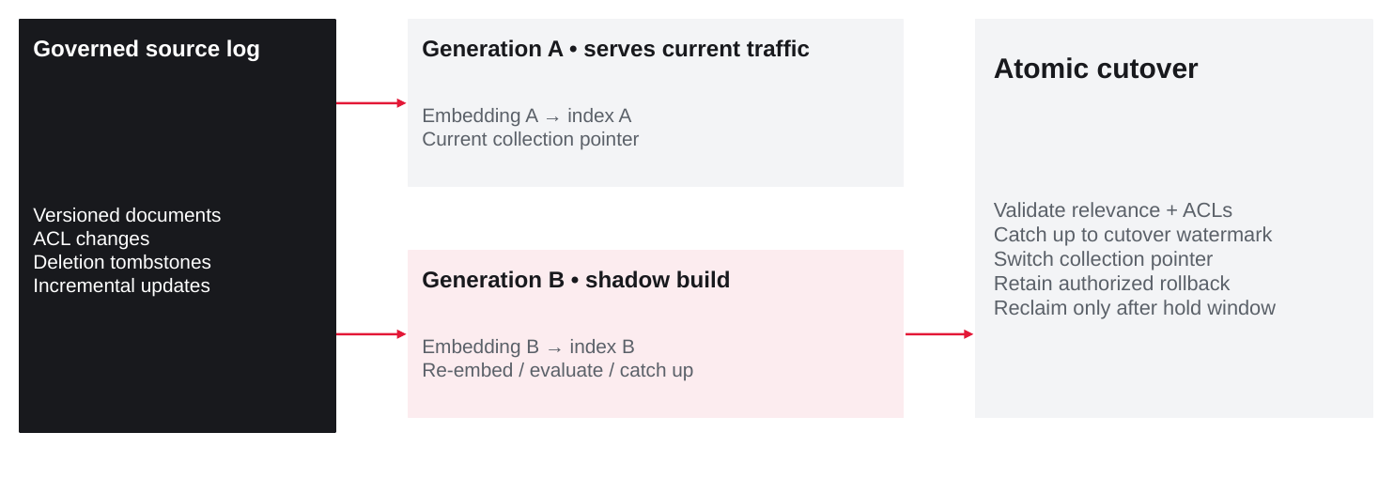
Figure A14. Shadow re-embedding and a durable collection pointer avoid mixing incompatible representations.
An embedding change is also a data-product change. Create a new collection generation, re-embed from authorized source versions, validate retrieval relevance and end-to-end answer quality, and catch up source changes before switching the serving pointer. Parser, chunking and schema changes may require the same migration.

Cutover contract
Maintain an ingestion watermark and source-change log. New documents, changes, deletion tombstones and ACL revisions must reach both active and candidate generations as required. An atomic metadata transaction changes the active collection pointer only after the candidate reaches the chosen watermark and its policy tests pass. Optional dual-read evaluations remain tenant-scoped.

Rollback and deletion
Retain one permitted old generation during the rollback window, but continue enforcing current ACLs and deletions. A rollback must not revive removed documents or old permissions. A legal/retention erase applies across all retained generations and backups according to the customer contract; tombstones and key destruction need a tested policy where used.

Capacity during migration
Budget two index generations, source snapshots, re-embedding compute and temporary ingestion backlog. Do not assume normal interactive and rebuild throughput maxima can run simultaneously. The Serving Manager throttles background work to the qualified mixed-service envelope.
Source lifecycle: [B1] §§8, 12, 14. Watermarks, atomic pointer and tombstone propagation are proposed implementation detail.

TECHNICAL APPENDIX / A15

A15. OS, firmware and platform upgrades
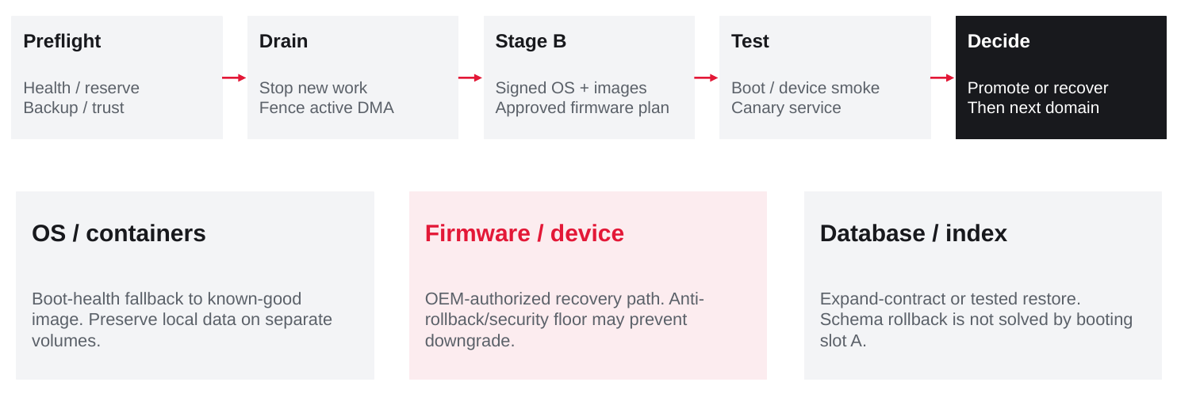
Figure A15. Coordinate the release, but keep rollback mechanisms distinct.
Artifact / state | Upgrade and recovery contract
OS and container baseline | Preflight, stage signed candidate root/images, drain selected fault domain, boot and smoke-test, promote or restore known-good OS. Customer state lives on separate protected volumes.
ATMOS / switch / OEM firmware | Use approved vendor image and recovery tooling; document reset scope, partial-flash handling, anti-rollback floor and replacement procedure. A/B host OS cannot revert firmware.
Metadata database | Use compatible expand-contract migrations or tested backup/restore. Define writable-version overlap and rollback limitations; never assume an old binary can read a new schema.
Model / index contract | Revalidate affected packs and collection compatibility; retain required old/candidate generations before advancing the next domain.

The release controller must confirm surviving service capacity, control/data quorum, backup validity and recovery access before drain. Test power loss during install, truncated images, invalid signatures, loss of registry, device timeouts and failed boot. Security-revoked versions cannot be automatic downgrade targets.
V3 platform workflow, offline and reserve requirements: [B1] §14. RKE2 offline artifacts [R4] and update trust roles [R15] provide component mechanisms, not the complete A/B implementation.

TECHNICAL APPENDIX / A16

A16. Operations, support and outage semantics
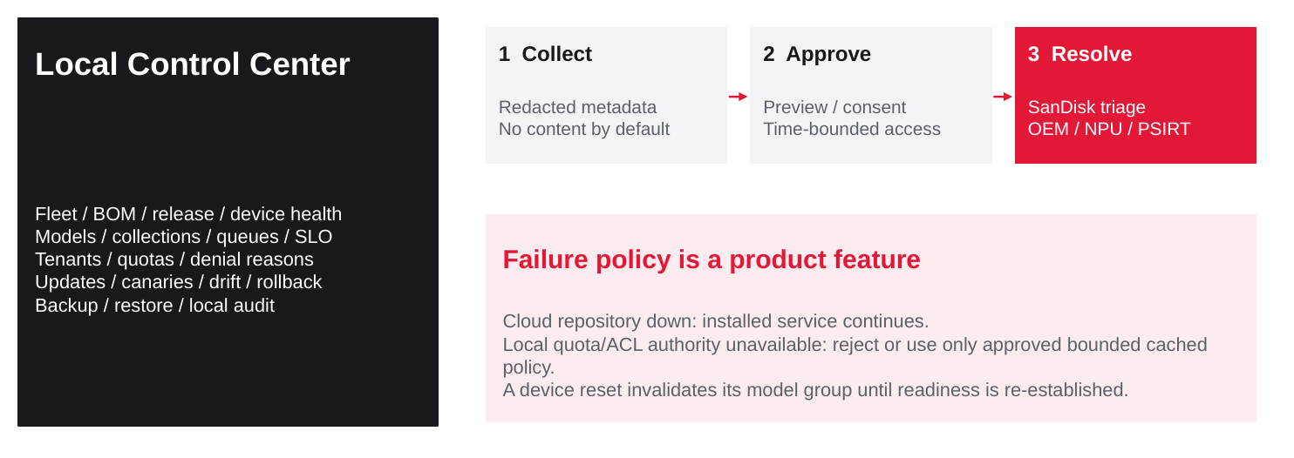
Figure A16. Local operations remain independent of vendor availability; support export is customer-controlled.
Event | Required response
SanDisk catalog/support offline | Continue installed, entitled services locally. Queue metadata-only case actions; do not block inference on a vendor callback.
Local hard-quota authority down | Reject new work or use only pre-approved bounded grants. Settle outstanding reservations after safe reconciliation.
Identity / ACL service down | Honor only explicitly approved still-valid cached policy where safe; deny unauthorized new work. Never bypass tenant checks.
Device / runtime reset | Withdraw affected complete group; fence old DMA/completions; rebuild generation and revalidate readiness.
Support escalation | Preview/redact bundle; customer approval; SanDisk case and reproduction; scoped OEM/NPU/PSIRT escalation; signed remedy and closure evidence.

Control Center exposes inventory/BOM, model and collection generations, policy revisions, denied work, queue delay, admitted throughput, latency tails, memory, thermal/link/reset health, backup and update state. No raw content is logged or exported by default. Diagnostic access is time-bounded, approved and audited; a reverse tunnel is not mandatory.
V3 support/telemetry/security: [B1] §§11–12, 14. Detailed outage responses are proposed product policy, not current service commitments.

TECHNICAL APPENDIX / A17

A17. Build / integrate / verify ownership
Keep all nine V3 software products. Assign an accountable owner and acceptance artifact before each becomes a customer promise. N = new deliverable; M = integrate/modify; V = verify/reuse.
Product | Action / reusable base | SanDisk or partner deliverable | Acceptance artifact
AI OS | M/V • Linux + containerd + RKE2 | Composed signed image, kernel/driver train, bootstrap, A/B recovery and offline installer. | Golden image + install/recovery report
Device Service | N • DRA/CDI or qualified plugin | Driver, queues, group allocation, IOMMU, reset fencing, health and topology. | Device ABI + allocation/fault suite
Model Services | N/M • native NPU backend / vLLM plugin where suitable | Full operator graph, active KV allocator, batching, collectives and supported API behavior. | Certified service profile + golden suite
ModelPacks | N • artifact/CI tooling | Weight/tokenizer/program packaging, precision and memory plan, license, signing and catalog. | Pack schema + evidence + digest
Serving Manager | M/N • gateway/KServe candidates | Readiness, routing, policy, durable reservations, admission and generation lifecycle. | Policy model + overload/failover tests
Knowledge Agent | M/N • connector/index/RAG components | ACL-first ingestion/retrieval, citations, tools, budget inheritance and reindex lifecycle. | SolutionPack + leakage/quality tests
Control Center | N/M • telemetry/inventory components | Local setup, fleet/service view, updates, policy UI and support export. | Admin flows + audited API contract
SDK | N/M • REST/Python clients | Supported endpoint/parameter definitions, job/stream semantics and examples. | Versioned OpenAPI + client tests
Enterprise Support | N/M • portal/registry/case systems | Release catalog, LTS/CVE policy, entitlement, reproduction lab, OEM escalation and spares. | Runbooks + support/RMA drill

Delivery sequence
Build the platform/device/ABI and artifact trust first; add one certified model and one ACL-safe retrieval workflow; enforce quotas; then validate model/index/platform upgrades, disconnected operation and multi-node failure. A broad model/connector catalog is expansion work after the same common contracts pass.
V3 product names/ownership: [B1] §§7, 10–11. This table expands deliverables and evidence without changing the business portfolio.

TECHNICAL APPENDIX / A18

A18. Acceptance tests and decision gates
These tests complement, not replace, V3 performance, thermal, business and support gates. A successful simulator/emulator result is not physical silicon or service certification.
ID | Test | Pass evidence
TK-01 | Tampered image / wrong BOM / invalid signer | Reject staging or boot according to policy; preserve known-good recovery and auditable denial.
TK-02 | Device reset with active DMA | No stale completion accepted; no cross-tenant mapping; group withdrawn and safely requalified.
TK-03 | Concurrent hard-budget requests | Aggregate issued reservations never exceed the configured hard budget; settlement is reconciled after crash/cancel.
TK-04 | Tenant spoof / ACL revoke / injection | Identity headers cannot override verified claims; unauthorized evidence and unapproved actions are blocked.
TK-05 | Complete native model service | Golden task outputs, declared API features and per-device memory/SLO profile pass on the exact release.
TK-06 | Model canary failure / in-flight session | Old sessions retain approved generation; new promotion stops; valid rollback restores eligible new service.
TK-07 | Embedding cutover with live changes | No mixed embedding schema; candidate reaches watermark; deletions/ACLs remain enforced after cutover and rollback.
TK-08 | Interrupted OS / firmware update | Tested OS recovery and separate firmware procedure; data compatible or restored; no unsafe security downgrade.
TK-09 | Air-gapped install / update / expiry | All dependencies imported and verified locally; no unexpected network call; new invalid metadata rejected; installed offline policy honored.
TK-10 | Worker/control/storage failure | Complete replicas, reserve and durable data satisfy the declared fault policy; no false seamless-KV claim.
TK-11 | Support / replacement exercise | Redacted bundle and one case reach correct owner; reproduce, issue approved remedy, replace/sanitize component and close evidence.

DECISIONS TO CLOSE Approve the OS/distribution and isolation baseline; name the native-runtime commitment; select a repository/trust design; approve hard-budget/offline policies; assign the nine product owners. Keep V3 prices, service rates and launch claims gated.

V3 G1/R1 performance and recovery contracts remain controlling [B1] §§5, 9, 19–20. Test IDs and evidence detail are proposed additions.

TECHNICAL APPENDIX / SCHEMAS

Technical annex: ModelPack and deployment records
Illustrative schema for design review only. These fields are not an existing released API or Kubernetes CRD. Digest placeholders must be replaced by signed immutable references in any implementation.
kind: CertifiedModelPack
identity:
model: <publisher-and-checkpoint-revision>
tokenizerDigest: sha256:<tokenizer-and-chat-template>
programDigest: sha256:<compiled-npu-program>
weightsDigest: sha256:<weight-manifest>
precision: <weights-activations-accumulation-kv>
compatibility:
npuRevision: <qualified-revision>
firmwareAbi: <qualified-abi>
runtimeDigest: sha256:<runtime>
topologyProfiles: [<qualified-domain-or-mesh>]
resources:
perDeviceHbfBytes: <budget-vector>
perDeviceWorkingBytes: <kv-buffers-scratch-vector>
certifiedShapes: <input-output-context-concurrency>
service:
apiProfile: <supported-parameters-and-stream-contract>
solutionCompatibility: <index-and-policy-contract>
evaluationDigest: sha256:<golden-quality-slo-tests>
rights:
licenseRef: <approved-license>
tenantScope: <public-catalog-or-private-tenant>
release:
signerPolicy: <approved-identities>
rollbackTargets: [sha256:<compatible-approved-pack>]
supportChannel: <production-or-lts>
evidenceRef: <certification-record>

Local DeploymentRecord
Record appliance serial/BOM; OS, kernel, driver, firmware and runtime identity; allocated device IDs and reset epoch; ModelPack and solution digests; collection generation; secret references; tenant/policy revision; endpoint; readiness evidence; update approvals; backup location and recovery result. Do not place secret values, prompts, private signing keys or raw KV in this record.

Retention rule
Artifacts referenced by production, canary, active sessions, rollback or legal retention cannot be garbage-collected merely because a tag is old. Catalog deprecation, key revocation and customer erasure have separate authorization and audit workflows.
Pack/lifecycle content derives from [B1] §§6, 10, 12, 14. Concrete schema is a new proposal.

TECHNICAL APPENDIX / SOURCES

Evidence and reference register
B1 is controlling. The older PRD and conversation explain history but do not override V3. Public references establish reusable mechanisms only. Ubuntu/RKE2, optional KVM, repo implementations, namespaces, quota accounting and sample schemas are proposed design decisions in this appendix.
[B1] SanDisk ATMOS AI Appliance Strategy PRD v3
Controlling product baseline: sections 7-14; native/retrieval-only service roles, nine software products, HA, security, lifecycle and offline operation.
[B2] SanDisk ATMOS Executive Proposal v3
Visual and executive baseline. Portfolio and commercial claims are unchanged by this appendix.
[R1] Ubuntu security maintenance and kernel lifecycle
Enterprise Linux lifecycle reference only; Ubuntu 24.04 LTS is a proposed engineering base, not an approved ATMOS OS.
[R2] RKE2 requirements
Kubernetes distribution prerequisites; exact version, OS and ATMOS driver matrix must be qualified.
[R3] RKE2 high availability
Three-server control-plane pattern and fixed registration endpoint; does not provide application/data HA by itself.
[R4] RKE2 air-gap installation
Bundled containerd, image archives and private registry deployment patterns.
[R5] Linux VFIO
IOMMU-group-based device assignment; not evidence of ATMOS passthrough, SR-IOV or migration support.
[R6] Kubernetes device plugins
Discovery and allocation framework. SanDisk still builds the ATMOS allocation implementation.
[R7] Kubernetes dynamic resource allocation
ResourceClaim/ResourceSlice model. Topology-aware ATMOS claims require a driver and version-specific validation.
[R8] Kubernetes resource quotas
Namespace object/compute quotas, not LLM-token, daily-spend or NPU working-memory enforcement.

Terminology
Term | Meaning in this appendix
ModelPack | Certified model identity, weights, NPU execution artifacts, runtime/memory/API contract and test evidence.
SolutionPack | Versioned workflow, connector/parser, retrieval/tool policy and compatible model/index profile.
ProductRelease | Signed cross-layer compatibility and distribution record.
DeploymentRecord | Customer-local, secret-free record of what actually runs and who approved it.
Allocation domain | Qualified group of devices and topology constraints; not coherent memory or an HA guarantee.

TECHNICAL APPENDIX / SOURCES_2

References and traceability, continued
[R9] KServe with inference gateway integration
Gateway, inference-pool and usage-accounting precedent. Does not make ATMOS native execution or strict budgets available automatically.
[R10] vLLM platform plugin system
Out-of-tree platform interfaces and compatibility obligations; pin a tested release.
[R11] Tenstorrent vLLM backend plugin
Native platform-backend precedent. Existing TT hardware support is not ATMOS silicon certification.
[R12] Harbor tag immutability
Registry immutability pattern; pin artifacts by digest and protect retained generations.
[R13] Sigstore signature verification
Verify identity, digest and signature. Offline trust material and local policy are still required.
[R14] Sigstore bundle format
Signature-verification material. Bundle plus locally provisioned trust enables disconnected verification design.
[R15] The Update Framework roles and metadata
Root/targets/snapshot/timestamp separation for update trust, version and freshness. Offline refresh windows need explicit policy.
[R16] Envoy AI Gateway API reference
Usage-based request/token accounting; the strict reservation ledger in this appendix is additional SanDisk design.

Traceability to V3
V3 baseline | Appendix implementation detail
§7 customer deliverables / execution roles | A1–A4, A6: local planes, concrete stack, device allocation and APIs.
§8 Knowledge Agent / seven APIs | A4–A5, A6.1, A14: request accounting, source ACLs and collection lifecycle.
§9 HA / capacity after failure | A7: control quorum, complete replicas, durable state and recovery semantics.
§10–11 backend / support | A8–A11, A16–A18: release factory, repos, image delivery, setup, support and tests.
§12 tenant / security | A2–A5, A6.1, A9–A10: isolation, policy, signing and offline trust.
§13–14 OEM brand / upgrades | A8–A15: OEM factory records, lifecycle, ModelPack/index/platform release flows.

UNRESOLVED PRODUCT GATES No public source establishes native ATMOS runtime support, hypervisor passthrough, final kernel/driver versions, production performance or OEM field entitlements. Those require contracts and qualification evidence.

References reviewed 6 October 2026. Public pages can change; freeze versioned docs and source revisions in the implementation record.

