SANDISK INTERNAL • PRE-PRODUCT CONCEPT

ATMOS E3.S Server Architecture Options
Customer deployment, OEM integration, adoption trade-offs and qualification plan

Purpose: define the main ways ATMOS E3.S devices and the full-length ATMOS card could be packaged into enterprise servers, explain what changes electrically and operationally, and provide a customer/OEM decision framework. Architecture values and compatibility remain subject to engineering validation.

September 2026

1. Executive Summary
ATMOS can be exposed to customers through more than one server architecture. The fundamental compute-and-memory module may be similar, but the placement of that module, the PCIe switching boundary, the service unit, and the OEM integration model change the customer experience. The choice should therefore be made from workload communication needs, serviceability, lane budget, power/cooling, software maturity, and adoption friction—not from form factor alone.
Architecture | Customer sees | Primary strength | Primary concern | Recommended role
A. Full-length ATMOS card | One internal accelerator card | Large-model locality; integrated module group | Larger acquisition/service unit; x16 slot and card cooling | Very large dense/MoE or tightly cooperating modules
B. Direct-attached E3.S pool | Multiple front-accessible accelerator devices | Modularity; independent services; incremental capacity | Host lane budget; cross-device traffic can be awkward | One-model/device, retrieval shards, replicas
C. E3.S pool + separate PCIe switch AIC | Front E3.S devices plus internal switch card | Consolidated connectivity and potential common P2P domain | Switch/uplink oversubscription; extra card/cabling | Multi-device pools needing better locality/P2P
D. OEM-integrated switched E3.S | Native server platform with switched front bays | Best operational integration and cleanest product experience | Requires deeper OEM co-design and qualification | Strategic production platform after workload proof
E. Hybrid node | E3.S pool plus full-length ATMOS card | Right-size services and large-model acceleration in one node | Runtime and support complexity | Mixed AI service portfolio
F. Multi-node / rack pool | Qualified ATMOS nodes behind a network fabric | Fleet scale, HA and service-level scheduling | Network, placement, failure-domain and operations cost | Hyperscaler/shared enterprise service

Executive recommendation
Do not force one architecture to serve every use case. Use direct-attached E3.S as the simplest modular baseline, use switched E3.S when the workload or host lane budget justifies it, retain the full-length card for large cooperating models, and pursue an OEM-integrated switched platform only after the device and workloads have survived qualification. Treat the hybrid node and rack-scale pool as deployment patterns built from these qualified building blocks.
Source basis: ATMOS E3.S Product & Workstream Proposal, pp. 6–12; ATMOS E3.S Executive Product & Partner Proposal, pp. 9–10; user-provided PCIe-switch/E3.S topology slide. Internal planning assumptions require validation.

2. The Hardware Mental Model
The easiest way to avoid confusion is to separate three independent questions:
Question | What it means | Typical choices
Where is compute physically packaged? | Where the NPU, HBF, LPDDR and local control physically live. | Eight modules on one full-length AIC; one module per E3.S device.
How are devices connected? | Which PCIe path links each device to the host and to peers. | Direct CPU/root-port lanes; separate switch AIC; switch integrated into motherboard/backplane.
How does software group them? | Whether devices act independently or cooperate on one logical service. | Independent replicas/shards; EP/TP group; host-routed pool; rack-scale service.
E3.S and PCIe are not alternatives. E3.S is a device form factor/service model; PCIe is a host/device interconnect. A PCIe switch is an active routing component that may or may not sit between the E3.S device and the CPU.

Terminology customers and solution architects must understand
Term | Plain-language definition | Why it matters
AIC (add-in card) | A board installed in a PCIe expansion slot. | Can contain the whole ATMOS accelerator or only a PCIe switch.
E3.S bay/device | A front-serviceable EDSFF device location / module. | Defines modular service and density; does not guarantee protocol, lanes or power.
Backplane | Board behind the front bays connecting devices to power/data paths. | Can be passive routing or contain active components depending on OEM design.
MCIO | High-speed connector/cable system used to carry PCIe-class signals between boards. | Cable/connector, not a switch.
PCIe root complex / root port | Host-side PCIe connection infrastructure, usually associated with a CPU socket. | Determines host locality and possible peer path.
PCIe switch | Active routing device with one or more upstream/downstream ports. | Aggregates devices; may enable a common P2P domain; introduces shared uplinks.
Bifurcation | Splitting a wider host port into multiple independent narrower links. | Alternative to using a switch when the platform supports it.
Retimer | Signal-conditioning device used to extend high-speed links. | Improves signal integrity; does not perform switch routing.
NUMA | CPU/memory locality in multi-socket servers. | Host buffers, interrupts and control threads can be local or remote to a device.
P2P | Device-to-device transfer without a host-memory copy when platform/driver allow it. | Important for cooperating E3.S devices; must be verified, not assumed.

3A. Full-Length ATMOS Accelerator Card
Eight compute-and-memory modules and their local PCIe switch are packaged into one internal accelerator card.
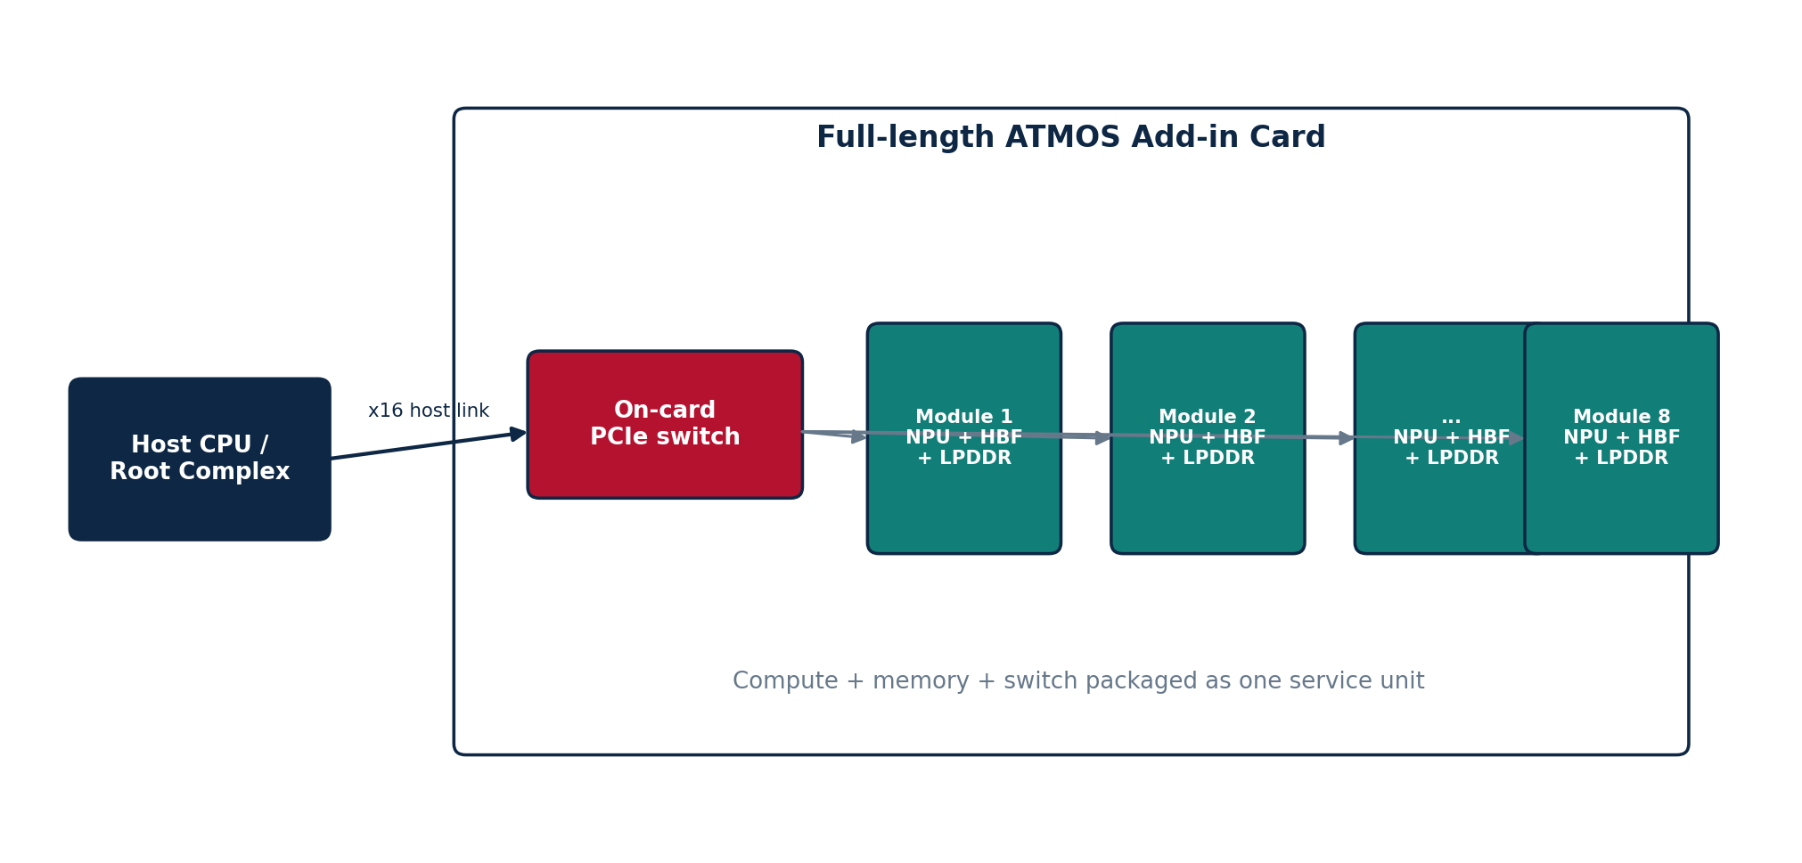
Dimension | Design interpretation | Customer implication
Service unit | One internal full-length accelerator card | Procure, install, qualify and usually replace at card granularity.
Host attachment | Wide host PCIe link (current concept: x16 planning direction) | Consumes a premium accelerator slot and associated power/cooling budget.
Module communication | On-card switch among modules | Frequent module-to-module traffic may stay within the card boundary if supported.
Model topology | Best aligned with one large dense/MoE model or tightly cooperating group | Reduces need to spread a single model across many front-bay devices.
Operations | Internal service access | Less modular than replacing one front E3.S device.

How a customer will perceive it
The customer sees this as a conventional accelerator purchase: one larger unit that owns a substantial model-capacity and compute domain. It is conceptually closest to how customers already think about GPU accelerator cards, even though the internal memory hierarchy is different.

Benefits
- Strong locality among the eight modules compared with a server-wide distributed pool.
- Large aggregate HBF capacity in one service boundary.
- Simpler software grouping for a large model than managing many individually addressable bay devices.
- Fewer host-visible devices can simplify orchestration.

Issues / trade-offs
- Requires a supported full-length slot, power delivery, mechanical retention and card cooling.
- Larger blast radius and replacement unit when one internal element fails.
- Potentially higher acquisition granularity for customers who only need one small service.
- Internal module switching still has bandwidth and scheduling limits; aggregate HBF is not uniform shared memory.

Adoption path
Qualify the exact card mechanics, power, airflow, PCIe topology, firmware/driver, module exposure, internal P2P behavior and failure isolation in an OEM accelerator-capable server.
Best fit: Very large dense/MoE models, high-capacity serving groups, or workloads with frequent module-level coordination.

3B. Direct-Attached E3.S Device Pool
Each ATMOS compute-and-memory module is packaged as an independent E3.S device and receives its host PCIe path through the server backplane/cabling without a required common switch card.
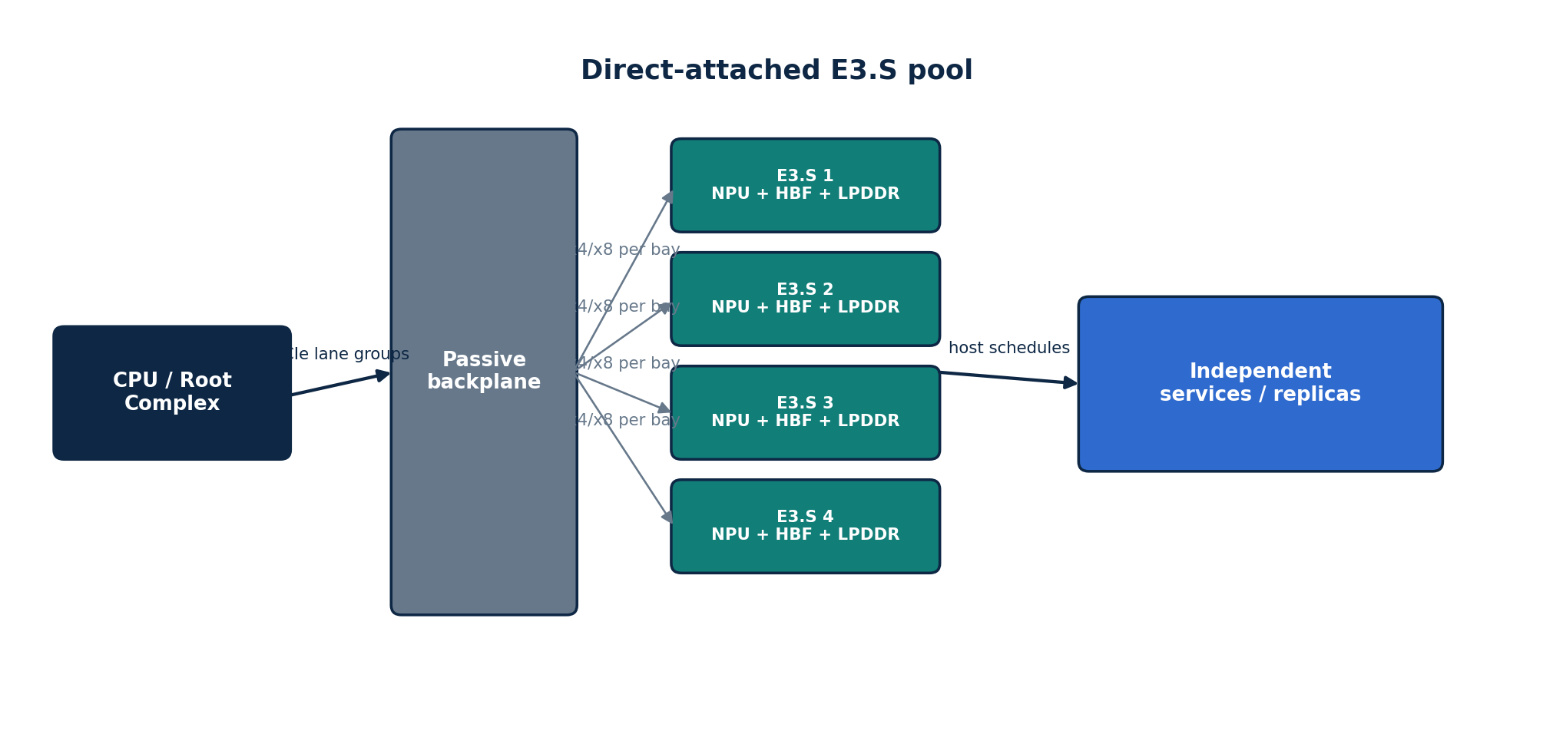
Dimension | Design interpretation | Customer implication
Service unit | One front-accessible E3.S device | Add or replace capacity in smaller increments.
Connectivity | Per-bay PCIe lane group to host/root-port infrastructure | Host lane budget and slot/backplane wiring become critical.
Communication pattern | Host-routed independent requests are the natural first design | Best when devices do useful local work and return compact results.
Model topology | One model/service per device or homogeneous replicated/sharded pool | Easy horizontal scaling when cross-device synchronization is low.
Operations | Device-level inventory, health and replacement | Potentially attractive operational model, but safe accelerator service semantics still need qualification.

How a customer will perceive it
The customer sees a modular accelerator pool: similar operationally to front-bay devices, but each device contains compute and persistent HBF rather than being merely a storage drive.

Benefits
- Fine-grained capacity and service scaling.
- Independent failures can potentially be isolated to a device.
- Good match for retrieval shards, embedding/reranking pools, tenant/domain models and replicas.
- Can preserve expensive PCIe slot space for NICs or larger accelerators, depending on OEM lane design.

Issues / trade-offs
- Large model sharding across many E3.S devices can recreate communication complexity.
- CPU/root-port lane budget may limit population or force narrower links.
- Cross-root-complex P2P is platform dependent; host staging may appear if direct P2P is unavailable.
- Power and thermal density in front bays must be proven under sustained compute, not inferred from SSD precedent.

Adoption path
Start with one device, then 4–8 independent devices. Validate per-bay lanes, enumeration, DMA, NUMA placement, device health, sustained thermal behavior and host-routed fan-out/merge. Add cross-device model parallelism only after the simple pool is understood.
Best fit: Independent neural services, vector/refinement shards, model replicas and workloads where each device can reduce data locally before returning compact results.

3C. E3.S Pool Behind a Separate PCIe Switch Add-In Card
Front-bay ATMOS E3.S devices connect through a passive backplane/MCIO cabling to a PCIe switch mounted on a separate AIC.
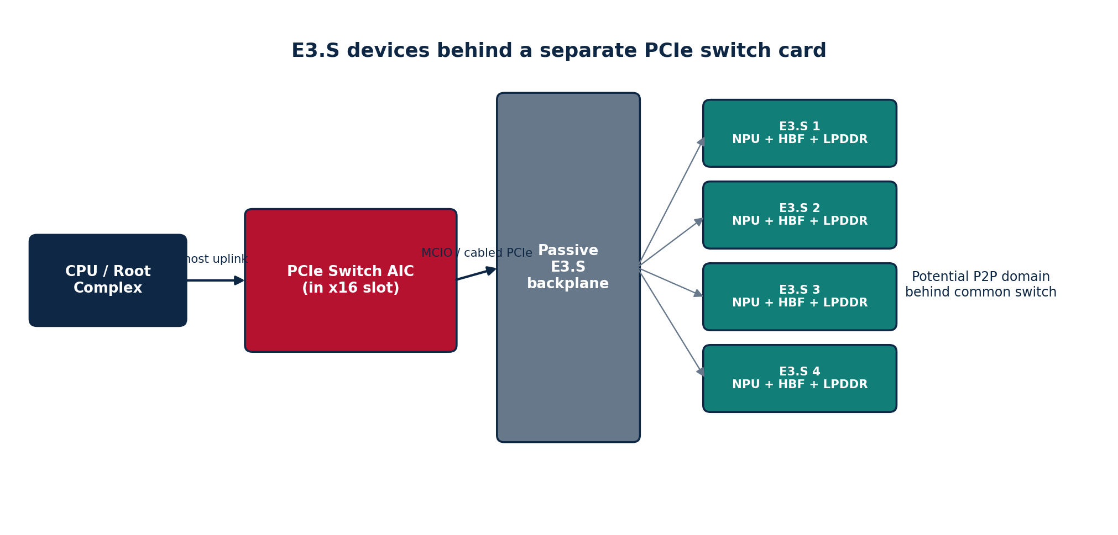
Dimension | Design interpretation | Customer implication
Service unit | Front E3.S devices + shared switch card | Devices remain modular, but connectivity depends on a second field-replaceable/shared component.
Host attachment | One or more switch uplinks to motherboard PCIe slots | Can aggregate many device links onto fewer host root-port connections.
Peer path | Potential device-to-device path behind a common switch | Attractive for cooperating devices if endpoint, switch and driver support are verified.
Oversubscription | Aggregate downstream width may exceed host uplink width | Excellent for local P2P or independent local compute; not all devices can simultaneously push full rate to host.
Operations | Backplane + cables + switch AIC + devices | More parts to qualify and monitor than direct-attached bays.

How a customer will perceive it
The customer sees modular front devices, but with a dedicated connectivity subsystem. This can look like a purpose-built accelerator shelf inside one server: serviceable devices at the front, with a PCIe fabric behind them.

Benefits
- Can reduce pressure on limited CPU root ports by aggregating downstream devices.
- May keep peer traffic inside the switch domain rather than traversing CPU root complexes.
- Allows E3.S modularity while giving the pool a more explicit local fabric.
- Potential retrofit path when the motherboard was not designed with enough native E3.S accelerator connectivity.

Issues / trade-offs
- Shared uplink can become a host-traffic bottleneck.
- The switch adds power, cost, firmware/management dependencies and another failure domain.
- Cable/backplane/signal-integrity complexity increases.
- P2P must be validated end-to-end; a common switch alone does not prove runtime support.
- The switch card consumes an internal PCIe slot that could otherwise hold a NIC or accelerator.

Adoption path
Use a dedicated lab fixture to measure one-device, simultaneous-device, host-bound and peer-bound traffic separately. Publish the lane map and oversubscription ratio. Only promote this to a customer architecture when P2P, reset, error isolation, firmware lifecycle and switch health are supportable.
Best fit: Multi-device pools where host lane consolidation matters or where device-to-device locality can materially reduce model-parallel or shard-exchange traffic.

3D. OEM-Integrated Switched E3.S Platform
The PCIe switching function is designed into the OEM motherboard, riser or active backplane instead of being supplied on a separate switch AIC.
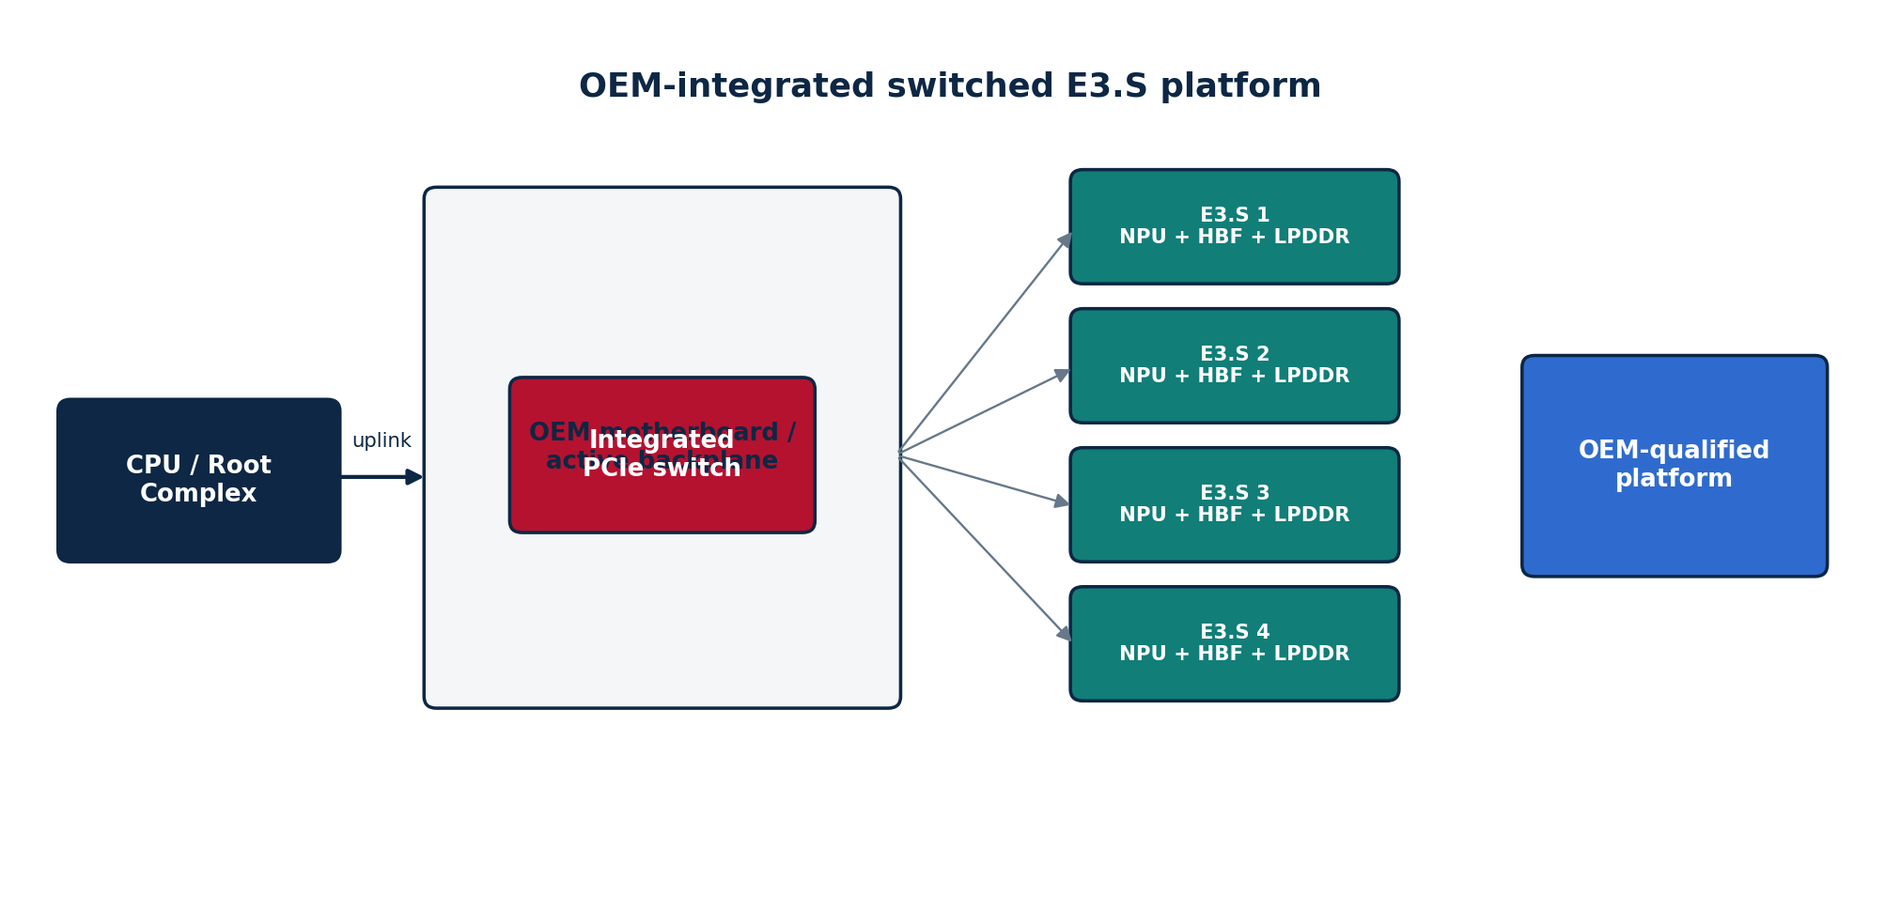
Dimension | Design interpretation | Customer implication
Platform integration | Switch/backplane are part of the qualified server design | Cleaner production experience and fewer unsupported field modifications.
Lane planning | OEM controls root-port allocation, retimers, switch uplinks and device population | Potentially best signal integrity and mechanical/thermal optimization.
Management | BIOS/BMC can natively inventory switch and device health | Enterprise support model can be stronger than an engineering retrofit.
Upgrade model | Bound to the OEM's qualified platform generation | Less flexibility for arbitrary component swaps.
Procurement | Server SKU / solution configuration | Customer buys a complete supported node, not a collection of experimental parts.

How a customer will perceive it
The customer sees a productized server solution rather than an adapter experiment. This is the most natural architecture for enterprise adoption if workload proof justifies deeper OEM co-design.

Benefits
- Best opportunity for clean cable routing, thermal design, firmware coordination and support ownership.
- Potentially better serviceability and telemetry than a retrofit.
- OEM can optimize switch hierarchy and population rules for the intended E3.S accelerator density.
- Simpler customer procurement and support escalation.

Issues / trade-offs
- Requires the deepest OEM engineering commitment and qualification cycle.
- Server design may become specific to one platform generation or supplier.
- Changes to power class, lane width or form factor can require a new server qualification.
- Customer adoption is gated by OEM availability, firmware maturity, supply chain and support policies—not just ATMOS silicon readiness.

Adoption path
After workload and single-node proof, work with one primary OEM and one alternative OEM to define exact lane maps, power/thermal envelopes, BIOS/BMC integration, firmware update/reset procedures, service limits and supported device counts.
Best fit: Production enterprise deployment when a repeatable workload and credible device volume justify OEM platform investment.

3E. Hybrid ATMOS Node
A single server contains a modular E3.S ATMOS pool and one or more full-length ATMOS cards, each used for the workload it handles best.
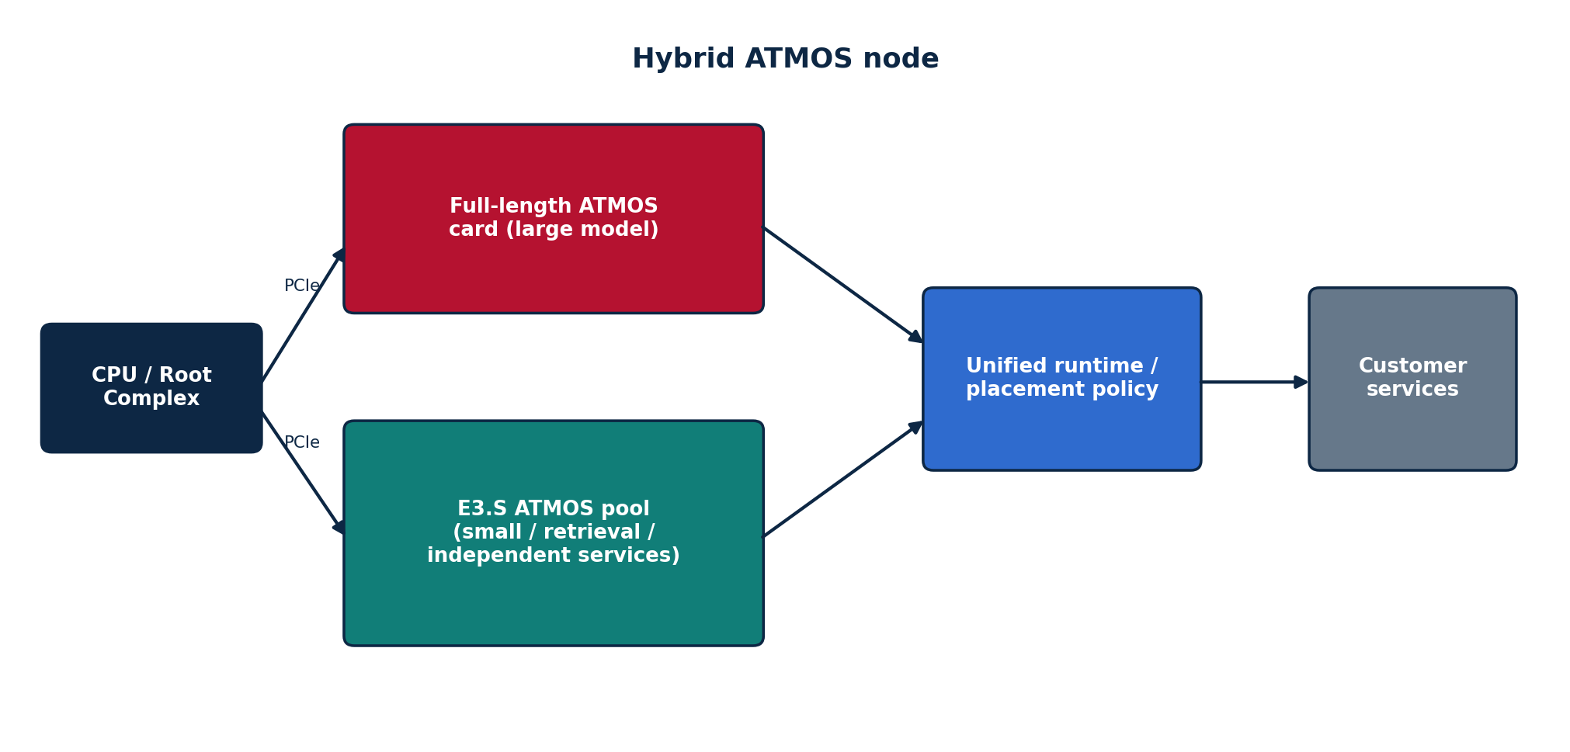
Dimension | Design interpretation | Customer implication
Large-model path | Full-length ATMOS card | Use for a large dense/MoE model needing module locality.
Modular services | E3.S ATMOS pool | Use for search/refinement, embeddings, smaller models, guards or independent services.
Runtime | Placement/routing layer chooses device class | Customer sees one node but software must manage two accelerator resource types.
Capacity planning | Separate pools and failure domains | Can right-size each workload rather than overprovisioning one universal device.
Operations | More SKUs and dependencies | Higher qualification and support complexity.

How a customer will perceive it
The customer sees an AI service node with specialized accelerators: a large internal accelerator for heavyweight generation and a pool of front-bay devices for role-specific or independently scalable services.

Benefits
- Can avoid forcing small services onto expensive large accelerators.
- Lets one chassis support multiple AI pipeline stages.
- Creates a migration path while the E3.S and full-card product tracks mature at different rates.
- Potentially attractive for RAG pipelines: retrieval/refinement on E3.S, large generation on full card.

Issues / trade-offs
- Two device classes, drivers, firmware flows and capacity pools complicate operations.
- Routing policy can create stranded capacity if workloads do not match planned ratios.
- Failure and upgrade coordination are more complex.
- Economics must include the complete node, not isolated device efficiency.

Adoption path
Use only after both component classes work independently. Define stable runtime resource classes, health reporting and placement rules, then run complete-node power, failure and SLO tests.
Best fit: Mixed portfolios where large-model serving and smaller/retrieval services coexist at meaningful utilization.

4. Architecture F - Multi-Node / Rack-Scale ATMOS Service
Rack scale is not a new E3.S electrical form factor; it is the deployment layer above a qualified node. The architecture question becomes how many devices belong to one service shard, which failures require rerouting or rebuild, and when network fan-out/merge dominates the benefit of local HBF.
Customer concern | What must be answered
Scale | Does useful throughput scale with added nodes, or does fan-out/merge/network contention become the limit?
Availability | What capacity remains after one device/node fails? How fast is rebuild or re-registration?
Placement | Are complete replicas, independent shards, or distributed model groups used?
Networking | NIC bandwidth/latency, RDMA/transport support, switch oversubscription, cross-rack path and congestion.
Operations | Fleet inventory, firmware rollout, health, telemetry, drain/replace, capacity reserve and security.
Economics | Accepted work per rack, watt and dollar after HA reserve, networking and support.
Customer message: do not sell '8 devices = 8× bandwidth' unless the workload actually executes independent shards in parallel and the host/network merge path sustains the result.

5. Side-by-Side Customer Decision Matrix
Decision dimension | Full-length card | Direct E3.S | E3.S + switch AIC | OEM-integrated switched E3.S | Hybrid
Acquisition granularity | Large | Small | Small devices + shared switch | Complete server solution | Mixed
Serviceability | Internal card | Front device | Front device + internal switch | OEM-native | Mixed
Best communication locality | Inside card | Host-oriented | Behind common switch if supported | OEM-designed switched domain | Depends on placement
Host lane pressure | One wide card link | Potentially high per device | Aggregated via switch uplink | OEM-optimized | High overall complexity
Large model fit | Strong candidate | Weak as lead use case if sharded | Possible but communication-sensitive | Possible if OEM fabric is adequate | Strong via full card
Independent shard/service scaling | Moderate | Strong | Strong | Strong | Strong
P2P potential | On-card | Platform dependent | Potentially good | Potentially best-supported | Mixed
Power/cooling challenge | Accelerator-card thermal design | Per-bay sustained compute density | Devices + switch card | OEM co-designed | Highest whole-node complexity
Adoption friction | Familiar accelerator pattern | New E3 compute-device concept | New E3 device + switch subsystem | Lowest once OEM-qualified | Higher software/ops complexity
Primary proof needed | Internal module path | Per-bay path + thermals | Oversubscription + P2P | OEM support + service lifecycle | Runtime placement + whole-node TCO

6. What Customers Should Think About
A customer should not begin with 'Which ATMOS form factor is fastest?' The right questions are:
- What is the service unit: one model per device, a shard per device, or one model spanning several modules/devices?
- How much data stays local to HBF/NPU, and how many bytes must cross PCIe or the network per accepted request?
- Does the workload need frequent device-to-device communication, or can each device work independently and return compact results?
- Which latency target matters: TTFT, TPOT, p99 query latency, batch completion, or end-to-end workflow latency?
- What remains when one device, switch, card or node fails?
- What is the supported population under sustained power and airflow, not just the number of physical bays?
- Who owns firmware update, reset, error handling, BMC inventory, security, sanitization and RMA?
- Which infrastructure cost actually disappears if ATMOS succeeds: GPU cards, DRAM, SSD I/O, server count, rack space, energy, or downstream ranking work?
- Does the architecture remain beneficial after availability reserve, integration effort and OEM support cost?

7. Adoption Model by Architecture
Phase | Direct E3.S | Switched E3.S | Full-length card | OEM-integrated
1. Lab discovery | 1 device on approved host; prove local compute/memory path | Switch fixture with 2–4 devices; characterize lane map | Single card in approved accelerator server | Not required yet
2. Node validation | 4–8 independent devices; host fan-out/merge | Multi-device contention + P2P tests | Large-model serving-group tests | OEM engineering sample / platform definition
3. Operational qualification | Thermals, resets, firmware, replacement | Add switch health/failure/service procedures | Card reset/failure and module degradation behavior | BIOS/BMC/firmware/support integration
4. Customer POC | One or few repeatable services | Only if P2P/aggregation solves a demonstrated issue | Large-model case with clear residency benefit | Use when partner/OEM path is committed
5. Production | Qualified SKU and supported device count | Qualified switch/backplane/cable BOM | Qualified accelerator card SKU | Preferred long-term enterprise node if economics justify

8. Qualification and POC Requirements
Area | Required evidence across every architecture
Mechanical | Form factor, dimensions, slot/bay occupancy, retention, cable clearance, service procedure.
Power | Idle/typical/sustained/peak device and shared-component power; PSU and rail limits.
Thermal | Airflow, pressure, inlet limits, fan policy, temperature sensors, throttling and full-population behavior.
PCIe topology | Actual generation/width, switch ports, root complexes, retimers, shared uplinks and payload efficiency.
P2P / NUMA | Supported peer routes; host-memory staging; CPU/memory affinity; remote-socket penalties.
Firmware / management | Enumeration, reset, firmware update, health, BMC inventory, error isolation, recovery.
Software | Driver/runtime versions, queue semantics, device discovery, Kubernetes/resource model, observability.
Workload | Model/vector footprint, access pattern, context/concurrency, batch, SLO, error/quality target.
Evidence | Measured control separated from modeled ATMOS; assumption owner and version; negative/no-fit results retained.
Economics | Complete-node cost, HA reserve, utilization, support, engineering effort, energy and removable incumbent cost.

9. Recommended Product/Platform Strategy
A sensible product strategy is a portfolio of deployment modes sharing a common device/runtime contract, rather than one universal chassis design.
Near-term | Mid-term | Long-term
Direct E3.S as the lowest-complexity modular proof point; full-length card retained for large-model locality. | Introduce a switch-AIC reference design only if lane consolidation or P2P materially improves a measured workload. Qualify one hybrid node if customer pipeline requires mixed services. | Co-design an OEM-integrated switched E3.S platform when repeatable workloads, projected volumes and support economics justify deeper server integration.

Decision rules
- Choose direct-attached E3.S when the device can work independently and host traffic is modest.
- Choose switched E3.S when a measured problem is solved by lane aggregation or a common P2P domain, and the shared uplink remains adequate.
- Choose the full-length card when one large model benefits from keeping multiple modules within one accelerator boundary.
- Choose OEM-integrated switching only when the server is moving from engineering fixture to supported production platform.
- Choose hybrid only when two distinct workload classes are both large enough to justify their own accelerator pools.
- At rack scale, keep the node architecture stable first; do not hide a weak node behind aggregate fleet arithmetic.

10. Customer-Facing Positioning
Architecture | Suggested customer wording | Wording to avoid
Full-length card | Integrated high-capacity ATMOS serving group for models that benefit from module locality. | 'One card automatically replaces N GPUs.'
Direct E3.S | Modular front-bay compute-and-HBF devices for independently scalable neural or retrieval services. | 'It is just an SSD with an NPU.'
Switched E3.S | A modular E3.S pool with a dedicated local PCIe fabric for connectivity and potential peer traffic. | 'The switch combines all devices into one big memory.'
OEM-integrated | An OEM-qualified ATMOS service node with native platform management and supported E3.S population. | 'Any E3.S server can run it.'
Hybrid | A role-specialized node using E3.S services beside a larger ATMOS accelerator. | 'The mixed architecture is always more efficient.'

11. Partner and OEM Engagement Plan
The partner conversation should progress from topology facts to workload evidence, not from a generic request to 'support ATMOS'.
Step | What Sandisk brings | What OEM / customer must provide | Exit artifact
1. Architecture review | Device envelope, proposed host link, power/thermal range, runtime concept | Exact server topology, bay/slot map, switch/root-port ownership, support constraints | Approved topology and unknowns list
2. Lab configuration | Reference BOM, driver/firmware requirements, workload harness | Engineering configuration, BIOS/BMC versions, cabling/backplane information | Qualified lab build
3. Path characterization | Microtraces and instrumentation needs | PCIe/NUMA/P2P measurements, power/thermal telemetry | Measured path map
4. Workload POC | Frozen workload/SLO/controls | Representative traffic and incumbent baseline | Fit/no-fit result
5. Operational review | Update/reset/failure requirements | Service, security, lifecycle and support owners | Deployment gap list
6. Commercial review | Measured node rate, capacity, power and support assumptions | Pricing, deployment volume, refresh timing, availability reserve | Price/performance envelope and go/hold/stop

12. Open Questions to Resolve with Architecture and OEM Teams
- Which topology is the current product baseline: direct E3.S, switch-AIC E3.S, OEM-integrated switch, full-length card, or a deliberate portfolio?
- What is the approved E3.S/E3.S 2T host link generation and lane width for the intended revision?
- For the switch-AIC concept, what is the exact switch part, host uplink generation/width, downstream port map and oversubscription ratio?
- Which traffic may remain behind the switch, and which must traverse a CPU root complex or host memory?
- Does the runtime expose each E3.S device independently? What peer DMA and synchronization primitives exist?
- What are the sustained per-device and full-population power/thermal limits?
- What is the supported reset / service model for an accelerator device in a front bay?
- Which architecture is the preferred path for search/refinement, which for dense LLM, and which for large MoE?
- What exact OEM configuration will be used as the golden engineering platform?
- Which assumptions should the Bridge Emulator model first: direct host paths, switched paths, or both?

13. Conclusion
The architectural choice is not 'E3.S versus PCIe switch.' E3.S devices always need a host connectivity path. The real decision is where the compute is packaged and where the PCIe switching boundary sits: inside a full-length ATMOS card, directly behind CPU/root ports, on a separate switch AIC, or natively inside an OEM server platform. Each choice changes locality, lane sharing, serviceability, failure domains, software expectations and customer adoption.
The recommended approach is to qualify the simplest topology that satisfies the workload, then add switching or hybrid complexity only when measured evidence justifies it. This creates a credible path from one device to an OEM-supported node and eventually to rack-scale service without turning form-factor flexibility into uncontrolled platform complexity.

Source Basis and Evidence Boundary
- ATMOS E3.S Product and Workstream Proposal: source for one-module E3.S concept, eight-module full-length card, OEM responsibilities, server deployment modes and qualification requirements.
- ATMOS E3.S Executive Product and Partner Proposal: source for one-device-to-OEM-node progression, serviceability/economics boundaries and the rule that form factor alone does not qualify the physical path.
- ATMOS/HBF OEM Platform & LLM Evaluation Plan: source for cloud-first/OEM-proof sequence, hardware swapping boundaries, OEM selection evidence and topology/NUMA measurement requirements.
- ATMOS Bridge Emulator Proposal: source for PCIe switch/oversubscription and topology modeling requirements.
- User-provided E3.S/MCIO/PCIe-switch architecture slide: source for the separate PCIe-switch-AIC topology concept discussed in this proposal.
Evidence boundary: this document is an architecture and adoption proposal. It does not establish that a specific Dell/Lenovo/OEM server supports ATMOS, that the proposed switch-AIC topology is the final product design, or that any topology has measured performance advantage before qualification.

