RACK-SCALE TARGET • RTX POC/MVP • MoE ONLY • SWITCHED E3.S
ATMOS E3.S for MoE Serving
Hybrid expert acceleration for NVIDIA NVL and AMD Helios • RTX as POC/MVP reference
Executive summary
This proposal defines a phased path for transforming ATMOS from a pre-silicon concept into a qualified MoE inference accelerator. The real product target is rack-scale serving on NVIDIA NVL and AMD Helios; an eight-RTX + eight-ATMOS configuration is used only as the POC/MVP vehicle to prove the heterogeneous expert ABI, switched E3.S subsystem, runtime/DMA path and economic threshold. Across platforms, the native GPU tier keeps attention, active KV and the learned router while ATMOS keeps routed-expert weights in HBF and executes their FFNs.
- Product target: earn the product on NVIDIA NVL and/or AMD Helios; RTX is evidence, not the final ROI claim.
- Economic thesis: increase accepted MoE work per unit of GPU infrastructure, then spend the headroom on throughput, KV/concurrency, fewer active GPU units, or lower scale-out traffic while preserving quality, TTFT and TPOT.
- Portability rule: use stock CUDA/NCCL or ROCm/HIP/RCCL; do not modify proprietary GPU firmware/drivers; keep ATMOS outside NVLink/NVSwitch and UALink. Host staging is the guaranteed transport baseline.
- Validation discipline: four grouped POCs progress from a vendor-neutral expert primitive to the switched E3.S subsystem, RTX MVP, and independent rack-scale qualification on NVIDIA NVL and AMD Helios.

Reading map
Part | Question answered | Outcome
Background | Why can an ATMOS expert tier matter? | Value hypothesis, claim boundary and common resource model.
Product target | How does the RTX POC/MVP lead to rack scale? | NVIDIA NVL and AMD Helios are the production targets; RTX is the proving ground.
Part I | How does the switched E3.S subsystem attach? | Gen5 baseline, Gen6 path, DMA/peer rules and OEM/rack gates.
Part II | What changes in the serving stack? | One vendor-neutral workstream with explicit NVIDIA and AMD seams.
Part III | What can the architecture mean economically? | RTX MVP insurance calibration plus a rack-scale translation rule.
Part IV | What evidence is needed before product commitment? | Four grouped POCs ending in NVL/Helios rack-scale qualification.

Background: Why an ATMOS expert tier can matter at rack scale
Large Mixture-of-Experts models create a useful asymmetry: every token activates only a subset of experts, yet the serving system must keep a much larger expert population resident and ready. On GPU systems, those expert tensors compete with attention weights, live KV, graph/workspace and batching headroom. At scale, Expert Parallelism can also add dispatch/combine traffic across GPUs and racks.
ATMOS is not treated as a storage device. Each E3.S worker combines HBF, local LPDDR/SRAM working memory and an NPU. The architectural bet is to keep routed-expert weights beside the NPU that executes them, leaving the native GPU platform to do what it already does well. RTX is used to prove that split first; the production value must then be re-established against the much stronger memory, compute and scale-up fabrics of NVIDIA NVL and AMD Helios.
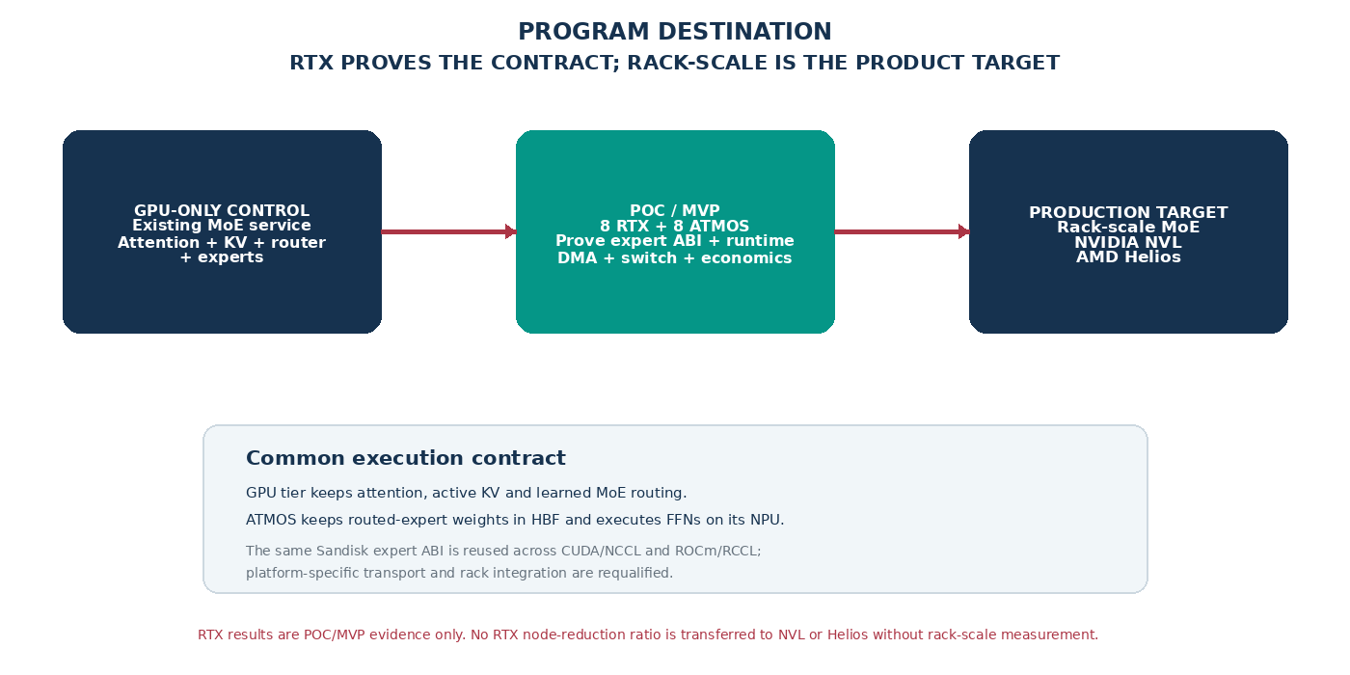

The reference resource envelope
Resource | POC/MVP reference and ATMOS planning view | How to interpret it
GPU memory | RTX POC/MVP: RTX PRO 6000 Blackwell Server Edition, 96 GB GDDR7 per GPU; 8 GPUs = 768 GB nominal distributed GDDR. Rack-scale GPU memory is platform-specific. | GPU memory remains the home of attention, active KV, router/shared state and runtime workspace. Re-run the capacity balance on NVL/Helios; do not transfer RTX ratios.
HBF | Up to 128 GB nominal per E3.S; 1,024 GB nominal across eight. Use 100 GB/application/device = 800 GB study budget. | Distributed expert capacity, not a unified 1-TB GPU memory pool.
HBF read | 200 GB/s source target per module; 1.6 TB/s arithmetic sum for simultaneous local reads. | Local NPU feed potential only; not host, GPU or network bandwidth.
Working memory | GPU GDDR + on-chip caches  8–16 GB LPDDR per module plus local SRAM. | Must separately fit activation tiles, DMA buffers and NPU workspace.
Host link | RTX POC/MVP uses the selected server path. ATMOS endpoint target is PCIe Gen5/Gen6 x4; rack-scale attachment is OEM/platform specific. | Local PCIe branch where approved; otherwise a companion ATMOS tray/service is a separate topology with its own latency and bandwidth budget.
Compute | ATMOS source uses a mixed 64 TOPS/TFLOPS INT8/FP8 label per module. | No tokens/s follows until the exact FFN operator and memory path are qualified.

What we can claim — and what we cannot
Expected mechanism | Defensible target | Not assumed
GPU memory relief | ATMOS-owned expert tensors are omitted from GPU residency, creating useful GDDR headroom. | That every freed GB converts directly into cash savings.
Additional compute | ATMOS NPU performs the expert FFN instead of returning weights to a GPU for execution. | That NPU peak TOPS maps directly to token throughput.
Throughput / node count | At fixed SLO, accepted work per GPU service unit increases enough to serve more demand or reduce required GPU nodes/trays/racks. | A universal node- or rack-reduction ratio, or transfer of the RTX MVP result to NVL/Helios.
TTFT / TPOT | Preserve the existing SLO; improve tails if reduced queueing/expert work is on the critical path. | Automatic per-request latency improvement.
Network locality | A larger local expert bank can reduce remote expert edges when the complete execution graph and transport path are actually local. | That an E3.S switch joins NVLink/NVSwitch or UALink, or eliminates scale-out communication by itself.

Rack-scale is the product; RTX is the proving ground
The common Sandisk contract is intentionally independent of one GPU vendor: vLLM selects the same neural experts, the Sandisk adapter maps those experts to ATMOS workers, and the ATMOS runtime executes them. What changes by platform is the GPU framework seam, transport path, host architecture, rack topology and lifecycle integration.
Stage | Concrete reference | Native GPU fabric / software | ATMOS integration rule
POC / MVP | 8 × RTX PRO 6000-class server + 8 ATMOS E3.S | CUDA / NCCL on a conventional server topology | Prove expert ABI, switched E3.S, DMA, vLLM integration and economic threshold. Not the final product claim.
NVIDIA target | NVIDIA NVL rack-scale family; GB300 NVL72 and Vera Rubin NVL72 are current concrete references | CUDA / NCCL with NVLink/NVSwitch; Grace/Vera host architecture varies by generation | Preserve the NVLink scale-up domain. Use only an OEM-approved PCIe branch or a separately costed companion ATMOS service/tray.
AMD target | AMD Helios reference architecture with 72 Instinct MI455X GPUs and EPYC Venice hosts | ROCm / HIP / RCCL with UALink-based scale-up | Preserve the UALink scale-up domain. Reuse the logical expert ABI; requalify HIP transport, rack attachment, operator and service economics.
ARCHITECTURE INVARIANT — ATMOS does not become an NVLink/NVSwitch or UALink endpoint, and the product does not require proprietary NVIDIA or AMD GPU firmware/driver modifications. Stock vendor stacks are the supported boundary.

HARDWARE PLATFORM
Part I — Switched E3.S subsystem: one building block from RTX MVP to rack scale
Topology | Pros | Cons
Direct E3.S reference | No shared switch/uplink; simple endpoint debugging; useful POC control when host lanes are readily available. | Within an eight-device local design, consumes 32 host lanes; not the production rack-scale baseline; no common managed fabric.
Switched E3.S baseline | One host-facing uplink fans out to eight x4 ATMOS devices; common diagnostics/reset domain; manageable E3.S subsystem for MVP and rack integration. | Adds cost/power and a shared failure domain. It does not place ATMOS in NVLink/NVSwitch or UALink, and the rack OEM must expose a supported host path.

Topology 1:- Direct-attached E3.S pool
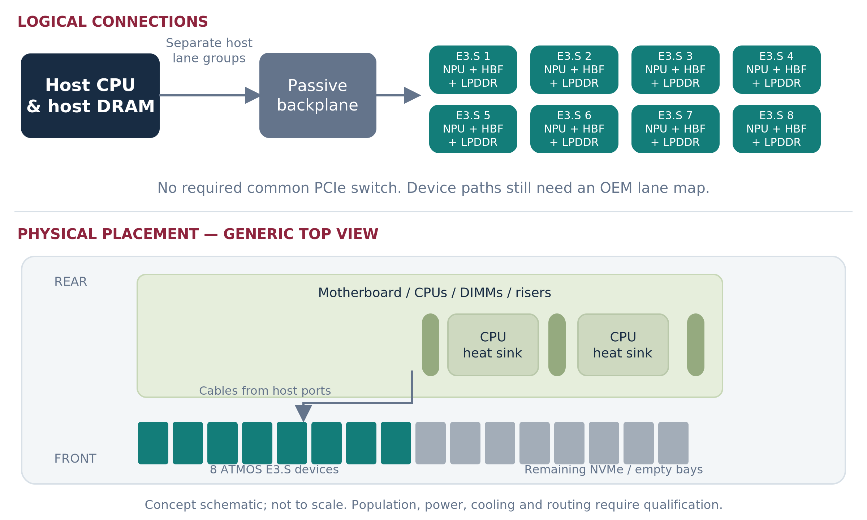

Direct attachment remains useful for early endpoint bring-up because it removes the switch from the debug path. In any local eight-device design, however, eight x4 E3.S endpoints consume 32 host lanes and create eight separately managed paths. The proposed product building block is therefore a switched ATMOS E3.S subsystem with one host-facing uplink and eight x4 downstream endpoints. RTX uses this as the MVP fixture; NVL and Helios use it only when their OEM exposes an approved local PCIe integration boundary.

ARCHITECTURE DECISION Keep direct attachment only as a bring-up/reference path. The reusable hardware building block is a switched E3.S ATMOS subsystem. RTX is the POC/MVP host; production requires an independently qualified NVIDIA NVL or AMD Helios integration. The fully integrated eight-module ATMOS card remains out of scope.

Topology 2 :- Switched E3.S pool
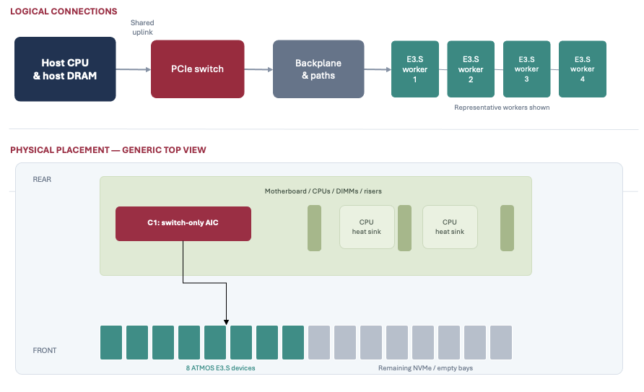

Figure 5. The switch is an ATMOS branch, not a replacement for the GPU platform fabric. The GPU compute domain and NICs remain on their native platform paths. The drawing represents the local-PCIe attachment option; a companion ATMOS tray/service is a separate topology when the rack does not expose a suitable local route.
Gen5 baseline: settle the 48-lane fan-out first
Candidate | Public fit | Role in the program | Adoption gate
Microchip PM50052 | Switchtec PFX Gen5, 52 lanes. Microchip publishes a 52-lane reference design and ChipLink-based enablement path. | Primary engineering-enablement inquiry because the 48-lane target map leaves four lanes of arithmetic margin. | Vendor-confirmed x16 upstream + 8×x4 downstream map, non-NVMe endpoint interoperability, board/firmware support, quote and lifecycle owner.
Broadcom PEX89048 | 48-lane PCIe Gen5 ExpressFabric switch; exact arithmetic for x16 + 8×x4. | Parallel fixed-eight-device alternative to avoid vendor lock-in and compare OEM-supported board availability. | Exact port grouping/configuration, board support, peer/ACS/DPC/reset behavior, diagnostics, quote and support owner.
Microchip PM50100 / larger Gen5 | Up to 100 lanes in the Gen5 Switchtec family. | Only when the actual server port map needs wider uplinks, more endpoints or additional fabrics. | Concrete extra-port requirement; do not pay area/power/cost merely because a larger switch exists.

Gen5 first for the subsystem; Gen6 when the rack path earns it
- A Gen6 x16 host uplink can approximately match the headline line rate of eight Gen5 x4 downstream links, but only when the selected NVL/Helios host path, switch, board/channel and firmware all support the combination. Gen6 is therefore a platform qualification, not a paper upgrade.
- Microchip publicly describes Gen6 Switchtec low-lane-count 48/64-lane families with x2/x4/x8/x16 flexibility. Keep this as the first Gen6 engineering inquiry after the Gen5 subsystem behavior is understood.
- Do not choose Gen6 simply to upgrade a Gen5 endpoint. ATMOS endpoint generation, host/root generation and switch uplink/downlink configuration are independent decisions.
- Treat any larger Gen6 switch as a vendor/OEM roadmap item until an exact orderable part, x4 grouping, board path, firmware profile, supply plan and support owner are returned.
GPU-to-ATMOS DMA qualification: host staging first, peer path optional
The initial MoE architecture does not require ATMOS-to-ATMOS P2P. The critical data path is GPU-to-ATMOS activation dispatch and ATMOS-to-GPU result return. A host-staged path using stock vendor APIs is the mandatory functional baseline. Direct GPU-memory peer DMA is enabled only when documented NVIDIA or AMD interfaces, Linux/IOMMU policy, the ATMOS endpoint and the runtime all support the exact route; lack of that path must never force a proprietary GPU driver or firmware modification.
Gate | What must be proven | Owner(s)
1. ATMOS endpoint | Registered-buffer mechanism; programmable DMA; ordering/completion; reset invalidation; bounded access. Peer-visible aperture only if required by a supported route. | Sandisk silicon/FW + driver
2. Switch fabric | Required x16 + 8×x4 map; diagnostics; ACS/DPC/security policy; containment and firmware profile. ATMOS-to-ATMOS P2P is optional for the first product. | Microchip/Broadcom FAE + OEM
3. OEM / OS | BIOS address windows, IOMMU mapping, NUMA/root reachability, security policy, reset and failure containment for the selected host/rack. | OEM + Linux/platform
4. NVIDIA GPU path | Stock vendor-supported CUDA/driver path. Host-staged pinned memory is sufficient for baseline; optional peer DMA only through documented interfaces. No NVIDIA firmware/driver patch. | Sandisk runtime/driver + OEM
5. AMD GPU path | Stock ROCm/HIP/amdgpu path. Host-staged pinned memory is sufficient for baseline; optional peer path uses documented/open interfaces. No private AMD extension is required. | Sandisk runtime/driver + OEM
6. Runtime semantics | Pinned lifetime, token/expert identity, fences, cancellation, timeout, retry, backpressure and generation-safe cleanup. DMA and NPU completions remain separate. | Sandisk runtime + Tenstorrent
7. Service evidence | Measure producer→expert→continuation latency, bandwidth and queueing under all-eight-device load; compare host-staged and any qualified peer path at identical model/SLO. | Performance + validation

DESIGN RULE The switch is useful for ATMOS fan-out and lifecycle even if no peer DMA is enabled. ATMOS-to-ATMOS P2P is not required for the initial expert architecture. Preserve the native GPU scale-up fabric; if a direct GPU peer route is unavailable, use host staging or change the physical integration rather than modifying proprietary GPU software.

OEM deliverable required before the switch is “settled”
Returned artifact | Required content
Qualified BOM / configuration ID | One exact configuration per stage: RTX POC/MVP fixture, then NVIDIA NVL and/or AMD Helios rack integration. Include ATMOS switch/board, cables/retimers, NICs, boot/storage and spare strategy.
Lane + NUMA map | CPU/root path, native GPU scale-up fabric boundary, ATMOS switch uplink, all eight x4 endpoints, generations, oversubscription and any root/rack crossing.
Power / cooling envelope | ATMOS device/switch budget plus simultaneous GPU workload, airflow/liquid-cooling interaction, BMC telemetry, throttling and service access.
BIOS / BMC / reset contract | Enumeration, address windows, IOMMU/ACS, DPC/AER, FLR/reset domains, secure boot/update sequence and failure recovery for the selected platform.
Support boundary | Who owns ATMOS switch board/firmware, field replacement, diagnostics, spares and escalation. Sandisk owns the ATMOS service boundary; native GPU stack ownership stays with its vendor/platform.
Measured route matrix | Host-staged and any qualified peer paths, with payload, latency, queueing, root/rack crossings and unsupported combinations explicitly listed for each target platform.

Production selection rule
- Choose the production Gen5 switch only after POC 2 proves the required port map, fault/reset behavior and sustained DMA behavior, and POC 3 confirms that the subsystem can support the end-to-end MVP service rate. Lane count alone is not a winner criterion.
- A separate switch AIC is acceptable as the POC/MVP engineering fixture when it shortens bring-up. For rack-scale deployment, prefer the OEM-integrated or companion-tray path that produces the clearest BOM, lifecycle and support boundary.
- Gen6 is a later platform qualification delta, not an MVP blocker. Promote it when the Gen5 uplink is a measured bottleneck and the selected NVL/Helios integration exposes a supported Gen6 root path.
WHAT “SETTLED” MEANS One exact ATMOS switch/board revision and E3.S population, plus a platform-specific integration record for RTX MVP and each rack-scale target: lane/route map, reset/security contract, supported software stack, power/cooling envelope and accountable first-response owner.

Part II — One workstream: Heterogeneous MoE Execution & Infrastructure Efficiency
The proposal intentionally uses one workstream because expert execution, reclaimed GPU memory, locality and infrastructure reduction are one economic chain. The same execution architecture can spend its headroom on more throughput, more KV/concurrency, fewer GPU service units or less remote expert traffic. The software contract is common across NVIDIA and AMD; only the GPU-facing seam and physical platform integration change.
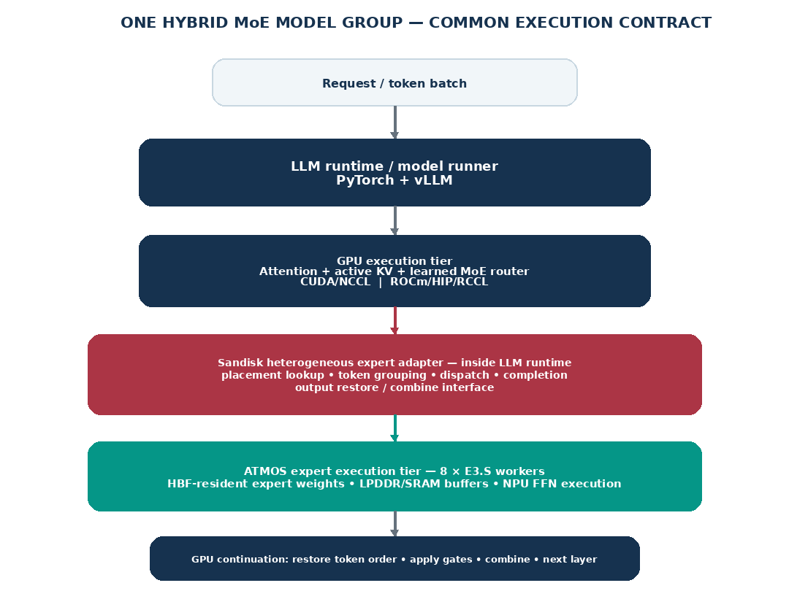

Execution sequence
- 1. vLLM/PyTorch runs the existing attention and shared/non-expert GPU path on the stock platform stack: CUDA/NCCL for NVIDIA or ROCm/HIP/RCCL for AMD. The learned MoE router computes the same top-k expert IDs and gate weights as the GPU-only reference.
- 2. The Sandisk heterogeneous expert adapter, in-process with the LLM runtime, groups routed tokens by model version, layer, expert and physical destination. Placement is deployment-time state; it does not predict future “hot” experts.
- 3. For an ATMOS-owned expert, the adapter submits hidden activations through the Sandisk transport abstraction into registered ATMOS buffers. Host-staged transport is always supported; direct peer DMA is a platform-specific optimization.
- 4. ATMOS moves the required working tiles through HBF/LPDDR/SRAM and the NPU executes the expert FFN. Expert weights stay resident in ATMOS; no request-time weight copy to GPU is required.
- 5. The GPU continuation path restores token order, applies the learned gate exactly once, combines all required top-k contributions and advances to the next dependent layer. The native GPU collective stack remains untouched.
- 6. At deployment scale, complete expert coverage and replica placement are optimized against the actual rack topology, demand and failure policy. RTX POC/MVP placement is not assumed to be optimal for NVL or Helios.
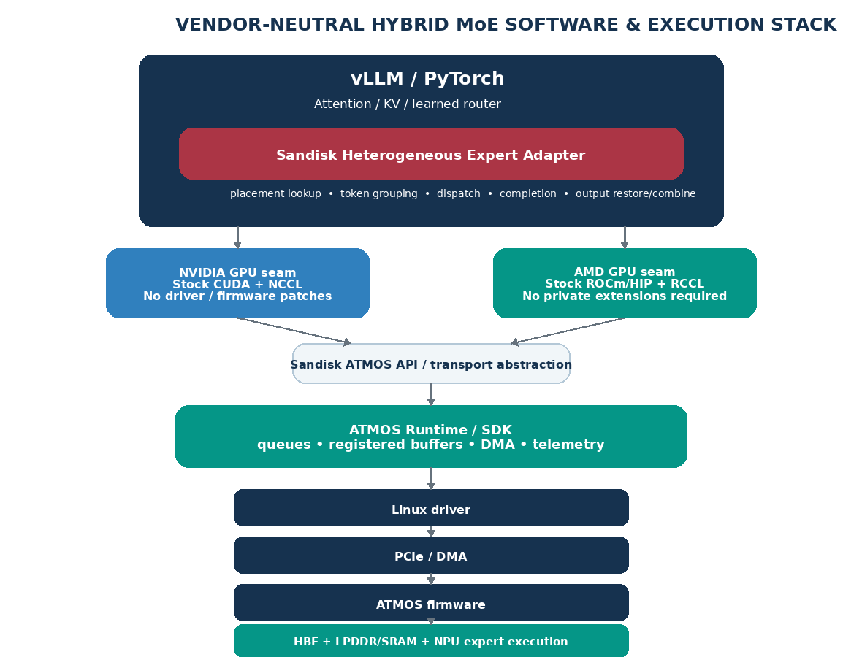

Serving-stack impact: common Sandisk core with NVIDIA and AMD platform seams
Source / note: V = verify/reuse; M = configure/modify; N = new Sandisk/partner artifact. The architecture is deliberately built around stock vendor-supported GPU software. No product feature is allowed to depend on a proprietary NVIDIA or AMD firmware/driver modification; if a peer path is unavailable, the system retains host staging or changes the physical integration.

Domain | Artifact | Action | Common Sandisk requirement | GPU-platform path (NVIDIA / AMD) | Primary owner
Software | Model contract / learned router | V | Freeze checkpoint, tokenizer, expert function, top-k and gate normalization. Trace export only; neural expert selection is unchanged. | NVIDIA: unchanged model semantics.  AMD: unchanged model semantics. | Sandisk
Software | ExpertPack compiler | N | Compile every ATMOS-owned (layer, expert) FFN into a versioned NPU pack with weight layout, precision/scales, scratch budget and golden outputs. | Same pack identity and expert ABI for both GPU ecosystems. | Sandisk + Tenstorrent
Software | vLLM MoE integration | M/N | Add one ATMOS-aware prepare/expert/finalize seam. Skip GPU allocation of ATMOS-owned experts and preserve customer APIs. | NVIDIA: pinned vLLM/PyTorch/CUDA build.  AMD: pinned vLLM/PyTorch/ROCm build. No separate model fork. | Sandisk + Tenstorrent
Software | Heterogeneous expert adapter / placement | N | Map (model, layer, expert) to resident ATMOS owners; group tokens; preserve identity, gates, queue bounds and placement epochs. | Vendor-neutral logic; no CUDA/NCCL or HIP/RCCL rank identity for ATMOS. | Sandisk + Tenstorrent
Software | GPU framework seam | M | Implement packing, result restore/combine, async buffers and explicit synchronization in Sandisk code. | NVIDIA: stock PyTorch/CUDA APIs.  AMD: stock PyTorch/ROCm/HIP APIs. No GPU driver/FW patches. | Sandisk + Tenstorrent
Software | GPU collectives | V | Keep ATMOS outside the GPU collective domain; revalidate GPU rank/group configuration after experts move off GPU. | NVIDIA: stock NCCL.  AMD: stock RCCL. No collective-library modification. | Vendor Runtime
Software | ATMOS SDK + Linux driver | N | Discovery, buffer registration, queue/DMA submission, completion, cancel/error, reset invalidation, telemetry and bounded BAR access. | Identical ATMOS API contract; host build may differ (x86-64 vs Arm64) by platform. | Sandisk + Tenstorrent
Software | Kubernetes allocation | M/N | Expose ATMOS as whole-device resources initially; co-allocate qualified GPU+ATMOS groups and publish topology/health. | NVIDIA: preserve NVIDIA GPU Operator.  AMD: preserve AMD GPU Operator. Sandisk operator remains separate. | Sandisk + Tenstorrent
Software | Operator / lifecycle | N | Stage complete ExpertPacks, publish readiness only for a complete generation, drain/update/rollback/recover and fail closed on missing experts. | Common lifecycle contract; package separately for supported distro/CPU architecture. | SRE/release
Software | Telemetry / evidence | N | Correlate request/layer/token IDs across GPU, transport and NPU; expose queue time, bytes, errors, TTFT/TPOT and accepted throughput. | Common schema so RTX, NVL and Helios results can be compared without changing definitions. | Perf/validation
Hardware | ATMOS NPU + HBF/LPDDR path | V/M | Qualify exact routed-FFN shapes, precision, useful HBF delivery, LPDDR contention, tile/ring buffers, thermals and small-batch behavior. | Independent of GPU vendor; service curve must be re-tested under each host/rack traffic pattern. | NPU + memory
Hardware | PCIe endpoint / DMA | V/M | Fix endpoint generation, address widths, MSI-X, registered buffers, DMA descriptors, ordering, completions and errors. | Same endpoint contract; platform-specific root/IOMMU and host architecture are requalified. | Silicon/FW
Hardware | GPU-to-ATMOS transport | V/M | Host-staged pinned-memory path is the required baseline. Direct GPU-memory peer DMA is optional only through documented interfaces. | NVIDIA: public supported CUDA/driver path only.  AMD: public/open ROCm/HIP/amdgpu path only. No proprietary patch dependency. | Sandisk + OEM
Hardware | Native GPU scale-up fabric | V | Preserve the rack GPU fabric; ATMOS does not masquerade as a native GPU-fabric endpoint. | NVIDIA: do not modify NVLink/NVSwitch domain.  AMD: do not modify UALink domain. | OEM/platform
Hardware | Switch / backplane | V/M | Qualify selected Gen5 switch, x16+8×x4 map, cables/retimers, ACS/IOMMU/DPC, diagnostics and reset containment. | Common ATMOS subsystem; exact upstream/root connection is different on RTX, NVL and Helios. | OEM + switch FAE
Hardware | Server / rack envelope | V/M | Preserve GPU/NIC service, account for displaced storage, mixed-load power, cooling, BMC telemetry, serviceability and failure coupling. | NVIDIA: NVL OEM/Grace/Vera host path.  AMD: Helios ORW/EPYC Venice/OEM path. | OEM engineering
Product | Compatibility manifest | N | Bind ATMOS hardware/firmware, switch, OS, vLLM, model/pack hashes, Kubernetes, workload envelope and known limits. | Separate qualified manifests for RTX MVP, NVIDIA NVL and AMD Helios. | Sandisk release
Product | Economic / support contract | N | Report qualified service rate, SLO, failure reserve, avoidable GPU/rack cost and one accountable support route. | ROI is earned separately per platform; RTX economics are not transferred to rack scale. | Product + SA

Definition of done for Part II
The common expert ABI, vLLM adapter, ATMOS runtime/driver and switched E3.S subsystem must first operate as a reproducible RTX POC/MVP while preserving model quality and the required TTFT/TPOT. Product completion requires the same logical contract to pass on at least one named rack-scale target — NVIDIA NVL or AMD Helios — using the stock GPU stack, a qualified physical route and a measured economic benefit. The two rack platforms are released independently.

Part III — Insurance scenario: RTX MVP calibration and rack-scale translation
The following scenario remains intentionally concrete, but it is now used as an RTX POC/MVP calibration case rather than the final production sizing. It shows how the heterogeneous expert architecture could create measurable headroom with ~235B and ~671B MoE classes. Once the MVP is measured, the same demand, model quality and latency contract is replayed against NVIDIA NVL and AMD Helios using their own GPU memory, scale-up fabric, rack topology and service rate.
Scenario demand
Input | Assumption
User scale | 60,000 active-user population; assume 40% active on a selected day.
Daily calls | 10 model calls per active user → 240,000 calls/day.
Service window | 8-hour concentrated business window → 8.33 calls/s mean.
Peak factor | 3× mean → 25 calls/s peak.
Traffic mix | 80% claims-assistant traffic (20 RPS peak); 20% complex-claims traffic (5 RPS peak).
Availability | Each independently scalable service class carries one complete replica/group of reserve capacity.
Latency contract | Claims assistant: TTFT ≤2.5 s, TPOT ≤45 ms. Complex claims: TTFT ≤5 s, TPOT ≤70 ms.

Source / note: The user count is an enterprise-scale anchor only. Activity, call count, traffic mix, context/output lengths, model choices, node rates and inventory are scenario assumptions for sizing—not customer disclosures.
Two MoE classes — different expert populations and precision pressure
Model class | Published / chosen geometry | Routed-expert raw size | 8-ATMOS implication
Qwen3-235B-A22B | 235B total / ~22B active; 94 layers; 128 routed experts per MoE layer; top-8. | ~227.1B routed-expert parameters → ~227 GB FP8 or ~454 GB at 16-bit. | Both raw expert sets fit inside the 800-GB application HBF study budget, subject to pack/runtime reserve and per-device placement.
DeepSeek-V3-class | ~671B total / ~37B active; 61 layers, first 3 dense; 256 routed + 1 shared expert; top-8. | ~653.9B routed-expert parameters → ~654 GB FP8 or ~1.308 TB at 16-bit. Shared expert excluded from this routed count. | FP8 routed experts plausibly fit in 8 ATMOS under the 800-GB study budget. 16-bit does not; use mixed placement or at least two hybrid nodes / more devices.

Source / note: Qwen geometry is from the published Qwen3-235B-A22B configuration (128 experts, top-8, 94 layers, hidden 4096, MoE intermediate 1536). DeepSeek-V3 configuration publishes 256 routed experts, 1 shared expert, top-8 and 61 layers with the first three dense. Raw bytes exclude scales, packing, metadata, shared tensors and replicas.
WHY THE 700B-CLASS FP8 CASE IS ESPECIALLY INTERESTING
Eight RTX PRO 6000 GPUs provide 768 GB nominal distributed GDDR. A ~671-GB raw FP8 model leaves little practical room for KV, workspace and fragmentation. If ~654 GB of routed experts can instead live and execute on the eight ATMOS devices, the GPU side keeps a much smaller non-expert working set plus live KV. That changes the service geometry even if per-request latency does not improve.

SAME DEMAND • SAME MODEL QUALITY • SAME LATENCY SLA
Baseline and hybrid sizing
The node rates below are explicit planning assumptions for the RTX calibration case and are replaced by measured complete-service rates. They are useful only to set an MVP economic threshold. NVIDIA NVL and AMD Helios are not sized by multiplying or reusing these node ratios.
Service class | GPU-only RTX POC/MVP baseline | RTX + ATMOS MVP target case | Peak demand | Nodes incl. one reserve
Claims assistant — Qwen3-235B class | 1 × 8-RTX node per replica; 1.3 accepted RPS/node at the SLO. | 1 × 8-RTX + 8-ATMOS node; 2.2 accepted RPS/node target. | 20 RPS | GPU-only: 1 + ceil(20/1.3) = 17  Hybrid: 1 + ceil(20/2.2) = 11
Complex claims — ~671B FP8 MoE | 2 × 8-RTX nodes per complete replica/group; 0.7 accepted RPS per two-node group. | 1 hybrid node if the FP8 routed-expert pack and non-expert GPU state fit; 0.7 accepted RPS/node target. | 5 RPS | GPU-only: [1 + ceil(5/0.7)] × 2 = 18  Hybrid: 1 + ceil(5/0.7) = 9
TOTAL | 35 RTX servers = 280 RTX GPUs | 20 hybrid servers = 160 RTX GPUs + 160 ATMOS modules | 25 RPS | 43% fewer servers and 120 fewer RTX GPUs in the target case

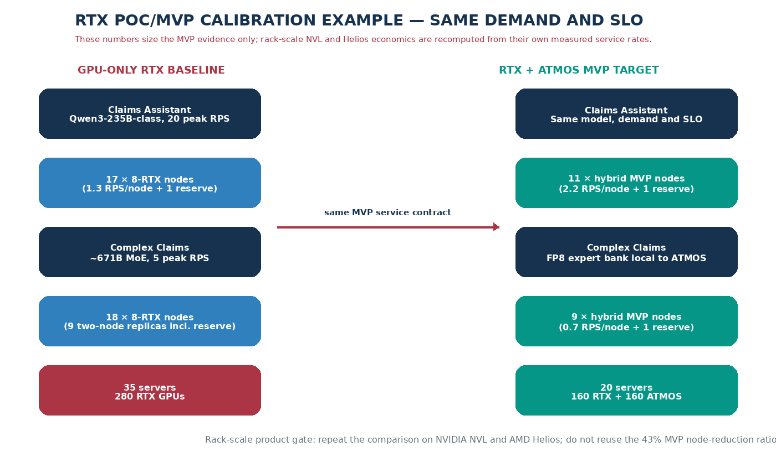

Figure 4. RTX MVP calibration only. The large-model benefit comes primarily from changing the complete replica geometry; the Qwen-class benefit also assumes higher accepted rate per hybrid node. Rack-scale NVL/Helios results must be re-measured from their own control configurations.
Sensitivity: how much node improvement is required to justify the hybrid premium?
Normalize a GPU-only node’s comparable three-year cost to 100 units and assume the hybrid node costs 120 units after ATMOS modules, switch, power/support and platform overhead. Integration NRE is accounted separately. The table shows why the program needs service-rate evidence rather than a capacity-only story.
Case | Qwen hybrid qualified rate | Large-MoE hybrid qualified rate | Hybrid fleet | Node reduction | Comparable cost vs GPU-only
Minimum useful | 1.7 RPS/node | 0.55 RPS/node | 24 nodes | 31% | 2,880 vs 3,500 units → ~18% lower
Target planning case | 2.2 RPS/node | 0.70 RPS/node | 20 nodes | 43% | 2,400 vs 3,500 units → ~31% lower
Stretch | 2.6 RPS/node | 0.90 RPS/node | 16 nodes | 54% | 1,920 vs 3,500 units → ~45% lower

Source / note: These rates and the 20% hybrid-node premium are scenario inputs, not forecasts. The illustrative dollar translation is an RTX-MVP calibration only and must not be presented as NVL or Helios TCO. Rack-scale economics use actual GPU-rack quotes, power, networking, availability reserve and measured accepted service rate.
Operational effect beyond server count
- Fewer RTX nodes means fewer GPU/NIC/server firmware combinations to patch, monitor, spare and recover, but each hybrid node adds ATMOS firmware/driver and switch lifecycle that must be supported as one release.
- A complete local expert bank can reduce inter-node EP traffic for the supported group. That may simplify network sizing and tail behavior, but the saving is counted only when ports/bandwidth or service capacity can actually be removed or avoided.
- More free RTX GDDR can be spent on live KV and active sequences. This can reduce admission pressure and queueing; any TTFT/TPOT improvement must be measured at identical offered load and is not included in the node-count arithmetic above.
- The 16-bit ~671B case is a deliberate limit case: the routed expert bank alone is ~1.31 TB raw, so eight ATMOS devices under the 800-GB study budget do not make it a one-node service. Precision and actual pack size determine the valid topology.
RACK-SCALE TRANSLATION RULE Hold the model, request mix, quality, TTFT/TPOT and failure reserve constant. Compare GPU-only NVL with NVL+ATMOS and GPU-only Helios with Helios+ATMOS. Credit only measured gains such as more accepted tokens/requests per rack, more usable KV/concurrency, fewer active GPU trays/racks, or avoidable scale-out traffic. Do not transfer the 43% RTX-MVP node reduction.

EVIDENCE SEQUENCE
Part IV — Validation plan: four grouped gates from primitive to rack-scale product
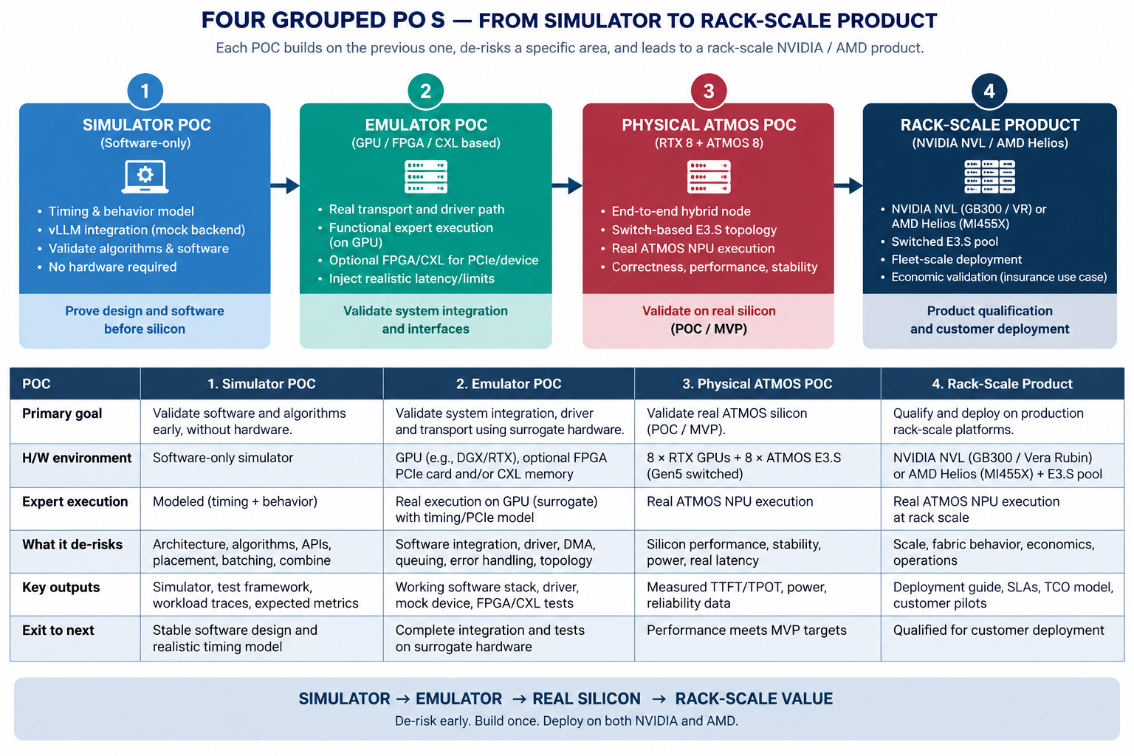POC decision scoreboard
Question | Pass means | If it fails
Can ATMOS execute routed experts correctly behind a vendor-neutral ABI? | POC 1 passes numerical, lifecycle and interface gates. | Stop/narrow the MoE operator or precision scope.
Can eight E3.S devices operate as a manageable switched subsystem? | POC 2 returns one supported switch/BOM/route/failure contract with bounded DMA. | Keep direct/reference hardware for lab use or redesign the subsystem.
Does the RTX MVP create useful end-to-end headroom? | POC 3 preserves SLO and exceeds the economic threshold with measured reuse of freed GDDR. | Do not infer rack-scale value from capacity fit.
Does the architecture improve a real rack-scale service? | POC 4 passes independently on NVIDIA NVL and/or AMD Helios with reconciled rack economics. | No broad product on the failing platform; retain successful platform or narrow scope.

RECOMMENDED PROGRAM SHAPE
Decision summary
This proposal asks one product question: can a switched ATMOS E3.S expert tier materially improve rack-scale MoE serving economics on NVIDIA NVL and AMD Helios while preserving the native GPU stack and service SLOs? The RTX 8+8 configuration is the proving ground and MVP, not the final destination.
- Approve one heterogeneous MoE workstream with one expert ABI, one ATMOS runtime/driver contract and one switched E3.S subsystem. Keep GPU-vendor differences behind a narrow platform seam.
- Hold model quality, TTFT/TPOT and failure policy constant. Count latency improvement only after measurement; the business case may succeed through throughput, KV/concurrency, rack consolidation or reduced scale-out traffic.
- Use Gen5 switched E3.S as the common subsystem baseline and direct E3.S only for bring-up. Preserve NVLink/NVSwitch and UALink; do not require proprietary GPU firmware/driver modifications.
- Fund four grouped POCs: vendor-neutral expert primitive, switched E3.S subsystem, RTX POC/MVP, and rack-scale product qualification. POC 4 — not the RTX MVP — is the product/economics gate.
- Qualify NVIDIA NVL and AMD Helios independently. The same Sandisk model/expert/placement contract is reused, but transport, host architecture, rack topology, orchestration and economics are re-proven per platform.
FINAL PRODUCT STATEMENT TO EARN “For the named MoE checkpoint, workload and rack-scale platform, a qualified ATMOS E3.S expert tier increases accepted service capacity or reduces comparable GPU infrastructure cost while preserving model quality, TTFT/TPOT, availability and supported lifecycle.” This statement is earned independently for NVIDIA NVL and AMD Helios.

