ARCHITECTURE • WORKLOADS • SOFTWARE • OEM • ECONOMICS

ATMOS Program Master Proposal

Executive summary
This proposal defines a phased ecosystem-engagement and product-readiness plan for transforming ATMOS from a pre-silicon concept into a qualified, customer-deployable AI inference and retrieval platform. It recommends starting with direct-attached E3.S devices to prove the value of local HBF and NPU execution, expanding to switched E3.S configurations only when shared connectivity or peer communication provides a measured benefit, and progressing to an integrated ATMOS accelerator card for large models requiring close coordination across multiple compute-and-memory modules. The plan also identifies the customer, OEM, silicon, runtime, operating-system, integration, and validation work required at each phase, with evidence-based release gates to ensure that product and performance commitments are made only after the complete service has been measured and qualified.

Type | Offering | Initial program treatment
A • Direct E3.S pool | Independent local models or representation shards, with fine purchase and service increments. | Primary simple-device and local data-path reference.
B • Switched E3.S pool | Same modular workers with an explicit shared fabric and practical population plan. | AIC switch (Auxiliary /OEM integrated).
C • Hybrid Node | Hybrid service nodes and replicated multi-node pools built from qualified A/B. | Deployment patterns, not additional silicon programs.

What we will deliver first
Within the first approved quarter: a reviewed specification ledger, one reproducible local memory-path study, candidate-refinement evidence, a small dense/MoE control, a bounded software release contract, an exact OEM fixture definition, and a customer-price versus product-cost envelope. Hardware-dependent evidence is delivered only when the relevant component exists.

Technical baseline and open specifications
Parameter | One module / E3.S direction | Eight-module / eight-device sum
HBF capacity | Up to 128 GB nominal; usable budget TBD. | 8 × 128 = 1,024 GB nominal; deck normalizes to ~1,000 GB.
HBF read bandwidth | 200 GB/s source target. | 1.6 TB/s sum only for simultaneous local work.
HBF write / access | Source card table: 64 GB/s writes and 4 KB minimum access. Per-module write allocation not independently qualified. | 64 GB/s aggregate table value; service distributions/endurance TBD.
LPDDR capacity | 8–16 GB, distinct from HBF. | 64–128 GB distributed; upper option is not universal.
LPDDR bandwidth | 50 GB/s per-module direction. Combined-bus versus directional scope unresolved. | 400 GB/s read / write labels in original table; do not assume 800 GB/s simultaneous traffic.
SRAM | Up to 32 MB SoC-local direction; NPU SRAM separately identified. | 256 MB SoC SRAM; 96 MB NPU SRAM in source table. Do not add without ownership/layout confirmation.
Compute | 64 TOPS/TFLOPS mixed INT8/FP8 source label. | 512 TOPS / TFLOPS direction. Datatype, dense/sparse and operator rate must be resolved.
Links | E3.S Gen5/Gen6 x4 candidate; x8 requires a separate supported design. | IMA image: internal Gen6 x4; host Gen5 x16.
Power / mechanics | E3.S vs 2T; final power and dimensions not approved. | 200 W class deck target; full-length label only—slot thickness and exact size TBD.

Offering A — Direct-attached E3.S pool
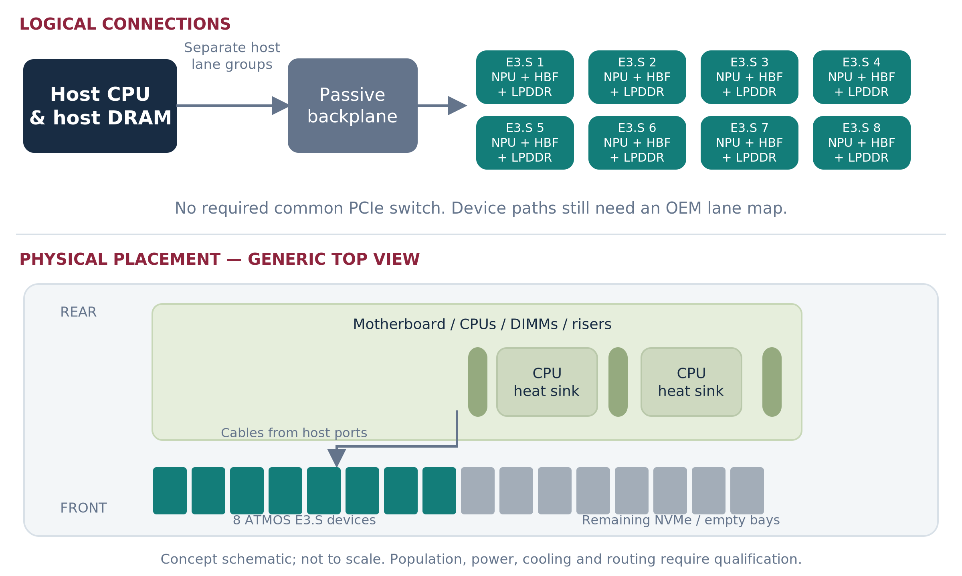
Figure 4. B: one module per bay-mounted device, routed to host ports without a required common switch AIC. [I1 §3B]

Scope | Phase A release candidate | Explicitly deferred
Workloads | P0 local memory-path tests; P1 fixed-candidate scoring. One small dense/MoE model only after kernel and quality gates. | Fine-grained cross-device expert parallelism; arbitrary models; universal GPU replacement.
Capacity / paths | 128 GB nominal HBF, 100 GB planning budget and 8–16 GB LPDDR per worker. Gen5 x4 ≈15.75 GB/s coded ceiling per direction before transaction overhead. | Treating 200 GB/s HBF as PCIe bandwidth; coherent pooling.
Scaling | 1 → 4 → 8 independent workers. Eight direct x4 paths consume 32 host lanes, if physically routed. | Automatic eightfold query throughput for a query requiring every shard.
Software | Sandisk command/driver contract; selected TT primitive backend; one maintained scorer boundary; whole-worker allocation. | Production serving support from a simulator callback alone.
Operations | Safe drain, reset, versioned packs/snapshots, health, error reporting, installation and rollback. | Unqualified surprise removal, fractional sharing and same-device dual-fabric failover.

Offering B — One switched-E3.S family
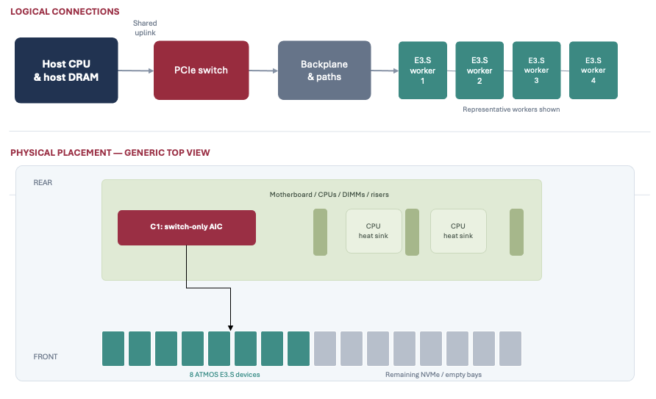
Capability | B baseline | B extension, separately gated
Links | Gen5 x16 host; eight Gen5 x4 endpoint paths. One sufficiently sized switch can connect all eight. | Gen6 host uplink and/or endpoint links only with exact switch, endpoint and OEM support.
Capacity / local reads | 1,024 GB nominal HBF / 800 GB planning budget; 64–128 GB distributed LPDDR. Up to 1.6 TB/s target sum of local reads. | No increase in per-worker memory/compute from adding a switch.
Host traffic | ~126 GB/s aggregate Gen5 downstream coded ceiling versus ~63 GB/s upstream; nominal 2:1 concentration. | Mixed-generation payload measurements; no raw-rate claim of guaranteed nonblocking service.
Workloads | Larger retrieval corpus, independent small-model replicas, P2 multi-vector scoring after primitive proof. | Cooperating MoE subgroup only after peer path, runtime, per-rank fit and complete-group recovery pass.
P2P | Not required for host fan-out / compact result merge. Maintain host-coordinated reference. | ATMOS peer apertures, DMA, ordering, security and software lifecycle must all work.
Availability | Replicate required data/model service across independent nodes or declared domains. | Two switch chips alone are not HA; dual-port same-device failover is separate architecture.

What the switch must earn
With eight existing bays, B still holds eight devices. Its value is lower host-lane consumption, potential local peer routing and a manageable fabric. The saved 16 host lanes have value only if the OEM routes them to a usable NIC, GPU, storage or second fabric connection. Price the switch, cabling, power, support and shared-failure exposure against that benefit.

B1 / B2: ownership and support
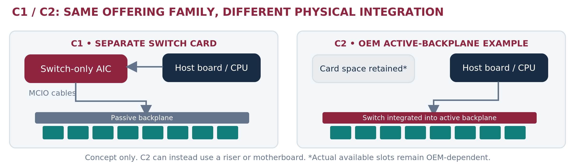
Figure 6. C1 and C2 share the switched-worker concept, but move switching and service ownership. [I1 §§3C–3D]
Responsibility | B1 • Separate switch AIC | B2 • OEM-integrated switch
Physical switch location | Separate board in a supported expansion position; cabled to the backplane. | Motherboard, riser or active backplane designed into the OEM platform.
Who makes the switch silicon? | May be a third-party chip supplier. | May be the same third-party supplier.
Who supplies the board? | Sandisk, partner or OEM—contract must name the provider. | OEM/ODM or its qualified board supplier.
Sandisk owns | ATMOS device requirements, driver/runtime contract, device telemetry and qualification inputs. | Same device/software obligations; coordinated platform lifecycle.
OEM owns | Approved slot, cable/backplane map, full-node power/cooling, BIOS/BMC integration and supported population. | Integrated fabric and node qualification, platform firmware and service configuration.
Service boundary | Devices plus separate switch field-replaceable unit; switch loss can affect the pool. | Devices plus platform-board service scope; precise failure containment must be tested.
Commercial consequence | Potentially faster engineering fixture; extra component/support interfaces. | Deeper platform investment; potentially simpler procurement once qualified.

Switch (Gen5) silicon vendors
The first B map is 1 × x16 host + 8 × x4 ATMOS = 48 lanes and nine ports. All candidates must pass the actual port-grouping, endpoint, power and software gates. The ranking below is a provisional engineering preference—not a price or measured-performance ranking.
Priority / exact choice | Published specification / fit | Reason and condition
1 • Microchip  PM50052 | Switchtec PFX Gen5, 52 lanes /28 ports; published In Production. 48-lane target map leaves four lane positions in arithmetic. | Engineering-first inquiry: documented reference platform and ChipLink path. Require vendor-confirmed x16 +8×x4 map and compatible board firmware.
2 • Broadcom  PEX89048 | PEX89000 Gen5 family, 48 lanes. Exact lane budget for host x16 plus eight x4 workers. | Strong fixed-eight-worker alternative; base fan-out mode and accelerator endpoint use are documented. Promote to #1 if OEM-approved board/support and total cost are better.
3 • Microchip  PM50100 | Switchtec PFX Gen5, 100 lanes; published In Production. More room for wider/more endpoints. | Use when extra GPU/NIC links, expansion or topology require them—not to make the same eight x4 workers faster.
4 • Broadcom  PEX89072 / PEX89088 / PEX89104 / PEX89144 | Gen5 family options: 72 /88 /104 /144 lanes. Width/generation configuration is product-specific. | Consider for hybrid or expanded fabrics after a concrete port map. Larger lane count alone does not justify price, power or board area.
Not a separate ranked part  “Broadcom PEX89000” | This is a family name that includes PEX89048 and larger variants. | Procurement must quote an exact part/revision; do not compare a family label as if it were another 48-lane device.

Gen6 and P2P qualification gates
Choice | First engagement / fit | Required evidence before adoption
Gen5 B baseline | PM50052 and PEX89048 inquiry now; eight Gen5 x4 endpoints, Gen5 x16 host. | Non-NVMe endpoint function; supported map; actual payload/latency/contended behavior; production support owner.
Microchip Gen6 low-lane family | Public 48/64-lane direction supports x2/x4/x8/x16. First Gen6 technical inquiry for eight x4 workers. | Exact orderable part/revision, reference board, supply date, power, mixed-speed map and OEM Gen6 host. Family announcement is insufficient.
Broadcom PEX90000 family / PEX90144 candidate | Parallel Gen6 roadmap/architecture inquiry, particularly for larger or integrated fabrics. | Exact downstream x4 grouping, mode/firmware and approved C port map. Do not assume every large Gen6 part supports the needed map.
Mixed Gen5 endpoints / Gen6 uplink | Candidate B optimization when host traffic is limiting and the OEM has a real Gen6 root path. | Measure usable payload in each direction and mixed-generation translation/queue effects; no automatic zero-oversubscription claim.
Native Gen6 C card | Source target has internal Gen6 links and a Gen5 host connection. | Native endpoint PHY, package/board channel, clocking, firmware, errors and thermals; do not validate by a Gen5 surrogate.

Engagement
Direct means a Sandisk owner runs the technical/commercial interface and receives a controlled deliverable. “Now” means architecture discovery, not an award or purchase. Supplier selection remains contingent on compatibility, quotes and support.
Counterparty / first route | Phase A / immediate ask | Phase B / Phase C deliverable | Sandisk owner
Dell • primary OEM | R770 direct E3.S feasibility, device power and actual lane/reset map. | B1/B2 fabric BOM and support owner; C XE7740-class card/thermal feasibility. | OEM/platform lead
HPE • alternate OEM | Bounded DL380 Gen12 alternative review and comparison quote. | Qualify an alternate only when primary risk or customer standard warrants it. | OEM + procurement
Microchip • Switchtec FAE / applications | PM50052 configuration, tools/access, eight-x4 map and endpoint interoperability workshop. | B: qualified Gen5 fabric. C/Gen6: exact supported part, x4 map and board-design support. | PCIe architect + FW
Broadcom • PCIe switch applications | PEX89048 fan-out and peer-routing review; equivalent RFI to avoid lock-in. | B/C: firmware/EEPROM profile, error/reset map, SDK/support and quote. | PCIe architect + procurement
Selected board partner: Serial Cables first inquiry; LR-LINK / c-payne alternatives | Confirm orderability, non-NVMe endpoint support, cables and configured port exposure. | B1 engineering fixture, then production support scope; C reference/layout guidance as contracted. | Lab/platform lead
Sandisk device, HBF, packaging and manufacturing teams • internal direct | Approve HBF/LPDDR path, PCIe/DMA contract, power envelope and validation vehicles. | B: eight-endpoint behavior; C: card BOM, thermal design, yield/test and lifecycle release. | Hardware + memory leads

Boards, availability and cost boundaries
Board / vendor | Verified public configuration | ATMOS decision / procurement status
Serial Cables / Microchip  PCI5-AD-x16HI-MG5-52 | PM50052 Gen5 reference path; four x4 MCIO connections plus one x16 straddle connection. Microchip documents evaluation/support and ChipLink access. | First enablement inquiry, not a claimed eight-x4 turnkey card. Confirm breakout/reconfiguration and delivery; surfaced maker listing says “coming soon.”
LR-LINK / Linkreal  LRSV9500-4I | Advertised Broadcom PEX89048 Gen5 x16 adapter with four MCIO 8i connectors and support for eight x4 NVMe devices. | Useful exact-fan-out board candidate. Storage advertisement does not qualify ATMOS BAR/DMA/reset/firmware behavior. Request non-NVMe support statement and quote.
c-payne  PM50052 MCIO switch board | 52-lane board; default x16 upstream +2×x16 +x4 downstream; six MCIO 8i plus one MCIO 4i. Maker lists €1,050. | Alternative lab vehicle only after supported eight-x4 configuration/breakout review. Board listing is not eight-x4 ATMOS proof; stock/delivery need confirmation.
c-payne  PM50100 MCIO switch board | 100-lane board; default x16 upstream +5×x16 +x4; twelve MCIO 8i plus one MCIO 4i. Maker lists €2,000. | Only when extra links are useful. More configurable lane capacity does not imply qualified firmware or a lower-cost production route.

P2P has four owners
Sandisk endpoint/FW: peer-visible buffers/apertures, programmable DMA, ordering, completion and reset. Switch vendor: routing, port map, diagnostics and accepted security configuration. OEM/OS: BIOS, IOMMU, address windows and failure containment. Tenstorrent/Sandisk runtime: buffer ownership, dependencies, collectives and safe retry/cleanup.
For retrieval and independent replicas, P2P is optional. For fine-grained MoE it can be important, but it only avoids the host uplink when the producer and consumer are on a supported peer route below that uplink. A GPU outside the fabric does not become local because the switch supports P2P.

Platform preferences and the lane map
Preference / public platform | Proposed use | What the OEM must return
1 • Dell PowerEdge R770 | A and B E3.S investigation. Public configurations include E3.S populations; this is not ATMOS qualification. | Chosen 8/16-device population, exact backplane/riser, direct-versus-switched paths, supported compute power and firmware modifications.
1 • Dell PowerEdge XE7740 | C mechanical/thermal investigation and RTX control. Public platform supports Gen5 accelerator slots and E3.S storage options. | C card fit, power, cooling, slot spacing, partial populations and service replacement. GPU support does not certify ATMOS.
2 • HPE ProLiant Compute DL380 Gen12 | Alternate A/B feasibility and quotation path. Public E3.S-capable server family. | Equivalent supported population and operational contract; promote for customer standard or primary-platform blocker.
3 • Lenovo ThinkSystem SR650 V4 | Contingency A/B path; public Gen5 platform with E3.S options. | Exact CTO configuration and non-NVMe endpoint permission; do not fund a third full qualification without demand.
Conditional • Wiwynn / Quanta-QCT route | Direct platform co-design when the anchor buys ODM infrastructure or B2/C requires it. | Named design/manufacturing ownership, engineering access, firmware lifecycle and support contract; no assumed OEM relationship.

The host lanes saved by B must have a destination
At eight Gen5 x4 devices, A uses 32 routed host lanes; B can use 16. Ask the OEM to identify the specific reclaimed root port and physical connector and price the use: an x16 GPU/NIC, additional storage or another switch domain. If the board cannot reroute those lanes, the economic benefit may be zero.
A switch does not add E3.S slots. Increasing beyond eight devices requires available compatible bays, board paths, power/cooling and a supported population. An external enclosure is a new qualification and support scope, not a free extension of B.

Required workshop exit artifact
Return one configuration ID with BOM, lane/NUMA map, endpoint and uplink generations, switch/retimer/cable revisions, address-space/reset matrix, BIOS/BMC requirements, thermal budget, engineering quote and single first-response owner. Declare unsupported P2P and removal modes explicitly.

PART II • WORKLOAD FIT AND LIMITATIONS

Model residency: use published checkpoints
The table is a capacity screen using representative released models, not a ranking of current model quality or a claim of ATMOS compiler support. Each experiment must pin the checkpoint, tokenizer, license, quantizer and compiled ModelPack. Raw arithmetic excludes scales, mixed-precision tensors, layout, duplicates and auxiliaries.
Model / type | Total / active parameters | 8-bit raw | 16-bit raw | 100 GB local budget
Qwen3-30B-A3B • MoE | 30.5B / 3.3B | 30.5 GB | 61 GB | Both raw screens pass
Qwen3-32B • dense | 32.8B / 32.8B | 32.8 GB | 65.6 GB | Both raw screens pass
Qwen3-235B-A22B • MoE | 235B / 22B | 235 GB | 470 GB | Must partition or use other capacity
DeepSeek-V3 • MoE | 671B / 37B | 671 GB | 1,342 GB | Must partition
Kimi K2 • MoE | 1T / 32B | 1,000 GB | 2,000 GB | Must partition

Published architecture/counts: [R6–R11]. These reference checkpoints are chosen for reproducible size classes, not as a comprehensive latest-model inventory.

One card is not one independently executing memory pool
With the deck’s illustrative 900 GB/card weight allocation, a 671B model passes the raw 8-bit screen while a 1T model does not. With 100 GB/application/module, eight modules instead provide 800 GB. A model fitting either aggregate still needs valid per-rank placement and supported internal transfers. [I2 slide 6; A1]

A larger-model stress case
A hypothetical 1.2 TB compiled pack, at 100 GB usable per module, needs at least 12 modules for capacity alone. A uses at least two eight-module cards; B/C could use at least 12 individually installed modules if the OEM supports that population. Runtime partition sizes, duplicate shared layers, workspace or performance may increase either count.
DO NOT MAKE “1T” A UNIVERSAL SHARDING RULE
Precision and artifact size determine weight fit; working memory and service targets determine whether local execution is viable. Replicas duplicate complete weights. Total parameters, active parameters and bytes actually read per step are different quantities.

LOGICAL KV SIZING • PER-RANK VALIDATION STILL REQUIRED

Long context is a working-memory problem
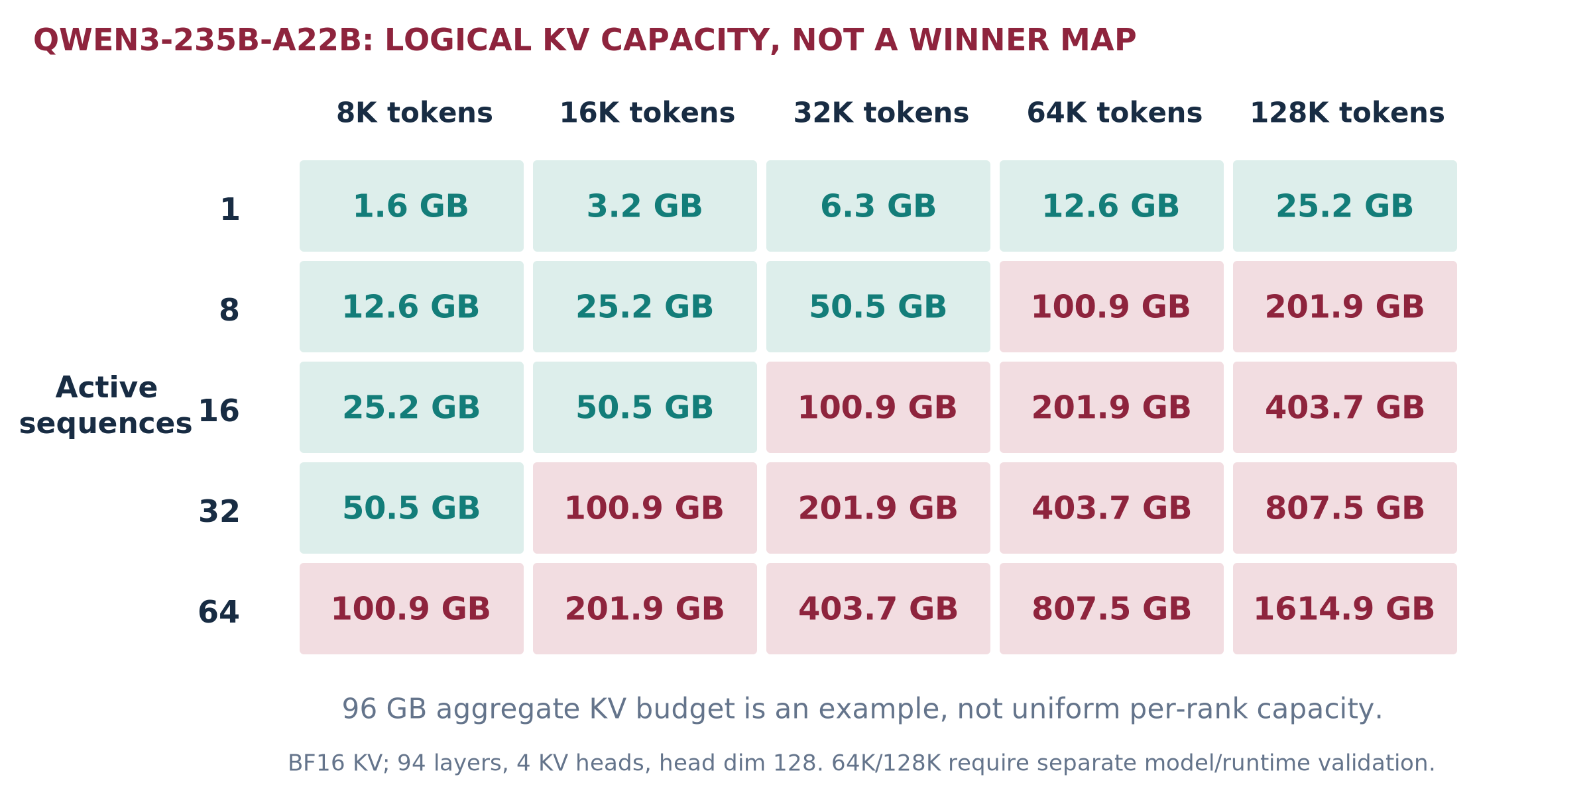
Figure 12. Calculated logical KV requirement using Qwen3-235B-A22B geometry; pink cells exceed the 96 GB aggregate example. [R9; A2]
KV bytes = active sequences × retained tokens × 2 × layers × KV heads × head dimension × bytes/value
Here: 94 layers, four KV heads, head dimension 128, BF16 values. One 32K retained sequence requires 6.31 GB logical KV. A 96 GB aggregate KV allocation holds at most 15 such sequences before layout duplication, block rounding and other constraints. The source deck’s 128-active-job cells therefore cannot be interpreted as this same one-card configuration. [I2 slides 6,8]
For the smaller Qwen3-30B-A3B geometry, the corresponding value is 3.22 GB at 32K. A selected 8 GB KV allocation allows only two such active sequences before other losses. Weights remaining in HBF do not expand LPDDR. Long-context model validation is separate from the arithmetic. [R7; A2]

Mitigate in a controlled order
Use admission and length-aware queues; separate long-context traffic; qualify KV quantization and reusable-prefix sharing; reclaim paused state; then add replicas or supported partitioning. Each changes latency, quality, memory traffic or cost. Cross-tenant cache reuse is prohibited unless explicitly authorized. HBF KV spill is conditional on its restore path, writes and service tails—not a free extension of active memory.

ANALYTICAL BOUNDS, NOT BENCHMARK PREDICTIONS

Dense serving: capacity can fit while speed fails
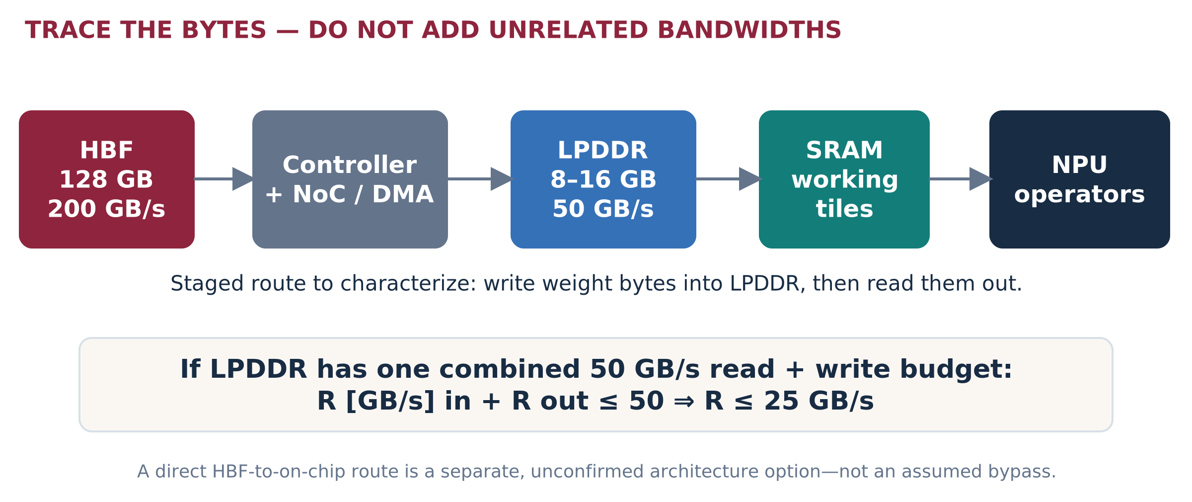
Figure 13. The staged path can constrain useful delivery below media bandwidth. The combined LPDDR-budget interpretation is an explicit assumption. [I3; A3]
32 GB of uncached weights per decode step | Ideal weight-transfer time | Meaning
Direct useful delivery at 200 GB/s | 160 ms / step | At most 6.25 single-sequence output tokens/s from weight delivery alone.
Staged useful delivery at 25 GB/s | 1.28 s / step | At most 0.78 tokens/s from this path alone.
Requested 50 ms step budget | Requires ≥640 GB/s useful delivery | Not feasible under the stated full-streaming 200 GB/s limit.

This is a hypothetical 32 GB delivered weight set, not an exact Qwen artifact. Cached weights reduce those bytes. A microbatch can reuse a weight read across multiple sequences and raise aggregate throughput, but it does not automatically reduce the per-user step time. Computation, attention, KV and scheduling add costs; overlap cannot violate the bottleneck bound. [A3]
Prefill requirement: for a hypothetical 32B-active dense model and 8,192 input tokens, 2 × P × tokens gives about 524 TFLOP of linear-layer work. A two-second processing target requires at least 262 TFLOP/s effective for that work alone, before attention. The mixed “64 TOPS/TFLOPS” source label is insufficient to establish that rate. [A3; I3]

KEEP THE NO-P2P BASELINE HONEST

MoE: residency, routing and grouping
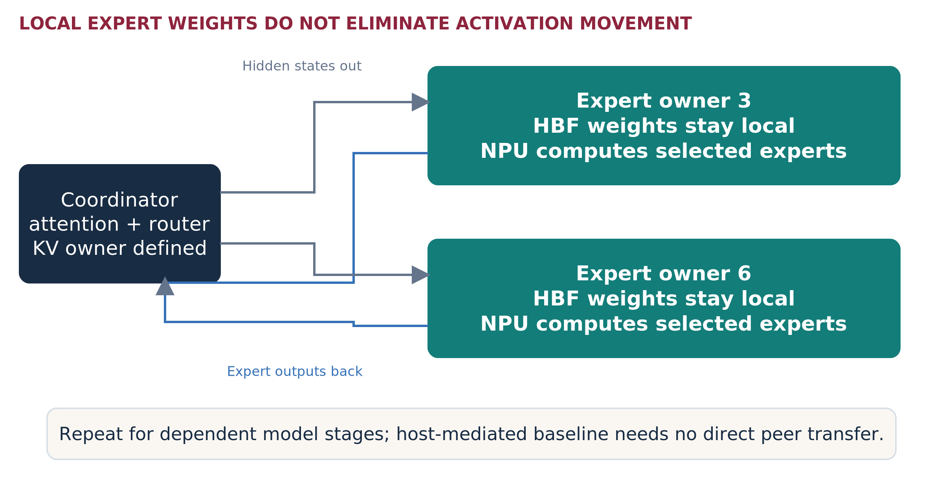
Figure 14. Illustrative host-coordinated expert invocation. Attention/router/KV ownership must be defined; the CPU need not perform all neural math. [I6; R18]
A local expert bank avoids moving expert weights across the host link for each invocation. It does not avoid sending the hidden states and returning expert outputs. Compare host-mediated execution first; enable peer DMA or collectives only as a separately supported path. InfiniBand is not a prerequisite for the local test.
Deployment strategy | What to test | Main risk
Complete replica | Whole model on one worker; load balance independent requests. | Weight fit is insufficient if KV or compute fails.
EP / TP / PP combinations | TP1/EP1 control, supported EP groups, within-card TP alternatives, stage partitioning and replicas. | Communication, synchronization, duplicated state and unsupported shapes.
Advanced placement | Replicate hot experts, balance token demand, colocate frequent routes, prefetch/double buffer. | Extra memory, stale popularity, wasted prefetch and fairness.

For 128 experts and top-8 routing, a purely synthetic independent uniform model touches an expected 8, 51.6, 111.8 and 125.9 distinct experts across batches of 1, 8, 32 and 64 tokens. This explains why a larger batch can increase active weight traffic. It is not a measured routing profile. Replace it with token/layer/expert traces. [A4]

EXPERT PLACEMENT • TRAFFIC COMES FROM A PRODUCER

MoE placement across A, B and C
The expert partition is not determined by the enclosure name. Place experts from actual activation producers, routing frequency, per-rank memory and execution load. Experts selected together do not necessarily communicate with one another; the important edges are dispatch and combine paths.
Topology | Placement / execution implication | Test that decides value
A • Direct-attached | Keep a host-coordinated baseline. Prefer complete local replicas where possible; for a studied split, minimize root/NUMA crossings and balance expert demand. | Host buffers/CPU overhead versus valid root-complex peer paths. Do not assume root traversal always copies through host DRAM.
B • Switch, no enabled P2P | The same expert partition may run, but host-facing traffic shares the uplink. A switch alone does not make expert parallelism more efficient. | Dispatch/combine under simultaneous workers, background loads and queueing; compare against equal-worker A.
B • Verified peer domain | Keep producer/consumer traffic local to the switch when the runtime and endpoints support it. Replicate hot experts only when useful and affordable. | Per-port peer bytes, hot destinations, scheduling delay and cross-domain traffic. A producer GPU above/outside the switch still uses its host path.
C • Integrated group | Use the on-card fabric for a validated complete model group; explicit ownership for attention/router/KV/shared tensors. | Per-rank weights/KV, internal synchronization, module skew and complete-card failure/recovery.
Multiple switch domains / cards | Partition from the measured traffic graph and load; preserve complete logical service under the declared failure policy. | Cross-domain bytes, full-group latency, replica reserve and reconfiguration time—not only capacity sum.

Communication budget to request from the customer/runtime
Per MoE layer, dispatch + combine ≈ 2 × T × d × b × k bytes
Here T is tokens in the routed batch, d hidden dimension, b bytes/value and k selected experts. This is a simple no-coalescing traffic screen, not a universal implementation count. Grouping experts on a worker, padding, metadata, tensor parallelism and producer placement change it. Measure link direction separately because PCIe is full duplex.
P2P QUALIFICATION IS NOT A COLLECTIVE IMPLEMENTATION
The switch routes transactions. Tenstorrent/Sandisk must supply supported dispatch/combine or collective algorithms, completion ordering and failure semantics. Keep large-group enablement gated even when a simple peer copy succeeds.

A PRACTICAL PORTFOLIO—NOT EVERY USE CASE AT ONCE

Complex workload coverage
Workload | Candidate combination | Qualify / reject boundary
Interactive small dense / complete small MoE | B/C replicas; A module allocation only if supported. | Strict TTFT/TPOT, context and active KV; CPU/GPU resident control can remain best.
Large MoE expert groups | A or supported C group; separate host-coordinated baseline. | Per-rank fit, activation movement, imbalance, shared tensors and recovery.
Long-context / paused agents | Dedicated length class, replicas; optional retained-prefix tier. | Read/write budget, restore-versus-recompute, burst resumes, secure cache keys.
Vector candidate refinement | B/C shard pools; A can also host shards if allocation economics work. | Gather, top-k, masks, index/candidate quality and update behavior.
Late interaction / multi-vector | B/C for selected document features; dedicated reduction kernels. | Variable vector counts, MaxSim, pruning, tail amplification; compressed Vespa control.
Cross-encoder neural reranking | Supported NPU pool or current GPU; keep distinct from vector scoring. | Pairs × token lengths drive compute; HBF may not be the primary value.
Embedding / OCR / VLM | Supported local models or a retained accelerator pool. | Operator coverage, preprocessing/vision components, quality and host payload.
Batch enrichment with interactive traffic | Separate queues or nodes; combine only after interference tests. | Interactive SLO during ingestion; deadlines and bounded backlog.
Multi-tenant model catalog | Versioned packs, whole-worker allocation initially. | Isolation, artifact licensing, swap cost and unutilized capacity.
Cross-node inference / retrieval | F overlay with replicas or explicit groups. | Network/merge, failover capacity, dependency and consistent snapshots.

Do not interpret user workflows as hardware placement. An agent is not one NPU; a premium chatbot instance is not one model; a vector shard is not a complete replica. Define a service contract, then select its physical placement.
Dense/MoE quality comes from a functional reference, not a timing simulator. Retrieval quality comes from ground truth and ranking evaluation, not candidate-byte arithmetic. All meaningful comparisons hold those quality obligations constant. [I4 §§4–5; I6 §3; R15]

PUBLISHED SCALE • PROPOSED INFRASTRUCTURE EXERCISE

Financial case study: JPMorganChase
Named use case: employee research, drafting and evidence-grounded assistance. The public reference is LLM Suite. This is an architecture study inspired by its published scale—not a representation of the bank’s actual models, traffic, infrastructure or interest in ATMOS.
Published fact | Source / date | What it can establish
LLM Suite grew to 200,000 onboarded users within eight months. | JPMorganChase, 3 June 2025. | A historical enterprise-adoption scale. Not daily activity or concurrency.
The service supported idea generation and content drafting. | Same first-party account. | A useful general-assistance workload category.
Additional internal data access and agentic workflows were described as next steps. | Same first-party account. | A direction for the then-future service—not proof of a deployed retrieval fleet.

[R1]. These are the only bank operating facts used in the numerical scenario. Public reporting does not disclose a reproducible RPS/model/context/GPU inventory for this exercise.

Proposed service decomposition—not the bank’s architecture
Service contract | Candidate placement | Acceptance concern
Ordinary drafting/summarization | B/C complete supported replicas; compare current GPU or hosted service. | Factuality, approved input handling, latency and output format.
Evidence/policy retrieval | Existing search engine plus optional B/C refinement. | Entitlements, source versions, relevance, deletions and stage overhead.
Complex analysis | A/C cooperating model group only when a larger model adds judged quality. | Model access, valid partition, communication and full-job time.
Ingestion / document processing | Scheduled supported devices or retained CPU/GPU processing. | Update deadlines and no interactive-service interference.

The customer should keep authoritative records, access controls, workflow approvals and financial decisions in its existing governed systems. The first POC would replace one bounded stage using synthetic or specifically authorized data, while retaining a rollback path. This is a proposed control boundary, not legal-compliance certification.

CALCULATION A6 • EVERY TRAFFIC INPUT IS AN ASSUMPTION

JPMorganChase-scale demand example
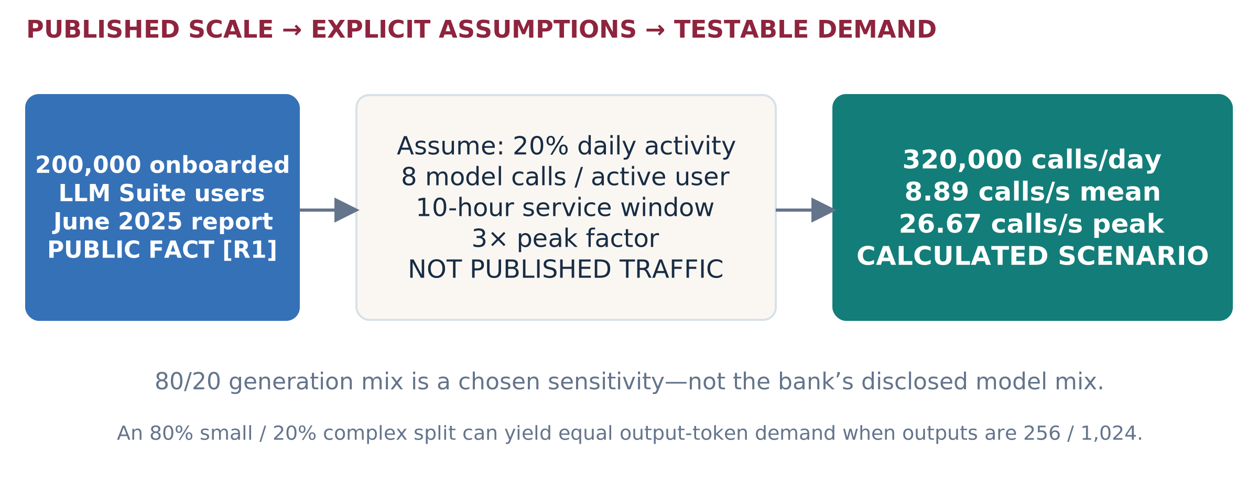
Figure 16. Historical public adoption is the anchor; activity, calls and peaks are selected scenario inputs. No actual JPMC load is inferred. [R1; A6]
Chosen generation class | Share / peak calls per second | Output target | Peak output-token demand
Ordinary service | 80% / 21.33 | 256 tokens | 5,461 tokens/s
Complex service | 20% / 5.33 | 1,024 tokens | 5,461 tokens/s
Combined | 100% / 26.67 | Mixed | 10,923 tokens/s

These are offered demands, not ATMOS rates. The mix is not the bank’s disclosed model mix. If selected stable mean end-to-end times were 20 seconds and 120 seconds, rate × mean time gives about 427 and 640 unfinished requests respectively. Those are service-boundary averages—not active GPU sequences or KV allocations. Do not substitute p99 into this average relationship. [A6]

Size only after measuring each complete service unit
Required identical replicas, tolerating one lost replica = 1 + ceil(peak class demand / qualified usable rate per replica)
Apply the formula per independently replicable service class, with the rate already including the chosen headroom. A cooperating model group is one replica for this calculation, not each expert module. Node/rack correlated failures require a placement-specific availability model rather than blindly adding one device.

TURN AN ADOPTION STORY INTO A QUALIFIED OPPORTUNITY

Financial deployment and buying decision
Start with an authorized business unit or workload slice, not a hypothetical replacement of every employee-facing AI call. Determine which work may move from the existing cloud or on-prem service, which models can legally and technically run locally, and what deployment cost can actually disappear.
Proposed configuration | Why the customer might adopt it | Evidence before buying
B local-service pool | Independent models/refinement with incremental growth; retain existing generation for unqualified cells. | Same business quality; model/shard registration; device health and steady-state economics.
C switched E3.S | Same services with a qualified larger population or a better host connectivity plan. | Switch earns its cost under real demand, updates and failover; no assumed P2P benefit.
A complex-analysis pool | Several modules execute the approved larger model with useful local capacity. | End-to-end time, per-rank KV/weights, communication and group recovery.
E / F combinations | Separate pools by interactive/complex/retrieval workload; replicate across node boundaries. | Resource ratios, failure reserve and mixed workload cost justify the added pools.

A deliberate negative-control case
Assume only 60% of the example model calls need one retrieval. Peak retrieval demand is then about 16 queries/s. Assume ten million chunks: one 1,024-dimensional FP16 vector/chunk is 20.48 GB. That representation can be a strong conventional memory-resident control. The public employee count does not by itself create a need for HBF. [A6]
A richer assumed representation—128 vectors/chunk, 128 FP16 dimensions—would be 327.68 GB, before indexes and replicas. B/C becomes more interesting only if that representation improves judged relevance at the required cost and query mix. Richer storage alone is not evidence; compressed late-interaction controls remain mandatory. [A5; R15]

Partner approach
Ask the account sponsor for one service owner, one incumbent baseline, a permitted trace and a buying decision. Run a joint 60-minute discovery, freeze the service boundary, then propose a two-stage evaluation: incumbent bottleneck confirmation followed by ATMOS threshold/physical-path testing. No supplied source establishes a JPMC POC commitment.

PUBLISHED WORKFLOWS • NOT AN ATMOS CUSTOMER CLAIM

Insurance case study: Allianz
Named use case: claims evidence assistance with employee AI and bounded agent workflows. Allianz offers public examples of multiple AI service shapes. The proposed ATMOS placement below is new analysis, not its disclosed hardware design.
Public anchor | Date | What it means—and does not mean
AllianzGPT: over 60,000 active users, 60 premium instances, and over 10 million prompts to date. | 18 Feb 2025 | Historical cumulative prompts, not peak QPS. Active-user interval unspecified; instances are not device counts. Data stays in Allianz Azure Cloud. [R2]
Insurance Copilot introduced for Austrian automotive claims in 2024. | 5 Feb 2025 | Document/contract assistance with human decisions. No accelerator inventory or request trace is disclosed. [R3]
Project Nemo: seven specialized agents, launched in Australia in July 2025; final human payout decision. | 3 Nov 2025 | A workflow reference. Seven agents do not imply seven LLM calls or seven NPUs per case. [R4]
More than 900 AI use cases internally registered worldwide. | 18 Mar 2026 | Portfolio breadth; not 900 production LLM deployments. [R5]

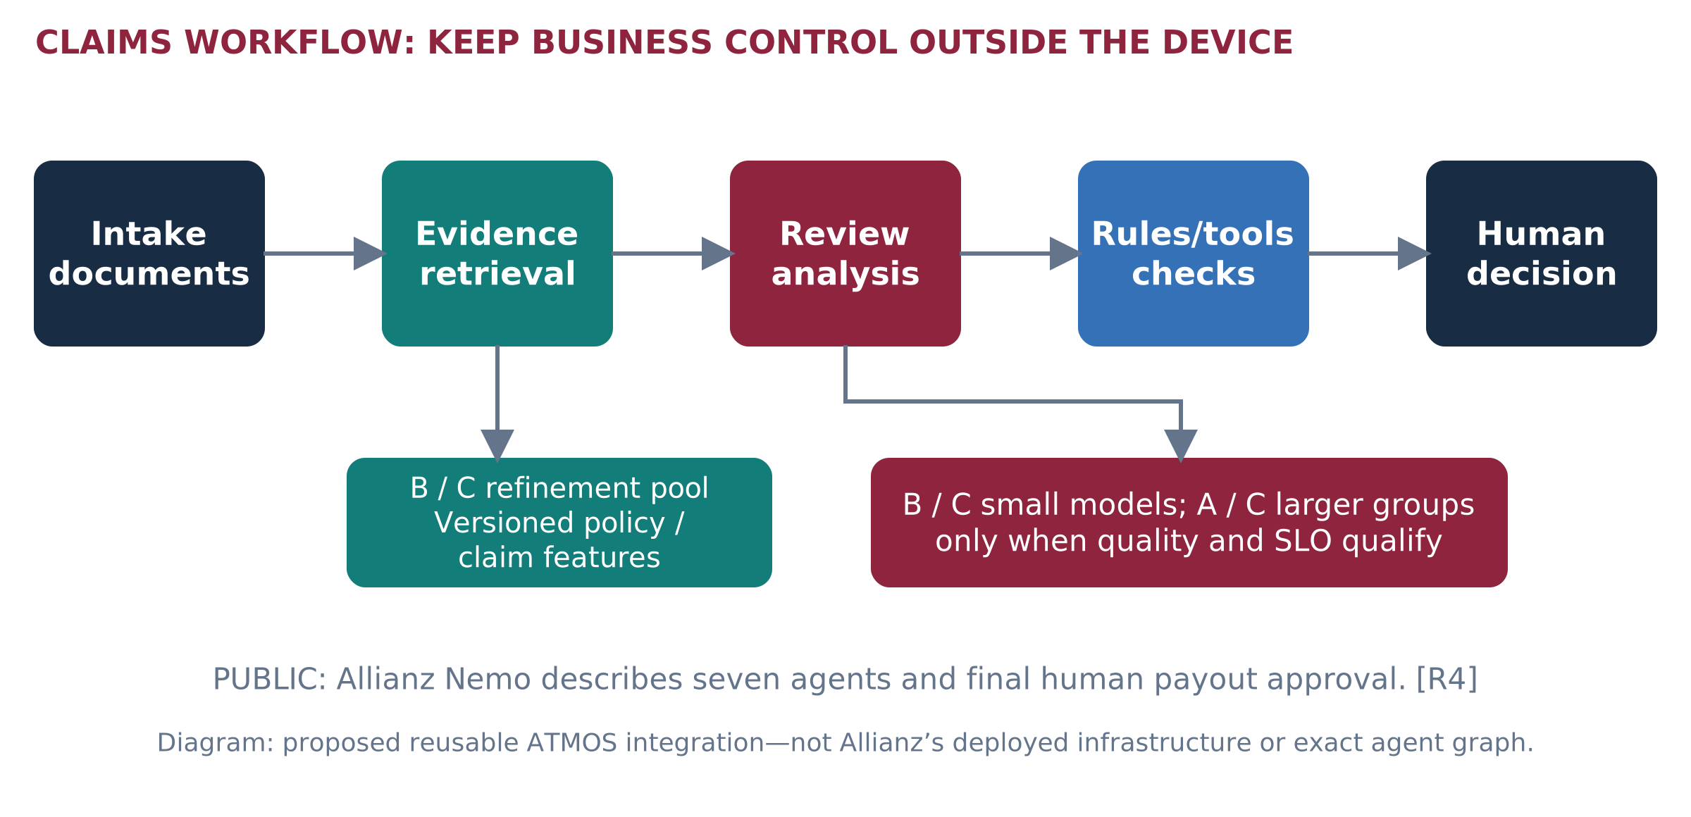
Figure 17. Proposed placement of retrieval and neural execution inside a claims workflow. The customer retains rules, tools and the final decision. [R3–R4; proposed design]
No hardware-performance gain or business-time reduction reported by Allianz is attributed to ATMOS. Public reports do not supply complete prompt distributions, model packs, actual claim rates or corpus size.

CALCULATION A7 • NO INVENTED ACTUAL CLAIMS VOLUME

Insurance sizing and adoption example
Explicit scenario assumption | Calculated demand | Boundary
60,000 reported active users as anchor; assume 25% active on a selected day, six model calls each, eight hours and 3× peak. | 90,000 calls/day; 3.125 calls/s mean; 9.375 peak. | Daily fraction, call count, window and peak are not public Allianz data.
Catastrophe test: 10,000 claim workflows in a four-hour window; four neural calls/workflow. | 40,000 calls; 2.78 calls/s mean; test bursts separately. | 10,000 and four are synthetic inputs, not a report about Nemo. Do not multiply by seven agents again.
Representation study: 30 million single FP16 vectors, dimension 1,024. | 61.44 GB raw representations. | A plausible conventional-memory control; HBF benefit may be weak.
Alternative: 32 token vectors/chunk, 128 FP16 dimensions. | 245.76 GB raw; at least three 100 GB shards before metadata. | Quality-approved richer retrieval plus reserve may require more.

How the portfolio could be adopted
Phase 1: a B/C refinement service for a versioned policy/claim-feature snapshot, plus one supported small-model worker. Keep the current claims system and existing model endpoints. Measure full workflow impact, not only the accelerated stage.
Phase 2: when complex claims demonstrably benefit from a supported larger model, add an A/C cooperating group and route only the approved class. A premium app instance is not an automatic reason for dedicated hardware. Share or isolate only under the agreed data and service policy.
Phase 3: use C2 or a qualified C1 deployment when sustained population and operating economics justify it. Replicate complete logical shard sets or ensure every required shard survives the declared failure. The simple three-shard example is not available after losing a unique shard without a copy.

Contract, quality and cloud boundary
Existing proprietary model services cannot simply be loaded onto ATMOS. A local supported open-weight substitute is a new quality/migration decision. Where the service is Azure-hosted, the operator and approved deployment path must participate in hardware changes. Do not promise cloud avoidance or closed-model equivalence. Use human-reviewed evidence and preserve the original business authorization boundary.
[R2–R5; A7]. The numbers are a test design, not an estimate of Allianz’s installed fleet or purchasing requirement.

PART III • SOFTWARE, OPERATIONS AND OEM DELIVERY

What “turnkey” must include
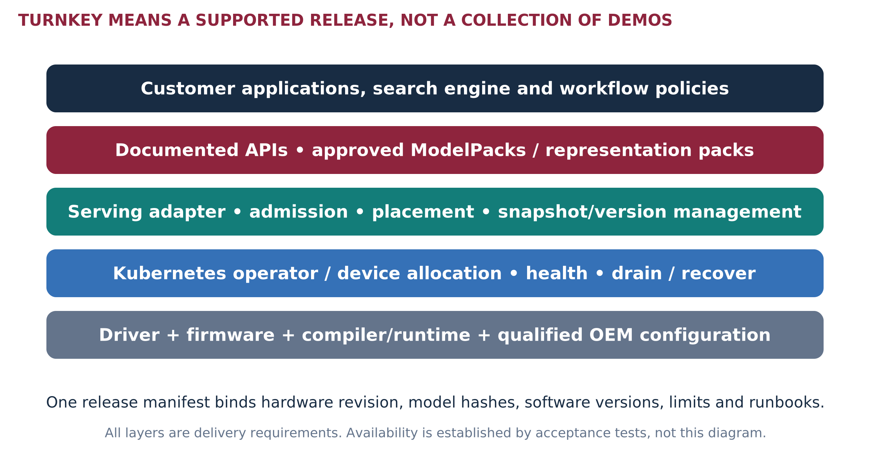
Figure 18. Required delivery stack across A, B and C. The program is not claiming these components currently exist as a released ATMOS product.
Package | What the customer receives | Release condition
Evaluation kit | Pinned simulator/profiles, reference datasets, current GPU controls, CLI/reports, assumptions and limitations. | Reproducible by an engineer other than the author; no ATMOS performance claim.
Device developer kit | Supported physical device, firmware/driver, runtime primitives, sample ModelPack/scorer, diagnostics and API contract. | Functional and physical-path tests; disclosed unsupported operations.
Turnkey service release | Qualified OEM configuration, signed software bundle, maintained adapters/operator, model registry, telemetry, recovery and support matrix. | Customer acceptance on deployment, quality, SLO, failure and lifecycle—not a demo.

A turnkey release must bind the exact hardware revision, model/shard formats, supported context and batch envelope, software versions, known limitations and operational tests in one release manifest. “Install a container” alone does not supply a compiler, device driver, secure DMA or an operator-quality backend.
Expanded program requirement based on [I3 §§6–7; I4 §7; I6 §1.2]. The Bridge explicitly excludes production driver/Kubernetes implementation; those are separate funded deliverables here.

SOFTWARE RESPONSIBILITIES THE FORM FACTOR DOES NOT SOLVE

Kubernetes, isolation and recovery
Initial allocation: whole independently supported workers or explicit complete model groups. Expose capacity and topology metadata without claiming fractional hardware isolation that has not been proven. An eight-module A card need not enumerate as eight allocatable devices. [I1 §3A]
Requirement | Implementation target | Acceptance test
Discovery and allocation | Device plugin or approved resource-allocation integration; NUMA/group/health metadata. | Correct count and grouping after reboot, partial failure and replacement.
Scheduling / admission | Placement honors per-worker KV/weight fit, supported kernels and complete-group readiness. | Reject oversubscription visibly; no late off-device fallback surprise.
Model/shard lifecycle | Immutable hashes, atomic activation, compatible versions, rollback and bounded staging. | No mixed snapshots or unready models serve live traffic.
Security | Least-privilege device access, DMA/IOMMU policy, signed firmware/images, secrets handling and scrubbed telemetry. | Cross-tenant boundary, malicious request bounds and reset sanitization tests.
Resilience | Drain and reschedule policies aware of card/switch/node dependencies. | Recover complete service under the declared fault; measure RTO and work lost.
Observability | Per-stage timing, errors, bytes, queues, temperatures, throttling and versions. | A slow request links to a reproducible resource trace.

Kubernetes device-plugin health reporting does not automatically migrate pods already using a failed device. The application/operator must supply workload-aware recovery. A pod restart is not a new model replica or recovered vector shard. [R16]

No safety bypass as a tuning step
Do not disable security isolation or permit unsupported live removal to obtain a faster benchmark. Fault tests run only on approved lab hardware with disposable data. Front access supports serviceability, but safe compute hot removal depends on outstanding work, reset behavior, firmware and the replication plan. [I7 §5]

BUILD WHAT MAKES THE HARDWARE ADOPTABLE

Software workstreams and release ownership
Workstream | First deliverable | Next delivery gate | Accountable role
Firmware + driver | Versioned commands, queues, DMA/buffer ownership, errors, reset and telemetry specification. | Prototype driver and functional smoke suite; physical path validated. | FW/driver lead
Compiler + kernels | Supported operator/precision matrix; tiled matrix, attention and gather/reduction microtests. | Signed ModelPacks or scorer packs with numerical tolerances and declared fallback. | NPU/compiler lead
Serving integration | One LLM adapter, request timing and admission; one retrieval interface spike. | End-to-end fixed workload passes with maintained dependency versions. | Runtime lead
Platform operator | Inventory/readiness, allocation, health, drain and upgrade design. | Two-node lifecycle and loss-of-device tests pass. | Platform/SRE lead
Quality + security | Reference datasets, tolerances, retrieval labels, sensitive-data rules and supply-chain inventory. | No silent corruption; authorization and rollback tests pass. | Validation/security
Field/release tooling | Installer/preflight, support bundle, sizing inputs, README and example configurations. | New user reproduces result; first-response and escalation owners assigned. | Release + solution architect

Software reuse across offerings
Reuse the driver contract, model/shard packaging, telemetry schema, admission rules and evidence runner where hardware permits. Keep topology, reset domain, usable capacity and power envelope as explicit capabilities. A and C may share grouped execution primitives; B and C share modular device operations. Compatibility is tested, not assumed from identical API names.

Two things the program must not confuse
Simulation adapter versus production backend: a timing callback does not execute the model. KV-cache connector versus weight/operator backend: a cache layer such as LMCache does not implement the NPU compiler, expert execution or device memory semantics. Those require separate engineering and qualification. The prior document’s optional runtime paths remain options, not already completed integrations. [I6; I7]
General-purpose training, arbitrary PyTorch compatibility, universal CUDA/ROCm binary support and unrestricted fractional multi-tenancy remain outside the first release. Every extension needs demand, an owner and a test contract.

PARALLEL ENGAGEMENT WITH ONE PRIMARY AND ONE ALTERNATE OEM

OEM integration: choose fixtures, not logos
The preferred lab is reconfigurable, but not every configuration belongs in one chassis. Keep a small family of matched, qualified fixtures when E3.S, accelerator power, riser layout or AMD OAM packaging prevents a single-host comparison. Cloud is useful for controls, not physical ATMOS qualification. [I7 §§2–4]
Fixture | Candidate reference | What the OEM must confirm
F1 • E3.S host | Dell PowerEdge R770 family: published E3.S/internal layout reference. | Exact backplane, per-bay lanes/CPU affinity, sustained accelerator power, cooling, management and supported mixed population.
F2 • Integrated card / GPU | Dell PowerEdge XE7740 or a documented alternate accelerator server. | Card size, spacing, retention, auxiliary power, partial populations, RTX/ATMOS revisions and support for the proposed modifications.
F3 • Switched E3.S | Qualified C1 reference BOM or C2 OEM engineering platform. | Switch part, uplink/device generations, port map, cables/retimers, firmware, isolation and service responsibility.
F4 • AMD control | OEM-supported MI350X OAM platform. | Complete platform and ROCm versions. Not a swap into an ordinary card fixture.

Public investigation basis [R12–R13, R20–R21]; private platform plan [I7]. None is identified here as an ATMOS-qualified server or purchase recommendation.

First OEM workshop: requested output
Bring the device envelope, A/B/C layouts, target service contracts and priority microtraces. Request a returned lane map, bill of materials, power/cooling allocation, BIOS/BMC requirements, management/reset matrix, qualification scope, engineering access conditions and a priced configuration. End with a configuration ID and unresolved-owner list.

Protect the storage plan
Price the authoritative store, spare/update capacity, boot drives and networking after ATMOS devices occupy bays. Preserve the required SSD capacity and I/O service; do not move a hidden cost to network storage. For 2T devices, count occupied width and cooling, not merely the printed bay count. [I3 §4; A1]

EVIDENCE CHECKLIST USED BY HARDWARE AND SOFTWARE TEAMS

OEM qualification and collaboration gates
Gate | Sandisk provides | OEM/customer provides | Exit evidence
O0 • Requirements | Approved device envelope, host interface, power range, command/runtime requirements. | Exact chassis, CPU/riser/backplane map and operating constraints. | Versioned feasibility and unknowns.
O1 • Engineering build | Device/sample, FW/driver, microtraces and diagnostics. | Supported lab modification, fixtures, cables, BIOS/BMC and safe access. | Repeatable boot, enumeration, mapping and local DMA.
O2 • Paths / population | Transfer workload, NUMA/P2P tests, read/write/load interference. | Topology observability, approved security settings, full population. | Measured path map; limits and unsupported routes.
O3 • Sustained operation | Reference service trace, temperatures, firmware update and failure tests. | Airflow/inlet/PSU conditions, fan policy, service procedure. | No unaccounted throttling; recoverable update/reset behavior.
O4 • Service acceptance | Qualified runtime/packs, node/shard recovery and installer. | Customer quality/SLO targets and authorized datasets. | Matched service report, operational gaps closed.
O5 • Release/support | Compatibility matrix, diagnostics, release notes, incident ownership. | Supported SKU/BOM, supply, spares, escalation and change control. | Signed release readiness, pricing and lifecycle agreement.

A switch’s P2P capability is not an application guarantee. Measure endpoint, driver and route support. Host-root traversal does not necessarily mean a host-DRAM copy; record the real payload path. Never disable isolation just to produce a preferred peer result. [R17; I7 §5]

A future generation is a new qualification
Changing PCIe generation, package power, HBF/LPDDR revision or GPU model is not a software setting that creates missing hardware support. Requalify affected links, thermals, memory mappings, model packs, recovery and service results. Maintain compatibility by configuration ID, not an unqualified server-family claim. [I7 §4]

ONE EVIDENCE SYSTEM • NOT ONE INTERCHANGEABLE TRUTH

Simulation, prototypes and real execution
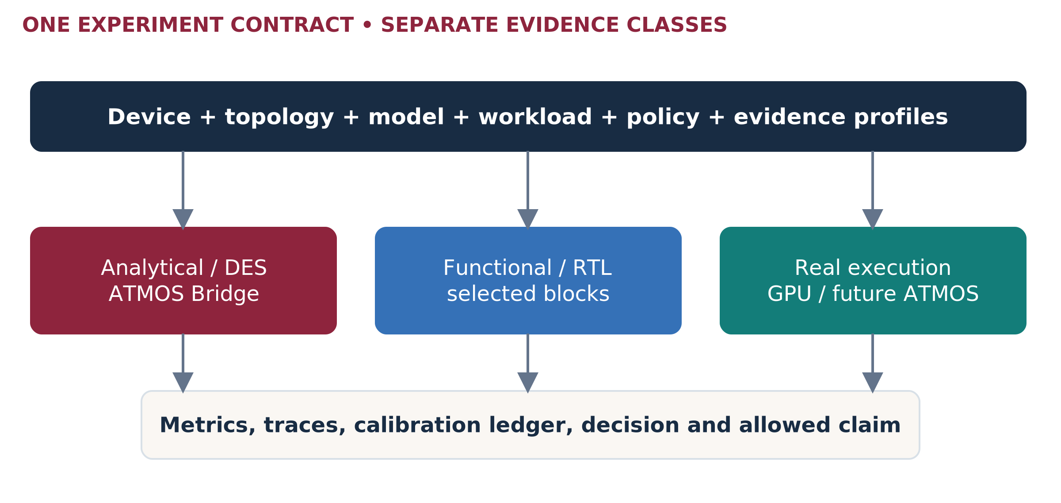
Figure 19. The common runner accepts multiple evidence backends. Their results remain visibly different classes. [I6 §§2–3]
Use the reviewed Python/SimPy Bridge recommendation for rapid resource modeling. TokenSim is an optional serving adapter; search traces need their own workload adapter. C++/Rust is an optimization option for measured hot paths, not a second parallel core to build by default. The prior Rust/C++ design remains a source of contracts and questions. [I6 §6; I9]
Environment | What we can learn | What we cannot claim
Capacity / analytical model | Fit, traffic, bounds and required performance. | Achieved tokens/s, p99 or model correctness.
Discrete-event model | Queues, contention, scheduling and sensitivity. | Silicon timing simply because the code is deterministic.
Selected partner/RTL model | Supported command/kernel behavior and bounded calibration. | Full ATMOS memory/controller/platform functionality unless supplied.
Physical reference / ATMOS | Observed service and operational behavior of the tested configuration. | Untested scale, models or future revisions.

The February 2027 partner milestone in the source is an internal assumption to reconfirm. Existing reviewed partner material is block-level evidence, not a complete ATMOS replacement. Keep restricted details under approved access and preserve release IDs; this reference does not redistribute internal RTL constants. [I6 §11]

TEST THE THESIS, NOT THE PRESENTATION

POC ladder and acceptance method
POC | Question / first scope | Go / no-fit evidence
P0 • Local memory path | Size, alignment, sequential/random, outstanding depth, staged/bypass variants, simultaneous working-memory traffic. | Useful NPU-consumed bytes/s and service tails; isolate the limiting resource.
P1 • Candidate refinement | One representation; fixed candidate IDs, filters, scores and local top-k. | Numerical/ordering equivalence; p99 and cost threshold against strong resident and disk controls.
P2 • Multi-vector | One MaxSim/reduction pipeline over precomputed features. | Judged relevance, variable document size, compression control, tail and capability coverage.
L1 • Small dense / MoE | One complete supported model on one worker; fixed trace. | Real quality first, then TTFT/TPOT, KV, bytes and sustained goodput.
L2 • Cooperating model | Valid EP/TP/PP combination; no-P2P baseline plus supported alternate path. | Complete-group service, imbalance, per-rank memory and recovery.
O1 • Node / fleet | A/B/C population, background traffic, restart and node loss. | Service remains within the declared degraded-state contract.
V1 • Customer workflow | One finance and one insurance stage, then authorized composition. | Joint continue/iterate/stop decision; no extrapolated fleet claim.

Rules for every run
Freeze data/model/precision, business quality, SLO and evidence class. Record arrivals separately from completions, active sequences separately from API concurrency, and logical bytes separately from physical transfers. Test low/target/burst/saturation loads, mixed traffic and negative controls. Show errors, timeouts, rejected requests and backlog; do not hide difficult requests.
Measure full-service distributions directly; never sum component p99 values into an end-to-end p99. Critical-path waiting is distinct from the sum of overlapping resource waits. A small deterministic toy trace can validate causality but cannot establish a production p99. [R22; I6 §8; I2 slide 5 notes]

Initial sweep—not one promised operating envelope
LLM inputs: 4K / 8K / 16K / 32K tokens; outputs: 128 / 256 / 1,024 tokens; active sequences: 1 / 4 / 8 / 16 / 32 / 64. Independently sweep fixed outstanding-client load and offered requests/s. Add 64K/128K only with a qualified model/runtime. Batch size and client concurrency are different variables. Vector candidates: 1K / 5K / 10K; query batches: 1 / 8 / 32. Start with screening and promote decision-critical cells rather than exhaust the Cartesian product. These are proposed test points, not supported ATMOS specifications. [I7 §6; R22]
Prior two-scenario outputs are teaching-only replay results, not completed TokenSim/C++ or physical ATMOS benchmarks. Reuse schemas and tests—not their latency numbers. [I10]

PART IV • INVESTMENT, LAUNCH AND PROGRAM OPERATION

Customer economics: show a feasible region
Use complete service cost at equal quality, latency and availability. The following reproduces the supplied executive proposal’s illustrative retrieval scenario, not quotes or ATMOS benchmarks: 800 GB representations, 4,000 peak QPS, 1,000 average accepted QPS; at least three complete copies normally and two after one node fails. [I4 §§11–12; A8]
Input | Conventional reference | ATMOS candidate
Assumed qualified rate/node | 2,500 QPS | 3,500 QPS
Sizing rate after 70% admission factor | 1,750 QPS | 2,450 QPS
Fleet meeting one-node-loss constraint | 4 nodes | 3 nodes / 24 devices
Hardware price | 4 × $60,000 | 3 × ($20,000 host + 8 × $2,000 devices)
Mean complete-node power | 1.2 kW | 0.8 kW
Incremental one-time integration | $0 | $60,000

Three-year undiscounted cost | Reference | Candidate
Hardware | $240,000 | $108,000
Support: 12% of hardware/year | $86,400 | $38,880
Electricity: PUE 1.3, $0.12/kWh | $19,678 | $9,839
Operations + non-energy facilities | $144,000 | $138,000
Common retrieval/source services | $180,000 | $180,000
Integration | $0 | $60,000
Total | $670,078 | $534,719

The conditional reduction is 20.2%. It is narrow: lower candidate rate, extra replicas, storage displaced, integration effort or a better incumbent can erase it. Generation, taxes, financing and unlisted corporate overhead are outside this specific boundary; add real differences before purchase.
COUNT ONLY COST THAT CHANGES
Freed but still purchased GPU memory is not immediate cash saving. For a deployed fleet, compare incremental spending and genuinely avoidable operating cost—not sunk purchase cost. For a new purchase, use full lifecycle costs. [I4 §10]

SENSITIVITY IS MORE USEFUL THAN ONE FAVORABLE CELL

Price, rate and supplier viability
Candidate QPS/node → fleet | At $1K/device | At $2K/device | At $4K/device | At $8K/device
1,000 → 7 nodes | −3.2% | −14.6% | −37.3% | −82.8%
2,000 → 4 nodes | +18.0% | +11.5% | −1.5% | −27.5%
3,500 → 3 nodes | +25.1% | +20.2% | +10.5% | −9.0%
5,000 → 3 nodes | +25.1% | +20.2% | +10.5% | −9.0%

Reduction in the illustrative three-year TCO on p.35. Positive = cheaper; negative = more expensive. Rates/prices are assumptions, not confidence intervals or forecasts. [I4 §12; A8]
A faster node does not reduce fleet count below the complete-copy/failure requirement. Under this scenario, candidate rate must exceed about 2,857 QPS/node before the 70% factor to meet peak demand on two surviving nodes. At the three-node point, an approximately $2,041/device ceiling retains a 20% cost reduction; exact quotes must replace the assumptions.

The supplier floor must fit below the customer ceiling
Required end-customer price = fully burdened unit cost / [(1 − channel discount) × (1 − hardware margin)]
For illustration only, $800 variable unit cost, 20% channel discount and 40% hardware margin imply a $1,667 price floor. At a $2,000 end price, supplier revenue is $1,600 and contribution is $800 before fixed costs. A hypothetical $5M development investment needs 6,250 such units before ongoing fixed costs, financing and taxes. These are not Sandisk policy, BOM or NRE estimates. [I4 §13; A8]

What changes by offering
Quote A as a complete card, B per device plus required host configuration, C as devices plus qualified fabric/management, and C2 with platform engineering amortization. E/F include mixed-pool utilization, network, spare capacity and recovery. Do not assume equal module count implies equal price or equivalent revenue.
A funded POC, a technically successful demo, a design win and booked revenue are separate milestones. The program needs repeatable deployment volume and service ownership beyond the anchor account. [I4 §§3,13]

RELATIVE WINDOWS, WITH EXPLICIT READINESS GATES

Phased portfolio launch
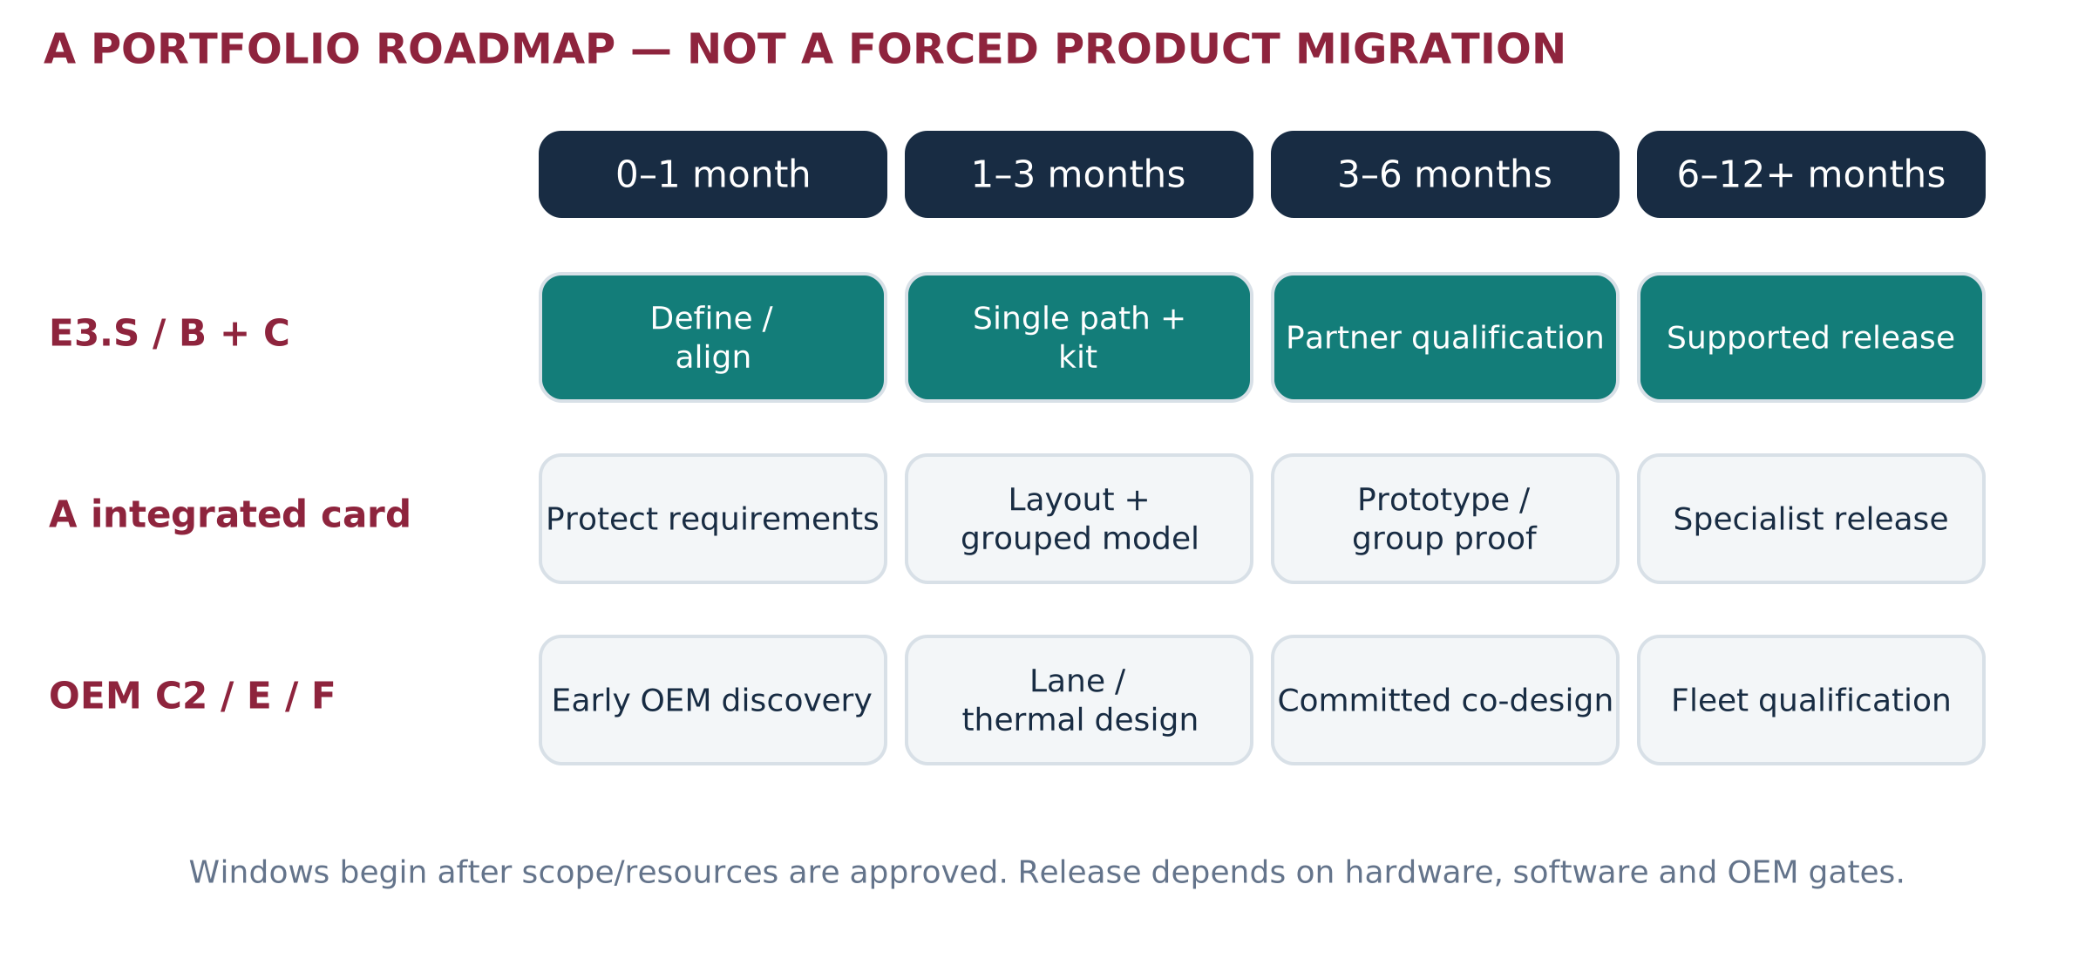
Figure 20. Proposed planning windows from an approved T0; hardware and commercial delivery dates are not established. [Proposed roadmap]
Milestone | E3.S-first output | Protected portfolio output
Month 1 | Confirm anchor requirements, device envelope, approved profile and local-path/SDK scope. | A/C1/C2 mappings, bay opportunity cost and model-group requirements.
Month 3 | Reproducible P0/P1, maintained integration spike, prototype capability and conventional controls. | Small dense/MoE control; A mechanical/timing feasibility; OEM alternative map.
Month 6 | Physical E3.S service qualification if hardware exists; otherwise calibrated requirements and explicit blockers. | A/C group experiments, turnkey operating tests, price/rate envelope and committed OEM path.
Month 12+ | Release supported configurations that pass gates; expand volume and supported workloads selectively. | Specialist A offering, C2 co-design or E/F deployment when economics and support qualify.

Not a mandatory B → C1 → C2 migration. The anchor may require C1 first. B may remain the best independent-worker offering. A should not wait for C2, and C2 should not become a product simply to complete a diagram. OEM discovery starts early; expensive platform commitments remain gated.
E3.S anchor priority [U1]; original multi-offering direction [I1 §9]. Google’s signed scope, dates, reuse rights and purchase commitment are not supplied. No public partnership or hardware adoption is asserted.

SUGGESTED FIRST-QUARTER ENVELOPE—NOT APPROVED STAFFING

Resource plan and ownership
Use one cross-functional delivery team rather than one team per form factor. The following 12-week planning envelope funds evidence and integration definition; it does not fund a complete NPU, production firmware, full compiler, silicon program or OEM NRE. FTE is full-time-equivalent effort, not necessarily a separate person per row.
Role | FTE | Accountability
Program / solution architect | 1.0 | Service contracts, architecture baseline, customer/OEM alignment and decision reports.
Performance/modeling | 1.0 | Resource model, benchmark controls, arithmetic, calibration and tails.
Runtime/compiler integration | 1.5 | Supported primitives/packs, reference execution and maintained adapters.
Firmware/driver liaison | 0.5 | Commands, DMA, reset, safety and device visibility requirements.
Hardware/OEM engineering | 0.5 | Envelope, topology, mechanics, power/thermal and fixture approval.
Validation/security | 0.75 | Correctness, failure, isolation and acceptance evidence.
Build/release/SRE | 0.25 | CI, manifests, packaging and operational tests.
Product/account coordination | 0.25 | Priority, partner path, pricing inputs and release scope.
Total | 5.75 | 69 FTE-weeks over 12 weeks.

Illustrative loaded labor at $4K–$6K/FTE-week gives $276K–$414K, plus $25K–$75K direct study spend: $301K–$489K total planning envelope. Actual pay, quotes, licenses, hardware purchase, tapeout and platform NRE are not supplied. This is a new phased estimate, not the earlier proposal’s budget. [A9]

Protect priorities
Suggested effort split: 35% shared foundation, 45% E3.S/anchor path, 20% integrated-card and independent-market investigation. Shared foundations directly support E3.S. Product/sponsor must approve changes; no workload adds a separate stack without a reuse decision.
With only the solution architect and periodic reviewers, narrow the quarter to a ledger, one local-path model, one measured control and one reviewed customer/OEM charter. Do not promise multiple production adapters or a qualified release on a solo schedule.

MAKE THIS A MAINTAINED SOURCE OF TRUTH

Program governance and first 30 days
Record | Required fields | Accountable role
Specification ledger | Value, units, scope, source, owner, release, confidence, approval and replaced values. | Architecture
Requirement / decision register | Need, option, workload impact, dependencies, decision, owner, due date, affected artifacts. | Program + product
Experiment manifest | Hardware/topology/model/trace hashes, policy, evidence class, versions, raw data and conclusion. | Performance
Claim register | Exact wording, supporting results, limitations, approval and allowed audience. | Product / legal / communications
Compatibility matrix | Qualified device/server/firmware/software/model combination and known limits. | Release + OEM
Risk / partner action log | Trigger, impact, mitigation, external dependency, owner and next decision. | Program / account

First month commitments
Week | Output | Review
1 | Confirm C-family naming, anchor scope, source priority, three service contracts and named specification owners. | Raj + architecture + product
2 | Approved topology candidates; source/assumption ledger; bounded P0 and real-control experiment; software gap map. | Hardware + runtime + performance
3 | Reproducible path/capacity artifacts; customer fact-versus-assumption packs; OEM requirements workshop. | Validation + OEM + account
4 | Evidence review: top five constraints, no-fit results, month-3 scope, resource decision and publication boundaries. | Cross-functional decision review

Use weekly engineering reviews, biweekly architecture decisions and monthly portfolio reviews. Freeze a release baseline for every POC. When a value changes, update affected equations, diagrams, tests, economics and approved wording together; archive superseded winner charts and duplicated specification tables.
The master remains usable only if another engineer can find the current value and reproduce the decision. The author is not the sole approval authority. Restricted partner details and customer traces stay in controlled repositories, linked by ID rather than copied into broadly shared versions.

A PROGRAM RESULT CAN BE “NOT A FIT”

Risks, gates and definition of done
Risk / trigger | Response | Decision owner
Anchor requirements consume all capacity | Protect shared interfaces and a bounded alternate-market track; confirm reusable IP and scope. | Sponsor/product
HBF delivery path cannot feed useful compute | Reprofile staging/window/NoC limits; change requirements or stop the workload. | Memory/NPU
Weight fit mistaken for latency readiness | Run per-rank KV and actual operator path; no TOPS-to-token conversion. | Performance/runtime
E3.S displaces required storage or overheats | Revise population/form factor or separate nodes; price the additional infrastructure. | OEM/hardware
Driver/compiler maturity blocks turnkey | Fund separate deliverables, keep evaluation-only label, and retain incumbent production path. | Software/product
Simulation appears as a measured claim | Automated evidence labels; no unsupported winner maps in field material. | Validation/claims
Partner/silicon delivery slips | Continue controls and sensitivity; change calendar commitments, not evidence labels. | Program/partner
No repeatable customer economics | Stop broad SKU investment; retain useful tooling and narrowly justified services. | Product/finance

Release gates
G1: definition — owners, source envelope, interface and bounded workload agreed. G2: function — numerical/operator and data-safety tests pass. G3: service — sustained workload meets quality/SLO under the named topology. G4: operations — update, reset, failure and recovery pass. G5: economics/support — quote-backed model, support owner and supply plan. G6: release — new users reproduce installation and operation from the package.
DEFINITION OF DONE
A customer can deploy the named configuration, run a supported model or representation service, understand its limits, observe it, recover it and receive support. The matched evidence explains why it was selected and where it should not be used. This is the standard for “turnkey,” not slide completeness.

ACTUAL SLIDE POSITIONS IN THE ATTACHED 15-SLIDE FILE

PIN ACTUAL REVISIONS BEFORE EXECUTION

Public sources — models and hardware
R6 Qwen3-30B-A3B — published model card
30.5B total / 3.3B active reference model; counts are not a final compiled pack.
R7 Qwen3-30B-A3B — config.json
48 layers, four KV heads, head dimension 128 for the logical KV example.
R8 Qwen3-32B — published model card
32.8B dense reference; model/native/extended-context behavior requires exact configuration.
R9 Qwen3-235B-A22B — configuration
94 layers, four KV heads, head dimension 128, 128 experts and top-eight selection. 235B/22B model class also appears in source deck [I2].
R10 DeepSeek-V3 — publisher model card
671B total / 37B active reference. Complete model and mixed precision require artifact audit.
R11 Kimi K2 Instruct — publisher model card
1T total / 32B active reference, MLA attention. Do not use the GQA KV formula blindly for this model.
R12 NVIDIA RTX PRO 6000 Blackwell Server Edition
96 GB GDDR7; 1,597 GB/s; up to 600 W; air dual-slot FHFL. Product specifications, not the measured control.
R13 AMD Instinct MI350X
288 GB HBM3E; 8 TB/s; 1,000 W TBP; OAM packaging. Requires a supported OAM server fixture.
These are representative released references, not a complete current-model leaderboard. Recheck artifact sizes, licensing, firmware, support and URLs at experiment freeze.

PRIMARY DOCUMENTATION AND PRACTICAL REFERENCE LINKS

Public sources — serving and integration
R14 OpenSearch — Disk-based vector search
Quantized selection and full-precision rescoring reference; configure a strong incumbent.
R15 Vespa — ColBERT embedder and compressed late interaction
Reference for data-local multi-vector scoring and compression; not ATMOS integration.
R16 Kubernetes — Device plugins
Discovery, allocation and health boundaries. Pin the customer-supported Kubernetes version.
R17 Linux kernel — PCI peer-to-peer DMA support
Topology and host-bridge constraints. A switch alone does not certify an application peer path.
R18 vLLM — Expert parallel deployment
Expert execution and communication reference. Existing vLLM support does not establish an ATMOS backend.
R19 NVIDIA — GPUDirect Storage overview
Supported direct storage-to-GPU-memory paths; GDS is not MoE cache policy.
R20 Dell — PowerEdge R770 inside view
Physical server reference; no ATMOS qualification implied.
R21 Dell — PowerEdge XE7740
Accelerator-server investigation candidate; exact modified BOM and support remain to be agreed.
R22 NVIDIA — LLM inference benchmarking fundamentals
Definitions of service load and token/latency metrics; use a workload-specific acceptance contract.
R23 Kioxia — EDSFF E3 form-factor overview
Physical format context; form factor alone does not establish accelerator compatibility.
R24 TokenSim — public repository
Audit and pin the implementation used. Public simulator capabilities do not supply an ATMOS component model automatically.
Cited technical sources support general mechanisms. The new architecture, phased plan, thresholds and delivery requirements remain program recommendations unless an approved evidence record says otherwise.

