
We present a novel software-based mechanism for on-line estimation of current power consumption and total energy consumption of wireless sensor nodes, implemented in the Contiki operating system. Unlike previous approaches, our mechanism enables network-scale energy-aware mechanisms and protocols, and system-level energy-evaluation of sensor network mechanisms and protocols.
ESNA
(ITEA 05023)
.........................

Partners:
ABB
Acciona Infraestructuras
CRL
Edosoft Factory
EGC
Emwitech
Langmead
Métodos y Tecnología de Sistemas y Procesos
SICS
Siemens d.d.
Space Applications Services
Vendolocus
Vibrel
Vrije Universiteit Brussel
VTT

Countries involved
Belgium
Croatia
Finland
Spain
Sweden

Project start
June 2006

Project end
December 2008

Contact
Project Leader:
Olle Olsson, SICS

Email:
olleo@sics.se

ITEA Symposium 2007
Demo: XXXX
ITEA Symposium 2007
Software-based Sensor Node Energy Estimation
Unique features of our mechanism are:
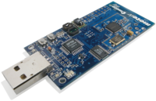
- Zero hardware cost
- Zero deployment cost
- Good accuracy
- No changes to applications or protocols
- Only two lines of code needed in a few low-level drivers
- Can be used in live systems
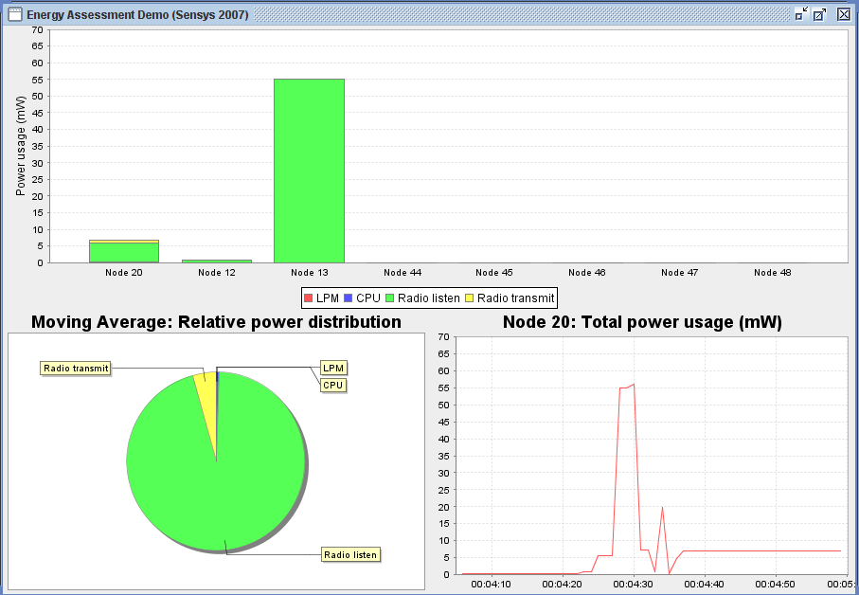
- Enables full-system energy estimation
Contact point for this topic:
Adam Dunkels, SICS, adam@sics.se, +46 8 633 1614
ESNA
(ITEA 05023)
.........................

Partners:
ABB
Acciona Infraestructuras
CRL
Edosoft Factory
EGC
Emwitech
Langmead
Métodos y Tecnología de Sistemas y Procesos
SICS
Siemens d.d.
Space Applications Services
Vendolocus
Vibrel
Vrije Universiteit Brussel
VTT

Countries involved
Belgium
Croatia
Finland
Spain
Sweden

Project start
June 2006

Project end
December 2008

Contact
Project Leader:
Olle Olsson, SICS

Email:
olleo@sics.se

