Nick Contini and Michelle Kojs

ECE 304

Bipolar Junction Transistor Basics

**Dates experiment performed:** 9/23/2014 & 9/30/2014

**Date report written:** 10/13/2014

**Objective**

The objective of this experiment was to learn the basic operation of a bipolar junction transistor. This includes analyzing current gain and the transistor’s operation mode. In this lab we only used an npn transistor, although these concepts can be applied to an pnp transistor as well.

**Diagram**

We were required to make two transistor circuit configurations for this lab: common base and common emitter. Common base involved connecting the base to ground, as shown in figure 1. The 1 kOhm resistor used for RE was measured as 986.66 Ohms, while RC was measured as 973.18. VCC was set to 10.16 V. VEE was set to 1V initially, and incremented by 1V for each measurement, stopping after VEE was set to 4V. The process was then repeated for VCC set to 15.05V and 20.6V.

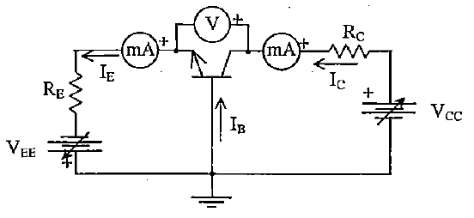

Figure 1

The common emitter configuration involved connecting the emitter to ground. VCC was set to 15V, while VBB, mainly staying between .8 and 1.7 V, was set to get IC to equal approximately 1 mA. Rb used was set to a 21.53 kOhm resistor. Rc was initially set to a 101.143 Ohm resistor, until a malfunction caused us to switch to a 97.756 Ohm resistor when setting IC to 4, 5, and 6 mA. For the second part, we set Ic to 6 mA and slowly decreased VCC until we found a sharp decrease in IC

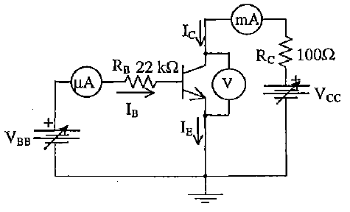

Figure 2

**Equipment List**

Transistor

100Ω resistor

22 kΩ resistor

Two 1 kΩ resistor

wires

breadboard

2 DC voltage supply

DMM

**Procedure**

The first part of this experiment involved Figure 1 where RE = 1kΩ and RC = 1 kΩ. We set up the circuit using a breadboard, wires, transistor, and two separate voltage sources. The goal of this part of the experiment was to measure and record the values for IE, IC, VCE, and VBE for values of VEE = 1, 2, 3, and 4V and where VCC = 10, 15, and 20V. Orginallinaly we attempted to use the handheld meter as a milliammeter but we decided not to use this since the readings of the currents were not precise. Therefore, we decided to use the DMM (Digital Multimeter) to measure the voltage and current. In Table 1, the readings for IE, IC, VCE, and VBE for each value where VEE = 1, 2, 3, and 4V and VCC = 10, 15, and 20V are tabulated.

For part two of this experiment, Figure 2 was the circuit which was built on the breadboard. The value of VCC was set to 15V. VBB was adjusted until IC was set to 1 mA. This was done by measuring IC with the DMM and adjusting the voltage of VBB until IC had the value of 1 mA. The value of VBB that gave IC to be 1 mA ended up being .87V. This procedure of finding the value of VBB  was repeated for IC = 2, 3, 4, 5, and 6 mA. This data is shown in Table 2. The next part of this experiment was to determine the value of VCE(sat) for this transistor. This was done by setting VBB to 1.63 V when IC = 6 mA. The value of VCC was decreased while keeping an eye on the values of IC and VCE. Once we noticed a sharp decrease in IC, we knew that we had hit the saturation point for this transistor. So then we went back and determined the values of IC and VCE when this sharp decrease occurred. The values for IC and VCE were 4.998 mA and 257.2 mV respectively. VCE(sat) for this transistor was determined to be 257.2 mV. The data for part 2b is shown in Table 3.

**Data**

**Part 1:**

|  |  |  |  |  |  |
| --- | --- | --- | --- | --- | --- |
| **VCC (V)** | **VEE (V)** | **IE (mA)** | **IC (mA)** | **VCE (V)** | **VBE (V)** |
| 10.16 | 1.263 | .6007 | .6042 | 10.1954 | .66047 |
| 10.16 | 2.029 | 1.3377 | 1.3448 | 9.4931 | .68056 |
| 10.16 | 3.0067 | 2.3321 | 2.343 | 8.5514 | .6938 |
| 10.16 | 3.9978 | 3.3 | 3.3 | 7.5947 | .667 |
| 15.05 | 1.263 | .6014 | .6041 | 15.077 | .66042 |
| 15.05 | 2.1169 | 1.4332 | 1.4417 | 14.282 | .68125 |
| 15.05 | 3.0494 | 2.3507 | 2.3640 | 13.39 | .66614 |
| 15.05 | 4.017 | 3.2854 | 3.3398 | 12.450 | .650 |
| 20.6 | 1.274 | .619 | .6208 | 20.563 | .65866 |
| 20.6 | 2.062 | 1.3818 | 1.389 | 19.384 | .6665 |
| 20.6 | 3.080 | 2.3882 | 2.4026 | 18.861 | .6714 |
| 20.6 | 4.017 | 3.3252 | 3.3418 | 17.96 | .6854 |

Table 1

**Part 2a:**

|  |  |  |  |  |
| --- | --- | --- | --- | --- |
| **VCC (V)** | **IC (mA)** | **VBB (V)** | **IB (mA)** | **VCE (V)** |
| 15 | 1.014 | .87 | .113 | 14.857 |
| 15 | 2.048 | 1.06 | .121 | 14.74 |
| 15 | 3.021 | 1.21 | .121 | 14.647 |
| 15 | 4.046 | 1.35 | .151 | 14.952 |
| 15 | 5.089 | 1.5 | .161 | 14.456 |
| 15 | 6.009 | 1.63 | .163 | 14.366 |

Table 2

**Part 2b:**

Note: notice that dIC/dVCC at VCC=15 is much smaller than at VCC=.8, hence VCC=.8 is the saturation point.

|  |  |  |  |
| --- | --- | --- | --- |
| **VCC (V)** | **IC (mA)** | **VBB (V)** | **VCE (V)** |
| 15 | 5.85 | 1.62 | 14.24 |
| .8 | 4.998 | 1.63 | 0.2572 |
| .38 | 2.3225 | 1.63 | 0.135 |

Table 3

**Calculations**

In Table 4 the values for IB, α, β, and VCB (V) are shown for their respective values of VCC, VEE, IE, IC, VCE, and VBE. The value of IB(mA) wa calculated from the equation: IE = IC + IB. The value of α was calculated from the equation: α = Ic/Ie. The value of β was calculated from the equation: β = α / 1 - α. The value of VCB was calculated from the equation: VCB = VCE - VBE. Since our value of IB is negative we determined the state from the values of VCE and VBE. The rules that we followed were:

Cutoff -> VBE < .65V

Saturation -> VCE <= .2 V and VBE >= .65V

Active -> .2 < VCE < VCC and VBE >= .65V.

|  |  |  |  |  |  |  |  |  |  |  |
| --- | --- | --- | --- | --- | --- | --- | --- | --- | --- | --- |
| **VCC (V)** | **VEE (V)** | **IE (mA)** | **IC (mA)** | **VCE (V)** | **VBE (V)** | **IB(mA)** | **α** | **β** | **VCB (V)** | **State** |
| 10.16 | 1.263 | .6007 | .6042 | 10.1954 | .66047 | -3.5 | 1.0058 | -173.41 | 9.53 | Cutoff |
| 10.16 | 2.029 | 1.3377 | 1.3448 | 9.4931 | .68056 | -7.1 | 1.0053 | -189.68 | 8.81 | Active |
| 10.16 | 3.0067 | 2.3321 | 2.343 | 8.5514 | .6938 | -12 | 1.0047 | -213.77 | 7.86 | Active |
| 10.16 | 3.9978 | 3.3 | 3.3 | 7.5947 | .667 | 0 | 1 |  | 6.93 | Active |
| 15.05 | 1.263 | .6014 | .6041 | 15.077 | .66042 | -2.7 | 1.0045 | -223.22 | 14.42 | Cuffot |
| 15.05 | 2.1169 | 1.4332 | 1.4417 | 14.282 | .68125 | -8.5 | 1.0059 | -170.49 | 13.60 | Active |
| 15.05 | 3.0494 | 2.3507 | 2.3640 | 13.39 | .66614 | -13.3 | 1.0057 | -176.44 | 12.72 | Active |
| 15.05 | 4.017 | 3.2854 | 3.3398 | 12.450 | .650 | -54.4 | 1.0166 | -61.24 | 11.80 | Active |
| 20.6 | 1.274 | .619 | .6208 | 20.563 | .65866 | -1.8 | 1.0029 | -345.83 | 19.90 | Active |
| 20.6 | 2.062 | 1.3818 | 1.389 | 19.384 | .6665 | -7.2 | 1.0052 | -193.31 | 18.72 | Active |
| 20.6 | 3.080 | 2.3882 | 2.4026 | 18.861 | .6714 | -14.4 | 1.006 | -167.67 | 18.19 | Active |
| 20.6 | 4.017 | 3.3252 | 3.3418 | 17.96 | .6854 | -10.4 | 1.005 | -201.0 | 17.27 | Active |

Table 4

|  |  |  |  |  |  |  |  |  |
| --- | --- | --- | --- | --- | --- | --- | --- | --- |
| **VCC (V)** | **IC (mA)** | **VBB (V)** | **IB (mA)** | **VCE (V)** | **β** | **α** | **IE** | **State** |
| 15 | 1.014 | .87 | .113 | 14.857 | 8.97 | .8997 | 1.127 | Active |
| 15 | 2.048 | 1.06 | .121 | 14.74 | 16.92 | .9442 | 2.169 | Active |
| 15 | 3.021 | 1.21 | .121 | 14.647 | 24.97 | .9615 | 3.142 | Active |
| 15 | 4.046 | 1.35 | .151 | 14.952 | 26.79 | .964 | 4.197 | Active |
| 15 | 5.089 | 1.5 | .161 | 14.456 | 31.61 | .9694 | 5.25 | Active |
| 15 | 6.009 | 1.63 | .163 | 14.366 | 36.87 | .9736 | 6.172 | Active |

**Results**

The characteristic curves for each part are shown below. 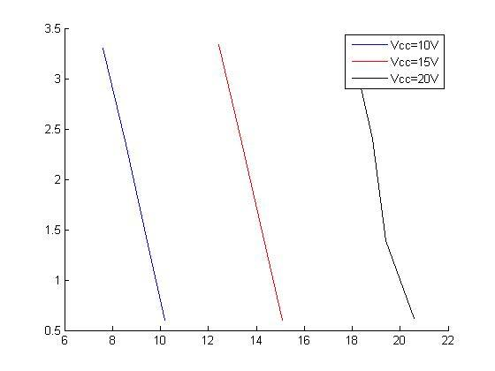

This figure shows IC on the dependent axis and VCE on the independent axis for the common base configuration. It shows the characteristic curve that we studied during lecture and how with a different load voltage that the graph shifts.

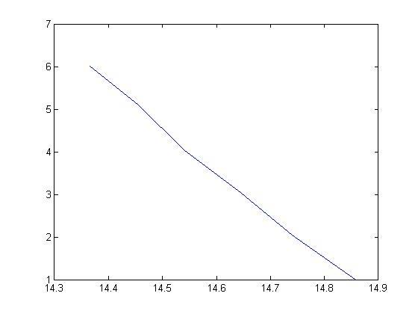

This figure shows IC VS VCE just as before, showing the load line for the common emitter configuration.

**Conclusion**

This experiment has solidified our understanding on the basic operation of two different configurations of transistor circuits. The preparation gave us good practice with basic transistor analysis, also giving us an idea of what to expect during the experiment. The prelab calculations are very similar to the measured results of the experiments.

**Common Base**

The common base configuration we used stayed mostly in active mode. Although this mode amplifies the input signal, the amplification is very little. α constantly stays at about 1.005, meaning the gain between the collector and the emitter is very small.

**Common Emitter**

The common emitter configuration we used stayed mostly in active mode. The amplification in this configuration is also very minor. β stays between 8 and 37, which provides a very insignificant gain, considering the base current is often measured in as small as microamps.