Racah Inst. Of physics, The Hebrew University handed in by:
Prof. Ofer Biham Amir Zait 060473451
April 2007 Giora Engel 043046226
Oren Kolodny 040478448

Computational physics of complex systems: Exercise 2

Problem 1
Given a random number generator that generates random numbers in [0,1] uniformly, we would like to generate numbers according to the following distribution:

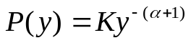

Integrating the probability we get the cumulative distribution function with a cutoff

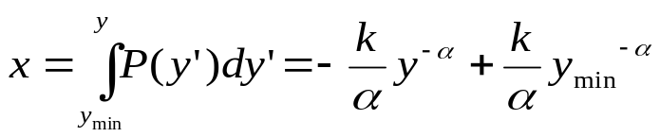

We can now solve for y:
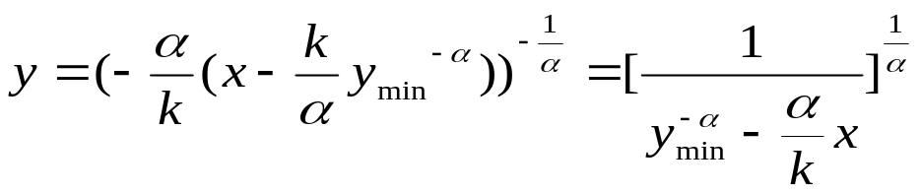
The constant k can be found by the normalization condition:
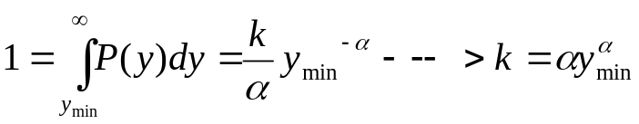

So that finally:
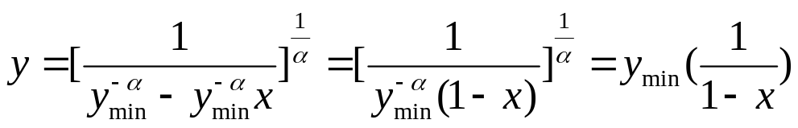
In order to generate the next number in the sequence, we simply generate the random number x, substitute in the formula for y, an return y.

פתרון שאלה 2, תרגיל 2
A.
We have the rate equation 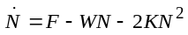. The stationary solution will be found by setting dN/dt to 0:
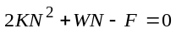
The solution to this equation is simply:
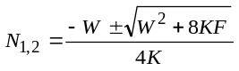
We will analyze this solution in the two extremes 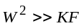, and 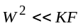.
1.
We shall use the tailor series to its first approximation (using the series for 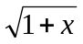, where x is small):
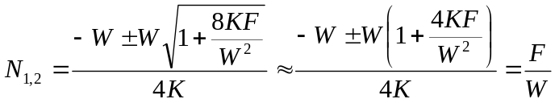,
taking only the positive solution, which is physically valid.

In this case, 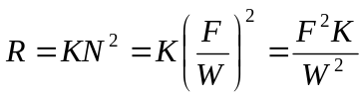, and so the efficiency is in the order of 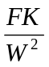, thus 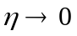.

2. 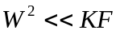
We try to use again the same approximation (after reorganizing the equation):
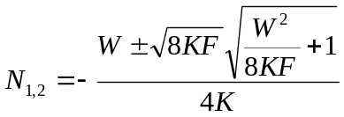
But this leads us to a small odyssey which gives us finally the same answer which we would have gotten by the simpler approximation of throwing the 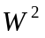(and so, we bring here only the short analysis) :
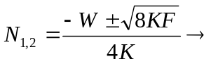taking only positive (physically valid) solution:
R=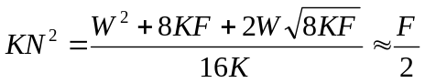
(Taking only the dominant component).
This is the leading order of the solution to the taylor series approximation as well, as noted before.

The efficiency, , is thus in the order of 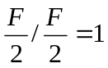.

B. We will try to solve the full equation analytically:
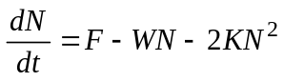

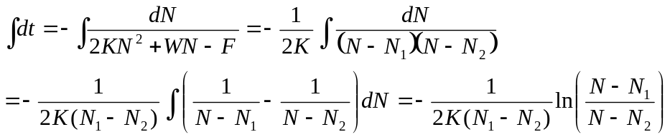

Leading us to :
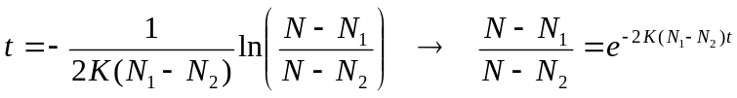
"Easily" bringing to :
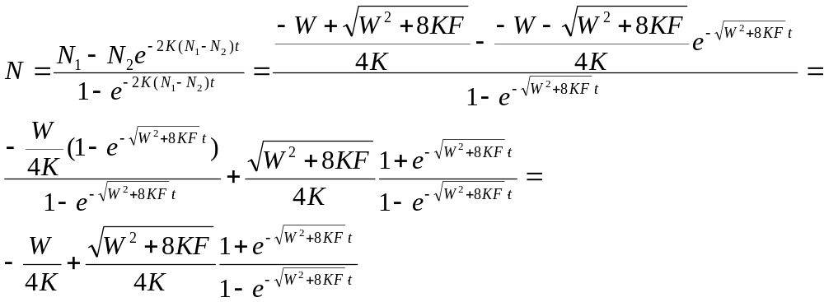
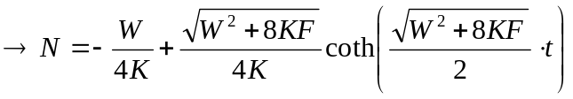

We have now
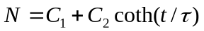
The relaxation time will be, then:
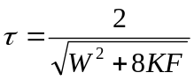

Problem 3
Question 1
Showing that the master equations are balanced, namely that the time derivative of the sum of all probabilities vanishes. We wrote the master equations for P(N):
We will now add 3 adjacent terms of these equations:
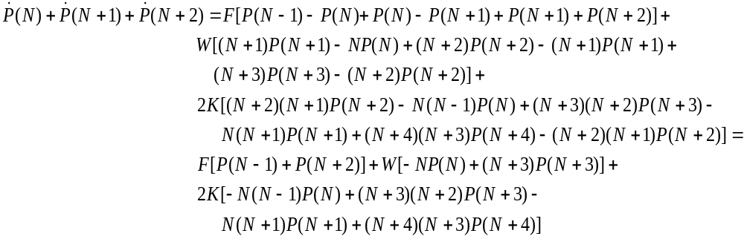As we can see, the first term (multiplied by F) is a telescopic sum, so that all terms cancel out, except for the first one, which is P(-1). Obviously, there is no meaning to P(-1), which does not appear in the master equations.
The second term (multiplied by W), is also a telescopic sum. The first term in this sum, which is the only one that does not cancel out, is 0P(0), which is obviously 0…
The third term contains a telescopic sum for the even terms, from which the only element left is -0(0-1)P(0), and a telescopic sum for the odd terms, from which the only element left is 0(0+1)P(1). Obviously, these two terms are 0, and so the entire sum vanishes.

Question 2

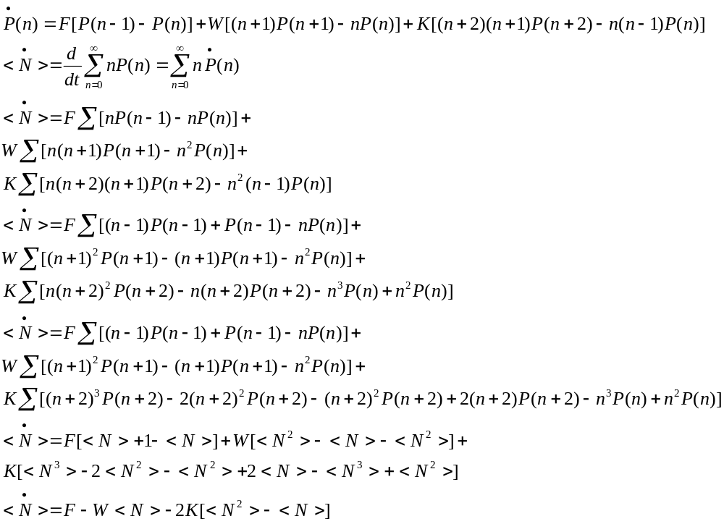The original rate equation was:
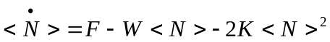
A probability function that satisfies both equations should satisfy the condition:
A Poisson distribution satisfies this equation:
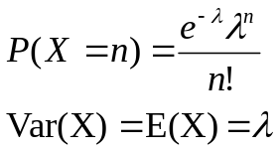

Question 3

Question 4
When <N> is small the discrete nature of the problem comes into play. For small values of <N> the rate equation gives an over-estimation of the production rate. In our dust particle example, the rate equation considers an average <N>=0.5 particles as being capable of creating a reaction, while in reality we must have at least 2 particles to create a reaction. The fluctuations about the average play a much larger role in small systems, than they would when <N> >> 1. For large systems <N>² is a good estimation for <N²>-<N>, which allows us to use the rate equation.

Question 5
We take the first moment equation from question 2:
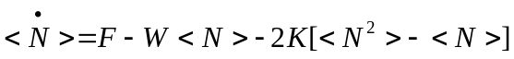
Writing the equation for the second moment:
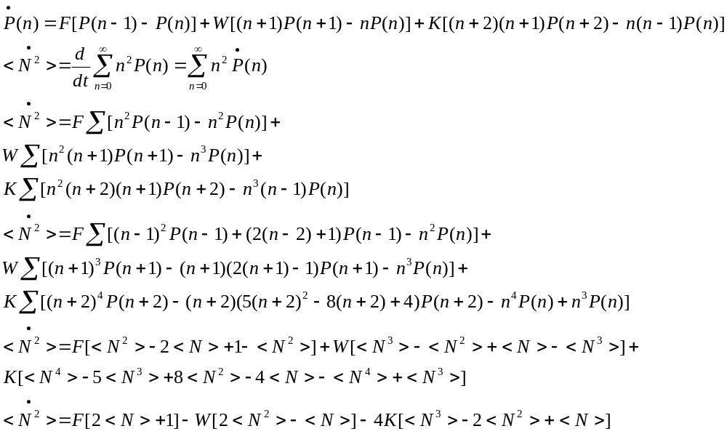
In the same manner we get for the third moment:
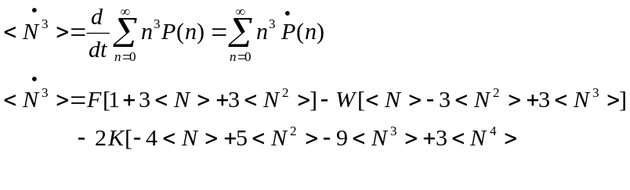
A finite set of moment equations would not be complete because each equation contains one higher moment. We can make an estimation by applying a strict cutoff on the master equation, such that P(n)=0 for n>2. We get:
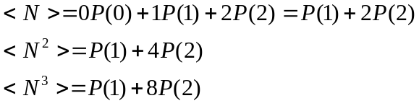
We can express P(1) and P(2) using the first two moments and substitute them in the third equation:
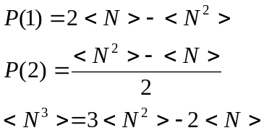
We substitute the third moment in the moment equations and get the following set:
