Grazer exclusion and invertebrate communities: a global meta-analysis
Methods and Results (draft)

2 | MATERIALS AND METHODS

2.1 | Literature search and study selection
[To be completed by the authors: databases searched, search string, date of search, inclusion criteria, screening procedure and PRISMA flow diagram.]
Studies were included if they reported an invertebrate response (abundance or density, taxonomic richness, or a diversity index) in plots from which vertebrate grazers had been excluded and in paired plots where grazing continued, together with a measure of variance and sample size for both groups. Most comparisons came from fenced exclosure experiments; a minority compared naturally ungrazed with grazed areas (hereafter ‘natural grazed vs. ungrazed’ designs) and were retained but examined in a sensitivity analysis.

2.2 | Data extraction and coding
For each comparison we extracted the mean, variance (SD or SE) and sample size of the response under exclusion and under grazing, together with study location (latitude, longitude), the grazers excluded, the year exclusion began, the sampling date(s) and the invertebrate taxon, trophic group and stratum. Every sampling year reported by a study was retained as a separate effect size. Studies whose sites lay within 100 km of one another were assigned to a common location (complete-linkage clustering) to account for spatial non-independence.
The extracted data were checked and cleaned before analysis, and every change was logged. Errors arising from spreadsheet auto-fill were reset to the source value; an exclusion year stored as a date serial was corrected; and taxonomic order and trophic-group labels were standardised (e.g. misspellings corrected, families entered as orders moved to their order, synonymous trophic labels merged). Where a group mean was zero (two studies), a constant equal to half the smallest non-zero mean in that study was added to both group means. Where a non-zero mean had a reported SE of zero (two studies), the SE was imputed from the study’s mean coefficient of variation. Fourteen comparisons lacking a sample size, variance or interpretable response type were excluded.
Responses were grouped as abundance (abundance and density), richness (taxonomic richness) and diversity (Shannon and other diversity indices) and analysed separately. Moderators were coded as follows. Stratum: above-ground (vegetation-dwelling), ground and litter-dwelling, or below-ground (soil). Grazer size: the body-mass class of the excluded grazers (Small < 10 kg, Medium 10–100 kg, Large 100–1000 kg, Mega ≥ 1000 kg), coded as the largest class excluded; where several classes were excluded together, the comparison was assigned to the largest. Grazer origin: native (wild) or domestic (livestock); comparisons excluding mixed assemblages (k = 19) or invasive grazers alone (k = 3) were omitted from origin analyses. Time since exclusion: years between the start of exclusion and sampling (ranges were represented by their midpoint, open-ended values by their bound), analysed as ln(years + 1). Trophic group: herbivore, pollinator, omnivore, predator, parasitoid, detritivore, bacterivore, fungivore, scavenger or algivore, as reported or inferred from taxonomy; comparisons reporting whole communities (‘total’), mixed guilds (herbivore/detritivore) or no trophic information were excluded from trophic analyses.
Biome was assigned by intersecting each site with the RESOLVE Ecoregions 2017 map (Dinerstein et al., 2017). Sites falling just outside a polygon (coastal sites, coordinate rounding; six sites, all within 7 km) were assigned to the nearest ecoregion. Thirteen studies that did not report coordinates were located from their site descriptions; for two of these (one in Spain without a named site, one spanning 16 stands across Sweden) the assignment is approximate. Continent was assigned from the study country (Greenland was assigned to North America).

2.3 | Effect size
Effects were expressed as the natural log response ratio, lnRR = ln(X̄_{E} / X̄_{G}), where X̄_{E} and X̄_{G} are the mean response in exclosures and grazed plots respectively (Hedges et al., 1999). Positive values indicate higher values where grazers were excluded. Standard errors were converted to standard deviations (SD = SE × √n) before computing lnRR and its sampling variance with the escalc function (measure ‘ROM’) of metafor. For presentation, estimates were back-transformed to percentage change, 100 × (e^{lnRR} − 1).

2.4 | Statistical analyses
All models were multilevel random-effects meta-analyses fitted by restricted maximum likelihood with rma.mv in metafor v4.4 (Viechtbauer, 2010) in R (R Core Team, 2024). Random intercepts were included for location, study nested within location, and effect size nested within study. Where several comparisons within a study shared the same exclosure or grazed group, the resulting sampling covariance (the shared group’s contribution, SD² / (n × X̄²)) was included in the variance–covariance matrix (Lajeunesse, 2011). Tests and confidence intervals used t-distributions with containment degrees of freedom. Because the number of locations was modest and effect sizes were strongly clustered, we also report cluster-robust (CR2) standard errors, confidence intervals and Wald tests, clustered by location, with small-sample corrections (Pustejovsky & Tipton, 2018; clubSandwich). We regard effects as robust only when they are supported by both approaches.
Because responses to grazer exclusion are known to vary widely among sites, we quantified this variation explicitly. Cochran’s Q tests whether effect sizes vary more than expected from sampling error alone. The multilevel I² expresses the proportion of the total variance in effect sizes attributable to true differences rather than sampling error, and partitions it among locations, studies within locations and effect sizes within studies (Nakagawa & Santos, 2012). Because most locations contributed a single study, the location and study components are poorly separated, so we interpret their sum (variation among studies and locations) alongside the within-study component. Because I² is a relative measure, we also report 95% prediction intervals for the overall effects, which give the range within which the effect of grazer exclusion at a new site is expected to fall (Borenstein et al., 2017; IntHout et al., 2016). From the same distribution of true effects we estimated the proportion of sites at which exclusion is expected to have a negative effect. Finally, for each moderator we calculated the proportion of heterogeneity it explained as 1 − Σσ²_{moderator} / Σσ²_{null}, where Σσ² is the sum of the variance components of the model with and without the moderator fitted to the same data (pseudo-R², truncated at zero; Raudenbush, 2009).
Each moderator was tested in a separate model within each response. For categorical moderators we report level-specific estimates from a model without an intercept, and an omnibus F-test of differences among levels from the equivalent model with an intercept. Levels represented by fewer than three studies were excluded from that model. Grazer size was additionally tested as a linear trend across ordered classes. Time since exclusion was analysed as a continuous moderator. Grazer origin (native vs. domestic) was tested first; because it did not explain variation in any response (see Results), all other moderators were analysed with comparisons pooled across origins.
Robustness was assessed by (i) comparing exclosure experiments with natural grazed vs. ungrazed comparisons; (ii) refitting the overall models without comparisons in which a zero mean had been adjusted; (iii) leave-one-study-out refits of the overall models; and (iv) a multilevel Egger-type regression with the effect-size standard error as a moderator, whose intercept provides a small-study-adjusted estimate (Nakagawa et al., 2022), alongside funnel plots. Biome and continent were examined as additional exploratory moderators. Figures were produced with ggplot2 and follow the orchard-plot format (Nakagawa et al., 2021). Code and data are available at [repository URL].

3 | RESULTS

3.1 | Dataset
The final dataset comprised 578 effect sizes from 79 studies at 52 locations in 22 countries, published between 1992 and 2026 (Figure 1). Of these, 417 effect sizes (68 studies, 44 locations) concerned abundance, 115 (35 studies, 31 locations) richness and 46 (17 studies, 16 locations) diversity. Most comparisons came from exclosure experiments (k = 533; natural grazed vs. ungrazed comparisons, k = 45). Exclusion had been in place for 0–54 years (median 4 years). Comparisons involved the exclusion of native grazers (k = 318), domestic grazers (k = 238), mixed assemblages (k = 19) or invasive grazers (k = 3). Studies were concentrated in Europe (32 studies), Asia (18), North America (17) and Africa (10), with two studies from Australia and none from South America (Figure 1).

3.2 | Overall effects of grazer exclusion and grazer origin
On average, excluding grazers increased invertebrate abundance by 14.8% (lnRR = 0.138, 95% CI: 0.011 to 0.265, p = .034; robust p = .025) and taxonomic richness by 24.1% (lnRR = 0.216, 95% CI: 0.038 to 0.395, p = .019; robust p = .019), but had no detectable effect on diversity (+10.3%, 95% CI: −15.9% to +44.8%, p = .45; Figure 2a; Table 1). Leave-one-study-out estimates ranged from 0.098 to 0.157 for abundance, 0.159 to 0.238 for richness and 0.008 to 0.150 for diversity, so no single study determined these averages.
Responses did not differ between the exclusion of native and domestic grazers for abundance (native +15.8%, domestic +10.8%; F_{1,394} = 0.14, p = .71), richness (native +28.2%, domestic +21.9%; F_{1,32} = 0.17, p = .69) or diversity (native +4.8%, domestic +18.4%; F_{1,15} = 0.50, p = .49; Figure 2b; Table 1). Grazer origin was therefore not considered further, and all subsequent analyses pool comparisons across origins.

3.3 | Variation in responses among studies and sites
The average effects concealed very large variation. Effect sizes varied far more than expected from sampling error for all three responses (abundance: Q₄₁₆ = 2851, richness: Q₁₁₄ = 719, diversity: Q₄₅ = 322; all p < .001), and true differences among effects accounted for 96.6%, 95.6% and 99.6% of the total variance, respectively (Figure 3a). Where this variation lay differed between responses. For abundance, it was split almost equally between differences among studies and locations (I² = 53.9%) and differences among effect sizes within the same study (42.7%), that is, among taxa, strata and sampling years at the same site. For richness and diversity, by contrast, nearly all of the variation occurred among studies and locations (91.9% and 89.4%), and effects from the same study were consistent (within-study I² = 3.8% and 10.2%).
As a consequence, the outcome of excluding grazers at any particular site is highly uncertain. The 95% prediction intervals, which give the range of effects expected at a new site, spanned from a 63% decrease to a 252% increase in abundance (lnRR −0.98 to 1.26), from a 52% decrease to a 223% increase in richness (−0.74 to 1.17) and from a 64% decrease to a 235% increase in diversity (−1.01 to 1.21; Figure 3b). Assuming normally distributed true effects, the effect of grazer exclusion is expected to be negative at 40% of sites for abundance, 32% for richness and 42% for diversity. Thus, although exclusion increases abundance and richness on average, it reduces them at a large minority of sites.
None of the moderators examined accounted for an appreciable share of this variation (Figure 3c; Table 1). Grazer origin, stratum, grazer size, time since exclusion, trophic group and biome each explained between 0% and 3.2% of the heterogeneity in abundance and richness, and between 0% and 2.8% for diversity. The largest values were for time since exclusion (3.2%, abundance) and a linear trend in grazer size for diversity (13.4%; 16 studies, p = .086). The variation among sites therefore remained almost entirely unexplained by the study characteristics available.

3.4 | Stratum and grazer size
Responses did not differ significantly among strata for abundance (F_{2,413} = 1.05, p = .35), richness (F_{2,112} = 0.81, p = .45) or diversity (F_{2,14} = 0.50, p = .62; Figure 4a; Table 1). Nevertheless, the increase in abundance was concentrated in above-ground invertebrates (+22.6%, 95% CI: +5.1% to +43.0%, p = .010; robust p = .024), whereas ground- and litter-dwelling (+8.6%, p = .34) and below-ground invertebrates (+9.8%, p = .48) showed no significant change. Richness increased in above-ground (+26.6%, 95% CI: +2.3% to +56.7%, p = .031; robust p = .051) and ground- and litter-dwelling assemblages (+24.9%, 95% CI: +2.3% to +52.4%, p = .029; robust p = .032), but not below ground (+15.0%, p = .22).
Abundance responses differed among the size classes of excluded grazers in the model-based test (F_{3,369} = 9.14, p < .001), but not in the cluster-robust test (robust p = .38; Figure 4b), and grazer size explained none of the heterogeneity in abundance. The difference was driven by a large increase following the exclusion of small grazers (+276%, 95% CI: +124% to +533%), estimated from only eight effect sizes from three studies at two locations. Excluding medium-sized (−3.2%, p = .76) or mega-herbivores (−7.8%, p = .68) had no detectable effect on abundance, whereas excluding large grazers increased abundance marginally (+22.5%, 95% CI: +0.3% to +49.6%, p = .047; robust p = .12), with responses varying widely among locations. There was no linear trend in abundance responses across size classes (slope = −0.047 per class, p = .54). Excluding large grazers increased richness (+36.3%, 95% CI: +9.7% to +69.4%, p = .006; robust p = .043), but richness responses did not differ significantly between medium and large grazers (F_{1,92} = 2.24, p = .14). Diversity did not vary with grazer size (F_{1,34} = 1.51, p = .23; linear trend p = .086).

3.5 | Time since exclusion
Abundance responses tended to decline with time since exclusion (slope = −0.108 per unit ln[years + 1], 95% CI: −0.226 to 0.011, p = .074; robust p = .39), from an estimated +41% at the start of exclusion to close to zero after several decades (Figure 5), although time since exclusion explained only 3.2% of the heterogeneity in abundance. Time since exclusion was unrelated to richness (slope = 0.075, p = .38) or diversity responses (slope = −0.012, p = .93).

3.6 | Trophic groups
Trophic groups did not differ significantly in their abundance responses to grazer exclusion (F_{7,320} = 1.27, p = .27; Figure 6; Table 2), and trophic group explained none of the heterogeneity in any response. Point estimates were positive for most groups and largest for parasitoids (+51.0%, 95% CI: +2.1% to +123.1%, p = .039; four studies), bacterivorous nematodes (+37.6%, p = .097) and detritivores (+35.8%, 95% CI: +4.3% to +76.9%, p = .023), intermediate for predators (+18.5%, p = .13) and herbivores (+12.8%, p = .26), and negative only for pollinators (−13.0%, p = .53). None of the group-level effects was significant in cluster-robust tests (all robust p ≥ .17). Richness (F_{2,66} = 0.42, p = .66) and diversity (F_{1,13} = 0.02, p = .90) responses likewise did not differ among trophic groups.

3.7 | Biome and continent
Responses did not differ among biomes for abundance (F_{6,33} = 1.21, p = .33), richness (F_{4,20} = 0.36, p = .83) or diversity (F_{3,8} = 0.93, p = .47; Figure S1), and biome explained none of the heterogeneity. The only biome-level estimate that differed from zero was an increase in abundance in temperate conifer forests (+59.9%, 95% CI: +10.4% to +131.5%, p = .015), which came from 15 studies at seven locations and was not supported by the cluster-robust test (robust p = .19). Likewise, responses did not differ among continents for abundance (F_{3,38} = 0.40, p = .75), richness (F_{3,26} = 0.27, p = .85) or diversity (F_{2,12} = 0.01, p = .99).

3.8 | Sensitivity analyses and publication bias
Effects on abundance were positive in exclosure experiments (+17.8%, 95% CI: +2.9% to +34.9%, p = .019) but not in natural grazed vs. ungrazed comparisons (−5.2%, p = .77), although the two designs did not differ significantly (F_{1,42} = 1.26, p = .27); design did not affect richness (p = .39) or diversity (p = .12). Excluding comparisons with zero-adjusted means did not alter the overall abundance estimate (+14.0%, 95% CI: +0.9% to +28.9%). The multilevel Egger test revealed strong small-study asymmetry for abundance (slope on SE = 0.757, 95% CI: 0.449 to 1.066, p < .001; robust p = .003): less precise studies reported larger positive effects (Figure S2). The bias-adjusted intercept for abundance was close to zero (−8.3%, 95% CI: −21.4% to +7.1%, p = .27), indicating that the overall increase in abundance should be interpreted with caution. There was no evidence of small-study effects for richness (p = .12) or diversity (p = .47).

TABLE 1 Overall effects of grazer exclusion, heterogeneity and moderator tests for each response. Estimates are percentage change (95% CI) in exclosures relative to grazed plots. Moderator tests are model-based F-tests with containment degrees of freedom (cluster-robust p in brackets); R² is the percentage of heterogeneity explained by the moderator.
 | Abundance | Richness | Diversity
Overall effect, % (95% CI) | +14.8 (+1.1, +30.3) | +24.1 (+3.9, +48.4) | +10.3 (−15.9, +44.8)
p (robust p) | .034 (.025) | .019 (.019) | .45 (.45)
95% prediction interval, % | −62.6 to +252.3 | −52.3 to +223.1 | −63.7 to +235.4
Sites with negative effect (%) | 40 | 32 | 42
k / studies / locations | 417 / 68 / 44 | 115 / 35 / 31 | 46 / 17 / 16
Q (df) | 2851 (416)*** | 719 (114)*** | 322 (45)***
I² total (%) | 96.6 | 95.6 | 99.6
I² among studies/locations (%) | 53.9 | 91.9 | 89.4
I² within studies (%) | 42.7 | 3.8 | 10.2
Grazer origin | F_{1,394} = 0.14, p = .71 (.69); R² = 0 | F_{1,32} = 0.17, p = .69 (.78); R² = 0 | F_{1,15} = 0.50, p = .49 (.41); R² = 0
Stratum | F_{2,413} = 1.05, p = .35 (.35); R² = 1.7 | F_{2,112} = 0.81, p = .45 (.37); R² = 0 | F_{2,14} = 0.50, p = .62 (.34); R² = 0
Grazer size (largest class) | F_{3,369} = 9.14, p < .001 (.38); R² = 0 | F_{1,92} = 2.24, p = .14 (.31); R² = 1.8 | F_{1,34} = 1.51, p = .23 (.48); R² = 2.8
Grazer size (linear trend) | p = .54 (.71); R² = 0 | p = .98 (.99); R² = 0 | p = .086 (.16); R² = 13.4
Time since exclusion | p = .074 (.39); R² = 3.2 | p = .38 (.24); R² = 0 | p = .93 (.85); R² = 0
Trophic group | F_{7,320} = 1.27, p = .27 (–); R² = 0 | F_{2,66} = 0.42, p = .66 (.79); R² = 0 | F_{1,13} = 0.02, p = .90 (.83); R² = 0
Biome | F_{6,33} = 1.21, p = .33 (.93); R² = 0 | F_{4,20} = 0.36, p = .83 (.16); R² = 0 | F_{3,8} = 0.93, p = .47 (.82); R² = 0
Continent | F_{3,38} = 0.40, p = .75 (.90) | F_{3,26} = 0.27, p = .85 (.77) | F_{2,12} = 0.01, p = .99 (.99)
Study design | F_{1,42} = 1.26, p = .27 (.28) | F_{1,33} = 0.77, p = .39 (.42) | F_{1,15} = 2.68, p = .12 (.18)
Egger test (SE slope) | p < .001 (.003) | p = .12 (.086) | p = .47 (.70)
Note: ***p < .001. The robust omnibus test for trophic group (abundance) could not be computed because the number of levels was large relative to the number of locations.
TABLE 2 Effects of grazer exclusion on the abundance of invertebrate trophic groups. Values are percentage change in exclosures relative to grazed plots (95% CI); p values are model-based (cluster-robust in brackets).
Trophic group | Change, % (95% CI) | p (robust p) | k (studies)
Herbivore | +12.8 (−8.6, +39.1) | .26 (.35) | 119 (35)
Pollinator | −13.0 (−43.6, +34.2) | .53 (.61) | 19 (6)
Omnivore | +3.9 (−25.5, +44.8) | .82 (.89) | 26 (5)
Predator | +18.5 (−5.0, +47.8) | .13 (.19) | 77 (24)
Parasitoid | +51.0 (+2.1, +123.1) | .039 (.24) | 16 (4)
Detritivore | +35.8 (+4.3, +76.9) | .023 (.17) | 47 (14)
Bacterivore | +37.6 (−5.6, +100.5) | .097 (.19) | 12 (4)
Fungivore | +9.2 (−23.2, +55.2) | .62 (.65) | 12 (4)
Note: Scavengers and algivores (one study each) were not estimated.

References
Borenstein, M., Higgins, J. P. T., Hedges, L. V., & Rothstein, H. R. (2017). Basics of meta-analysis: I² is not an absolute measure of heterogeneity. Research Synthesis Methods, 8, 5–18.
Dinerstein, E., Olson, D., Joshi, A., Vynne, C., Burgess, N. D., Wikramanayake, E., … Saleem, M. (2017). An ecoregion-based approach to protecting half the terrestrial realm. BioScience, 67, 534–545.
Hedges, L. V., Gurevitch, J., & Curtis, P. S. (1999). The meta-analysis of response ratios in experimental ecology. Ecology, 80, 1150–1156.
IntHout, J., Ioannidis, J. P. A., Rovers, M. M., & Goeman, J. J. (2016). Plea for routinely presenting prediction intervals in meta-analysis. BMJ Open, 6, e010247.
Lajeunesse, M. J. (2011). On the meta-analysis of response ratios for studies with correlated and multi-group designs. Ecology, 92, 2049–2055.
Nakagawa, S., Lagisz, M., O’Dea, R. E., Rutkowska, J., Yang, Y., Noble, D. W. A., & Senior, A. M. (2021). The orchard plot: Cultivating a forest plot for use in ecology, evolution, and beyond. Research Synthesis Methods, 12, 4–12.
Nakagawa, S., Lagisz, M., Jennions, M. D., Koricheva, J., Noble, D. W. A., Parker, T. H., … O’Dea, R. E. (2022). Methods for testing publication bias in ecological and evolutionary meta-analyses. Methods in Ecology and Evolution, 13, 4–21.
Nakagawa, S., & Santos, E. S. A. (2012). Methodological issues and advances in biological meta-analysis. Evolutionary Ecology, 26, 1253–1274.
Pustejovsky, J. E., & Tipton, E. (2018). Small-sample methods for cluster-robust variance estimation and hypothesis testing in fixed effects models. Journal of Business & Economic Statistics, 36, 672–683.
Raudenbush, S. W. (2009). Analyzing effect sizes: Random-effects models. In H. Cooper, L. V. Hedges, & J. C. Valentine (Eds.), The handbook of research synthesis and meta-analysis (2nd ed., pp. 295–315). Russell Sage Foundation.
R Core Team. (2024). R: A language and environment for statistical computing. R Foundation for Statistical Computing.
Viechtbauer, W. (2010). Conducting meta-analyses in R with the metafor package. Journal of Statistical Software, 36(3), 1–48.

Figures
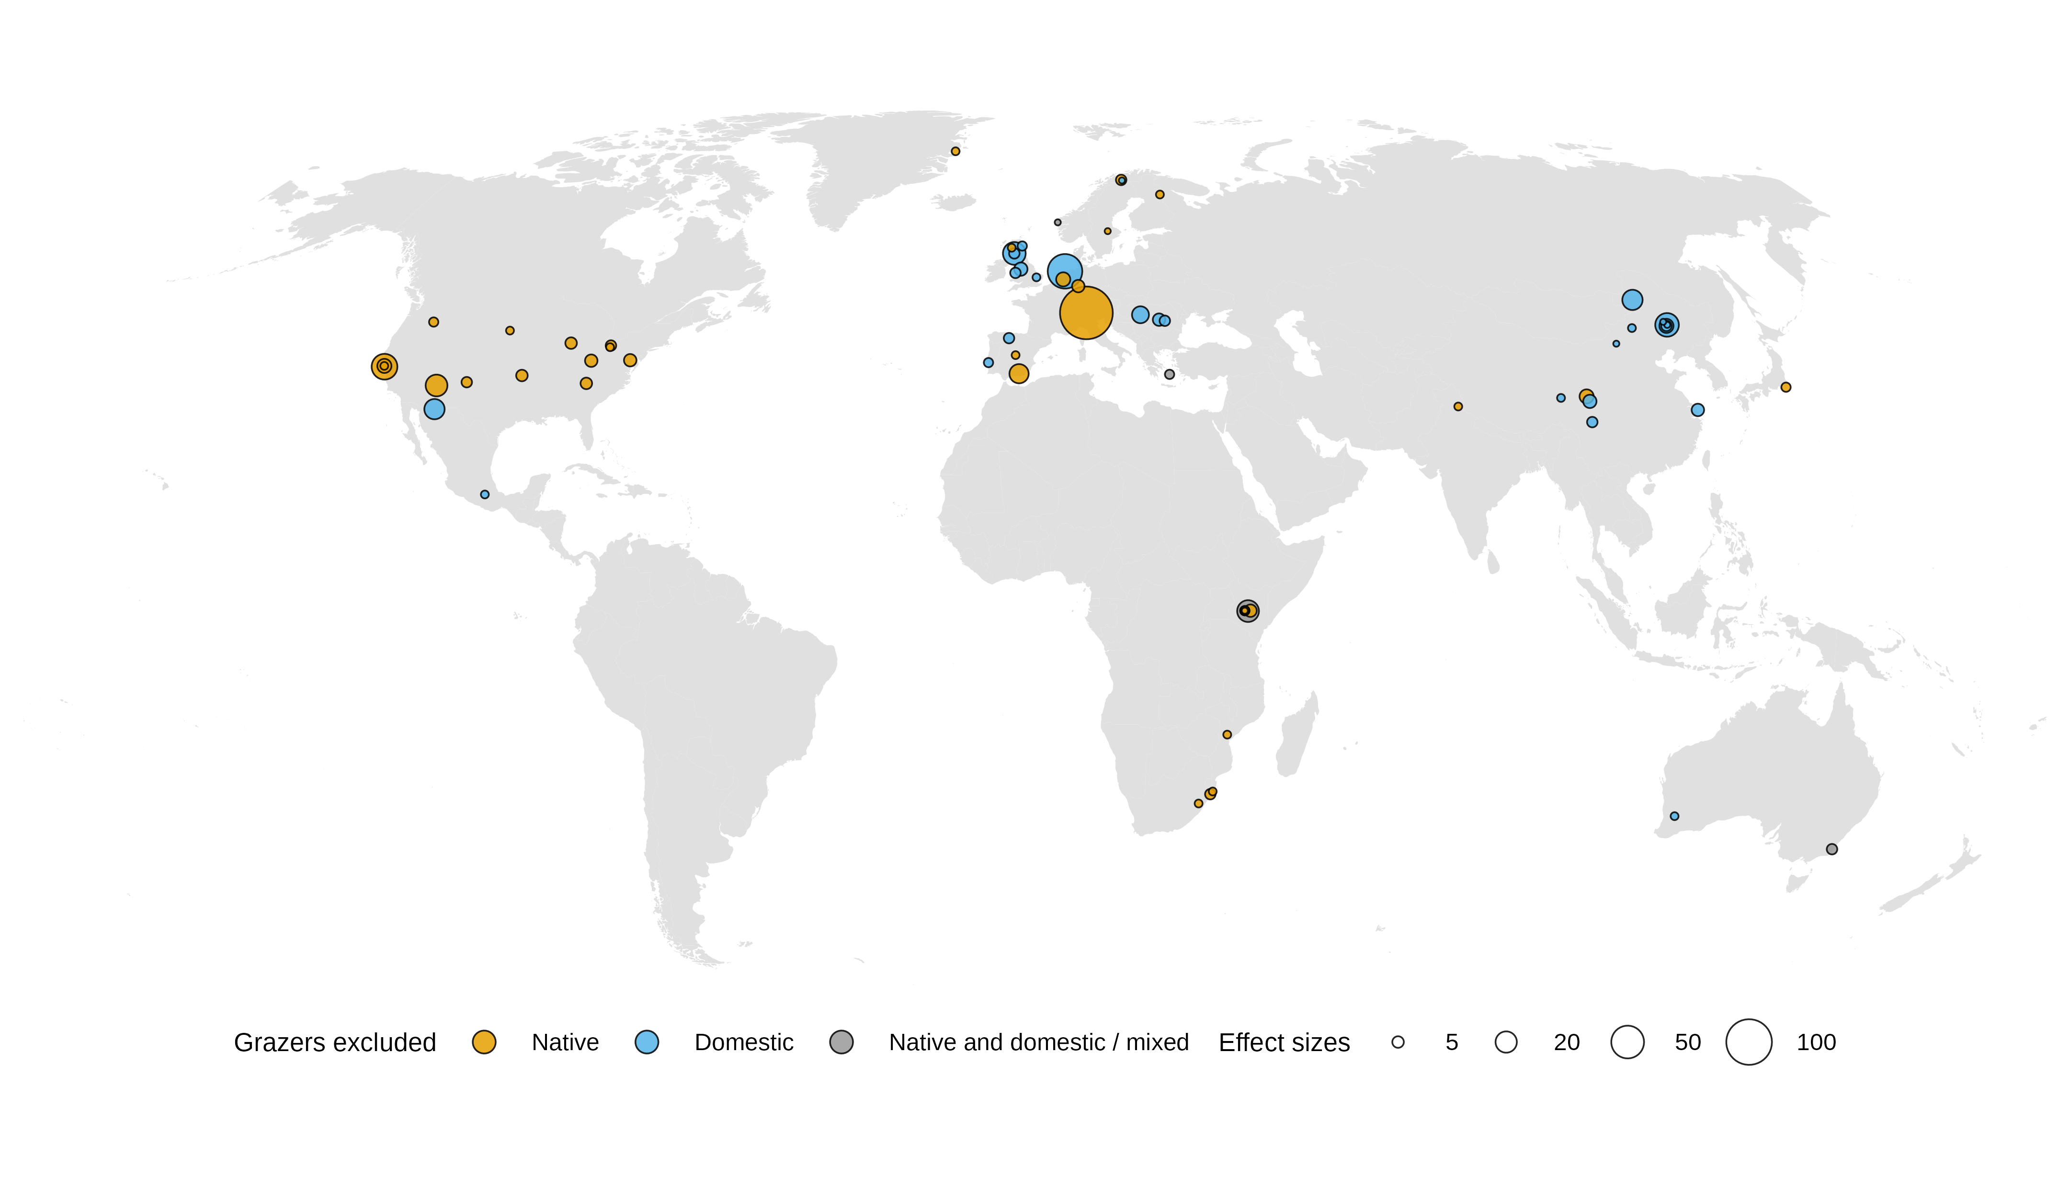
Figure 1 Locations of the 79 studies (52 locations) included in the meta-analysis. Point area is proportional to the number of effect sizes from each site; colour shows whether native, domestic or both/mixed grazers were excluded. Robinson projection.

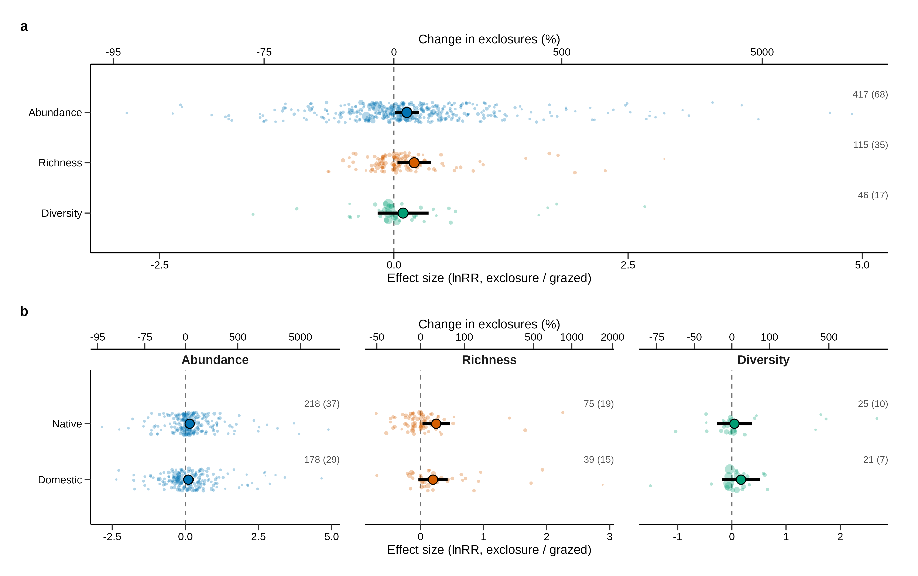
Figure 2 Effects of grazer exclusion on invertebrate abundance, richness and diversity (a) overall and (b) by the origin of the excluded grazers (native vs. domestic). Small points are individual effect sizes (size proportional to precision, 1/SE); large points and bars are model estimates and 95% confidence intervals from multilevel meta-analytic models. The upper axis gives the equivalent percentage change in exclosures relative to grazed plots. Numbers give effect sizes (studies). Positive values indicate higher values where grazers were excluded.

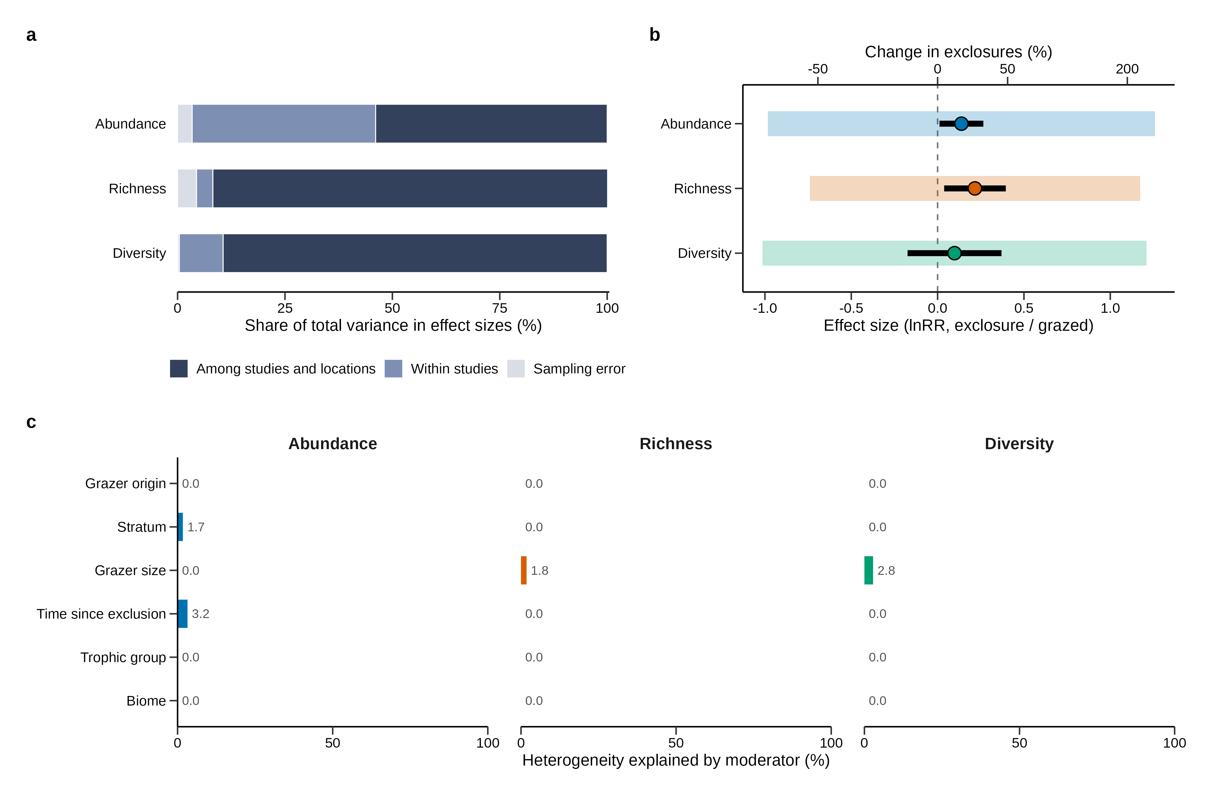
Figure 3 Variation in invertebrate responses to grazer exclusion. (a) Partitioning of the total variance in effect sizes into variation among studies and locations, among effect sizes within studies, and sampling error (multilevel I²). (b) Mean effect with its 95% confidence interval (black bar) and the 95% prediction interval (shaded band), the range within which the effect at a new site is expected to fall. (c) Percentage of the between-study and within-study heterogeneity explained by each moderator (pseudo-R²).

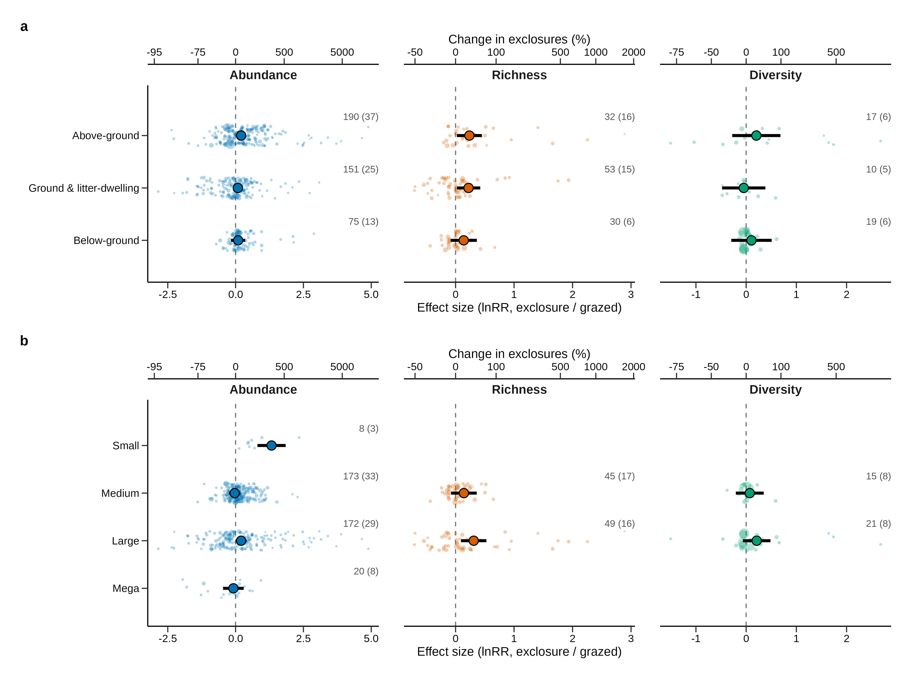
Figure 4 Effects of grazer exclusion (a) by invertebrate stratum and (b) by the largest size class of grazer excluded (Small < 10 kg, Medium 10–100 kg, Large 100–1000 kg, Mega ≥ 1000 kg). Symbols as in Figure 2. Levels represented by fewer than three studies are not shown.

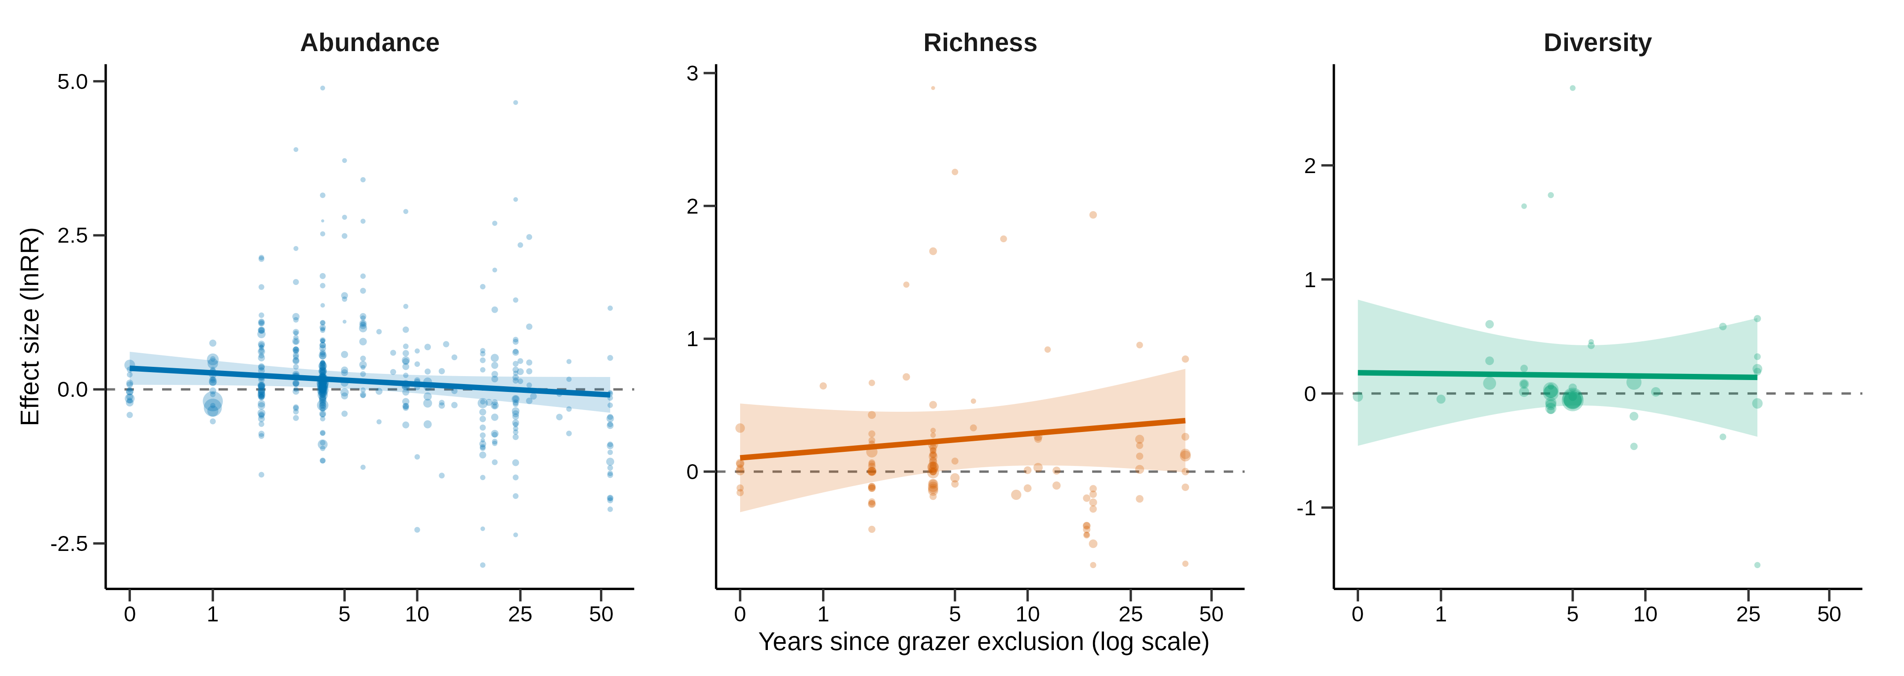
Figure 5 Effects of grazer exclusion in relation to time since exclusion. Points are effect sizes (size proportional to precision); lines and shaded bands are meta-regression fits and 95% confidence intervals. The x-axis is ln(years + 1), labelled in years.

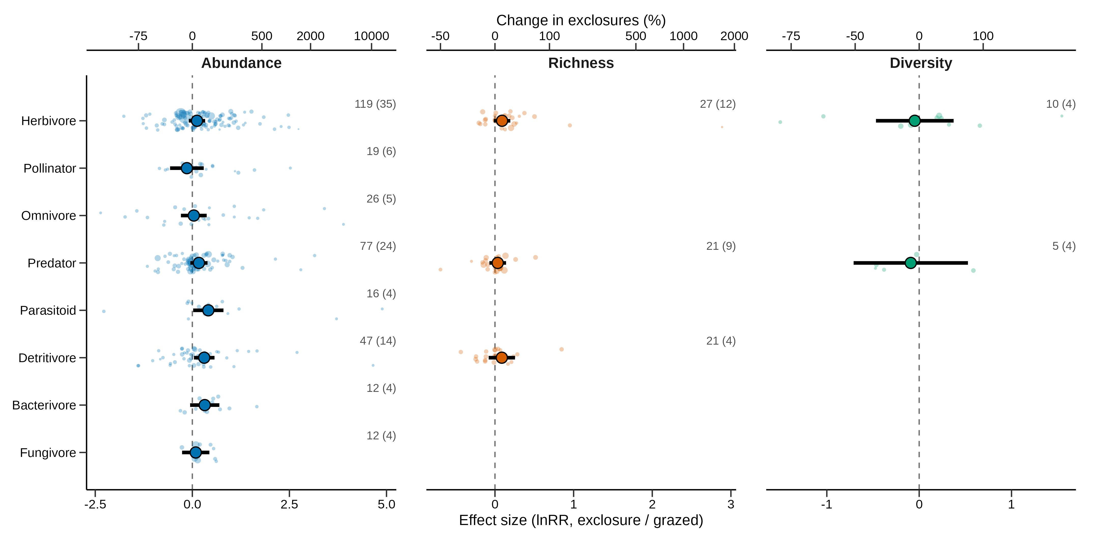
Figure 6 Effects of grazer exclusion on invertebrate trophic groups. Symbols as in Figure 2. Trophic groups represented by fewer than three studies within a response are not shown.

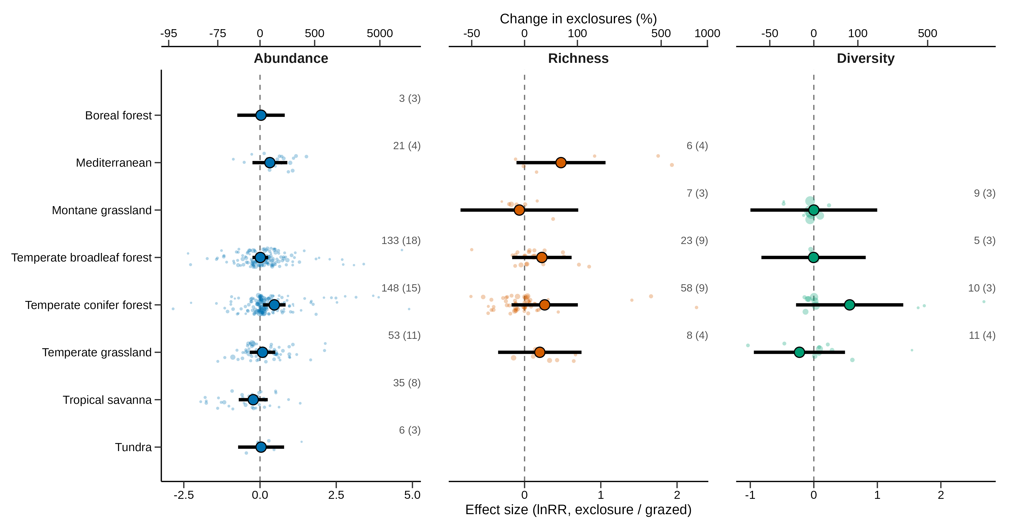
Figure S1 Effects of grazer exclusion by biome (RESOLVE Ecoregions 2017). Symbols as in Figure 2. Biomes represented by fewer than three studies within a response are not shown.

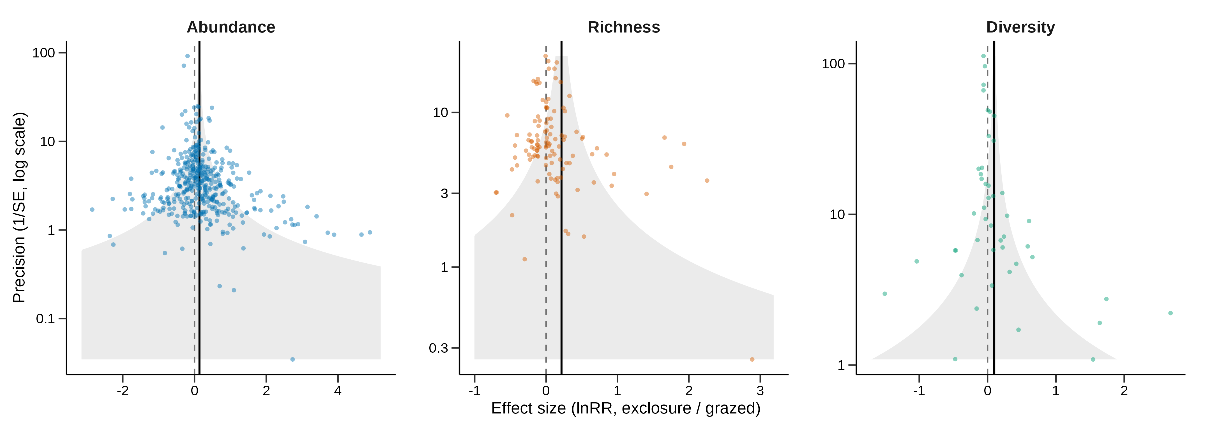
Figure S2 Funnel plots of effect sizes against precision (1/SE, log scale). Vertical solid lines show the overall estimate, shaded regions its expected 95% range given each precision, dashed lines zero.

