VENDOR CONTRACT

NAME
Project-Task-Award

The following addendum is incorporated into and made a part of Research Foundation Purchase Order Number R_________.

1. Work and/or Services to be Provided

All goods and/or services provided hereunder shall in all respects comply with the description set forth on the face of the above referenced Purchase Order, and with the description of services as described in the “Scope of Work and Payment Schedule”, labeled Exhibit A, which is attached to and incorporated herein.

2. Designated Contacts

The FOUNDATION’s designated contact point for questions which VENDOR may have regarding the training or technical issues relating to this procurement agreement is its project director/manager, ___________________. FOUNDATION’s contact point for questions concerning payment of approved invoices is Office of Sponsored Funds Accounting. The VENDOR’s contact person is ________________________.

3. Term

The goods and/or services which are being procured hereunder shall be provided during the period _______________through ______________, unless terminated sooner or extended by mutual consent of the parties hereto in accordance with provisions set forth elsewhere in this agreement.

4. Compensation and Payment

The FOUNDATION shall reimburse VENDOR up to (in words-ALL CAPS) _____________________________________________________ DOLLARS and _________CENTS ($_________________) for goods and/or services pursuant to this procurement agreement. The actual amount payable to VENDOR shall be the amount of allowable costs which are incurred by VENDOR to carry out the work/services covered by this procurement agreement. The FOUNDATION shall reimburse VENDOR per the terms of the attached Payment Schedule upon submission of an itemized invoice(s) to the campus address identified below. Invoices shall be submitted after successful completion of the training/deliverables, will reference the FOUNDATION’s purchase order number R __________and should be sent to: (department contact) name, department, University at Albany, State University of New York, Building/room, 135 Western Avenue/1400 Washington Avenue, Albany, NY 12222.

5. Termination

FOUNDATION may terminate this procurement agreement on 10 days written notice if FOUNDATION has reason to believe that VENDOR is in breach of its obligations hereunder.

It is understood and agreed, however, in the event that FOUNDATION has evidence that VENDOR is in default upon any of its obligations hereunder, FOUNDATION shall be entitled to either suspend the contract until an acceptable remedy is established, or to terminate the agreement. Such termination shall be effective immediately upon receipt of official written notification from FOUNDATION. FOUNDATION shall also be entitled to pursue any rights or remedies which FOUNDATION may have against VENDOR by reason of such default, and FOUNDATION may withhold any payments to VENDOR for the purpose of set-off until such time as the exact amount of damages may be determined.

6. Liability to Third Parties

If either VENDOR or Foundation is negligent in carrying out its obligations hereunder, the negligent party agrees to take responsibility for said negligence and to indemnify the innocent party against the consequences of said negligence, including claims of third parties for damages and expenses which arise from or are related to the negligent party’s performance or failure to perform pursuant to this procurement agreement.

7. Assignment of VENDOR's Obligations

VENDOR shall not assign its obligation to provide goods or services under this procurement agreement without prior written consent of the FOUNDATION.

- Status of Parties

The nature of the relationship which the VENDOR shall have to the FOUNDATION pursuant to this Agreement shall be that of an independent contractor. In connection with its status as an independent contractor, VENDOR hereby warrants that it is in compliance with all tax filing and similar requirements imposed on independent contractors, and acknowledges that it is solely responsible for paying income taxes, FICA taxes, and other taxes and assessments which arise from receipt of payments under this Agreement. This Agreement shall not be construed to contain any authority either express or implied, enabling the VENDOR to incur any expense or perform any act on behalf of the FOUNDATION.

9. Insurance

VENDOR, at no additional cost to the FOUNDATION, shall maintain or cause to be maintained throughout the term of this agreement, insurance of the types and in the amounts specified in this section. All such insurance shall be evidenced by Certificates of Insurance if requested by FOUNDATION. These Certificates shall be endorsed to cover the State of New York, State University of New York and the FOUNDATION as additional insured; provide that such policy may not be canceled or modified until at least 30 days after receipt by sponsor of written notice thereof; and be reasonably satisfactory to sponsor in all other respects.

a) Workers compensation insurance for all employees of VENDOR engaged in performing this agreement, as required by applicable laws.

b) Disability insurance in accordance with the provisions of applicable law.

c) Employer's liability or similar insurance for damages arising from bodily injury, by accident or disease, including death at any time resulting therefrom, sustained by employees of VENDOR while engaged in performing this agreement.

d) If this agreement is a contract where an auto will be required to complete the scope of work, Automobile Liability Insurance covering any auto with a combined single limit of liability of $1,000,000.

10. Warranty of Originality

VENDOR warrants that all material produced by VENDOR and delivered to FOUNDATION hereunder shall be original except for such portion as is included with permission of the copyright owners thereof, that it shall contain no libelous or unlawful statements or materials, and will not infringe upon any copyright, trademark, patent, statutory or other proprietary rights of others and that it will hold harmless the FOUNDATION from any costs, expenses and damages resulting from any breach of this warranty.

11. Rights in Work Product

VENDOR agrees that material produced by VENDOR hereunder shall be considered “work for hire” which shall be owned by the FOUNDATION. VENDOR agrees that VENDOR shall not claim or assert any proprietary interest in any of the data or materials required to be produced or delivered by VENDOR in the performance of VENDOR’s obligation hereunder, and hereby assigns all rights, title and interest in said data and materials to FOUNDATION. VENDOR further agrees not to publish, permit to be published, or distribute for public consumption, any information, oral or written, concerning the results or conclusions made pursuant to this agreement without the prior written consent of the FOUNDATION.

Notwithstanding the foregoing, VENDOR will retain ownership of intellectual property included in deliverables to the extent that said intellectual property has been independently developed by VENDOR without Research Foundation financial support. With respect to such VENDOR owned intellectual property, VENDOR hereby grants to Research Foundation a royalty-free, nonexclusive license to use such intellectual property for purposes consistent with the Research Foundation’s obligations under the grant or contract which funds this project.

12. Confidentiality/Proprietary Information

In the course of carrying out this procurement agreement, FOUNDATION will share information provided by the project director/manager. VENDOR agrees that these materials shall not be utilized for purposes other than those specified in Exhibit A, and shall be returned to the FOUNDATION upon completion of this contract.

13. Governing Law

This agreement and any disputes relating thereto shall be construed under the laws of the State of New York.

14. Compliance with Laws and Regulations

In addition to the terms and conditions relating to laws, rules and regulations which are referenced on the Purchase Order, VENDOR agrees to comply with the following provisions:

a) In the performance of the work authorized pursuant to this agreement, VENDOR agrees to comply with all applicable laws and regulations, as well as policies of the sponsor applicable to VENDOR’s performance hereunder, and the express terms of FOUNDATION’s agreement with the sponsor, which shall be deemed to be inserted herein, and this agreement shall be read and enforced between the parties as though all such provisions were included verbatim herein.

THE FOLLOWING IS OPTIONAL LANGUAGE TO BE USED WHEN AGREEMENT IS SUBJECT TO FEDERAL DEBARMENT PROVISIONS (WHEN ISSUED UNDER A FEDERAL GRANT, COOPERATIVE AGREEMENT, SCHOLARSHIP, OR FELLOWSHIP). SEE INFORMATIONAL COMMUNIQUÉ 204.

- This procurement agreement is subject to debarment and suspension regulations published in the Federal Register for May 26, 1988. In order to assure compliance with these regulations, VENDOR must provide the certification set forth in Exhibit ___, which is attached to and made a part of this
procurement agreement. By executing this procurement agreement, VENDOR

acknowledges that it is also making the required certification.

THE FOLLOWING IS OPTIONAL LANGUAGE TO BE USED WHEN PROCUREMENT AGREEMENT IS SUBJECT TO FEDERAL LOBBYING PROVISIONS (ANY PROCUREMENT AGREEMENT EXCEEDING $100,000.00 THAT IS ISSUED UNDER A FEDERAL CONTRACT, GRANT OR COOPERATIVE AGREEMENT). SEE ACTION REQUIRED NOTICE DATED MAY 8, 1990.

c) VENDOR hereby represents that it is familiar with the provisions of 31 USC 1352 entitled “Limitation on the Use of Appropriated Funds to Influence Certain Federal Contracting and Financial Transactions” and the regulations issued thereunder (hereinafter “Lobbying Act”). VENDOR acknowledges that by executing this procurement agreement VENDOR is also making the certification required by the Lobbying Act, a copy of which is attached to and made a part of this procurement agreement as Exhibit _____. VENDOR also agrees that it will submit Standard Form-LLL, “Disclosure Form to Report Lobbying”, to the RESEARCH FOUNDATION as required by the Lobbying Act.

THE FOLLOWING IS OPTIONAL LANGUAGE TO BE USED IF THE SUBCONTRACT IS SUPPORTED BY FEDERAL FUNDS.

d) VENDOR agrees to encourage compliance with Executive Order 13043, “Increasing Seat Belt Use in the United States” by adopting and enforcing on-the-job seat belt policies and programs for employees when operating company-owned, rented, or personally-owned vehicles.

THE FOLLOWING IS OPTIONAL LANGUAGE TO BE USED IF THE AGREEMENT IS TO PROCURE TEXTILES, INCLUDING LAB COATS, T-SHIRTS, UNIFORMS, AND ANY APPAREL, ETC.

e) As outlined in the Laws of New York 2002 Chapter 350 known as the “Apparel Workers Fair Labor Conditions and Procurement Act”, The Research Foundation of SUNY, University at Albany, shall not enter into a contract to purchase or obtain for any purpose any apparel from a bidder unable or unwilling to provide documentation as part of its bid: (A) attesting that such apparel was manufactured in compliance with all applicable labor and occupational safety laws, including, but not limited to, child labor laws, wage and hour laws and workplace safety laws; (B) stating, if known, the name and address of each subcontractor to be utilized; and (C) stating, if known, all manufacturing plants utilized by the bidder or subcontractor.

The Research Foundation of SUNY, University at Albany, has the authority to determine that a bidder on a contract for the purchase of apparel is not a responsible bidder based upon either of the following considerations: (A) The labor standards applicable to the manufacture of the apparel, including but not limited to employee compensation, working conditions, employee rights to form unions, and the use of child labor, or (B) the bidders failure to provide

information sufficient for the Research Foundation of SUNY, University at Albany to determine the labor conditions applicable to the manufacture of the apparel. In order to assure compliance with these regulations, VENDOR must provide the certification set forth in Exhibit ___, which is attached to and made a part of this procurement agreement.

15. Modifications and Changes

This agreement may be changed, amended, modified, extended, or terminated by mutual consent provided that such consent shall be in writing and executed by the parties hereto.

16. Entire Agreement

This agreement represents and embodies all the agreements and negotiations between the parties hereto and no prior or contemporaneous, oral, or written agreements or correspondence prior to the date of execution of this agreement shall be held to vary the provisions hereof.

17. Order of Precedence

In the event of any inconsistency between clauses 1-17 of this agreement and the scope of work, if attached, the inconsistency should be resolved by giving precedence to clauses 1-17.

- Foreign Nationals

As a result of September 11, 2001, Contractors are required by Federal law to verify that all its employees and as subcontractors in its employ are legally entitled to work in the United States. Accordingly, the Research Foundation SUNY, University at Albany reserves the right to request legally mandated Contractor-held documentation attesting to the same for each employee assigned work under any contract awarded. In accord with such laws, the Research Foundation SUNY, University at Albany does not discriminate against individuals on the basis of national origin or citizenship.

THIS PROCUREMENT AGREEMENT is being executed by the parties hereto as evidence of their agreement to the terms and conditions of the above referenced Purchase Order, including the additional terms and conditions set forth in this addendum, and the provisions of any exhibits which are incorporated into said Purchase Order.

THE RESEARCH FOUNDATION OF VENDOR NAME

STATE UNIVERSITY OF NEW YORK

By____________________________ By____________________________
Kevin C Wilcox, Associate Vice President name
Finance and Business/Controller

Date___________________________ Date____________________________

Fed. ID No. _____________________

ACKNOWLEDGEMENT BY INDIVIDUAL
STATE OF NEW YORK )
SS.:
COUNTY OF )

On this___________day of _______________, 20____, before me personally came
___________________________________, to me known and known to me to be the person
described in and who executed the foregoing instrument and he/she acknowledged to me that he/she executed the same.
___________________________
Notary Public

ACKNOWLEDGEMENT BY UNINCORPORATED ASSOCIATION
STATE OF NEW YORK )
SS.:
COUNTY OF )

On this ___________day of ________________,20____, before me personally came
____________________________________, to me known and known to me to be the person

described in and who executed the above instrument, who, being duly sworn by me, did for himself/herself depose and say that he/she is a member of the firm of ____________________ and that he/she executed the foregoing instrument in the firm name of ____________________, and that he/she had authority to sign same, and he/she did duly acknowledge to me that he/she executed the same as the act and deed of said firm of _________________________, for the uses and purposes mentioned therein.

___________________________

Notary Public

ACKNOWLEDGEMENT BY CORPORATION
STATE OF NEW YORK )
SS.:
COUNTY OF )

On this___________day of ______________, in the year 20__, before me personally came________________________________, to me known, who, being by me duly sworn did depose and say that he/she resides in ___________________________; that he/she is the
____________________________ of the _____________________________, the corporation described in and which executed the above instrument; that he/she knows the seal of said corporation; that the seal affixed to said instrument is such a corporate seal, that it was so affixed by the order of the Board of Directors of said corporation, and that he/she signed his/her name thereto by like order.
____________________________
Notary Public

EXHIBIT ___________



University at Albany
Office of Research Purchasing & Contracts

CERTIFICATION REGARDING
DEBARMENT, SUSPENSION, AND OTHER RESPONSIBILITY MATTERS
- LOWER TIER TRANSACTION

PURPOSE

Federal regulations prohibit participants in federal non-procurement transactions from purchasing goods and services from organizations excluded from participation in federal programs due to debarment or suspension. These regulations are set forth in the May 26, 1988 Federal Register. The Certification below must be returned to the Research Foundation office from which it originated. The form requires you to certify that neither your firm nor principals of the firm are debarred or suspended from participating in federal non-procurement transactions. In addition, although the certification refers to “proposals,” the form must be signed without modification even when an order, subcontract, or consulting agreement is not preceded by submission of a proposal. See reverse for certification instructions.

CERTIFICATION

(1) The prospective lower tier participant certifies, by submission of this proposal, that neither it nor its principals is presently debarred, suspended, proposed for debarment, declared ineligible, or voluntarily excluded from participation in this transaction by any Federal department or agency.

(2) Where the prospective lower tier participant is unable to certify to any of the statements in this certification, such prospective participant shall attach an explanation to this proposal.

_________________________________ ___________________________________
Authorized Signature Print Name

_________________________________ ____________________________________
Company Date
Instructions for Certification

1. By signing and submitting this proposal, the prospective lower tier participant is providing the certification set out on the reverse.

2. The certification in this clause is a material representation of fact upon which reliance was placed when this transaction was entered into. If it is later determined that the prospective lower tier participant knowingly rendered an erroneous certification, in addition to other remedies available to the Federal Government, the department or agency with which this transaction originated may pursue available remedies, including suspension and/or debarment.

3. The prospective lower tier participant shall provide immediate written notice to the person to which this proposal is submitted if at any time the prospective lower tier participant learns that its certification was erroneous when submitted or has become erroneous by reason of changed circumstances.

4. The terms “covered transaction,” “debarred,” “suspended,” “ineligible,” “lower tier covered transaction,” “participant,” “person,” “primary covered transaction,” “principal,” “proposal,” and “voluntarily excluded,” as used in this clause, have the meanings set out in the Definitions and Coverage sections of rules implementing Executive Order 12549. You may contact the person to which this proposal is submitted for assistance in obtaining a copy of those regulations.

5. The prospective lower tier participant agrees by submitting this proposal that, should the proposed covered transaction be entered into, it shall not knowingly enter into any lower tier covered transaction with a person who is debarred, suspended, declared ineligible, or voluntarily excluded from participation in this covered transaction, unless authorized by the department or agency with which this transaction originated.

6. The prospective lower tier participant further agrees by submitting this proposal that it will include this clause titled, “Certification Regarding Debarment, Suspension, Ineligibility, and Voluntary Exclusion -- Lower Tier Covered Transaction,” without modification, in all lower tier covered transactions and in all solicitations for lower tier covered transactions.

7. A participant in a covered transaction may rely upon a certification of a prospective participant in a lower tier covered transaction that it is not debarred, suspended, ineligible, or voluntarily excluded from the covered transaction, unless it knows that the certification is erroneous. A participant may decide the method and frequency by which it determines the eligibility of its principals. Each participant may, but is not required to check the Nonprocurement List.

8. Nothing contained in the foregoing shall be construed to require establishment of a system of records in order to render in good faith the certification required by this clause. The knowledge and information of a participant is not required to exceed that which is normally possessed by a prudent person in the ordinary course of business dealings.

9. Except for transactions authorized under paragraph 5 of these instructions, if a participant in a covered transaction knowingly enters into a lower tier covered transaction with a person who is suspended, debarred, ineligible, or voluntarily excluded from participation in this transaction, in addition to other remedies available to the Federal Government, the department or agency with which this transaction originated may pursue available remedies, including suspension and/or debarment.

EXHIBIT _____

CERTIFICATION REGARDING LOBBYING
Certification for Contracts, Grants, Loans, and Cooperative Agreements
___________________________________________________________________

PURPOSE

This certification is required by the regulation implementing Section 1352 of Title 31 of the United States Codes entitled “Limitation on the Use of Appropriated Funds To Influence Certain Federal Contracting and Financial Transactions.”

CERTIFICATION

The Contractor certifies, to the best of its knowledge and belief, that:

(1) No federal appropriated funds have been paid or will be paid, by or on the behalf of the Contractor, to any person for influencing or attempting to influence an officer or employee of any agency, a member of Congress, an officer or employee of Congress, or an employee of a member of Congress in connection with the awarding of any federal contract, the making of any federal grant, the making of any federal loan, the entering into of any cooperative agreement, and the extension, continuation, renewal, amendment, or modification of any federal contract, grant, loan, or cooperative agreement.

(2) If any funds other than federal appropriated funds have been paid or will be paid to any person for influencing or attempting to influence an officer or employee of any agency, a member of Congress, an officer or employee of Congress, or any employee of a member of Congress in connection with this federal contract, grant, loan or cooperative agreement, the Contractor shall complete and submit Standard Form-LLL, “Disclosure Form to Report Lobbying,” in accordance with its instructions.

(3) The Contractor shall require that the language of this certification be included in the award documents of all subawards at all tiers (including subcontracts, subgrants, and contracts under grants, loans, and cooperative agreements) and that all subrecipients shall certify and disclose accordingly. This certification is a material representation of fact upon which reliance was placed when this transaction was made or entered into. Submission of this certification is a prerequisite for making or entering into this transaction imposed by Section 1352, Title 31, U.S. Code. Any person who fails to file the required certification shall be subject to a civil penalty of not less than $10,000 and not more than $100,000 for each such failure.

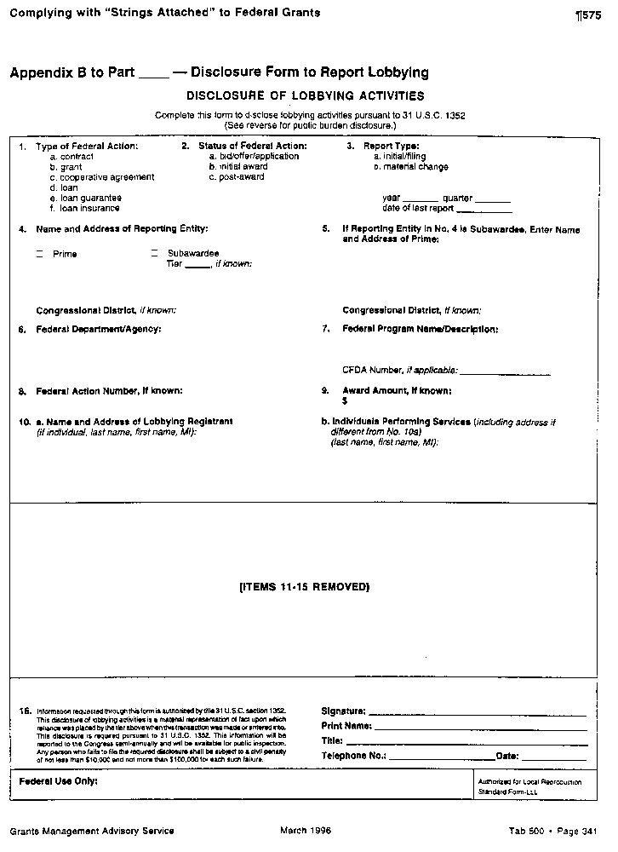

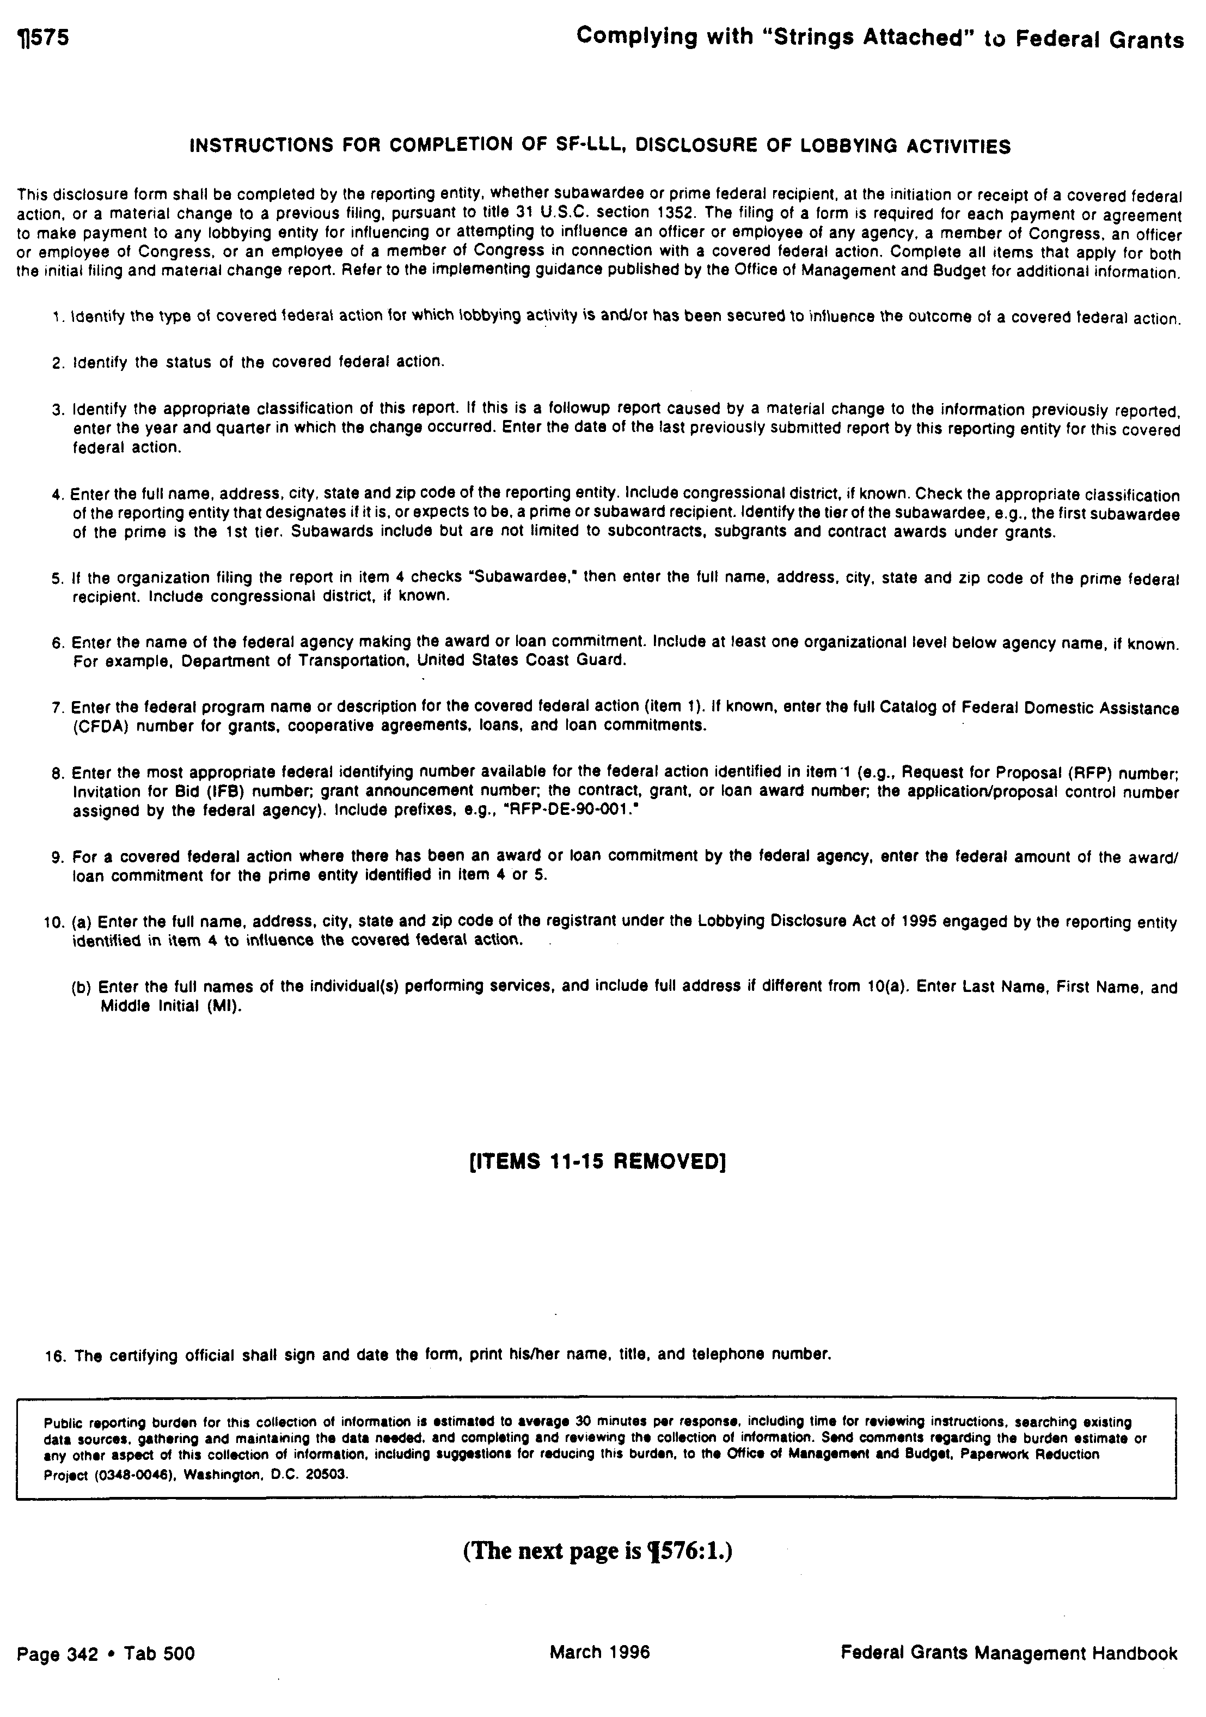

EXHIBIT ______

Vendor Certification of Compliance with Fair Labor Conditions

______________________________certifies that he/she is the_______________________
(Name of individual) (Title e.g. owner, president)

of_______________________conducting business at____________________________
(Name of business) (Business address)

__________________________________________________________________________

The Research Foundation of State University of New York intends to purchase

________________________________________________________________________
(Description of goods)

________________________________________________________________________

Certifies that:

- The items of apparel described in the Purchase Order were or will be manufactured in compliance with all applicable labor and occupational safety laws, including, but not limited to, child labor laws, wage and hour laws and workplace safety laws.

- The name and address of each subcontractor utilized or to be utilized in the manufacture of such apparel are:

- The manufacturing plants utilized or to be utilized in the production of the apparel are:

I affirm under penalty of law that the information provided in this certification is accurate and that no false information has been provided.

(Signature of vendor)

Notary Public

State of New York,

County of ___________________

On this _______day of ________in the year 20___, before me personally

came_______________________________________, to me known, who, being by me duly

sworn did depose and say that he/she resides in________________________________:

that he/she is the _______________________________________________________,

of the _______________________________________________________________

corporation described in and which executed the above instrument; that he/she knows the seal of said corporation; that the seal affixed to said instruments is such corporate seal, that it was so affixed by the order of the Board of Directors of said corporation, and that he/she signed his/her name thereto by like order.

Notary Public

Mr./Ms.
TelTech Education
39 Broadway
New York, NY 10006

RE: Vendor Contract
1234567-0-12345-R123456

Dear Mr./Ms. :

I have enclosed three (3) copies of the above referenced document. Please sign all copies of the agreement and forward to me for execution by this institution. A copy will be returned to you with a purchase order for the contract services.

Also enclosed is a Form W-9, Taxpayer Identification Number Request. Please complete all sections of the form and return it with the signed contracts.

If you have any questions, please feel free to call me at (518) 437-4585. Thank you for your assistance.

Sincerely,

Jan Kurposka

jmk

Enclosures

cc: B. Buchanan ** only bonny gets copies of this memo so she knows it’s
req # in the works (our deal) - no other p.d.

namepo#

Mr./Ms.
TelTech Education
39 Broadway
New York, NY 10006

RE: Vendor Contract
1234567-0-12345-R123456

Dear Mr./Ms. :

I have enclosed a fully executed copy of the above referenced document and a purchase order for the contract.

Please use the above referenced number on any invoices you submit. If you have any questions, feel free to call me at (518) 437-4585. Thank you for your assistance.

Sincerely,

Jan Kurposka

jmk

Enclosures

cc: P. Director
Accounting

namepo#

