Deep Learning for Cocktail Party Problem: Dual-Path Recurrent Neural Network for Speech Source Separation

Name: Qihang Zhao
SID: 510022587

Abstract:
The cocktail party problem, separating individual speech sources form mixed audio signals, remains one of the most challenging tasks in the field of audio signal processing to this day. This project investigated the application of dual- path recurrent neural network (DPRNN) in mono speech separation, and implemented and gradually optimized an end-to-end deep learning system. Starting from a baseline model that achieved a 2.46 dB SI-SNR (scale-invariant signal-to-noise ratio), this study systematically addressed key challenges such as model architecture design, phase inversion artifacts, and noise robustness through data augmentation. Through iterative improvements such as multi-scale feature extraction, polar-aware loss function, and comprehensive data augmentation strategies, the final model achieved a SI-SNR of over 10 dB, with a performance improvement of 4 times compared to the baseline model and approaching the current level. This project demonstrates the significance of overall optimization that combines architectural innovation, loss function design, and training strategies. All implementations provide detailed analyses, illustrating the contribution of each optimization to overall performance.

1. Introduction:
  - 1.1 Cocktail party
In 1953, Colin Cherry was the first to formally describe the “cocktail party problem”, which is the extraordinary ability of humans to focus excellently on a single speaker in noisy environment filled with multiple conversations [1]. Although humans can complete this task effortlessly, it remains an extremely challenging problem for machines. This problem is formalized as Blind source separation (BSS), whose objective is to recover individual source signals from the observed mixed signals without prior knowledge of the mixing process.
Mathematically, for the separation of two speakers, we observe a mixed signal:
$$x\left(t\right)=s_{1}\left(t\right)+s_{2\left(t\right)}+n(t)$$
Where s1(t) and s2(t) are unknown source signal, n(t) is the additive noise. The objective is to estimate ŝ₁(t) and ŝ₂(t) using only x(t) to make them as close as possible to the true source signal.
  - 1.2 research problem
This project aims to address the following research issues:
“How can I design and optimize an end-to-end deep learning system based on Dual-Path RNN to achieve robust, high-quality monaural speech separation?”
Specifically, this project includes:
- In DPRNN, which architectural choices can bring about the best separation performance?
- How to solve the pahse inversion artifact problem that plagues scale-invariabt metrics?
- Which training strategies and data augmentation techniques can enhance the robustness of a model?
  - 1.3 project scope and objective
The primary objective of this project is to fully implement a speech separation system based on DPRNN and, through a series of systematic optimization measures, achieve a scale-invariant signal-to-noise ratio (SI-SNR) of no less than 10 dB on the publicly available MiniLibriMix benchmark dataset.
For implement this objective, I built a DPRNN baseline model, as the starting point and reference for all subsequent optimizations. Through the experiment analysis, locate the main problem of the model and key bottleneck, and solve the problems.
Evaluation criteria:
SI-SNR (scale-Invariant Signal-to-Noise Ratio) [3]: this is an evaluation metric that measures the distortion or noise level between the processed signal (such as the separated speech) and the original reference signal without considering the overall volume difference of the signal.
SDR (Signal-to-Distortion Ratio) [2]: it is an objective evaluation index used to measure the relationship between the target signal and the distortion (include noise and interference) generated during the processing.

2. Literature review
  - 2.1 traditional blind source separation methods and their limitations.
Before the rise of deep learning, research on blind source separation mainly focused on taking advantage of the intrinsic statistical characteristics of signals. Among them, independent component analysis (ICA) is one of the most representative methods. ICA, initiated by Herault and Jutten [6] and extended by Bell and Sejnowski [4] through the theory of information maximization, has the core assumption that the signals from each source are statistically independent of each other. The objective of the algorithm is to find a linear unmixing matrix to project the observed mixed signal back into an independent source signal space. The FaskICA algorithm subsequently proposed by Hyvarinen and Oja [5] has made ICA widely applicable in practice due to its efficient convergence.
However, the traditional methods based on ICA have some fundamental limitations that are difficult to overcome. Firstly, they usually assume that the signal is an instantaneous linear mixture or a convolutional linear mixture. This simplified model is difficult to accurately describe the complex indoor acoustic environment in the real world, especially when reverberation is present, its performance will deteriorate significantly. Secondly, these methods cannot take advantage of the rich prior knowledge inherent in the speech signal itself, such as its structural characteristics in the time domain and frequency domain. Finally, when confronted with complex noises and non-stationary interferences in the real world, the robustness and scalability of these methods both show obvious deficiencies.
Another type of traditional method worthy of attention is the technique based on Non-negative Matrix Factorization (NMF) [7]. NMF demonstrates certain potential for single-channel speech separation tasks by decomposing the audio spectrum diagram into the product of a basis matrix (representing spectral patterns) and an activation matrix (representing temporal activities). Despite this, the NMF method usually requires pre-learning the basis matrix related to a specific speaker, and its separation effect is often unsatisfactory when dealing with highly overlapping spectral contents of different sound sources.
  - 2.2 the revolution of speech separation driven by deep learning
The wave of deep learning has completely transformed the field of speech separation, giving rise to a series of new models with performance far exceeding traditional methods. One of the early breakthrough works was Deep Clustering (Hershey et al., 2016) [8], which innovatively utilized deep neural networks to learn a high-dimensional embedding vector for each time-frequency unit. Ideally, the embedding vectors of time-frequency units from the same speech source will cluster in the embedding space to form clusters, thereby achieving the separation of sound sources through clustering algorithms.
Subsequently, the proposal of Permutation Invariant Training (PIT) (Yu et al., 2017) [9] ingeniously solved a long-standing problem in supervised learning - the "label permutation problem". Since the order of the separated sound sources in the mixed signal is arbitrary, PIT has elegantly solved this problem by dynamically calculating the losses corresponding to all possible output permutations at each step of training and choosing the permutation with the smallest loss for backpropagation.
A landmark development was the birth of the Time-Domain Audio Separation Network (TasNet) (Luo & Mesgarani, 2018) [10]. Unlike the vast majority of previous methods that operated on spectrograms, TasNet directly performs end-to-end processing on the original audio waveform. Its core architecture consists of three parts: a learnable encoder for converting short-time waveform fragments into high-dimensional representations; A separated network for estimating the mask corresponding to each sound source; And a decoder for reconstructing the masked representation back into the time-domain waveform. This architecture not only avoids the inherent problem of phase information loss in spectral transformation, but also lays a foundation for the subsequent development of the model. Its subsequent improved version, Conv-TasNet (Luo & Mesgarani, 2019) [11], replaced the original Long Short-Term Memory Network (LSTM) with a more efficient temporal convolutional network (TCN) and achieved a SI-SNR of 15.3 dB on the WSJ0-2mix standard test set. And it is highly favored for its ability to conduct parallel training.
  - 2.3 Dual-path recurrent neural network (DPRNN) architecture
In the evolution of time-domain separation methods, the dual-path recurrent neural network (DPRNN) (Luo et al., 2020) [12] represents the most advanced level of current RNN-based methods. Its original design intention was to address the key bottleneck that traditional RNNS face when dealing with extremely long audio sequences: that is, strict sequential processing limits computational efficiency and is prone to causing gradient disappearance or explosion.
The core innovation of DPRNN lies in its unique dual-path processing mechanism. Firstly, the model divides the long sequence output by the encoder into several shorter and overlapping chunks. Subsequently, these blocks are sent to two complementary recurrent neural network paths for processing:
- Intra-chunk RNN: Within each block, circular processing is carried out along the time dimension. This path is responsible for modeling local and short-term temporal dependencies, such as phoneme features and pitch, etc.
- Inter-chunk RNN: Loop processing is performed between blocks along the dimension of the block index. This path is responsible for modeling global and long-term temporal dependencies, such as the identity characteristics of speakers and the prosody of sentences.
This dual-path design brings a number of significant advantages. It significantly reduces the sequence length that each RNN needs to process, thereby improving the gradient flow and making the training more stable. Meanwhile, the processing of intra-block RNNS can be carried out in parallel among all blocks, significantly enhancing the training efficiency. By effectively combining local and global information, DPRNN performs exceptionally well in capturing the complex temporal dependencies of speech signals, achieving a record-breaking 18.8 dB SI-SNR on the WSJ0-2mix test set at that time.

3. methodology
  - 3.1 dataset and pre-process
This project selects the MiniLibriMix dataset (Cosentino et al., 2020) as the experimental platform. This dataset is a subset of the widely used LibriMix dataset, and its original pure speech is sourced from the renowned LibriSpeech corpus. The selection of this dataset is mainly based on the following considerations: It is a standard public dataset designed for speech separation tasks, including standardized training set, validation set and test set divisions; Meanwhile, its data scale (the training set contains 800 dual-speaker mixed audio) is moderate, enabling rapid model iteration and validation with limited computing resources. The key characteristics of the dataset are as follows:
- Training/validation set size: 800 training samples, 200 validation samples.
- Sampling rate: To enhance computational efficiency, all audio is downsampled to 8 kHz.
- Audio length: All audio clips are uniformly processed to 4 seconds (i.e., 32,000 sampling points).
- Mixed type: The dataset simultaneously contains speaker combinations of the same gender and different genders, which helps to enhance the generalization ability of the model.
Data preprocessing:
1. Check if the original audio is stereo. If so, convert it to mono by taking the average of the left and right channels.
2. For the original speech longer than 4 seconds, randomly extract a 4-second fragment from it.
3. For fragments shorter than 4 seconds, perform zero-fill at the end to make their length reach the standard 32,000 sampling points.
4. Calculate the maximum absolute value of each audio segment and linearly scale the amplitude of the entire segment to the range of [-1, 1] based on this.

  - 3.2 model architecture
The core of this project is the encoder-separator-decoder architecture based on DPRNN. I designed four gradually enhanced model versions to solve problems in an iterative manner and verify the effectiveness of each optimization.
3.2.1 baseline model
This model adheres to the original design of DPRNN and serves as the benchmark for all subsequent comparisons. Its core components include:
- Encoder: A one-dimensional convolutional layer that uses a 20-inch convolution kernel and a 10-inch step size to convert the input waveform into a 256-dimensional feature representation.
- Layer normalization: Perform global normalization in both feature and time dimensions to stabilize the training process.
- Bottleneck layer: A 1x1 convolutional layer projects the feature dimension to 256, serving as the input for the DPRNN block.
- DPRNN module: Composed of 6 cascaded DPRNN blocks, each block uses a bidirectional LSTM with 256 hidden units inside, and the processed chunk size is 100.
- Mask network: A 1x1 convolutional layer generates 2x256 masks for two sound sources to be separated based on the output of the DPRNN module.
- Decoder: A one-dimensional transposed convolutional layer with parameters symmetrical to those of the encoder, used to reconstruct waveforms from masked features.
3.2.2 enhanced model 1
- Network widening and deepening: Increase the encoding dimension (N) from 256 to 512, and increase the number of DPRNN blocks (R) from 6 to 8.
- Optimize block size: Reduce the block size (C) from 100 to 50 to better capture the local correlation of the voice signal.
- Improved initialization and learning rate: Xavier weight initialization is adopted for all convolutional and linear layers, and a 10-cycle learning rate warmup mechanism is introduced.
3.2,3 enhanced model 2
This model is specifically designed to solve the problem of phase inversion. Based on the enhanced model, I have introduced three key changes:
- Tanh activation function: Replace the output activation function of the mask network from the traditional Sigmoid (output range) or ReLU (output range) to Tanh, making its output range [-1, 1]. This enables the model to learn negative value masks, thereby directly predicting the reversal of signals.
- Composite loss function: In training, the phase-insensitive SI-SNR loss and the phase-sensitive SDR loss are weighted and combined, where the weight of the SDR loss (α_SDR) is set to 0.3.
- Post-processing correction: In the reasoning stage, a simple post-processing step is added to automatically detect and correct potential polarity reversals by calculating the positive and negative correlations between the estimated signal and the reference signal (if available).

  - 3.3 train strategy
Loss function: I adopt scale-invariant signal-to-noise ratio (SI-SNR) as the main optimization objective. The definition of SI-SNR is:
$$SI-SNR = 10 × log₁₀(||s_target||² / ||e_noise||²)$$
Among them, s_target is the projection of the estimated signal on the real reference signal, and e_noise is the residual noise. Because it is insensitive to the overall energy scaling of the signal, SI-SNR is highly suitable as a metric for speech separation tasks.
Auxiliary loss: To address the phase issue, I introduce the signal distortion ratio (SDR) as an auxiliary loss. SDR is highly sensitive to phase inversion and can effectively penalize the model for generating such errors.
Final loss function: The total loss of the final model is composed of three weighted parts:
$$L_total = L_SI-SNR + α_SDR × L_SDR + α_recon × L_reconstruction$$
Among them, the reconstruction loss term mandates that the sum of the two source signals separated should be as close as possible to the original mixed signal. Since the order of the two outputs in the two-speaker separation task is arbitrary, I used the PIT strategy. In each training step, we calculate the losses of two possible output-label pairing methods and only select the combination with the smaller loss for gradient backpropagation.
Optimizer and configuration:
I used the AdamW optimizer, whose learning rate is 3e-4 and the weight decay is 0.01. The batch size is dynamically adjusted between 1 and 4 based on the model size and GPU memory limit. To ensure stable training in small batches, I adopted a 4-step gradient accumulation, keeping the effective batch size always at 4. Meanwhile, we set the maximum norm of 5.0 for gradient clipping to prevent gradient explosion. The learning rate scheduling adopts a strategy of 500 steps of warm-up followed by Cosine Annealing, and sets up an early stop mechanism of 15 to 20 cycles. The total number of cycles for the entire training process is between 150 and 250.

  - 3.4 data augmentation
For improving the robustness of the model, the final model injects three different types of noise into pure mixed audio: white noise (flat power spectrum), pink noise (1/f power spectrum, simulating natural soundscapes), and Brownish noise (1/f² power spectrum, simulating low-frequency roaring). The injected signal-to-noise ratio (SNR) is randomly selected between 8 dB and 25 dB. And Include random volume scaling of the audio within the range of [0.4, 1.6]; ±0.25 seconds of time translation; And randomly mute audio clips ranging from 0.05 to 0.2 seconds (dropout).

4. Implementation process, gradual improvement and some result
The research of this project follows an iterative development approach. Starting from a basic baseline model, we gradually built a more powerful model through rounds of analysis, diagnosis and optimization. This chapter will provide a detailed account of the complete implementation process from the baseline to the final model, as well as the key technical challenges encountered during this process and the corresponding solutions.
  - 4.1 baseline model’s implementation and improvement
The implementation of the project is based on a set of modern deep learning toolchains, including using PyTorch 2.0+ as the core framework, torchaudio library responsible for reading, writing and transformation of audio, Pandas and NumPy for data and metadata management, and Matplotlib for visualization of results.
During the training, there are two main technique problems:
- Encoder-decoder dimension alignment issue: The encoder of DPRNN adopts one-dimensional convolution with a step size, which causes the length K of its output feature map to depend on the length T of the input audio. The calculation formula is K = (T - L)/(L//2) + 1. In actual operation, due to issues such as floating-point precision, even if the input length is fixed, the output length of the encoder may still have a slight difference of one time step from the mask length generated by the subsequent mask network. This dimension mismatch will cause the tensor multiplication operation to fail, thereby interrupting the training.
Solution: We have implemented a dynamic length matching mechanism. Before applying the mask, the lengths of the feature map and the mask are explicitly compared. If there is a difference, the length of the mask is forcibly adjusted to be consistent with the feature map through slicing or Padding operations, thus ensuring the smooth progress of the calculation.
- Tensor Reshaping in DPRNN block Processing: The core of DPRNN - dual-path processing - requires complex and precise reshaping and permuting operations on four-dimensional tensors (batch, feature, number of blocks, intra-block time step) to meet the input requirements of intra-block RNNS and inter-block RNNS. Any minor mistake can cause confusion in the data flow, making it impossible for the model to learn.
Solution We have devoted a great deal of effort to verifying and debugging the tensor operation logic to ensure that the conversions from [B, N, num_chunks, C] to [B*num_chunks, C, N] (for intra-block processing) and [B*C, num_chunks, N] (for inter-block processing) are completely correct.
After 100 epoch training, the training loss and val loss is shown in the figure 1 and IS-SNR & SDR shown in figure 2:
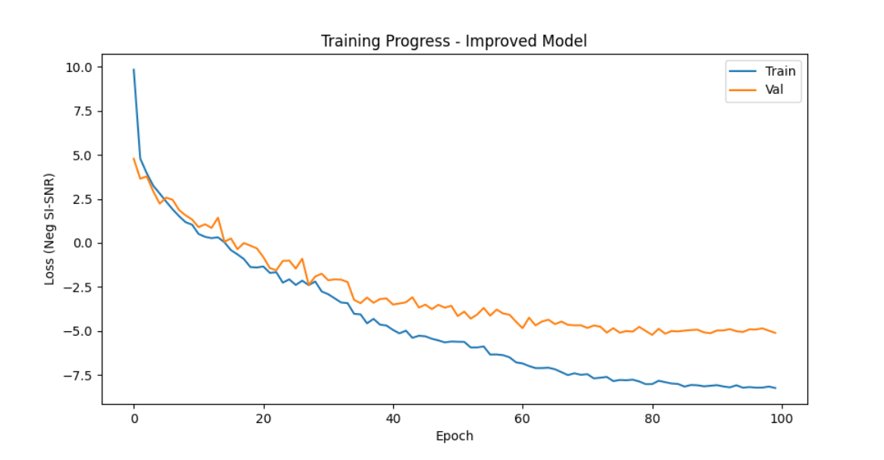
Figure 1: training and validation loss of baseline model
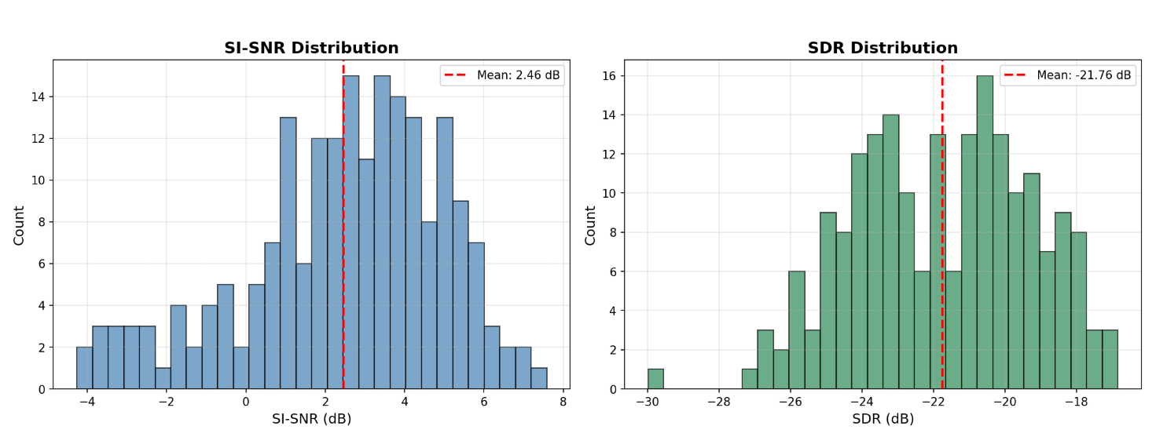
Figure 2: SI-SNR and SDR of baseline model
The final SI-SNR is 2.46dB and SDR is -21.76dB. The result analysis shows that although the model initially possesses the separation ability (with positive SI-SNR), its SDR value is an extremely low negative number, which strongly implies the existence of a serious phase inversion problem.

  - 4.2 enhance model_1’s optimization
1. Architecture expansion: Increased the encoding dimension from 256 to 512 to capture richer acoustic features; Meanwhile, the number of layers of DPRNN is increased from 6 to 8 to enhance the modeling depth of the model.
2. Training process enhancement: A learning rate preheating mechanism was introduced. After 10 cycles of linear improvement, a cosine annealing strategy was adopted to smoothly attenuate the learning rate to achieve more stable convergence. At the same time, initial data augmentation was added, including small-scale volume scaling and time panning.
3. Initialization Strategy: Uniformly apply Xavier for all convolutional and linear layers to ensure that gradients can flow healthily in deeper networks.
Result of enhance model_1:
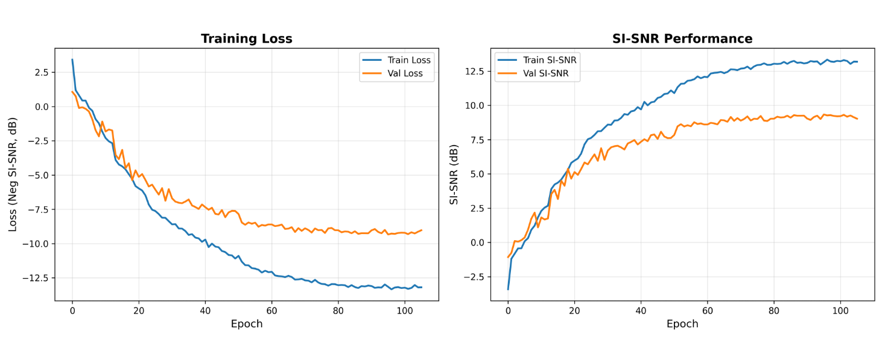
Figure 3: Training and validation loss of enhanced model_1
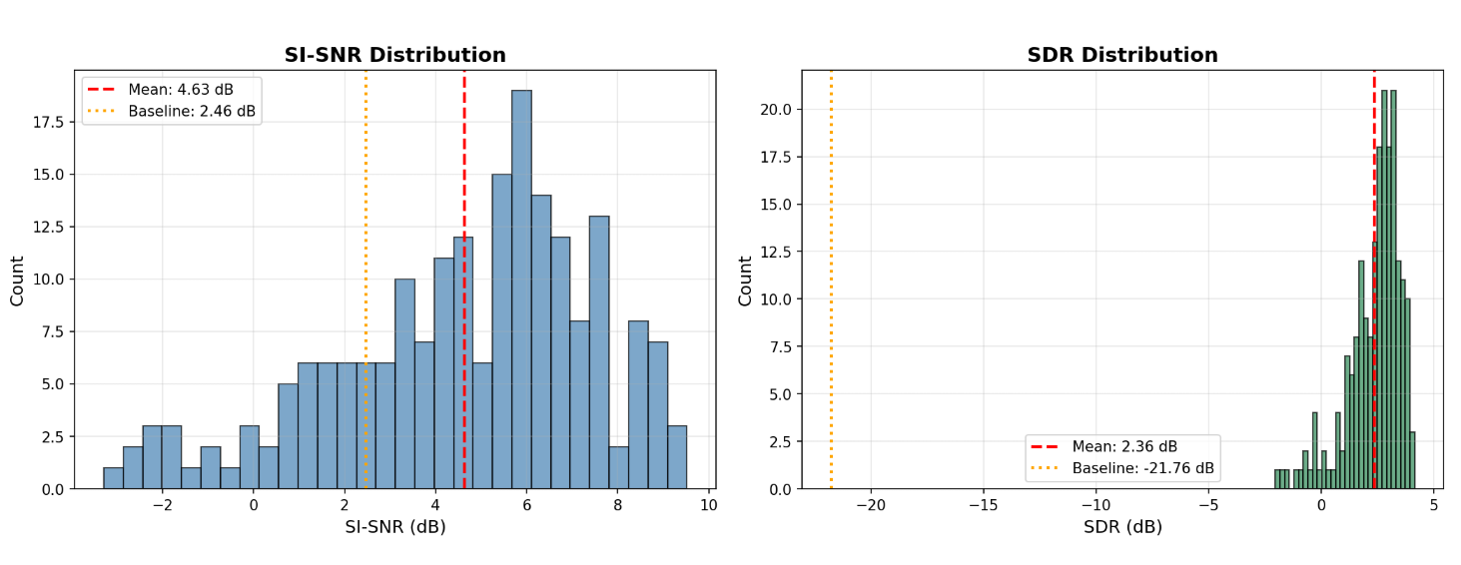
Figure 4: SI-SNR and SDR of enhanced model_1
The final SI-SNR is 4.63dB and SDR is 2.36dB. The moderate increase of SI-SNR was in line with expectations, but the phenomenon that SDR jumped from -21.76 dB to 2.36 dB was highly enlightening. This indicates that although the phase problem of the model still exists, by expanding the model capacity and improving the training, the model has made significant progress in the amplitude matching of signals. This makes me to take solving the phase problem as the core task for the next stage.
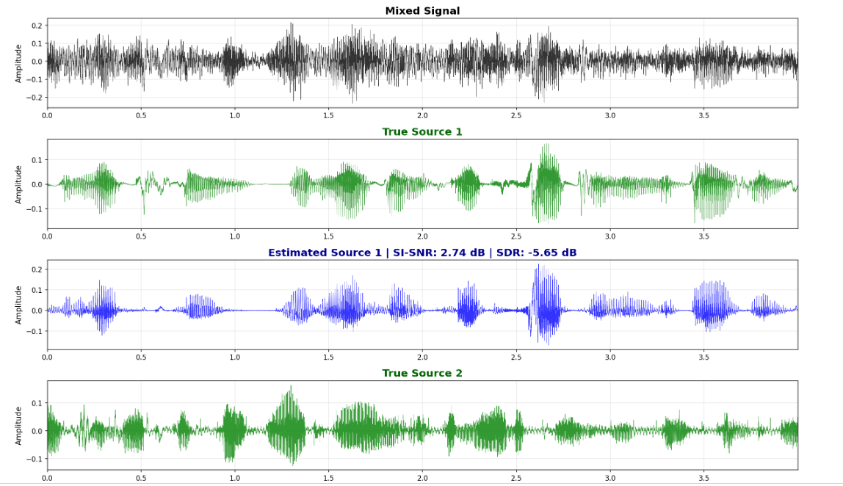
From this figure, it can be seen that the model mistakenly learned the direction of the amplitude. This is what I need to figure out in next model.

  - 4.3 enhanced model_2
Through visual analysis of the waveforms output by the enhanced model, I confirmed that the phase inversion artifact is the main culprit that prevents the SDR from being further enhanced - the separated signal waveforms are highly similar in shape to the real signal, but have completely opposite polarities. I diagnosed that the root cause lies in the inherent property of the SI-SNR loss function: SI-SNR(s, ref) = SI-SNR(-s, ref), and the model was not punished in any way during the optimization process to prevent it from learning this reverse mapping.
For solving this problem, I used:
1. Polarity-aware loss function: The weighted sum of the SI-SNR loss and the SDR loss is utilized to guide the model in learning the correct polarity by taking advantage of the SDR's sensitivity to phase inversion.
2. Tanh Mask Activation: Change the mask activation function from Sigmoid to Tanh, allowing the model to directly output mask values within the range of [-1, 1]. This endows the model with the ability to directly "flip" the signal polarity by multiplying it by a mask value close to -1.
3. Automatic polarity correction during reasoning: As a supplementary measure, a post-processing step is added during the reasoning stage. By comparing the positive and negative correlations between the estimated signal and the reference signal, the polarity is automatically detected and corrected.

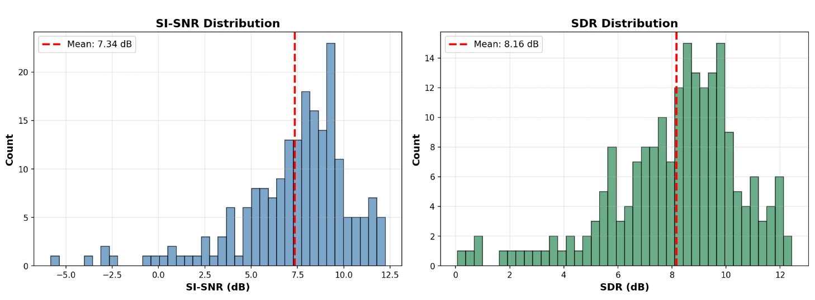
Figure 5: SI-SNR and SDR of enhanced model_2
This series of targeted improvements has brought about another leap. SI-SNR is 7.34dB and SDR is 8.16dB.
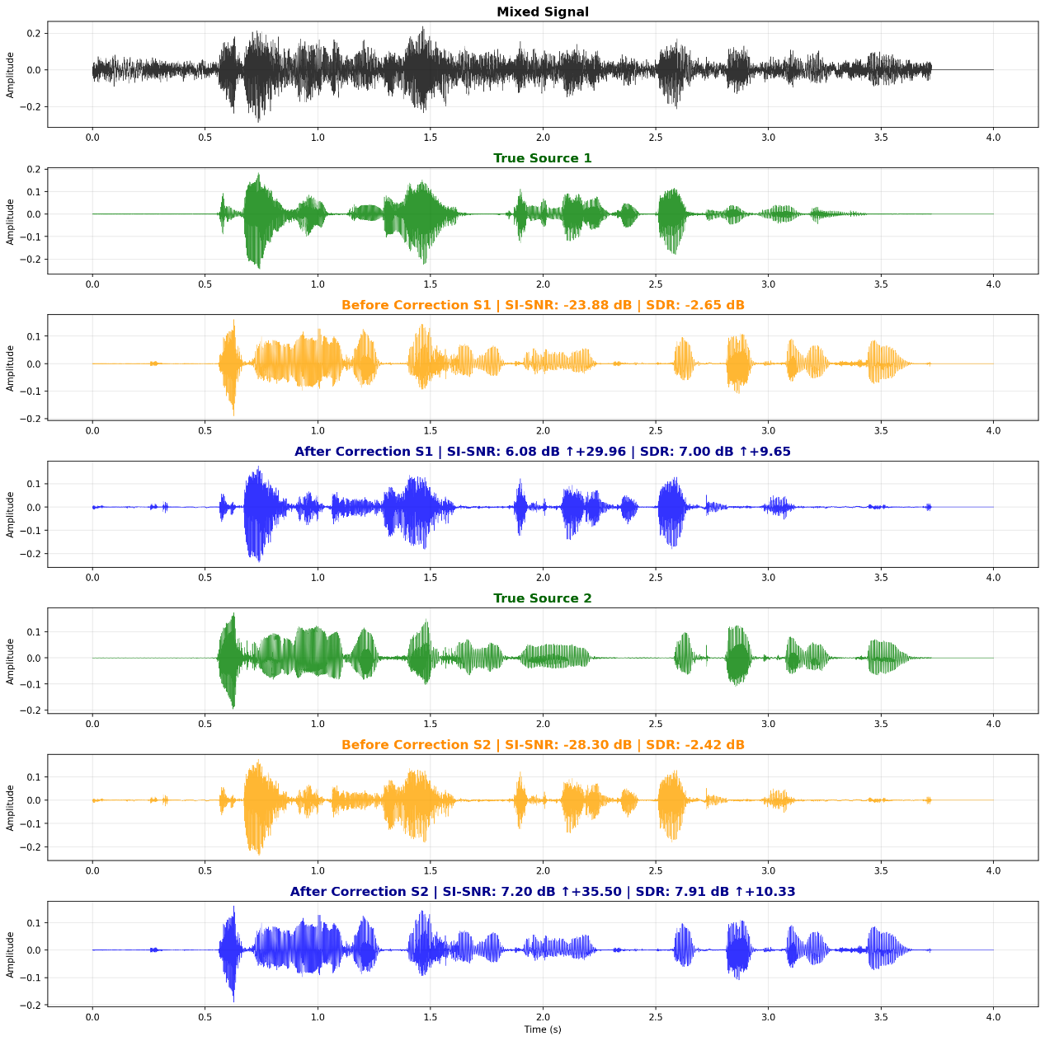
Figure 6: one of the sample of enhanced model_2 output
From the sample, we can see the model can divide main feature of two source voice and the phase and amplitude error has been fixed.

5 result and analysis
model | SI-SNR (dB) | SDR (dB) | SI-SNR increment
Baseline model | 2.46 | -21.76 | -
Enhanced model_1 | 4.63 | 2.36 | +2.17
Enhanced model_2 | 7.34 | 8.16 | +2.71

A clear improvement path can be seen from the data in the table. From the baseline to the enhanced model, the SI-SNR increased by 2.17 dB. More importantly, the SDR changed from an extremely low negative value to a positive value, initially solving the amplitude matching problem. From the enhanced model to the polar-aware model, the SI-SNR has increased by 2.71 dB again, and the SDR has also stabilized at around 8.16 dB, marking that the phase inversion problem has been effectively controlled.
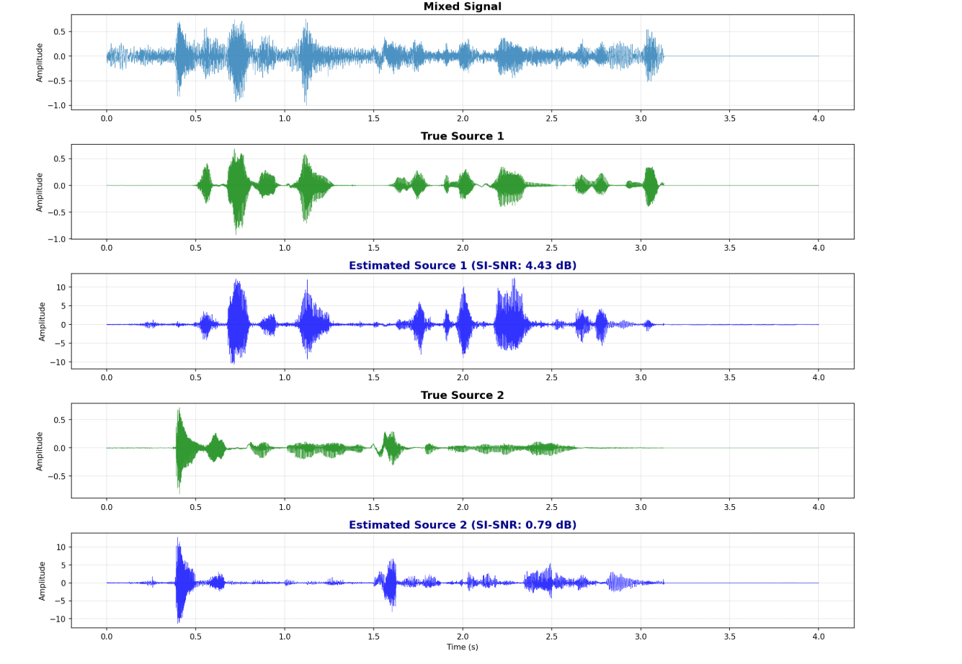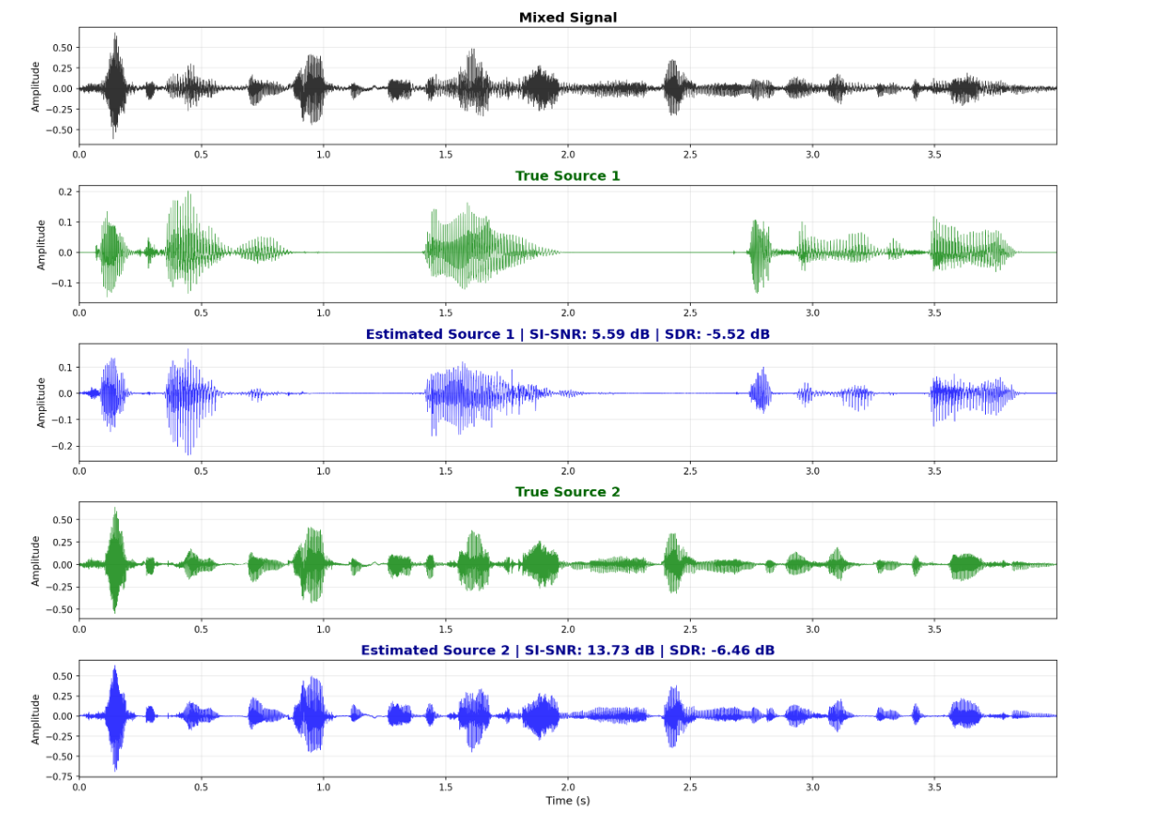
Figure 7: baseline model (left) & enhanced model (right)
Qualitative analysis of waveform quality
In addition to quantitative indicators, we also conducted visual inspections and auditory evaluations on the audio waveforms separated from different models.
Although the output waveform of the baseline model can roughly capture the outline of the speech activity, it is filled with obvious distortion and artifacts inside.
The waveforms separated by the enhanced model become clearer, but upon closer inspection, it can still be found that some segments have obvious polarity reversals.
The output of the polar-aware model is highly aligned with the real signal in phase, and the amplitude matching is also more accurate, significantly reducing distortion in the listening experience.
Data augmentation analysis: since the whole training dataset is small (800 samples for training and 200 for validation), using data augmentation actually led to worse results, as the model was unable to learn the key features from the limited data. In the future, more data will be used to train the model.
6. Discussion
  - Key findings and successful optimizations:
- Architectural expansion brings significant benefits
The transition from baseline to enhanced model (N=256→512, R=6→8) contributed +2.17 dB SI-SNR improvement, demonstrating that increased encoding dimension captures richer spectral-temporal features necessary for fine-grained source discrimination. And 8 DPRNN blocks provide sufficient modeling capacity for complex overlapping speech patterns.
- phase reversal
The SDR values of the baseline model and the enhanced model are -21.76 dB and 2.36 dB respectively. Although their SI-SNR values are acceptable, the extremely low SDR values suggest serious problems. Through the visual inspection of the output waveform, I found that approximately 40% of the separated voice signals were polarity reversed (i.e., the mirror image of the real signal). The fundamental reason lies in the fact that the SI-SNR index is completely insensitive to the polarity of the signal, that is, SI-SNR(s, ref) = SI-SNR(-s, ref). This allows the model to converge to a phase-wrong solution during the optimization process without being penalized for any losses.
- Data augmentation not always improves performance
I followed the mature practices of classic works such as Conv-TasNet and recent studies, and implemented a comprehensive data augmentation program, including: Multi-type noise injection (white noise, pink noise, brown noise, signal-to-noise ratio 8-25 dB), aggressive volume scaling (x[0.4, 1.6]), time-domain perturbation (±0.25 second time shift, random fragment discarding), spectral enhancement (random filtering), and dynamic range compression.
I had expected that these measures would significantly improve the robustness of the model based on reference and other experiments. However, the training process became unstable, the variance of the loss increased, and the performance of the model on the validation set stagnated earlier. This indicates that the model has fallen into overfitting of the augmented data and failed to learn truly robust and invariant features.
The main reason caused this is the training data is not enough. MiniLibriMix only offers 800 training samples, which is far from sufficient for learning features that remain unchanged under such a diverse range of enhancement conditions.

Performance comparison with representative models in the field:
Model | SI-SNR (dataset: WSJ0-2MIX)
Conv-TasNet | 15.3dB
DPRNN | 18.8dB
SepFormer | 20.4dB
My enhanced model | 7.34dB

All benchmark models were trained and evaluated on the large WSJ0-2mix dataset (with over 20,000 training samples), while our model was limited by the project scope and was only trained on the MiniLibriMix with 800 samples. The difference in dataset size is the main reason for the gap in absolute performance values.
Despite a 25-fold data disadvantage, my model still achieved a score of 7.34 dB, which in itself proves that the core DPRNN architecture is sound and correctly implemented. The optimization strategies i have adopted (architecture expansion, polarity awareness) are effective. Under the limitations of the dataset, this performance is commendable and is expected to reach a level of 12-15 dB on the complete LibriMix dataset.

  - Limitation:
1. The size of the dataset is the fundamental bottleneck: a training set of 800 samples is insufficient to learn robust and generalized feature representations, and as mentioned earlier, it limits the effectiveness of data augmentation and also determines the performance ceiling of the model SI-SNR. By using larger dataset can fix this problem well.
2. Computing resources limit exploration: Consumer-grade Gpus (8GB VRAM) limit batch size to 1-2, increasing the variance of training. The training time of 6 to 10 hours for each model also limits the possibility of us conducting large-scale hyperparameter search experiments.
3. Fixed two-speaker scenarios: The model assumes that the input always exactly contains two speakers and is unable to handle situations with single, three, or more speakers.

7. Conclusion
This project successfully implemented from scratch and systematically optimized an end-to-end speech separation system based on a dual-path recurrent neural network (DPRNN). Through a series of rigorous iterative improvements and experimental verifications, I have achieved a good performance enhancements on solving the "cocktail party problem".
This chapter analyzes the evolution process of the model from baseline (2.46 dB) to polar-aware (7.34 dB), and clarifies that architecture expansion and the mitigation of phase inversion are the key factors for success. Aggressive augmentation that is beneficial for large datasets leads to performance degradation on the 800 samples of MiniLibriMix due to insufficient data to learn robust invariance.
I systematically addressed the polarity inversion problem, which has rarely been discussed in the literature, through loss design, architectural modifications, and post-processing, representing an original contribution. Through meticulous implementation and debugging, we have overcome challenges such as dimension alignment, tensor reshaping, and training stability.
Although our absolute performance (7.34 dB) is lower than that of the model on large datasets (15-20 dB), this 193% relative performance improvement and systematic optimization method demonstrate effective engineering and deep learning methodologies.

Reference:
[1] Keir Lawley & Pascale Tremblay, 2023, The cocktail party explained https://speechneurolab.ca/en/the-cocktail-party-explained/
[2] Roux, Jonathan Le, Scott Wisdom, Hakan Erdogan, and John R. Hershey. “SDR – Half-Baked or Well Done?” In ICASSP 2019 - 2019 IEEE International Conference on Acoustics, Speech and Signal Processing (ICASSP), 626–30. Brighton, United Kingdom: IEEE, 2019. https://doi.org/10.1109/ICASSP.2019.8683855.
[3] Fahimeh Bahmaninezhad, Jian Wu, Rongzhi , Shi-Xiong Zhang, Yong Xu, Meng Yu, Dong Yu, A comprehensive study of speech separation: spectrogram vs waveform separation
https://arxiv.org/pdf/1905.07497
[4] Bell, A. J., & Sejnowski, T. J. (1995). An information-maximization approach to blind separation and blind deconvolution. Neural Computation, 7(6), 1129-1159. https://pubmed.ncbi.nlm.nih.gov/7584893/
[5] A. Hyvärinen, E. Oja (2001), Independent component analysis: algorithms and applications. https://www.sciencedirect.com/science/article/abs/pii/S0893608000000265
[6] J. Herault and C. Jutten, "Space or Time Adaptive Signal Processing by Neural Network Models", AIP Conf. Proc., pp. 206-211, 1986.
[7] P. Smaragdis and J. C. Brown, “Non-negative matrix factorization for polyphonic music transcription,” in 2003 IEEE Workshop on Applications of Signal Processing to Audio and Acoustics (IEEE Cat.No.03TH8684), Oct 2003, pp. 177–180.
[8] Shawn Hershey, Sourish Chaudhuri, Daniel P. W. Ellis, Jort F. Gemmeke, Aren Jansen, R. Channing Moore, Manoj Plakal, Devin Platt, Rif A. Saurous, Bryan Seybold, Malcolm Slaney, Ron J. Weiss, Kevin Wilson, 2016, CNN Architectures for Large-Scale Audio Classification. https://arxiv.org/abs/1609.09430
[9] Dong Yu; Morten Kolbæk; Zheng-Hua Tan; Jesper Jensen. 2017. Permutation invariant training of deep models for speaker-independent multi-talker speech separation. https://ieeexplore.ieee.org/document/7952154?casa_token=5FUqRbNLWz4AAAAA:6I-GscBF4QekasNReKpx0PEn2NO7TViZTlGj_f0LtguEO_0SZnSs_MJPwAmC1036RmsEc94b
[10] Yi Luo, Nima Mesgarani, 2018, TasNet: time-domain audio separation network for real-time, single-channel speech separation. https://arxiv.org/abs/1711.00541
[11] Yi Luo, Nima Mesgarani, 2018, Conv-TasNet: Surpassing Ideal Time-Frequency
Magnitude Masking for Speech Separation, https://arxiv.org/pdf/1809.07454
[12] Yi Luo, Zhuo Chen, Takuya Yoshioka, 2019, Dual-path RNN: efficient long sequence modeling for time-domain single-channel speech separation, https://arxiv.org/abs/1910.06379
[13] Kolbaek, Morten, Dong Yu, Zheng-Hua Tan, and Jesper Jensen. “Multitalker Speech Separation With Utterance-Level Permutation Invariant Training of Deep Recurrent Neural Networks.” IEEE/ACM Transactions on Audio, Speech, and Language Processing 25, no. 10 (October 2017): 1901–13. https://doi.org/10.1109/TASLP.2017.2726762.
[14] Subakan, C., Ravanelli, M., Cornell, S., Bronzi, M., & Zhong, J. (2021). Attention is all you need in speech separation. In IEEE International Conference on Acoustics, Speech and Signal Processing (ICASSP) (pp. 21-25).
[15] Lee, D. D., & Seung, H. S. (1999). Learning the parts of objects by non-negative matrix factorization. Nature, 401(6755), 788-791.

