

# How to Escape from Bates Motel

## Summary:

This project aims to build a user oriented hotel recommender.

Steps:

1. Uncovered the latent features using k-Means and hierarchical clustering.
2. Built a collaborative filtering recommender using kNN with a KD tree structure.
3. Evaluated assorted matrix factorization models by RMSE, precision and recall score, and FCP (fraction of concordant pairs).

Key features:

* Visualized latent structures of travelers’ reviews using NLP.
* Customized a k-dimensional tree that reduced runtime from 5 hours to 5 µs.
* Demonstrated that the CoClustering model performs best in building top-N recommenders.

I’m now working on building a recommender app using Django and the above models.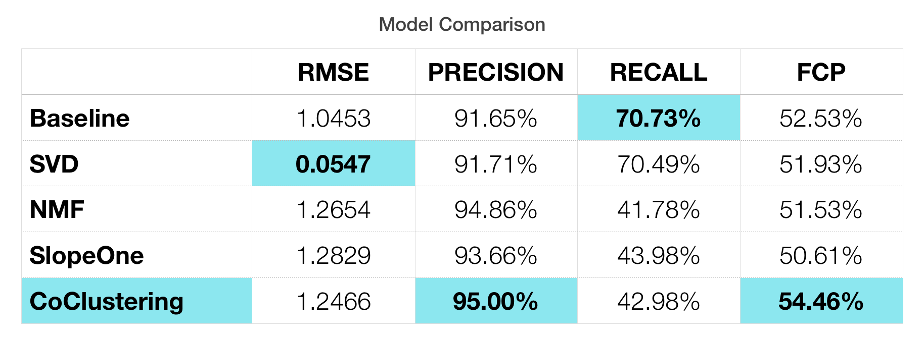

Project links:

<https://github.com/mathilda0902/howtoescapefrombatesmotel>