1.- ====================================

Download DWservice.net

cd /home/cnc/Downloads

chmod 777 dwagent.sh

sudo ./dwagent.sh

=================================

2.- Mover Panel de arriba para abajo

3.- Delete Panel Central

4.- Don’t Sleep Aplicaciones --→ Configuracion → Gestor de Energia

======================

5.- Abrir Axis de Linuxcnc

=============

6.- Autologin

sudo vi /etc/lightdm/lightdm.conf

Line 126 uncomment and cnc

=============

7.- Grub Time

=============

8.- Change Desktop Icons size:

Right click on desktop:

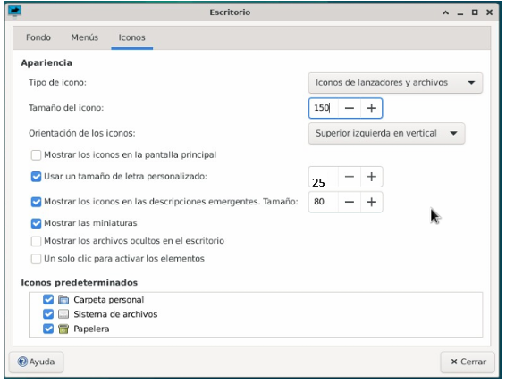

9.- =============

Icono de Apagado /usr/sbin/shutdown -h now

=============

10.-

==========================================

Instalar Tarjeta de Red y BT

https://github.com/lwfinger/rtw88

sudo apt update && sudo apt upgrade

sudo apt install linux-headers-generic build-essential git

git clone https://github.com/lwfinger/rtw88

cd rtw88

make

sudo make install

sudo make install_fw

==========================================

sudo apt install bluetooth blueman

==========================================