1.- ====================================
Download DWservice.net
cd /home/cnc/Downloads
chmod 777 dwagent.sh
sudo ./dwagent.sh
=================================

2.- Mover Panel de arriba para abajo
3.- Delete Panel Central
4.- Don’t Sleep Aplicaciones --→ Configuracion → Gestor de Energia
======================
5.- Abrir Axis de Linuxcnc
=============
6.- Autologin
sudo vi /etc/lightdm/lightdm.conf
Line 120 uncomment and cnc
=============
7.- Grub Time
=============
8.- Change Desktop Icons size:
Right click on desktop:

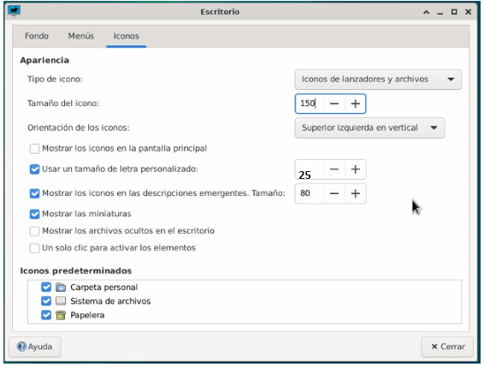

9.- =============
Icono de Apagado /usr/sbin/shutdown -h now
=============

10.-

sudo apt install git
cd ~
mkdir -p dev
cd dev
git clone https://github.com/Lcvette/qtpyvcp-trixie-installer.git
cd qtpyvcp-trixie-installer

./install_for_qtpyvcp.sh

11.-

pip uninstall probe_basic
cd /home/cnc/dev/probe_basic
pip install --editable .

=======================

cd
sudo rm -rf ~/cnm
sudo git clone https://github.com/controlnumerico/cnm.git
sudo cp -r /home/cnc/cnm/* /home/cnc/dev/probe_basic/src/probe_basic
sudo cp -r ~/dev/CNM/* /home/cnc/dev/probe_basic/src/probe_basic/
sudo cp -r ~/dev/CNM/images/iMG/*.TTF /usr/local/share/fonts
sudo cp -r ~/dev/CNM/images/iMG/*.otf /usr/local/share/fonts

==========================================
Instalar Tarjeta de Red y BT

https://github.com/lwfinger/rtw88

sudo apt update && sudo apt upgrade
sudo apt install linux-headers-generic build-essential git

git clone https://github.com/lwfinger/rtw88
cd rtw88
make
sudo make install
sudo make install_fw

==========================================
sudo apt install bluetooth blueman
==========================================

============================================

Design Instalation
sudo apt install python3-pyqt5 python3-dbus.mainloop.pyqt5 python3-pyqt5.qtopengl \
python3-pyqt5.qsci python3-pyqt5.qtmultimedia \
python3-pyqt5.qtquick qml-module-qtquick-controls gstreamer1.0-plugins-bad \
libqt5multimedia5-plugins pyqt5-dev-tools python3-dev \
python3-setuptools python3-wheel python3-pip python3-six \
python3-docopt python3-qtpy python3-pyudev python3-psutil python3-markupsafe \
python3-opengl python3-vtk9 python3-pyqtgraph python3-simpleeval \
python3-jinja2 python3-deepdiff python3-sqlalchemy git python3-distro \
python3-serial
cd /home/cnc
git clone https://github.com/kcjengr/qtpyvcp
sudo apt install qttools5-dev qttools5-dev-tools python3-wheel python3-venv
python3 -m venv venv --system-site-packages
source venv/bin/activate
pip install hiyapyco
If you don’t want to type source command each session, you can add this lines to the end of ~/.bashrc file source /home/cnc/venv/bin/activate
cd /home/cnc/qtpyvcp/
pip install --editable .
================================
cd /home/cnc/qtpyvcp/pyqt5designer/Qt5.15.4-64bit/python3.10
sudo ./install.sh
Copiar los 3 archivos que funcionan

sudo cp /home/cnc/Descargas/LCNC/Plug/* /usr/lib/x86_64-linux-gnu/qt5/plugins/designer
================================
========= Copy Examples============
cd /home/cnc/qtpyvcp/
cp -r linuxcnc $HOME
git clone https://github.com/kcjengr/vcp-template.git
cd vcp-template
./copy.sh
cd /home/cnc/vcp1
pip install --editable .
probebasic
sudo apt install zenity
cd ~
mkdir dev
cd dev
git clone https://github.com/Lcvette/qtpyvcp-bookworm-installer.git
cd qtpyvcp-bookworm-installer
./install_for_qtpyvcp.sh
==================================================

MSDOS
Diskpart
List disk
Select disk 1
Clean
create partition primary format fs=NTFS quick

====================== MBUS ======================
udev rule for constant USB device

https://unix.stackexchange.com/questions/66901/how-to-bind-usb-device-under-a-static-name

udevadm info --name=/dev/ttyUSB0 --attribute-walk | grep idProduct | head -1
udevadm info --name=/dev/ttyUSB0 --attribute-walk | grep idVendor | head -1

Edit file /etc/udev/rules.d/70-persistent-cd.rules

SUBSYSTEM=="tty", ATTRS{idVendor}=="1a86", ATTRS{idProduct}=="7523", SYMLINK+="MBus485"

sudo udevadm trigger
======================

git clone https://github.com/controlnumerico/cnm3a.git

Descomprimir e instalar en c:/home/cnc

cd /home/cnc/cnm3a
pip install -e .

mkdir /home/cnc/.iMG
sudo cp -r /home/cnc/cnm3a/src/cnm3a/ui/rs/* /home/cnc/.iMG/
sudo cp -r /home/cnc/cnm3a/src/cnm3a/ui/rs/*.TTF /usr/local/share/fonts
sudo cp -r /home/cnc/cnm3a/src/cnm3a/ui/rs/*.otf /usr/local/share/fonts

===========
DISPLAY = cnm3a
HIDE_MENU_BAR = 1
FULLSCREEN = 1
KEYBOARD_JOG = true
KEYBOARD_JOG_SAFETY_OFF = true
MACHINE_BOUNDRY = on
MACHINE_TICKS = on
MACHINE_LABELS = on
OPEN_FILE = /home/cnc/Escritorio/Gcode/1.ngc
=======================

==============
Date and Time:

sudo date -s '2009-02-13 11:31:30'
sudo hwclock --show
sudo hwclock --systohc
==============

