A Quick Look at:

LummaC2/Lumma Stealer

Document Control

Version Number | Date | Change Summary
0.1 | 11 Feb 2024 | Initial draft.

Table of Contents
Document Control 2
What is LummaC2/Lumma Stealer? 3
Distribution of Lumma 3
Execution of Lumma 3
Stealer Sample 1 4
Integrity Checking 4
Threat Actors, Associated Accounts and Other Intel 5
Indicators of Compromise 6
Appendices 7
Bibliography 12
Table of Figures 12

What is LummaC2/Lumma Stealer?
The Lumma stealer gets its name from the threat actor “Shamel” – who originally offered the stealer for sale on various different underground markets, “Shamel” used the alias “Lumma” in making the posts. “Shamel” is also responsible for the 7.62mm Stealer [1]. The stealer first emerged in 2022, appearing in tweets from August/September 2022.

Lumma primarily targets cryptocurrency wallets, browser extensions and two factor authentication. Lumma is able to pull information from compromised targets including: system data, installed program data, cookies, usernames, passwords, credit card numbers, connection history, cryptocurrency wallet data [2].

Lumma is priced from $250 (The “Experienced” edition) up to $1000 (the “Corporate” edition). The source code for Lumma was also available to purchase for a time for $20000 [2]. Payments are processed via Coinbase using a wide range of cryptocurrency options [3].

Distribution of Lumma
Lumma has typically been distributed under the guise of cracked/fake popular software. This has been seen in the form of a fake crack for Nitro Pro, other variants include claiming to be popular software like VLC or Sony VEGAS Pro, or even as a fake browser update [4]. However, as recently as Jan 2024, Lumma has been seen distributed via malicious URLs on YouTube videos, the videos offer free software to users and encourage them to download a malicious zip file [5].

Lumma has also seen distribution via Discord. A user will receive a message from someone, asking them to test out their new game and offering to pay for their time. Upon accessing the link sent, the Lumma download is triggered multiple times, and if executed, it will talk back to its C2 server and attempt to exfiltrate sensitive information from the machine [6].

Lumma has also been seen targeting YouTubers in spear-phishing campaigns [7]. The download links to the software are typically for well known, trusted file hosting services like SharePoint/OneDrive, Mediafire and DropBox.

Execution of Lumma
Once the stealer has acquired a foothold on a victim machine via direct execution, the malware reaches out to a command and control server to transfer pilfered data. The stealer itself is heavily obfuscated, using many techniques including Control Flow Flattening to make it very hard to determine exactly what is going on.
When a connection is established, Lumma sends a POST request to its C2 server with a hardcode user agent and a parameter “act=life” to check in. Next, another POST request is sent with the Lumma ID and parameter “act=receive-message”, which will then upload a compressed version of any stolen data to the C2 server at URI “/api.” [8] Lumma is still being actively developed and updated to better evade anti-virus detections.

Stealer Sample 1

Stealer sample acquired from:
https[://]bazaar[.]abuse[.]ch/sample/19fefb958bd9c9280d07754ab903022a3dc9fc380a6964733a1dcc016aba8150/

Stealer SHA-256: 19fefb958bd9c9280d07754ab903022a3dc9fc380a6964733a1dcc016aba8150

Integrity Checking

Once extracted, the sample is confirmed to be a Windows PE32 Executable with command: file [filename]. The integrity is confirmed by running sha256sum [filename] where the output returns: 19fefb958bd9c9280d07754ab903022a3dc9fc380a6964733a1dcc016aba8150.

Threat Actors, Associated Accounts and Other Intel
Telegram
Display Name | Link | Description | State
@LummaC2Link Figure 1 Figure 2 | hxxps[://]t[.]me/s/LummaC2Link | Channel with master list of Lumma telegram contacts. | ONLINE
@LummaC2Stealer Figure 3 Figure 4 | hxxps[://]t[.]me/LummaC2Stealer | Main channel for Lumma stealer, posts updates. | ONLINE
@LummaC2Team Figure 5 | hxxps[://]t[.]me/LummaC2Team | Main public channel for the Lumma C2 Team, no preview available. | ONLINE
@lummaseller126 Figure 6 | hxxps[://]t[.]me/lummaseller126 | Main account for the primary(?) verified seller of Lumma. | ONLINE
Lumma C2 – reviews Figure 7 | hxxps[://]t[.]me/+zq0CE4r--ZEyM2Fi | Channel to post reviews for Lumma. | ONLINE
@lummanowork Figure 8 | hxxps[://]t[.]me/lummanowork | Bug reporting user account for Lumma. | ONLINE
@LummaC2Blacklist Figure 9 Figure 10 | hxxps[://]t[.]me/LummaC2Blacklist | Blacklist of scammers/false sellers of Lumma. | ONLINE

Documentation
Document | Link | Description | Stable [Safe] Link
About Lumma Document (ENG) | hxxps[://]telegra[.]ph/LummaC2---universal-stealer-a-malware-for-professionals-07-27 | Document written by the creators outlining the current capabilities of Lumma. | https://github.com/contrxl/malware/blob/main/Lumma_Documents/Lumma_About_ENG.md
About Lumma Document (RU) | hxxps[://]telegra[.]ph/LummaC2---unikalnyj-stiller-instrument-dlya-professionalov-07-05 | Document written by the creators outlining the current capabilities of Lumma. | https://github.com/contrxl/malware/blob/main/Lumma_Documents/Lumma_About_RU.md

Indicators of Compromise

IP Addresses

82[.]117[.]255[.]80

Files

Appendices
Figure 1: Lumma links Telegram channel.
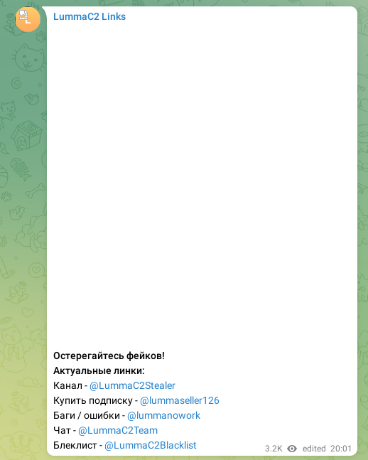Figure 2: Inside Lumma links Telegram channel.
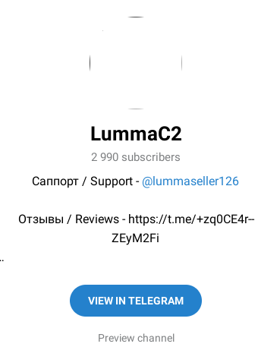Figure 3: Lumma Stealer Telegram channel.
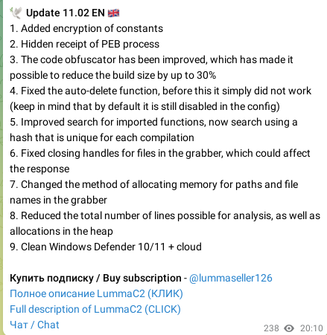Figure 4: Most recent update notes from Luma stealer Telegram channel.

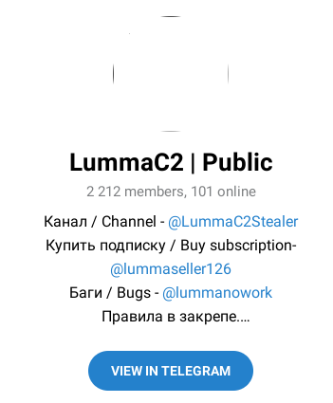Figure 5: Lumma C2 Team Telegram channel.
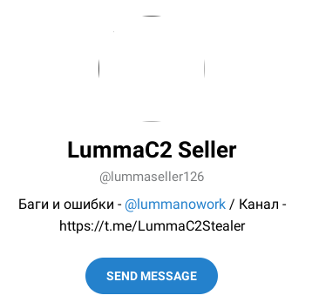Figure 6: Lumma seller Telegram channel.
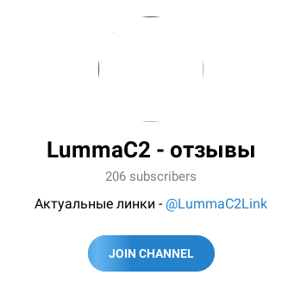Figure 7: Lumma reviews Telegram channel.
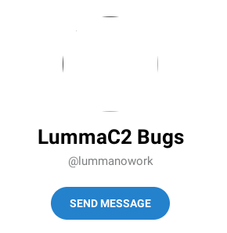Figure 8: Lumma bug reporting Telegram user.
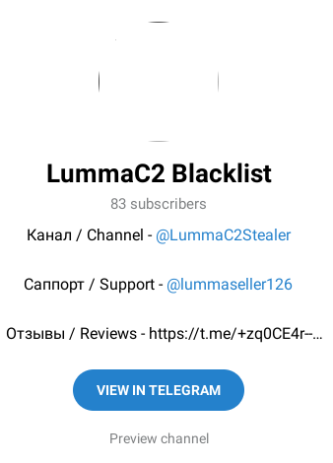Figure 9: Lumma blacklist Telegram channel.
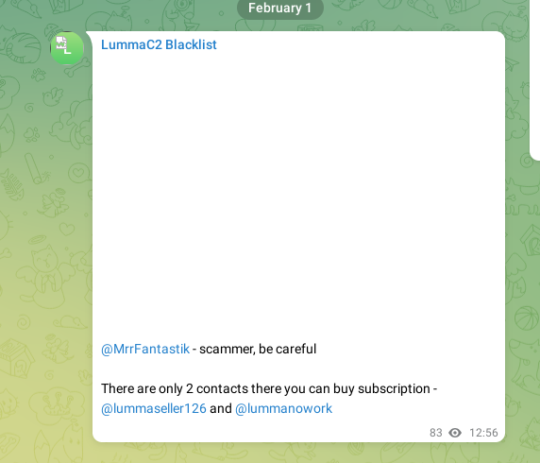Figure 10: Inside Lumma blacklist telegram channel.

Bibliography
1: KELA Cyber Intelligence Centre, The Next Generation of Info Stealers, 2022
2: Emily Megan Lim, The Rise of the Lumma Info-Stealer, 2023
3: Alberto Marin, Everything you need to know about the LummaC2 stealer: leveraging IDA Python and Unicorn to deobfuscate Windows API hashing, 2023
4: eSentire Threat Response Unit, Fake Browser Updates Distribute LummaC Stealer, Amadey and PrivateLoader Malware , 2023
5: Cyware Alerts - Hacker News, Researchers Disclose New Lumma Stealer Campaign Distributed via YouTube., 2024
6: Carl Malipot, Beware: Lumma Stealer Distributed via Discord CDN, 2023
7: Jiho Kim, Sebin Lee, Lumma Stealer targets YouTubers via Spear-phishing Email, 2023
8: Cara Lin, Deceptive Cracked Software Spreads Lumma Variant on YouTube, 2024

Table of Figures
Figure 1: Lumma links Telegram channel. 7
Figure 2: Inside Lumma links Telegram channel. 7
Figure 3: Lumma Stealer Telegram channel. 8
Figure 4: Most recent update notes from Luma stealer Telegram channel. 8
Figure 5: Lumma C2 Team Telegram channel. 9
Figure 6: Lumma seller Telegram channel. 9
Figure 7: Lumma reviews Telegram channel. 10
Figure 8: Lumma bug reporting Telegram user. 10
Figure 9: Lumma blacklist Telegram channel. 11
Figure 10: Inside Lumma blacklist telegram channel. 11

