What can be measured from the broadcast? Validity of single-camera video for football-kick kinematics and swing-leg joint loads
Roberto Martín Gutiérrez¹
Preprint, October 2026
Author. Roberto Martín Gutiérrez¹ (corresponding author). ¹ Independent researcher, Spain. ORCID: 0009-0004-5724-3502. E-mail: convderover@gmail.com. LinkedIn: roberto-martín-gutiérrez-ingeniería-biomédica.
Article type: Original Investigation. Running title: Kick biomechanics from broadcast video. Word count (main text): 4,365.

Abstract
Professional football now measures the ball, but the kicking body is only visible on broadcast video. This method-comparison study asked for which practical uses single-camera broadcast-like video can measure kicking kinematics and swing-leg joint loads. Optical motion capture of 90 laboratory kicks (7 ball kicks; 83 participants) served as reference. Kicks were filmed by a virtual broadcast camera carrying the real 2D detector error of 200 Premier League shots, lifted to 3D, and checked on real video with synchronised capture and a per-recording digital twin. Six kinematic features and three swing-leg joint moments were judged against literature-based criteria for comparing with laboratory norms, ranking players and monitoring individuals. Broadcast detection error was 7.6–12.9 % of player height. From a single camera (80 px, 25 fps) and the published lifter no variable met any criterion (best ICC 0.64). The digital twin predicted real-video errors (r = 0.84). Fusing three replays with a laboratory correction made kicking-knee flexion acceptable for ranking players (ICC 0.80) and trunk leans comparable with laboratory norms (MAE < 5°); no variable could monitor individuals. A swing-leg load index tracked kick intensity in the laboratory (ρ = 0.79) but was not recoverable from video (reliability 0.08), so validating it as an injury predictor would need about 590 injuries (12–24 LaLiga seasons). Smartphone recordings of real kicks reproduced these patterns. Single-camera broadcast video does not yet support individual kicking biomechanics or load-based injury scores; replay fusion and ball-contact timing allow limited ranking uses, pending validation on football-specific data.
Keywords: football; kicking; broadcast video; markerless motion capture; agreement; inverse dynamics

1. Introduction
Kicking defines football and is also a mechanism of injury. Muscle injuries account for almost one third of time-loss injuries in men’s professional football, with adductor (23 %) and quadriceps (19 %) injuries prominent (Ekstrand et al. 2011), and hip and groin injuries represent 12–16 % of all injuries every season (Werner et al. 2009, 2019). Kicking is one of the two main actions behind acute adductor longus injuries (Serner et al. 2019) and a principal mechanism of rectus femoris strains (Mendiguchia et al. 2013). The biomechanics of the kick — the backswing that stretches the hip flexors, the rapid knee extension and the braking of the shank before impact — is well described in the laboratory (Lees et al. 2010; Kellis and Katis 2007; Nunome et al. 2002; Dörge et al. 2002; Apriantono et al. 2006; Shan and Westerhoff 2005; Charnock et al. 2009).
In matches, however, the kick is only observed through broadcast video. Since August 2026 LaLiga EA Sports instruments every match ball with a sensor that reports the instant of every touch (LaLiga 2026): the ball is measured, the body that strikes it is not. Monocular pose estimation now extracts kicking posture from a single camera: AutoSoccerPose builds 2D and 3D shot-posture sequences from broadcast footage (Yeung et al. 2024), Noworolnik and Jaworek-Korjakowska rate shooting technique from side-view features (Noworolnik and Jaworek-Korjakowska 2025), and 3D player pose from broadcasts is an active topic (Tianjian Jiang et al. 2024; Khan et al. 2026; Baumgartner and Klatt 2023).
What is missing is the measurement error of the kicking variables themselves under broadcast conditions. Markerless systems have been validated with several laboratory cameras (Kanko et al. 2021; Needham et al. 2021; Uhlrich et al. 2023) and for kicking against manual digitisation (Palucci Vieira et al. 2022), but a broadcast camera is different: shooters often occupy 30–90 pixels, the camera angle is arbitrary, the frame rate is 25 or 50 fps and images are compressed. In athletic movements monocular joint angles can correlate with motion capture while joint velocities do not (Yeung et al. 2025); joint loads, which need second derivatives of position, should be even more fragile — yet they are what a medical department would want for a “joint suffering” or injury-risk score. Without a known measurement error, broadcast-derived technique or load metrics cannot be interpreted, and injury models built on them cannot be validated.
Our research question was: for which practical uses — comparison with laboratory norms, ranking players or monitoring an individual — are kicking kinematics and swing-leg joint loads estimated from single-camera broadcast-like video acceptable, and how large would a study validating a broadcast-derived load score as an injury predictor have to be? We also quantified the real 2D detector error on broadcast shots, tested the simulation against real video, and evaluated three remedies.

2. Methods

2.1 Design, data and reporting
This was a method-comparison (agreement) study using secondary analysis of public datasets, complemented by a field example (Section 2.6), with optical motion capture as the reference (Figure 1, Table 1). A virtual broadcast camera filmed each laboratory kick at controlled player sizes, views and frame rates, its exact 2D projections were corrupted with the error a detector actually makes on broadcast shots, and a temporal lifter reconstructed 3D, from which features and loads were recomputed. The same pipeline ran on real video with synchronised capture, and each real recording was reproduced by its digital twin. Reporting follows the Guidelines for Reporting Reliability and Agreement Studies (GRRAS) (Kottner et al. 2011) (checklist in the supplementary material). The study was not pre-registered.
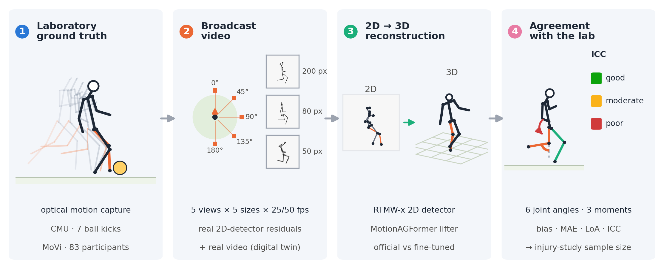
Figure 1. Study design. (1) Laboratory kicks recorded with optical motion capture provide the ground truth (shown: a CMU ball kick, fading poses up to ball contact). (2) A virtual broadcast camera films each kick from five views at five player sizes and 25 or 50 fps (insets: the same instant at 200, 80 and 50 px), and its exact 2D projections are corrupted with the residuals that a detector makes on real broadcast shots; real video with synchronised capture (MoVi) and a digital twin of each recording test the simulation. (3) The 2D keypoints are lifted to 3D with MotionAGFormer, with official or kick-adapted weights. (4) Six kinematic features and three swing-leg joint moments are compared with the laboratory (bias, mean absolute error, limits of agreement, ICC with the classes of Koo and Li), and the reliability is translated into the size of the injury study needed to validate a load score.
CMU (ball kicks). Seven trials labelled “soccer – kick ball” from the CMU Graphics Lab Motion Capture Database (Carnegie Mellon University Graphics Lab 2003) (subject 10, trials 01–06; subject 11, trial 01; Vicon, 120 Hz), using the virtual joint centres of the capture software. Six trials have three ball markers; 11_01 includes a run-up; 10_04 is a slow kick (peak ankle speed 4.1 m/s versus 10.2–13.1 m/s).
MoVi (multi-participant, with video). The F round of MoVi (Ghorbani et al. 2021) contains, for 90 participants, one kicking action captured at 120 Hz and processed with Visual3D, with synchronised video from two calibrated stationary cameras (800 × 600 px, 30 fps), height and body mass. Joints stored as (0, 0, 0) were treated as gaps; gaps up to 0.25 s were interpolated and kicks with longer gaps excluded, leaving 83 participants (55 female). These are air kicks by non-footballers, so they validate the measurement chain rather than describe football technique. Synchronisation (capture frame = 4 × video frame) was verified by projecting the capture onto the detections (offset 0 ± 2 capture frames).
Table 1. Data sets used.
Data set | Role | Size | Rate | Notes
CMU | Ground truth: real ball kicks | 2 participants, 7 kicks | 120 Hz | Vicon; ball markers in 6 kicks; one with run-up
MoVi (round F) | Ground truth and real video | 83 participants, 83 air kicks, 2 cameras | 120 Hz; video 30 fps | Visual3D; height and mass; non-commercial licence
3DSP | Broadcast 2D detector error | 200 Premier League shots, 6 000 detections | 25 fps | Manual 2D annotation of the shooter

2.2 Kinematic features and swing-leg joint loads
The kicking leg is the one whose ankle reaches the higher peak speed, and contact is approximated by the peak of kicking-ankle speed; in the CMU trials with ball markers we compared it with the true contact, obtained by extrapolating the ball’s launch line back to its resting position. Six features were computed from an eight-joint skeleton (shoulders, hips, knees, ankles; Figure 2a–d): support-knee flexion at contact; kicking-knee peak flexion and kicking-hip peak extension (−0.3 s to contact); kicking-hip range of motion (−0.3 to +0.2 s); and trunk sagittal and lateral lean at contact. These overlap with previous single-camera pipelines (Noworolnik and Jaworek-Korjakowska 2025) and with determinants of kick performance (Lees et al. 2010; Kellis and Katis 2007).
Between the end of the backswing and ball contact the kicking leg does not touch the ground, so the net moments at its knee and hip are determined by the kinematics and inertia of thigh, shank and foot (Figure 2e). We used a Newton–Euler model with the body-segment parameters of de Leva (1996), the foot as a point mass at the ankle (broadcast skeletons have no foot points) and segment angular velocity from the longitudinal axis (ω = u × u̇). Moments were projected onto the pelvis lateral axis (positive: knee extensor, hip flexor) after zero-lag Butterworth filtering (12 Hz, or 0.35 × fps if lower). Three peaks normalised by body mass were extracted: peak hip-flexor and knee-extensor moments from the end of the backswing to contact, and peak knee-flexor (braking) moment in the 100 ms before contact; a Kick Load Index (KLI) is their mean expressed as z-scores relative to the MoVi laboratory distribution. The model was verified analytically (static limb, mirror symmetry, quadratic scaling with speed) and was identical for reference and estimate, so the comparison isolates the measurement chain. On a full and a slow kick by the same player it gives 1.01 versus 0.43 N·m/kg of hip-flexor moment and 0.89 versus 0.12 N·m/kg of knee-flexor moment (Figure 2f).
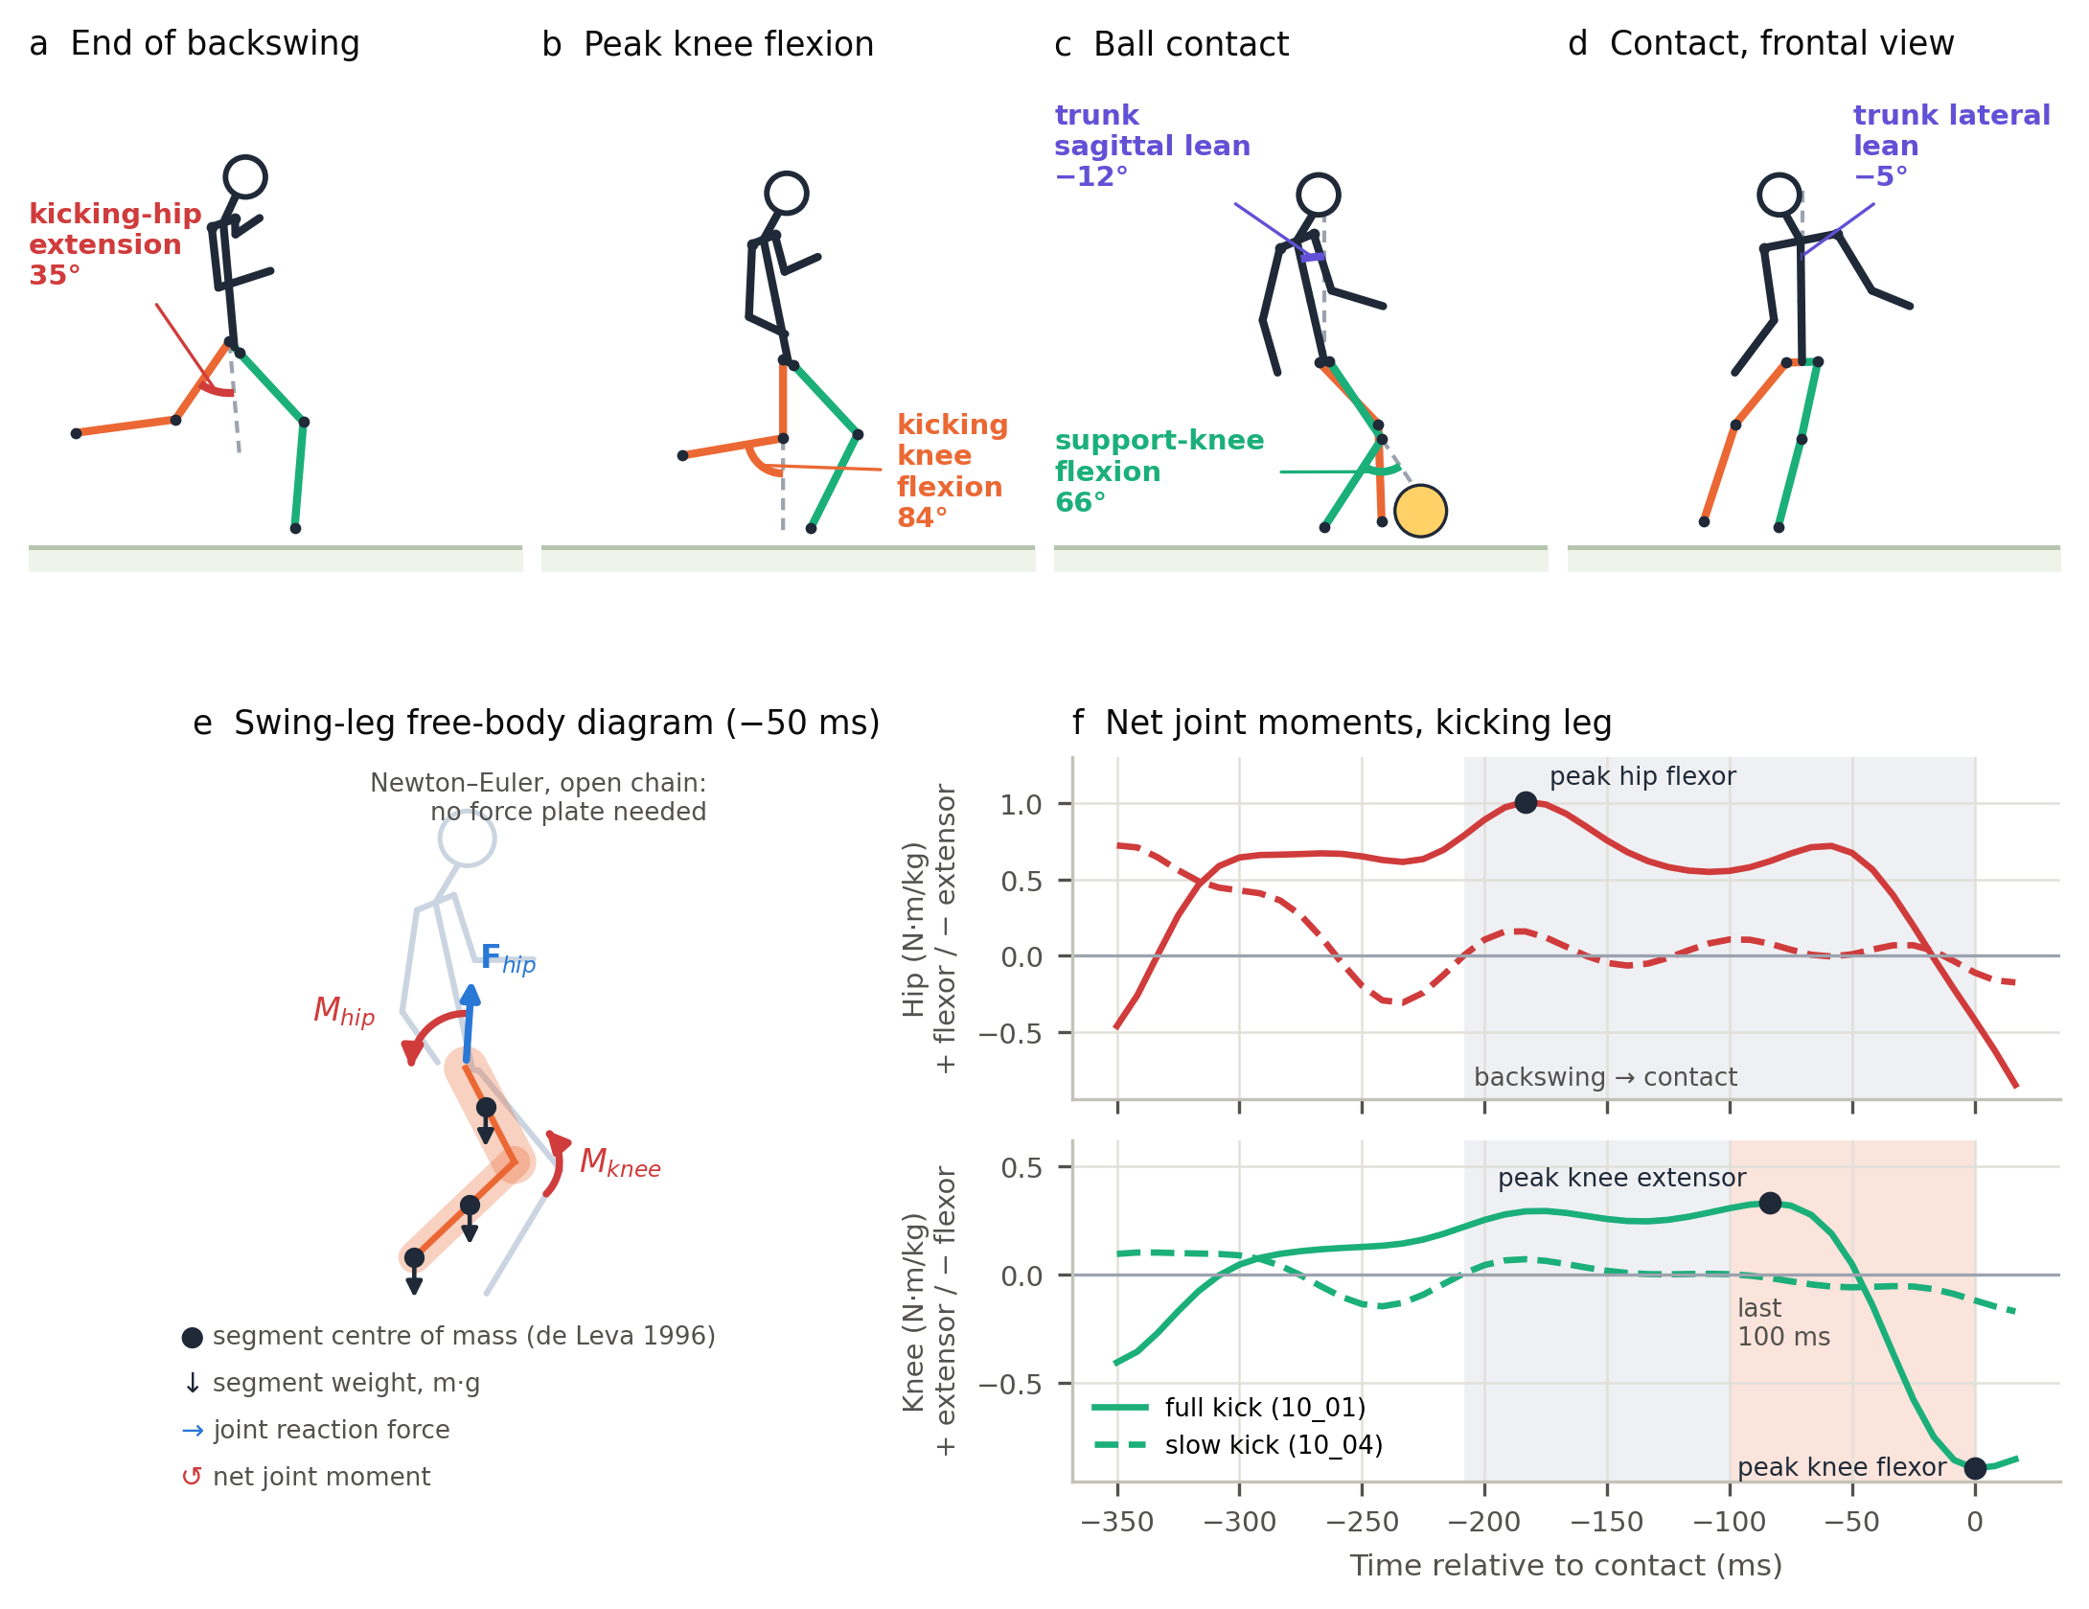
Figure 2. The kick model on a real ball kick (CMU 10_01, 120 Hz). (a–d) Five of the six kinematic features read from the skeleton (the sixth is the kicking-hip range of motion): kicking-hip extension at the end of the backswing (a), kicking-knee peak flexion (b), support-knee flexion and trunk sagittal lean at ball contact (c) and trunk lateral lean at contact (d); orange: kicking leg; green: support leg. (e) Free-body diagram of the swing leg 50 ms before contact: segment weights at the centres of mass, hip reaction force and net joint moments. (f) Net hip and knee moments of this kick and of a slow kick by the same player (10_04, dashed); grey band: end of backswing to contact; orange band: last 100 ms; dots: the three load peaks used as variables.

2.3 Broadcast 2D error, virtual camera and 3D lifting
We used the 3D Shot Posture dataset (3DSP) (Yeung et al. 2024): 200 shots from English Premier League broadcasts (via SoccerNet (Deliège et al. 2021)), 20 consecutive frames at 25 fps, with 17 manually annotated keypoints of the shooter. RTMW-x (Tao Jiang et al. 2024; Jiang et al. 2023) was run inside the annotated person box, also at 75 % and 50 % scale for a quarter of the shots (6 000 detections). We report the RMS error per axis as a function of player height H and fit σ(H) = √((aH)² + b²), an upper bound of detector error because annotations have their own error.
Each ground-truth kick was resampled to 25 or 50 fps and filmed by a pinhole camera 40 m away at 15° elevation and azimuths of 0° (frontal), 45°, 90° (lateral, kicking-leg side), 135° and 180°, with H ∈ {400, 200, 120, 80, 50} px. Three 2D error models were added: none; independent Gaussian noise with the measured σ(H); and a bootstrap of whole 20-frame sequences of real RTMW residuals from 3DSP, scaled by H, which preserves temporal correlation and gross failures such as left–right swaps.
We lifted 2D to 3D with MotionAGFormer-B and its official Human3.6M weights (Mehraban et al. 2024; Ionescu et al. 2014). Two details had first-order effects: the 2D input must be normalised in a crop centred on the player, because full-frame normalisation, as in the public demo, yields 50–90° errors for small players even without noise; and RTMW scores are not probabilities, so they were replaced by a constant confidence of 0.9 (passing them unchanged under-estimated kicking-knee flexion by 41°). The reconstruction was scaled to the reference thigh length (equivalent to knowing stature) and rigidly aligned once per sequence (equivalent to pitch calibration). Contact was either known (as a ball sensor provides) or automatic (ankle-speed peak of the reconstruction). Apart from scale and alignment, the video estimates never used the reference.

2.4 Real video and digital twin
For every MoVi participant and camera, YOLOX-m (Ge et al. 2021) detected the person; images were downscaled so that the participant measured 120, 80 or 50 px and JPEG-compressed, or kept at native resolution (about 330 px), and RTMW-x estimated the pose. In the digital twin, each recording was re-simulated at exactly its calibrated geometry and frames with three 2D error models: none, real RTMW residuals from the other MoVi participants, and broadcast residuals. If the twin reproduces the errors measured on real images, its broadcast variant is a credible estimate of broadcast error.

2.5 Remedies
Replay fusion. We averaged the per-view estimates of two (45°, 135°) or three (45°, 90°, 135°) virtual replays with independent 2D errors. Bias correction. A view-specific linear calibration (reference ≈ a + b·estimate) was learnt on laboratory kicks and applied to unseen participants (leave-one-participant-out), and, to test transfer, learnt on all MoVi kicks and applied to the CMU ball kicks. Kick- and broadcast-adapted lifter. MotionAGFormer-B was fine-tuned on synthetic broadcast data generated from MoVi motion capture (all 21 recorded actions; random view, elevation 5–25°, distance 15–60 m, H 40–400 px, 25 or 50 fps; broadcast residuals, Gaussian noise or exact projections) for 1 000 iterations with the original loss. Participants were split into two folds and each model was tested only on participants it never saw. The 3DSP shots were split into two halves stratified by player height: training used one half and every virtual-camera test of the adapted lifter the other. CMU ball kicks were never used for training.

2.6 Field example
To illustrate the pipeline on genuine football kicks, the author (adult male, 177 cm, 78 kg, recreational right-footed player) performed 13 instep kicks of a stationary ball on an outdoor hard court (8 strong, 5 soft), each filmed once with a smartphone at a fixed position (1920 × 1080 px, 60 fps) from one of four views: lateral (5 kicks), diagonal from behind (4), diagonal from the front (2) and front (2). The player measured 170–241 px (median 199 px). The videos were processed with the same detector and lifter at native resolution and with the player downscaled to 80 px and JPEG-compressed. The reconstruction was scaled with a thigh length of 0.245 × stature (Winter 2009), the image vertical was taken as the world vertical (level camera), occasional left–right swaps of knee and ankle labels were corrected by temporal continuity (Viterbi; 20 of 10 200 frames), and contact was the speed peak of the right (kicking) ankle. Without motion capture this example tests plausibility — whether strong and soft kicks are told apart — and consistency across resolutions, not validity.

2.7 Statistics and acceptability criteria
For each variable we report bias, mean absolute error (MAE), 95 % limits of agreement (Bland and Altman 1986), ICC(2,1) for absolute agreement (Shrout and Fleiss 1979) with the classes of Koo and Li (Koo and Li 2016), and the calibration slope λ (regression of the reference on the estimate), with 95 % confidence intervals from 1 000 bootstrap resamples of participants. The typical broadcast condition is H = 80 px, 25 fps, broadcast residuals, known contact and replay views (45–135°). Sample size was fixed by the available datasets (83 participants, above the minimum of 30 heterogeneous samples recommended for reliability studies (Koo and Li 2016)).
Fitness for use was judged against criteria taken from the literature, one per practical use. Comparison with laboratory norms (angles): MAE ≤ 5°, the level above which kinematic error is considered concerning (McGinley et al. 2009), and a bias equivalent to zero within ±5° (two one-sided tests, α = 0.05, one value per participant (Schuirmann 1987; Lakens 2017)). Ranking players: ICC ≥ 0.75 with the lower 95 % confidence limit ≥ 0.5. Monitoring an individual: random error (SD of the differences) no larger than the smallest worthwhile change, 0.2 between-player SDs (Hopkins et al. 2009).
Group-mean waveforms of laboratory and reconstructed knee and hip flexion were compared with non-parametric one-dimensional statistical parametric mapping (Pataky 2012; Pataky et al. 2015; Nichols and Holmes 2002): paired t statistics at each instant, with critical threshold and cluster p-values from 10 000 sign-flip permutations of the maximum |t| (family-wise α = 0.05).

2.8 Size of an injury study
If a load score W measures the true load X with random error, an association between X and injury estimated through W is attenuated by the reliability λ (Hutcheon et al. 2010). With Schoenfeld’s formula (Schoenfeld 1983), the number of injuries needed to detect a hazard ratio HR per SD of X (α = 0.05, power 0.8) is D = (z_{0.975} + z_{0.8})² / (λ · ln² HR). We translate D into LaLiga seasons assuming 20 clubs × 25 players and 0.05–0.10 kicking-related adductor or quadriceps injuries per player-season (0.6 muscle injuries per player-season, 42 % adductor or quadriceps (Ekstrand et al. 2011), a quarter to a half attributable to kicking (Serner et al. 2019; Mendiguchia et al. 2013); an explicit assumption).

3. Results

3.1 Contact instant and broadcast detector error
In the five CMU kicks with ball markers the peak of kicking-ankle speed preceded the true contact by 19.6 ms (6.8–32.2 ms; Supplementary Figure S1), less than one broadcast frame, and computing the features at that peak changed them by at most 2.1°.
On broadcast shots the detector’s RMS error per axis followed σ(H) = √((0.063 H)² + 3.9²) px, falling from 12.9 % of player height at about 27 px to 7.6 % at about 86 px (Figure 3a). Ankles (14.4 %) and wrists (13.7 %) were the least accurate joints, hips (5.6 %) and shoulders (5.5 %) the most (Figure 3b). On laboratory video downscaled to the same sizes the same detector erred by 3.1–4.0 % of H: broadcast images are more than twice as hard.
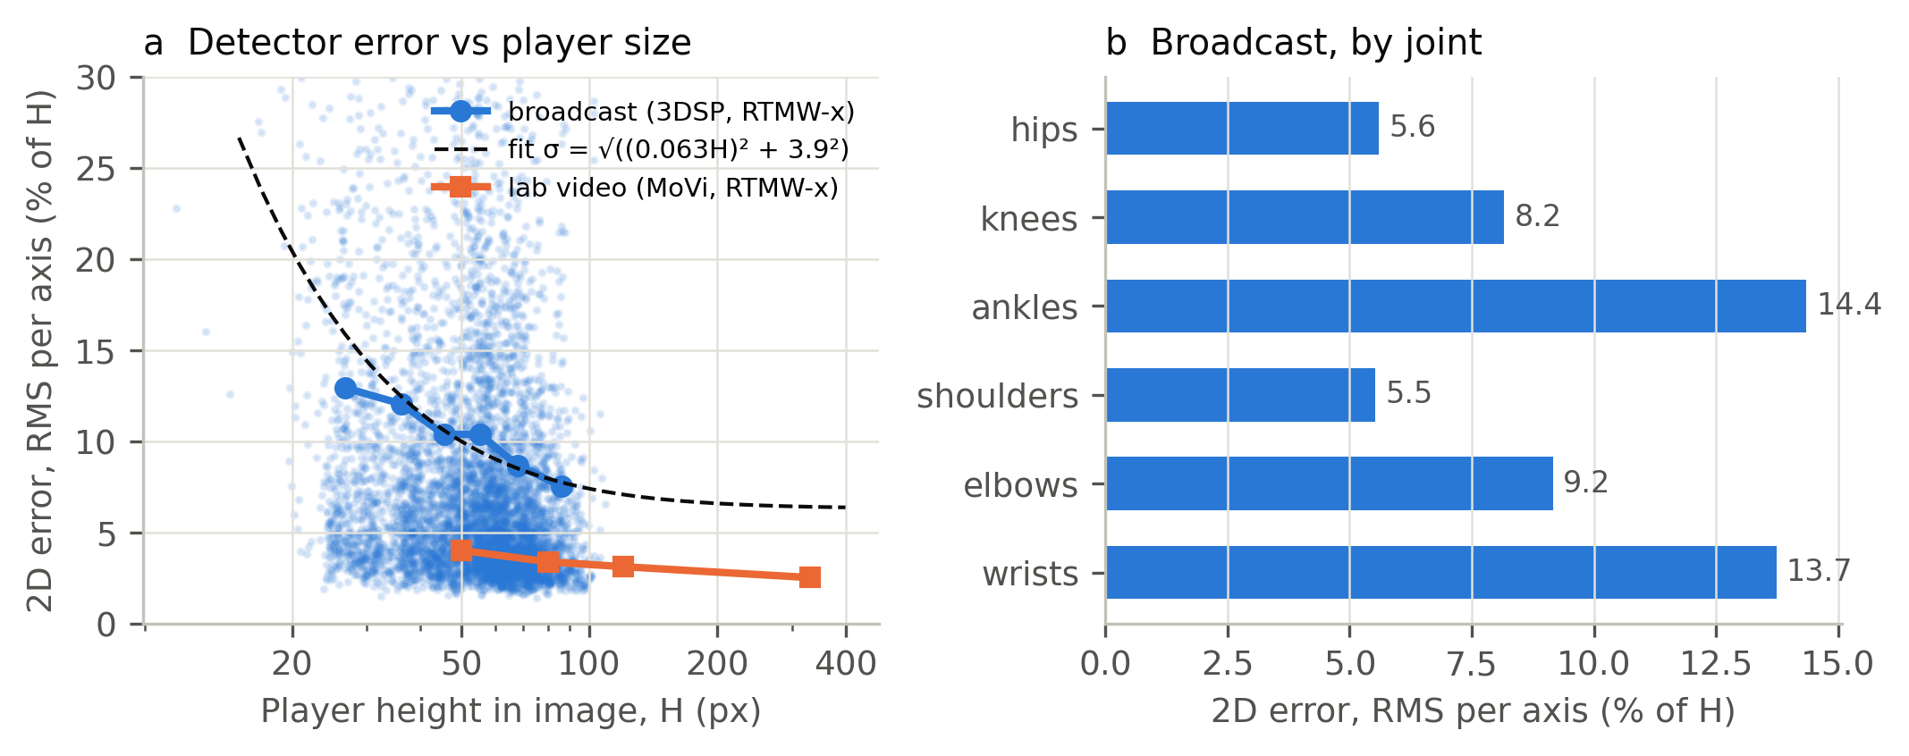
Figure 3. 2D detector error. (a) RMS error per axis relative to player height on broadcast shots (3DSP; dots: frames; line: binned RMS; dashed: fitted model) and on laboratory video downscaled to broadcast sizes (MoVi). (b) Broadcast error by joint.

3.2 Sensitivity to view, size, frame rate, error model and contact
Without 2D noise the lifter alone produced a mean feature error of 9.2° on the MoVi kicks and 15.0° on the CMU ball kicks; within MoVi the error was unrelated to kick intensity (Spearman ρ = 0.12, p = 0.27; Supplementary Figure S2). With broadcast residuals the camera view dominated: MoVi errors were 11.9° (lateral), 13.5° (135°), 19.0° (45°), 20.0° (rear) and 22.6° (frontal) (Supplementary Figures S3 and S4). Player size had little effect between 50 and 400 px (16.8–18.2°). Independent Gaussian noise of the measured magnitude over-stated the error of real residual sequences by 1.05–1.8 times; 50 fps did not improve on 25 fps (16.7° versus 17.4°); and detecting the contact from the reconstructed pose instead of knowing it increased the error from 17.4° to 23.1° (Supplementary Figure S5).
On the average waveform (Figure 4), from a lateral camera the reconstructed hip flexion followed the laboratory curve closely (mean difference 3.3°; significant only between −160 and −120 ms, p = 0.011), and knee flexion followed it up to peak flexion, but the knee extension through contact was missed: 18° too flexed at contact and 36° 120 ms later (significant from −40 to +200 ms, p < 0.001). From a frontal camera the reconstructed knee angle was nearly flat (85–101° against 19–86°; significant over the whole window, p < 0.001).
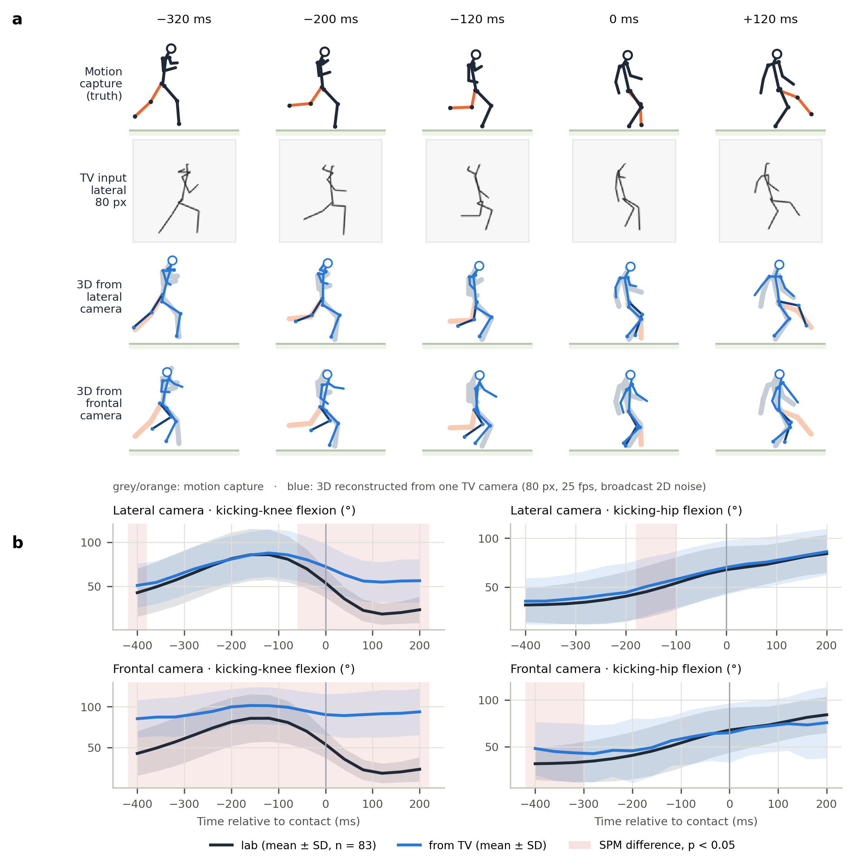
Figure 4. What the broadcast camera sees and what is reconstructed. (a) A real ball kick (CMU 10_01) at five instants around contact: motion capture (top row); the 2D input of a lateral broadcast camera with the player 80 px tall, 25 fps and real broadcast 2D residuals (second row); and the 3D reconstructed from a lateral and from a frontal camera (blue) superimposed on the truth (grey, kicking leg orange), aligned at the pelvis. (b) Kicking-knee and kicking-hip flexion around contact, laboratory versus reconstruction from a single camera in the same condition: mean ± SD over the 83 MoVi participants; time 0 is the contact taken from the laboratory skeleton; red bands: intervals where the curves differ (non-parametric SPM, p < 0.05).

3.3 Agreement in the typical broadcast condition
Only two features reached moderate between-player agreement (Table 2): kicking-knee peak flexion (MAE 16.5°, ICC 0.64) and kicking-hip peak extension (15.7°, 0.55). The trunk leans were poor (ICC 0.42) despite errors of about 7°, because players differ by only about 7° in them. Support-knee flexion carried a proportional bias (+15.6° on average; Supplementary Figure S6) and no agreement (ICC 0.07). Agreement was lower still from frontal and rear views (Supplementary Figure S7).
Table 2. Agreement between the broadcast-like estimate and motion capture (MoVi, n = 83; 80 px, 25 fps, broadcast residuals, known contact, replay views 45–135°). MAE and ICC with 95 % bootstrap confidence intervals; SD: between-player standard deviation of the reference.
Variable | Reference SD | Bias | MAE (95 % CI) | 95 % LoA | ICC(2,1) (95 % CI) | Class
Support-knee flexion at contact (°) | 8.8 | +15.6 | 20.4 (18.8–22.1) | −25.6 to 56.8 | 0.07 (0.02–0.13) | poor
Kicking-knee peak flexion (°) | 28.7 | +2.9 | 16.5 (14.6–18.8) | −41.2 to 47.1 | 0.64 (0.55–0.71) | moderate
Kicking-hip peak extension (°) | 20.0 | +1.2 | 15.7 (13.9–17.6) | −40.9 to 43.3 | 0.55 (0.39–0.68) | moderate
Kicking-hip range of motion (°) | 22.0 | +2.7 | 18.0 (15.4–21.1) | −55.3 to 60.7 | 0.45 (0.31–0.63) | poor
Trunk sagittal lean at contact (°) | 7.0 | −1.6 | 7.1 (6.3–8.0) | −19.9 to 16.8 | 0.42 (0.28–0.54) | poor
Trunk lateral lean at contact (°) | 7.5 | −4.3 | 7.0 (6.1–7.9) | −19.9 to 11.3 | 0.42 (0.32–0.51) | poor
Peak hip-flexor moment (N·m/kg) | 0.30 | +0.54 | 0.63 (0.54–0.72) | −1.01 to 2.09 | 0.11 (0.06–0.17) | poor
Peak knee-extensor moment (N·m/kg) | 0.11 | +0.11 | 0.17 (0.15–0.20) | −0.38 to 0.61 | 0.16 (0.05–0.30) | poor
Peak knee-flexor moment (N·m/kg) | 0.08 | +0.17 | 0.21 (0.19–0.24) | −0.30 to 0.64 | 0.06 (0.00–0.12) | poor

3.4 Real video and digital twin
On the real MoVi recordings (82 participants with usable video × 2 cameras) feature errors grew only moderately from native resolution to 50 px (Table 3, Figure 5a). Two features carried large size-independent biases — kicking-hip peak extension (+22 to +25°) and trunk sagittal lean (−13°) — consistent with the different definitions of detector keypoints (skin-surface hips and shoulders) and joint centres. At 80 px agreement was good for trunk lateral lean (ICC 0.71) and moderate for hip range of motion (0.67) and knee peak flexion (0.56). The digital twin reproduced the real-image errors (Figure 5b): simulating each recording with its own geometry and the residuals of the other participants predicted the MAE measured on real images with r = 0.84 and a mean discrepancy of 3.9° (13.0° simulated versus 14.8° real); it was slightly optimistic for the two features with definitional biases, so the broadcast errors above are, if anything, lower bounds.
Table 3. Real-video agreement with motion capture (MoVi, 82 participants, two cameras, known contact). MAE in degrees, with ICC(2,1) in brackets.
Feature | Native (~330 px) | 120 px | 80 px | 50 px | Bias at 80 px
Support-knee flexion at contact | 10.3 (0.45) | 11.4 (0.39) | 12.5 (0.27) | 12.8 (0.24) | −8.5
Kicking-knee peak flexion | 16.5 (0.62) | 18.4 (0.61) | 20.3 (0.56) | 24.5 (0.48) | −8.8
Kicking-hip peak extension | 22.4 (0.48) | 23.7 (0.42) | 24.1 (0.38) | 25.9 (0.29) | +23.4
Kicking-hip range of motion | 16.0 (0.67) | 15.5 (0.68) | 15.5 (0.67) | 17.7 (0.57) | +3.5
Trunk sagittal lean at contact | 13.1 (0.18) | 13.5 (0.16) | 13.6 (0.15) | 13.4 (0.16) | −13.4
Trunk lateral lean at contact | 3.5 (0.77) | 3.8 (0.73) | 3.8 (0.71) | 4.4 (0.63) | −0.9
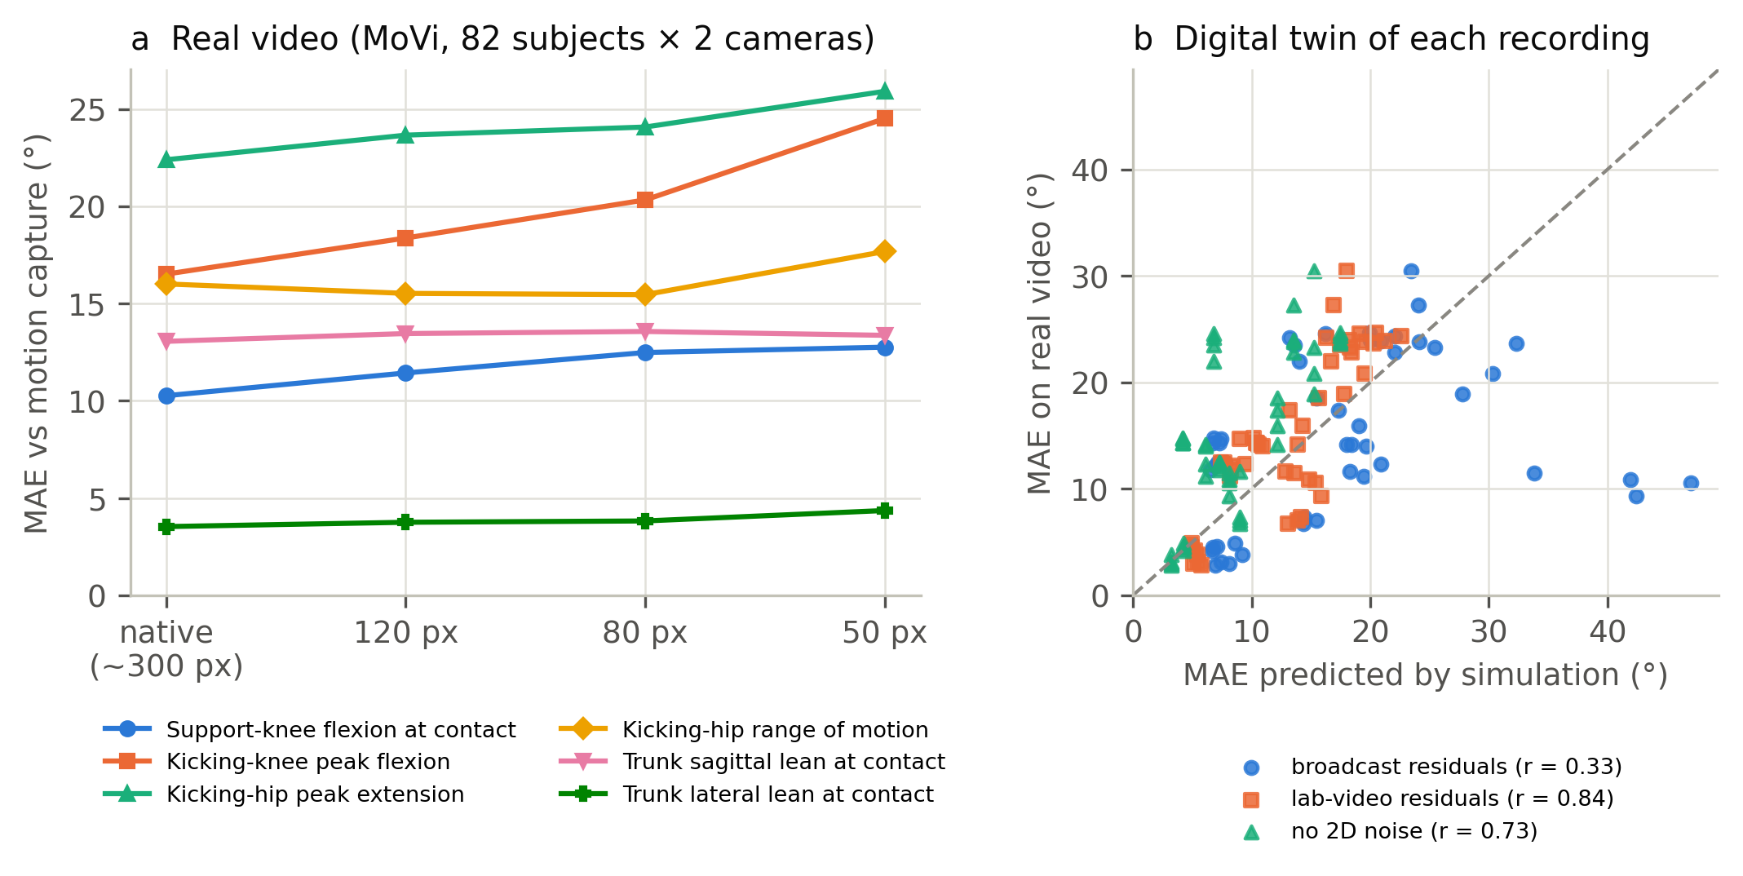
Figure 5. Real-image validation. (a) MAE of each feature on real video at native resolution and downscaled to broadcast player sizes. (b) Digital twin: MAE predicted by simulating each recording with its own camera geometry versus MAE measured on the real images, for three 2D error models.

3.5 Swing-leg joint loads
In the laboratory each peak moment increased with kick intensity (Spearman ρ = 0.56–0.58 with peak ankle speed, p < 10⁻⁷) and the KLI did so strongly (ρ = 0.79; Figure 6a); the CMU ball kicks produced peak hip-flexor moments of 1.0–2.0 N·m/kg against 0.71 ± 0.30 N·m/kg for the MoVi air kicks. From broadcast-like video the loads were biased upwards, agreement was poor (ICC 0.06–0.16; Table 2, Figure 6b) and calibration slopes were 0.05–0.11. A ridge model predicting the laboratory loads from the six posture features explained 19–34 % of their variance and, applied to broadcast postures, reached λ = 0.30–0.38. Detecting a hazard ratio of 1.5 per SD of the true KLI therefore requires 48 injuries with a laboratory-grade measurement, 126 with the posture surrogate and about 590 with inverse dynamics from broadcast-like video (Figure 6c) — one to two, three to five and twelve to twenty-four seasons of the whole of LaLiga EA Sports, respectively.
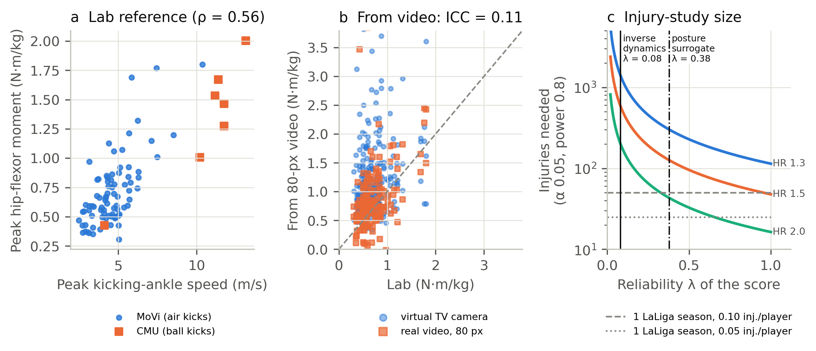
Figure 6. Swing-leg joint loads. (a) Laboratory peak hip-flexor moment versus peak kicking-ankle speed (construct validity). (b) Peak hip-flexor moment from broadcast-like video (80 px, 25 fps, replay views) versus the laboratory reference. (c) Injuries needed to detect a given hazard ratio per SD of true load as a function of the reliability λ of the measured score; horizontal lines: injuries accrued by the whole league in one season at two assumed incidences.

3.6 Remedies
Replay fusion and bias correction. Averaging three replay angles raised between-player agreement over a single 45° camera for kicking-hip peak extension (ICC 0.40 → 0.78; MAE 19.3° → 9.4°), kicking-knee peak flexion (0.61 → 0.76), hip range of motion (0.32 → 0.66) and trunk sagittal lean (0.48 → 0.68) (Figure 7); two replays captured most of the gain. A lab-learnt bias correction reduced absolute errors where bias was large (support-knee flexion from 12.9–34.7° to about 7°) but did not raise agreement, and, learnt on air kicks and applied to the CMU ball kicks, made them worse (support-knee flexion 4.8° → 31.2°; kicking-hip peak extension 7.1° → 27.8°).
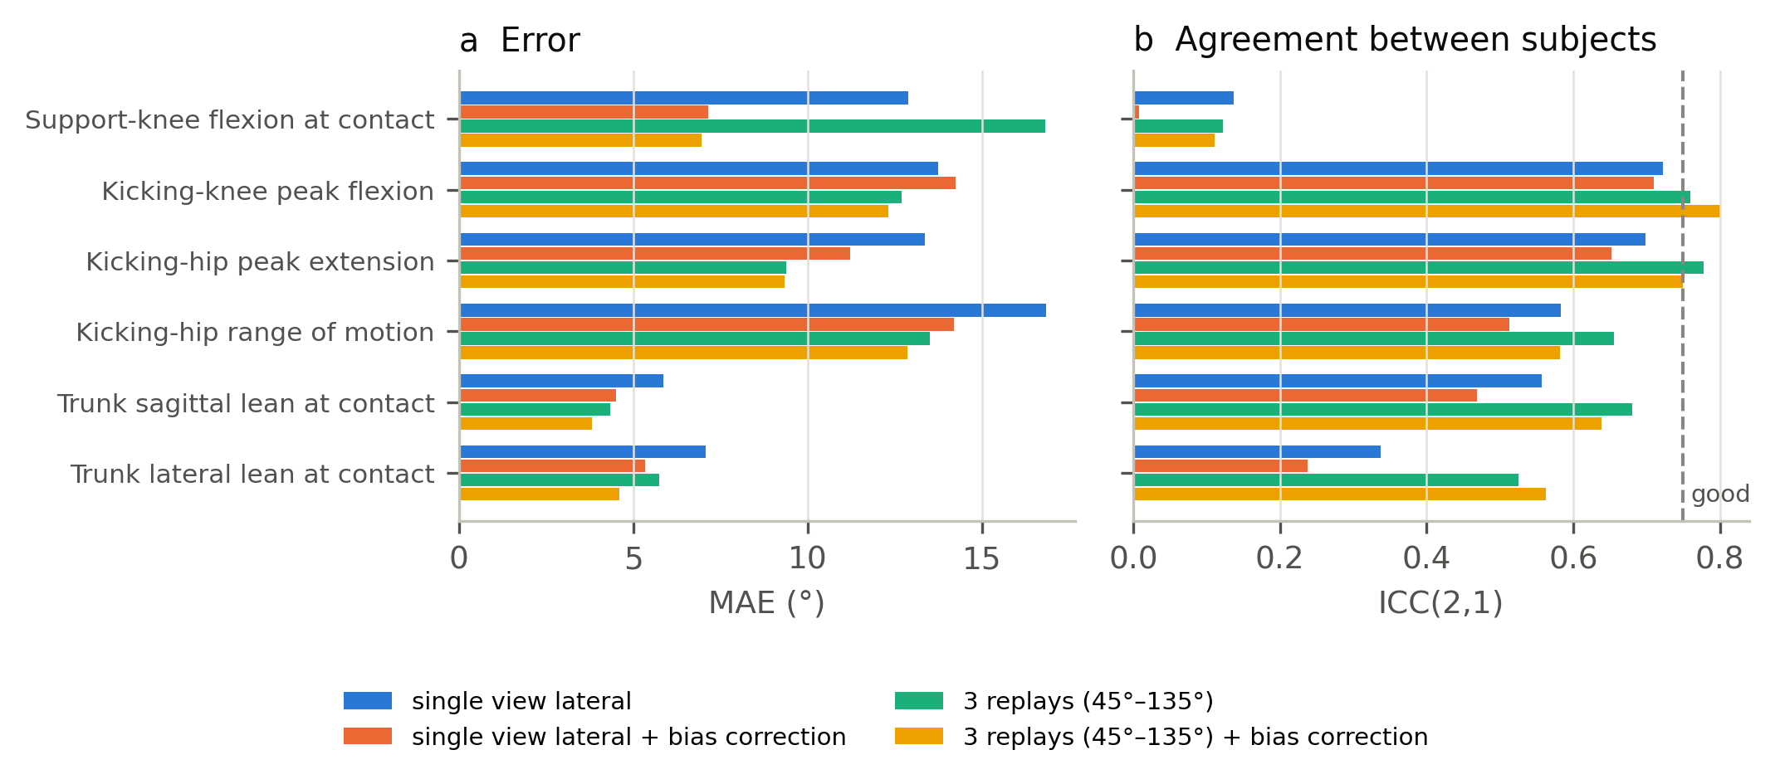
Figure 7. Remedies at 80 px and 25 fps (MoVi, unseen participants): single lateral camera versus fusion of three replays, each without and with lab-learnt bias correction.
Adapted lifter. Fine-tuning the lifter reduced its 3D error on synthetic broadcast windows of unseen participants by 60–64 % (MPJPE from about 0.09 to 0.033–0.037 player heights). On the virtual camera at 80 px with held-out broadcast residuals the mean feature error fell from 14.7° to 8.3°, and agreement rose for every feature (for example kicking-knee peak flexion ICC 0.64 → 0.82, trunk lateral lean 0.37 → 0.77, support-knee flexion 0.08 → 0.51; Supplementary Figure S8a). On real video downscaled to 80 px the gain was smaller (mean error 15.0° → 13.3°; kicking-hip range of motion ICC 0.67 → 0.76, kicking-knee peak flexion 0.56 → 0.67), and support-knee flexion worsened (12.5° → 14.6°). On the CMU ball kicks, absent from training, the adapted lifter was worse than the official one (mean error 11.8° → 16.7°; kicking-hip range of motion 18.2° → 33.0°; Supplementary Figure S8b). Joint loads remained unreliable (ICC ≤ 0.41).

3.7 Fitness for use
From a single broadcast camera no variable was fit for any use (Table 4). With three fused replays and laboratory bias correction, kicking-knee peak flexion became fit for ranking players (ICC 0.80, 95 % CI 0.70–0.87), kicking-hip peak extension fell just short (0.749, 0.61–0.85), and both trunk leans agreed with laboratory values within 5°. With the adapted lifter a single simulated camera sufficed for kicking-knee peak flexion and trunk lateral lean to rank players, and on real video at 80 px kicking-hip range of motion became fit for ranking (ICC 0.76, 0.68–0.83); with the official lifter, only trunk lateral lean met a criterion on real video (comparison with norms; MAE 3.8°). No variable, in any condition, could monitor an individual player (random errors 2.7 to 16.5 times the smallest worthwhile change), and no joint load met any criterion.
Table 4. Fitness for use against literature-based criteria (MoVi; 80 px, 25 fps, known contact). Each cell gives the uses met and, in brackets, MAE (° or N·m/kg) and ICC(2,1); “—”: no use met. Norms: comparison with laboratory norms (angles: MAE ≤ 5° and bias equivalent to zero within ±5°, TOST); ranking: ranking players (ICC ≥ 0.75 with lower 95 % limit ≥ 0.5). No variable met the monitoring criterion (random error ≤ 0.2 between-player SD) in any condition. The first three columns are simulated (virtual camera, broadcast residuals, replay views; the adapted lifter with held-out residuals); 95 % confidence intervals are in Supplementary file 2.
Variable | Single camera | 3 replays + correction | Single camera, adapted lifter | Real video | Real video, adapted lifter
Support-knee flexion at contact (°) | — (20.4°; 0.07) | — (7.0°; 0.11) | — (7.3°; 0.51) | — (12.5°; 0.27) | — (14.6°; 0.22)
Kicking-knee peak flexion (°) | — (16.5°; 0.64) | ranking (12.3°; 0.80) | ranking (13.3°; 0.82) | — (20.3°; 0.56) | — (18.5°; 0.67)
Kicking-hip peak extension (°) | — (15.7°; 0.55) | — (9.3°; 0.749) | — (9.6°; 0.746) | — (24.1°; 0.38) | — (20.0°; 0.46)
Kicking-hip range of motion (°) | — (18.0°; 0.45) | — (12.9°; 0.58) | — (12.0°; 0.74) | — (15.5°; 0.67) | ranking (12.6°; 0.76)
Trunk sagittal lean at contact (°) | — (7.1°; 0.42) | norms (3.8°; 0.64) | norms (3.9°; 0.70) | — (13.6°; 0.15) | — (10.3°; 0.26)
Trunk lateral lean at contact (°) | — (7.0°; 0.42) | norms (4.6°; 0.56) | norms + ranking (3.6°; 0.77) | norms (3.8°; 0.71) | norms (4.1°; 0.747)
Peak hip-flexor moment (N·m/kg) | — (0.63; 0.11) | — (0.21; 0.21) | — (0.30; 0.41) | — (0.39; 0.28) | — (0.43; 0.31)
Peak knee-extensor moment (N·m/kg) | — (0.17; 0.16) | — (0.07; 0.21) | — (0.08; 0.34) | — (0.13; 0.21) | — (0.12; 0.26)
Peak knee-flexor moment (N·m/kg) | — (0.21; 0.06) | — (0.06; 0.05) | — (0.08; 0.18) | — (0.20; 0.06) | — (0.14; 0.11)

3.8 Field example
From the lateral and diagonal-behind views (Figure 8), strong kicks were told apart from soft ones by peak kicking-ankle speed (mean 12.0 m/s, range 8.9–14.7, versus 8.7 m/s, 8.0–10.4), kicking-knee peak flexion (93° versus 72°) and kicking-hip range of motion (113° versus 85°), and the ankle speeds were similar to those of the laboratory ball kicks (10.2–13.1 m/s). From the front the ordering was lost (6.7 m/s for the strong kick versus 8.1 m/s for the soft one) and kicking-hip peak extension became implausible (−32° and −25°), as the simulation predicted for frontal views (Supplementary Figure S9). Downscaling the player to 80 px changed knee peak flexion, hip extension and trunk leans by 1.4–3.4° on average and ankle speed by 1.1 m/s, but biased support-knee flexion (+7.6° on average, up to 24°). The estimated swing-leg moments, in contrast, were implausible: peak hip-flexor moments of 2.0–5.4 N·m/kg, well above the 1.0–2.0 N·m/kg of the laboratory ball kicks, and a soft kick could carry the same estimated load as a strong one (3.5 versus 3.6 N·m/kg; Supplementary Figure S10).
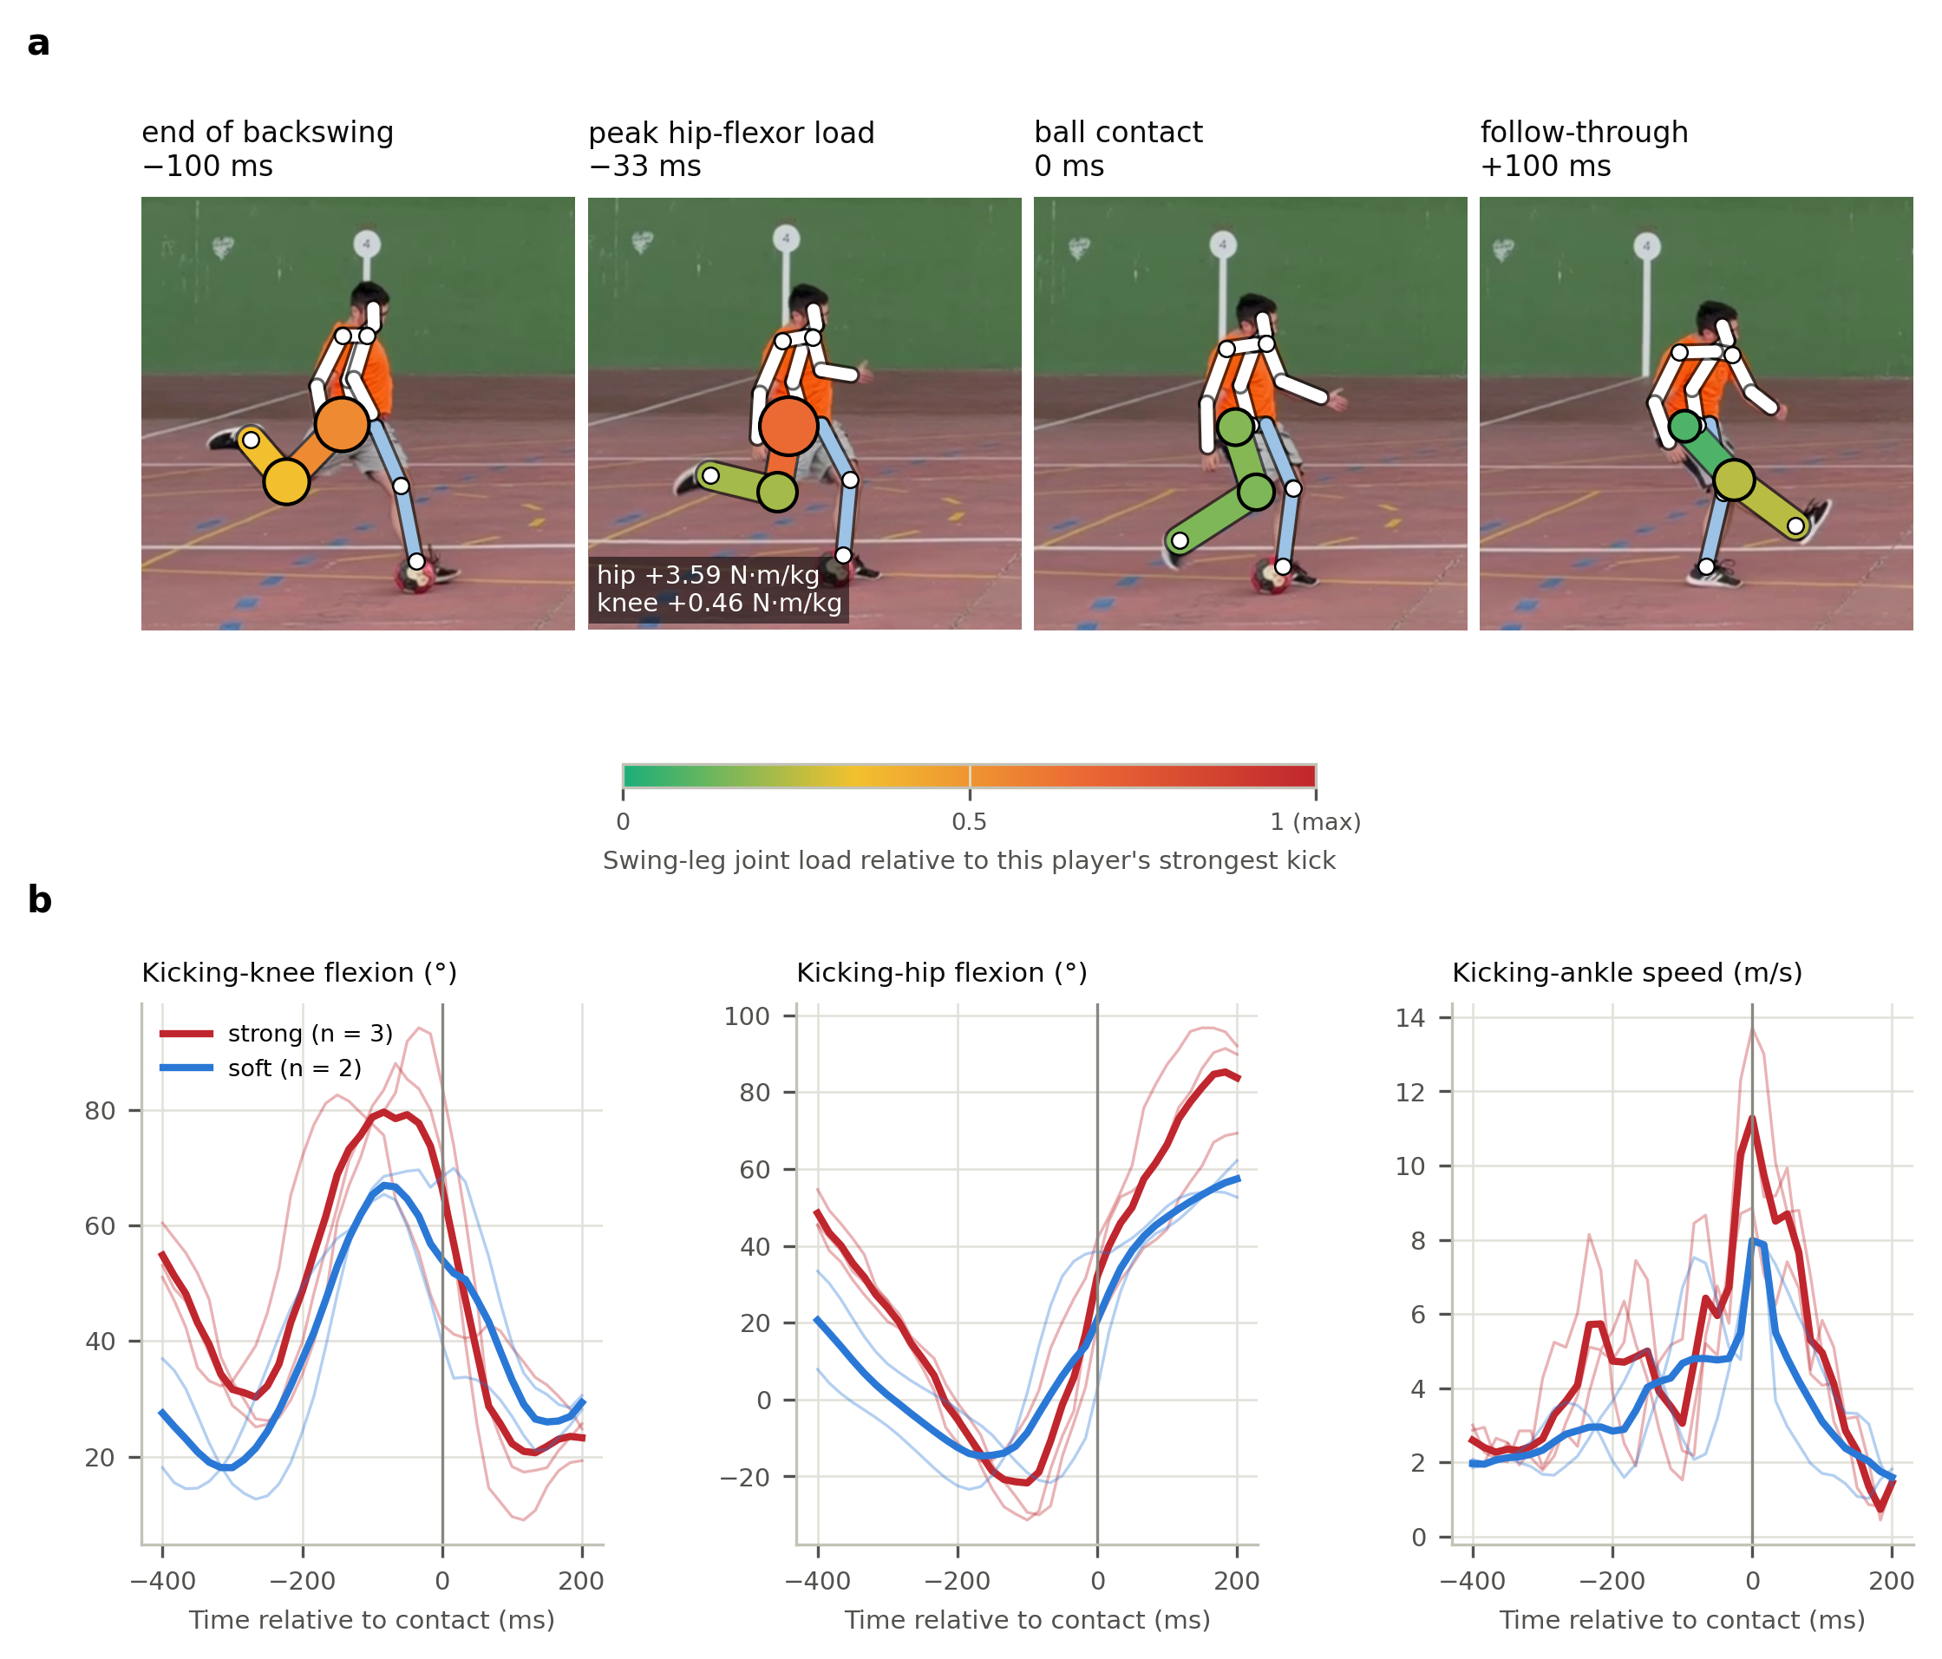
Figure 8. Field example: the author’s kicks filmed with a smartphone (1080p, 60 fps; player about 200 px tall). (a) A strong kick from the lateral view at four instants, with the 2D skeleton detected by RTMW-x; thigh and shank of the kicking leg are coloured by the net hip and knee moment estimated by inverse dynamics, relative to the largest value in the player’s strong kicks — an illustration of where and when the load concentrates, not a validated injury risk, because video-based moments are inflated (Section 3.5). (b) Kicking-knee and kicking-hip flexion and kicking-ankle speed around contact for the strong (red, n = 3) and soft (blue, n = 2) lateral kicks; thin lines: individual kicks; thick lines: mean.

4. Discussion

4.1 What broadcast video can measure today
With open, general-purpose models a single broadcast camera does not deliver usable kicking biomechanics: no variable met a literature-based criterion for any practical use, leg-angle errors were 15–20° — of the order of the differences between players — and the best between-player agreement was moderate. A small absolute error is not enough: trunk leans were measured within about 7°, yet could not rank players because players differ little in them; a broadcast metric must be judged against the spread of the population it will rank. Frame rate did not matter, whereas the camera view, the detector’s error at small sizes and the contact instant did, so progress depends on better 2D detection of small players, the right camera and knowing when the foot meets the ball rather than on higher frame rates. Information that broadcasts already have changes the verdict: fusing the replay angles shown for most shots, with a laboratory-learnt correction, made kicking-knee flexion fit for ranking players and the trunk leans comparable with laboratory norms. Monitoring an individual, however — for example detecting that a player’s backswing has changed after injury — remained out of reach (random errors at least 2.7 times the smallest worthwhile change). Finally, Gaussian noise of the right magnitude over-stated errors by up to 1.8 times, so simulation studies of video biomechanics should use real residual sequences or, better, check themselves against real images, as our digital twin did. The field example reproduced these patterns on genuine ball kicks filmed with a phone: kick intensity was visible in ankle speed and posture from side and rear-diagonal views but not from the front, and the inverse-dynamics loads were implausible.

4.2 The connected ball and football-specific data
Knowing the contact instant reduced the error of the leg features by a quarter. LaLiga’s connected ball timestamps every touch (LaLiga 2026) at a resolution that our CMU analysis shows to be sufficient (the ankle-speed peak precedes contact by about 20 ms, which changes the features by at most 2°), so combining the ball’s timestamp with broadcast pose should be a default rather than a refinement. The limits of the other remedies point to the same bottleneck: a correction learnt on air kicks made the errors of real ball kicks worse, and a lifter adapted to kicking under broadcast noise, which improved unseen air kicks in simulation and on real images, degraded the ball kicks. Models and corrections must therefore be trained and validated on football kicks with run-up and impact, filmed by broadcast cameras with synchronised 3D. Such data exist inside clubs and leagues, and the released protocol turns any such dataset into a validation benchmark.

4.3 A joint-load score: measurable in the laboratory, not yet from television
The swing-leg model behaved as a load measure should: the KLI increased steeply with kick intensity, ball kicks loaded the hip flexors up to almost three times more than air kicks, and a slow kick had a fraction of the load of a full kick by the same player. Peak hip-flexor and knee moments are the mechanical counterpart of the eccentric demand on rectus femoris and iliopsoas in the backswing-to-forward-swing transition, the phase implicated in rectus femoris and adductor injuries (Mendiguchia et al. 2013; Serner et al. 2019; Charnock et al. 2009). From broadcast-like video, however, the score could not be recovered (λ ≈ 0.08), because inverse dynamics needs second derivatives that a 25-fps reconstruction does not contain. As measurement error attenuates any true association, an injury study would need about 48 kicking-related injuries with a laboratory-grade measurement but about 590 with today’s broadcast estimate — a study so long that squads, training and medical practice would change during it. Reliability must therefore be raised before any prospective injury study is attempted.

4.4 Practical implications
Within the limits below, our results suggest that single-camera broadcast estimates of leg angles, velocities or joint loads should not be used for decisions about individual players; that comparisons between players should fuse the available replays, anchor each kick to the ball’s contact time and use only variables shown fit for ranking; and that any vendor metric of technique or load should be accompanied by its agreement with motion capture under broadcast conditions.

4.5 Limitations
The reference is laboratory-based: only seven kicks (two participants) are football kicks with a ball, and the 83 MoVi kicks are air kicks by non-footballers, slower than match shots; lifter errors were larger for ball kicks (15.0° versus 9.2° without noise), so our errors are probably optimistic for match shots. The 2D error comes from 200 shots of one competition, with annotations that include their own error, and is extrapolated above about 90 px. The virtual camera reproduces geometry, size, frame rate and detector error, but not motion blur, occlusion or camera motion, and the digital twin checks this only on laboratory images. Scale and the vertical were given; in practice both add error. The load model is simplified and identical for reference and estimate, so it quantifies measurability rather than tissue loading. The acceptability criteria come from the literature but were applied after the main results were known, the study was not pre-registered, and the injury incidence is an explicit assumption. The field example involves one recreational player and no reference, and its player size (about 200 px) is closer to a broadcast close-up than to a wide shot. We evaluated one detector and one lifter, which is why the benchmark is released.

4.6 Conclusions
Broadcast detection error, about 10 % of a typical shooter’s height, is the bottleneck. With a published general-purpose lifter, no kicking variable measured from a single broadcast camera is fit for comparison with laboratory norms, ranking players or monitoring individuals; fusing replays, adapting the lifter and anchoring kicks to the ball’s contact time make a few variables usable for ranking or comparison with norms, but none for monitoring an individual. A swing-leg joint-load index tracks kick intensity in the laboratory, which supports its construct validity but not its value as an injury predictor, and it is not measurable from broadcast today, and validating it as an injury predictor would require football-specific data to raise its reliability first.

Acknowledgements
The CMU data used in this project was obtained from mocap.cs.cmu.edu; the database was created with funding from NSF EIA-0196217. The author thanks the BioMotion Lab (MoVi), the authors of 3DSP/AutoSoccerPose and SoccerNet, OpenMMLab (RTMW, YOLOX) and the authors of MotionAGFormer for releasing their data and models.

Author contributions (CRediT)
Roberto Martín Gutiérrez: Conceptualization, Investigation (field recordings), Supervision (direction of the AI-assisted work and choice among the options proposed during it), Writing – review & editing. Methodology, Software, Formal analysis, Visualization and Writing – original draft were carried out with generative AI under the author’s direction (see Declaration of generative AI use).

Funding
No funding was obtained for this work.

Disclosure of interest
The author reports there are no competing interests to declare. The author is employed as a research engineer in AI and computational cardiology at ICICOR – Hospital Clínico Universitario de Valladolid; this study was carried out independently, and the employer had no role in it.

Declaration of generative AI use
Generative AI (Claude, Anthropic, used through Claude Code) was used extensively. Under the author’s direction it proposed the study design and the analyses, searched and checked the literature, wrote and ran the analysis code and its unit tests, produced the figures, and drafted, edited and translated the manuscript. The author conceived the project and its football focus, chose among the options proposed, recorded the field example, reviewed the figures and the manuscript and requested changes, and takes full responsibility for the content. All code, intermediate outputs and statistical results are public so that every number can be checked independently.

Data availability statement
The datasets analysed are available from their owners: the CMU Graphics Lab Motion Capture Database (mocap.cs.cmu.edu), MoVi (non-commercial research licence; (Ghorbani et al. 2021)) and 3D Shot Posture (Yeung et al. 2024). Aggregated results, all figures and the broadcast residual bank (numerical 2D residuals, no images) are available at https://github.com/convderover/broadcast-kick-biomechanics and archived in Zenodo (10.5281/zenodo.23439408). Per-participant results derived from MoVi cannot be redistributed under its licence but are regenerated by the released code. The field-example videos show the author and are available from him on request; the per-kick results are in the repository.

Code availability statement
All code (Python) for the simulation, reconstruction, statistics and figures, with unit tests, is available at https://github.com/convderover/broadcast-kick-biomechanics under the MIT licence and archived at Zenodo (10.5281/zenodo.23439408, version v1.0.0). The complete statistical outputs are provided as a supplementary file.

Data deposition
The broadcast residual bank and the aggregated results are deposited in Zenodo (10.5281/zenodo.23439408).

Ethics approval and informed consent
This secondary analysis used only public, de-identified datasets collected by their owners with ethical approval and participants’ informed consent; no new data were collected for the main analyses, so no further approval was required. The only person in the field example is the author, who consents to the publication of his images.

References
Apriantono, Tommy, Hiroyuki Nunome, Yasuo Ikegami, and Shinya Sano. 2006. “The Effect of Muscle Fatigue on Instep Kicking Kinetics and Kinematics in Association Football.” Journal of Sports Sciences 24 (9): 951–60. https://doi.org/10.1080/02640410500386050.
Baumgartner, Tobias, and Stefanie Klatt. 2023. “Monocular 3D Human Pose Estimation for Sports Broadcasts Using Partial Sports Field Registration.” Proceedings of the IEEE/CVF Conference on Computer Vision and Pattern Recognition Workshops (CVPRW), 5109–18. https://doi.org/10.1109/CVPRW59228.2023.00539.
Bland, J. Martin, and Douglas G. Altman. 1986. “Statistical Methods for Assessing Agreement Between Two Methods of Clinical Measurement.” The Lancet 327 (8476): 307–10. https://doi.org/10.1016/S0140-6736(86)90837-8.
Carnegie Mellon University Graphics Lab. 2003. CMU Graphics Lab Motion Capture Database. http://mocap.cs.cmu.edu.
Charnock, Brandi L., Cara L. Lewis, William E. Garrett, and Robin M. Queen. 2009. “Adductor Longus Mechanics During the Maximal Effort Soccer Kick.” Sports Biomechanics 8 (3): 223–34. https://doi.org/10.1080/14763140903229500.
de Leva, Paolo. 1996. “Adjustments to Zatsiorsky–Seluyanov’s Segment Inertia Parameters.” Journal of Biomechanics 29 (9): 1223–30. https://doi.org/10.1016/0021-9290(95)00178-6.
Deliège, Adrien, Anthony Cioppa, Silvio Giancola, Meisam J. Seikavandi, Jacob V. Dueholm, et al. 2021. “SoccerNet-v2: A Dataset and Benchmarks for Holistic Understanding of Broadcast Soccer Videos.” Proceedings of the IEEE/CVF Conference on Computer Vision and Pattern Recognition Workshops (CVPRW), 4503–14. https://doi.org/10.1109/CVPRW53098.2021.00508.
Dörge, Henrik C., Thomas Bull Andersen, Henrik Sørensen, and Erik B. Simonsen. 2002. “Biomechanical Differences in Soccer Kicking with the Preferred and the Non-Preferred Leg.” Journal of Sports Sciences 20 (4): 293–99. https://doi.org/10.1080/026404102753576062.
Ekstrand, Jan, Martin Hägglund, and Markus Waldén. 2011. “Epidemiology of Muscle Injuries in Professional Football (Soccer).” American Journal of Sports Medicine 39 (6): 1226–32. https://doi.org/10.1177/0363546510395879.
Ge, Zheng, Songtao Liu, Feng Wang, Zeming Li, and Jian Sun. 2021. YOLOX: Exceeding YOLO Series in 2021. arXiv:2107.08430. https://doi.org/10.48550/arXiv.2107.08430.
Ghorbani, Saeed, Kimia Mahdaviani, Anne Thaler, et al. 2021. “MoVi: A Large Multi-Purpose Human Motion and Video Dataset.” PLoS ONE 16 (6): e0253157. https://doi.org/10.1371/journal.pone.0253157.
Hopkins, William G., Stephen W. Marshall, Alan M. Batterham, and Juri Hanin. 2009. “Progressive Statistics for Studies in Sports Medicine and Exercise Science.” Medicine & Science in Sports & Exercise 41 (1): 3–13. https://doi.org/10.1249/MSS.0b013e31818cb278.
Hutcheon, Jennifer A., Arnaud Chiolero, and James A. Hanley. 2010. “Random Measurement Error and Regression Dilution Bias.” BMJ 340: c2289. https://doi.org/10.1136/bmj.c2289.
Ionescu, Catalin, Dragos Papava, Vlad Olaru, and Cristian Sminchisescu. 2014. “Human3.6M: Large Scale Datasets and Predictive Methods for 3D Human Sensing in Natural Environments.” IEEE Transactions on Pattern Analysis and Machine Intelligence 36 (7): 1325–39. https://doi.org/10.1109/TPAMI.2013.248.
Jiang, Tao, Peng Lu, Li Zhang, et al. 2023. RTMPose: Real-Time Multi-Person Pose Estimation Based on MMPose. arXiv:2303.07399. https://doi.org/10.48550/arXiv.2303.07399.
Jiang, Tao, Xinchen Xie, and Yining Li. 2024. RTMW: Real-Time Multi-Person 2D and 3D Whole-Body Pose Estimation. arXiv:2407.08634. https://doi.org/10.48550/arXiv.2407.08634.
Jiang, Tianjian, Johsan Billingham, Sebastian Müksch, et al. 2024. “WorldPose: A World Cup Dataset for Global 3D Human Pose Estimation.” Computer Vision – ECCV 2024, Lecture notes in computer science, vol. 15077: 343–62. https://doi.org/10.1007/978-3-031-72655-2_20.
Kanko, Robert M., Elise K. Laende, Elysia M. Davis, W. Scott Selbie, and Kevin J. Deluzio. 2021. “Concurrent Assessment of Gait Kinematics Using Marker-Based and Markerless Motion Capture.” Journal of Biomechanics 127: 110665. https://doi.org/10.1016/j.jbiomech.2021.110665.
Kellis, Eleftherios, and Athanasios Katis. 2007. “Biomechanical Characteristics and Determinants of Instep Soccer Kick.” Journal of Sports Science and Medicine 6 (2): 154–65. https://pmc.ncbi.nlm.nih.gov/articles/PMC3786235.
Khan, Simon, Laurent Gajny, Jennyfer Lecompte, and Sébastien Laporte. 2026. Field Converter: Geometry-Initialized Temporal Residual Refinement for World-Grounded Player Pose Estimation from Soccer Broadcasts. arXiv:2609.10498. https://doi.org/10.48550/arXiv.2609.10498.
Koo, Terry K., and Mae Y. Li. 2016. “A Guideline of Selecting and Reporting Intraclass Correlation Coefficients for Reliability Research.” Journal of Chiropractic Medicine 15 (2): 155–63. https://doi.org/10.1016/j.jcm.2016.02.012.
Kottner, Jan, Laurent Audigé, Stig Brorson, et al. 2011. “Guidelines for Reporting Reliability and Agreement Studies (GRRAS) Were Proposed.” Journal of Clinical Epidemiology 64 (1): 96–106. https://doi.org/10.1016/j.jclinepi.2010.03.002.
Lakens, Daniël. 2017. “Equivalence Tests: A Practical Primer for t Tests, Correlations, and Meta-Analyses.” Social Psychological and Personality Science 8 (4): 355–62. https://doi.org/10.1177/1948550617697177.
LaLiga. 2026. LALIGA EA SPORTS Becomes the First National Football Competition to Roll Out Connected Ball Technology Across All Its Matches. https://www.laliga.com/en-GB/news/laliga-ea-sports-becomes-the-first-national-football-competition-to-roll-out-connected-ball-technology-across-all-its-matches.
Lees, Adrian, Takeshi Asai, Thomas Bull Andersen, Hiroyuki Nunome, and Thorsten Sterzing. 2010. “The Biomechanics of Kicking in Soccer: A Review.” Journal of Sports Sciences 28 (8): 805–17. https://doi.org/10.1080/02640414.2010.481305.
McGinley, Jennifer L., Richard Baker, Rory Wolfe, and Meg E. Morris. 2009. “The Reliability of Three-Dimensional Kinematic Gait Measurements: A Systematic Review.” Gait & Posture 29 (3): 360–69. https://doi.org/10.1016/j.gaitpost.2008.09.003.
Mehraban, Soroush, Vida Adeli, and Babak Taati. 2024. “MotionAGFormer: Enhancing 3D Human Pose Estimation with a Transformer-GCNFormer Network.” Proceedings of the IEEE/CVF Winter Conference on Applications of Computer Vision (WACV), 6905–15. https://doi.org/10.1109/WACV57701.2024.00677.
Mendiguchia, Jurdan, Eduard Alentorn-Geli, Fernando Idoate, and Gregory D. Myer. 2013. “Rectus Femoris Muscle Injuries in Football: A Clinically Relevant Review of Mechanisms of Injury, Risk Factors and Preventive Strategies.” British Journal of Sports Medicine 47 (6): 359–66. https://doi.org/10.1136/bjsports-2012-091250.
Needham, Laurie, Murray Evans, Darren P. Cosker, et al. 2021. “The Accuracy of Several Pose Estimation Methods for 3D Joint Centre Localisation.” Scientific Reports 11: 20673. https://doi.org/10.1038/s41598-021-00212-x.
Nichols, Thomas E., and Andrew P. Holmes. 2002. “Nonparametric Permutation Tests for Functional Neuroimaging: A Primer with Examples.” Human Brain Mapping 15 (1): 1–25. https://doi.org/10.1002/hbm.1058.
Noworolnik, Filip, and Joanna Jaworek-Korjakowska. 2025. “Assessing the Quality of Soccer Shots from Single-Camera Video with Vision-Language Models and Motion Features.” Proceedings of the IEEE/CVF International Conference on Computer Vision Workshops (ICCVW), 2754–61. https://doi.org/10.1109/ICCVW69036.2025.00287.
Nunome, Hiroyuki, Takeshi Asai, Yasuo Ikegami, and Shinji Sakurai. 2002. “Three-Dimensional Kinetic Analysis of Side-Foot and Instep Soccer Kicks.” Medicine and Science in Sports and Exercise 34 (12): 2028–36. https://doi.org/10.1097/00005768-200212000-00025.
Palucci Vieira, Luiz H., Paulo R. P. Santiago, Allan Pinto, Rodrigo Aquino, Ricardo da S. Torres, and Fabio A. Barbieri. 2022. “Automatic Markerless Motion Detector Method Against Traditional Digitisation for 3-Dimensional Movement Kinematic Analysis of Ball Kicking in Soccer Field Context.” International Journal of Environmental Research and Public Health 19 (3): 1179. https://doi.org/10.3390/ijerph19031179.
Pataky, Todd C. 2012. “One-Dimensional Statistical Parametric Mapping in Python.” Computer Methods in Biomechanics and Biomedical Engineering 15 (3): 295–301. https://doi.org/10.1080/10255842.2010.527837.
Pataky, Todd C., Jos Vanrenterghem, and Mark A. Robinson. 2015. “Zero- Vs. One-Dimensional, Parametric Vs. Non-Parametric, and Confidence Interval Vs. Hypothesis Testing Procedures in One-Dimensional Biomechanical Trajectory Analysis.” Journal of Biomechanics 48 (7): 1277–85. https://doi.org/10.1016/j.jbiomech.2015.02.051.
Schoenfeld, David A. 1983. “Sample-Size Formula for the Proportional-Hazards Regression Model.” Biometrics 39 (2): 499–503. https://doi.org/10.2307/2531021.
Schuirmann, Donald J. 1987. “A Comparison of the Two One-Sided Tests Procedure and the Power Approach for Assessing the Equivalence of Average Bioavailability.” Journal of Pharmacokinetics and Biopharmaceutics 15 (6): 657–80. https://doi.org/10.1007/BF01068419.
Serner, Andreas, Andrea B. Mosler, Johannes L. Tol, Roald Bahr, and Adam Weir. 2019. “Mechanisms of Acute Adductor Longus Injuries in Male Football Players: A Systematic Visual Video Analysis.” British Journal of Sports Medicine 53 (3): 158–64. https://doi.org/10.1136/bjsports-2018-099246.
Shan, Gongbing, and Peter Westerhoff. 2005. “Full-Body Kinematic Characteristics of the Maximal Instep Soccer Kick by Male Soccer Players and Parameters Related to Kick Quality.” Sports Biomechanics 4 (1): 59–72. https://doi.org/10.1080/14763140508522852.
Shrout, Patrick E., and Joseph L. Fleiss. 1979. “Intraclass Correlations: Uses in Assessing Rater Reliability.” Psychological Bulletin 86 (2): 420–28. https://doi.org/10.1037/0033-2909.86.2.420.
Uhlrich, Scott D., Antoine Falisse, Łukasz Kidziński, et al. 2023. “OpenCap: Human Movement Dynamics from Smartphone Videos.” PLoS Computational Biology 19 (10): e1011462. https://doi.org/10.1371/journal.pcbi.1011462.
Werner, Joar, Martin Hägglund, Jan Ekstrand, and Markus Waldén. 2019. “Hip and Groin Time-Loss Injuries Decreased Slightly but Injury Burden Remained Constant in Men’s Professional Football: The 15-Year Prospective UEFA Elite Club Injury Study.” British Journal of Sports Medicine 53 (9): 539–46. https://doi.org/10.1136/bjsports-2017-097796.
Werner, Joar, Martin Hägglund, Markus Waldén, and Jan Ekstrand. 2009. “UEFA Injury Study: A Prospective Study of Hip and Groin Injuries in Professional Football over Seven Consecutive Seasons.” British Journal of Sports Medicine 43 (13): 1036–40. https://doi.org/10.1136/bjsm.2009.066944.
Winter, David A. 2009. Biomechanics and Motor Control of Human Movement. 4th ed. John Wiley & Sons. https://doi.org/10.1002/9780470549148.
Yeung, Calvin, Kenjiro Ide, and Keisuke Fujii. 2024. “AutoSoccerPose: Automated 3D Posture Analysis of Soccer Shot Movements.” Proceedings of the IEEE/CVF Conference on Computer Vision and Pattern Recognition Workshops (CVPRW), 3214–24. https://doi.org/10.1109/CVPRW63382.2024.00327.
Yeung, Calvin, Tomohiro Suzuki, Ryota Tanaka, Zhuoer Yin, and Keisuke Fujii. 2025. “AthletePose3D: A Benchmark Dataset for 3D Human Pose Estimation and Kinematic Validation in Athletic Movements.” Proceedings of the IEEE/CVF Conference on Computer Vision and Pattern Recognition Workshops (CVPRW), 5935–46. https://doi.org/10.1109/CVPRW67362.2025.00592.

Supplementary material
Supplementary file 1: GRRAS checklist. Supplementary file 2: complete statistical outputs (CSV and JSON). Supplementary figures follow.
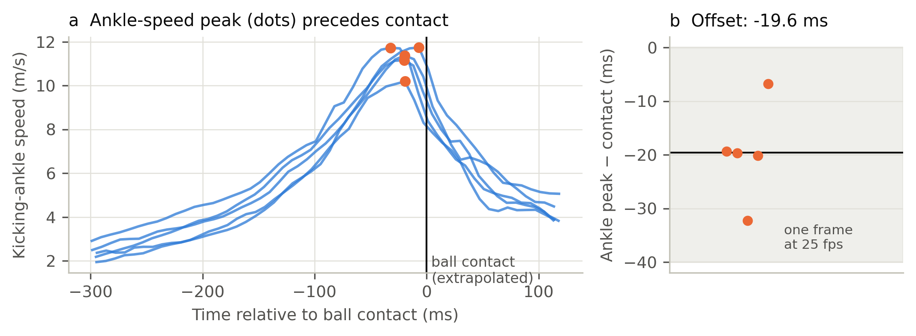
Figure S1. Ankle-speed peak versus true ball contact in the CMU ball kicks. (a) Kicking-ankle speed aligned to the extrapolated contact; dots mark the speed peak. (b) Offset of the peak relative to contact; the grey band is one frame at 25 fps.
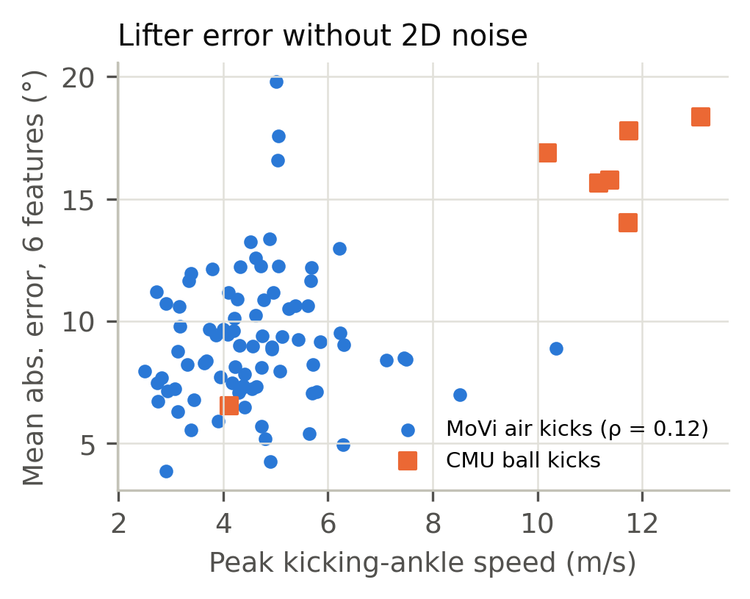
Figure S2. Lifter error without 2D noise (mean absolute error of the six features, all views and sizes, 25 fps) versus kick intensity (peak kicking-ankle speed). MoVi air kicks and CMU ball kicks.
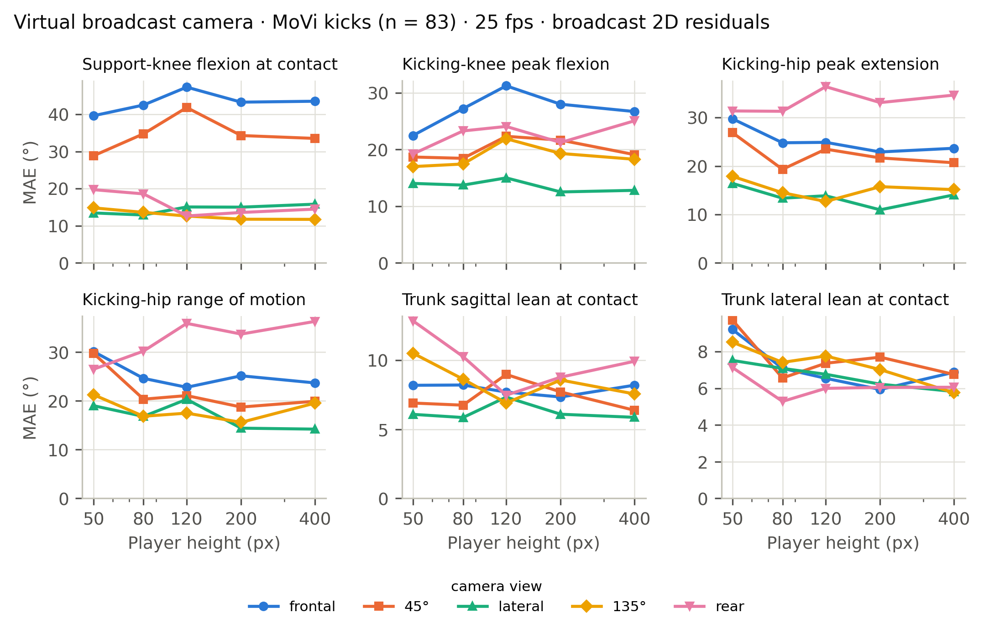
Figure S3. Virtual broadcast camera, MoVi kicks (n = 83), 25 fps, broadcast residuals, known contact: mean absolute error of each feature versus player height, by camera view.
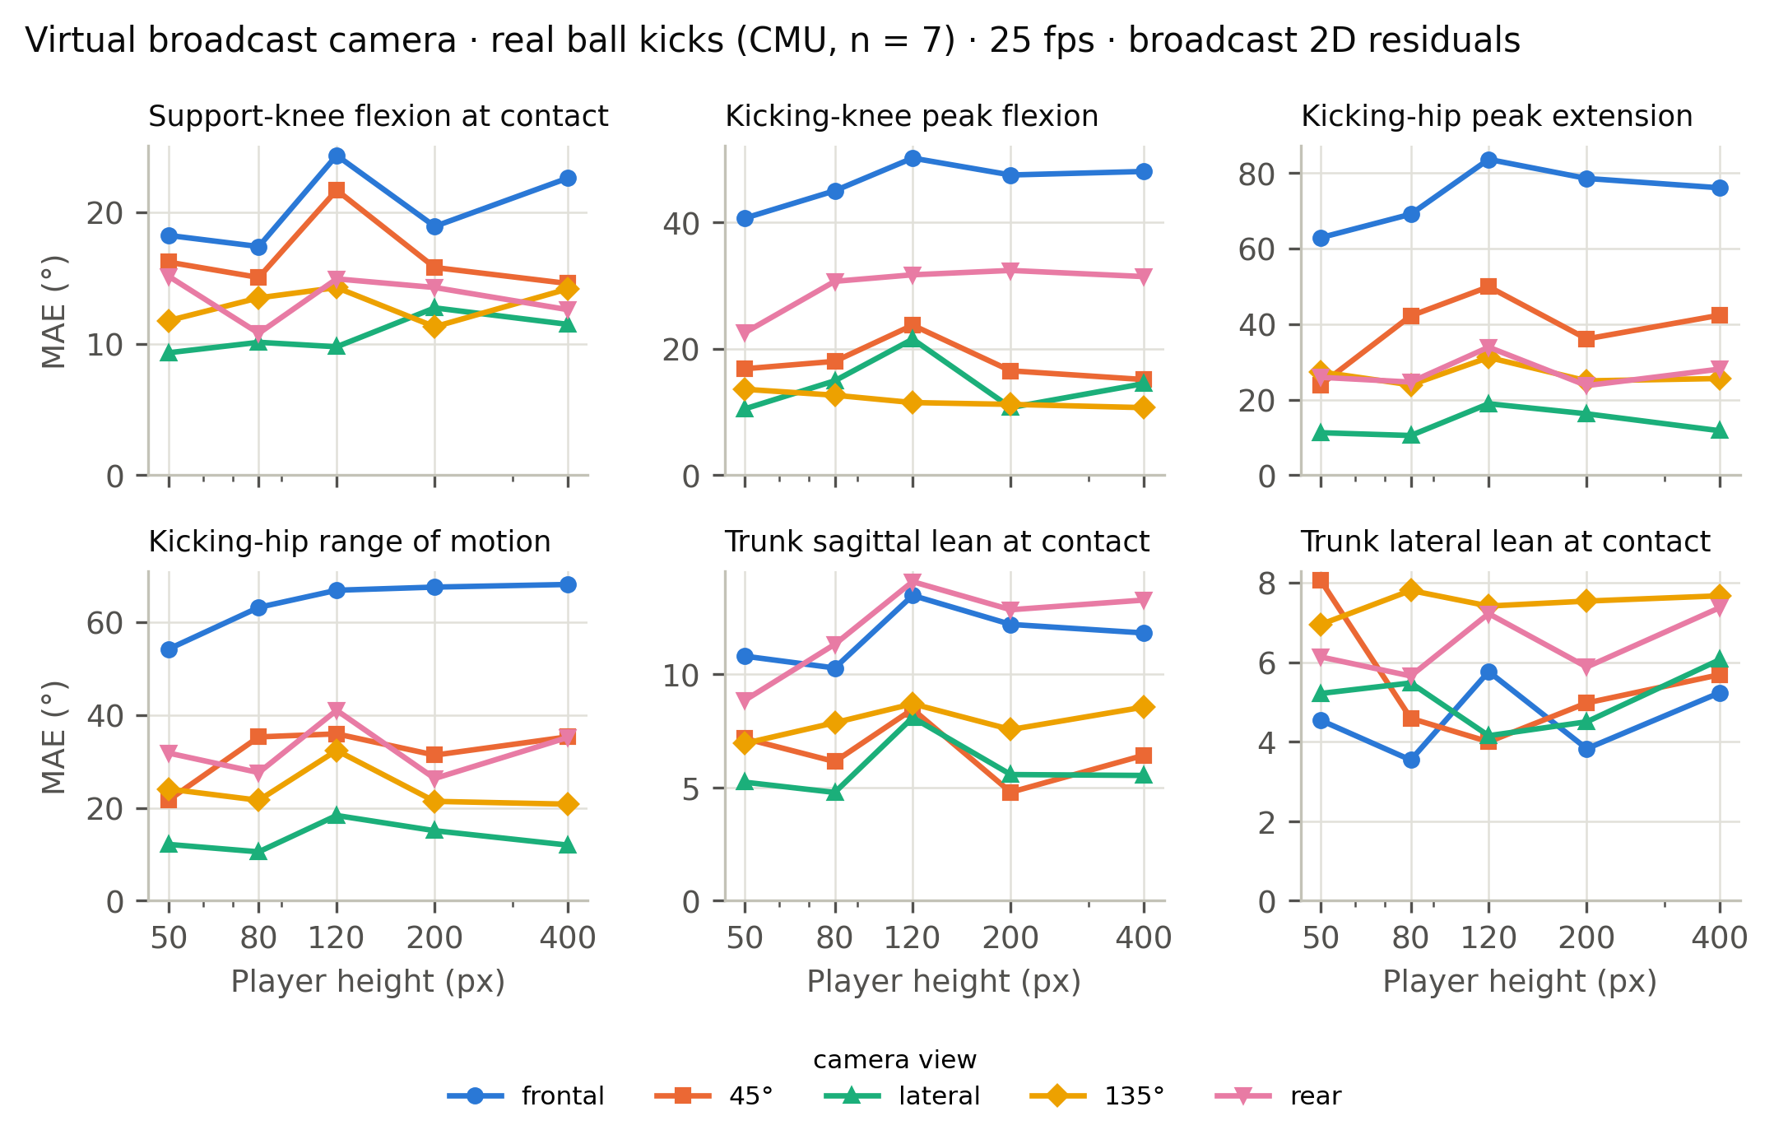
Figure S4. Virtual broadcast camera, real ball kicks (CMU, n = 7), 25 fps, broadcast residuals, known contact: mean absolute error of each feature versus player height, by camera view.
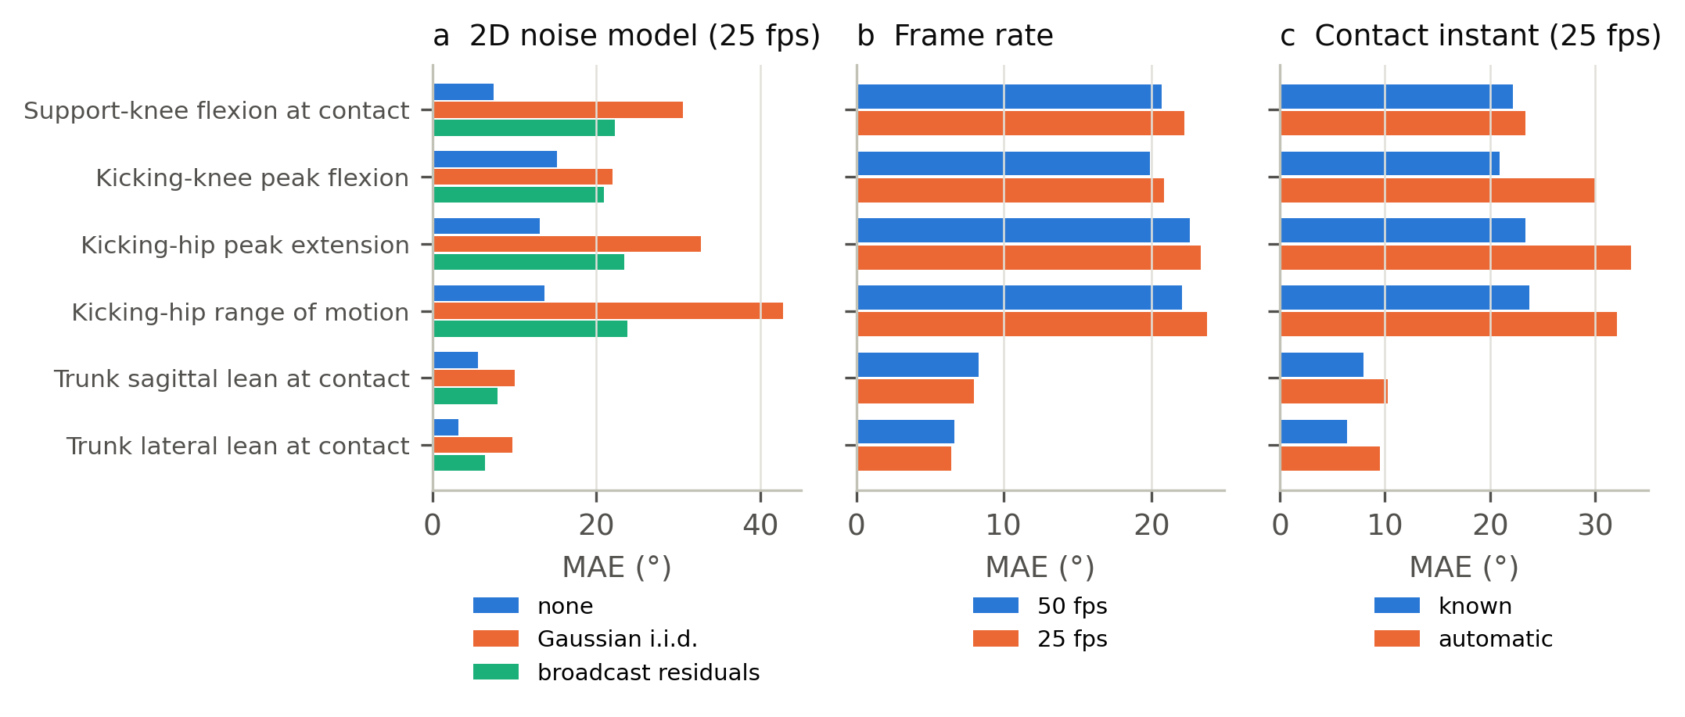
Figure S5. Effect of (a) the 2D error model, (b) the frame rate and (c) knowing the contact instant, at 80 px.
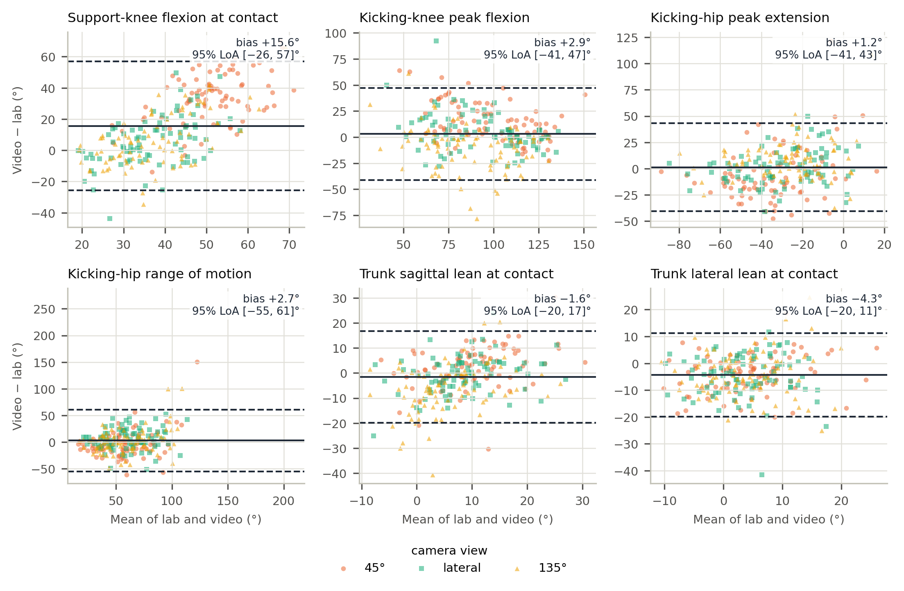
Figure S6. Bland–Altman plots of the six kinematic features in the typical broadcast condition (MoVi, n = 83; 80 px, 25 fps, broadcast residuals, known contact; replay views 45°, lateral and 135°). Solid line: bias; dashed lines: 95 % limits of agreement.
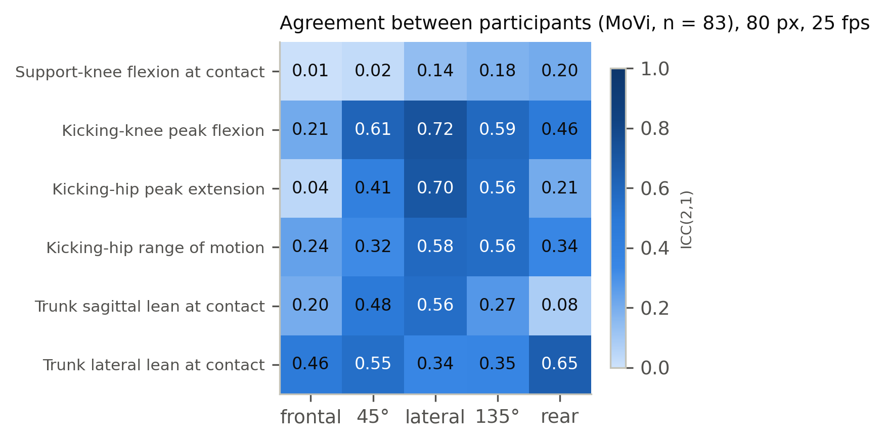
Figure S7. Between-player agreement, ICC(2,1), by feature and camera view (MoVi, 80 px, 25 fps, broadcast residuals, known contact).
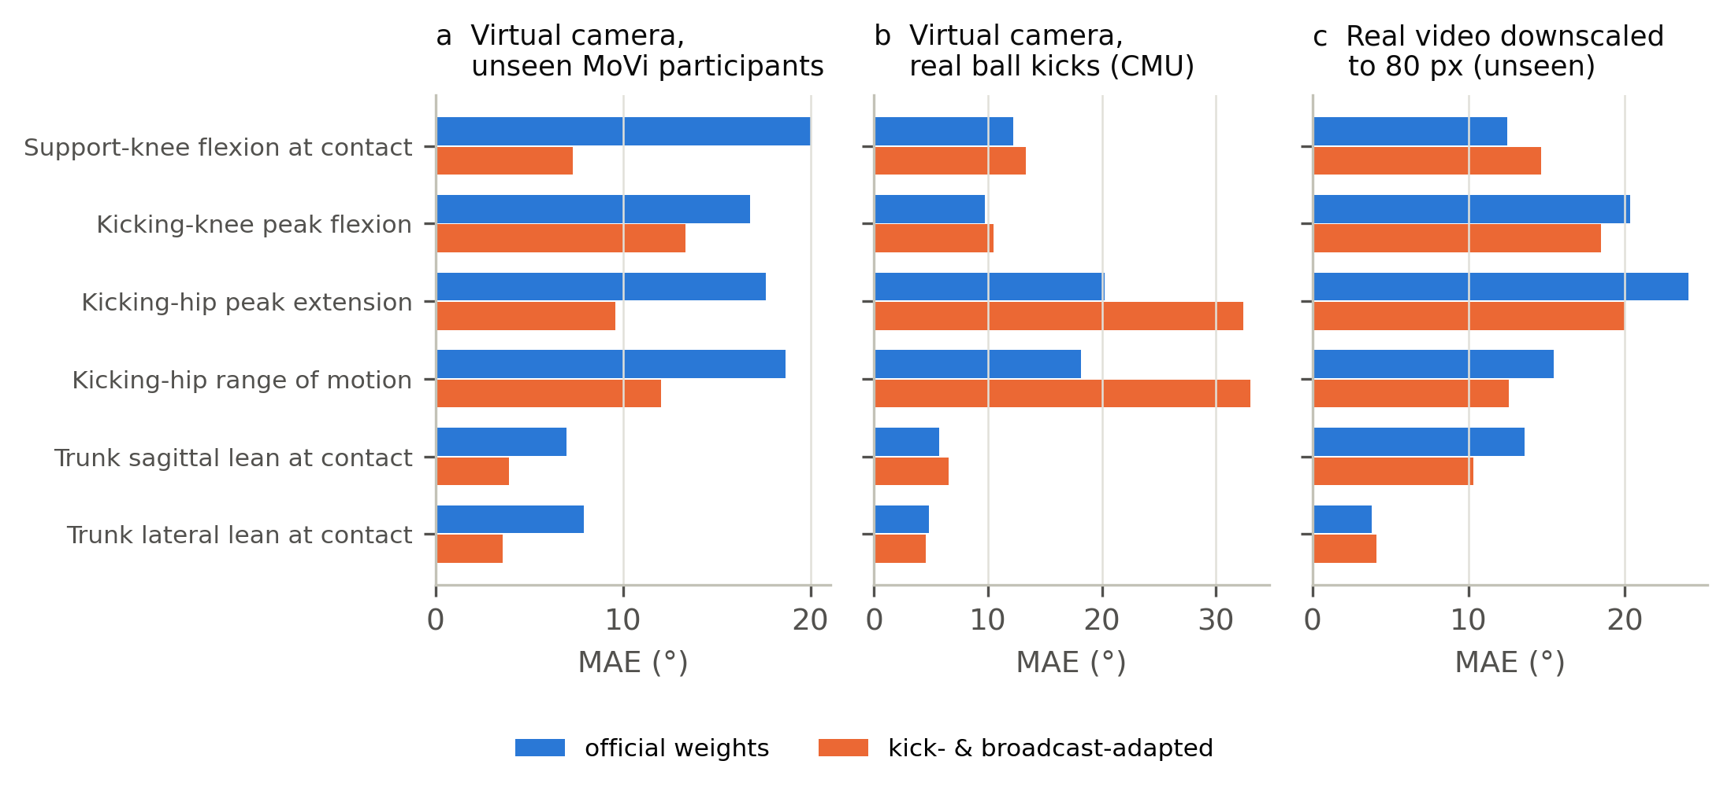
Figure S8. Official versus kick- and broadcast-adapted MotionAGFormer on (a) the virtual camera with unseen MoVi participants and held-out broadcast residuals, (b) the virtual camera with the CMU ball kicks, never used in training, and (c) real video downscaled to 80 px. Mean absolute error; 80 px, known contact.
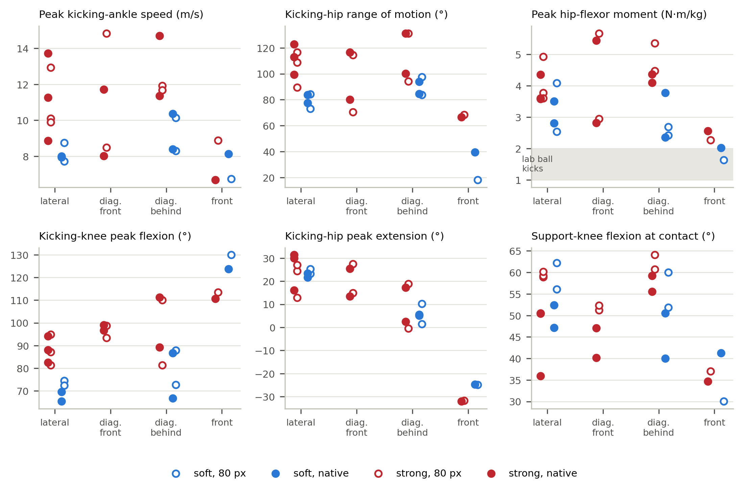
Figure S9. Field example by camera view: strong (red) and soft (blue) kicks at native resolution (filled) and with the player downscaled to 80 px (open). Grey band: peak hip-flexor moment of the laboratory ball kicks (CMU).
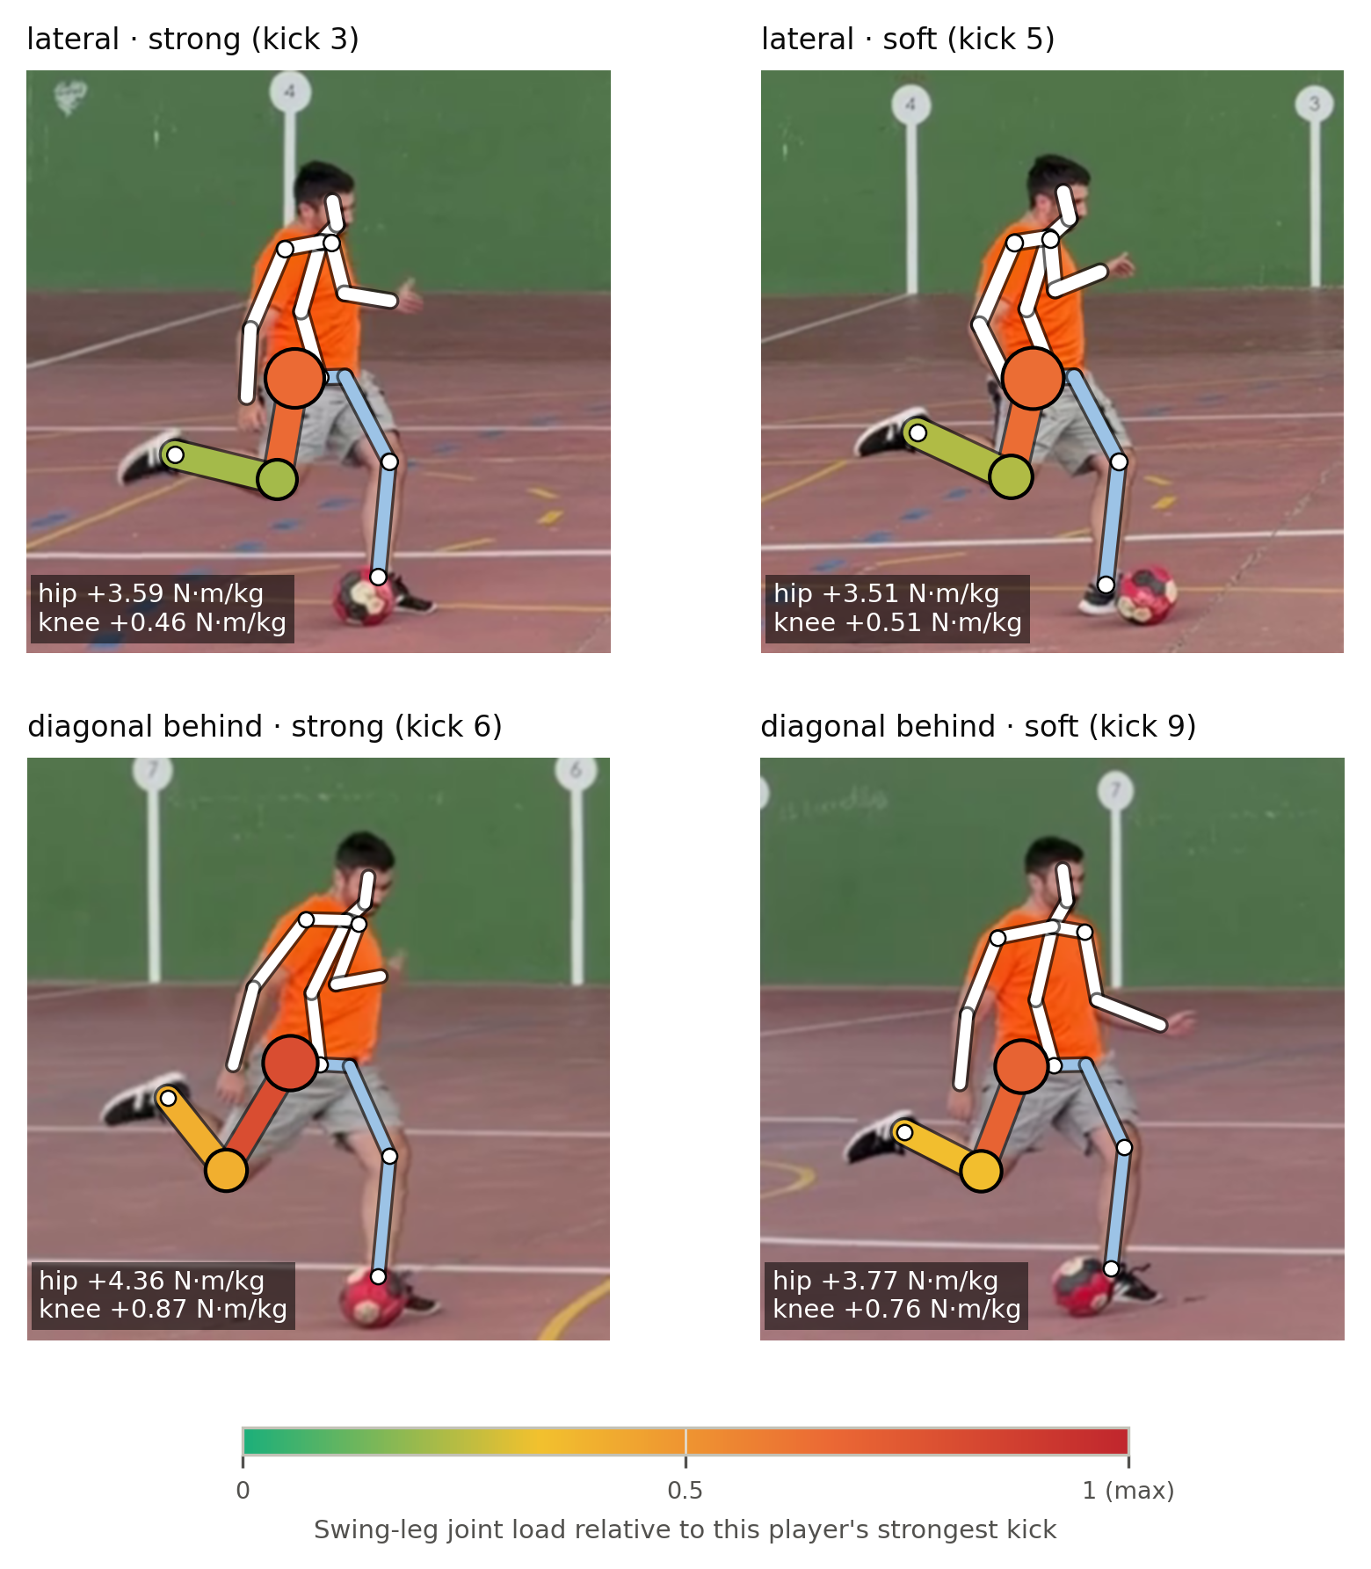
Figure S10. Field example: strong versus soft kicks at the instant of peak hip-flexor load, lateral and diagonal-behind views. Colours as in Figure 8a; boxes: estimated net hip and knee moments.

