Surveying the landscape of approaches to assessing societal benefits of Earth science information: a systematic map

Casey C. O’Hara (https://orcid.org/0000-0003-2968-7005)1*,

Mabel Baez-Schon2,

Rebecca Chaplin-Kramer2,

Samantha Cheng2,

Alejandra Echeverri (https://orcid.org/0000-0002-8821-0509)3,

Gillian Galford (https://orcid.org/0000-0003-2192-7385)4,5,

Rachelle K. Gould (https://orcid.org/0000-0002-6307-8783)4,5,

Cristina Mancilla1,

Maura Muldoon (https://orcid.org/0009-0007-8151-3164)4,5,

Gerald Singh (https://orcid.org/0000-0003-4333-1988)6,

Priscilla Baltezar7,

Yusuke Kuwayama8, (https://orcid.org/0000-0001-8933-9876)

Stephen Polasky (https://orcid.org/0000-0003-4934-2434)9,

Amanda D. Rodewald (https://orcid.org/0000-0002-6719-6306)10,

Richard P. Sharp (<https://orcid.org/0000-0002-9797-472X>)2 ,

Elizabeth Tennant (https://orcid.org/0000-0003-3858-9693)11,

Jiaying Zhao (https://orcid.org/0000-0003-0902-4343)12,

Benjamin S. Halpern1,13

**Short Title:** TBD

### Affiliations

1. National Center for Ecological Analysis and Synthesis, Santa Barbara CA 93101 USA
2. Global Science, World Wildlife Fund, Washington, DC, 10024 USA
3. Department of Environmental Science, Policy and Management. University of California, Berkeley, Berkeley CA, 94709
4. Rubenstein School of Environment and Natural Resources, University of Vermont, Burlington VT 05401, USA
5. Gund Institute for Environment, University of Vermont, Burlington VT 05401, USA
6. School of Environmental Studies, University of Victoria, VIctoria BC V8P 5C2 Canada
7. Massachusetts Institute of Technology Space Enabled Research Group, Cambridge MA 02139, USA
8. School of Public Policy, University of Maryland, Baltimore County, Baltimore MD 21250
9. Department of Applied Economics, University of Minnesota, St. Paul MN 55108
10. Cornell Lab of Ornithology and Department of Natural Resources and the Environment, Cornell University, Ithaca NY 14850
11. Dyson School of Applied Economics and Management, SC Johnson College of Business, Cornell University, Ithaca, NY 14853
12. Department of Psychology, Institute for Resources, Environment and Sustainability, University of British Columbia, Vancouver BC, Canada, V6Z 1T4
13. Bren School of Environmental Science & Management, UC Santa Barbara, Santa Barbara CA 93106 USA

**\*Correspondence to:** Casey O’Hara, ohara@nceas.ucsb.edu

**Keywords:** TBD

## This file includes:

* Main Text
* Figures 1-6
* References 1-63

# Abstract

Remotely sensed Earth science information (ESI) has become increasingly central to addressing global challenges, yet its societal value, i.e., the difference ESI makes in real-world decisions and outcomes, is rarely quantified. In this study, we systematically map peer-reviewed literature that explicitly assesses the societal value of ESI across instrumental, intrinsic, and relational value types. Drawing from 13,823 publications across Scopus, Web of Science, and a curated library of ESI valuation studies, we identify 170 studies that applied ESI in a decision context and used a valuation method to compare outcomes with and without ESI. The majority of these studies employed decision analysis methods such as Value of Information and Cost-Benefit Analysis, focusing primarily on quantitative instrumental values (e.g., profit, crop yield, lives saved), particularly in agricultural contexts. Studies that applied preference elicitation methods including stated preference, surveys, interviews, and focus groups were able to capture qualitative benefits and relational values including quality of life improvements, empowerment, and procedural justice. By highlighting the breadth of valuation methods that have been applied to date, we aim to expand our understanding of the societal benefits of ESI to help guide investment in future missions, enhance public support, and ensure that science and policy goals are well aligned.

# Significance statement

Earth science information (ESI) from satellites and other remote sensing technologies is critical for managing climate, agriculture, disasters, and more. Yet, the societal value of ESI, particularly how it improves real-world decisions and outcomes, remains poorly understood. We systematically map studies that quantify this value, revealing how different methods capture diverse benefits, from economic efficiency and lives saved to empowerment and justice. Our findings demonstrate that while most studies emphasize instrumental benefits, relational and intrinsic values are also recognized. This synthesis expands the evidence base for why ESI matters, helping guide future investments, promotes public support, and aligns Earth science with societal goals.

# Main Text:

## Introduction

In recent decades, remotely sensed information about the state of our planet has become increasingly vital for understanding and addressing global challenges such as climate change, water resource management, biodiversity conservation, sustainable development, and public health (4). Rapid technological progress has led to widespread availability of Earth science information (ESI), comprising global or regional datasets from remote sensing (e.g., satellite hyperspectral imagery, aerial drone photography, in-situ sensor networks) as well as models founded on such data (e.g., climate forecast models, famine early warning systems), at increasingly detailed and nearly continuous spatial and temporal coverage of the planet’s surface (WEF 2024). These advances in the availability and sophistication of ESI have accelerated its application across a wide range of decision contexts (5), supporting societal benefits as varied as impeding transmission of polio in Nigeria (Borowitz et al. 2023), protecting blue whales in the Eastern Pacific (6), improving targeting of cash transfers to poor villages in sub-Saharan Africa (7, 8), and empowering Indigenous communities to monitor deforestation (9). While the contribution of ESI to such societal benefits is undeniable, the magnitude of this contribution is rarely assessed. Yet if we don't understand the value of ESI, we risk producing information that is less valuable than it could be, or underinvesting in information essential for protecting or enhancing our quality of life.

The gap in valuation of ESI is due, in part, to the separation of Earth system science from social and decision sciences, and further compounded by a lack of information-valuation frameworks that integrate different value types (e.g., instrumental, intrinsic, relational). Understanding the breadth and magnitude of societal benefit of ESI, i.e., the value of practical application to society that goes beyond scientific merit (1), is important for guiding development of information that is actionable, meaningful , and credible for society’s needs, thereby justifying investment in future missions, garnering public support, fostering ESI uptake, and ensuring that science and policy goals are well aligned.

The mechanism by which ESI, indeed any information, generates value is through its ability to improve decision making toward socially desirable outcomes. It does this, by reducing uncertainty in the decision context, thus reducing the likelihood of making decisions that lead to unexpectedly undesirable outcomes. Economic frameworks to quantify the value of information typically calculate the difference in expected outcomes of a decision made in a world with the information and the decision made in a world without that information (e.g., REFS). Such value of information models have played a critical role in demonstrating ESI’s potential to improve societal outcomes with instrumental values (e.g., improving crop yields) (10; Laxminarayan and Macauley 2012). However, not all societal values can be so readily quantified in instrumental values, or a means to an end.

Inclusive and pluralistic value systems that go beyond instrumental value have long been a topic of discussion in conservation science and sustainable development (e.g., (11–14)). The Intergovernmental Science-Policy Platform on Biodiversity and Ecosystem Services (IPBES) Values Assessment (15), a multi-year effort by scores of experts in diverse forms of valuation, identified three categories of value that reflect the ways in which nature and ecosystems are important for people: instrumental (value as a means to satisfying specific human needs or interests), intrinsic (value independent of reference of people as valuers; inherent moral value), and relational (value deriving from meaningful, just, and reciprocal relationships with people and nature; toward living a “good life”) (16) (Table S1). While the IPBES assessment focused on value types and valuation methods in the context of nature, we can expand these considerations to examine values we hold for the information about our relationship with Earth systems (ESI) that can guide our decisions about how we manage that relationship.[WE NEED TO SAY HERE HOW WE WOULD INTERPRET THE THREE DEFINITIONS DIFFERENTLY AS RELATES TO INFORMATION.] Failing to capture potential gains related to non-instrumental values will greatly underestimate the contribution of ESI to societal benefits.

Conventional socioeconomic assessment approaches like value of information models are well-suited to measuring instrumental value, but these models are not sufficient for capturing the pluralistic ways in which ESI can contribute to intrinsic and relational values such as sustainability, justice, and human well-being (17). Other valuation methods can account for instrumental and non-instrumental values alike by eliciting individual and societal preferences for goods and services through quantitative, qualitative, and mixed-methods approaches (e.g., market price, stated/revealed preference, surveys, interviews, focus groups) (18). While these methods are commonly used for valuation of goods and services, they can also be leveraged to estimate the value of information in cases where they are used to account for the value of the differential outcome between a decision made with ESI relative to the decision made without, or can be used in other aggregative valuation techniques to weave together multiple value types (e.g., ____).

In this study, we ask four questions: 1) To what degree have various valuation methods been used to evaluate the societal value of ESI? 2) Which types of value(s) (instrumental, intrinsic, relational) do these methods capture, and how are these values articulated? 3) How are qualitative, quantitative, and mixed-method approaches distributed across sectors and decision contexts? And finally, 4) what opportunities exist to develop more inclusive, systematic, and interdisciplinary approaches to ESI valuation? Here we present a systematic map of peer-reviewed literature, based on literature databases plus an existing curated library of ESI valuation literature (Social Benefits Library, SBL, REF) (USGS 2024 !!!REF). Our literature search involved three facets: (1) Application of ESI, (2) within a decision context, (3) whose outcome translated into a societal benefit (See SI Methods and Fig. S1 for search string). The resulting citations were screened with assistance of machine learning tools to identify studies of a decision supported by ESI in whichvaluation involved a comparison to some other (non-ESI) information source. Through this systematic map of the peer-reviewed literature across a wide range of disciplines we clarify the current landscape of ESI valuation, identify methodological and disciplinary gaps, highlight emerging practices, and point toward a more pluralistic and actionable valuation framework. Understanding and improving the way we value information will promote investments in Earth observations that not only expand scientific understanding but also deliver equitable and measurable benefits across diverse communities and decision contexts.

## Results

### Screening Process

Application of the search string (see SI Methods and Fig. S1) to Scopus and Web of Science databases, combined with references from the SBL, yielded 28,331 results. Pre-screening eliminated conference abstracts, spurious matches, duplicates, and incomplete records, narrowing the corpus to13,823 unique citations ( Fig. 1, Fig. S2). The unique citations were screened according to the following criteria: 1) the study made substantive use of ESI; 2) ESI was applied in a decision context; 3) the predicted or realized outcome of an ESI-based decision was compared to that under an alternative information set; and 4) the difference in outcome was translated into some measure of societal benefit. Reviews were excluded as they do not present original data. Through a machine-learning assisted title and abstract screening process, trained on 1,072 documents reviewed by the team, 770 documents out of the 13,823 unique citations met the criteria and were included in full text screening. Full text reviews resulted in 170 documents that met all criteria (Fig. 2,Fig. S2).

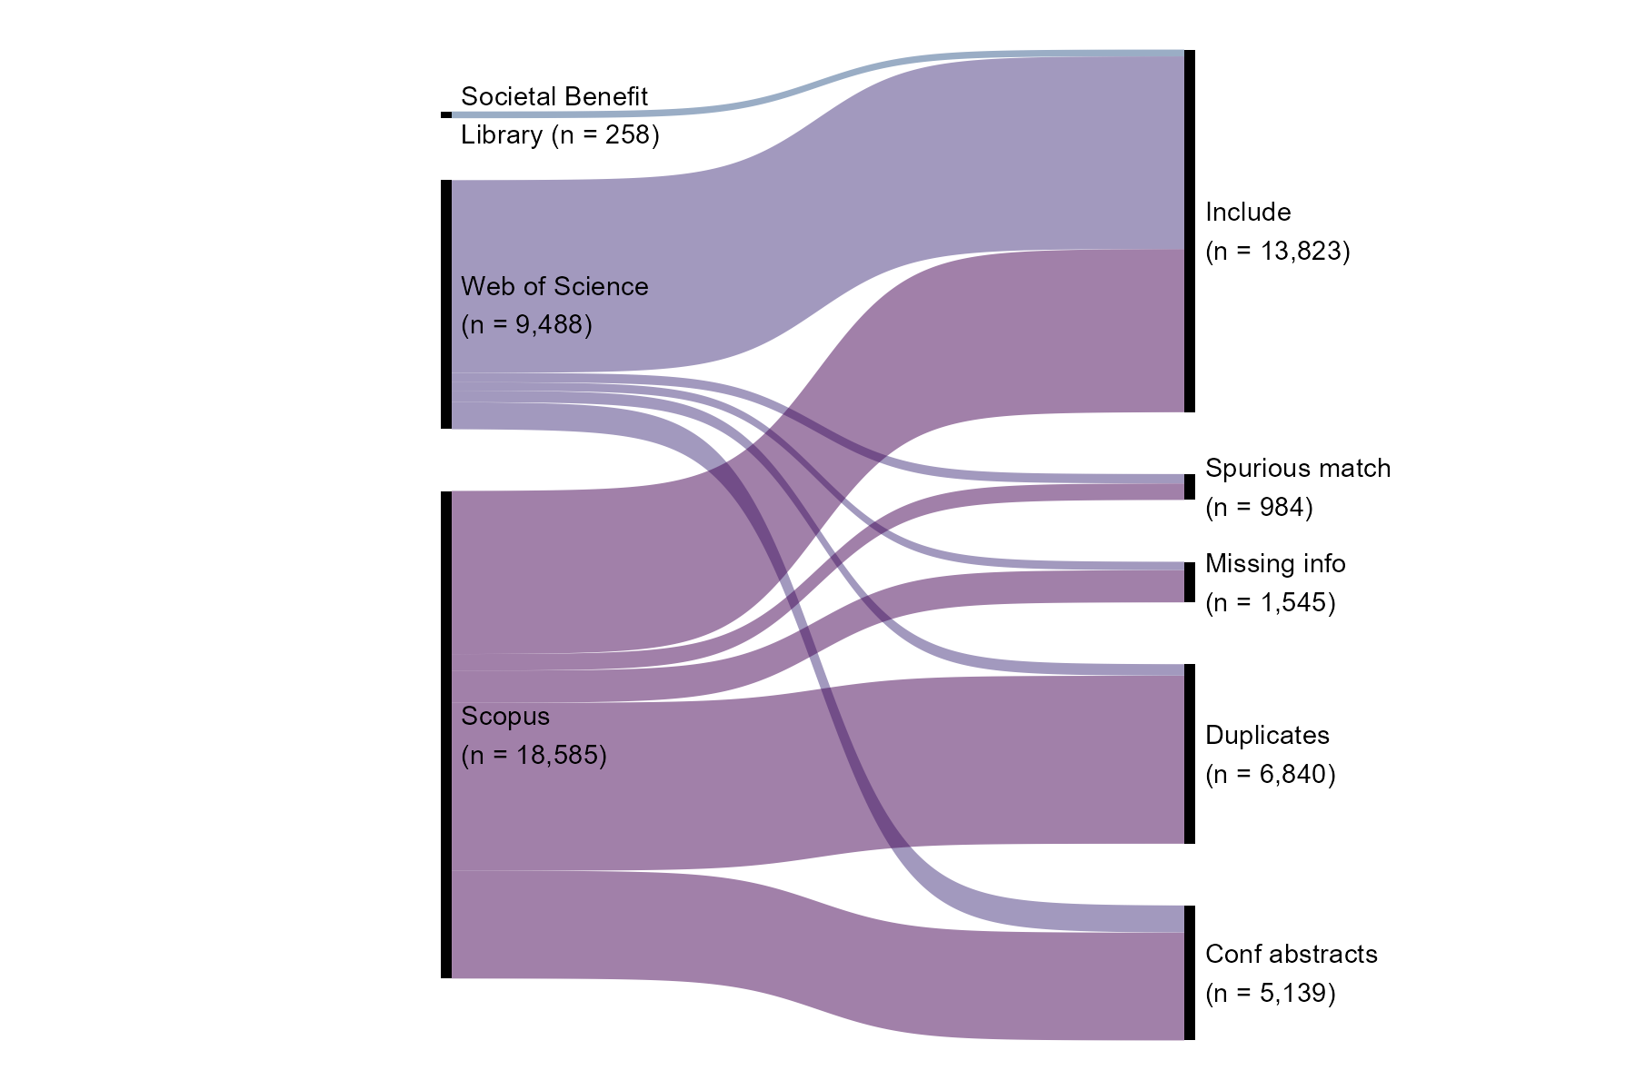

Figure 1. Citation retrieval and pre-screening results. Documents noted as “Include” proceeded to title/abstract screening stage (see Fig. 2)

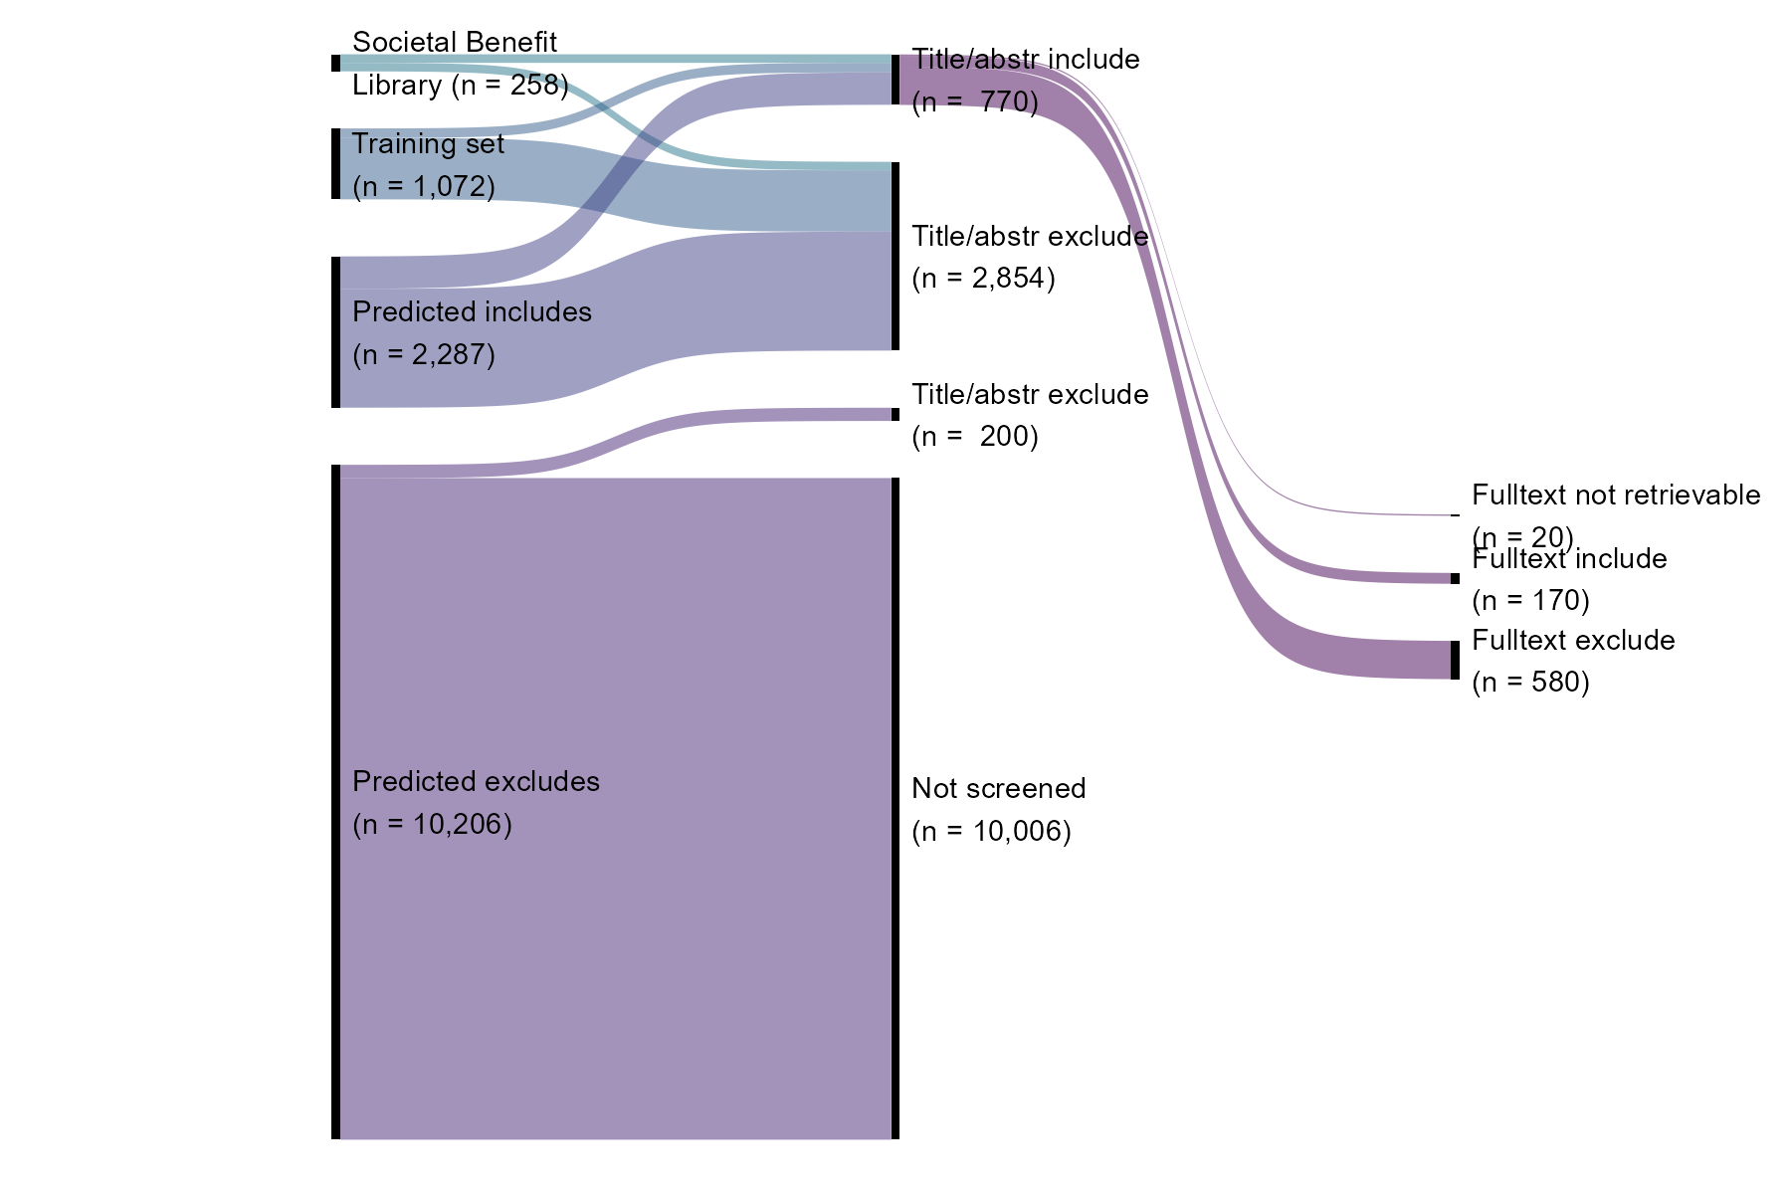

Figure 2. Citation screening and full text screening results. Following pre-screening (Fig. 1), the n = 13,823 documents were considered for inclusion or exclusion based on title and abstract. Title/abstract screening was performed in the Colandr web-based machine-learning assisted screening app. Full text screening was performed using Zotero reference management software.

### Valuation Methods

Nearly a third (54 studies) of the 170 included documents utilized more than one valuation method, with a total of 224 instances of valuation methods being applied (Fig. 3; see Table S2 for operational definitions used to categorize valuation methods). Assessing societal benefits of ESI are most commonly quantitative economic approaches: Value of Information (VOI) methods (n = 81; 48% of papers) and Cost-Benefit Analysis (CBA) (n = 33; 19%) (Fig. 3;). Applied qualitative or subjective methods were also frequently observed, including surveys of preference assessments (n = 26; 15%) and semi-structured or in-depth interviews (n = 23; 14%). Deliberative and consensus-based approaches were rare (n = 3 and 1 studies, respectively). Methods based on decision analysis (n = 144) were more frequently observed than methods based on preference elicitation (n = 80)

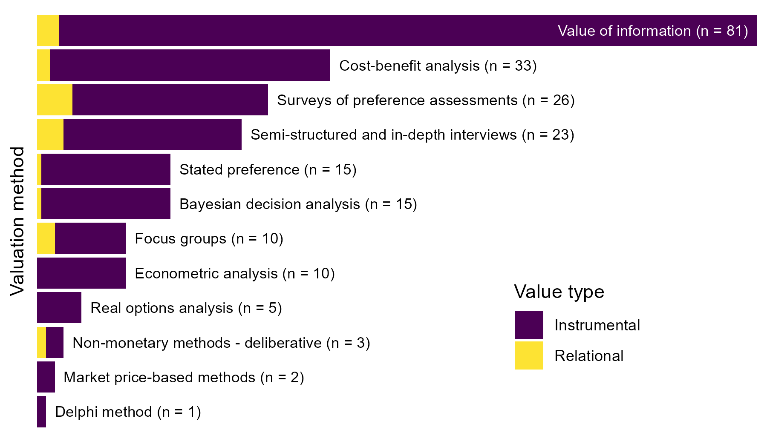

Figure 3. Number of valuation methods observed across included studies. Some studies applied multiple methods for valuation, thus the total number of observed methods (224) exceeds the total number of included studies (170). Color indicates value types assessed: instrumental, i.e., means to an end, and relational, i.e., deriving from meaningful and often reciprocal relationships among people, nature, and society (see Table S1).

All method types most commonly measured the instrumental values associated with societal benefits (e.g., improved profit, pollution reduction, lives saved) (n = 209), often accounting for multiple instrumental metrics simultaneously (e.g., reduced crop pesticide application and the associated increase in profit; see Table S1 for definitions and examples). Methods that measured relational values associated with societal benefits (e.g., poverty alleviation, social justice, knowledge transfer among community, Table S1) were far less common (n = 15) and were studied more frequently using qualitative preference elicitation methods, especially surveys, interviews, and focus groups. Relational values were rarely the sole focus of an assessment, more typically examined alongside instrumental values; for example, recreational fishing both as a pastime and as an economic activity (19). No studies in our resulting corpus evaluated ESI outcomes in terms of intrinsic value.

The most commonly combined methods were decision-analytic methods, [INSERT BRIEF DEFINITION OF WHAT IS MEANT BY THIS TERM], particularly VOI with CBA (n = 12 studies of 54 combining methods) (Fig. 4). For example, Fritz et al. (2) apply the counterfactual framework of VOI to estimate benefit, then model marginal cost based on CBA to construct their benefit chain model for valuing ESI from hypothetical satellite remote sensing data. Another common pairing combined qualitative preference elicitation methods of individual interviews and focus groups (n = 8). For example, Roberts et al. (20) used focus groups/workshops to qualitatively predict the value of weather forecast information for avoiding storm-related drownings in Lake Victoria, then after implementation of a severe weather warning system, followed with user interviews to quantify the realized benefits in lives saved. Of the remaining 34 multiple-method studies, 14 combined VOI with some other method (beyond CBA) and 16 combined surveys with some other method (beyond VOI). Paired quantitative methods were more common (n = 26) than paired qualitative (n = 16) and mixed methods (n = 12). Most of the mixed methods studies combined surveys with some quantitative method (n = 8).

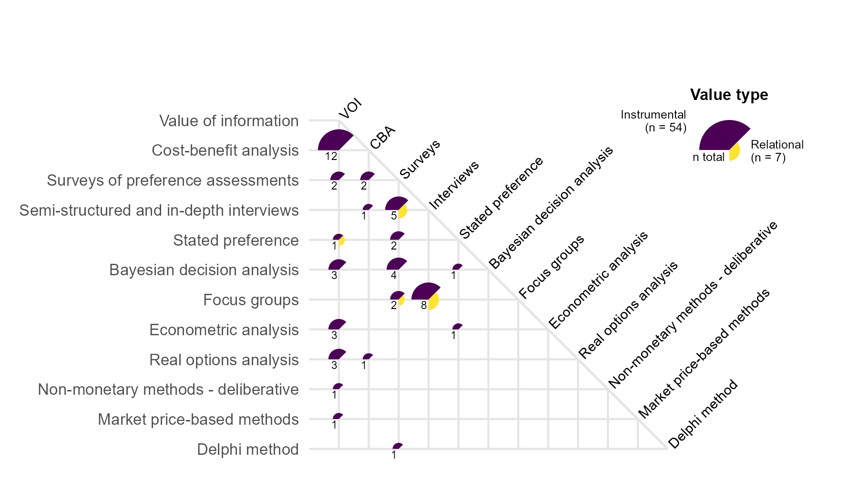

Figure 4. Number of papers applying multiple approaches to valuing ESI. The quadrants and colors at each intersection indicate which value types were examined; the size of the quadrants indicate how many papers examined that value type. The number in the bottom left quadrant indicates the total number of papers that implemented the combination of methods. The majority of papers did not use a combination of methods.

### Societal Benefit Domains

Across the 170 included studies we observed societal benefits in 215 specific decision contexts (i.e., 45 studies examined societal benefits in multiple contexts across 8 general decision context areas, based on existing classes from GEOSS Societal Benefit Areas and NASA Applied Sciences themes (REFS), shown in Fig. 5). Studies largely focused on the societal benefits of ESI within agriculture, including fisheries and forestry (n = 78, 46% of studies). A smaller but still substantial number of studies examined benefits across climate (n = 25, 15%), water resources (n = 22, 13%), and ecological conservation (n = 22, 13%) (Fig. 5). A comparable number included multiple contexts (n = 27, 16%), with the most common combination being agricultural impacts alongside water resources (n = 10), climate (n = 8), ecological conservation (n = 4), and capacity building (n = 4) (Fig. 6). Four studies examined capacity building across various contexts, involving training and supporting groups of stakeholders with diverse roles within their communities, e.g., participatory mapping projects in Nepal (23) and Tanzania (24). Societal benefits were least frequently examined in the contexts of disaster response (n = 9, 5%), health and air quality (n = 8, 5%), and wildfires (n = 6, 4%). Two studies focused on ESI benefits in other areas: one for monitoring pavement infrastructure (21), and one for assessing preferences for living and recreating in disturbed landscapes (22).

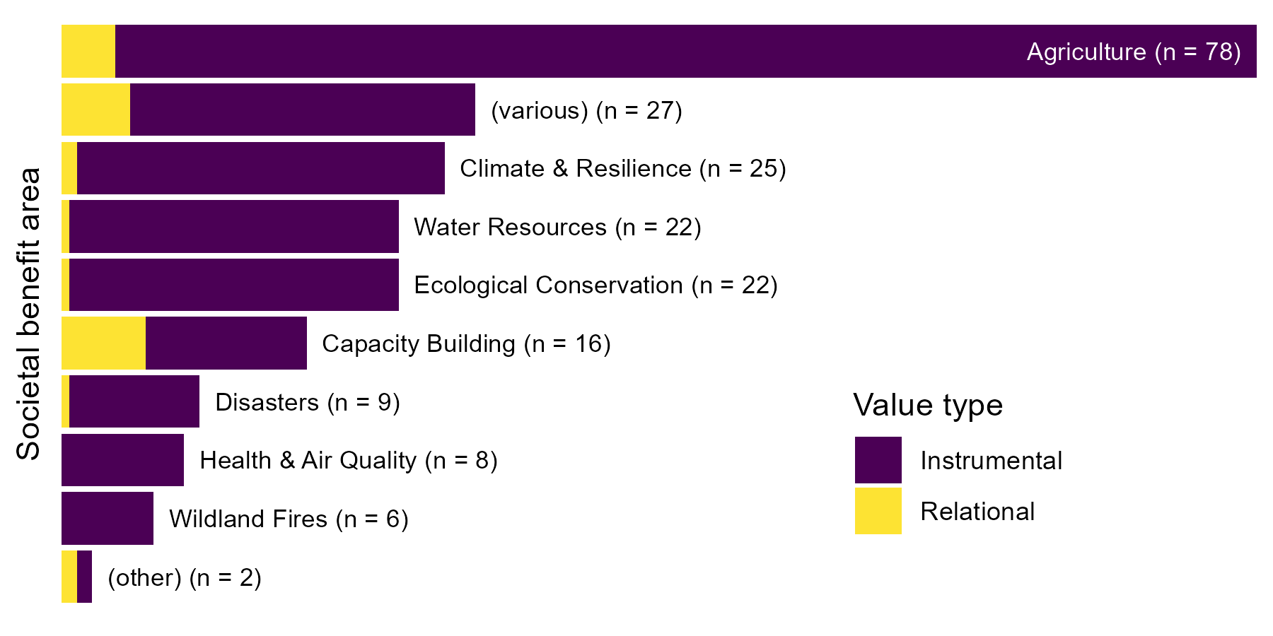

Figure 5. Number of studies investigating value of information in different general decision context areas . Some studies examined more than one general decision context, thus the total number of specific contexts (215) exceeds the total number of included studies (170). The label “(various)” indicates studies where three or more decision context areas were discussed; “(other)” indicates studies where the societal benefit did not fit into any of these categories. Color indicates value types used to assess societal benefits: instrumental, i.e., means to an end, and relational, i.e., deriving from meaningful and often reciprocal relationships among people, nature, and society (see Table S1). No intrinsic values were found.

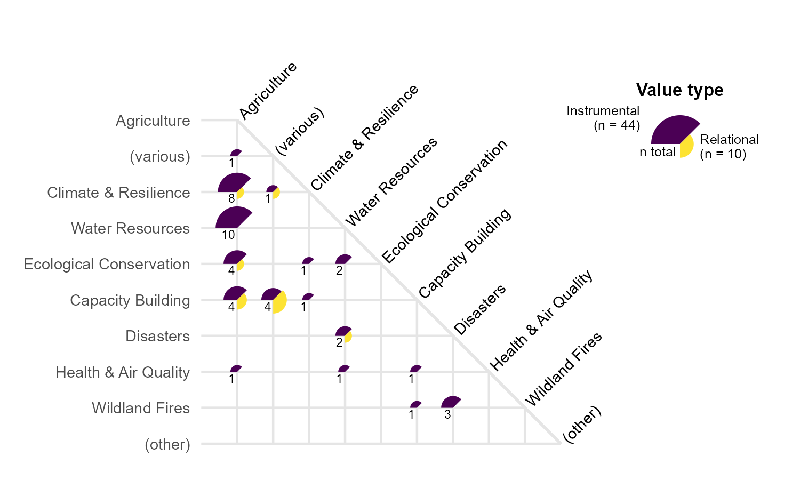

Figure 6. Number of papers valuing ESI in multiple contexts. The quadrants and colors at each intersection indicate which value types were examined; the size of the quadrants indicate how many papers examined that value type. The number in the bottom left quadrant indicates the total number of papers involving that pair of contexts.

## Discussion

We found very few examples of evaluations of the societal benefit of ESI applied in decision-support contextsit, despite a broad, inclusive search for research on diverse methods for valuing earth observation information, t. Such a low inclusion rate (1.2%) is to be expected, as our inclusion criteria are specific to methods of valuing information and data, but our search string was intentionally designed to be inclusive to maximize opportunities to find edge cases in the literature. The paucity of research directly addressing the value of ESI suggests a strong need to better understand and address how ESIis or can be used to generate societal benefits.

The challenge of valuing information, as opposed to valuing goods or services, lies in identifying a relevant counterfactual information set as the basis of comparison. Here, we focused only on valuation methods that were used in a manner that was responsive to the ESI in a decision context. In many of the publications we identified, multiple valuation methods were used in sequence to first identify the difference in outcome based on the inclusion of ESI, and then to translate that difference in outcome to some other metric, usually monetary. The first step is clearly dependent upon the availability of the ESI in question; the second step may or may not be, depending on the assumptions of a given study. For example, Späti et al. (25) modeled the effect of variable-rate nitrogen application on crop yield for small-scale farmers based on several spatial resolutions of ESI data; they then valued the increased yield and reduced nitrogen made possible through the improved resolution into economic terms (Swiss francs) using market prices. However, the nitrogen and crop prices were treated as independent of the ESI - a reasonable assumption for a small-scale farmer trading commodities within a global market - and thus this second valuation step was effectively a unit conversion, and not germane to our study. Conversely, Adams et al. (26) modeled the benefits of an El Niño early warning system for agriculture across five Mexican states, accounting for alternative cropping decisions to optimize yield in the face of seasonal predictions, then translated the resulting crop yield into economic terms using modeled market prices. In this case, the market model accounted for changes in price due to ESI-driven changes in supply, and therefore this second valuation step was considered relevant for our study.

We found that VOI methods dominate the current literature evaluating the societal benefits for ESI for decision support (Fig. 3). VOI is a well established and intuitive method, and Macaulay (10) described a framework for applying VOI to ESI contexts that continues to influence recent research initiatives (e.g.,(27)). VOI methods are very well suited to situations where a reduction in uncertainty, based on an improved information set, can be expected to drive a clear and measurable improvement in decision outcomes. This is especially the case where costs of a mistake are high, where benefits can be expressed as objective quantities (typically instrumental value), and where the outcome is highly responsive to the set of actions that can be taken. For these reasons, VOI is particularly suited to agricultural contexts, where an improved seasonal forecast can improve farmers’ decisions about crop choices and crop management to maximize yield and profit in the face of uncertainty; this is reflected in the high rates of VOI use in agricultural studies.

CBA is the second most prevalent method identified (Fig. 3), a well established and reasonably intuitive manner of estimating the net present value of a particular investment decision over an extended time frame generally with an implicit counterfactual. In an information context, this could be considered as the expected net benefit of investment in the infrastructure required to generate ESI, such as satellite instruments, and/or investment in technologies and labor to process ESI. In many CBA studies, a VOI method is implemented to estimate the benefits of ESI, while the costs of ESI are drawn from actual or projected budgets for producing the ESI. Using CBA in valuation of ESI is most commonly observed in agriculture and conservation contexts, and, like VOI, is focused primarily on instrumental value due to its traditionally monetary nature.

Valuation methods based on decision analysis necessarily focus on decision outcomes that can be quantified. However, many decision outcomes valued by individuals and society are impossible to objectively quantify and/or can be qualitatively valued across multiple, potentially incommensurable, value types. Preference elicitation methods can readily account for qualitative and subjective benefits related to ESI-based decision outcomes in instrumental and non-instrumental terms. For example, Altamirano et al. (22) surveyed people’s preferences for visiting, living, scenic beauty, and well being across gradients of landscape disturbance, comparing perceptions based on eye-level and aerial photos. Colloredo-Mansfeld et al. (28), using participatory mapping and in-depth interviews, found that farmers given access to UAV photography perceived their land with a greater sense of scale and interconnectedness.

In addition to eliciting qualitative and subjective outcomes, preference elicitation methods can provide insights into benefits related to the decision process itself. We found three example studies that illustrate this. Eilola et al. (24) used interviews and focus groups to study how participatory mapping using ESI improved practitioners’ perceptions of work quality, professional competence, participation, and spatial understanding. Gonzalez and Kroger (9) used focus groups and interviews to examine how training in and adoption of remote observation technology improved empowerment and agency of Indigenous people in protecting their land from illegal deforestation. Styers (29) surveyed her undergraduate students to gauge how the incorporation of satellite data into her courses improved student engagement, curiosity, collaborative skills, and learning outcomes. In these cases and others, ESI use addresses issues of saliency and legitimacy of decision making processes (30), providing value independent of outcome.

A few studies bridged the divide between decision-analytic methods and preference-elicitation methods. In several interrelated studies, Bouma et al. (31–34) applied Bayesian decision analysis to quantify societal benefits of ESI for managing water quality, but leveraged surveys of experts to elicit prior beliefs and expectations of accuracy of the ESI to parameterize the Bayesian analysis. Flipping that script, Luseno et al. (35) used a conceptual Bayesian framework to guide the design of surveys and interviews of pastoralists in Ethiopia and Kenya to understand their preferences around ESI-derived climate forecasts, including the pastoralists’ prior beliefs based on traditional forecasting methods, trust in ESI forecast skill, and likelihood of using the ESI-based forecasts.

The scientific, political, and commercial structures governing ESI - especially whether datasets are publicly accessible or proprietary, freely available or commercial - in part determine who is likely to benefit from their societal value (36). Clearly, making ESI data freely available enhances the ability to generate societal benefits; for example, citations and downloads for Landsat data surged following the shift from a paid service to a free and open data policy in 2008, ultimately stimulating billions of dollars in scientific and societal benefits (5, 37). Alvarez León and Gleason (38) analyze how varying property rights can reinforce or challenge assumptions of scientific objectivity and ultimately users’ ability to translate ESI into scientific and societal value. Recent data from the European Space Agency (ESA)’s SPOT (Satellite Pour l’Observation de la Terre) mission is commercially available, and users can request that the sensor can be directed to capture imagery of particular regions of commercial interest. As a result, historical SPOT data (through 2015), while freely available through various portals, are skewed toward scenes that were valuable to commercial users at the time of capture. In contrast, Landsat data of USGS are freely and openly available, with a fixed collection path, although historical data may not be comprehensive in all regions of the world due to archives affected by physical function of data downlink nodes and historical agreements in data sharing (38).

Even freely and openly available satellite data come with barriers to technical expertise and capacity that pose significant hurdles to use for many practitioners (39), and poor integration with ground-based and local knowledge hampers development of machine learning algorithms to translate remote sensing imagery into actionable information (40–42). Capacity building can help local communities and Indigenous peoples access and incorporate ESI to co-produce knowledge across contexts including conservation (e.g., (43)), deforestation (e.g., (9)), marine resource management (e.g., (44, 45), and resilience to climate change (35, 46). Such collaborations can reduce power asymmetries and increase agency and self-governance of communities as they seek to address challenges facing indigenous landscapes and territories (9, 46); however, they can also result in internal power divisions between tech adopters and non-adopters, and potentially result in shifts in or loss of cultural values (9).

While most of the reviewed studies identify positive societal benefits due to ESI, the trade-off between information and privacy becomes increasingly relevant as advancements in the quality and quantity of remote sensing data accelerate the ability to identify and monitor objects and people on the ground. In general, remote sensing allows the observer to shift information asymmetry between the observer and the observed, in favor of the observer. Brennan and Macauley (47) describe several important use cases that determine whether the shift in information asymmetry is potentially beneficial or detrimental to society, based on whether the observer and the observed are state actors or private actors (corporations, groups, individuals) and whether the relationship between observer and observed is adversarial or cooperative. The ability of state actors to monitor and enforce compliance with conservation policy, emissions targets, and peace treaties certainly produce societal benefits by enabling cooperation (Furumo & Lambin, 2021); monitoring also holds promise for reducing international conflict (48), supporting human rights (49), and responding to genocide (50). To the extent that an open, transparent government whose laws and regulations reflect the will of the governed, these information asymmetries may actually promote societal benefits, e.g., reduced crime or pollution (47). However, the risks of abuse loom large, creating a clear tradeoff between the increasing capabilities of remote sensing technology and the privacy rights of the individual.

While most of the papers excluded from our target corpus either did not apply ESI data (e.g., spurious matches that were missed during our preliminary screening), or applied ESI data to calculate some other outcome (e.g., using land cover classification data to estimate ecosystem service value, but no further examination of the value of the ESI itself), two categories of excluded papers merit further consideration. These two categories of studies offer clear opportunities for those interested in evaluating the societal benefits of ESI.

First, a number of papers explicitly used cost-benefit analysis to demonstrate that an ESI data set could achieve equal or near-equal performance for a decision context but with less cost (e.g., reduced costs of labor or equipment relative to on-the-ground research) (e.g., (51)). We did not include these in our final corpus, reasoning that if the information itself is essentially identical between the ESI and non-ESI alternative, any outcome of a given decision would necessarily be identical, and therefore no additional marginal societal benefit would result from use of the ESI. We acknowledge that in resource-constrained settings, government or NGO cost savings can closely translate into improved societal outcomes (e.g., lowering taxes on lower income people, or increasing budgets for social safety nets), but these second-order benefits were not explicitly examined in any of the papers we screened. While these excluded studies focused on a one-time analysis, reduced costs of labor and/or equipment imply the potential for increased frequency of measurement, which would prove valuable for certain types of decision contexts that involve rapidly changing phenomena, e.g., disaster response or wildfire management. We included several studies that explicitly valued the benefits of higher spatial resolution, though we encountered no studies that explicitly accounted for the value of higher temporal resolution. This suggests an opportunity for future valuation studies, especially in light of trends toward increasingly fine temporal resolution of accessible satellite data.

Second, a larger subset of excluded papers compared the ability of ESI to accurately predict on-the-ground phenomena measured by some other means. For example, Marino (2023) examined the potential for Sentinel-2 time series imagery to delineate subfields of sunflower crops and found that the image-based vegetation index provided a good proxy for ground-measured crop status; however, the implications for harvest decisions and resulting societal benefit were not explored. Similarly, Andrada et al. (2023) demonstrated the efficacy of a drone-based LiDAR system for rapidly and accurately mapping potential wildfire fuel for forest management, but the authors did not quantify the societal benefit from this valuable scientific information. Such validation studies typically report accuracy scores, e.g., RMSE or AUC, often demonstrating the superiority of a particular ESI dataset or algorithm over the alternative approach. Importantly, while these studies presented results in terms of scientific value, they did not examine how the improved scientific knowledge would affect the decisions that generate societal benefits - though most included conceptual descriptions of potential decisions or societal value in their conclusions. With often minor additional information or simple economic modeling, many calibration/validation studies could readily translate the improved scientific accuracy of an ESI dataset relative into a hypothetical or realized decision that could be translated into calculable societal benefits.

Our wide-ranging search string resulted in a large corpus of studies identified as potential candidates for inclusion, but recent developments in machine learning (ML) have made such a large screening process much more feasible. We implemented two distinct ML algorithms in our screening process. First, we used the Colandr ML-assisted web-based screening tool (52) to perform all title and abstract screening. As a user screens documents and codes them as “include” or “exclude,” Colandr develops a predictive model and iteratively sorts the remaining unscreened documents, presenting the user with the most likely relevant documents early. As fewer and fewer relevant documents are identified, and the inclusion rate approaches zero, the user can opt to establish an early-stopping rule as the remainder of the corpus is deemed increasingly irrelevant. Importantly, Colandr does not decide the disposition of a document - the user is intentionally involved throughout and ultimately makes the decision (52). Second, we generated a training set based on a subset of the full corpus and used this to train an ML algorithm to predict the inclusion/exclusion status of the remaining corpus, identifying nearly 80% of the corpus as likely “excludes.” Because this ML process is recommending the disposition of documents, a low false negative rate (low chance of excluding a relevant document) is critical, though false positives are less problematic as they are subject to additional human screening. Because our systematic map focused not on study questions or results, typically foregrounded in the title and abstract, but rather on methods, which are often described only vaguely if at all in the abstract, it was difficult to tune the ML model to reduce the false positive rate, but for studies focused on top-line results typically described in the title and abstract, such ML methods would likely be far more discerning. Increasingly sophisticated ML algorithms and AI tools such as Elicit, OpenAI Deep Research, and SciSpace Deep Review will almost certainly accelerate rapid systematic evidence synthesis, though the threat of a flood of AI-generated fraudulent literature may require a sea change in how such reviews are conducted (53).

*While our literature search presented here is quite broad, we acknowledge that it is not necessarily comprehensive. Our search was limited primarily to two databases of academic peer-reviewed literature (Scopus and Web of Science), and while some grey literature was contained in the Societal Benefits Library, we did not systematically include other grey literature sources in our search.* Of the 770 documents identified as candidates for full-text screening, 10 were not retrievable, and 20 more were excluded as not in English; while exclusion of non-English sources could potentially lead to bias, this subset is a tiny fraction of the retrieved papers (2.6%) so omitting these studies is unlikely to substantially affect our results. We note that many ESI applications may rely on highly derived, modeled, or processed data, such that remote-sensing terms (e.g., “satellite”) or the name of the initial sensor (e.g., “Landsat”) do not appear in the title, abstract, or keywords, which may limit the citations in our corpus; however, generalizing the search by excluding the ESI terms from the search string would have made the search impossibly large.

## Conclusion

As technological and capacity advance to increase cost-effectiveness , data storage and processing, and human capacity, ESI may further proliferate in decision support contexts. For example, Canada’s WildfireSat constellation of mission-specific microsatellites, slated to launch in 2029, will image the entirety of Canada in near real time to inform wildfire management, potentially saving billions of dollars in avoided damages as wildfire regimes become increasingly extreme (55). Examining the societal benefits of Earth observation is important to justify existing and future investment (10), promote diffusion of use and applications (56), and identify gaps and priorities for future applications and missions (57, 58). Methods exist to evaluate ESI contributions across societal benefit areas and value types. However, even as the use of ESI data has grown to encompass a wide range of applications across the globe (56), published peer reviewed studies that attempt to qualitatively or quantitatively assess these contributions remain rare.

Our literature review revealed a large subset of research that demonstrated the scientific value of particular ESI datasets and models but did not proceed to translate this scientific value into explicit societal value. A major impediment to the uptake of valuation methods as applied to ESI may lie in the gap between science and policy. This gap may be attributable in part to lack of in-house social science and policy knowledge to apply valuation methods, and in part to poor engagement between academics and user communities (59).

As technical capabilities of ESI instruments and machine learning models rapidly increase, opportunities to translate raw observations into actionable intelligence and into measurable societal benefit will multiply, but only if the methods used to apply ESI data are used appropriately. Here we have identified concrete examples of qualitative and quantitative valuation methods across a range of societal benefit areas and value types. By doing so, we hope to inspire other ESI researchers to explore the societal benefit of their own work and contribute to a greater network of valuation practitioners.

## Methods

Our analysis of the literature consisted of five major phases (described in detail below): 1) developing a search string; 2) applying the search string to academic databases to acquire a set of citations; 3) screening citations by the title and abstract; 4) screening the full text of papers that passed the title and abstract screening stage using natural language processing and language models; and 5) coding the papers to identify ESI data source, valuation method, societal benefit area, and value type.

To develop a search string (see SI Methods), we focused on three key domains: 1) application of ESI, 2) a decision context or analysis framework in which the ESI is applied, and 3) an expected or observed change in societal benefits based on decision outcome due to use of ESI. The research team collected (via Google Scholar searches) and solicited (via professional networks) a preliminary set of 72 candidate documents, which were screened based on these three domains. Of these 72 candidate documents, 14 were identified as a benchmark set that the research team felt exemplified valuation of ESI. From this benchmark set, we developed a preliminary search string combining the three domains: ESI (e.g., “remote sensing”, “satellite”, “Sentinel”, “Landsat”), decision context (e.g., “management”, “policy”, “cost-benefit”, “contingent valuation”), and societal benefit (e.g., “value”, “benefit”, or “utility” combined with terms such as “societal”, “cultural”, “environmental”, “ecosystem service”, or terms related to GEOSS societal benefit areas). The preliminary set of terms was used to collect citations (title, abstract, authors, metadata) from Web of Science (n = 1,158). We applied the functionality of the litsearchr package in R (60) to this preliminary citation set, using text mining and keyword co-occurrence networks to identify additional terms to increase the inclusion of our search string. The final search string (see SI Methods) was used to collect citations from Web of Science (January 26, 2024, n = 9,488) and Scopus (February 4, 2024, n = 18,585), including all 14 benchmark papers. In addition to these two citation sets we included a curated set of citations from the USGS Joint Societal Benefits of Earth Observation Digital Library (!!!REF USGS 2024) (SBL, n = 258). See Fig. S2 for PRISMA flow diagram.

The results of the search (Web of Science and Scopus) were then cleaned. Citations noted as conference abstracts or proceedings (n = 1,030 and n = 4,109 respectively) were dropped. Then, citations with missing title, author, abstract, or digital object identifier (DOI) field (n = 319 and n = 1,226 respectively) were dropped. After resolving minor differences among titles, author names, and DOI fields, 6,840 duplicate citations were removed from the combined citation set. The resulting set of 14,807 distinct citations were subjected to a preliminary screening to remove known spurious matches (n = 984), leaving n = 13,823 citations for screening and analysis (Fig. 1).

Screening was performed in two stages, to enable implementation of a classification algorithm to more efficiently screen papers (Fig. 2). In the first stage, the citations from the SBL and a random sample of ~1000 citations from the Web of Science/Scopus corpus were subjected to title/abstract screening, and then full-text screening on the title/abstract “include” papers, based on a set of inclusion criteria (See SI Methods for screening criteria). All title/abstract screening was performed using the Colandr web-based screening application (52), which uses machine learning and natural language processing to continually predict and sort citations in order of predicted relevance based on user screening decisions.

The resulting set from this first stage was then used to train a classification model based on the XLNet generalized autoregressive pretraining algorithm, which considers all permutations of dependencies between sets of words in the citation titles and abstracts to “understand” the context (61), to classify citations in the remainder of the corpus as either “include” or “exclude”. The predicted “include” citations were then title/abstract screened (using Colandr) and those that passed were full-text screened. The include/exclude classification model showed a low false negative rate (1.2%, sensitivity 92.3%) on the training data, but to ensure this held true of the larger document set, a random sample of 1000 predicted “excludes” was uploaded to Colandr. After screening 200 of these documents and finding no relevant matches to our screening criteria despite Colandr’s ability to prioritize relevant articles, this screening phase was stopped early. While the classifier’s false positive rate was higher (27.1%, specificity 71.2%), these false positives were subject to title/abstract screening so were not a concern. Of the 13,823 unique citations retrieved from Scopus, Web of Science, and the SBL, our screening process resulted in only n = 170 documents that met all screening criteria for inclusion (see SI Methods) in our corpus, for a final inclusion rate of 1.2%.

Documents included in the final corpus were screened and coded to identify valuation methods and value types according to Tables S1 and S2. All analysis and figures performed using R statistical software version 4.4.1 (62) and the tidyverse metapackage version 2.0.0 (63).

## Author Contributions

Conceptualization, TBD; Methodology, TBD; Software, CCO; Formal Analysis, CCO; Data Curation, CCO; Writing - Original Draft, CCO; Writing - Review & Editing, CCO, GLG, TBD; Visualization, CCO; Supervision, BSH, BCK; Funding Acquisition, BSH, BCK, GLG.

## Acknowledgments

TBD We thank the National Center for Ecological Analysis and Synthesis (NCEAS) for computational support. "This work was supported in part by the National Aeronautics and Space Administration (NASA)(Grant 80NSSC23K0914). It may not necessarily express the views of the NASA. This work contributes to the Global Land Programme science plan (https://glp.earth).

# References

1. M. K. Macauley, Ascribing Societal Benefit to Environmental Observations of Earth from Space: The Multiangle Imaging Spectroradiometer (Misr). *SSRN Electronic Journal* (2006). <https://doi.org/10.2139/ssrn.901785>.

2. S. Fritz, R. J. Scholes, M. Obersteiner, J. Bouma, B. Reyers, [A Conceptual Framework for Assessing the Benefits of a Global Earth Observation System of Systems](https://doi.org/10.1109/JSYST.2008.926688). *IEEE Systems Journal* **2**, 338–348 (2008).

3. F. Rydzak, M. Obersteiner, F. Kraxner, Impact of Global Earth Observation - Systemic view across GEOSS societal benefit areas. *International Journal of Spatial Data Infrastructures Research* 216–243 (2010).

4. A. Tassa, [The socio-economic value of satellite earth observations: Huge, yet to be measured](https://doi.org/10.1080/17487870.2019.1601565). *Journal of Economic Policy Reform* **23**, 34–48 (2020).

5. Z. Zhu, *et al.*, [Benefits of the free and open Landsat data policy](https://doi.org/10.1016/j.rse.2019.02.016). *Remote Sensing of Environment* **224**, 382–385 (2019).

6. R. Bernknopf, A. Steinkruger, Y. Kuwayama, “Earth Observations Can Enable Cost-Effective Conservation of Eastern North Pacific Blue Whales: A Value of Information Analysis” (Resources for the Future, 2021).

7. K. R. Varshney, *et al.*, Targeting villages for rural development using satellite image analysis. *Big Data* (2015). <https://doi.org/10.1089/big.2014.0061>.

8. I. S. Smythe, J. E. Blumenstock, [Geographic microtargeting of social assistance with high-resolution poverty maps](https://doi.org/10.1073/pnas.2120025119). *Proceedings of the National Academy of Sciences* **119**, e2120025119 (2022).

9. N. C. Gonzalez, M. Kroger, The adoption of earth-observation technologies for deforestation monitoring by indigenous people: Evidence from the amazon. *Globalizations* (2023). <https://doi.org/10.1080/14747731.2022.2093556>.

10. M. K. Macauley, [The value of information: Measuring the contribution of space-derived earth science data to resource management](https://doi.org/10.1016/j.spacepol.2006.08.003). *Space Policy* **22**, 274–282 (2006).

11. K. M. A. Chan, *et al.*, [Opinion: Why protect nature? Rethinking values and the environment](https://doi.org/10.1073/pnas.1525002113). *Proceedings of the National Academy of Sciences* **113**, 1462–1465 (2016).

12. U. Pascual, *et al.*, [Valuing nature’s contributions to people: The IPBES approach](https://doi.org/10.1016/j.cosust.2016.12.006). *Current Opinion in Environmental Sustainability* **26–27**, 7–16 (2017).

13. A. Klimková, [Value pluralism in sustainable development: Towards transdisciplinary research](https://doi.org/10.29119/1641-3466.2018.122.7). *Scientific Papers of Silesian University of Technology. Organization and Management Series* **2018**, 59–66 (2018).

14. B. T. Fazendeiro, “[Political Pluralism to Address the Sustainable Development Goals](https://doi.org/10.1007/978-3-319-71066-2_89-1)” in *Peace, Justice and Strong Institutions*, W. Leal Filho, *et al.*, Eds. (Springer International Publishing, 2021), pp. 1–9.

15. IPBES, “[Summary for Policymakers of the Methodological Assessment Report on the Diverse Values and Valuation of Nature of the Intergovernmental Science-Policy Platform on Biodiversity and Ecosystem Services (IPBES)](https://doi.org/10.5281/zenodo.7410287),” U. Pascual, *et al.*, Eds. (IPBES secretariat, 2022).

16. A. Himes, *et al.*, [Why nature matters: A systematic review of intrinsic, instrumental, and relational values](https://doi.org/10.1093/biosci/biad109). *BioScience* **74**, 25–43 (2024).

17. P. D. Glynn, *et al.*, [Value of Information: Exploring Behavioral and Social Factors](https://doi.org/10.3389/fenvs.2022.805245). *Frontiers in Environmental Science* **10**, 805245 (2022).

18. P. Arias-Arévalo, E. Gómez-Baggethun, B. Martín-López, M. Pérez-Rincón, [Widening the Evaluative Space for Ecosystem Services: A Taxonomy of Plural Values and Valuation Methods](https://doi.org/10.3197/096327118X15144698637513). *Environmental Values* **27**, 29–53 (2018).

19. K. Wieand, [A Bayesian Methodology for Estimating the Impacts of Improved Coastal Ocean Information on the Marine Recreational Fishing Industry](https://doi.org/10.1080/08920750701866436). *Coastal Management* **36**, 208–223 (2008).

20. R. D. Roberts, *et al.*, Taking the highway to save lives on lake victoria. *Bulletin Of The American Meteorological Society* (2022). <https://doi.org/10.1175/bams-d-20-0290.1>.

21. M. Li, A. Faghri, A. Ozden, Y. Yue, Economic feasibility study for pavement monitoring using synthetic aperture radar-based satellite remote sensing cost-benefit analysis. *Transportation Research Record* (2017). <https://doi.org/10.3141/2645-01>.

22. A. Altamirano, *et al.*, Landscape disturbance gradients: The importance of the type of scene when evaluating landscape preferences and perceptions. *Land* (2020). <https://doi.org/10.3390/land9090306>.

23. B. P. Parajuli, *et al.*, An open data and citizen science approach to building resilience to natural hazards in a data-scarce remote mountainous part of nepal. *Sustainability* (2020). <https://doi.org/10.3390/su12229448>.

24. S. Eilola, N. Kayhko, N. Fagerholm, Lessons learned from participatory land use planning with high-resolution remote sensing images in tanzania: Practitioners’ and participants’ perspectives. *Land Use Policy* (2021). <https://doi.org/10.1016/j.landusepol.2021.105649>.

25. K. Spaeti, R. Huber, R. Finger, Benefits of increasing information accuracy in variable rate technologies. *Ecological Economics* (2021). <https://doi.org/10.1016/j.ecolecon.2021.107047>.

26. R. M. Adams, *et al.*, [The benefits to Mexican agriculture of an El Niño-southern oscillation (ENSO) early warning system](https://doi.org/10.1016/S0168-1923(02)00201-0). *Agricultural and Forest Meteorology* **115**, 183–194 (2003).

27. Resources for the Future, “The VALUABLES Consortium: Six Years of Assessing the Socioeconomic Value of Satellite Data” (Resources for the Future, 2023).

28. M. Colloredo-Mansfeld, F. J. Laso, J. Arce-Nazario, Drone-based participatory mapping: Examining local agricultural knowledge in the galapagos. *Drones* (2020). <https://doi.org/10.3390/drones4040062>.

29. D. M. Styers, Using big data to engage undergraduate students in authentic science. *Journal Of Geoscience Education* (2018). <https://doi.org/10.1080/10899995.2018.1411699>.

30. D. Cash, *et al.*, Salience, Credibility, Legitimacy and Boundaries: Linking Research, Assessment and Decision Making. *SSRN Electronic Journal* (2003). <https://doi.org/10.2139/ssrn.372280>.

31. J. A. Bouma, O. J. Kuik, H. J. van der Woerd, A. G. Dekker, The value of Earth Observation for marine water quality management in *Remote Sensing of Environment*, (2009), pp. 1–4.

32. J. Bouma, O. Kuik, A. Dekker, The Value of Earth Observation for Managing the Great Barrier Reef. (2009).

33. J. A. Bouma, H. J. van der Woerd, O. J. Kuik, [Assessing the value of information for water quality management in the North Sea](https://doi.org/10.1016/j.jenvman.2008.07.016). *Journal of Environmental Management* **90**, 1280–1288 (2009).

34. J. A. Bouma, O. Kuik, A. G. Dekker, [Assessing the value of Earth Observation for managing coral reefs: An example from the Great Barrier Reef](https://doi.org/10.1016/j.scitotenv.2011.07.023). *Science of The Total Environment* **409**, 4497–4503 (2011).

35. W. K. Luseno, J. G. McPeak, C. B. Barrett, P. D. Little, G. Gebru, [Assessing the Value of Climate Forecast Information for Pastoralists: Evidence from Southern Ethiopia and Northern Kenya](https://doi.org/10.1016/S0305-750X(03)00113-X). *World Development* **31**, 1477–1494 (2003).

36. R. Harris, L. Miller, [Earth observation and the public good](https://doi.org/10.1016/j.spacepol.2011.09.010). *Space Policy* **27**, 194–201 (2011).

37. J. Loomis, S. Koontz, H. Miller, L. Richardson, [Valuing Geospatial Information: Using the Contingent Valuation Method to Estimate the Economic Benefits of Landsat Satellite Imagery](https://doi.org/10.14358/PERS.81.8.647). *Photogrammetric Engineering and Remote Sensing* **81**, 647–656 (2015).

38. L. F. Alvarez León, C. J. Gleason, Production, property, and the construction of remotely sensed data. *Annals Of The American Association Of Geographers* (2017). <https://doi.org/10.1080/24694452.2017.1293498>.

39. M. Kganyago, P. Mhangara, [The Role of African Emerging Space Agencies in Earth Observation Capacity Building for Facilitating the Implementation and Monitoring of the African Development Agenda: The Case of African Earth Observation Program](https://doi.org/10.3390/ijgi8070292). *ISPRS International Journal of Geo-Information* **8**, 292 (2019).

40. M. Burke, A. Driscoll, D. B. Lobell, S. Ermon, [Using satellite imagery to understand and promote sustainable development](https://doi.org/10.1126/science.abe8628). *Science* **371**, eabe8628 (2021).

41. O. Adelusi, *et al.*, [Utilizing satellite imagery for economic development in Africa: Advances, challenges and future directions](https://doi.org/10.30574/gscarr.2025.22.2.0032). *GSC Advanced Research and Reviews* **22**, 088–093 (2025).

42. R. A. King, B. S. Halpern, [Implementation of automated biodiversity monitoring lags behind its potential](https://doi.org/10.1088/1748-9326/add02d). *Environmental Research Letters* **20**, 064022 (2025).

43. L. Pintea, “[From the cloud to the ground: Converting satellite data into conservation decisions](https://doi.org/10.1093/oso/9780198850243.003.0002)” in *Conservation Technology*, 1st Ed., S. A. Wich, A. K. Piel, Eds. (Oxford University PressOxford, 2021), pp. 13–34.

44. M. Lauer, S. Aswani, Integrating indigenous ecological knowledge and multi-spectral image classification for marine habitat mapping in oceania. *Ocean & Coastal Management* (2008). <https://doi.org/10.1016/j.ocecoaman.2008.04.006>.

45. B. Mackenzie, *et al.*, [The Role of Stakeholders in Creating Societal Value From Coastal and Ocean Observations](https://doi.org/10.3389/fmars.2019.00137). *Frontiers in Marine Science* **6**, 137 (2019).

46. S.-J.-T. Manga, When digital technology innovation enhances indigenous peoples’ e-participation in climate change resilience-building: Perspectives under the "e-gis smart, inclusive, and, climate-resilient indigenous peoples landscape and community clearing-house mechanism solution". *Journal Of Environmental Planning And Management* (2023). <https://doi.org/10.1080/09640568.2022.2078690>.

47. T. J. Brennan, M. K. Macauley, Remote sensing satellites and privacy: A framework for policy assessment. *Information & Communications Technology Law* (1995). <https://doi.org/10.1080/13600834.1995.9965723>.

48. C. J. Gleason, A. N. Hamdan, Crossing the (watershed) divide: Satellite data and the changing politics of international river basins. *Geographical Journal* (2017). <https://doi.org/10.1111/geoj.12155>.

49. T. Notley, C. Webb-Gannon, Visual Evidence from Above: Assessing the Value of Earth Observation Satellites for Supporting Human Rights. *Faculty of Social Sciences - Papers (Archive)* (2016). <https://doi.org/10.15307/fcj.27.201.2016>.

50. M. Levinger, Geographical information systems technology as a tool for genocide prevention: The case of darfur. *Space And Polity* (2009). <https://doi.org/10.1080/13562570902781249>.

51. R. Bernknopf, *et al.*, [Monetising the savings of remotely sensed data and information in Burn Area Emergency Response (BAER) wildfire assessment](https://doi.org/10.1071/WF19209). *International Journal of Wildland Fire* **30**, 18 (2021).

52. S. h. Cheng, *et al.*, [Using machine learning to advance synthesis and use of conservation and environmental evidence](https://doi.org/10.1111/cobi.13117). *Conservation Biology* **32**, 762–764 (2018).

53. S. A. Reynolds, *et al.*, [Will AI speed up literature reviews or derail them entirely?](https://doi.org/10.1038/d41586-025-02069-w) *Nature* **643**, 329–331 (2025).

54. J. R. Kopacz, R. Herschitz, J. Roney, [Small satellites an overview and assessment](https://doi.org/10.1016/j.actaastro.2020.01.034). *Acta Astronautica* **170**, 93–105 (2020).

55. E. S. Hope, D. W. McKenney, L. M. Johnston, J. M. Johnston, [A cost-benefit analysis of WildFireSat, a wildfire monitoring satellite mission for Canada](https://doi.org/10.1371/journal.pone.0302699). *PLOS ONE* **19**, e0302699 (2024).

56. M. K. Macauley, J. A. Maher, J. S. Shih, From Science to Applications: Determinants of Diffusion in the Use of Earth Observations. *SSRN Electronic Journal* (2010). <https://doi.org/10.2139/ssrn.1565485>.

57. E. Zell, A. K. Huff, A. T. Carpenter, L. A. Friedl, [A User-Driven Approach to Determining Critical Earth Observation Priorities for Societal Benefit](https://doi.org/10.1109/JSTARS.2012.2199467). *IEEE Journal of Selected Topics in Applied Earth Observations and Remote Sensing* **5**, 1594–1602 (2012).

58. A. Andries, S. Morse, R. J. Murphy, J. Lynch, E. R. Woolliams, [Using Data from Earth Observation to Support Sustainable Development Indicators: An Analysis of the Literature and Challenges for the Future](https://doi.org/10.3390/su14031191). *Sustainability* **14**, 1191 (2022).

59. A. Perrels, Th. Frei, F. Espejo, L. Jamin, A. Thomalla, [Socio-economic benefits of weather and climate services in Europe](https://doi.org/10.5194/asr-10-65-2013). *Advances in Science and Research* **10**, 65–70 (2013).

60. E. M. Grames, A. N. Stillman, M. W. Tingley, C. S. Elphick, [An automated approach to identifying search terms for systematic reviews using keyword co-occurrence networks](https://doi.org/10.1111/2041-210X.13268). *Methods in Ecology and Evolution* **10**, 1645–1654 (2019).

61. Z. Yang, *et al.*, XLNet: Generalized Autoregressive Pretraining for Language Understanding in *Advances in Neural Information Processing Systems*, (Curran Associates, Inc., 2019).

62. R Core Team, *R: A Language and Environment for Statistical Computing* (R Foundation for Statistical Computing; R Foundation for Statistical Computing, 2024).

63. H. Wickham, *et al.*, [Welcome to the tidyverse](https://doi.org/10.21105/joss.01686). *Journal of Open Source Software* **4**, 1686 (2019).

Supporting information for: Surveying the landscape of approaches to assessing societal benefits of Earth science information: a systematic map

Casey C. O’Hara1*,

Samantha Cheng2,

Mabel Baez-Schon2,

Rebecca Chaplin-Kramer2,

Alejandra Echeverri3,

Gillian Galford4,5,

Rachelle K. Gould4,5,

Cristina Mancilla1,

Maura Muldoon4,5,

Gerald Singh6,

Priscilla Baltezar7,

Yusuke Kuwayama8,

Stephen Polasky9,

Amanda D. Rodewald10,

Elizabeth Tennant11,

Jiaying Zhao12,

Benjamin S. Halpern1,13

## List of Supporting Materials

### Tables S1 - S2

### Figures S1 – S2

### Supporting Methods

# 

# Value types

**Table S1.** This table is inspired by the work of Himes et al. (XXX) on valuation of nature, and adapted to account for potential value derived from Earth science information. In nearly all cases, the value of ESI is based on the degree to which the expected outcome of a decision is improved by incorporating ESI into the decision. Where applicable, we have broadened ecosystems, biodiversity, and ecosystem services to include social and natural features and outcomes that are improved by incorporation of ESI into decision making processes.

| Value type | Core Meaning | Salient Articulation | Examples in included corpus |
| --- | --- | --- | --- |
| Instrumental | Values of entities or processes  important as means to achieve human ends or satisfy human preferences (in principle replaceable, albeit not always in practice) | Means to an end (mostly intended as usefulness for humans, utility, or benefits, sometimes also for other-than-human beings); Leading to satisfaction of needs, preferences, interests, and desires; Nature’s value as a resource, for ecosystem services, as an asset, capital, or property | Increased crop yield and profit based on improved seasonal forecasts |
| Intrinsic | Values of entities expressed independently of any reference to people as valuers (including values associated with entities worth protecting as ends in and of themselves) | Defined negatively as noninstrumental value; Value of something that is an end in itself, has agency; Objective value or value independent of being valued or recognized by (human) valuer—inherent properties of something; Regardless of importance or usefulness to humans; Inherent moral value of natural beings (right to exist) | Not observed in literature |
| Relational | Values of meaningful and often reciprocal human relationships—beyond means to an end—with nature (often specified as a particular landscape, place, species, forest, etc.) or society, and among people through nature or society | Values of or deriving from desirable, meaningful, just and reciprocal relationships with “nature” or between people through nature; Values relative to or deriving from relationships that are constituent parts of identity (cultural, individual or collective); Values relative to or deriving from relationships that are constituent elements for living a “good life”; Values associated with sense of place, including interconnection of cultural and sacred landscapes; Values associated with care for or about specific landscapes, places, human and other-than-humans; Value of nature as a point of connection among people, binding communities together and supporting social networks, such as in traditional markets | (TBD) |

# 

# Valuation methods

Table S2. Decision analysis methods from XXX (Casey’s brain - anyone know of a good citeable source?). Preference elicitation methods are taken from Arias-Arevalo (2018) and adapted to apply to Earth science information.

| Category | Method | Description | Notes/indicators | Examples in included corpus |
| --- | --- | --- | --- | --- |
| Decision analysis (quantitative) | Bayesian Decision Analysis | Information is used to update a decision-maker’s prior beliefs about potential outcomes, generally to reduce uncertainty and/or variance in expected outcome.  Accounts for decision-maker’s prior beliefs about the quality of information. | Explicit comparison to counterfactual, often in the form of a payoff matrix.  Decisionmaker/stakeholder subjective beliefs about probabilities of outcomes and quality of information are explicitly accounted for. | Brathwaite and Saleh 2013, Bouma et al. 2011, Luseno et al. 2003 |
| Value of Information | Subset of Bayesian Decision Analysis. Compares expected/realized value of outcome with ESI vs counterfactual. Decision-maker’s prior beliefs not addressed. | Explicit comparison to counterfactual, often in the form of a payoff matrix.  Decisionmaker/stakeholder subjective beliefs about probabilities of outcomes and quality of information are not accounted for. | Macauley 2006, Oddo and Bolten 2019 |
| Cost-benefit analysis | Compares expected/realized value of outcome with new information to the cost of obtaining that information (implicit counterfactual is outcome with existing information, or other source new info/cost of new info).  Flows of benefits and costs over time are expressed on a common basis in terms of their net present value. For our purposes, the cost must be related to the cost of obtaining information, not the costs of implementing a program/decision. Benefits can be *avoided costs* e.g., use of ESI helps avoid loss of crop profits | Expected benefit minus cost of acquiring information to improve decision context.  Counterfactual is often implicit (i.e., business as usual - don’t invest in new information).  Flows of benefits and costs over time are expressed on a common basis in terms of net present value. | Li et a. 2017, Vuolo et al. 2015 |
| Real options analysis | Real options value based on the right, but not obligation, to act in the future based on resolution of uncertain outcomes. | Difference in value is determined by the difference in expected outcome between acting now with high uncertainty, or maintaining the option to wait for uncertainty to be resolved before acting. | Cooke and Golub 2020, Fuss et al. 2006 |
| Econometric analysis | Information is included in econometric analysis as an independent/predictor variable; its effect on outcome variable (monetary or other benefit) is used to determine value of information | Explicit inclusion of information state(s) in econometric analysis as categorical or continuous variable. | Bridges et al. 2018, Diana and Farida 2021 |
| Monetary valuation methods (quantitative) | Market price-based methods | Uses prices of ES traded in markets (e.g., water, timber) as a proxy for its monetary value | Purchase of commercial ESI e.g., commercial satellite data, market price sets floor for expected value to buyer, as it is at or below buyer’s willingness to pay. | NA |
| Market cost-based methods | Estimate the costs that are averted due to the ES functioning: costs of replacing an ES (e.g. waste treatment) or mitigating environmental damage (e.g. natural hazard mitigation by forests). The production function estimates how much an ES contributes to the delivery of a marketed good | Market cost generally applied to replacement of lost ecosystem services or avoided damages; information used to avoid damage or loss of ES would indicate a decision analysis method. | Stroming et al. (2020), Bernknopf et al. (2021) |
| Stated preference (contingent valuation; choice modeling) | Constructs hypothetical markets and asks about willingness to pay (WTP) to obtain a specified ESI, or willingness to accept (WTA) giving it up. Choice modelling infers WTP through trade-offs incurred when choosing between alternatives with different levels of ESI and costs | Questionnaire/survey asking about monetary preferences/willness to pay - i.e., a simulated market price. Respondent selects sets of price/quality at which they would purchase ESI. | Loomis et al. (2015) |
| Revealed preference (travel cost; hedonic pricing) | Travel cost method analyses individual choices in markets related to ES. Travel cost methods use the costs of travel to a natural area as a measure of the value of recreation. Hedonic pricing method reveals the monetary value of ES (e.g. green areas) mainly through house prices | Observations of participant behavior are used to deduce willingness to pay, based on cost of that behavior. | Newbold et al. (2022) |
| Benefit transfer | Estimates the monetary value of an ES by transferring a measure estimated in a similar context | Value of ESI estimated for one context is applied to a new context, based on contextual similarities. | NA |
| Monetary valuation methods - Mixed (quantitative and qualitative) | Economic field experiments | Experiments developed in naturally-occurring settings aimed at analysing behaviour and decision making (e.g. choices influenced by reciprocity, norms, altruism and uncertainty) | NA | Pakhtigian et al. (2024) |
| Deliberative economic valuation | Combines stated preference valuation methods with elements of deliberative processes | NA | NA |
| Non-monetary valuation methods (quantitative) | Surveys of preference assessments | Surveys aiming to rank or rate preferences for ESI. Used to analyse perceptions, knowledge and values of ESI demand/use | NA | NA |
| Photo-elicitation surveys | Visual elements (e.g. photographs, pictures) are included in surveys to assess individuals’ perception of ESI values and preferences towards landscape views | NA | NA |
| Time use surveys | Captures individuals’ willingness to give up time (WTT) for activities that promote ES maintenance | NA | NA |
| Psychometric surveys | Elicits data on individual attitudes, views, reported behaviour, motivations and values towards ESI | NA | NA |
| Non-monetary valuation methods - mixed (qualitative and quantitative) | Delphi Method | Uses expert opinion to reach an agreed conclusion. It may involve quantitative and qualitative assessments | NA | Runge et al. (2011) |
| Q Methodology | Analyses subjectivity (i.e. attitudes, shared perceptions and worldviews) through individual ranking of statements. Common worldviews are elucidated through factor analysis | NA | NA |
| Non-monetary valuation methods (qualitative) | Semi-structured and in-depth interviews | In-depth interviews capture how people value or understand something. In a semi-structured interview, the researcher orients the conversation to specific topics | NA | NA |
| Participatory observation | The researcher gets involved with people in their natural environment. Aimed at analysing people’s cultural behaviours and interactions | NA | NA |
| Participant diaries | Participants are asked to make regular records or narrative descriptions of personal experiences. Aimed at exploring thoughts, feelings and understandings of a topic of interest to the research | NA | NA |
| Photo-voice | Stakeholders take their own photographs of different features of ecosystems and landscapes (e.g. ES). Useful to integrate the perceptions of marginalised social groups | NA | NA |
| Focus groups | An externally-guided group discussion about a topic. Aimed at discovering different positions and to explore how participants interact in discussion | NA | NA |
| Non-monetary valuation methods - deliberative | Citizen juries | Groups of representative citizens – randomly chosen - act as jurors to consider issues of public importance | NA | NA |
| Deliberative focus groups | Similar to focus groups, but may have more than one reunion, and have an emphasis on consensus and collective decision | NA | NA |
| Participant action research | People work collaboratively with researchers in knowledge co-production. Aimed at finding solutions to problems of common interest | NA | NA |
| Participatory rural appraisal; rapid rural appraisal | Promotes local knowledge and enables local people to make their own appraisals, analysis and plans | NA | NA |
| Participatory scenario planning | A tool for analysing future prospects of change in ES and its trade-offs. Involves the participatory identification of storylines, drivers of change, uncertainties and scenario outcomes | NA | NA |
| Mediated modelling | Combines dynamic system modelling with stakeholder participation, aimed at creating a shared model of alternative outcomes | NA | NA |
| Deliberative mapping | Stakeholders create a map via consensus, indicating valuable ES and landscape futures | NA | NA |

# Methods

## Search string

Consolidated search term (January 26, 2024) included several broad topics: Earth science information; a decision context or value analysis; and some notion of societal benefit. Each of these broad topics was encoded as a collection of related terms joined by OR logic to maximize inclusivity within the topic; then the three topics were joined using AND logic to identify papers at the intersection of the three broad topics.

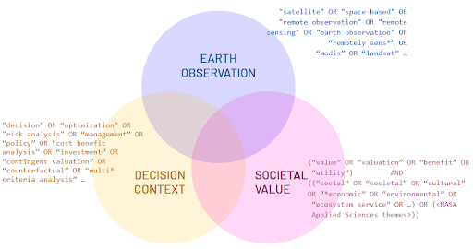

**Figure S1.** Conceptual diagram of search string.

Terms in italics are from the exploratory search on October 25, 2023; terms in bold were added following the use of litsearchr R package functionality (60); terms in bold italics were added following discussion at the American Geophysical Union conference in December 2024. The final Web of Science search was performed using these search strings on January 26, 2024; the final Scopus search was performed using these search strings on February 4, 2024.

* Earth science information terms:
  + (*“satellite” OR “space-based” OR “remote observation” OR “remote sensing” OR “earth observation”* OR **“remotely sens*” OR “MODIS” OR “Landsat”** OR ***“GRACE” OR “SRTM” OR “Sentinel” OR “VIIRS” OR “TERRA” OR “CLARREO”***)
* Decision context terms:
  + (*“decision” OR “optimization” OR “risk analysis” OR “management” OR “policy”* OR **“cost benefit analysis” OR “benefit cost analysis” OR “investment” OR “contingent valuation” OR “counterfactual”** OR ***“value chain analysis” OR “multi* criteria analysis” OR “multi* criteria decision analysis” OR “planning” OR “governance” OR “prioritization” OR “impact assessment” OR “impact evaluation” OR “willingness to pay”***)
* Societal benefit terms:
  + (*“value*” OR “valuation” OR “benefit*”* OR **“utility”**) AND (*“social” OR “societal” OR “cultural” OR “*economic”* OR **“environmental” OR “ecosystem service” OR “sustainable development” OR “protected area” OR “heritage site” OR “non use value” OR “capacity building” OR “disaster” OR “water resource*” OR “climate resilience” OR “air quality” OR “conservation” OR “wildland fire*” OR “wildfire”** OR ***“empower*” OR “power structure*” OR “justice” OR “equit*” OR “financial” OR “monetary” OR “health” OR “well-being” OR “livelihood” OR “community-*” OR “inspiration*” OR “educat*” OR “arts” OR “familial” OR “spiritual” OR “religious”***)

## Screening process

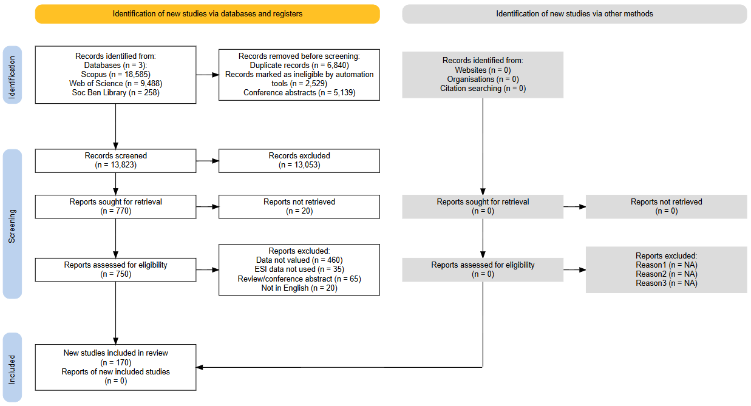

**Figure S2.** PRISMA flow diagram. Created using https://estech.shinyapps.io/prisma_flowdiagram/

## Preliminary screening of spurious matches

An early examination of search results showed that many of the ESI-focused terms resulted in spurious matches, since many of those terms on their own have alternate meanings unrelated to ESI. For example, “satellite” is used to describe sub-nodes in networks such as libraries or medical clinics; in medical research, “sentinel” (relating to the ESA’s Copernicus mission) can refer to lymph nodes and cells observed for early detection of cancers; and “terra” (relating to one of two satellites equipped with MODIS sensors) can be paired with “preta” to describe the carbon-rich black soil found in indigenous regions of the Amazon. To eliminate some of the most common instances of these spurious matches, we identified a set of terms to be excluded using regular expressions for flexibility; if these terms were removed from titles/abstracts and no other terms in the title or abstract matched other ESI-related terms, then that document would be excluded from further consideration.

* “Satellite” terms:
  + ‘satellite’ plus any of: ‘account’, ‘office’, ‘laborator(y|ies)’, ‘campus’, ‘([a-z]+.)?clinic’, ‘([a-z]+.)?hospital’, ‘([a-z]+.)?cent(er|re)’, ‘lesion’, ‘nodule’, ‘mass’, ‘h(a)?emodialysis’
* “Sentinel” terms (relating to the Sentinel satellites of ESA’s Copernicus programme):
  + ‘sentinel’ plus any of: ‘study’, ‘(lymph.)?node’, ‘site’, ‘([a-z]+.)?surveillance’, ‘species’, ‘behavior’, ‘catalyst’, ‘event’
* “Grace” terms (relating to NASA/JPL Gravity Recovery and Climate Experiment mission):
  + ‘grace.period’
* “Terra” terms (relating to NASA’s Terra MODIS satellite):
  + ‘Terra’ plus one of: ‘preta’, ‘nova’, ‘firme’, ‘nullius’
* Health terms that frequently showed up in spurious matches:
  + Any of ‘cancer’, ‘cardiac’, ‘cardio’

## Screening criteria

Exclusion criteria used in the citation screening (title + abstract) and full text phases:

* ESI data are not used:
  + No relation to Earth science information. For example, spurious matches related to health care remote observation.
  + Related to satellites but not related to information about Earth’s systems. For example, documents relating to space weather, solar or lunar information, or communications/navigation satellites.
* Data are not valued
  + ESI data are used to determine some scientific finding, but the scientific finding is not used to inform a specific societal decision or otherwise valued.
  + For example, ESI data used to estimate changes in ecosystem service value over time, but the resulting ecosystem service value is not used to inform any management decisions within the paper - i.e., the ESI measurement did not generate value.
* Valued data is not ESI
  + Valuation methods are used in the paper, but applied to data or information other than the ESI. For example, a study that applies a new classification algorithm to the same underlying data; in this case, the additional value is attributable to the algorithm rather than the underlying data.
* Review/opinion
  + Document is a review or opinion piece and does not provide new analysis or new frameworks for valuation.
* Conference abstract/proceedings
  + Document is a conference abstract or proceeding describing presentations rather than published work
* Validation/calibration
  + A special case of “Data is not valued” - ESI data are used to generate scientific information, and this information is compared to some reference to demonstrate scientific value; however, this scientific value is not then translated into societal benefit.
  + For example, NDVI data is used to estimate land cover, and this result is compared to some alternate information source and shown to be an adequate or even superior proxy, i.e., scientific merit. However, the resulting information is not used to inform a management decision that would translate to some societal benefit.