A Systematic Map of Methods for Assessing Societal Benefits of Earth Science Information

Casey C. O’Hara1*, Mabel Baez-Schon2, Rebecca Chaplin-Kramer2, Samantha Cheng2, Alejandra Echeverri3, Gillian L. Galford4,5, Rachelle K. Gould4,5, Cristina L. Mancilla2, Maura C. Muldoon4,5, Gerald Singh6, Priscilla Baltezar7, Yusuke Kuwayama8, Stephen Polasky9, Amanda D. Rodewald10, Richard P. Sharp2, Elizabeth Tennant11, Jiaying Zhao12, Benjamin S. Halpern1,13

**Short Title:** Assessing Societal Benefits of Earth Science Information

### Affiliations

1. National Center for Ecological Analysis and Synthesis, Santa Barbara CA 93101, USA
2. Global Science, World Wildlife Fund, Washington, DC, 10024, USA
3. Department of Environmental Science, Policy and Management. University of California, Berkeley, Berkeley CA, 94709
4. Rubenstein School of Environment and Natural Resources, University of Vermont, Burlington VT 05401, USA
5. Gund Institute for Environment, University of Vermont, Burlington VT 05401, USA
6. School of Environmental Studies, University of Victoria, Victoria BC V8P 5C2, Canada
7. Massachusetts Institute of Technology Space Enabled Research Group, Cambridge MA 02139, USA
8. School of Public Policy, University of Maryland, Baltimore County, Baltimore MD 21250, USA
9. Department of Applied Economics, University of Minnesota, St. Paul MN 55108, USA
10. Cornell Lab of Ornithology and Department of Natural Resources and the Environment, Cornell University, Ithaca NY 14850, USA
11. Charles H. Dyson School, Cornell University, Ithaca NY 14853, USA
12. Department of Psychology, Institute for Resources, Environment and Sustainability, University of British Columbia, Vancouver BC V6Z 1T4, Canada
13. Bren School of Environmental Science & Management, UC Santa Barbara, Santa Barbara CA 93106, USA

**\*Correspondence to:** Casey O’Hara, ohara@nceas.ucsb.edu

**Keywords:** satellite, remote sensing, value of information, societal benefit

## This file includes:

* Main Text
* Figures 1-5
* References 1-72

# Abstract

Remotely sensed Earth science information (ESI) has become increasingly central to addressing global challenges, yet its societal value, i.e., the difference ESI makes in real-world decisions and outcomes, is rarely quantified. In this study, we systematically map peer-reviewed literature that explicitly assesses the societal value of ESI across instrumental, intrinsic, and relational value types, and the diversity of approaches used to assess those values. Drawing from 13,823 publications across Scopus, Web of Science, and a curated library of ESI valuation studies, we identify 171 studies that applied ESI in a decision context and used a valuation method to compare outcomes with and without ESI. The majority of these studies employed decision analysis methods such as Value of Information and Cost-Benefit Analysis, focusing primarily on quantitative instrumental values (e.g., profit, crop yield, lives saved), particularly in agricultural contexts. Studies that applied preference elicitation methods including stated preference, surveys, interviews, and focus groups were able to capture qualitative benefits and relational values including quality of life improvements, empowerment, and procedural justice. By building on a solid foundation of methods and philosophy for valuation of ecosystem services and nature, we aim to expand our understanding of the societal benefits of ESI to help guide investment in future missions, enhance public support, and ensure that science and policy goals are well aligned.

# Significance statement

Earth science information (ESI) from satellites and other remote sensing technologies is critical for managing climate, agriculture, disasters, and more. Yet the societal value of ESI, how it improves real-world decisions and outcomes, remains poorly understood. We systematically map studies that quantify this value, revealing how different methods capture diverse benefits, from economic efficiency and lives saved to empowerment and justice. Our findings demonstrate that a rich array of methods exists to assess societal benefits of ESI across many decision contexts, identifying benefits in terms of instrumental and relational values. This synthesis expands the evidence base for why ESI matters and how it can help guide future investments, promote public support, and align Earth science with societal goals.

# Main Text

## Introduction

In recent decades, remotely sensed information about the state of our planet has become increasingly vital for understanding and addressing global challenges such as climate change, water resource management, biodiversity conservation, sustainable development, and public health (4). Rapid technological progress has led to widespread availability of Earth science information (ESI), comprising global or regional datasets from remote sensing (e.g., satellite hyperspectral imagery, aerial drone photography, in-situ sensor networks) as well as models founded on such data (e.g., climate forecast models, famine early warning systems), at increasingly detailed and nearly continuous spatial and temporal coverage of the planet’s surface (5). These advances in the availability and sophistication of ESI have accelerated its application across a wide range of decision contexts (6), supporting societal benefits as varied as impeding transmission of polio in Nigeria (7), protecting blue whales in the Eastern Pacific (8), improving targeting of cash transfers to poor villages in sub-Saharan Africa (9, 10), and empowering Indigenous communities to monitor deforestation (11). While the contribution of ESI to such societal benefits is undeniable, the magnitude of this contribution is rarely assessed. Yet if we don’t understand the value of ESI, we risk underinvesting in information essential for protecting or enhancing our quality of life.

The gap in valuation of ESI is due in part to the separation of Earth system science from social and decision sciences, and further compounded by a lack of information-valuation frameworks that integrate different value types (e.g., instrumental vs. intrinsic). Understanding the breadth and magnitude of societal benefit of ESI, i.e., the value of practical application to socially desirable outcomes that goes beyond scientific merit (1), is important for guiding development of information that is actionable, meaningful, and credible for society’s needs, thereby justifying investment in future missions, garnering public support, fostering ESI uptake, and ensuring that science and policy goals are well aligned.

Inclusive and pluralistic value systems have long been a topic of discussion in conservation science and sustainable development (e.g., (12–15)). The Intergovernmental Science-Policy Platform on Biodiversity and Ecosystem Services (IPBES) Values Assessment (16), a multi-year effort by scores of experts in diverse forms of valuation, identified three categories of value that reflect the ways in which nature and ecosystems are important for people: instrumental value as a means to satisfying specific human needs or interests, e.g., more revenue, higher crop yield, better health outcomes; intrinsic value independent of reference to people as valuers, e.g., the right of a whale to exist without regards to human preferences; and relational value deriving from meaningful and often reciprocal human relationships beyond means to an end, e.g., connection with a sacred landscape, a sense of responsibility toward one’s community (17) (Table S1). While the IPBES framework focused on value types in the context of nature, we can expand these considerations to examine values related to our relationship with both natural and social systems as observed through ESI-informed decision outcomes. Failing to capture potential gains related to non-instrumental values will greatly underestimate the contribution of ESI to societal benefits.

The mechanism by which ESI, indeed any information, generates societal value is through its ability to improve decision making toward socially desirable outcomes. It does this by aiding in the scoping of decision contexts and assessing alternatives, thus reducing the likelihood of making decisions that result in undesireable outcomes. Note that this indicates that information, when put to use, by definition has instrumental value, and information can have intrinsic scientific value, whether used or not. But the focus of our study is not on the nature of information itself, but rather on the societal benefits that arise from the use of ESI in decision contexts, i.e., the value of the decision outcome, whether that is expressed in instrumental, relational, or intrinsic terms.

Economic frameworks to quantify the value of information typically calculate the difference in expected outcome of a decision made in a world with, versus without, the information (e.g., (18)). Such decision analysis methods have played a critical role in demonstrating ESI’s potential to improve instrumental societal outcomes with instrumental values (i.e., means to an end, such as improved profits or crop yields) (19, 20). Value of information models based on decision analysis are well-suited to measuring socially desirable outcomes in terms of instrumental value, but these models are not sufficient to capture the ways in which ESI can contribute to intrinsic and relational values such as sustainability, justice, and human well-being (21). Other valuation methods can account for instrumental and non-instrumental values alike by eliciting individual and societal preferences for goods and services through quantitative, qualitative, and mixed-methods approaches (e.g., market price, stated/revealed preference, surveys, interviews, focus groups) (22). While these methods are commonly used for valuation of goods and services, they can also be leveraged to estimate the value of information in cases where they are used to account for the value of the differential outcome between a decision made with ESI relative to the decision made without.

In this study, we ask four questions: (1) To what degree have various valuation methods been used to evaluate the societal value of ESI? (2) Which types of value (instrumental, intrinsic, relational) do these methods capture, and how are these values articulated? (3) How is the application of various valuation methods distributed across sectors and decision contexts? And finally, (4) what opportunities exist to develop more inclusive, systematic, and interdisciplinary approaches to ESI valuation? Here we present a systematic map of the peer-reviewed literature to identify studies in which a valuation method was used to compare the result of a decision supported by ESI to the result supported by some alternate information source. Through this systematic map of the peer-reviewed literature across a wide range of disciplines, we clarify the current landscape of ESI valuation, identify methodological and disciplinary gaps, highlight emerging practices, and point toward a more pluralistic and actionable valuation framework. Understanding and improving the way we value information will promote investments in Earth observations that not only expand scientific understanding but also deliver equitable and measurable benefits across diverse communities and decision contexts.

## Results

### Screening Process

Application of the search string (see SI Methods and Fig. S1) to Scopus and Web of Science databases, combined with references from an existing curated library of ESI valuation literature (Societal Benefits Library, SBL) (not available online at time of publication), yielded 28,331 records. Pre-screening eliminated conference abstracts, spurious matches, duplicates, and incomplete records, narrowing the corpus to 13,823 unique citations (Fig. 1, Fig. S2). The unique citations were then screened according to the following criteria: 1) the study made substantive use of ESI; 2) ESI was applied in a decision context; 3) the predicted or realized outcome of an ESI-based decision was compared to that under an alternative information set; and 4) the difference in outcome was presented in terms of some societal benefit. Reviews were excluded as they do not present original data. After pre-screening, the full SBL and an additional 1,072 randomly-sampled documents were manually screened by the team and used as a training set to inform a machine-learning classifier model on the remaining 12,493 citations, resulting in 2,287 predicted “includes” and 10,206 predicted “excludes.” All predicted “includes” and a random sample of 200 predicted “excludes” then went through a title/abstract screening process. Of the 13,823 unique citations, 770 documents sufficiently met the title/abstract screening and were included in full text screening. Full text screening resulted in 170 documents that met all criteria (Fig. 1, Fig. S2), to which one more document was added based on prior knowledge of a coauthor (not shown in Fig. 1). All title/abstract screening was performed in the Colandr web-based machine-learning assisted screening app (23). Full text screening was performed using Zotero reference management software. The final list of 171 documents included in our study is listed in the supporting information (Table S3).

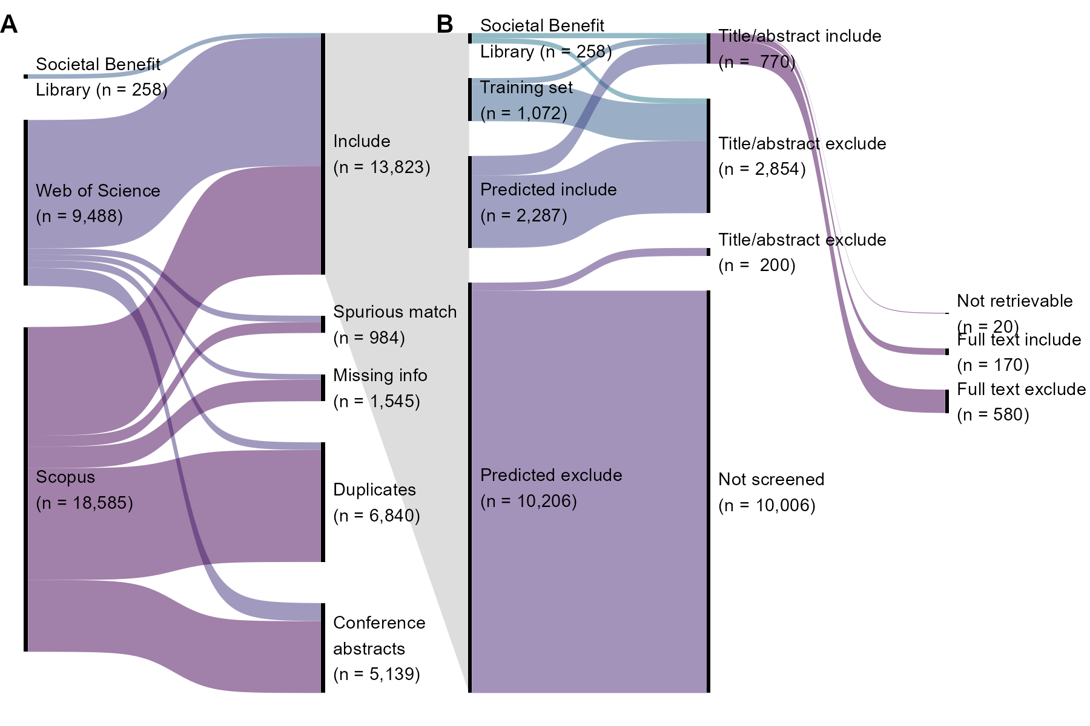

Figure 1. Citation retrieval, pre-screening, and screening results. A. Retrieval and pre-screening process and disposition of included and excluded records. Following pre-screening, n = 13,823 documents proceeded to title/abstract screening stage. B. Title/abstract screening and full text screening process and disposition of included and excluded documents. Following title/abstract and full text screening, n = 170 documents were included in our analysis. Based on expert knowledge, one additional document was added manually (not shown), resulting in a final corpus of n = 171 documents.

### Valuation Methods

Nearly a third (56 studies) of the 171 included documents applied more than one information valuation method, with a total of 227 instances of valuation methods being observed (Fig. 2; see Table S2 for operational definitions used to categorize valuation methods). The most common approaches to assessing societal benefits of ESI in the literature were quantitative economic approaches grounded in decision analysis: Value of Information (VOI) framework (n = 82; 48% of papers) and Cost-Benefit Analysis (CBA) (n = 33; 19%) (Fig. 2). Applied qualitative or subjective methods were also frequently observed, including surveys of preference assessments (n = 26; 15%) and semi-structured or in-depth interviews (n = 23; 13%). Deliberative and consensus-based approaches were rare (n = 3 and 1 studies, respectively). Methods based on decision analysis (n = 144) were more frequently observed than methods based on preference elicitation (n = 80) (See Table S2 for categorization of methods as decision analysis vs. preference elicitation).

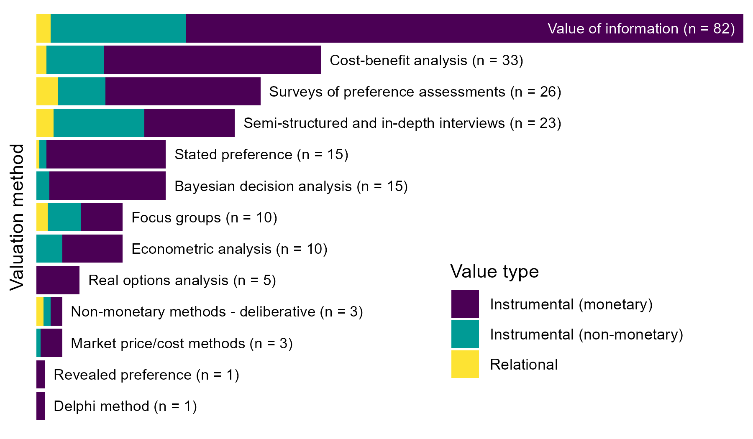

Figure 2. Number of valuation methods observed across included studies. Some studies applied multiple methods for valuation, thus the total number of observed methods (227) exceeds the total number of included studies (171). Color indicates value types assessed: instrumental, i.e., means to an end, including both monetary and non-monetary outcomes, and relational, i.e., deriving from meaningful and often reciprocal relationships among people, nature, and society (see Table S1).

Included studies most commonly measured societal benefits in terms of monetary instrumental value (e.g., improved profit) (n = 154) and/or non-monetary instrumental value (e.g., pollution reduction, lives saved) (n = 63), with many studies accounting for multiple instrumental metrics simultaneously (e.g., reduced crop pesticide application and the associated increase in profit; see Table S1 for definitions and examples). Studies that measured societal benefits in terms of relational value (e.g., connection with land, poverty alleviation, social justice, knowledge transfer among community, Table S1) were far less common in the literature (n = 17) and were more frequently assessed using qualitative preference elicitation methods, especially surveys, interviews, and focus groups. Studies rarely focused exclusively on outcomes associated with relational value, but typically examined relational value alongside instrumental value; for example, recreational fishing both as a pastime and as an economic activity (24). No papers in our study described decision outcomes in intrinsic terms such as the moral right of non-human species to exist in peace; one paper (8) examined potential for ESI to inform regulation to reduce fatal ship strikes of blue whales, but the authors focused on decision outcomes based on compliance with conservation policy, an instrumental goal.

Most studies in our corpus (n = 115) applied only a single method for valuing ESI. Studies that we identified as implementing multiple methods (n = 56) most commonly combined two decision analysis-based methods, particularly VOI with CBA (n = 12 of the 56 studies) (Fig. 3). For example, Fritz et al. (2) applied the counterfactual framework of VOI to estimate benefit, then modeled marginal cost based on CBA to construct their benefit chain model for valuing ESI from hypothetical satellite remote sensing data. Another common pairing combined preference elicitation methods of individual interviews and focus groups (n = 8). For example, Roberts et al. (25) used focus groups/workshops to qualitatively predict the value of weather forecast information for avoiding storm-related drownings in Lake Victoria, then after implementation of a severe weather warning system, followed with user interviews to quantify the realized benefits in lives saved. Of the remaining 36 multiple-method studies, 15 combined VOI with some other method (beyond CBA) and 16 combined surveys with some other method (beyond VOI). Paired decision analysis-based methods were more common (n = 22) than paired preference elicitation-based (n = 18), but 16 studies combined preference elicitation methods (mostly surveys) with decision analysis methods.

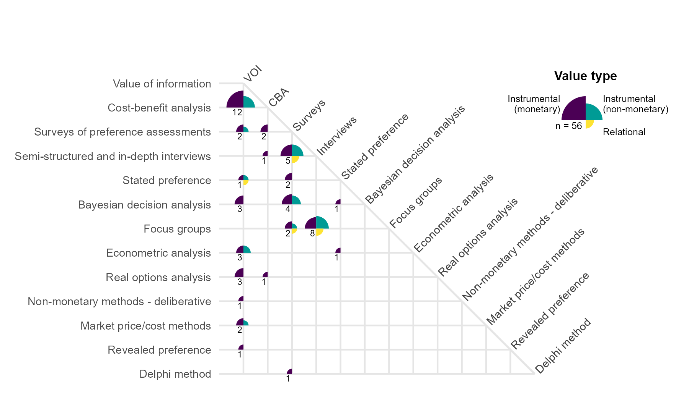

Figure 3. Number of papers applying multiple approaches to valuing ESI. The quadrants and colors at each intersection indicate which value types were examined; the size of the quadrants indicate proportion of papers that examined each value type. The number in the bottom left quadrant indicates the total number of papers that implemented the combination of methods. The majority of papers (115 out of 170) applied only a single method.

### Societal Benefit Context Areas

For each of the 171 included studies, we categorized societal benefits into eight general decision context areas, based on existing classes from GEOSS Societal Benefit Areas and NASA Applied Sciences themes (REFS) (Fig. 4). Across the 171 included studies we observed societal benefits in 216 specific decision contexts (i.e., 45 studies examined societal benefits in more than one context). Studies largely focused on the societal benefits of ESI within agriculture contexts, including fisheries and forestry (n = 78, 46% of studies) (Fig. 4). A smaller but still substantial number of studies examined benefits in context of climate (n = 25, 15%), water resources (n = 23, 13%), and ecological conservation (n = 22, 13%). Societal benefits were least frequently examined in contexts of disaster response (n = 9, 5%), health and air quality (n = 8, 5%), and wildfires (n = 6, 4%). Some studies did not focus deeply on any particular context but rather broadly across various or undifferentiated contexts (“various,” n = 27, 16%), for example, the value of an ocean observing network across many potential ocean uses (26) or the value of Landsat data that did not differentiate among user contexts (27). Two studies focused on ESI benefits in other areas (“other”): one for monitoring pavement infrastructure (28), and one for assessing preferences for living and recreating in disturbed landscapes (29).

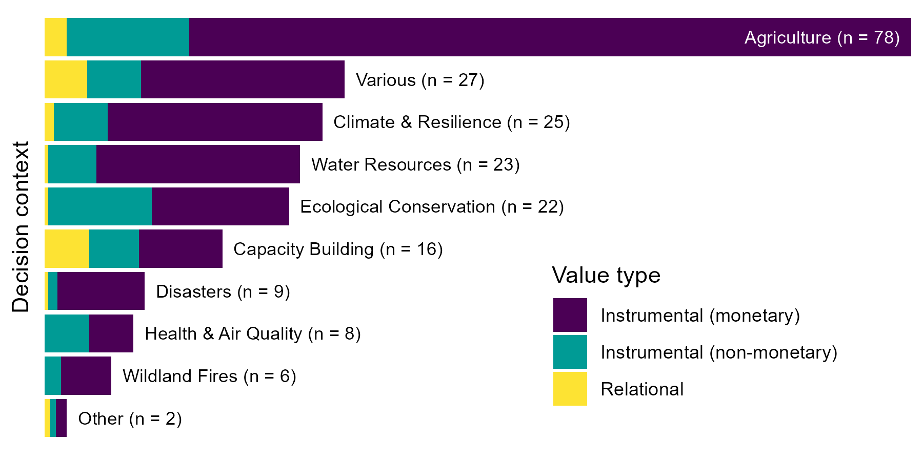

Figure 4. Number of studies investigating value of information in general decision context areas. Some studies examined more than one decision context, thus the total number of specific contexts (215) exceeds the total number of included studies (170). The label “various” indicates studies where decision contexts were broad or undifferentiated; “other” indicates studies where the societal benefit did not fit into any of these contexts. Color indicates value types assessed: instrumental, i.e., means to an end, including both monetary and non-monetary outcomes, and relational, i.e., deriving from meaningful and often reciprocal relationships among people, nature, and society (see Table S1).

Studies that valued ESI across multiple decision contexts (n = 45) most frequently examined agricultural impacts alongside water resources (n = 10), climate (n = 8), ecological conservation (n = 4), and capacity building (n = 4) (Fig. 5). Four studies examined capacity building across various contexts, involving training and supporting groups of stakeholders with diverse roles within their communities, e.g., participatory mapping projects in Nepal (30) and Tanzania (31).

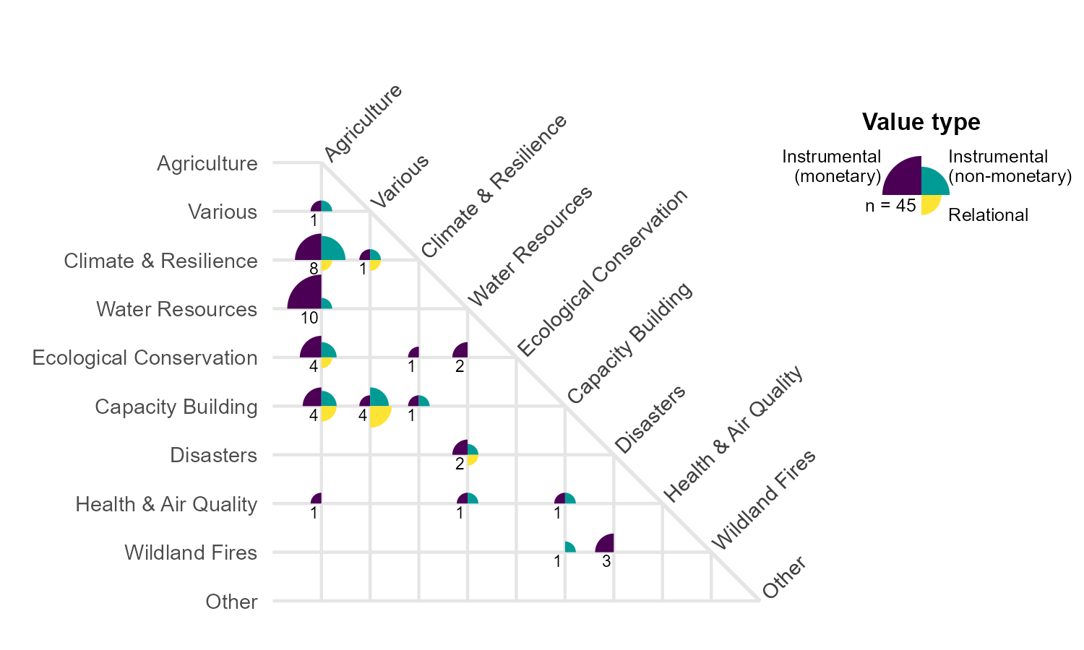

Figure 5. Number of papers valuing ESI in multiple contexts. The quadrants and colors at each intersection indicate which value types were examined; the size of the quadrants indicate how many papers examined that value type. The number in the bottom left quadrant indicates the total number of papers involving that pair of contexts.

## Discussion

Despite a broad, inclusive search for research on diverse methods for valuing earth observation information, we found very few examples of evaluations of the societal benefits of ESI. Such a low inclusion rate (1.2%) is not unexpected, as our inclusion criteria are specific to methods of valuing information and data, but our search string was intentionally designed to be inclusive to maximize opportunities to find edge cases in the literature. The paucity of research directly addressing the value of ESI suggests a strong need to better understand how such information is being used to generate societal value, and to identify methods that can effectively assess this value.

The challenge of valuing information, as opposed to valuing goods or services, generally lies in identifying a relevant counterfactual information set as the basis of comparison. The counterfactual can be explicit, such as stated assumptions of outcomes without ESI built into a VOI analysis, or implicit, such as the mental counterfactual a respondent may generate for comparison in a survey or interview. Here we focused only on valuation methods where the resulting value was a function of ESI. In several of the publications we identified, multiple valuation methods were used in sequence to first identify the difference in outcome based on the inclusion of ESI, and then to translate that difference in outcome to some other metric, usually monetary. The first step is clearly dependent upon the availability of the ESI in question (access to ESI generates a difference in outcome); the second step may or may not be, depending on the assumptions of a given study. For example, Späti et al. (32) modeled the effect of variable-rate nitrogen application on crop yield for small-scale farmers based on several spatial resolutions of ESI data; they then valued the increased yield and reduced nitrogen, made possible through the improved resolution, into economic terms (Swiss francs) using market prices. However, the nitrogen and crop prices were treated as fixed, in other words independent of the ESI (a reasonable assumption for a small-scale farmer trading commodities within a global market), and thus this second valuation step was effectively a unit conversion, and not germane to our study. Conversely, Adams et al. (33) modeled the benefits of an El Niño early warning system for agriculture across five Mexican states, accounting for alternative cropping decisions to optimize yield in the face of seasonal predictions, then translated the resulting crop yield into economic terms using modeled market prices. The difference in crop yield was again a result of access to ESI as in the previous example, but the market model accounted for changes in price due to ESI-driven changes in supply, and therefore this second valuation step was also considered relevant for our study.

Our systematic map shows that VOI methods have been the dominant approach to evaluating societal benefits derived from using ESI for decision support (Fig. 2). VOI is a well-established and intuitive method, and Macaulay (19) described a framework for applying VOI to ESI contexts that continues to influence recent research initiatives (e.g.,(34)). VOI methods are very well suited to situations where a reduction in uncertainty, based on an improved information set, can be expected to drive a clear and measurable improvement in decision outcomes. This is especially the case where costs of a mistake are high, where benefits can be expressed as objective quantities (typically in terms of instrumental value), and where the outcome is highly responsive to the set of actions that can be taken. For these reasons, VOI is particularly suited to agricultural contexts, where an improved seasonal forecast can inform farmers’ decisions about crop choices and crop management to maximize yield and profit in the face of uncertainty; this is reflected in the high rates of VOI use in agricultural studies.

Our analysis revealed that CBA, a common method for estimating the net present value of a particular investment decision over an extended time frame, is the second most prevalent method for valuing ESI (Fig. 2). In an information context, this could be considered as the expected net benefit of investment in the infrastructure required to generate ESI, such as aerial drones or satellite instruments, and/or investment in technologies and labor to process ESI. In some identified studies, CBA and VOI were used in tandem (Fig. 3): the benefits of ESI are estimated using a VOI framework, while the costs of ESI are drawn from actual or projected budgets for producing the ESI. Use of CBA in valuation of ESI is most commonly observed in agriculture and conservation contexts, and like VOI, is focused primarily on instrumental value due to its traditionally monetary nature.

Valuation methods based on decision analysis (Table S2) necessarily focus on decision outcomes that can be quantified. However, many decision outcomes valued by individuals and society are impossible to objectively quantify and/or can be qualitatively valued across multiple, potentially incommensurable, value types. Preference elicitation methods (Table S2) can more readily account for qualitative and subjective benefits related to ESI-based decision outcomes in instrumental and non-instrumental terms, including relational value. For example, Altamirano et al. (29) surveyed people’s preferences for visiting, living, admiring, and thriving across gradients of landscape disturbance, comparing perceptions of value based on eye-level photos to perceptions based on remote sensing photography. Colloredo-Mansfeld et al. (35), using participatory mapping and in-depth interviews, found that farmers given access to UAV photography perceived their land differently than before, improving relational value through a greater sense of scale and interconnectedness.

In addition to eliciting qualitative and subjective outcomes associated with ESI, preference elicitation methods are well suited to provide insights into the decision process itself, revealing relational values of stewardship, responsibility, and care within a community. For example, Eilola et al. (31) used interviews and focus groups to study how participatory mapping using ESI improved practitioners’ perceptions of work quality, professional competence, participation, and spatial understanding. Gonzalez and Kroger (11) used focus groups and interviews to examine how training in and adoption of remote sensing data improved empowerment and agency of Indigenous people in protecting their land from illegal deforestation. Styers (36) surveyed her undergraduate students to gauge how the incorporation of satellite data into her courses improved student engagement, curiosity, collaborative skills, and learning outcomes. In these cases and others, access to and use of ESI improves saliency and legitimacy of decision making processes (37), providing value independent of outcome.

A few studies bridged the divide between decision-analytic methods and preference-elicitation methods (Fig. 3). For example, in several interrelated studies, Bouma et al. (38–41) applied Bayesian decision analysis to quantify societal benefits of ESI for managing water quality, but leveraged surveys of experts to elicit prior beliefs and expectations of accuracy of the ESI to parameterize the Bayesian analysis. Flipping that script, Luseno et al. (42) used a conceptual Bayesian framework to guide the design of surveys and interviews of pastoralists in Ethiopia and Kenya to understand their preferences around ESI-derived climate forecasts, including the pastoralists’ prior beliefs based on traditional forecasting methods, trust in ESI forecast skill, and likelihood of using the ESI-based forecasts.

The scientific, political, and commercial structures governing ESI - especially whether datasets are publicly accessible or proprietary, freely available or commercial - in part determine who is likely to benefit from their societal value (43). Clearly, making ESI data freely available enhances the ability to generate societal benefits; for example, citations and downloads surged for Landsat data following the shift from a paid service to a free and open data policy in 2008, ultimately stimulating billions of dollars in scientific and societal benefits (6, 27). Alvarez León and Gleason (44) analyze how varying property rights can reinforce or challenge assumptions of scientific objectivity and ultimately users’ ability to translate ESI into scientific and societal value. For example, recent data from the European Space Agency (ESA)’s SPOT (Satellite Pour l’Observation de la Terre) mission is commercially available, and users can request that the sensor can be directed to capture imagery of particular regions of commercial interest. As a result, historical SPOT data (through 2015), while freely available through various portals, are skewed toward scenes that were valuable to commercial users at the time of capture. In contrast, Landsat data of USGS are freely and openly available, and its fixed sensing path avoids bias based on commercial interests (44), although systematic gaps in archival georegional coverage may exist due to technical failures and inconsistent data sharing among cooperating nations (45).

Even freely and openly available satellite data come with barriers to technical expertise and capacity that pose significant hurdles to use for many practitioners (46), and poor integration with ground-based and local knowledge hampers development of machine learning algorithms to translate remote sensing imagery into actionable information (47–49). Capacity building can help local communities and Indigenous peoples access and incorporate ESI to co-produce knowledge across contexts including conservation (e.g., (50)), deforestation (e.g., (11)), marine resource management (e.g., (51, 52), and resilience to climate change (42, 53). Such collaborations can reduce power asymmetries and increase agency and self-governance of communities as they seek to address challenges facing indigenous landscapes and territories (11, 53); however, they can also create internal power divisions between tech adopters and non-adopters, potentially resulting in shifts in or loss of cultural values (11).

Positive societal benefits aided by use of ESI were the focus of most of the studies we identified, but a trade-off between information and privacy becomes increasingly relevant as advancements in the quality and quantity of remote sensing data accelerate the ability to identify and monitor objects and people on the ground. In general, remote sensing allows the observer to shift information asymmetry between the observer and the observed, in favor of the observer. Brennan and Macauley (54) describe several important use cases that determine whether the shift in information asymmetry is potentially beneficial or detrimental to society, based on whether the observer and the observed are state actors or private actors (corporations, groups, individuals) and whether the relationship between observer and observed is adversarial or cooperative. The ability of state actors to monitor and enforce compliance with conservation policy, emissions targets, and peace treaties certainly produces societal benefits by enabling cooperation (55); monitoring also holds promise for reducing international conflict (56), supporting human rights (57), and responding to genocide (58). To the extent that an open, transparent government whose laws and regulations reflect the will of the governed, these information asymmetries may actually promote societal benefits, e.g., reduced crime or pollution (54). However, the risks of abuse loom large, creating a clear tradeoff between the increasing capabilities of remote sensing technology and the privacy rights of the individual.

While most of the papers excluded from our target corpus either did not apply ESI data (e.g., spurious matches that were missed during our preliminary screening), or applied ESI data to calculate some other outcome (e.g., using land cover classification data to estimate ecosystem service value, but no further examination of the value of the ESI itself), two categories of excluded papers merit further consideration. These two categories of studies offer clear opportunities for those interested in evaluating the societal benefits of ESI.

First, a number of papers used cost-effectiveness analysis, a close relative of cost-benefit analysis, to demonstrate that an ESI data set could achieve equal or near-equal performance for a decision context but with less cost (e.g., reduced costs of labor or equipment relative to on-the-ground research) (e.g., (59)). We did not include these in our final corpus, reasoning that if the information itself is essentially identical between the ESI and non-ESI alternative, any outcome of a given decision would necessarily be identical, and therefore no additional marginal societal benefit would result from use of the ESI. We acknowledge that in resource-constrained settings, government or NGO cost savings in one area can closely translate into improved societal outcomes in another (e.g., lowering taxes on lower income people, or increasing budgets for social safety nets), but these indirect benefits were not explicitly examined in any of the papers we screened. While these excluded studies focused on a one-time analysis, reduced costs of labor and/or equipment imply the potential for increased frequency of measurement, which would prove valuable for certain types of decision contexts that involve rapidly changing phenomena, e.g., disaster response or wildfire management. We included several studies that explicitly valued the benefits of higher spatial resolution, though we encountered only one study (60) that explicitly accounted for the value of higher temporal resolution. This suggests an opportunity for future valuation studies, especially in light of trends toward increasingly fine temporal resolution of accessible satellite data.

Second, a larger subset of excluded papers compared the ability of ESI to accurately predict on-the-ground phenomena measured by some other means. For example, Marino (61) examined the potential for Sentinel-2 time series imagery to delineate subfields of sunflower crops and found that the image-based vegetation index provided a good proxy for ground-measured crop status; however, the implications for harvest decisions and resulting societal benefit were not explored. Similarly, Andrada et al. (62) demonstrated the efficacy of a drone-based lidar system for rapidly and accurately mapping potential wildfire fuel for forest management, but the authors did not quantify the societal benefit from this valuable scientific information. Such validation studies typically report accuracy scores, e.g., RMSE or AUC, and generally aim to demonstrate the adequacy or superiority of a particular ESI dataset or algorithm over the alternative approach. Importantly, while these studies presented results in terms of scientific value, they did not examine how the improved scientific knowledge would affect the decisions that generate societal benefits - though most included conceptual descriptions of potential decisions or societal value in their conclusions. With often minor additional information or simple economic modeling, many calibration/validation studies could readily translate the improved scientific accuracy of an ESI dataset relative into a hypothetical or realized decision that could be translated into calculable societal benefits.

Our wide-ranging search string resulted in a large corpus of studies identified as potential candidates for inclusion, but recent developments in machine learning (ML) have made such large screening processes much more feasible. We implemented two distinct ML algorithms in our screening process. First, for all title/abstract screening, we used the Colandr ML-assisted web-based screening tool (23) which uses machine learning and natural language processing to continually predict and sort citations in order of predicted relevance based on user screening decisions. Importantly, Colandr does not decide the disposition of a document - the user is intentionally involved throughout and ultimately makes the decision (23). Second, we generated a training set based on a subset of the full corpus and used this to train an ML algorithm to predict the inclusion/exclusion status of the remaining corpus, identifying nearly 80% of the corpus as likely “excludes.” Because this ML process is recommending the disposition of documents, a low false negative rate (low chance of excluding a relevant document) is critical, though false positives are less problematic, as they are subject to additional human screening. Because our systematic map focused not on study questions or results (typically foregrounded in the title and abstract) but rather on methods (which are often described only vaguely if at all in the abstract), it was difficult to tune the ML model to reduce the false positive rate; however, for studies focused on top-line results typically described in the abstract, such ML methods would likely be far more discerning. Increasingly sophisticated ML algorithms and AI tools such as Elicit, OpenAI Deep Research, and SciSpace Deep Review will almost certainly accelerate rapid systematic evidence synthesis, though the threat of a flood of AI-generated fraudulent literature may drive an arms race in how such reviews are conducted (63).

While our literature search was broad, we restricted it to two databases of academic peer-reviewed literature (Scopus and Web of Science) and the Societal Benefits Library and did not systematically search grey literature sources. Of the 770 documents identified as candidates for full-text screening, 10 were not retrievable, and 20 more were excluded as not in English; while exclusion of non-English sources could potentially lead to bias, this subset is a tiny fraction of the retrieved papers (2.6%) so omitting these studies is unlikely to substantially affect our results. We note that many ESI applications may rely on highly derived, modeled, or processed data, such that remote-sensing terms (e.g., “satellite”) or the name of the initial sensor (e.g., “Landsat”) do not appear in the title, abstract, or keywords, which may limit the citations in our corpus; however, generalizing the search by excluding the ESI terms from the search string would have made the search impossibly large.

## Conclusion

As technological advances increase the cost-effectiveness and capacity for acquisition, storage, and processing of satellite imagery and remote sensing data, ESI will further proliferate in decision support contexts. For example, Canada’s WildfireSat constellation of mission-specific microsatellites, slated to launch in 2029, will image the entirety of Canada in near real time to inform wildfire management, potentially saving billions of dollars in avoided damages as wildfire regimes become increasingly extreme (64). Examining the societal benefits of Earth observation is important to justify existing and future investment (19), promote diffusion of use and applications (65), and identify gaps and priorities for future applications and missions (66, 67). Methods exist to evaluate ESI contributions across societal benefit areas and value types. However, even as the use of ESI data has grown to encompass a wide range of applications across the globe (65), published peer reviewed studies that attempt to qualitatively or quantitatively assess these contributions remain rare.

Our systematic map of the literature revealed a large subset of research that demonstrated the scientific value of particular ESI datasets and models but did not proceed to translate this scientific value into explicit societal value. A major impediment to the uptake of valuation methods as applied to ESI may lie in the gap between science and policy. This gap may be attributable in part to lack of in-house social science and policy knowledge to apply valuation methods, and in part to poor engagement between academics and user communities (68).

As technical capabilities of ESI instruments and machine learning models rapidly increase, opportunities to translate raw observations into actionable intelligence will multiply. Progress in measuring the instrumental, social, and relational value of ESI is essential to informing this work so that societies can mitigate risks and derive the greatest possible benefit. Here we have identified concrete examples of qualitative and quantitative valuation methods to measure societal benefits of ESI across a range of decision contexts and value types. By doing so, we hope to inspire other ESI researchers to explore the societal benefit of their own work and contribute to a greater network of valuation practitioners.

## Methods

Our analysis of the literature consisted of five major phases (described in detail below): 1) developing a search string; 2) applying the search string to academic databases to acquire a set of citations; 3) screening citations by the title and abstract; 4) screening the full text of papers that passed the title and abstract screening stage using natural language processing and language models; and 5) coding the papers to identify ESI data source, valuation method, societal benefit area, and value type.

To develop a search string (see SI Methods), we focused on three key domains: 1) application of ESI, 2) a decision context or analysis framework in which the ESI is applied, and 3) an expected or observed change in societal benefits based on decision outcome due to use of ESI. The research team collected (via Google Scholar searches) and solicited (via professional networks) a preliminary set of 72 candidate documents, which were screened based on these three domains. Of these 72 candidate documents, 14 were identified as a benchmark set that the research team felt exemplified valuation of ESI. From this benchmark set, we developed a preliminary search string combining the three domains: ESI (e.g., “remote sensing”, “satellite”, “Sentinel”, “Landsat”), decision context (e.g., “management”, “policy”, “cost-benefit”, “contingent valuation”), and societal benefit (e.g., “value”, “benefit”, or “utility” combined with terms such as “societal”, “cultural”, “environmental”, “ecosystem service”, or terms related to GEOSS societal benefit areas). The preliminary set of terms was used to collect citations (title, abstract, authors, metadata) from Web of Science (n = 1,158). We applied the functionality of the litsearchr package in R (69) to this preliminary citation set, using text mining and keyword co-occurrence networks to identify additional terms to increase the inclusion of our search string. The final search string (see SI Methods) was used to collect citations from Web of Science (January 26, 2024, n = 9,488) and Scopus (February 4, 2024, n = 18,585), including all 14 benchmark papers. In addition to these two citation sets we included a curated set of citations from the USGS Joint Societal Benefits of Earth Observation Digital Library (!!!REF USGS 2024) (SBL, n = 258). See Fig. S2 for PRISMA flow diagram.

The results of the search (Web of Science and Scopus) were then cleaned. Citations noted as conference abstracts or proceedings (n = 1,030 and n = 4,109 respectively) were dropped. Then, citations with missing title, author, abstract, or digital object identifier (DOI) field (n = 319 and n = 1,226 respectively) were dropped. After resolving minor differences among titles, author names, and DOI fields, 6,840 duplicate citations were removed from the combined citation set. The resulting set of 14,807 distinct citations were subjected to a preliminary screening to remove known spurious matches (n = 984), leaving n = 13,823 citations for screening and analysis (Fig. 1).

Screening was performed in two stages, the first to label a training set to train a supervised learning classification model, and the second to apply the classification model to predict relevant papers within the larger corpus (Fig. 2). In the first stage, the citations from the SBL and a random sample of ~1000 citations from the Web of Science/Scopus corpus were subjected to title/abstract screening, and then full-text screening on the title/abstract “include” papers, based on a set of inclusion criteria (See SI Methods for screening criteria). All title/abstract screening was performed using the Colandr web-based screening application (23), which uses machine learning and natural language processing to continually predict and sort citations in order of predicted relevance based on user screening decisions. As a user screens documents and codes them as “include” or “exclude,” Colandr develops a predictive model and iteratively sorts the remaining unscreened documents, presenting the user with the most likely relevant documents early. As fewer and fewer relevant documents are identified, and the inclusion rate approaches zero, the user can opt to establish an early-stopping rule as the remainder of the corpus is deemed increasingly irrelevant. For this initial stage, we did not set an early-stopping rule, and simply screened all citations.

The resulting set from the first stage was then used to train a classification model based on the XLNet generalized autoregressive pretraining algorithm, which considers all permutations of dependencies between sets of words in the citation titles and abstracts to “understand” the context (70), to classify citations in the remainder of the corpus as either “include” or “exclude”. The predicted “include” citations were then title/abstract screened (using Colandr) and those that passed were then screened based on the full text. The include/exclude classification model showed a low false negative rate (1.2%, sensitivity 92.3%) on the training data, but to ensure this held true of the larger document set, a random sample of 1000 predicted “excludes” was uploaded to Colandr. After screening 200 of these documents and finding no relevant matches to our screening criteria despite Colandr’s ability to prioritize relevant articles, this screening phase was stopped early. While the classifier’s false positive rate was higher (27.1%, specificity 71.2%), these false positives were subject to title/abstract screening so were not a concern. Of the 13,823 unique citations retrieved from Scopus, Web of Science, and the SBL, our screening process resulted in only n = 170 documents that met all screening criteria for inclusion (see SI Methods) in our corpus, for an inclusion rate of 1.2%. One additional reference was added post-screening, at the recommendation of one of the coauthors, for a final corpus of n = 171 documents.

Documents included in the final corpus were manually coded based on reading the full text to identify valuation methods and value types according to Tables S1 and S2. All analysis and figures were generated using R statistical software version 4.4.1 (71) and the tidyverse metapackage version 2.0.0 (72). All code and data are freely available at https://github.com/convei-wwf/sp1_systematic_map and in a persistent repository at the Knowledge Network for Biocomplexity (KNB DOI TBD).

## Author Contributions

Conceptualization: CCO, MBS, RCK, SC, AE, GLG, RKG, CLM, MCM, GS, PB, YK, SP, ADR, RPS, ET, JZ, BSH Methodology: CCO, MBS, SC, RPS, BSH Software: CCO, RPS Validation: CCO, MBS, SC, RKG, MCM Formal analysis: CCO Investigation: CCO Data Curation: CCO, RPS Writing - Original Draft: CCO Writing - Review & Editing: CCO, MBS, RCK, SC, AE, GLG, RKG, CLM, MCM, GS, PB, YK, SP, ADR, RPS, ET, JZ, BSH Visualization: CCO Supervision: RCK, BSH Project administration: MBS, RCK, BSH Funding acquisition: RCK, GLG, RKG, SP, ADR, RPS, BSH

## Acknowledgments

This work was supported in part by the National Aeronautics and Space Administration (NASA) (Grant 80NSSC23K0914). It may not necessarily express the views of the funder. This work contributes to the Global Land Programme science plan (https://glp.earth). We thank the National Center for Ecological Analysis and Synthesis (https://nceas.ucsb.edu) for computational support.

# References

1. M. K. Macauley, Ascribing Societal Benefit to Environmental Observations of Earth from Space: The Multiangle Imaging Spectroradiometer (Misr). *SSRN Electronic Journal* (2006). <https://doi.org/10.2139/ssrn.901785>.

2. S. Fritz, R. J. Scholes, M. Obersteiner, J. Bouma, B. Reyers, [A Conceptual Framework for Assessing the Benefits of a Global Earth Observation System of Systems](https://doi.org/10.1109/JSYST.2008.926688). *IEEE Systems Journal* **2**, 338–348 (2008).

3. F. Rydzak, M. Obersteiner, F. Kraxner, Impact of Global Earth Observation - Systemic view across GEOSS societal benefit areas. *International Journal of Spatial Data Infrastructures Research* 216–243 (2010).

4. A. Tassa, [The socio-economic value of satellite earth observations: Huge, yet to be measured](https://doi.org/10.1080/17487870.2019.1601565). *Journal of Economic Policy Reform* **23**, 34–48 (2020).

5. World Economic Forum, “Amplifying the Global Value of Earth Observation” (World Economic Forum, 2024).

6. Z. Zhu, *et al.*, [Benefits of the free and open Landsat data policy](https://doi.org/10.1016/j.rse.2019.02.016). *Remote Sensing of Environment* **224**, 382–385 (2019).

7. M. Borowitz, J. Zhou, K. Azelton, I.-Y. Nassar, [Examining the value of satellite data in halting transmission of polio in Nigeria: A socioeconomic analysis](https://doi.org/10.1017/dap.2023.12). *Data & Policy* **5**, e16 (2023).

8. R. Bernknopf, A. Steinkruger, S. Pesek, Y. Kuwayama, [Satellite-based remote sensing can enable cost-effective conservation of Eastern North Pacific blue whales: A value of information analysis](https://doi.org/10.1016/j.biocon.2025.111328). *Biological Conservation* **309**, 111328 (2025).

9. K. R. Varshney, *et al.*, Targeting villages for rural development using satellite image analysis. *Big Data* (2015). <https://doi.org/10.1089/big.2014.0061>.

10. I. S. Smythe, J. E. Blumenstock, [Geographic microtargeting of social assistance with high-resolution poverty maps](https://doi.org/10.1073/pnas.2120025119). *Proceedings of the National Academy of Sciences* **119**, e2120025119 (2022).

11. N. C. Gonzalez, M. Kroger, The adoption of earth-observation technologies for deforestation monitoring by indigenous people: Evidence from the amazon. *Globalizations* (2023). <https://doi.org/10.1080/14747731.2022.2093556>.

12. K. M. A. Chan, *et al.*, [Opinion: Why protect nature? Rethinking values and the environment](https://doi.org/10.1073/pnas.1525002113). *Proceedings of the National Academy of Sciences* **113**, 1462–1465 (2016).

13. U. Pascual, *et al.*, [Valuing nature’s contributions to people: The IPBES approach](https://doi.org/10.1016/j.cosust.2016.12.006). *Current Opinion in Environmental Sustainability* **26–27**, 7–16 (2017).

14. A. Klimková, [Value pluralism in sustainable development: Towards transdisciplinary research](https://doi.org/10.29119/1641-3466.2018.122.7). *Scientific Papers of Silesian University of Technology. Organization and Management Series* **2018**, 59–66 (2018).

15. B. T. Fazendeiro, “[Political Pluralism to Address the Sustainable Development Goals](https://doi.org/10.1007/978-3-319-71066-2_89-1)” in *Peace, Justice and Strong Institutions*, W. Leal Filho, *et al.*, Eds. (Springer International Publishing, 2021), pp. 1–9.

16. IPBES, “[Summary for Policymakers of the Methodological Assessment Report on the Diverse Values and Valuation of Nature of the Intergovernmental Science-Policy Platform on Biodiversity and Ecosystem Services (IPBES)](https://doi.org/10.5281/zenodo.7410287),” U. Pascual, *et al.*, Eds. (IPBES secretariat, 2022).

17. A. Himes, *et al.*, [Why nature matters: A systematic review of intrinsic, instrumental, and relational values](https://doi.org/10.1093/biosci/biad109). *BioScience* **74**, 25–43 (2024).

18. J. Hirshleifer, J. G. Riley, [The Analytics of Uncertainty and Information-An Expository Survey](https://www.jstor.org/stable/2723720). *Journal of Economic Literature* **17**, 1375–1421 (1979).

19. M. K. Macauley, [The value of information: Measuring the contribution of space-derived earth science data to resource management](https://doi.org/10.1016/j.spacepol.2006.08.003). *Space Policy* **22**, 274–282 (2006).

20. R. Laxminarayan, M. K. Macauley, Eds., [*The Value of Information: Methodological Frontiers and New Applications in Environment and Health*](https://doi.org/10.1007/978-94-007-4839-2) (Springer Netherlands, 2012).

21. P. D. Glynn, *et al.*, [Value of Information: Exploring Behavioral and Social Factors](https://doi.org/10.3389/fenvs.2022.805245). *Frontiers in Environmental Science* **10**, 805245 (2022).

22. P. Arias-Arévalo, E. Gómez-Baggethun, B. Martín-López, M. Pérez-Rincón, [Widening the Evaluative Space for Ecosystem Services: A Taxonomy of Plural Values and Valuation Methods](https://doi.org/10.3197/096327118X15144698637513). *Environmental Values* **27**, 29–53 (2018).

23. S. H. Cheng, *et al.*, [Using machine learning to advance synthesis and use of conservation and environmental evidence](https://doi.org/10.1111/cobi.13117). *Conservation Biology* **32**, 762–764 (2018).

24. K. Wieand, [A Bayesian Methodology for Estimating the Impacts of Improved Coastal Ocean Information on the Marine Recreational Fishing Industry](https://doi.org/10.1080/08920750701866436). *Coastal Management* **36**, 208–223 (2008).

25. R. D. Roberts, *et al.*, Taking the highway to save lives on lake victoria. *Bulletin Of The American Meteorological Society* (2022). <https://doi.org/10.1175/bams-d-20-0290.1>.

26. M. J. Kaiser, A. G. Pulsipher, [The potential value of improved ocean observation systems in the Gulf of Mexico](https://doi.org/10.1016/j.marpol.2003.11.002). *Marine Policy* **28**, 469–489 (2004).

27. J. Loomis, S. Koontz, H. Miller, L. Richardson, [Valuing Geospatial Information: Using the Contingent Valuation Method to Estimate the Economic Benefits of Landsat Satellite Imagery](https://doi.org/10.14358/PERS.81.8.647). *Photogrammetric Engineering and Remote Sensing* **81**, 647–656 (2015).

28. M. Li, A. Faghri, A. Ozden, Y. Yue, Economic feasibility study for pavement monitoring using synthetic aperture radar-based satellite remote sensing cost-benefit analysis. *Transportation Research Record* (2017). <https://doi.org/10.3141/2645-01>.

29. A. Altamirano, *et al.*, Landscape disturbance gradients: The importance of the type of scene when evaluating landscape preferences and perceptions. *Land* (2020). <https://doi.org/10.3390/land9090306>.

30. B. P. Parajuli, *et al.*, An open data and citizen science approach to building resilience to natural hazards in a data-scarce remote mountainous part of nepal. *Sustainability* (2020). <https://doi.org/10.3390/su12229448>.

31. S. Eilola, N. Kayhko, N. Fagerholm, Lessons learned from participatory land use planning with high-resolution remote sensing images in tanzania: Practitioners’ and participants’ perspectives. *Land Use Policy* (2021). <https://doi.org/10.1016/j.landusepol.2021.105649>.

32. K. Spaeti, R. Huber, R. Finger, Benefits of increasing information accuracy in variable rate technologies. *Ecological Economics* (2021). <https://doi.org/10.1016/j.ecolecon.2021.107047>.

33. R. M. Adams, *et al.*, [The benefits to Mexican agriculture of an El Niño-southern oscillation (ENSO) early warning system](https://doi.org/10.1016/S0168-1923(02)00201-0). *Agricultural and Forest Meteorology* **115**, 183–194 (2003).

34. Resources for the Future, “The VALUABLES Consortium: Six Years of Assessing the Socioeconomic Value of Satellite Data” (Resources for the Future, 2023).

35. M. Colloredo-Mansfeld, F. J. Laso, J. Arce-Nazario, Drone-based participatory mapping: Examining local agricultural knowledge in the galapagos. *Drones* (2020). <https://doi.org/10.3390/drones4040062>.

36. D. M. Styers, Using big data to engage undergraduate students in authentic science. *Journal Of Geoscience Education* (2018). <https://doi.org/10.1080/10899995.2018.1411699>.

37. D. Cash, *et al.*, Salience, Credibility, Legitimacy and Boundaries: Linking Research, Assessment and Decision Making. *SSRN Electronic Journal* (2003). <https://doi.org/10.2139/ssrn.372280>.

38. J. A. Bouma, O. J. Kuik, H. J. van der Woerd, A. G. Dekker, The value of Earth Observation for marine water quality management in *Remote Sensing of Environment*, (2009), pp. 1–4.

39. J. Bouma, O. Kuik, A. Dekker, The Value of Earth Observation for Managing the Great Barrier Reef. (2009).

40. J. A. Bouma, H. J. van der Woerd, O. J. Kuik, [Assessing the value of information for water quality management in the North Sea](https://doi.org/10.1016/j.jenvman.2008.07.016). *Journal of Environmental Management* **90**, 1280–1288 (2009).

41. J. A. Bouma, O. Kuik, A. G. Dekker, [Assessing the value of Earth Observation for managing coral reefs: An example from the Great Barrier Reef](https://doi.org/10.1016/j.scitotenv.2011.07.023). *Science of The Total Environment* **409**, 4497–4503 (2011).

42. W. K. Luseno, J. G. McPeak, C. B. Barrett, P. D. Little, G. Gebru, [Assessing the Value of Climate Forecast Information for Pastoralists: Evidence from Southern Ethiopia and Northern Kenya](https://doi.org/10.1016/S0305-750X(03)00113-X). *World Development* **31**, 1477–1494 (2003).

43. R. Harris, L. Miller, [Earth observation and the public good](https://doi.org/10.1016/j.spacepol.2011.09.010). *Space Policy* **27**, 194–201 (2011).

44. L. F. Alvarez León, C. J. Gleason, Production, property, and the construction of remotely sensed data. *Annals Of The American Association Of Geographers* (2017). <https://doi.org/10.1080/24694452.2017.1293498>.

45. M. A. Wulder, *et al.*, [The global Landsat archive: Status, consolidation, and direction](https://doi.org/10.1016/j.rse.2015.11.032). *Remote Sensing of Environment* **185**, 271–283 (2016).

46. M. Kganyago, P. Mhangara, [The Role of African Emerging Space Agencies in Earth Observation Capacity Building for Facilitating the Implementation and Monitoring of the African Development Agenda: The Case of African Earth Observation Program](https://doi.org/10.3390/ijgi8070292). *ISPRS International Journal of Geo-Information* **8**, 292 (2019).

47. M. Burke, A. Driscoll, D. B. Lobell, S. Ermon, [Using satellite imagery to understand and promote sustainable development](https://doi.org/10.1126/science.abe8628). *Science* **371**, eabe8628 (2021).

48. O. Adelusi, *et al.*, [Utilizing satellite imagery for economic development in Africa: Advances, challenges and future directions](https://doi.org/10.30574/gscarr.2025.22.2.0032). *GSC Advanced Research and Reviews* **22**, 088–093 (2025).

49. R. A. King, B. S. Halpern, [Implementation of automated biodiversity monitoring lags behind its potential](https://doi.org/10.1088/1748-9326/add02d). *Environmental Research Letters* **20**, 064022 (2025).

50. L. Pintea, “[From the cloud to the ground: Converting satellite data into conservation decisions](https://doi.org/10.1093/oso/9780198850243.003.0002)” in *Conservation Technology*, 1st Ed., S. A. Wich, A. K. Piel, Eds. (Oxford University PressOxford, 2021), pp. 13–34.

51. M. Lauer, S. Aswani, Integrating indigenous ecological knowledge and multi-spectral image classification for marine habitat mapping in oceania. *Ocean & Coastal Management* (2008). <https://doi.org/10.1016/j.ocecoaman.2008.04.006>.

52. B. Mackenzie, *et al.*, [The Role of Stakeholders in Creating Societal Value From Coastal and Ocean Observations](https://doi.org/10.3389/fmars.2019.00137). *Frontiers in Marine Science* **6**, 137 (2019).

53. S.-J.-T. Manga, When digital technology innovation enhances indigenous peoples’ e-participation in climate change resilience-building: Perspectives under the "e-gis smart, inclusive, and, climate-resilient indigenous peoples landscape and community clearing-house mechanism solution". *Journal Of Environmental Planning And Management* (2023). <https://doi.org/10.1080/09640568.2022.2078690>.

54. T. J. Brennan, M. K. Macauley, Remote sensing satellites and privacy: A framework for policy assessment. *Information & Communications Technology Law* (1995). <https://doi.org/10.1080/13600834.1995.9965723>.

55. P. R. Furumo, E. F. Lambin, [Policy sequencing to reduce tropical deforestation](https://doi.org/10.1017/sus.2021.21). *Global Sustainability* **4** (2021).

56. C. J. Gleason, A. N. Hamdan, Crossing the (watershed) divide: Satellite data and the changing politics of international river basins. *Geographical Journal* (2017). <https://doi.org/10.1111/geoj.12155>.

57. T. Notley, C. Webb-Gannon, Visual Evidence from Above: Assessing the Value of Earth Observation Satellites for Supporting Human Rights. *Faculty of Social Sciences - Papers (Archive)* (2016). <https://doi.org/10.15307/fcj.27.201.2016>.

58. M. Levinger, Geographical information systems technology as a tool for genocide prevention: The case of darfur. *Space And Polity* (2009). <https://doi.org/10.1080/13562570902781249>.

59. R. Bernknopf, *et al.*, [Monetising the savings of remotely sensed data and information in Burn Area Emergency Response (BAER) wildfire assessment](https://doi.org/10.1071/WF19209). *International Journal of Wildland Fire* **30**, 18 (2021).

60. S. Stroming, M. Robertson, B. Mabee, Y. Kuwayama, B. Schaeffer, [Quantifying the Human Health Benefits of Using Satellite Information to Detect Cyanobacterial Harmful Algal Blooms and Manage Recreational Advisories in U.S. Lakes](https://doi.org/10.1029/2020GH000254). *GeoHealth* **4**, e2020GH000254 (2020).

61. S. Marino, Understanding the spatio-temporal behaviour of the sunflower crop for subfield areas delineation using sentinel-2 ndvi time-series images in an organic farming system. *Heliyon* (2023). <https://doi.org/10.1016/j.heliyon.2023.e19507>.

62. M. E. Andrada, *et al.*, Mapping of potential fuel regions using uncrewed aerial vehicles for wildfire prevention. *Forests* (2023). <https://doi.org/10.3390/f14081601>.

63. S. A. Reynolds, *et al.*, [Will AI speed up literature reviews or derail them entirely?](https://doi.org/10.1038/d41586-025-02069-w) *Nature* **643**, 329–331 (2025).

64. E. S. Hope, D. W. McKenney, L. M. Johnston, J. M. Johnston, [A cost-benefit analysis of WildFireSat, a wildfire monitoring satellite mission for Canada](https://doi.org/10.1371/journal.pone.0302699). *PLOS ONE* **19**, e0302699 (2024).

65. M. K. Macauley, J. A. Maher, J. S. Shih, From Science to Applications: Determinants of Diffusion in the Use of Earth Observations. *SSRN Electronic Journal* (2010). <https://doi.org/10.2139/ssrn.1565485>.

66. E. Zell, A. K. Huff, A. T. Carpenter, L. A. Friedl, [A User-Driven Approach to Determining Critical Earth Observation Priorities for Societal Benefit](https://doi.org/10.1109/JSTARS.2012.2199467). *IEEE Journal of Selected Topics in Applied Earth Observations and Remote Sensing* **5**, 1594–1602 (2012).

67. A. Andries, S. Morse, R. J. Murphy, J. Lynch, E. R. Woolliams, [Using Data from Earth Observation to Support Sustainable Development Indicators: An Analysis of the Literature and Challenges for the Future](https://doi.org/10.3390/su14031191). *Sustainability* **14**, 1191 (2022).

68. A. Perrels, Th. Frei, F. Espejo, L. Jamin, A. Thomalla, [Socio-economic benefits of weather and climate services in Europe](https://doi.org/10.5194/asr-10-65-2013). *Advances in Science and Research* **10**, 65–70 (2013).

69. E. M. Grames, A. N. Stillman, M. W. Tingley, C. S. Elphick, [An automated approach to identifying search terms for systematic reviews using keyword co-occurrence networks](https://doi.org/10.1111/2041-210X.13268). *Methods in Ecology and Evolution* **10**, 1645–1654 (2019).

70. Z. Yang, *et al.*, XLNet: Generalized Autoregressive Pretraining for Language Understanding in *Advances in Neural Information Processing Systems*, (Curran Associates, Inc., 2019).

71. R Core Team, *R: A Language and Environment for Statistical Computing* (R Foundation for Statistical Computing; R Foundation for Statistical Computing, 2024).

72. H. Wickham, *et al.*, [Welcome to the tidyverse](https://doi.org/10.21105/joss.01686). *Journal of Open Source Software* **4**, 1686 (2019).