**OBJECTIVES**

By the end of this module, you should be able to:

* Recognize risk problems
* Understand how decision trees can be used to structure and solve risk problems
* Understand the concept of risk tolerance

Many of our decisions are made in the face of uncertainty. The next two modules (Module 11: Risk Problems and Module 12: Information Problems) address decisions in which uncertainty is a primary impediment.

**CLASSIFYING UNCERTAINTY**

There are many kinds of uncertainty, and many sources of uncertainty, and they can all affect decisions in different ways. In the PrOACT sequence, there can be uncertainty about any of the elements:

* Pr: uncertainty in how to structure the problem (*framing uncertainty*)
* O: uncertainty about the objectives, how to express them, or how to weigh them (*values uncertainty*)
* A: uncertainty in what alternatives are available (*engineering uncertainty*)
* C: uncertainty in the consequences (*scientific uncertainty*)
* T: uncertainty about how to find the preferred alternative (*optimization uncertainty*)

We can classify all of the diverse kinds of uncertainty that we encounter into three major types:

***Linguistic Uncertainty***

Regan et al. (2002) provided a taxonomy of uncertainty that included a class of uncertainty that arises from the language we use to talk about the elements of a decision. *Linguistic uncertainty* can be an impediment to analysis of a decision, to elicitation of information from experts, and to communication about the decision. It is *reducible*, however, or should be, through deliberate efforts to clarify terms. There are several different kinds of linguistic uncertainty, including:

* Vagueness: when the language we use permits borderline cases
* Context dependence: when the meaning of a term depends on the context
* Ambiguity: when a word can have more than one meaning
* Under specificity: when statements allow unwanted generality
* Indeterminacy of terms: when the understanding of a term changes over time

***Aleatory Uncertainty***

The Latin word for a gambler is *aleator*. Aleatory uncertainty is the kind of uncertainty that arises in games of chance: uncertainty that arises randomly and which cannot be fully controlled. Before a die is rolled, the outcome of the roll is unknown, not because our knowledge is lacking, but because it is an event which is essentially unpredictable. Aleatory uncertainty is *irreducible*, or practically so. Some examples of sources of aleatory uncertainty in natural resource management include:

* Environmental stochasticity: Natural variation in systems over space and time that is difficult to predict
* Demographic stochasticity: The chance events that happen to individuals in a population

***Epistemic Uncertainty***

Epistemic uncertainty arises from the limitations of our knowledge. There is a fact, but we don’t know it exactly. In this sense, epistemic uncertainty is potentially *reducible*—we could choose to undertake an effort to reduce the uncertainty, to learn more precisely about the underlying fact in question. Epistemic uncertainty can arise from a number of sources:

* Measurement error: our measuring instruments have limited precision
* Sampling error: in estimating a parameter of interest, we take a sample of the population and use its properties to make inference, but our precision is limited
* Systematic error (bias): our measuring instruments could be biased
* Model uncertainty: uncertainty in the outcomes of our models arising from limited knowledge of the structure of the system (structural uncertainty) or imprecision in the parameters (parametric uncertainty)
* Subjective judgment: when working with experts to estimate parameters that are otherwise difficult to measure, there will be uncertainty in the knowledge of the experts

**UNCERTAINTY, DECISIONS, AND RISK**

A good, structured process for decision analysis, as described in all the previous modules, is designed to help greatly reduce many of the kinds of uncertainty discussed above, including framing uncertainty, values uncertainty, and linguistic uncertainty.

The next module (Module 12: Information Problems) discusses what to do about epistemic uncertainty. This module discusses what to do about aleatory uncertainty (or epistemic uncertainty that you want to treat as irreducible).

Some decisions are made in the face of uncertainty, without the opportunity to reduce it. How should the decision‐maker grapple with the uncertainty?

Let’s first eliminate some linguistic uncertainty:

* Uncertainty. For the purposes of this module, we’ll use this term to refer to an inability to precisely predict what the outcomes of an action will be. We can use probability theory to express this uncertainty. Uncertainty, in itself, is not necessarily an impediment to a decision maker.
* Risk. Some of the possible outcomes associated with an action might be less desirable than others. In choosing that action, we take a risk that the less desirable outcomes may happen. Risk can be measured through lost utility, foregone performance, or other ways of expressing the reduction in the achievement of the fundamental objectives. If uncertainty is associated with risk, then it becomes a concern to the decision maker. What should we do about it?

**DECISION TREES**

***Deal or No Deal***

In the October 29, 2008 episode of “Deal or No Deal”, Tomorrow Rodriquez was trying to win $1,000,000. In the sixth round, she had eliminated all but 5 cases, and those contained:

* $300
* $400
* $1,000,000
* $1,000,000
* $1,000,000

The banker offered her $423,000 to stop playing

What should she have done?

What would you have done?

One approach to understanding risk is to draw a decision tree. For Ms. Rodriquez’ conundrum, a decision tree would look like this:

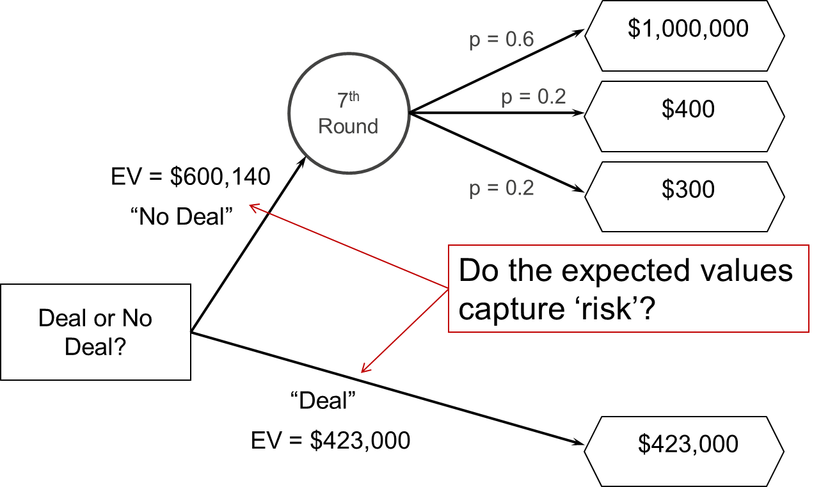

To “solve” a decision tree, we take expected values (weighted averages) of the outcomes associated with each chance node; and choose the most advantageous branch at each decision node.

What does the expected value calculation suggest that Ms. Rodriquez should do?

***Linked Decision Trees***

Consider the manager of a forest who wishes to minimize the number of acres lost to fire. It’s possible to conduct a fuel‐reducing burn as a preventative measure, but this will result in the loss of some acres. If a fuel reducing burn is not conducted and a wildfire erupts, there is a subsequent decision whether to fight the fire or not, with some uncertainty as to the efficacy. The uncertainties and risks are expressed in the following decision tree. What is the best decision?

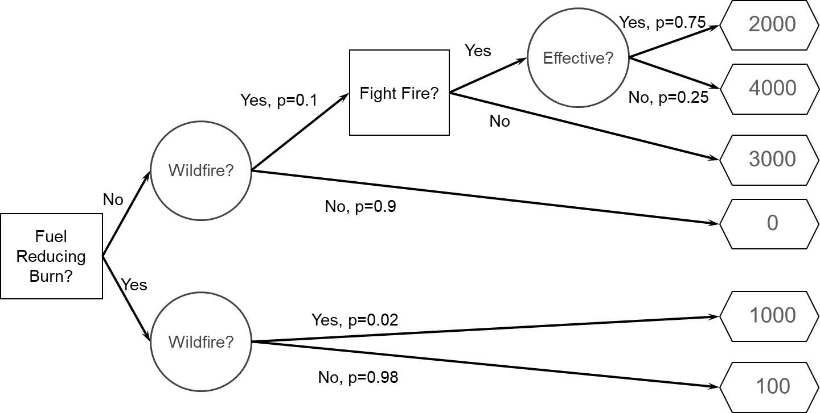

The solution is found by solving the tree from right to left, using expected values as chance nodes, and optimal (in this case, minimum) values at decision nodes.

In the first step, we take the expected value (weighted average) over the uncertainty about effectiveness, and reduce the last chance node to its average.

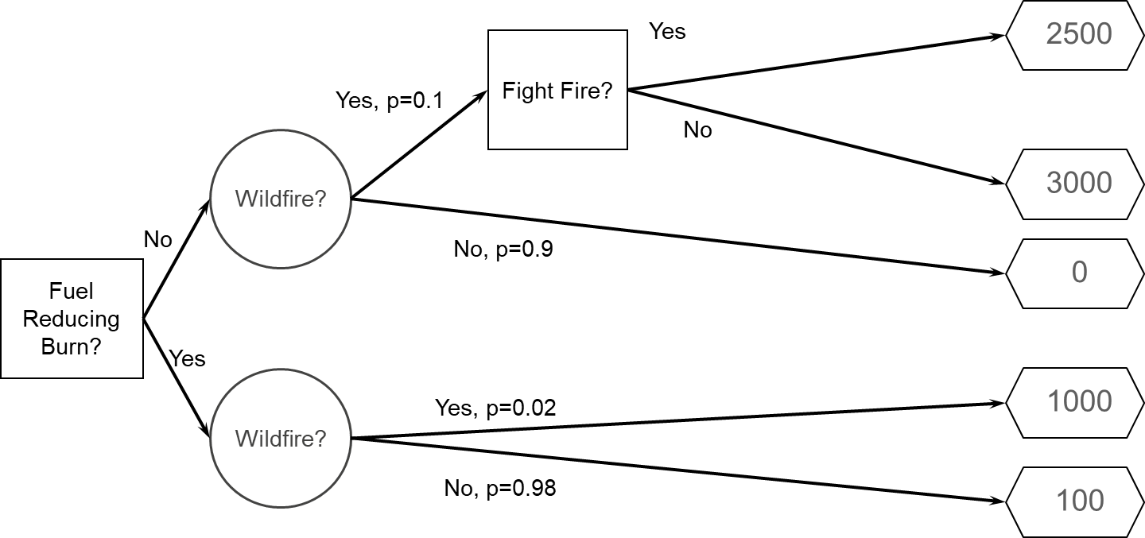

In the second step, we take the minimum over the “Fight Fire?” decision node (because if we got to that point, we would choose to fight the fire (expected value = 2500).

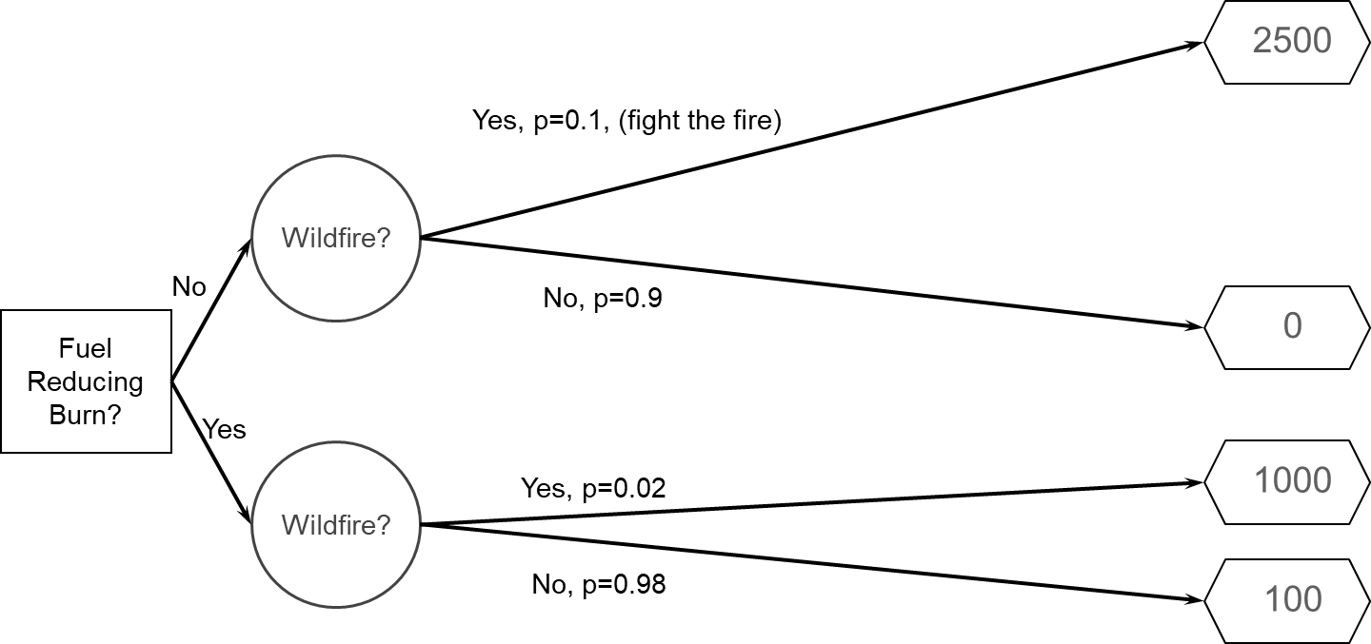

In the third step, the expected number of acres lost is found, using the probabilities of wildfire to weight the outcomes.

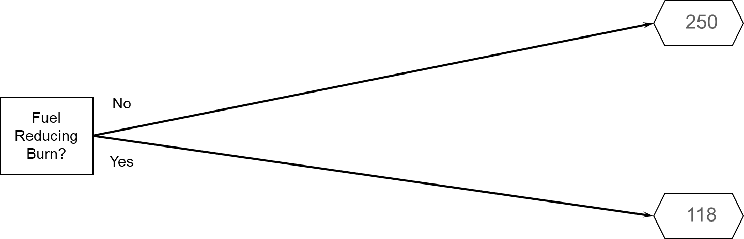

In the final step, the decision with the minimum expected value is found. Thus, we should choose to conduct the fuel‐reducing burn.

The simplest game in the Maryland Lottery is the Pick‐3. A ticket costs $1. You pick three numbers, in order. If you place a straight bet and your number comes up, you win $500**. Construct a decision tree to represent** **this situation, and solve it.** Should you buy a Pick‐3 lottery ticket?

**RISK TOLERANCE**

Why would anyone buy a lottery ticket?

Here’s a decision tree for car insurance (assuming it’s not mandatory):

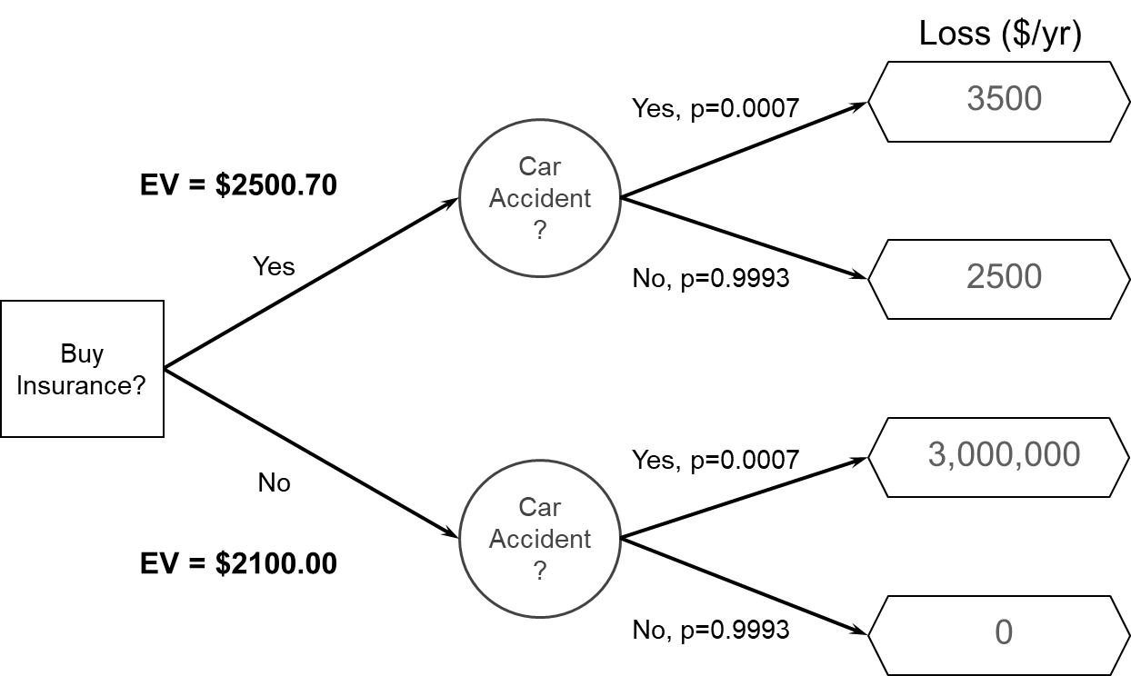

Why would anyone buy car insurance?

***Risk Attitude***

A risk‐neutral decision maker is happy to use the expected values to make a particular decision. But there are many occasions when the decision maker’s risk attitude is not neutral:

* Risk‐averse
* You would trade a gamble for a sure amount that is less than the expected value of the gamble
* e.g., buying insurance
* Risk‐seeking
* You would trade a sure amount for a gamble that has a smaller expected value (but the chance of a larger payout)
* e.g., buying lottery tickets
* The decision‐maker’s approach to risk is a function of their values
* Individuals have different risk avoidance and risk seeking preferences
* Risk tolerance is also context‐dependent
* In our context, the risk tolerance is often a public value; whose values matter? Who decides the approach to risk?
* Legal mandates (e.g., ESA)?
* Western science (5% p‐values)?
* Other?

***Methods for Grappling with Risk Attitude***

* Optimization
* Maximize (or minimize) the expected value of objective function
* Actual performance can be less, owing to uncertainty. Just accept that.
* Mini‐max, Maxi‐min
* Select the action that minimizes the maximum loss (i.e., minimize the worst case if the outcome is not what you wanted)
* Or maximize the minimum gain (i.e., select the action that gives you greatest chance of some minimum amount)
* Satisficing and robustness
* Focus on attaining a minimum satisfactory performance requirement
* Beyond that, select the action that guarantees this minimum performance over greatest range of uncertainty (robust to uncertainty)
* Utility
* Translate the values (return) into a utility scale that expresses risk attitude and select the action that has the highest “expected utility”

|  |  |  |  |  |  |  |  |
| --- | --- | --- | --- | --- | --- | --- | --- |
| Action | Outcome | | | | EV | Maxi-Min | P>15 |
|  | 0 | 10 | 20 | 30 |  |  |  |
|  |  |  |  |  |  |  |  |
|  |  |  |  |  |  |  |  |
| A | .25 | .25 | .25 | .25 | 15 | 0 | 50% |
| B | .00 | .25 | .50 | .25 | 20 | 10 | 75% |
| C | .10 | .20 | .00 | .70 | 23 | 0 | 70% |
| D | .20 | .00 | .80 | .00 | 16 | 0 | 80% |

***Decision Tree with Utility***

The manager of a hatchery has received a proposal to install a new technology. If it works, the new technology will increase the production from 40,000 to 70,000 fry per year. If it does not work, the carefully tuned methods of the hatchery will be disrupted and the production will drop to 10,000 fry/year. There is an 80% chance that the technology will work. Should the manager install the new technology?

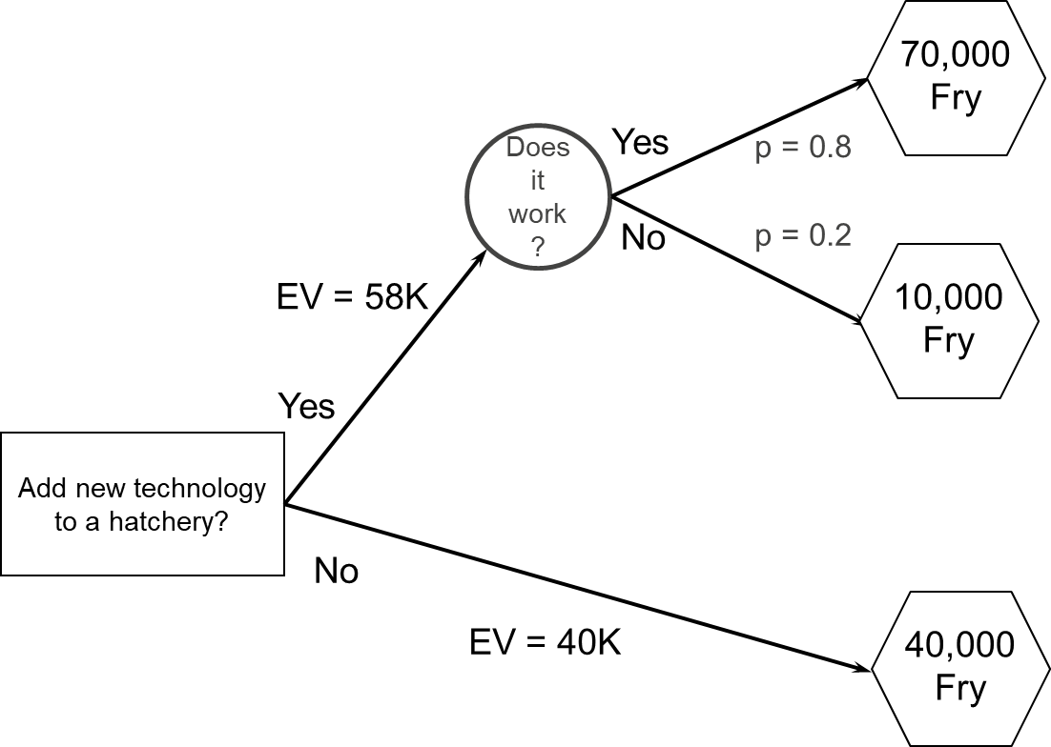

The answer depends on the decision maker’s risk attitude. Let the utility scale range from 0.0 for 10,000 fry (worst case) to 1.0 for 70,000 fry (best case). Suppose a particular decision maker is meeting Recovery Plan goals with 40,000 fry, but would not with 10,000 fry, so assigns a utility of 0.9 to the current production. What decision would the manager choose? How would you describe the risk attitude?

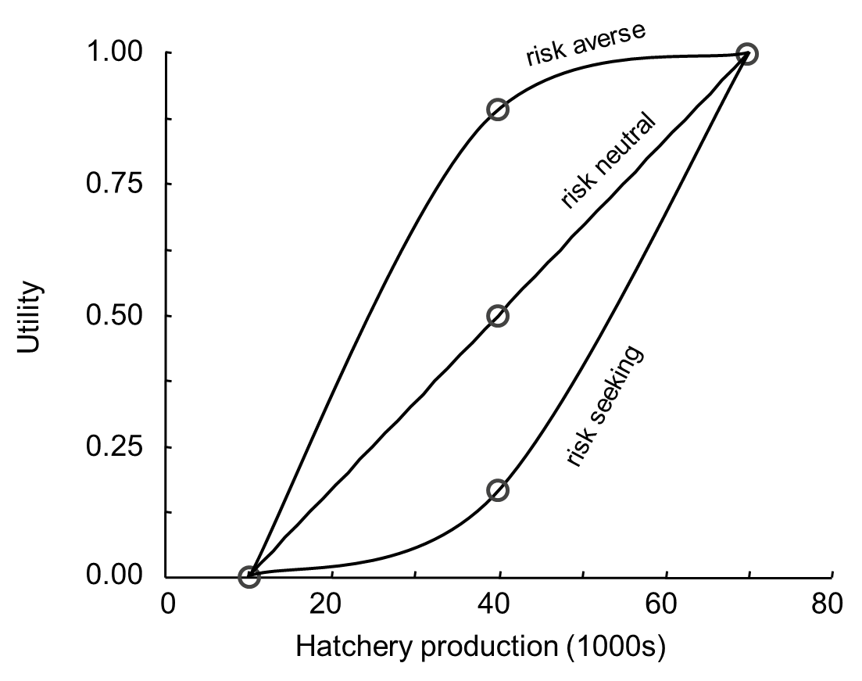

**SUMMARY OF RISK PROBLEMS**

* The challenge is irreducible uncertainty (or uncertainty that is too costly to reduce)
* The primary approach is to express the uncertainty with probability, and evaluate the alternatives using the expected value
* This requires considering a new values‐based aspect, the risk tolerance of the decision maker

**REFERENCES**

Regan HM, Colyvan M, Burgman MA. 2002. A taxonomy and treatment of uncertainty for ecology and

conservation biology. Ecological Applications 12:618‐628.

**MODULE DEVELOPED BY:**

Michael C. Runge, *USGS Patuxent Wildlife Research Center*

Suggested Citation for this Module:

Runge MC. 2016. Risk problems. Module 11 *in* Runge MC, Romito AM, Breese G, Cochrane JF, Converse

SJ, Eaton MJ, Larson MA, Lyons JE, Smith DR, Isham AF, eds. Introduction to Structured Decision Making, 2016 edition. U.S. Fish and Wildlife Service, National Conservation Training Center, Shepherdstown, West Virginia, USA.