**OBJECTIVES**

By the end of this module, you should be able to:

* Understand a variety of ways in which SDM can be applied, depending on the particular decision context
* Understand the value of rapid prototyping
* Understand the possible players and their roles in an SDM process
* Be able to identify and resolve common SDM process impediments

**SELF‐REFLECTION**

Refer to the five decisions you wrote down at the start of the course(see p. 01‐1), for some or all of them, what process did you use to make them, were you satisfied with that process; how much effort did you invest in the decision, and was that investment appropriate?

**DEPTH OF ANALYSIS CONSIDERATIONS**

* Decision analysis is useful for all decisions worth thinking about
* ONLY A SMALL FRACTION (10%) OF DECISIONS ARE WORTH THINKINGABOUT!!!!
* 20% are “no brainers” where the appropriate choice is obvious
* 70% are so inconsequential that they merit little or no thought

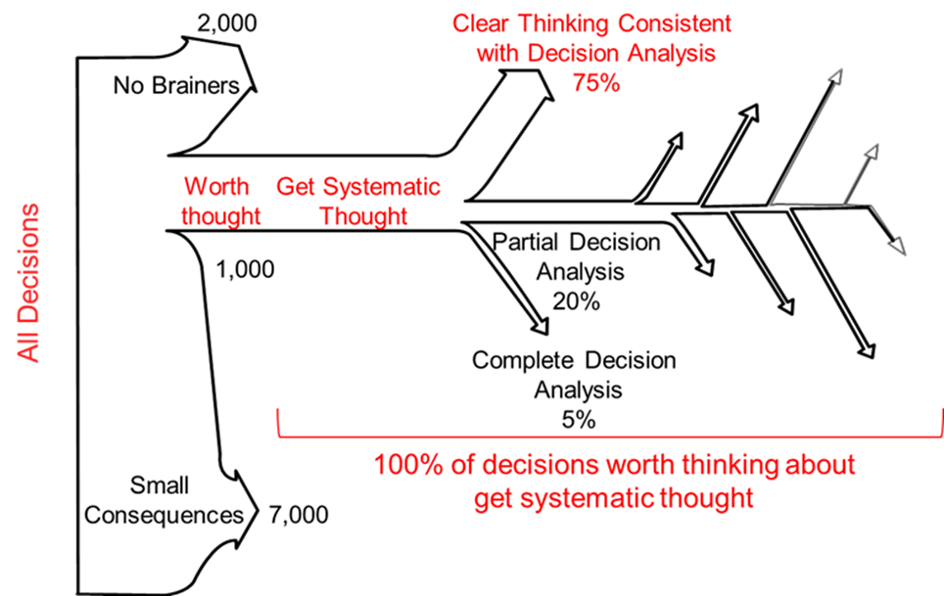

Figure 1. A prescription of how 10,000 hypothetical decisions should be resolved. Figure modified from Keeney (2004).

***When to apply decision analysis***

* Application does NOT necessarily mean doing a formal analysis.
* Application does NOT necessarily mean going through each of the elements on every decision
* Application DOES mean explicitly and logically addressing decision impediments
* Rough analysis is often sufficient to make good choices in most decision situations
* Rather than selecting the best alternative, just eliminate the bad alternatives

***Scale of decision problems at which SDM can be useful***

* A single decision maker at their desk with an hour
* An office team making a decision in a week
* Committee with 2‐3 months to make a decision
* Multi‐year, large stakeholder group process

**THE IMPORTANCE OF RAPID AND ITERATIVE PROTOTYPING**

Often, it is difficult to know at the outset how much time and energy to invest in a particular decision. A sensible solution is rapid and iterative prototyping, where you start small and expand effort incrementally until you’ve found the right investment.

* Develop a full but coarse prototype in a relatively short time period (~ a few days)
* Include all the elements of a structured decision, but keep them very simple
* Benefits:
* Low risk, high return approach
* Figure out if SDM is appropriate
* Identify roadblocks early
* Identify key uncertainties and data needs early
* Provide participants with idea of how it works
* Evaluate the prototype
* With the decision maker:
* Does the structure correctly represent the decision?
* Are the objectives complete and accurate?
* What insights are gained by the gut‐feeling reaction to the tentative preferred alternative?
* With the technical experts:
* What are the weakest parts of the analysis?
* What does sensitivity analysis reveal?
* Revise the prototype
* Based on the insights from the evaluation, invest time as appropriate in developing those aspects of the decision analysis that most need work. This may involve
* More work to articulate objectives and develop measurable attributes
* Model development, expert elicitation, or other analysis to refine the consequence analysis
* Stakeholder involvement to elicit weights on objectives or risk tolerances
* Implementation of technical aspects, like formal optimization
* Keep in mind that the problem could have been framed incorrectly, and may need wholesale revision
* Repeat as needed, always involving the decision maker at every evaluation step
* When are you finished?
* When the analysis meets the needs of the decision maker, both for deliberation and for communication
* The analysis does not need to be perfect—a decision analyst will always want to fix a few more details—it just needs to be useful. It needs to robustly provide the decision maker with the clarity of thought and justification to choose a course of action and communicate it to the appropriate constituents.

**HOW TO BE A VALUABLE PARTICIPANT IN A DECISION‐MAKING PROCESS**

***Process Alternatives & Scale Considerations***

The decision maker or the decision facilitator will have given thought to how to structure a decision‐making process, taking into account process objectives, the context of the decision, and other factors. There are many different shapes that an SDM process can take, depending on the needs of the decision maker and the context of the decision. They all start with an initial problem framing with the decision maker, but from there, they can take many forms:

* An analysis by the decision maker, either qualitative or quantitative, with relatively little input from others
* An internal analysis with the decision maker, a decision analyst, and possible a few staff experts
* A single workshop, with the rest of the analysis handled in house
* A workshop with stakeholder to understand the range of values positions
* A workshop with technical experts to understand the scientific underpinnings
* An expert elicitation to develop the consequence analysis
* A series of workshops
* With the same group of stakeholders, the series of workshop depends the analysis (with increasingly detailed prototypes)
* With a different group of stakeholders each time; often this starts with a small core group of stakeholders then broadens each time to make the group more and more inclusive

***Common Roles in Collaborative Decision Processes***

*(Definitions modified from Walker & Senecah 2011)****:***

* **Decision maker:** This party has the authority and resources to make and implement a decision.
* Single DM, multiple DMs, delegated authority, contested authority
* **Stakeholder:** An organization or person who may be directly affected by the decision in question, whose participation may be needed in the implementation of decisions, and/or who has a keen interest in the outcome of the decision. Advocates are stakeholders with a strong position on some issues.
* **Participant:** This party has an interest in the situation but no strong positions. A participant wants to be involved in the situation but is not a primary voice for a particular point of view or outcome.
* **Representative:** This party participates in or advocates on behalf of a group or organization. The representative may or may not have decision authority from the party that he or she represents.
* **Information provider:** This party provides data or information pertaining to relevant issues. The information provider is generally an expert in a technical field or an important source of local knowledge. These neutral parties include scientific experts, policy/legal experts, statistical experts, etc.
* Neutral parties
* **Initiator:** This party that identifies the need for the process. The initiator may then become a convener or sponsor or seek parties to fulfill other roles.
* **Sponsor:** This party provides support for the process. A sponsor may simply lend its name to the process or may also provide resources (money, a site, supplies, speaker, etc…). A sponsor may or may not also be the convener.
* **Convener:** The person or organization with sufficient credibility to invite stakeholders to address a problem collectively. This party will also act as a “champion” through‐out the longevity of the process.
* **Decision Coach:** This party guides all other parties through the decision‐related elements of the collaborative process. The decision coach may or may not also be the facilitator.
* Neutral party
* **Facilitator:** This party guides the process in an impartial manner. The facilitator may be internal to the situation (e.g., a member of an involved organization) or may be external (e.g., a consultant), but they should be a neutral party to the decision. The facilitator may or may not also be the decision coach.
* Neutral party

***Roles in the PrOACT Process***

* Information providers, decision coaches, and facilitators are neutral players throughout the SDM process
* Information providers (AKA: technical experts) may also have a stake in the decision outcome. If acting as technical experts, they need to agree to wear their “expert” hat
* Facilitators and decision coaches must be neutral and viewed as neutral by other players to be effective in their roles
* Facilitators and decision coaches play important roles throughout the PrOACT process
* Stakeholder involvement is important in the early design and development phases of PrOACT
* Problem framing, ID and structuring of objectives, objective weights, alternative development
* Information provider role is more important in later stages of PrOACT process
* Identification of creative alternatives
* Development of model that links objectives and decisions to system understanding
* Trade‐off evaluation and sensitivity analysis

**TABLE 1.** Key players in collaborative decision processes and their respective participation in each step of the structured decision process. In column 2, neutral roles are indicated with a “N,” while vested roles are indicated with a “V.” “X” indicates that the player has an active role in the step of the PrOACT process, while “?” indicates that the player’s role is variable (see governance section below).

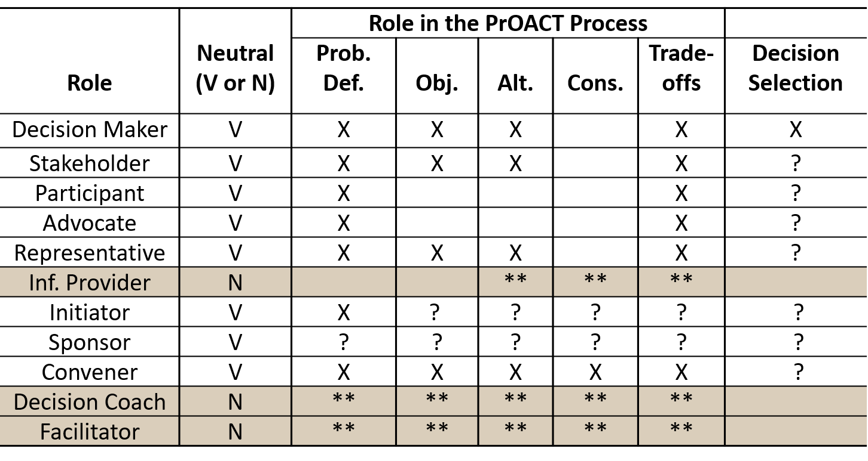

? = Participation is variable

** = Participation is active but neutral

V = Vested

N = Neutral

**PROCESS IMPEDIMENTS AND SOLUTIONS**

* Problem: Not involving important decision makers or stakeholders.
* Solution: Don’t rush Problem Definition and be on the look‐out for stranded objectives.
* Problem: Inability to garner buy‐in from important decision makers or stakeholders.
* Solution: Bottom‐up → Convince decision implementers that it helps them to do (and communicate) their job in a transparent fashion.
* Solution: Top‐down →Show decision‐makers that being involved helps their bottom line.
* Problem: Confusing scientific uncertainties with values/objectives.
* Solution: Define objectives first, then work on technical issues.
* Problem: Difficulty in solving large, complex problems.
* Solution: Use PrOACT approach to simplify problem into modular steps.
* Problem: Communication of approach and results to a lay audience.
* Solution: Describe results and approach using familiar examples, and emphasize the conceptual and graphical over the mathematical.
* Problem: Too much time on refinement of unimportant details.
* Solution: Structure technical working groups carefully, and encourage model simplicity.

**SUMMARY**

Decision processes matter. How much time to invest in a decision, who to include and what their roles should be, how to structure the sequence of analysis—all these questions are important to the success of a decision process. Know your role. Use PrOACT to guide you. Think about the depth of analysis warranted. Prototype. What would you have changed about the process you used in past decisions? How will this guide you in the future?

**REFERENCES**

Bourget L, Bingham G. 2011. Considering convener, stakeholder, and decision‐maker issues. *In* Bourget

L, ed. Converging Waters: Integrating Collaborative Modeling with Participatory Processes to make Water Resource Decisions. Alexandria, Virginia, IWR Press. 218 p.

Conroy MJ, Peterson JT. 2013. Decision Making in Natural Resource Management: A Structured Adaptive

Approach. Hoboken, New Jersey, USA: John Wiley and Sons, Ltd.

Keeney RL. 2004. Making better decision makers. *Decision Analysis* 1(4): 193‐204.

Keeney RL. 2007. Developing Objectives and Attributes. *In* Edwards W, Miles RF, von Winterfeldt D, eds.

Advances in Decision Analysis: From Foundations to Applications. Cambridge, Massachusetts, USA: Cambridge University Press. 539 p.

Walker GB, Senecah SL. 2011. Collaborative governance: Integrating institutions, communities, and

people. *In* Dukes EF, Firehock KE, Birkhoff JE, eds. Community‐based Collaboration: Bridging Socio‐ecologicalResearch and Practice. University of Virginia Press, Charlottesville, Virginia. 227 p.

**APPENDIX: WHAT IF YOU’RE THE FACILTATOR?**

**PLANNING A DECISION PROCESS**

***Consider Process Objectives***

* The process by which an alternative is chosen can be just as important as what alternative is chosen
* Process objectives are especially important for public decisions made by the government
* Recognize that the decision context of how to make the decision and the decision context of whatdecision to make are different.
* The same decision makers face both decision contexts, but the context differences areimportant. The objectives to be achieved and the alternatives for each are different.
* Examples of process objectives
* Use quality information
* Involve the public
* Communicate with all concerned parties
* Ensure quality decision‐making
* Coordinate with other decision‐makers
* Maximize process transparency
* Minimize budget and time for the analysis
* Incorporate tribal knowledge into consequence analysis

***Determining Workshop Purpose: Informational vs. Technical***

* Informational: Used to introduce larger stakeholder group to decision problem and SDM process
* Large group, may be open to the general public
* Good venue to foster buy‐in from higher‐up decision makers
* Used to foster process buy‐in and ensure transparency
* Technical: Used to conduct most of the SDM Process
* Should be a small group (< 20 people)
* Access limited to core working group
* Maintain consistency in core group (where appropriate)
* Strategically guide participant interaction

***Time & Cost Considerations***

* The front‐end of participatory SDM process may be more expensive but good decisions (and more robust results) can shorten the back‐end costs of a decision
* e.g., by helping to avoid litigation, contributing to learning, etc…
* Long‐term benefits (even if realized) don’t change the short‐term budget and time implications of the up‐front investment by:
* Agencies
* Stakeholders
* Technical experts, etc…
* Consider the following:
* What types of modeling and/or facilitation assistance will be needed?
* What other types of technical expertise will be needed?
* Is collaboration really necessary?
* Use stakeholder analysis to help make this determination
* Given the range of options for framing the scope of issues and defining the objective of the process, what might be the anticipated duration of the process?
* Will financial assistance be needed to get the right people to the table?
* Direct expenses (travel)
* Time commitments for technical experts
* If financial assistance is not available, what are other means of recognizing stakeholder or technical expert contributions?
* Involving stakeholders in planning discussions can be useful for:
* Trust‐building
* Transparency
* Ensuring process offers sufficient incentives for participation
* Building initiatives to raise funds from external sources

***A word about technical advisors***

* Should be viewed by stakeholders as neutral 3rd parties (and be willing to act as such)
* Sometimes the line b/w technical advisors and stakeholders is not clear → Must decide which “hat” to wear
* Choose wisely
* Keep # relatively small
* Assure relevant experience
* Avoid duplication of expertise
* Bonus: Good communicators

**DEVELOPING A GOVERNANCE STRUCTURE FOR COLLABORATIVE DECISION PROCESSES**

* Governance is fundamentally about the exercise of power in making decisions in the public sphere
* Collaborative governance emphasizes shared power and joint decision making
* Not all governance structures are collaborative BUT all parties involved should agree to the rules of engagement
* Governance rules should define structure and ID roles and responsibilities
* Rules of governance should establish how decisions will be made (some examples are provided below)
* Autocratic decision making is when the decision maker maintains absolute control of the decision. This means that the decision‐maker is completely responsible for the decision outcome.
* Advantages: Decisions are typically made quickly and there is a single decision maker to hold accountable for the outcome.
* Disadvantages: Low buy‐in from decision implementers and other stakeholders, a lack of transparency, and a high potential for conflict among parties affected by the decision outcome.
* Democratic decision making involves majority rule where the choice of a preferred decision is arrived at by simple majority vote.
* Advantage: Generally perceived as the fairest form of decision‐making
* Disadvantage: There are winners and losers in the process which can lead to conflict among stakeholders.
* Consultative decision making involves a single decision‐maker, but decisions are made after input is received from others. Similar to autocratic, one person still makes the decision, but others are solicited for ideas and suggestions.
* Advantage: Input helps the decision‐maker understand the issues at hand, and participants (biologists, scientists, the public) generally appreciate having their opinions heard and acknowledged.
* Disadvantage: Participants may assume that they will have a say in the final decision which is not the case.
* Consensus decision making is a process used by groups to generate widespread levels of participation and agreement.
* Advantages: There are variations among different groups regarding the degree of agreement necessary, but the goal of consensus processes is to generate as much as agreement as possible to facilitate ownership and buy‐in.
* Disadvantages: Reaching consensus can take a long time. And a lot of facilitation. Consensus also requires the willingness of stakeholders to share their objectives and ideas/beliefs openly. Finally, consensus can easily lead to gridlock as decisions can be forestalled by a single stakeholder.
* Governance structure should also define guidelines for conducting meetings
* How to conduct discussions
* How to introduce new topics
* Length limits for discussions
* Other limits – e.g., # of times participants can speak at a meeting (if necessary…)

**REGULATORY PROCESS CONSIDERATIONS**

There are some legal considerations regarding the process that is used to make decisions within the Federal Executive Branch. A few of those considerations follow.

***The Administrative Procedures Act (APA) and the National Environmental Policy Act (NEPA)***

* The APA
* Allows private citizen to challenge agency actions in Federal court.
* Action or order is "arbitrary and capricious, an abuse of discretion, or otherwise not in accordance with the law."
* The only mechanism to bring a NEPA challenge.
* Often used for ESA.
* Why it’s important to do it right:
* Statute of limitations for agencies under the APA is 6 years
* Challenges can come any time during that period
* NEPA
* Section 102(2)(c) requires that an environmental impact statement be prepared for major federal actions that may significantly affect the quality of the human environment.
* However, some level of NEPA is required whenever an Agency proposes an action. These actions may be covered by Categorical Exclusions to NEPA or analyzed in an EA or EIS.
* Take home messages from NEPA:
* Develop a transparent process for how actions would be implemented and adjusted over time
* Incorporate potential impacts of alternate management scenarios into analysis
* NEPA can be an easy legal challenge, don’t avoid your NEPA requirements

***The Federal Advisory Committee Act***

* FACA governs committees “established or utilized by one or more federal agencies in the interest of obtaining advice or recommendations.”
* FACA Exemptions:
* Group comprised ENTIRELY of federal, state, tribal and local government employees
* Group established to perform an operational rather advisory function
* Group that provides technical rather than policy advice
* Group that provides individual advice versus group consensus
* FACA Requirements:
* Committee charter developed and filed
* Renew charter every 2 years
* Maintain detailed minutes
* Meetings open to the public
* Take Home Messages for FACA
* Charter a committee if necessary for your planning process
* If time is critical, explore using possible FACA exceptions
* Work with your solicitors to avoid issues

**MODULE DEVELOPED BY:**

Angela Romito, *US FWS Southeastern Regional Office*

Mike Mayer, *Louis Berger Group, Inc.*

Michael C. Runge, *USGS Patuxent Wildlife Research Center*

Suggested Citation for this Module:

Romito A, Mayer M, Runge MC. 2016. Process. Module 14 *in* Runge MC, Romito AM, Breese G, Cochrane

JF, Converse SJ, Eaton MJ, Larson MA, Lyons JE, Smith DR, Isham AF, eds. Introduction to Structured Decision Making, 2016 edition. U.S. Fish and Wildlife Service, National Conservation Training Center, Shepherdstown, West Virginia, USA.