**MODULE OBJECTIVES**

* Understand the relationship between recurrent decisions, dynamic decisions, and adaptive decisions
* Understand the role of monitoring in adaptive management

**UNCERTAINTY**

* What do we do in the face of uncertainty?
  + Make decisions anyway
    - Risk
  + Conduct research to reduce uncertainty (then make a decision later)
    - Value of Information
  + Both, simultaneously
    - Adaptive management

**OUTLINE**

* Recurrent Decision Problems
  + What are recurrent decision problems
  + What are dynamic decision problems
  + How do we solve them?
* SDM for Recurrent Decisions
* Adaptive Management
  + Monitoring
  + Adaptive Optimization
    - Brielle on forward simulation approach

**RECURRENT DECISIONS**

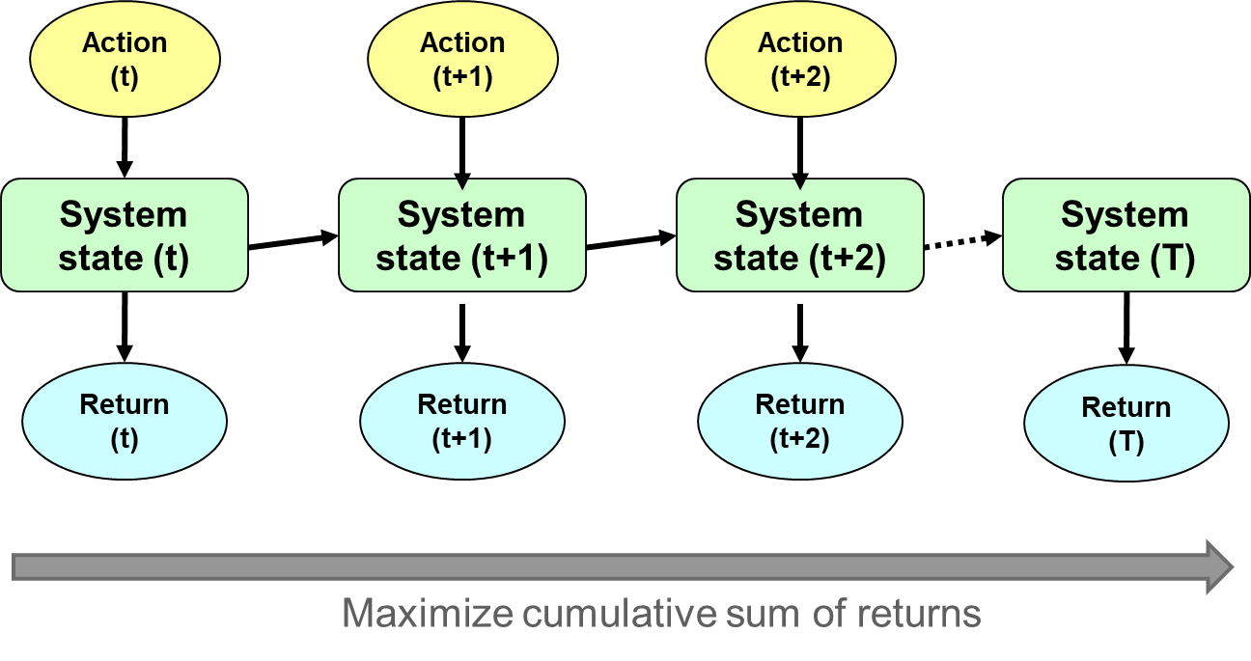

What are some examples of recurrent decisions in natural resources management?

**RECURRENT DECISIONS**

* We approach recurrent decisions using SDM. But there are nuanced differences:
  + They are typically dynamic (today’s decision affects future system state and thus future decisions)
  + They can be adaptive (monitoring the consequences of actions can help reduce uncertainty)

**DYNAMIC OPTIMIZATION**

* Wild Oryx (Tenhumberg et al. 2004)
* Objective: maximize persistence
* Annual decision: do nothing, capture wild animals, release captives
* Dynamics: figuring out what to do this year requires anticipating how our action this year will influence the population this year but also how it will influence our decisions and outcomes in all future years

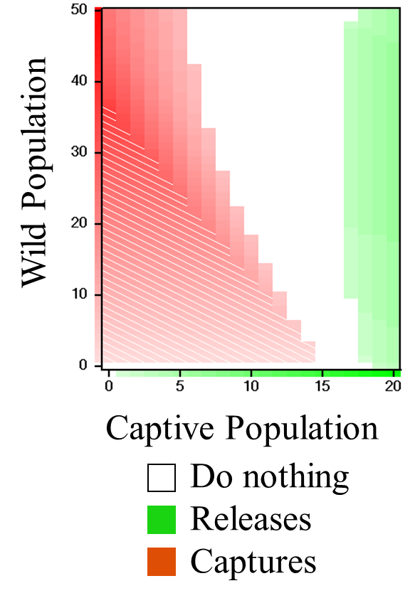

**LINKED DECISION TREES**

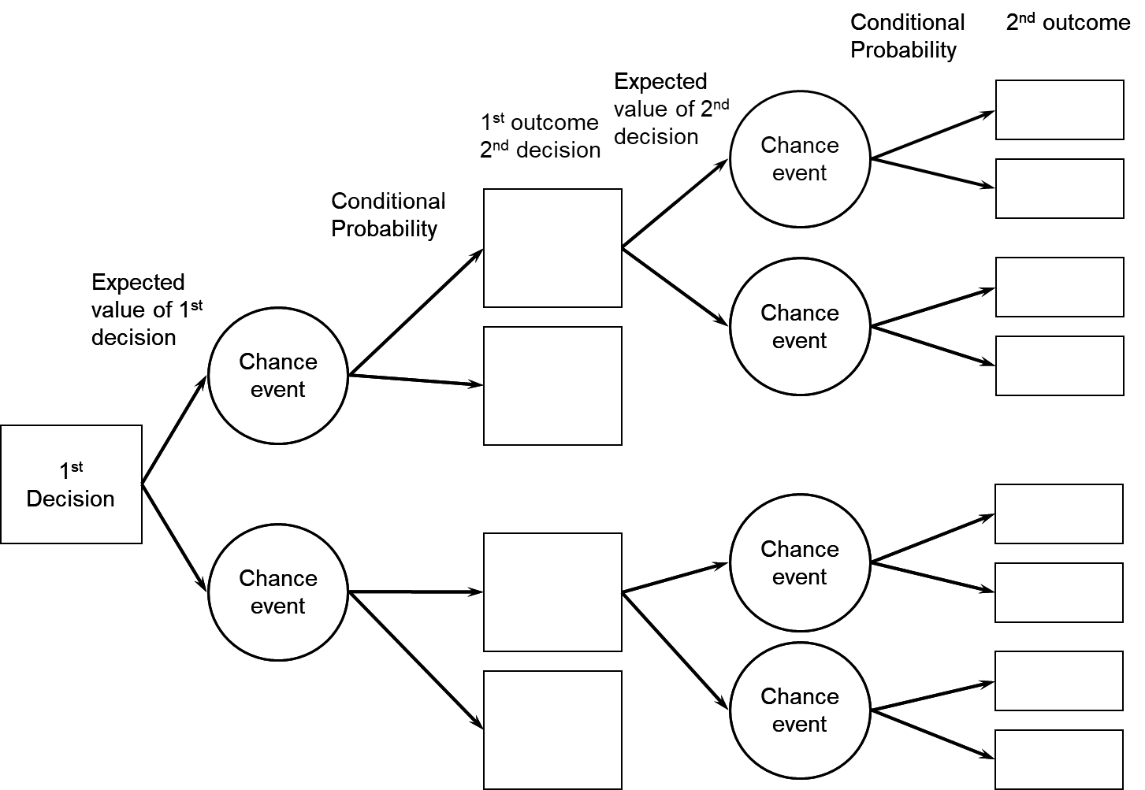

**SDM FOR DYNAMIC DECISIONS**

* How do the elements of SDM need to be thought of for recurrent decisions?
  + Objectives
  + Actions
  + Models
  + Optimization
  + Monitoring

**ADAPTIVE MANAGEMENT**

* Seeks to optimize management decisions in the face of uncertainty, using learning at one stage to influence decisions at subsequent stages
* In active adaptive management, we specifically consider the acquisition of information in the optimization
* In passive adaptive management, we take the smartest action we can take given what we know, but we monitor and continually update our models, and may switch actions based on that information

**MONITORING**

* Purposes
  + To determine if the objectives are being met
  + To assess the state of the system
  + To resolve uncertainty
* The development of the monitoring system should be tailored to these needs & driven by the decision context

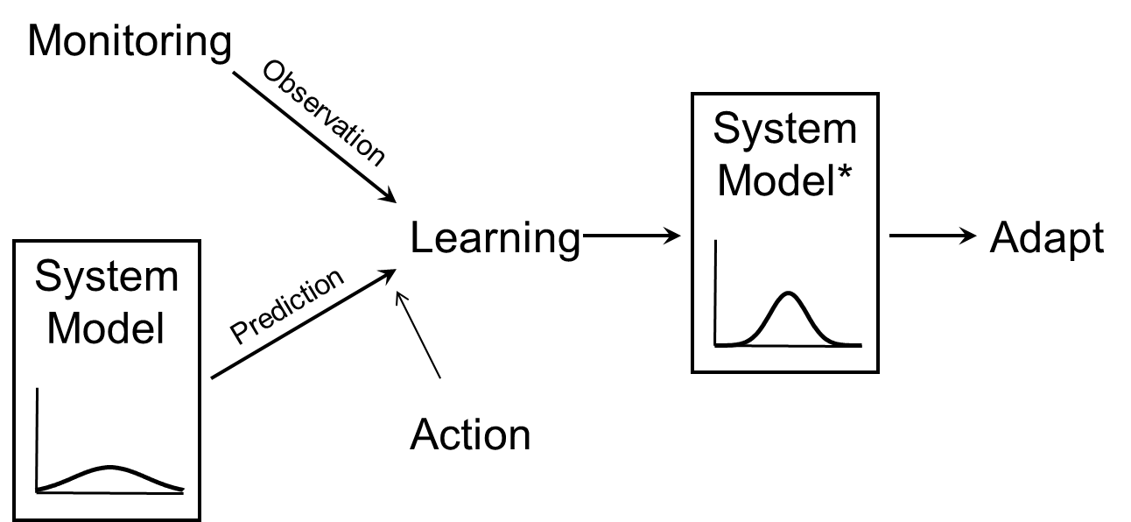

**ADAPTIVE OPTIMIZATION**

* Actions have the potential to reduce uncertainty
  + Perhaps not equally
* Thus, we need to also anticipate how our uncertainty will change over time, and how that will affect future decisions

**ADAPTIVE OPTIMIZATION**

* Adaptive optimization deals with the “Dual Control Problem,” balancing
  + the short-term costs of learning, with the
  + long-term benefits of learning (are “probing” actions warranted?)

**ADAPTIVE OPTIMIZATON**

* Brielle Thompson on AM for managing invasive crayfish

**READINGS**

* Tenhumberg B, AJ Tyre, K Shea, and H Possingham. 2004. Linking wild and captive populations to maximize species persistence: optimal translocation strategies. Conservation Biology 18:1304-1314.
* Marescot L, G Chapron, I Chades, PL Fackler, C Duchamp, E Marboutin, and O Gimenez. 2013. Complex decisions made simple: a primer on stochastic dynamic programming. Methods in Ecology and Evolution 4:872-884.
* Canessa S, G Guillera-Arroita, JJ Lahoz-Monfort, DM Southwell, DP Armstrong, I Chades, RC Lacy, and SJ Converse. 2016. Adaptive management for improving species conservation across the captive-wild spectrum. Biological Conservation 199:123-131.

**EXERCISE**

* Solve the linked decision tree problem
* This is a dynamic problem with only two time-steps
* You are deciding whether to release cohorts from captivity, with the goal of maximizing probability of persistence
  + If you release too many and the population declines, you threaten the species’ captive population
  + But the species will do better if it can get into the wild and grow
* You have a model that predicts the probability of persistence under different combinations of releases and population decline or growth

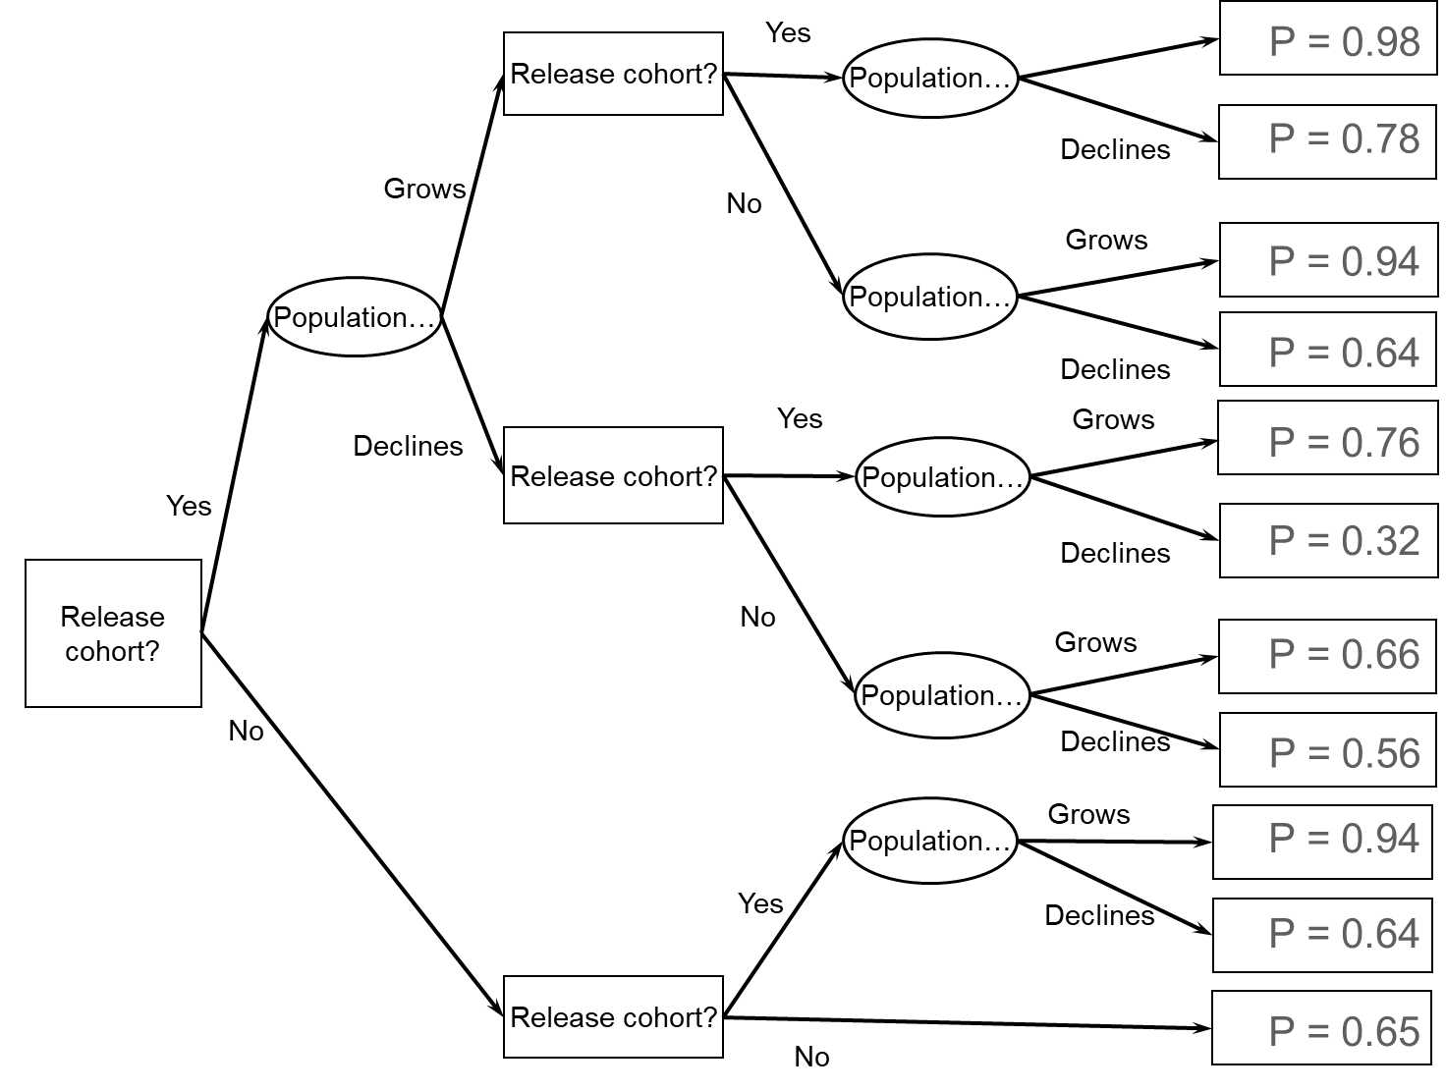

* Assume that the probability of growth is always 0.6 (and so probability of decline is always 0.4)
* Should you release at time 2 if you release at time 1 and the population grows?
* Should you release at time 2 if you release at time 1 and the population declines?
* Should you release at time 2 if you did not release at time 1?
* Should you release at time 1?

**SUMMARY**

* Many decisions we make in natural resource management are recurrent
* Recurrent decisions are frequently dynamic and may be adaptive
* Special consideration must be taken with the modeling and optimization for dynamic and adaptive decisions
* Monitoring is a key component of adaptive decisions

**MODULE DEVELOPED BY:**

Sarah J. Converse, *USGS Washington Cooperative Fish and Wildlife Research Unit, University of Washington*