**MODULE OBJECTIVES**

* Understand the concept of risk and how it affects decision making processes
* Be able to apply several common approaches to dealing with risk

**UNCERTAINTY**

* What do we do in the face of uncertainty?
  + Make decisions anyway
    - Risk
  + Conduct research to reduce uncertainty (then make a decision later)
    - Value of Information
  + Both, simultaneously
    - Adaptive management

**OUTLINE – RISK**

* Review of Risk
  + What is risk
  + How does it affect decision making
* Approaches to Decision-making under Uncertainty
  + Expected Value
  + Maxi-min/Mini-max
  + Robustness
  + Utility

**RISK**

* What is Risk?
  + The chance of a poor outcome
* No matter how careful you are, you still might not like the outcome
  + Cannot eliminate all risk
* Even if we can describe the risks accurately, we don’t know what to do in response

**DEALING WITH RISK**

1. Identify the uncertainty in possible outcomes (consequences) of alternative actions
2. Determine the decision maker or relevant stakeholders’ preferences for responding to risk
   * This is a values decision – either individual-based risk preferences or reflection of a public value
3. Use a transparent, structured approach to ‘solve’ the problem in the way that best reflects these risk attitudes

**DECISIONS UNDER UNCERTAINTY**

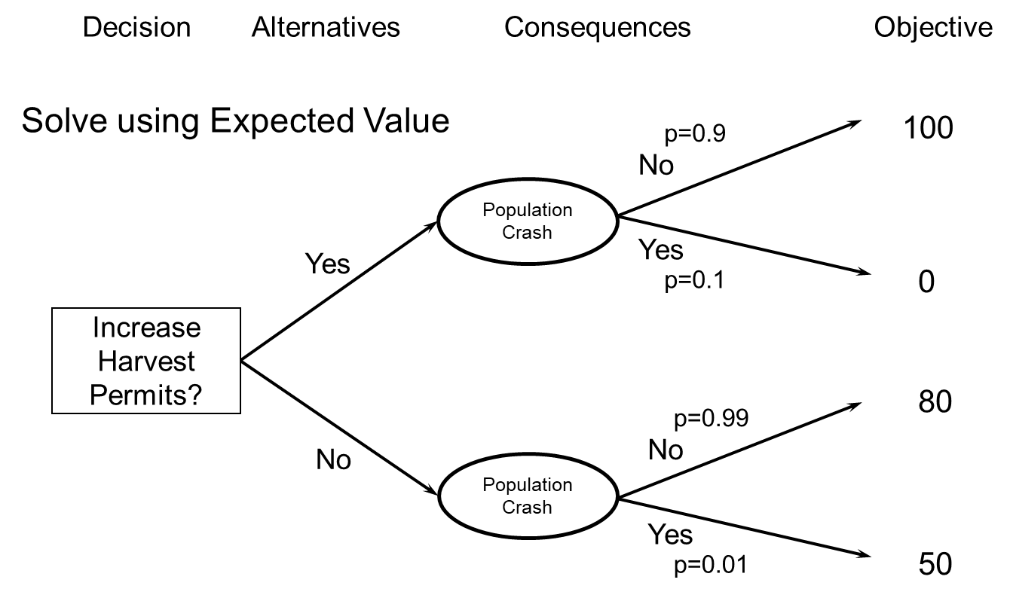

EV(Increase Harvest Permits) =

EV(Do not Increase Harvest Permits) =

**IS EXPECTED VALUE ALWAYS APPROPRIATE?**

* Choose a game to play
  + Game 1: Win $30 with prob 0.5  
     Lose $1 with prob 0.5
  + Game 2: Win $2000 with prob 0.5  
     Lose $1900 with prob 0.5

Which game would you choose?

**IS EXPECTED VALUE ALWAYS APPROPRIATE?**

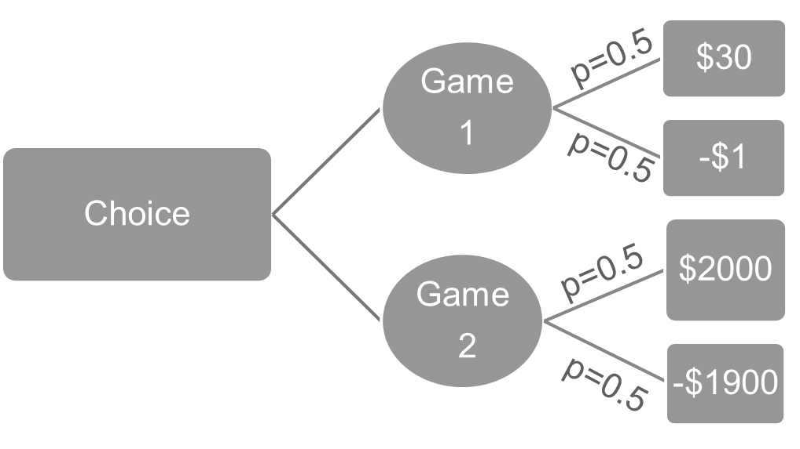

What is the EV of each game?

Did you choose the game with the higher EV?

**EXPECTED VALUE**

* The expected value criterion
  + Is based on long-run averages
* But maybe…
  + A particular decision is rare or unique
  + We care more about the possibility of large loss than about the possibility of an equally large gain

**DEALING WITH RISK**

* Mini-max, Maxi-min
  + Minimize maximum loss, or maximize minimum gain
* Satisficing and robustness
  + Focus on attaining a minimum performance requirement
  + Beyond that, seek a solution that guarantees minimum performance over greatest range of uncertainty
* Utility
  + Translate value into a utility scale that expresses risk attitude
  + Action with greatest *utility value*

**EV, MAXI-MIN, AND ROBUSTNESS**

|  |  |  |  |  |  |  |  |
| --- | --- | --- | --- | --- | --- | --- | --- |
| **Action** | **Outcome** | | | | **EV** | **Maxi-Min** | **P>15** |
|  | **0** | **10** | **20** | **30** |  |  |  |
| **A** | **.25** | **.25** | **.25** | **.25** | **15** | **0** | **50%** |
| **B** | **.00** | **.25** | **.50** | **.25** | **20** | **10** | **75%** |
| **C** | **.10** | **.20** | **.00** | **.70** | **23** | **0** | **70%** |
| **D** | **.20** | **.00** | **.80** | **.00** | **16** | **0** | **80%** |

**EXERCISE**

* We are considering four different alternatives for managing an endangered species:
  + Improve existing habitat quality
  + Expand habitat area
  + Supplement population at an existing site
  + Reintroduce to a new site
* Our outcomes and probabilities are as follows:

|  |  |  |  |  |  |  |  |  |  |
| --- | --- | --- | --- | --- | --- | --- | --- | --- | --- |
|  | **Decline Fast** | **Decline Slow** | **Stable** | **Increase Slow** | **Increase Fast** | **EV** | **Pr(no decline)** | **Maxi-min** | **Utility** |
| **Improve Habitat Quality** | **0.00** | **0.50** | **0.20** | **0.20** | **0.10** |  |  |  |  |
| **Expand Habitat Area** | **0.20** | **0.00** | **0.50** | **0.20** | **0.10** |  |  |  |  |
| **Supp Existing** | **0.05** | **0.20** | **0.35** | **0.30** | **0.10** |  |  |  |  |
| **Reintro** | **0.25** | **0.25** | **0.10** | **0.10** | **0.30** |  |  |  |  |
| **Pr(Persist)** | **0.1** | **0.25** | **0.75** | **0.95** | **1.00** |  |  |  |  |

* Identify the alternative that:
  + Has the highest expected value, in terms of probability of persistence
  + Is most likely to keep the population from declining
  + Has the best (i.e., maximum) worst (i.e., minimum) outcome (maxi-min criterion), in terms of probability of persistence

**UTILTIY**

* Risk-averse
  + You would trade a gamble for a sure amount that is less than the expected value of the gamble
  + e.g., buying insurance
* Risk-seeking
  + You would trade a sure amount for a gamble that has a smaller expected value (but the chance of a larger payout)
  + e.g., buying lottery tickets

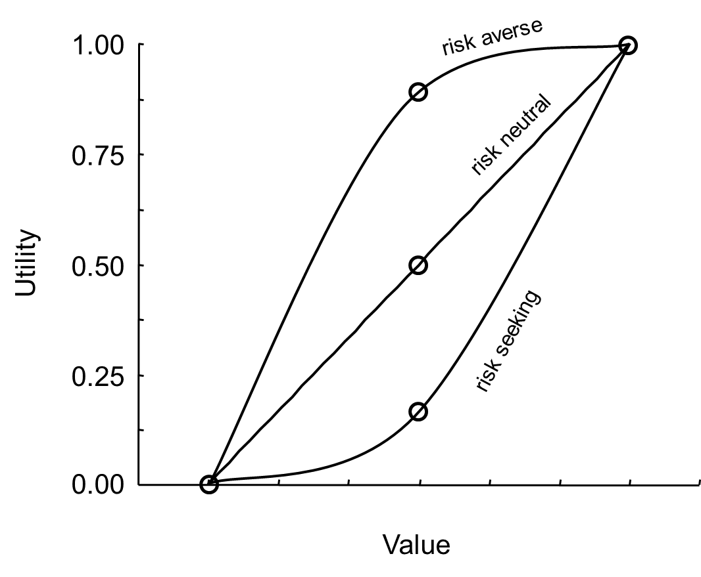

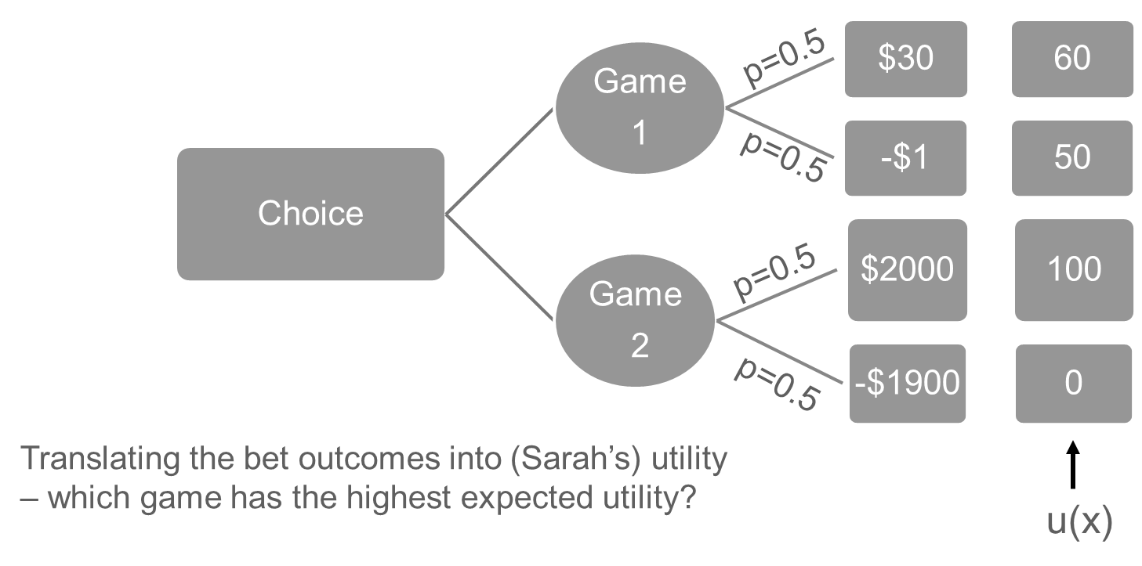

**UTILITY FUNCTIONS**

* Where do we get utility functions?
  + Direct elicitation
  + Probability equivalence, certainty equivalence, and value equivalence methods (these methods set up hypothetical lotteries relevant to the decision and ask decision makers to express their preference for those lotteries)
  + See Goodwin and Wright 2014 Chapter 5 in supplemental reading

**EXERCISE**

* Using my utility function, u(x) = 1/exp(-x/0.4), determine my preferred alternative for the endangered species management problem, where x = probability of extinction, and u(x) is my utility
* Hint: calculations will be just the same as for expected value, except you will substitute u(x) for probability of extinction

|  |  |  |  |  |  |  |  |  |  |
| --- | --- | --- | --- | --- | --- | --- | --- | --- | --- |
|  | **Decline Fast** | **Decline Slow** | **Stable** | **Increase Slow** | **Increase Fast** | **EV** | **Pr(no decline)** | **Maxi-min** | **Utility** |
| **Improve Habitat Quality** | **0.00** | **0.50** | **0.20** | **0.20** | **0.10** |  |  |  |  |
| **Expand Habitat Area** | **0.20** | **0.00** | **0.50** | **0.20** | **0.10** |  |  |  |  |
| **Supp Existing** | **0.05** | **0.20** | **0.35** | **0.30** | **0.10** |  |  |  |  |
| **Reintro** | **0.25** | **0.25** | **0.10** | **0.10** | **0.30** |  |  |  |  |
| **Pr(Persist)** | **0.1** | **0.25** | **0.75** | **0.95** | **1.00** |  |  |  |  |

**SUMMARY**

* Decisions in the face of uncertainty
  + Need to consider decision maker’s attitude toward risk
  + This amounts to valuing outcomes in way that is not linearly related to the gain or loss
  + The expected *utility* can capture the decision maker’s risk attitude
* This assumes we have to live with the uncertainty
  + We don’t always (VOI and adaptive management)

**MODULE DEVELOPED BY:**

Sarah J. Converse, *USGS Washington Cooperative Fish and Wildlife Research Unit, University of Washington*