**MODULE OBJECTIVES**

* Understand the concept of Value of Information
* Be able to calculate Expected Value of Perfect Information and Expected Value of Partial Perfect Information

**UNCERTAINTY**

* What do we do in the face of uncertainty?
  + Make decisions anyway
    - Risk
  + Conduct research to reduce uncertainty (then make a decision later)
    - Value of Information
  + Both, simultaneously
    - Adaptive management

**OUTLINE**

* Review of Information Problems
  + What are Information Problems?
* Value of Information
  + Value of Information Tools
  + Expected Value of Perfect Information
  + Expected Value of Partial Perfect Information

**WHAT ARE INFORMATION PROBLEMS?**

* Should we delay deciding and do some research?
* What monitoring data should we collect?
* What research should we prioritize?
* How much data will we need to collect to improve our decisions?
* Should we undertake adaptive management?

**WHAT ARE INFORMATION PROBLEMS?**

* The answer to all of these questions, in a management context, depends on the *Value of Information*
* How much can information improve our expected management outcomes?

**WHAT KINDS OF UNCERTAINTY ARE WE TALKING ABOUT?**

* Value of Information addresses the value of reducing *epistemic uncertainty*
  + Uncertainty that arises from our incomplete knowledge about our system and is, theoretically, reducible
* Value of Information does not address *aleatoric uncertainty*
  + Uncertainty that arises from inherent variability or stochasticity in a system that is not reducible

**WHAT KINDS OF UNCERTAINTY ARE WE TALKING ABOUT?**

* Epistemic Uncertainty takes two forms
  + Structural uncertainty – what is the overall structure of our model?
    - Example: what is the correct hypothesis regarding how grassland bird nest success varies with extent of prescribed burn within territories?
      * H1: $logit\left(S_{t}\right)= β_{0}+β_{1}*{burn_ex}_{t}$
      * H2: $logit\left(S_{t}\right)= β_{0}+β_{1}*{burn_ex}_{t}+β_{2}*{{burn_ex}_{t}}^{2}$
  + Parametric uncertainty – what is the value of a parameter within a single model?
    - Example: $β_{0} \sim Normal(0.5,0.25)$

**WHAT MAKES UNCERTAINTY MANAGEMENT-RELEVANT?**

Uncertainty is *management-relevant* if and only if…

***Different resolutions of that uncertainty would lead to different decisions AND those decisions would lead to different management outcomes***

What do we mean by “different resolutions of that uncertainty” for our grassland bird example? Put your thoughts in the chat.

**WHAT MAKES UNCERTAINTY MANAGEMENT-RELEVANT?**

In order to maximize nest success…

* Would we do something different if we knew H1 was true versus if we knew H2 was true?
  + H1: $logit\left(S_{t}\right)= β_{0}+β_{1}*{burn_ex}_{t}$
  + H2: $logit\left(S_{t}\right)= β_{0}+β_{1}*{burn_ex}_{t}+β_{2}*{{burn_ex}_{t}}^{2}$
* Would we do something different if we knew that the true value of $β_{0}$ was 0 versus if we knew it was 1?

$β_{0} \sim Normal(0.5,0.25)$

**HOW CAN WE IDENTIFY MANAGEMENT-RELEVANT UNCERTAINTY?**

* Value of Information Analysis
  + Expected Value of Perfect Information: how much would we expect our management outcomes to improve it we could completely eliminate uncertainty?
  + Expected Value of Partial Perfect Information: how much would we expect our management outcomes to improve if we could completely eliminate one source of uncertainty?
  + Expected Value of Sample Information: how much would we expect our management outcomes to improve if we could get a sample of information?
  + Qualitative Value of Information: a measure of EVPI based on a qualitative analysis

**EXPECTED VALUE OF PERFECT INFORMATION**

Back to our Grassland Bird example. This is what we know:

|  |  |  |  |  |
| --- | --- | --- | --- | --- |
| **Hypothesis** | **Belief** |  | **Predicted Outcome under Alternative and Hypothesis** | |
|  |  |  | **Alternative 1 – Heavy Burn** | **Alternative 2 –**  **Moderate Burn** |
| **H1** | **0.4** |  | **0.7** | **0.3** |
| **H2** | **0.6** |  | **0.45** | **0.65** |

Should we undertake research to determine which hypothesis is true?

EVPI = Expected Value under Certainty – Expected Value under Uncertainty

EV(Uncertainty) = maxA(EV(A))

* EV(A1) = Pr(H1)*V(A1|H1)+Pr(H2)*V(A1|H2) = 0.4*0.7 + 0.6*0.45 = 0.55
* EV(A2) = Pr(H1)*V(A2|H1)+Pr(H2)*V(A2|H2) = 0.4*0.3 + 0.6*0.65 = 0.51

EV(Uncertainty) = 0.55

EV(Certainty) = Pr(H1)*maxAV(A|H1)+Pr(H2)*maxAV(A|H2) = 0.4*0.7 + 0.6*0.65 = 0.67

EVPI = 0.67 – 0.55 = 0.12

Should we undertake research to determine which hypothesis is true?

…Put your thoughts in the chat.

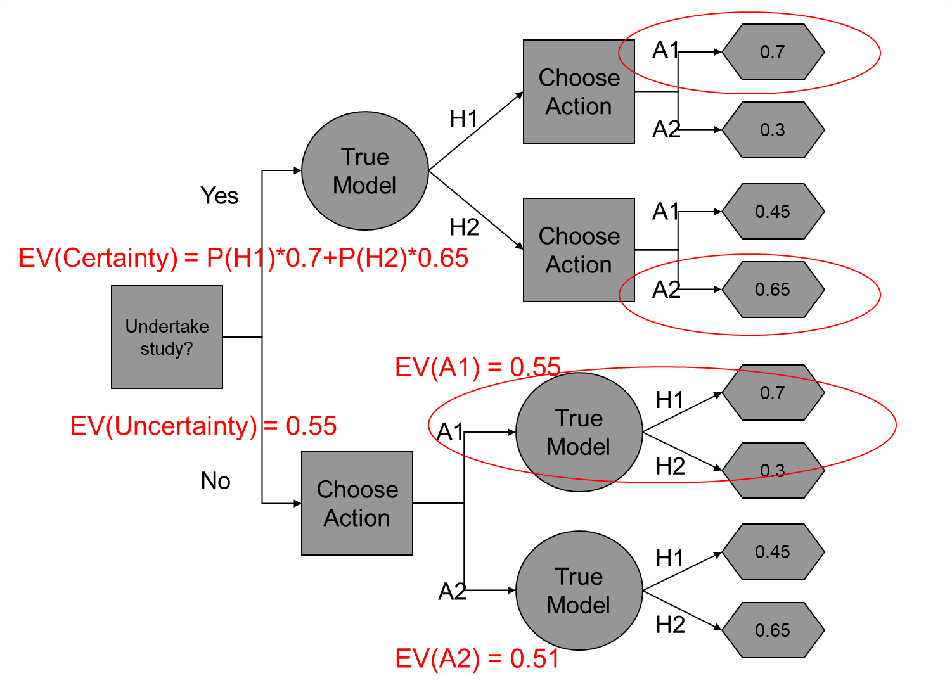

**EXPECTED VALUE OF PARTIAL PERFECT INFORMATION**

* Expected Value of Partial Perfect Information: how much would we expect our management outcomes to improve if we could completely eliminate one source of uncertainty?

We have a new hypothesis and a new action:

|  |  |  |  |  |  |
| --- | --- | --- | --- | --- | --- |
| **Hypothesis** | **Belief** |  | **Predicted Outcome under Alternative and Hypothesis** | | |
|  |  |  | **Alternative 1 – Heavy Burn** | **Alternative 2 –**  **Moderate Burn** | **Alternative 3 – No Burn** |
| **H1** | **0.4** |  | **0.7** | **0.3** | **0.2** |
| **H2** | **0.4** |  | **0.45** | **0.65** | **0.4** |
| **H3** | **0.2** |  | **0.4** | **0.5** | **0.6** |

H1: $logit\left(S_{t}\right)= β_{0}+β_{1}*{burn_extent}_{t}$

H2: $logit\left(S_{t}\right)= β_{0}+β_{1}*{burn_extent}_{t}+β_{2}*{{burn_extent}_{t}}^{2}$

H3: $logit\left(S_{t}\right)= β_{0}$

**EXPECTED VALUE OF PARTIAL PERFECT INFORMATION**

What if I could do an experiment that would either confirm or refute H3?

Let’s call our hypotheses H3 and not-H3

|  |  |  |  |  |  |
| --- | --- | --- | --- | --- | --- |
| **Hypothesis** | **Belief** |  | **Predicted Outcome under Alternative and Hypothesis** | | |
|  |  |  | **Alternative 1 – Heavy Burn** | **Alternative 2 –**  **Moderate Burn** | **Alternative 3 – No Burn** |
| **H1** | **0.4** |  | **0.7** | **0.3** | **0.2** |
| **H2** | **0.4** |  | **0.45** | **0.65** | **0.4** |
| **H3** | **0.2** |  | **0.4** | **0.5** | **0.6** |

H3 above becomes H3 below

H1 and H2 combine to become not-H3 below

* EV(A1|not-H3) = (Pr(H1)*V(A1|H1)+Pr(H2)*V(A1|H2)) / (Pr(H1)+Pr(H2))

= (0.4*0.7+0.4*0.45)/(0.4+0.4) = 0.575

|  |  |  |  |  |  |
| --- | --- | --- | --- | --- | --- |
| **Hypothesis** | **Belief** |  | **Predicted Outcome under Alternative and Hypothesis** | | |
|  |  |  | **Alternative 1 – Heavy Burn** | **Alternative 2 –**  **Moderate Burn** | **Alternative 3 – No Burn** |
| **not-H3** | **0.8** |  | **0.575** | **0.475** | **0.3** |
| **H3** | **0.2** |  | **0.4** | **0.5** | **0.6** |

Then just calculate EVPI on the new table

EV(Uncertainty) = maxA(EV(A))

* EV(A1) = 0.8*0.575+0.2*0.4 = 0.54
* EV(A2) = 0.8*0.475+0.2*0.5 = 0.48
* EV(A3) = 0.8*0.3+0.2*0.6 = 0.36

EV(Uncertainty) = 0.54

EV(Certainty) = Pr(not-H3)*maxAV(A|not-H3)+Pr(H3)*maxAV(A|H3) = 0.8*0.575+0.2*0.6 = 0.58

EVPXI(H3) = 0.58 – 0.54 = 0.04

**EXERCISE**

Calculate EVPXI(H1) and EVPXI(H2)

Considering EVPXI(H1), EVPXI(H2), and EVPXI(H3), if you could confirm or refute just one hypothesis, which one would you take on?

**SUMMARY**

* All information is not created equal – if we claim that information is important for management, we should be able to back that up with Value of Information analyses
* Qualitative Value of Information is a newer method that is designed to provide a qualitative (or semi-quantitative) estimate of EVPI when it is not possible to calculate EVPI
* Information for any VoI analyses can come from existing information or from expert judgment
* The set-up of VoI analyses by itself can be useful – sometimes the simple act of clarifying what our uncertainties are can take away some of the “management paralysis” associated with uncertainty

**MODULE DEVELOPED BY:**

Sarah J. Converse, *USGS Washington Cooperative Fish and Wildlife Research Unit, University of Washington*