**MODULE OBJECTIVES**

By the end of this module, you should be able to:

* Understand and manipulate a spreadsheet-based predictive model for decision making
* Understand the expert elicitation process and its role in decision making

**THE *C* IN PrOA*C*T**

* Models
  + All predictions are based on a model, explicit or not
  + A model is any simplified representation of reality intended to be useful for a particular purpose
  + “All models are wrong, some are useful” ‐ George Box

**ROLE OF MODELING**

Models are helpful for:

* Prediction
* Structuring the analytical problem
* Transparency

**QUANTITATIVE MODELS**

* Developing the structure of a model
* Estimating parameters
* Uncertainty in models

**MODELING TASKS (adapted from AM Starfield)**

* Define the problem and purpose of the model
* Identify the essential variables and appropriate temporal and spatial scale
  + Management alternatives will help identify some input variables
  + Objectives will identify output variables
* Estimate parameters using best available data
  + New data
  + Literature
  + Expert judgment
* Build the model and learn about the model world
* Interpret model results in terms of the real world, but know and document the underlying assumptions
* Conduct a sensitivity analysis
* Evaluate the effects of assumption violations
* Be able to explain model (and beware of models you can’t explain)

**RABBIT MANAGEMENT**

* Managing a population of an endangered rabbit
* Objective is to maximize population size
* Alternative actions are funding portfolios composed of:
  + Building fences to increase adult survival
  + Controlling feral cats to increase juvenile survival
  + Restoring habitat to increase fecundity (10-year delay)
* Need a model for the purpose of comparing actions

**RABBIT MANAGEMENT**

* What variables should be in the model?
  + Recall that:
    - Alternatives will help identify some input variables
    - Objectives will identify output variables
* The parameter values come from:
  + Recent studies
  + Literature
  + Expert judgment

**RABBIT MANAGEMENT**

* To build the model, start with an influence diagram

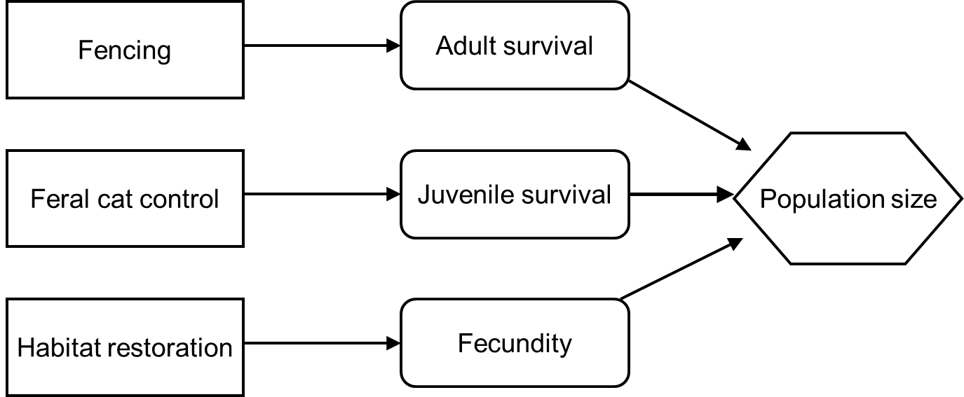

**RABBIT MANAGEMENT**

* Next, build a systems diagram

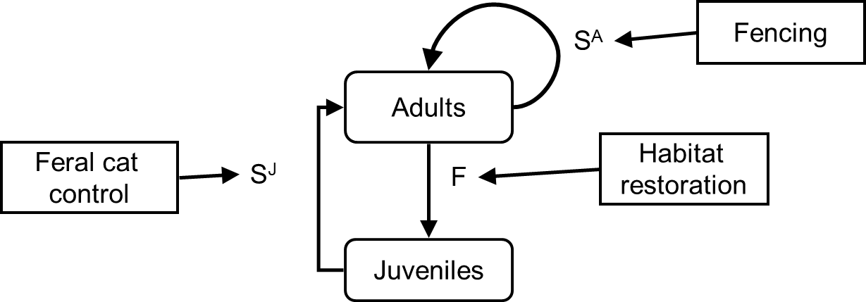

**RABBIT MANAGEMENT**

* Density independence
* Density dependence
  + Compensation
  + Depensation (Allee Effect)
* Start with a simple model, then see how adding complexity affects model performance

**Change in Population = recruits – deaths**



**Density independent population model:**



**RABBIT MANAGEMENT**

* Models link alternative actions to the population parameters
* Population parameters are a function of the proportion of the budget devoted to each action

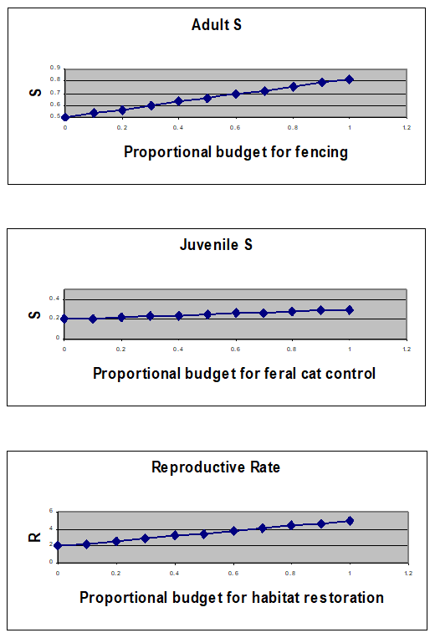

**Reproductive Rate**

If it has been less than 10 years since habitat restoration began, then:



Otherwise:



where *Rt* is reproductive rate in year *t*, *R0* is the initial reproductive rate, *Rmax* is the maximum reproductive rate, and *PH* is the proportion of the budget for habitat restoration

**GO TO SPREADSHEET**

* Rabbits_2023.xlxs
* What is the optimal allocation of the budget under the density independent model?

**HOW MUCH COMPLEXITY IS NEEDED?**

Density-independent growth



Density-dependent logistic growth



What about an Allee effect?

**ALLEE EFFECT OR DEPENSATION**

* Death rate exhibits negative density dependent
* Birth rate exhibits both negative and positive density dependent

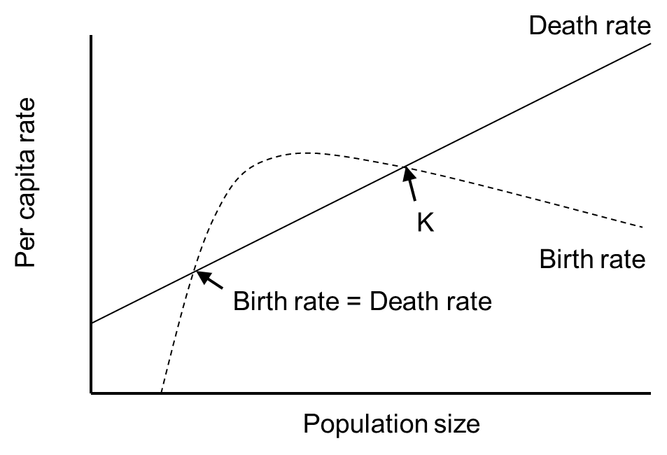

**GO TO SPREADSHEET**

* Rabbits_2023.xlxs
* Does the addition of density dependence affect the decision?
* What is the optimal allocation of the budget under the density dependent model?
* Does the addition of depensation affect the decision?
* At what point does depensation affect the decision?
  + Hint: change values for N(A) in cell S4: the population size at which the Allee effect kicks in

**SUMMARY**

* The role of predictive models
* Prediction
* Structuring the analytical problem
* Transparency
* Recall important tasks and considerations when building predictive models
* The amount of complexity depends on the system and the decision at hand

**REFERENCES**

Hemming V, MA Burgman, AM Hanea, MF McBride, and BC Wintle. 2017. A practical guide to structured

expert elicitation using the IDEA protocol. Methods in Ecology and Evolution 9:169-180.

Paxton EH and J Kraus. 2020. Keeping Hawai’i’s forest birds one step ahead of disease in a warming

world. Pages 37-47 in Runge MC, SJ Converse, JE Lyons, and DR Smith, editors. Structured decision making: case studies in natural resource management. Johns Hopkins University Press, Boston, USA.

Starfield AM. 1997. A pragmatic approach to modeling for wildlife management. Journal of Wildlife

Management 61:261-270.

**MODULE DEVELOPED BY:**

Sarah J. Converse, *USGS Washington Cooperative Fish and Wildlife Research Unit, University of Washington*

David R. Smith, *USGS Leetown Science Center*