|  |
| --- |
|  |
| Pharma Network |
| Smart Contract Solution Document |
| Manufacture, Distribute and Retail the drug in smart and secure way |
| **Saikumar K** |
| **2/17/2020** |

|  |
| --- |
| Document contains step by step guide to user who would like to understand different methods available implemented in the smart contracts and execute to understand the output. |

## Introduction

Pharma network is a platform where manufacturer can manufacture a drug and take it to consumer in a secure and smart way. In this document we will going through below topics which will help you to understand various functionalities available in this network.

* Setup HyperLedger network which create docker containers for various organization involved in this network
* Setup node module which allows client application to execute various methods available in the smart contract
* Execute each method through postman

## Pre-requisites

These smart contracts were developed using the VM provided by Upgrad which contains necessary software for deploying and executing smart contracts.

## Step 1-A: Bootstrap the network

### **Command:**

1. Locate ‘network’ folder under ‘pharma-net’ folder of the project
2. Execute the command ./fabricNetwork.sh up, which will prompt for the confirmation to boot the network. Enter ‘Y’ in the terminal to bring up the network.

### Terminal Screenshot:

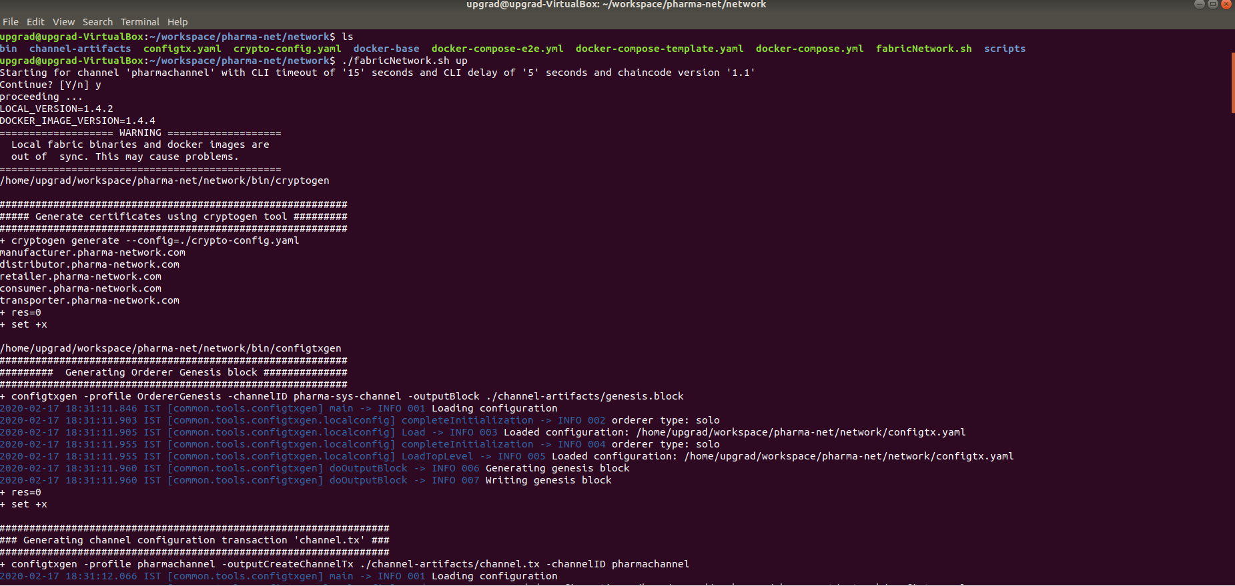

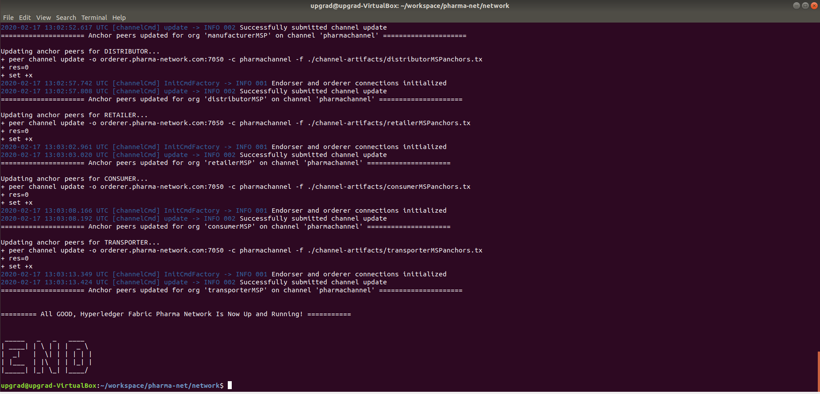

## Step 1-B: Start the chaincode node application

This is needed only for the first time when you setup the network to have necessary node modules are available inside chaincode folder to instantiate smart contract.

### Command:

1. Enter into docker container for chaincode using command docker exec -it chaincode /bin/bash
2. Install node modules using ‘npm install’ command which will install all necessary Node modules inside chaincode container.
3. Start the node application: npm run start-dev

## 

## Step 1-C: Chaincode Installation and Instantiation

### Command:

1. Once Step 1-B is complete, execute below command under ‘network’ folder which will install & instantiate the smart contracts in chaincode container and allow us to invoke different methods listed below.
2. ./fabricNetwork.sh install

### Terminal

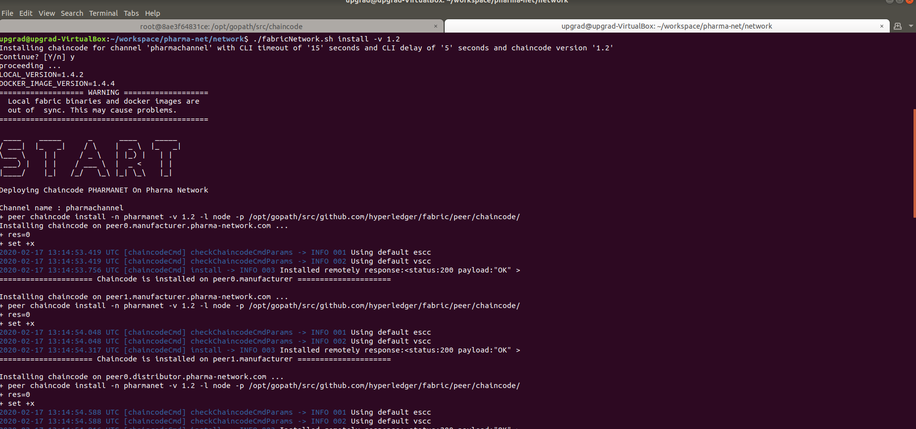

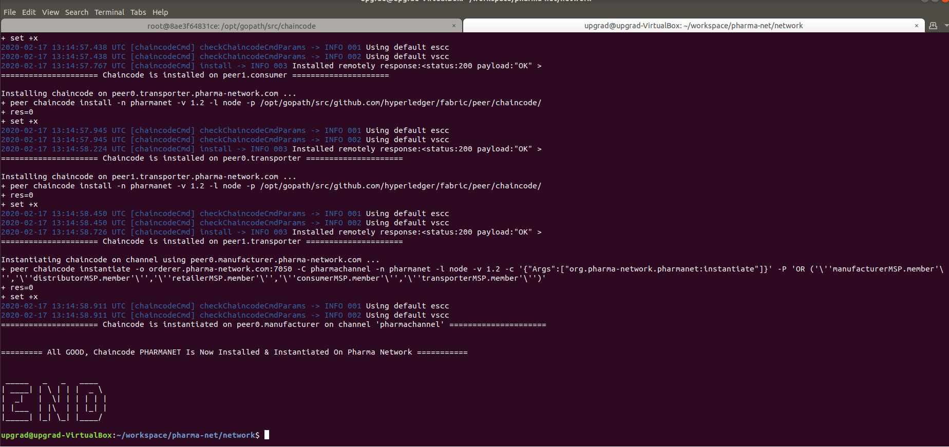

## Step 2: Start the chaincode node application

This is a must have step before proceeding to Step 4

### Command:

1. Go to ‘application’ folder available in ‘pharma-net’ folder.
2. Install node modules using ‘npm install’ command which will install all necessary Node modules required to configure the API URLs to be called by client application.
3. Start the node application: node .

### Terminal:

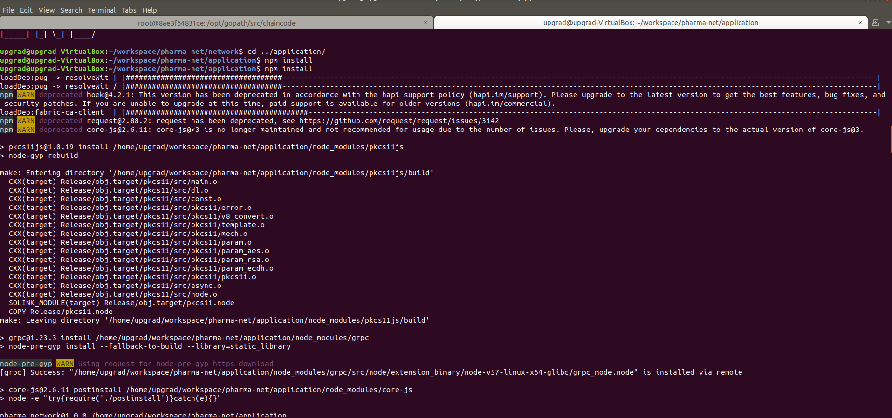

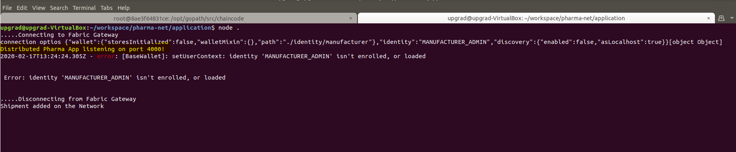

## Step 3: Invoke Smart Contract through REST API

#### Initiation Collection

##### addToWallet

In order to create each organization into the wallet, we need to have two files. In postman script, replace public and private key for each of the organization before executing ‘addToWallet’ method.

###### Public Key

**Transporter**: /home/upgrad/workspace/pharma-net/network/crypto-config/peerOrganizations/transporter.pharma-network.com/users/Admin@transporter.pharma-network.com/msp/signcerts/Admin@transporter.pharma-network.com-cert.pem

**Manufacturer**: /home/upgrad/workspace/pharma-net/network/crypto-config/peerOrganizations/manufacturer.pharma-network.com/users/Admin@manufacturer.pharma-network.com/msp/signcerts/Admin@manufacturer.pharma-network.com-cert.pem

**Retailer**: /home/upgrad/workspace/pharma-net/network/crypto-config/peerOrganizations/retailer.pharma-network.com/users/Admin@retailer.pharma-network.com/msp/signcerts/Admin@retailer.pharma-network.com-cert.pem

**Distributor**: /home/upgrad/workspace/pharma-net/network/crypto-config/peerOrganizations/distributor.pharma-network.com/users/Admin@distributor.pharma-network.com/msp/signcerts/Admin@distributor.pharma-network.com-cert.pem

###### Private Key

Go to below folder for each of the organization and replace the highlighted value.

**Transporter**: /home/upgrad/workspace/pharma-net/network/crypto-config/peerOrganizations/transporter.pharma-network.com/users/Admin@transporter.pharma-network.com/msp/keystore/ 5f2b1842c284acb31320b2c4c8c54af75ed73ead88e49a46f1210f97c9e8f1de_sk

**Manufacturer**: /home/upgrad/workspace/pharma-net/network/crypto-config/peerOrganizations/manufacturer.pharma-network.com/users/Admin@manufacturer.pharma-network.com/msp/keystore/ 4aa55d693d4828416a38510e6336af47bc046977b916433f64e6994b4917fc10_sk

**Retailer**: /home/upgrad/workspace/pharma-net/network/crypto-config/peerOrganizations/retailer.pharma-network.com/users/Admin@retailer.pharma-network.com/msp/keystore/ 706eadd3b87e0945e663c19f42b8df99d68d4b2d2a3a367b97be945c063d6ed5_sk

**Distributor**: /home/upgrad/workspace/pharma-net/network/crypto-config/peerOrganizations/distributor.pharma-network.com/users/Admin@distributor.pharma-network.com/msp/keystore/ fe1faa1b5c31776fae4e8ab50f0b5610b704b783a53b9ce661e1f47ee873a529_sk

###### Postman script for each organization: (can be found under ‘test’ folder)

Distributor: distributer-addToWallet

Manufacturer: manufacturer-addToWallet

Retailer: retailer-addToWallet

Transporter: transporter-addToWallet

###### Screenshot of Postman script execution:

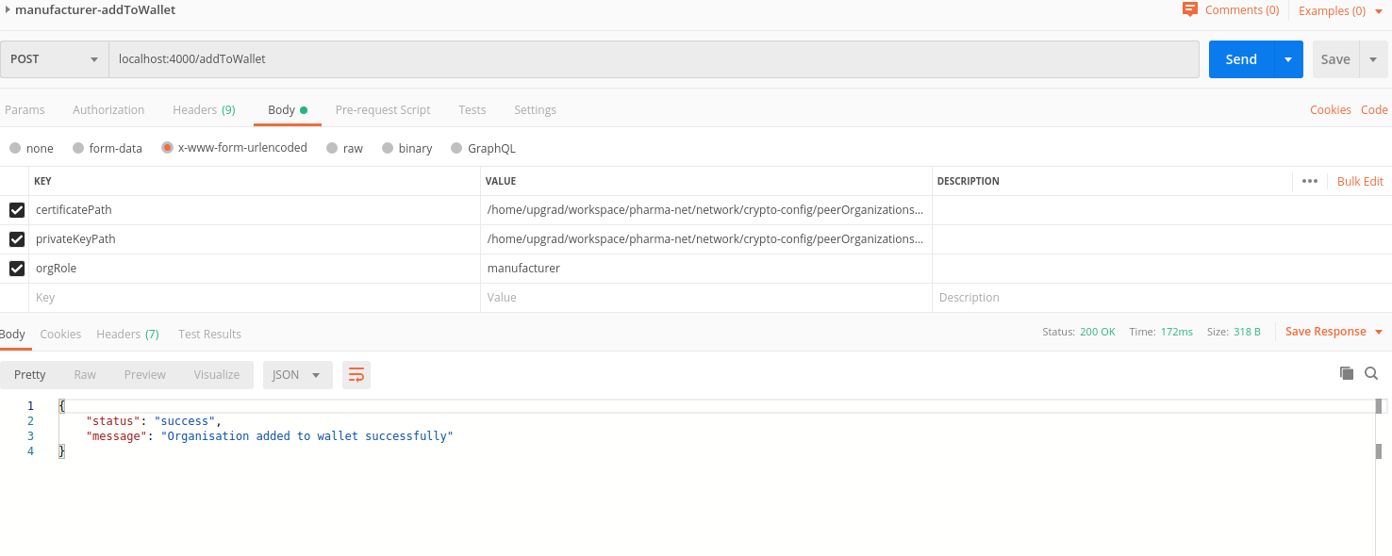

##### Register Company

For each of the company, we need to execute registerCompany method to perform the required operation for below mentioned other modules.

###### Postman script for each company: (scripts under initiation collection)

* Manufacturer: manufacturer-sunpharma-registerCompany
* Distributor: distributor-VGPharma-registerCompany
* Retailer: retailer-upgrad-registerCompany
* Transporter1: transporter-fedex-registerCompany
* Transporter2: transporter-bluedart-registerCompany

###### Screenshot of postman script execution:

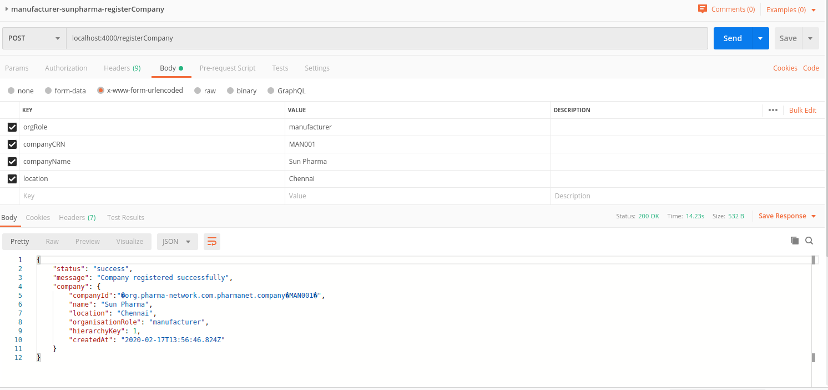

##### addDrug

Below mentioned postman scripts can be used to add 4 drugs in the network

###### Post man scripts (found under initiation collection)

* Drug 1: manufacturer-Paracetamol-001-addDrug
* Drug 2: manufacturer-Paracetamol-002-addDrug
* Drug 3: manufacturer-Paracetamol-003-addDrug
* Drug 4: manufacturer-Paracetamol-004-addDrug

###### Screenshot of postman script execution:

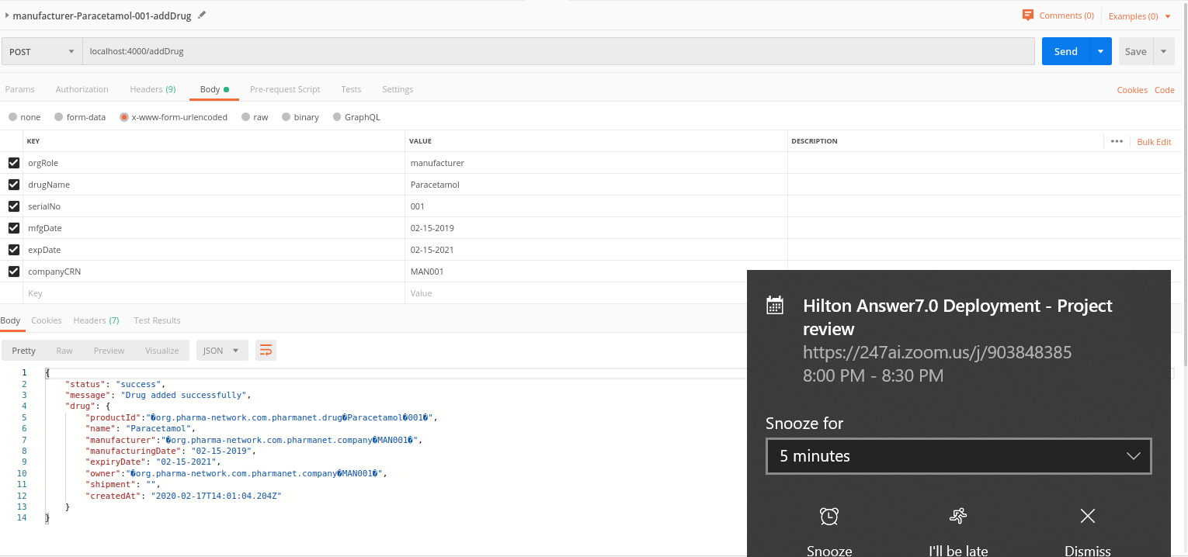

### Supply Chain Collection

Below post man scripts to be executed for each of the functions mentioned below. These postman scripts can be found under ‘Supply Chain’ collection.

#### Method Mapping

|  |  |  |
| --- | --- | --- |
| **Method** | **Functionality** | **Postman script** |
| SC1 | Create PO by Distributor | part-a-1-distributor-createPO |
| SC2 | Create shipment by Manufacturer | part-a-2-manufacturer-createShipment |
| SC3 | Update Shipment by Transporter1 | part-a-3-transporter-updateShipment |
| SC4 | Create PO by Retailer | part-b-1-retailer-createPO |
| SC5 | Create shipment by Distributor | part-b-2-distributor-createShipment |
| SC6 | Update shipment by Transporter 2 | part-b-3-transporter-updateShipment |
| SC7 | Retail drug by Retailer | part-c-1-retailer-retailDrug |

Screenshot of postman execution:

##### Method: SC1

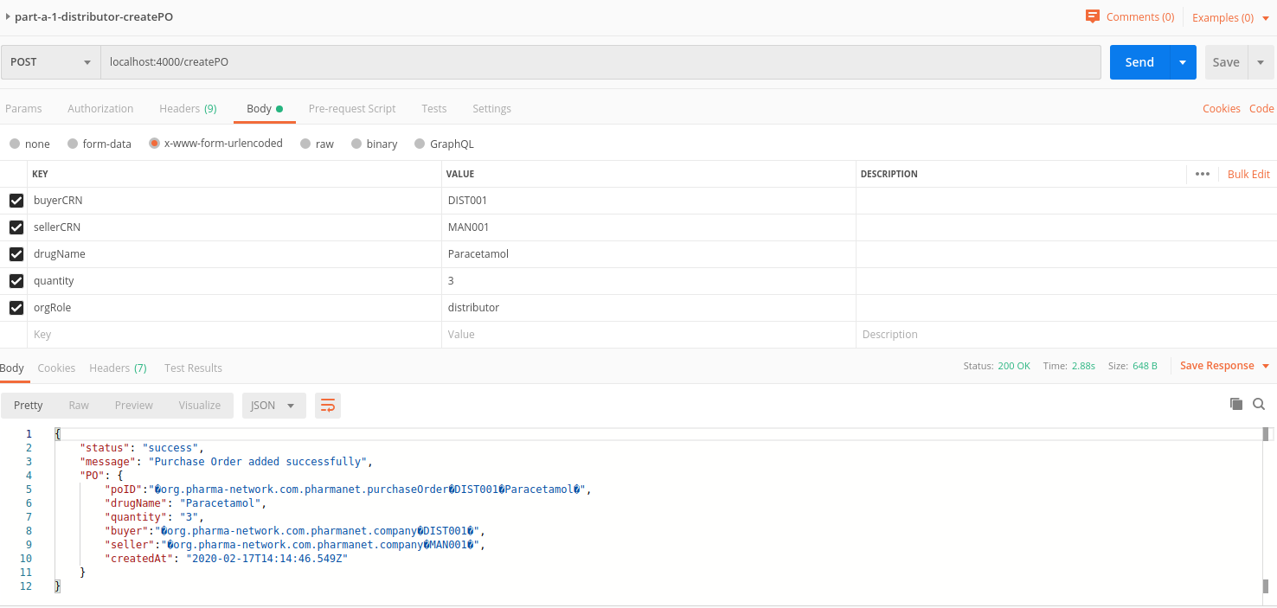

##### Method: SC2

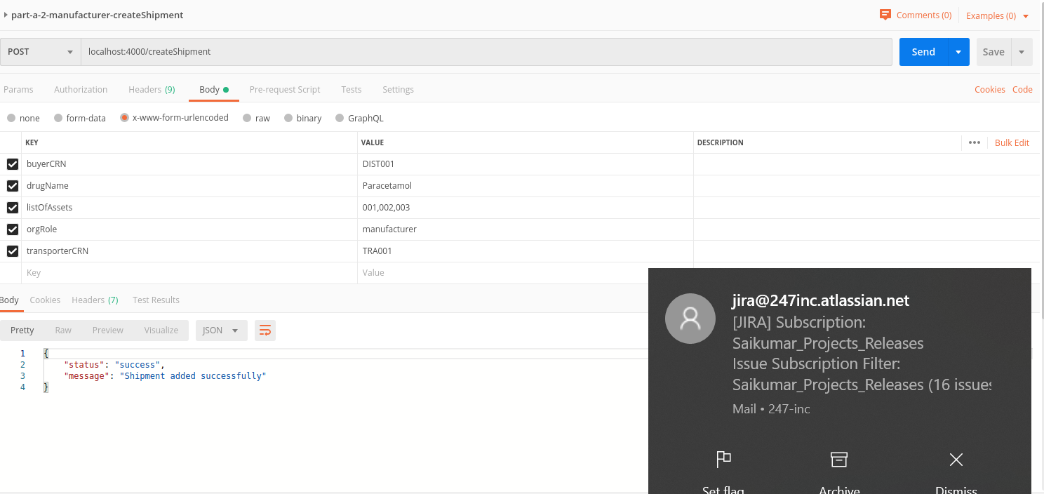

##### Method: SC3

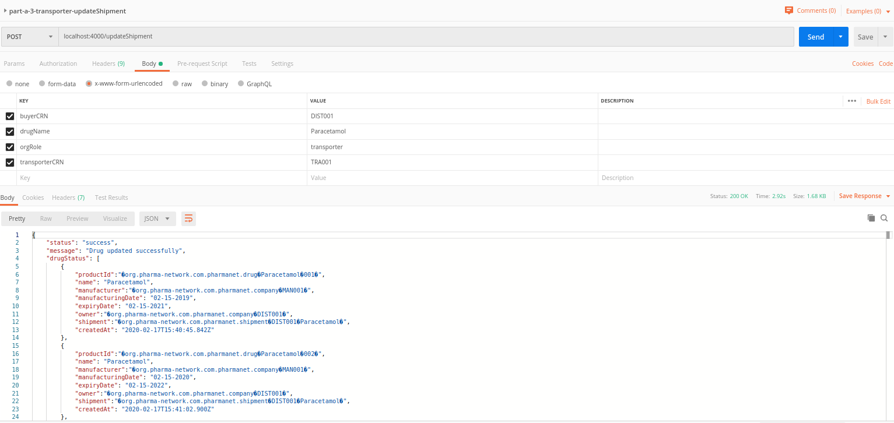

##### Method: SC4

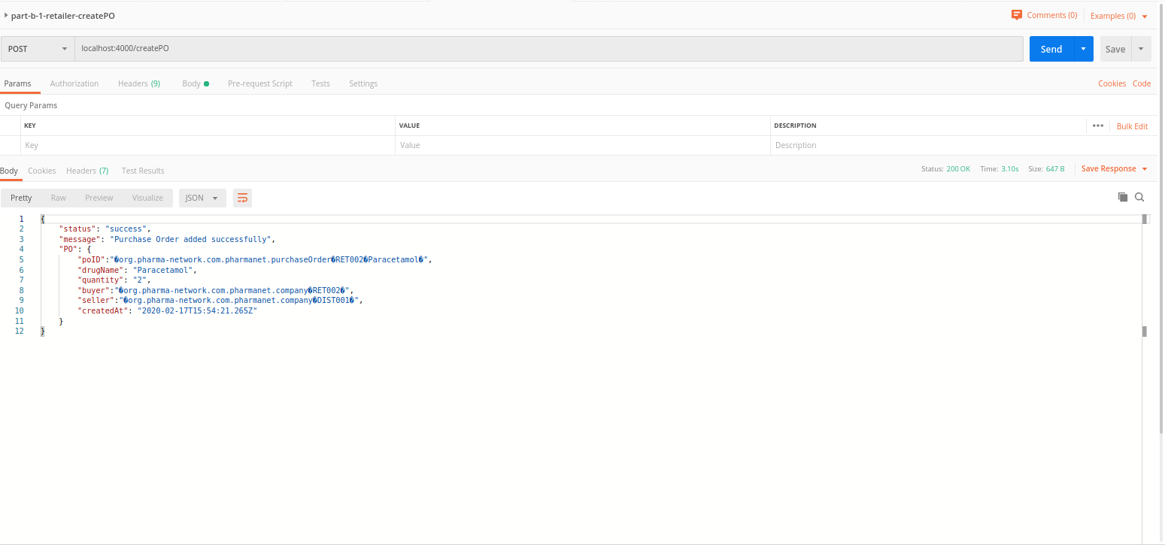

##### Method: SC5

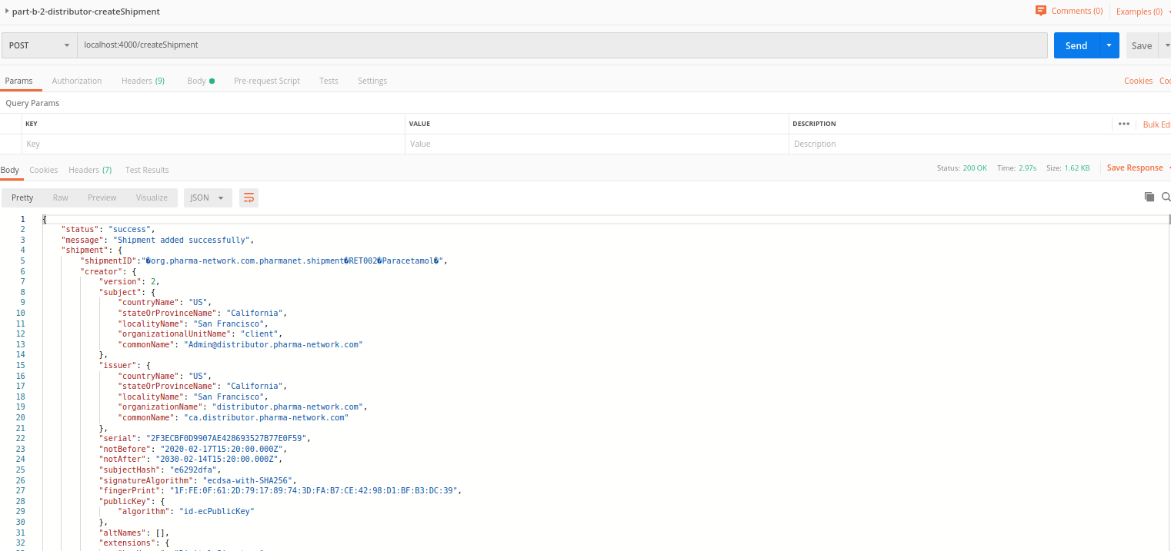

##### Method: SC6

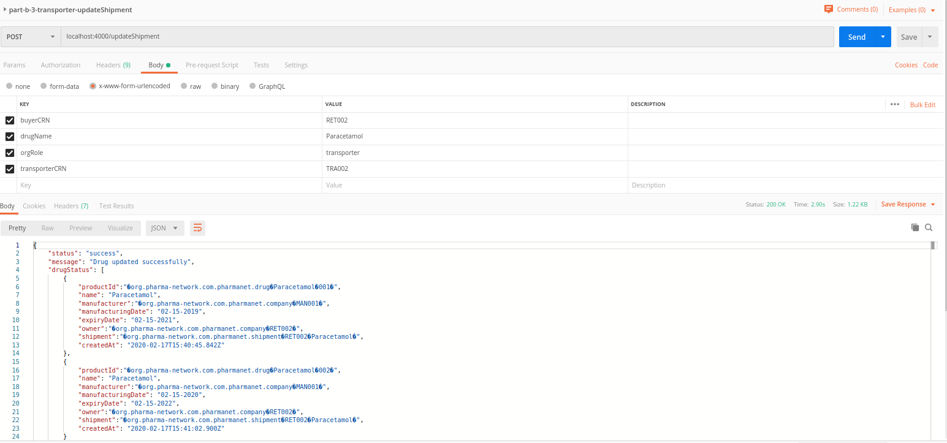

##### Method : SC7

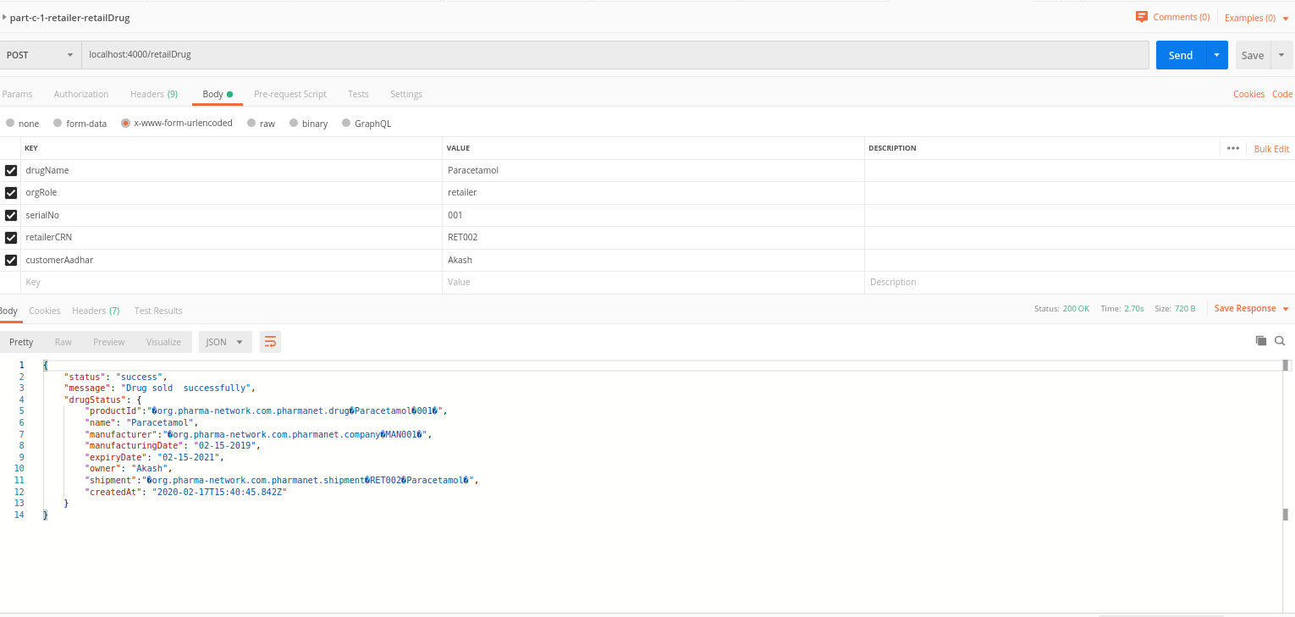

### History

#### viewHistory

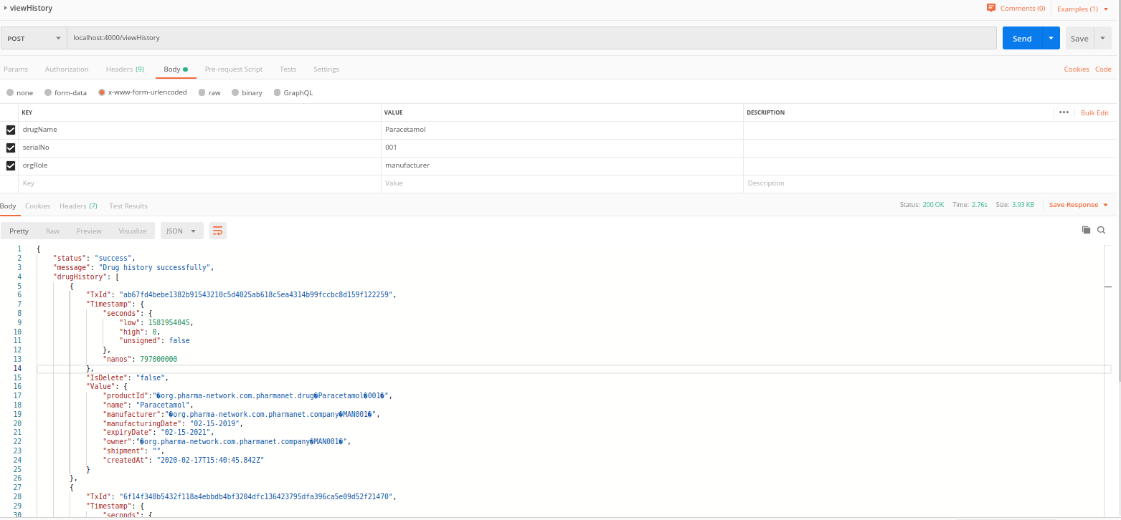

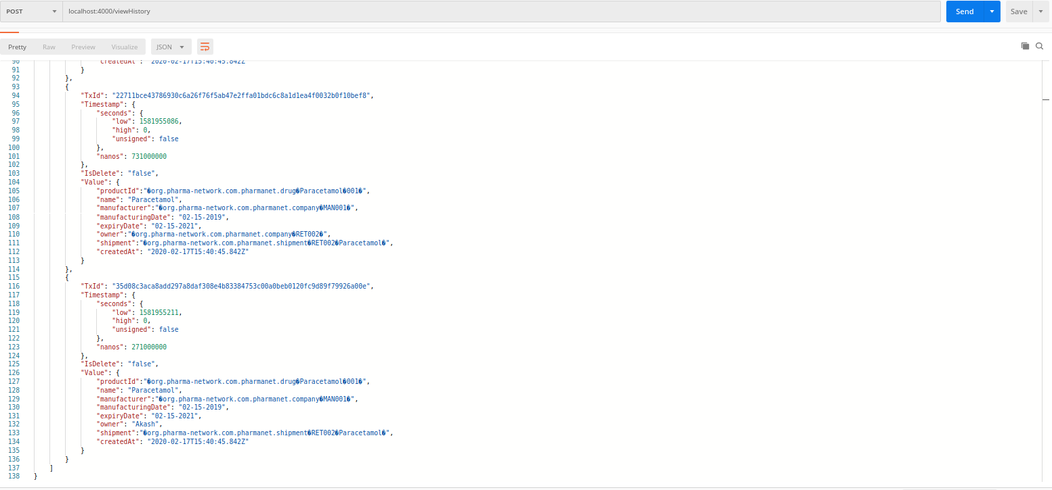

#### viewDrugCurrentState

