KONZAN CONSTRUCTION
Enterprise Resource Planning System
Entity Relationship Design (ERD)
Prepared for database & system design purposes
July 2026

1. Introduction & Scope
This document presents the Entity Relationship Design (ERD) for a company-wide Enterprise Resource Planning (ERP) system for Konzan Construction. The design covers the full project lifecycle — from tender and client acquisition through project execution, procurement, resource management, quality/safety control, and financial close-out.
Because a single, all-in-one diagram covering every module would be unreadable, the ERD is organized into five logically grouped diagrams that together form one connected data model. Shared entities (such as Project, Site, and Employee) appear in more than one diagram as connector points — in the real database each of these is a single physical table.
- Diagram 1 — Tender, CRM, Contract, Project & Site: the commercial and project-setup backbone.
- Diagram 2 — Procurement, Inventory, Equipment & Fleet: the supply chain and resource side.
- Diagram 3 — HR, Payroll & Security: the workforce and system-access side.
- Diagram 4 — Subcontractor, Quality/HSE & Risk: execution controls on site.
- Diagram 5 — Finance & Cost Control: budgeting, billing and accounting.
Each diagram is followed by a data dictionary listing every entity's attributes, primary keys (PK) and foreign keys (FK), to guide direct implementation in a relational database (e.g. PostgreSQL, MySQL, SQL Server).

2. ERD Notation Legend
All five diagrams use the same notation:
Symbol | Meaning | Description
Rectangle / box | Entity | Represents a table in the database (e.g. Project, Employee).
Bold, underlined attribute | Primary Key (PK) | Uniquely identifies each record in the entity.
Plain attribute marked (FK) | Foreign Key (FK) | Links to the Primary Key of a related entity.
1 | One | Exactly one related record.
0..1 | Zero or one | At most one related record (optional).
0..N | Zero or many | Any number of related records, including none.
1..N | One or many | At least one related record is required.

3. Diagram 1 — Tender, CRM, Contract, Project & Site
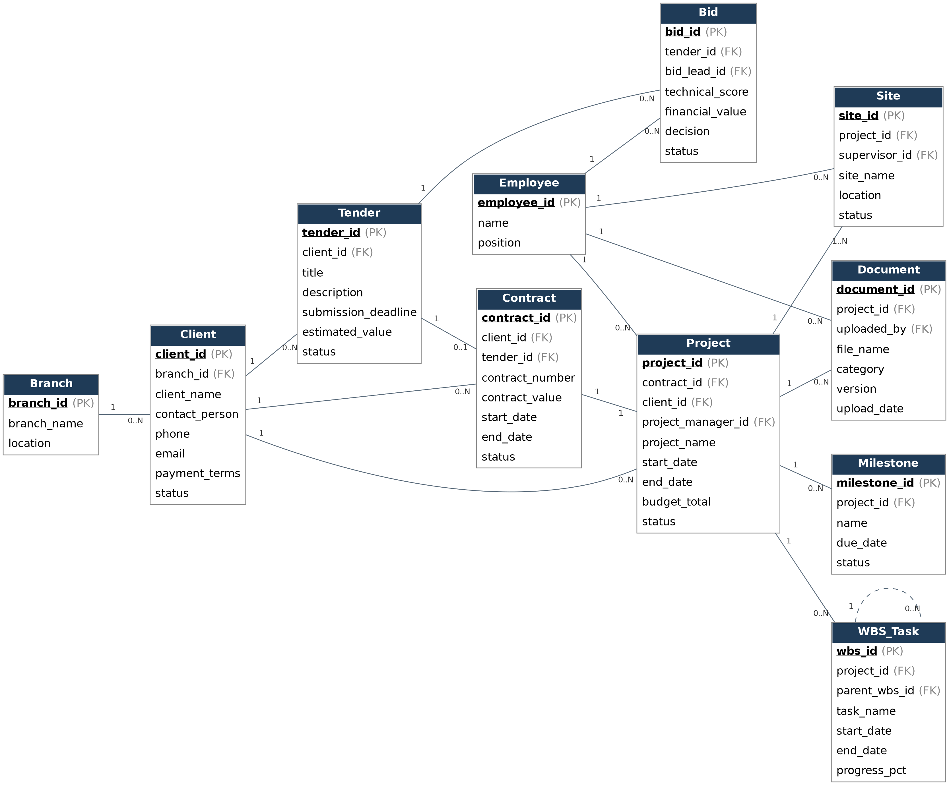

3.1 Data Dictionary — Diagram 1 — Tender, CRM, Contract, Project & Site
Branch
Attribute | Key | Notes
branch_id | PK | Unique identifier for this entity.
branch_name
location

Client
Attribute | Key | Notes
client_id | PK | Unique identifier for this entity.
branch_id | FK | References related entity's primary key.
client_name
contact_person
phone
email
payment_terms
status

Tender
Attribute | Key | Notes
tender_id | PK | Unique identifier for this entity.
client_id | FK | References related entity's primary key.
title
description
submission_deadline
estimated_value
status

Bid
Attribute | Key | Notes
bid_id | PK | Unique identifier for this entity.
tender_id | FK | References related entity's primary key.
bid_lead_id | FK | References related entity's primary key.
technical_score
financial_value
decision
status

Contract
Attribute | Key | Notes
contract_id | PK | Unique identifier for this entity.
client_id | FK | References related entity's primary key.
tender_id | FK | References related entity's primary key.
contract_number
contract_value
start_date
end_date
status

Project
Attribute | Key | Notes
project_id | PK | Unique identifier for this entity.
contract_id | FK | References related entity's primary key.
client_id | FK | References related entity's primary key.
project_manager_id | FK | References related entity's primary key.
project_name
start_date
end_date
budget_total
status

Site
Attribute | Key | Notes
site_id | PK | Unique identifier for this entity.
project_id | FK | References related entity's primary key.
supervisor_id | FK | References related entity's primary key.
site_name
location
status

WBS_Task
Attribute | Key | Notes
wbs_id | PK | Unique identifier for this entity.
project_id | FK | References related entity's primary key.
parent_wbs_id | FK | References related entity's primary key.
task_name
start_date
end_date
progress_pct

Milestone
Attribute | Key | Notes
milestone_id | PK | Unique identifier for this entity.
project_id | FK | References related entity's primary key.
name
due_date
status

Document
Attribute | Key | Notes
document_id | PK | Unique identifier for this entity.
project_id | FK | References related entity's primary key.
uploaded_by | FK | References related entity's primary key.
file_name
category
version
upload_date

Employee
Attribute | Key | Notes
employee_id | PK | Unique identifier for this entity.
name
position

4. Diagram 2 — Procurement, Inventory, Equipment & Fleet
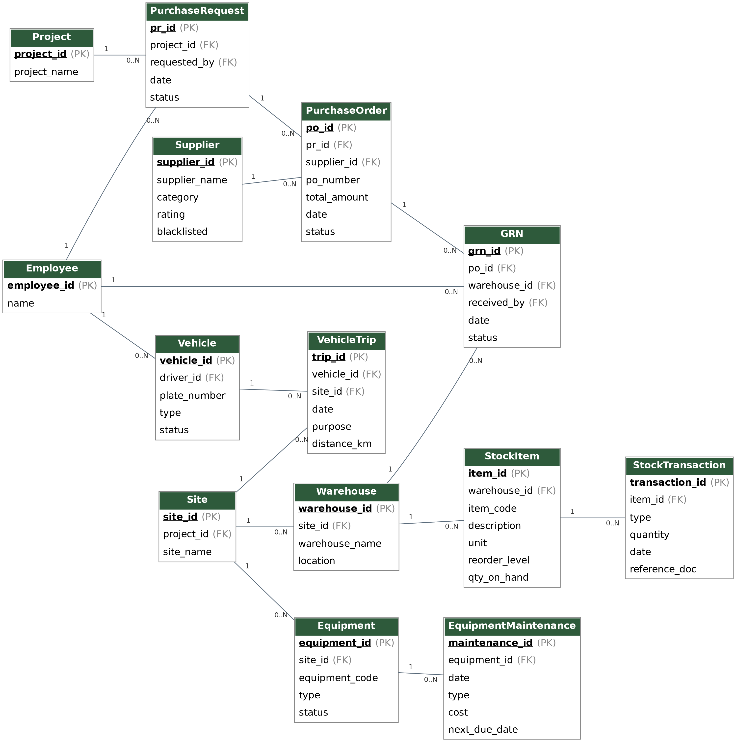

4.1 Data Dictionary — Diagram 2 — Procurement, Inventory, Equipment & Fleet
Project
Attribute | Key | Notes
project_id | PK | Unique identifier for this entity.
project_name

Site
Attribute | Key | Notes
site_id | PK | Unique identifier for this entity.
project_id | FK | References related entity's primary key.
site_name

Employee
Attribute | Key | Notes
employee_id | PK | Unique identifier for this entity.
name

Supplier
Attribute | Key | Notes
supplier_id | PK | Unique identifier for this entity.
supplier_name
category
rating
blacklisted

PurchaseRequest
Attribute | Key | Notes
pr_id | PK | Unique identifier for this entity.
project_id | FK | References related entity's primary key.
requested_by | FK | References related entity's primary key.
date
status

PurchaseOrder
Attribute | Key | Notes
po_id | PK | Unique identifier for this entity.
pr_id | FK | References related entity's primary key.
supplier_id | FK | References related entity's primary key.
po_number
total_amount
date
status

GRN
Attribute | Key | Notes
grn_id | PK | Unique identifier for this entity.
po_id | FK | References related entity's primary key.
warehouse_id | FK | References related entity's primary key.
received_by | FK | References related entity's primary key.
date
status

Warehouse
Attribute | Key | Notes
warehouse_id | PK | Unique identifier for this entity.
site_id | FK | References related entity's primary key.
warehouse_name
location

StockItem
Attribute | Key | Notes
item_id | PK | Unique identifier for this entity.
warehouse_id | FK | References related entity's primary key.
item_code
description
unit
reorder_level
qty_on_hand

StockTransaction
Attribute | Key | Notes
transaction_id | PK | Unique identifier for this entity.
item_id | FK | References related entity's primary key.
type
quantity
date
reference_doc

Equipment
Attribute | Key | Notes
equipment_id | PK | Unique identifier for this entity.
site_id | FK | References related entity's primary key.
equipment_code
type
status

EquipmentMaintenance
Attribute | Key | Notes
maintenance_id | PK | Unique identifier for this entity.
equipment_id | FK | References related entity's primary key.
date
type
cost
next_due_date

Vehicle
Attribute | Key | Notes
vehicle_id | PK | Unique identifier for this entity.
driver_id | FK | References related entity's primary key.
plate_number
type
status

VehicleTrip
Attribute | Key | Notes
trip_id | PK | Unique identifier for this entity.
vehicle_id | FK | References related entity's primary key.
site_id | FK | References related entity's primary key.
date
purpose
distance_km

5. Diagram 3 — HR, Payroll & Security
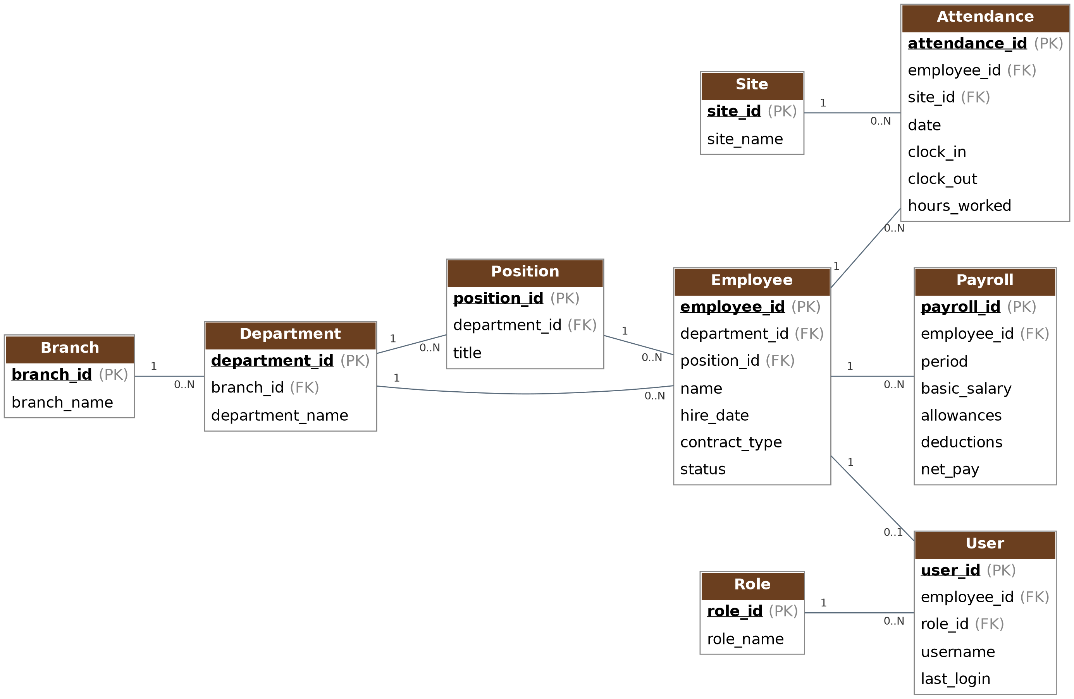

5.1 Data Dictionary — Diagram 3 — HR, Payroll & Security
Branch
Attribute | Key | Notes
branch_id | PK | Unique identifier for this entity.
branch_name

Department
Attribute | Key | Notes
department_id | PK | Unique identifier for this entity.
branch_id | FK | References related entity's primary key.
department_name

Position
Attribute | Key | Notes
position_id | PK | Unique identifier for this entity.
department_id | FK | References related entity's primary key.
title

Employee
Attribute | Key | Notes
employee_id | PK | Unique identifier for this entity.
department_id | FK | References related entity's primary key.
position_id | FK | References related entity's primary key.
name
hire_date
contract_type
status

Site
Attribute | Key | Notes
site_id | PK | Unique identifier for this entity.
site_name

Attendance
Attribute | Key | Notes
attendance_id | PK | Unique identifier for this entity.
employee_id | FK | References related entity's primary key.
site_id | FK | References related entity's primary key.
date
clock_in
clock_out
hours_worked

Payroll
Attribute | Key | Notes
payroll_id | PK | Unique identifier for this entity.
employee_id | FK | References related entity's primary key.
period
basic_salary
allowances
deductions
net_pay

Role
Attribute | Key | Notes
role_id | PK | Unique identifier for this entity.
role_name

User
Attribute | Key | Notes
user_id | PK | Unique identifier for this entity.
employee_id | FK | References related entity's primary key.
role_id | FK | References related entity's primary key.
username
last_login

6. Diagram 4 — Subcontractor, Quality/HSE & Risk
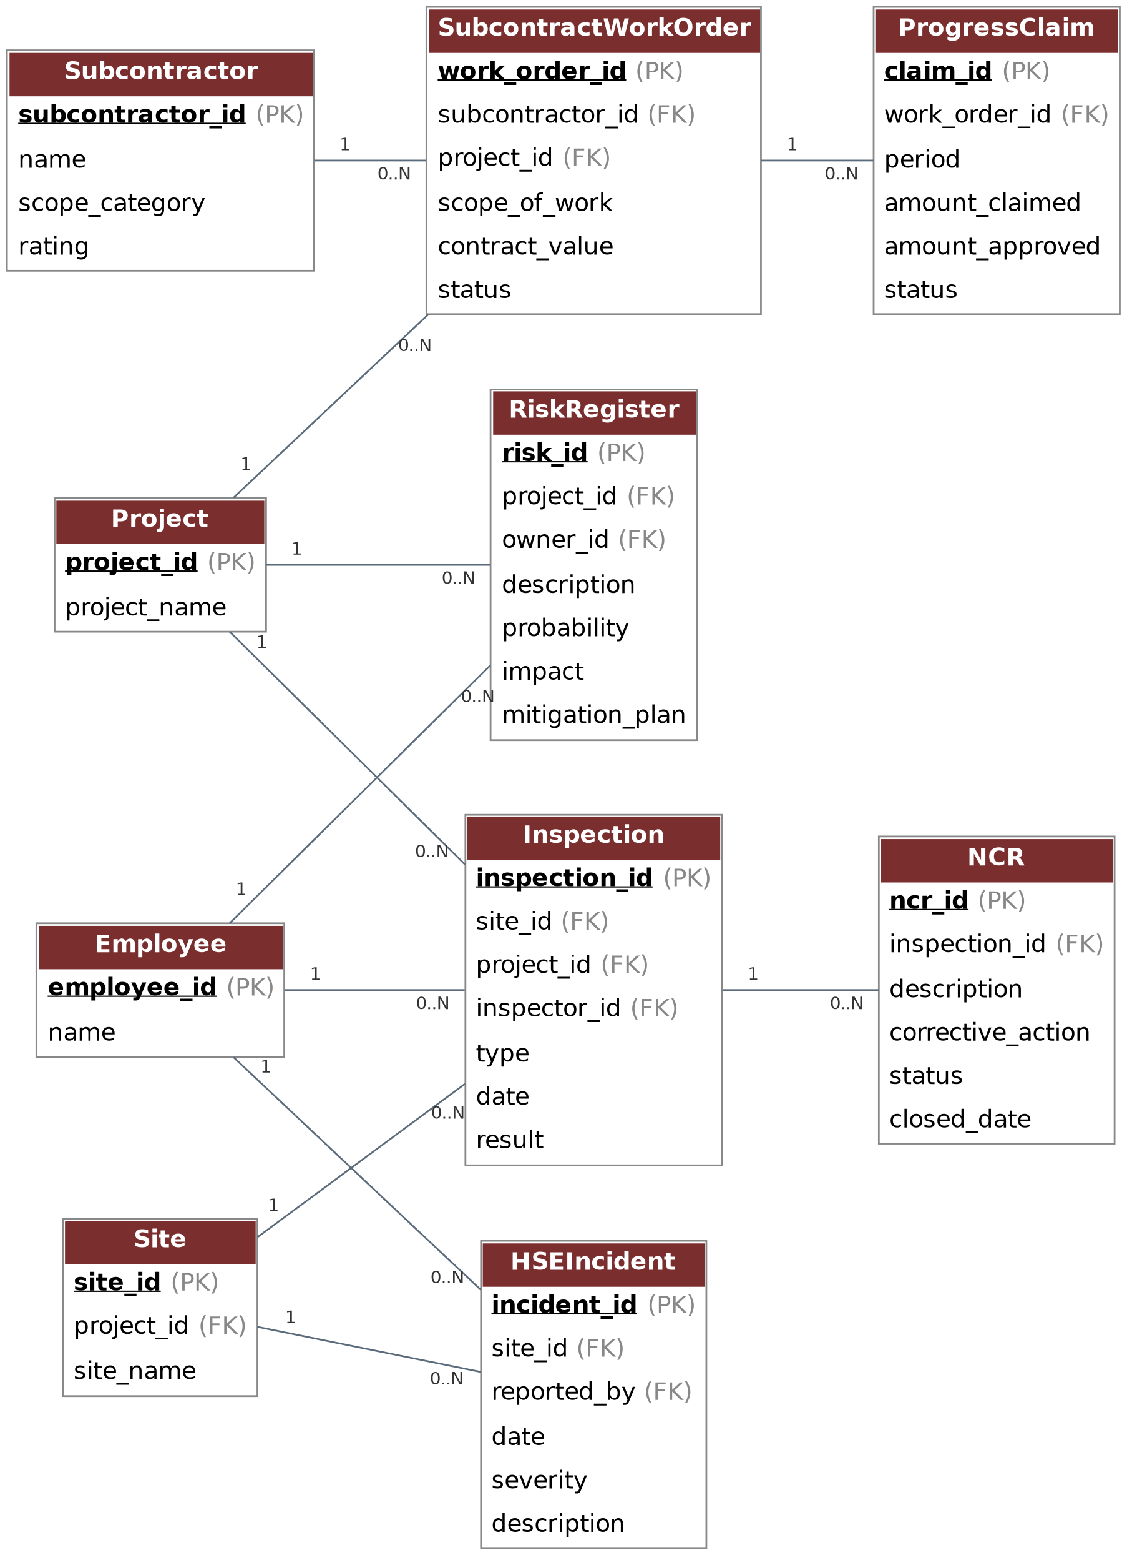

6.1 Data Dictionary — Diagram 4 — Subcontractor, Quality/HSE & Risk
Project
Attribute | Key | Notes
project_id | PK | Unique identifier for this entity.
project_name

Site
Attribute | Key | Notes
site_id | PK | Unique identifier for this entity.
project_id | FK | References related entity's primary key.
site_name

Employee
Attribute | Key | Notes
employee_id | PK | Unique identifier for this entity.
name

Subcontractor
Attribute | Key | Notes
subcontractor_id | PK | Unique identifier for this entity.
name
scope_category
rating

SubcontractWorkOrder
Attribute | Key | Notes
work_order_id | PK | Unique identifier for this entity.
subcontractor_id | FK | References related entity's primary key.
project_id | FK | References related entity's primary key.
scope_of_work
contract_value
status

ProgressClaim
Attribute | Key | Notes
claim_id | PK | Unique identifier for this entity.
work_order_id | FK | References related entity's primary key.
period
amount_claimed
amount_approved
status

Inspection
Attribute | Key | Notes
inspection_id | PK | Unique identifier for this entity.
site_id | FK | References related entity's primary key.
project_id | FK | References related entity's primary key.
inspector_id | FK | References related entity's primary key.
type
date
result

NCR
Attribute | Key | Notes
ncr_id | PK | Unique identifier for this entity.
inspection_id | FK | References related entity's primary key.
description
corrective_action
status
closed_date

HSEIncident
Attribute | Key | Notes
incident_id | PK | Unique identifier for this entity.
site_id | FK | References related entity's primary key.
reported_by | FK | References related entity's primary key.
date
severity
description

RiskRegister
Attribute | Key | Notes
risk_id | PK | Unique identifier for this entity.
project_id | FK | References related entity's primary key.
owner_id | FK | References related entity's primary key.
description
probability
impact
mitigation_plan

7. Diagram 5 — Finance & Cost Control
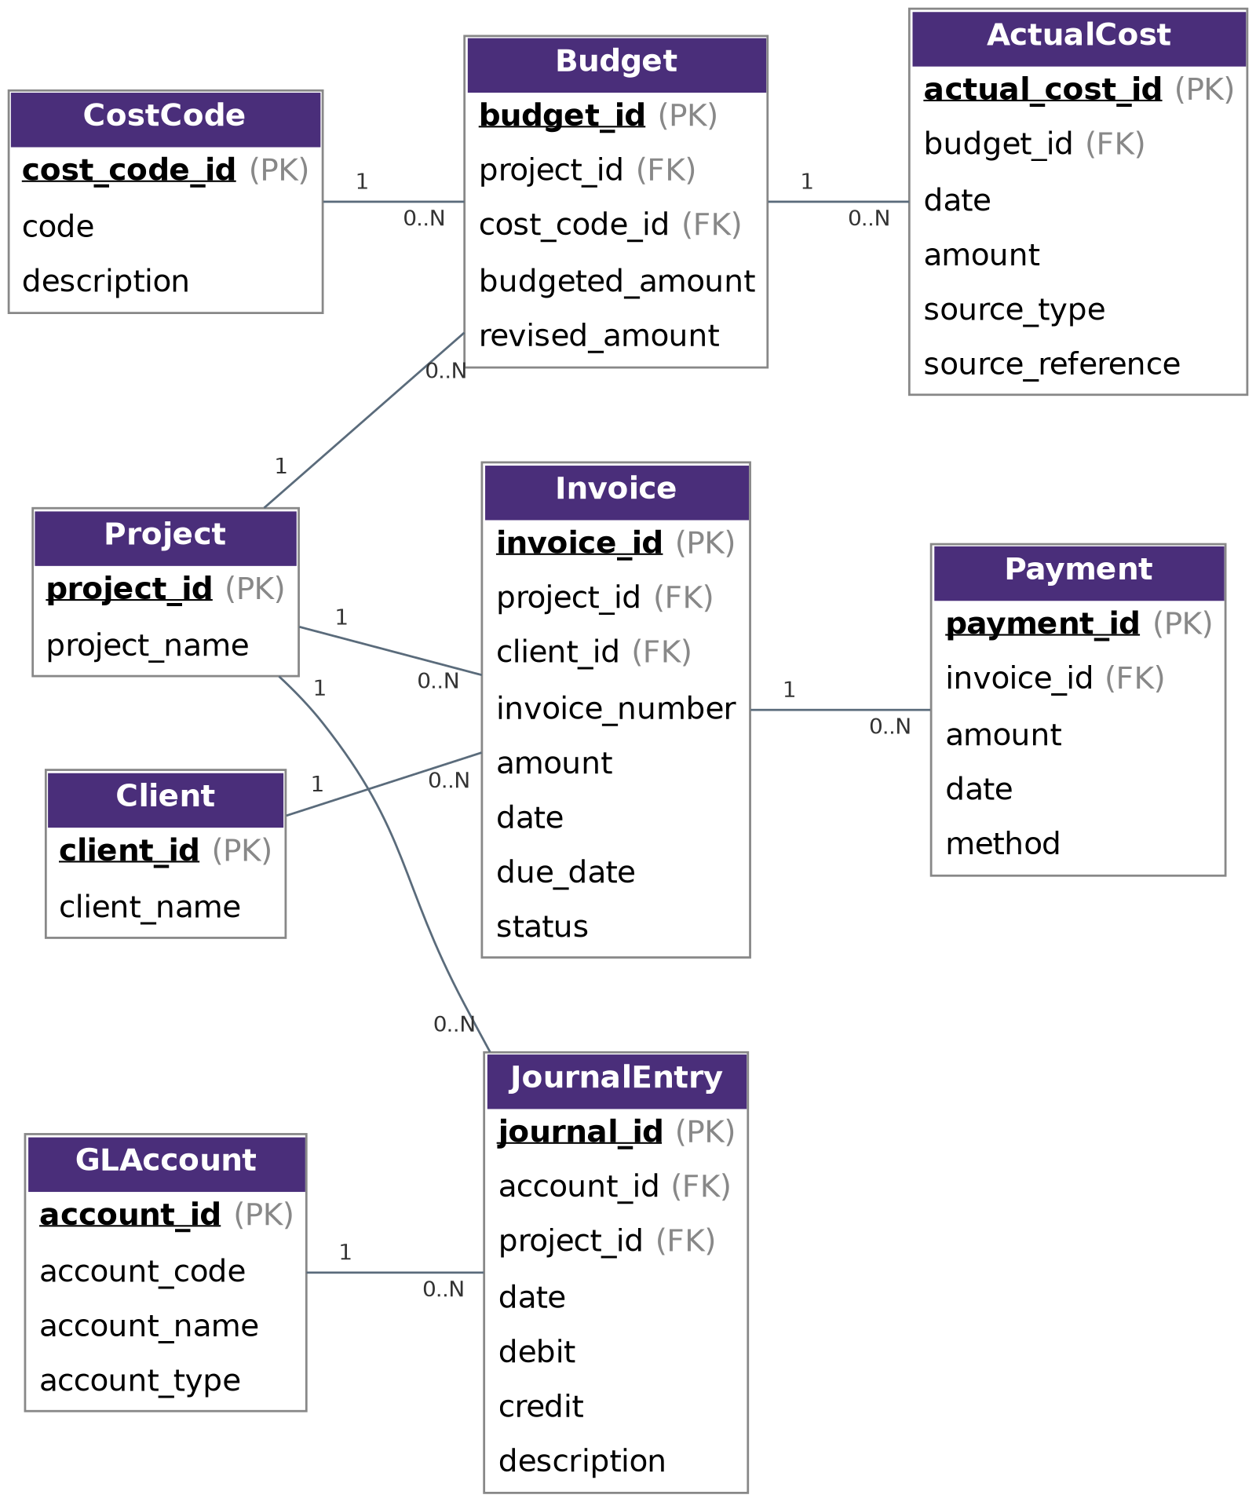

7.1 Data Dictionary — Diagram 5 — Finance & Cost Control
Project
Attribute | Key | Notes
project_id | PK | Unique identifier for this entity.
project_name

Client
Attribute | Key | Notes
client_id | PK | Unique identifier for this entity.
client_name

CostCode
Attribute | Key | Notes
cost_code_id | PK | Unique identifier for this entity.
code
description

Budget
Attribute | Key | Notes
budget_id | PK | Unique identifier for this entity.
project_id | FK | References related entity's primary key.
cost_code_id | FK | References related entity's primary key.
budgeted_amount
revised_amount

ActualCost
Attribute | Key | Notes
actual_cost_id | PK | Unique identifier for this entity.
budget_id | FK | References related entity's primary key.
date
amount
source_type
source_reference

Invoice
Attribute | Key | Notes
invoice_id | PK | Unique identifier for this entity.
project_id | FK | References related entity's primary key.
client_id | FK | References related entity's primary key.
invoice_number
amount
date
due_date
status

Payment
Attribute | Key | Notes
payment_id | PK | Unique identifier for this entity.
invoice_id | FK | References related entity's primary key.
amount
date
method

GLAccount
Attribute | Key | Notes
account_id | PK | Unique identifier for this entity.
account_code
account_name
account_type

JournalEntry
Attribute | Key | Notes
journal_id | PK | Unique identifier for this entity.
account_id | FK | References related entity's primary key.
project_id | FK | References related entity's primary key.
date
debit
credit
description

8. Design Notes & Implementation Guidance
- Every entity should carry standard audit columns in implementation (created_at, created_by, updated_at, updated_by, is_deleted) — omitted from the diagrams above for readability.
- Self-referencing relationships (e.g. WBS_Task to itself via parent_wbs_id) support unlimited work-breakdown hierarchy depth.
- The Employee entity is intentionally shared across several diagrams as it is referenced by many modules (site supervisor, bid lead, inspector, driver, requester, etc.) — implement it once as a master table.
- Project and Site are similarly shared master entities linking the commercial (Diagram 1), supply-chain (Diagram 2), workforce (Diagram 3), execution-control (Diagram 4) and finance (Diagram 5) sides of the system.
- Budget vs. ActualCost supports Earned Value / cost-control reporting by comparing planned amounts per cost code against real transactions sourced from GRNs, payroll, subcontractor claims, etc.
- This model can be extended with the remaining ERP modules from the requirements (Communication, Notifications, Compliance, Company Administration, Dashboards) as thin supporting tables that reference the core entities shown here — they were left out of the diagrams as they do not introduce new structural relationships.
- Recommended next step: validate cardinalities against Konzan's actual approval workflows (e.g. can a Purchase Order reference more than one Purchase Request?) before finalizing the physical schema.

