Salahov Kamal IG5LSM Client-Side tech hw documentation Angular Project
The application is a web-based information system based on the "Ice and Fire" universe. It provides users with information about characters, houses, and books from the world created by George R.R. Martin. The main functionality of the application includes:
- Displaying detailed information about characters, including their names, genders, cultures, births, deaths, titles, aliases, allegiances, books they appear in, TV series they are part of, and actors who played them.
- Providing information about houses, including their names, regions, coat of arms, words, titles, seats, current lord, heir, overlord, founder, ancestral weapons, cadet branches, and sworn members.
- Showing details about books, including their names, authors, number of pages, publisher, country, media type, and characters appearing in the book.
- Allowing users to navigate through the application by clicking on links to characters, houses, and books.

The application follows a client-server architecture, where the client is responsible for handling user interactions and rendering the user interface, while the server handles data retrieval and storage. The client communicates with the server through API calls to retrieve the required information. Components are the building blocks of the application's user interface. Application uses a hierarchical structure where components can nest inside each other to create a cohesive and modular application. The main components of the application are as follows:
- App Component: The root component of the application that serves as the entry point. It encapsulates the entire application and acts as a container for other components. The App Component brings together all the UI components and provides the overall layout and structure of the application.
- App Module (app.module.ts): The App Module is responsible for bootstrapping the application. It imports and declares all the necessary components, services, and modules used in the application. It provides the configuration for the application and sets up dependencies.
- App Routing Module (app-routing.module.ts): The App Routing Module handles the navigation within the application. It defines the routes and maps them to specific components. It allows users to navigate between different views by changing the URL or clicking on links. It acts as a central routing configuration for the application.
- Data Service: The Data Service connects to the API and retrieves data from the server. It handles making HTTP requests, processing responses, and returning the data to the respective components. The Data Service abstracts the data retrieval logic and provides a consistent interface for fetching data. It acts as a bridge between the UI components and the server-side API.
- UI Components: The UI components include the Home, Book List, Book Details, House List, House Detail, Character List, and Character Detail components. These components are responsible for rendering the user interface and displaying the relevant data to the user. They interact with the Data Service to retrieve the necessary data and present it in a structured and visually appealing manner.
The components interact with each other and the Data Service to fetch the required data and present it to the user. The App Component acts as the container that brings together all the UI components and sets up the overall structure of the application.

List of classes:
- DataService: This class handles the communication with the API and provides methods to fetch data such as books, houses, and characters. It encapsulates the HTTP requests and handles data transformation and error handling.
- House: This class represents a house in the application. It includes properties like name, region, coat of arms, and ancestral weapons. It provides a structured representation of house data.
- Character: This class represents a character in the application. It contains properties such as name, gender, culture, titles, and allegiances. It provides a structured representation of character data.
- AppComponent: This component serves as the root component of the application and is responsible for rendering the main layout and structure of the application. It acts as a container for other components.
- HomeComponent: This component displays the home page of the application and provides an overview of the available content and navigation options.
- BookListComponent: This component displays a list of books retrieved from the DataService. It handles the rendering of book items and allows users to select a book to view its details.
- BookDetailsComponent: This component displays detailed information about a specific book. It receives the selected book from the BookListComponent and fetches additional details from the DataService.
- HouseListComponent: This component displays a list of houses retrieved from the DataService. It handles the rendering of house items and allows users to select a house to view its details.
- HouseDetailsComponent: This component displays detailed information about a specific house. It receives the selected house from the HouseListComponent and fetches additional details from the DataService.
- CharacterListComponent: This component displays a list of characters retrieved from the DataService. It handles the rendering of character items and allows users to select a character to view their details.
- CharacterDetailsComponent: This component displays detailed information about a specific character. It receives the selected character from the CharacterListComponent and fetches additional details from the DataService.
- AppRoutingModule: This module handles the routing configuration for the application. It maps URLs to specific components and enables navigation between different views.
These classes and components work together to provide the main functionality of the application, allowing users to browse and view books, houses, and characters. The DataService acts as a central point for fetching data from the API, and the UI components handle the rendering and presentation of the data to the user.

The client-server communication in the application is facilitated by the HttpClient module provided by Angular. The DataService class utilizes this module to send HTTP requests to the server and retrieve data. Here is an overview of the client-server communication process:
- Import the HttpClient module:
- Inject the HttpClient module in the DataService class constructor:
- Define the base URL and specific endpoint URLs for the API: 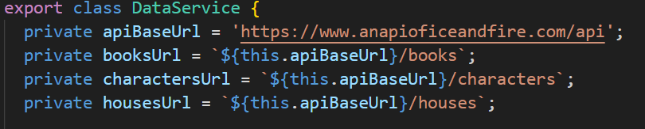
- Send an HTTP GET request to retrieve data from the server:
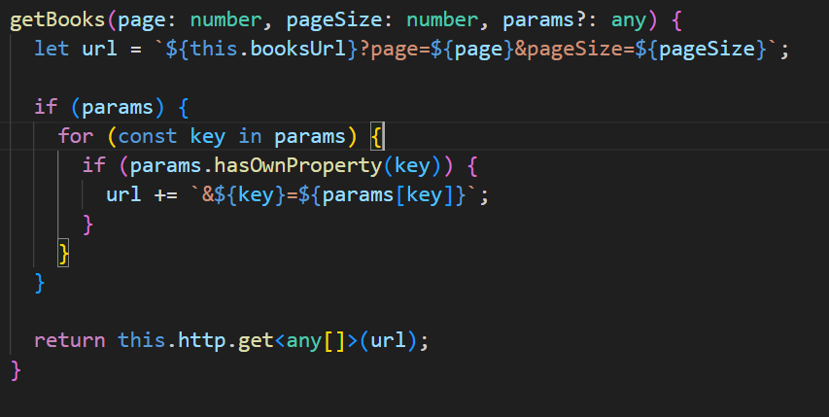
In the example above, the getBooks method sends an HTTP GET request to the server to retrieve a paginated list of books. The page and pageSize parameters are used to specify the desired page and number of items per page.
- Handle the response from the server:
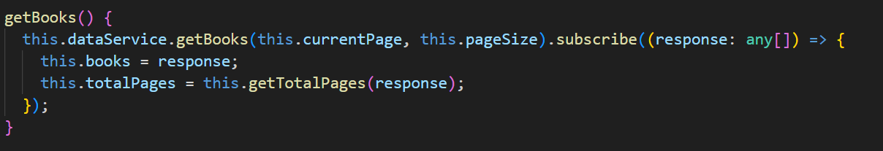
In the example above, the subscribe method is used to handle the response from the server. The first callback function receives the response data, which can be further processed or displayed in the application.
- Display the results in the application: Once the response is received, the data can be used to update the UI and display the results to the user. This is typically done in the component that invokes the DataService methods. Angular's data binding and structural directives are used to display the data.
By following this process, the application sends API requests to the server, receives the response, and updates the UI with the retrieved data.

