TECHNICAL DOCUMENTATION
Real-Time Linux
Server Health Monitor
Core Implementation — Critical Code Snippets & OS Concepts
Language: C | Bash Shell Script
Platform: Linux (Ubuntu) — /proc virtual filesystem
Key Concepts: Process Forking, Shared Memory IPC, Signal Handling, File I/O, exec()

Submitted By:
Muhammad Umair Arif (SP24-BCS-075)
Hamza Aslam(SP24-BCS-065)

1 | Introduction

This report documents the design and implementation of a Real-Time Linux Server Health Monitor. The system is a hybrid C and Bash CLI dashboard that continuously monitors CPU usage, memory consumption, disk utilisation, and process states in real time using the Linux /proc virtual filesystem.

2 | Problem Statement

System administrators require real-time visibility into server resources to detect bottlenecks, prevent outages, and maintain high availability. The objective was to build a monitoring tool that satisfies the following requirements:
- Continuously monitor CPU, memory, disk, and process states.
- Display a live, colour-coded dashboard with progress bars.
- Trigger WARNING and CRITICAL alerts when thresholds are exceeded.
- Log every event and metric to a daily timestamped file.
- Generate an automated hourly summary report using Bash.
- Demonstrate: fork/wait, shared memory IPC, signal handling, /proc scanning.

3 | System Architecture

3.1 System Architecture
The system is structured as follows:
- Core Engine (C): The parent process creates a POSIX Shared Memory segment and forks four child monitor processes. Each child reads metrics from /proc, writes to shared memory, and exits. The parent waits (waitpid), evaluates thresholds, renders the dashboard, and logs events.
- Reporting Engine (Bash): script/report_generator.sh uses grep, awk, and sed to parse the daily log file and produce a formatted hourly summary in reports/.

4 | Process Forking and Synchronization

The parent process continuously forks child processes to gather system metrics simultaneously. Each child is dedicated to a specific resource monitor (CPU, Memory, Disk, Process). The parent uses waitpid to ensure all children have completed before updating the dashboard, guaranteeing data consistency.

src/main.c

/* ── Fork Child Process 1: CPU Monitor ── */
pid_t pid_cpu = fork();
if (pid_cpu < 0) {
perror("fork failed for CPU monitor");
} else if (pid_cpu == 0) {
/* Child process: collect CPU metrics and exit */
collect_cpu_metrics(shm_ptr);
_exit(0);
}
/* ── Fork Child Process 2: Memory Monitor ── */
pid_t pid_mem = fork();
if (pid_mem < 0) {
perror("fork failed for Memory monitor");
} else if (pid_mem == 0) {
/* Child process: collect memory metrics and exit */
collect_mem_metrics(shm_ptr);
_exit(0);
}
/* ... similar for Disk and Process monitors ... */
/* ── Parent: Wait for all children to complete ── */
int status;
if (pid_cpu > 0) waitpid(pid_cpu, &status, 0);
if (pid_mem > 0) waitpid(pid_mem, &status, 0);
if (pid_disk > 0) waitpid(pid_disk, &status, 0);
if (pid_proc > 0) waitpid(pid_proc, &status, 0);

5 | Shared Memory IPC Initialization

POSIX shared memory provides an efficient inter-process communication channel between the parent and its forked children. Child processes write collected metrics directly into the shared memory segment, which the parent reads to refresh the dashboard without any copying overhead.

src/main.c

static void setup_shared_memory(void)
{
/* Create shared memory segment */
shm_id = shmget(SHM_KEY, sizeof(SystemMetrics), IPC_CREAT | 0666);
if (shm_id < 0) {
perror("shmget failed");
exit(1);
}
/* Attach shared memory to process address space */
shm_ptr = (SystemMetrics *)shmat(shm_id, NULL, 0);
if (shm_ptr == (SystemMetrics *)-1) {
perror("shmat failed");
exit(1);
}
/* Initialize to zero */
memset(shm_ptr, 0, sizeof(SystemMetrics));
}

6 | Signal Handling and Hourly Timers

Signals provide an asynchronous notification mechanism for graceful shutdown (SIGINT, SIGTERM) and for triggering the automated hourly report (SIGALRM). The SA_RESTART flag ensures that slow system calls interrupted by SIGALRM are transparently restarted.

src/main.c

static void setup_signal_handlers(void)
{
struct sigaction sa;
/* Handler for SIGINT (Ctrl+C) and SIGTERM */
memset(&sa, 0, sizeof(sa));
sa.sa_handler = signal_handler;
sa.sa_flags = 0;
sigemptyset(&sa.sa_mask);
sigaction(SIGINT, &sa, NULL);
sigaction(SIGTERM, &sa, NULL);
/* Handler for SIGALRM (hourly report trigger) */
memset(&sa, 0, sizeof(sa));
sa.sa_handler = alarm_handler;
sa.sa_flags = SA_RESTART;
sigemptyset(&sa.sa_mask);
sigaction(SIGALRM, &sa, NULL);
}
static void alarm_handler(int sig)
{
(void)sig;
gen_report = 1; /* Sets flag to generate report in the main loop */
}

7 | Reading the Virtual /proc Filesystem

Standard POSIX File I/O is used to read system statistics directly from the kernel via the /proc virtual filesystem. This avoids the need for privileged system calls; the kernel exposes real-time data as readable text files. The parser extracts MemTotal, MemFree, and MemAvailable to compute accurate usage percentages.

src/mem_monitor.c

void collect_mem_metrics(SystemMetrics *metrics)
{
FILE *fp = fopen("/proc/meminfo", "r");
if (!fp) return;
char line[256];
long mem_total = 0, mem_free = 0, mem_available = 0;
while (fgets(line, sizeof(line), fp)) {
if (strncmp(line, "MemTotal:", 9) == 0) {
mem_total = parse_meminfo_value(line);
} else if (strncmp(line, "MemFree:", 8) == 0) {
mem_free = parse_meminfo_value(line);
} else if (strncmp(line, "MemAvailable:", 13) == 0) {
mem_available = parse_meminfo_value(line);
}
}
fclose(fp);
/* Calculate used memory */
metrics->mem_total_kb = mem_total;
metrics->mem_used_kb = mem_total - mem_available;
if (mem_total > 0) {
metrics->mem_usage_percent =
(float)metrics->mem_used_kb / mem_total * 100.0;
}

8 | Automated Report Generation via fork and exec

When SIGALRM fires, the main loop detects the gen_report flag and calls generate_report(). A child process is forked and immediately replaces itself with the Bash report generator using execl. The parent does not wait, so report generation runs asynchronously and never blocks the real-time dashboard

src/main.c

static void generate_report(void)
{
char script_path[600];
snprintf(script_path, sizeof(script_path),
"%s/scripts/report_generator.sh", base_dir);
char log_path[600];
snprintf(log_path, sizeof(log_path), "%s/logs", base_dir);
char report_path[600];
snprintf(report_path, sizeof(report_path), "%s/reports", base_dir);
pid_t pid = fork();
if (pid == 0) {
/* Child: execute report generator bash script */
execl("/bin/bash", "bash", script_path,
log_path, report_path, NULL);
perror("execl failed for report generator");
_exit(1);
}
/* Parent does not wait — report runs asynchronously */
}

9 | Shell Scripting — Text Processing & Arrays

The Bash report generator leverages associative arrays, functions, and standard Unix text-processing utilities (grep, awk, sed, bc) to parse structured log files and compute statistical summaries (average, min, max) over the monitoring period.

scripts/report_generator.sh

# Function to calculate average using a loop and bc
calculate_average() {
local sum=0
local count=0
while read -r value; do
clean_val=$(echo "$value" | sed 's/[^0-9.]//g')
if [ -n "$clean_val" ]; then
sum=$(echo "$sum + $clean_val" | bc 2>/dev/null)
count=$((count + 1))
fi
done
if [ "$count" -gt 0 ]; then
echo "scale=2; $sum / $count" | bc 2>/dev/null
else
echo "0.00"
fi
}
# Extract CPU metrics from logs using grep and sed
extract_metric() {
local metric_name="$1"
if [ -f "$LOG_FILE" ]; then
grep "\[METRIC\]" "$LOG_FILE" 2>/dev/null | \
grep -oP "${metric_name}:[0-9.]+" | \
sed "s/${metric_name}://"
fi
}
# Read metrics into an array and calculate the average
declare -a cpu_values
mapfile -t cpu_values < <(extract_metric "CPU")
cpu_avg=$(printf '%s\n' "${cpu_values[@]}" | calculate_average)

Output Screenshots

Real-Time CLI Dashboard
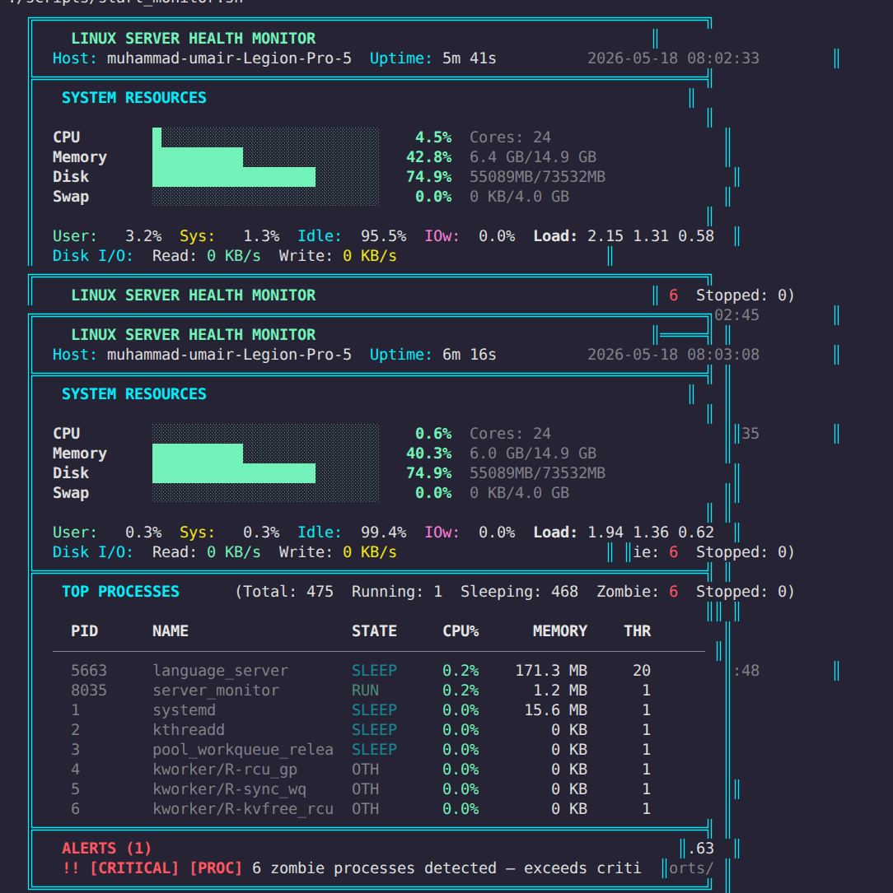

Hourly Summary Report
Every hour SIGALRM fires, triggering an asynchronous child process that executes the Bash report generator. The resulting text file summarises the monitoring period with statistical aggregates and an overall health assessment.
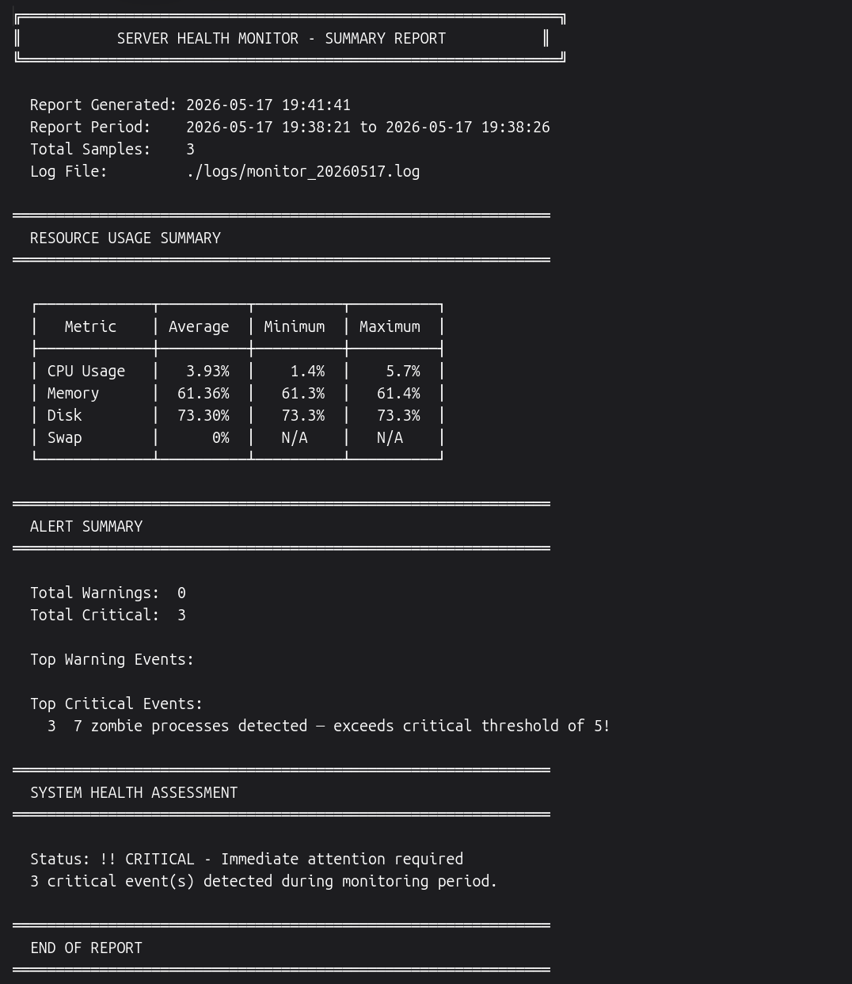

!! | CRITICAL — Status Assessment  3 critical event(s) detected during the monitoring period. Zombie process count (7) exceeds configured threshold. Immediate attention required.

