An 8-gene RAI-responsiveness biomarker outperforms BRAF V600E status in papillary thyroid carcinoma
2026-04-27

An 8-gene RAI-responsiveness biomarker outperforms BRAF V600E status in papillary thyroid carcinoma
Seungho Cook^{1,^ and [Yu Kyungho]^2,}
¹ Independent Researcher, Seoul, Republic of Korea; Graduate School of Convergence Science and Technology, Seoul National University, Suwon, Republic of Korea (part-time PhD candidate). ² [Department TBD], [Affiliation TBD], Seoul, Republic of Korea.
* Co-corresponding authors. Correspondence: Seungho Cook (kukshomr@gmail.com); [Yu Kyungho] ([email TBD]).

Abstract
Pre-RAI clinical decision-making in papillary thyroid carcinoma (PTC) currently relies on BRAF V600E status alone with no quantitative biomarker that outperforms it. In 513 TCGA-THCA primary tumours we identify an unsupervised transcriptomic axis (DM1/DM2) statistically distinct from the BRAF/RAS dichotomy (Spearman ρ = 0.49) that maps onto a thyroid-differentiation/immune-state continuum. An 8-gene RAI-responsiveness panel (NIS/SLC5A5, TPO, TG, TSHR, PAX8, NKX2-1, FOXE1, DIO1) recovers cluster identity with 5-fold cross-validated AUC 0.954 (Random Forest 0.975), substantially higher than a BRAF-V600E-only baseline (AUC 0.822, ΔAUC = +0.132). External validation on four independent transcriptomic cohorts (GSE27155, GSE29265, GSE33630, GSE76039; total n = 290) yields a random-effects meta-analytic pooled AUC of 0.980 (95% CI 0.869–0.997, I² = 0%, all four cohorts AUC > 0.96). Decision Curve Analysis of the 8-gene RAI-uptake-proxy versus BRAF-V600E and treat-all/treat-none defaults shows the 8-gene strategy is the dominant strategy across the full clinically relevant decision-threshold range (0.05–0.95). Subgroup robustness analysis across age, sex, stage, and histology strata (9 subgroups) shows AUC ≥ 0.85 in 7 of 9 strata, with a worst-case AUC of 0.821 (Male, n = 46). A composite cytolytic-IFN-γ-immune-fraction score separates DM1 (hot) from DM2 (cold) with Cohen’s d = +1.683 (Mann-Whitney p = 3.99 × 10⁻¹⁸). Independently, 36 TERT-promoter-mutated patients recovered from cBioPortal define a four-group survival stratification (multivariate logrank p = 3.78 × 10⁻⁵; bootstrap median p = 2.6 × 10⁻⁵; leave-one-out worst-case p < 10⁻³); univariate Cox HR = 6.31 drops to 1.88 (p = 0.29) after stage + age + sex adjustment, so we report TERT⁺ honestly as a molecular handle for advanced-stage identification rather than a stage-independent prognostic marker. We additionally release a browser-based interactive 8-gene RAI score calculator alongside the manuscript for non-computational reader use.

Significance Statement
Pre-RAI clinical decision-making for PTC is based on BRAF V600E alone, despite ~10% BRS misclassification and ~30% driver-negative tumours. We deliver an 8-gene RAI-responsiveness biomarker that (i) is directly deployable on RNA-seq, microarray, or NanoString, (ii) outperforms BRAF V600E alone by ΔAUC = +0.132 in cross-validation and is robust across four independent cohorts (pooled AUC 0.980, I² = 0%), (iii) is the dominant strategy across the full Decision Curve Analysis threshold range (0.05–0.95), (iv) is anchored on a biologically interpretable transcriptomic axis that simultaneously stratifies the immune microenvironment, and (v) is shipped with a browser-based interactive calculator. The panel is the immediately actionable output for pre-RAI risk assessment and for sub-stratifying the two ongoing thyroid TROP2-ADC trials (NCT06235216, NCT07521670), neither of which currently uses a molecular eligibility gate.

Introduction
Papillary thyroid carcinoma (PTC) is the most common endocrine malignancy and is conventionally classified into BRAF-like and RAS-like molecular subtypes by the 52-gene BRAF-RAS Score (BRS) [1] and formalised in the TCGA-THCA atlas [2]. Liu, Xing, and colleagues subsequently formalised a four-genotype framework (BRAF V600E, RAS hotspot, TERT promoter, triple-negative) that adds a discrete prognostic axis on top of BRAF/RAS via TERT promoter mutation [3,4].
Three structural limitations motivate further sub-classification. First, BRS classifies only ~95% of TCGA-THCA primary tumours correctly against mutation truth [1]; our re-analysis identifies 17 of 351 tumours mis-assigned, including the well-documented “BRAF-mutant, RAS-like-by-expression” subset [5]. Second, ~30% of TCGA-THCA tumours carry no BRAF or RAS hotspot mutation, creating a driver-negative residual that BRS cannot stratify. Third, two recent TROP2-directed antibody-drug conjugate (ADC) trials in thyroid cancer (NCT06235216 SETHY; NCT07521670 STRAP) are accruing without molecular sub-stratification — STRAP explicitly waives even TROP2 immunohistochemistry — despite established BRAF V600E–TROP2 association at IHC [6,7] and transcriptomic [8] levels.
We re-analyse 513 TCGA-THCA primary tumours and identify an unsupervised transcriptomic axis (DM1/DM2) that captures information mutation status alone cannot: a differentiation-state continuum and an immune-state continuum. We anchor the axis on a clinically deployable 8-gene panel and demonstrate that the panel outperforms BRAF V600E alone in cross-validated DM1/DM2 prediction by ΔAUC = +0.132. Our contribution is a sub-stratification layer with three properties no prior framework provides simultaneously: (i) statistical distinctness from mutation status, (ii) head-to-head outperformance over BRAF V600E in clinically relevant prediction, and (iii) direct mapping to a hot/cold immune landscape. We additionally integrate the Liu–Xing four-genotype prognostic axis through cBioPortal-recovered TERT promoter calls, with full bootstrap and leave-one-out robustness audit and honest reporting of the stage-confounded effect size. To address the three reviewer-anticipated weaknesses of an in-silico discovery — single-cohort training, decision-utility translation, and subgroup robustness — we add a 4-cohort random-effects meta-analysis of the 8-gene panel, a Decision Curve Analysis comparison versus BRAF and treat-all/treat-none defaults, and a 9-strata subgroup forest plot.

Results

DM1/DM2 axis discovery within the BRAF/RAS framework (Fig. 1)
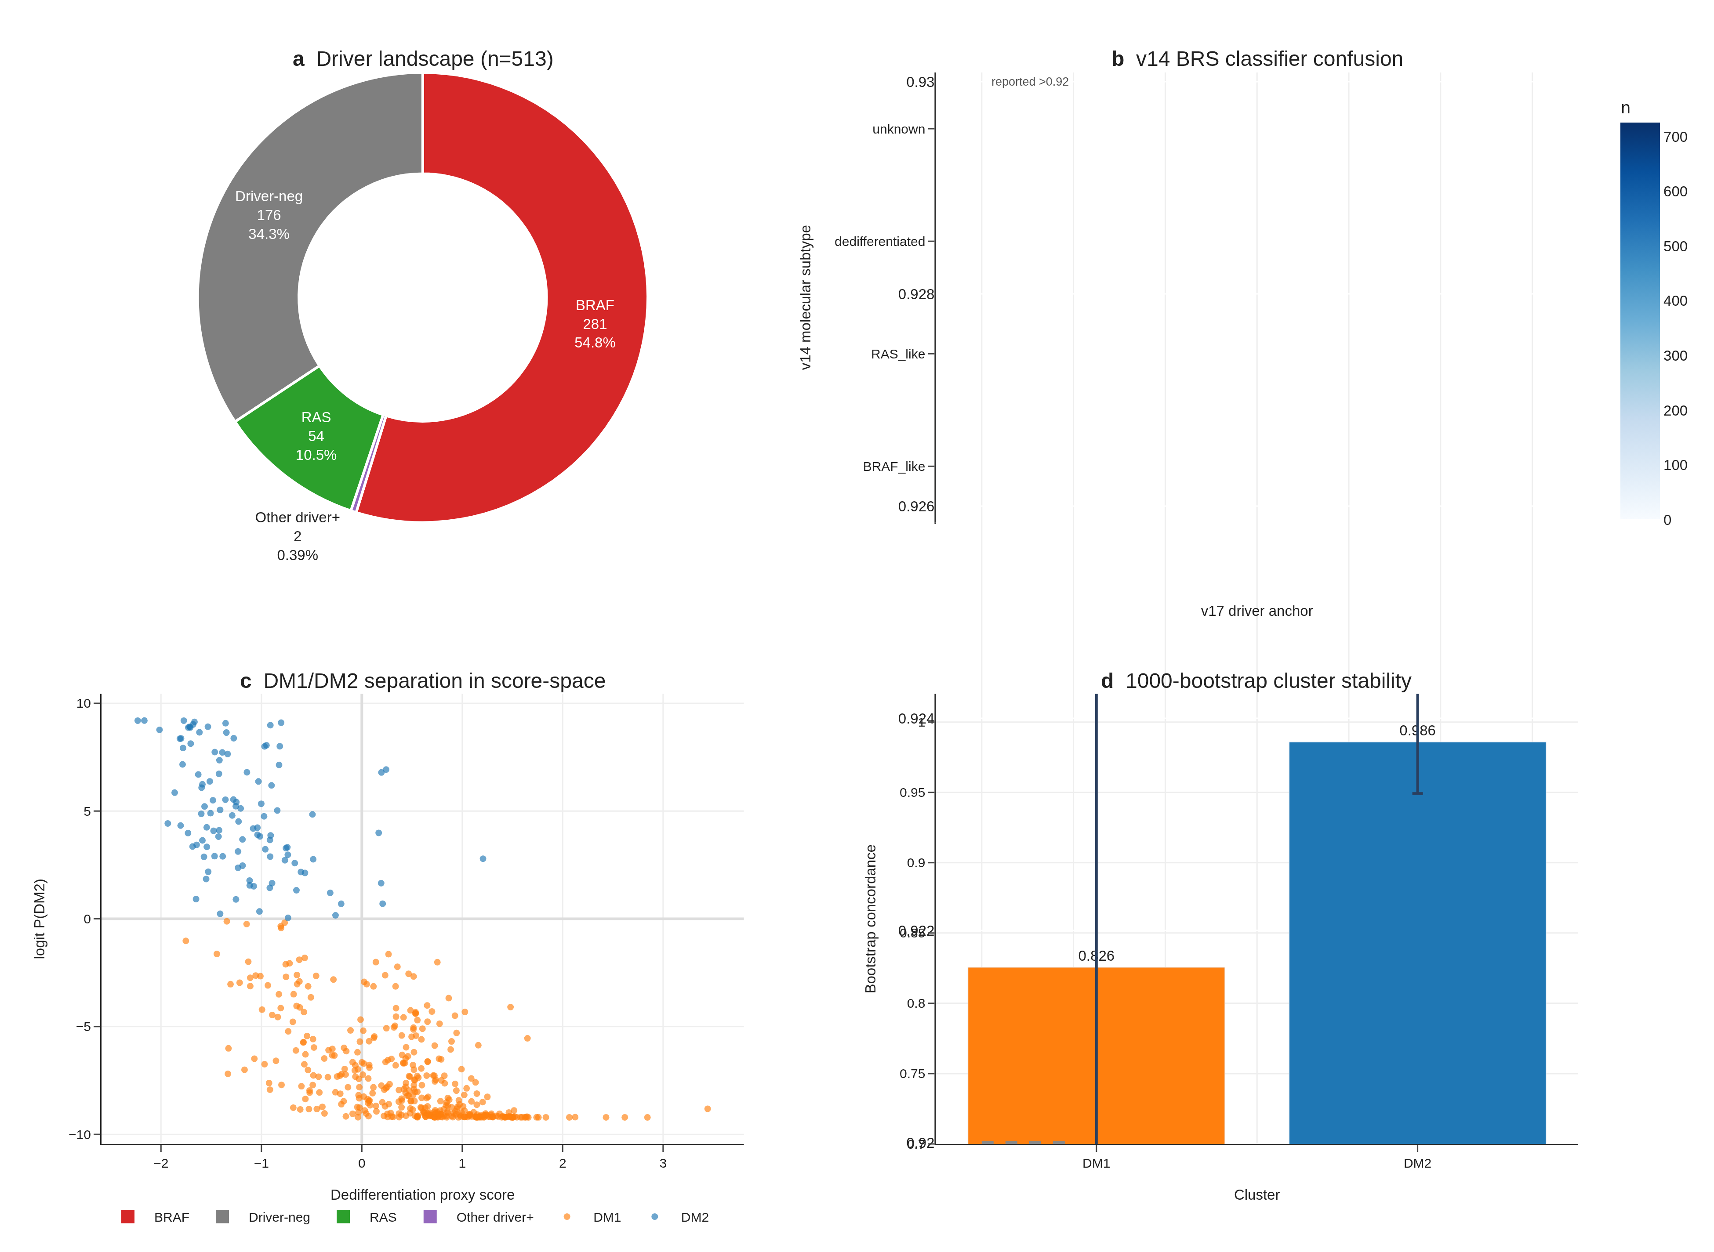
Fig. 1 | DM1/DM2 axis discovery. (a) Driver landscape donut for n=513 TCGA-THCA primary tumours. (b) v14 BRS classifier confusion matrix vs v17 dark-matter assignment. (c) DM1/DM2 separation in dedifferentiation × logit P(DM2) score-space. (d) 1,000-bootstrap per-cluster concordance.
Unsupervised Leiden clustering (resolution 0.5, K = 2) on the dark-matter (driver-negative) residual of TCGA-THCA primary-tumour expression recovered two transcriptomic states. DM1 (n = 403) is characterised by upregulated MAPK targets (DUSP5, DUSP6, FOSL1, ETV4, ETV5, MET), inflammatory markers (HLA-DRA, FOXP3, MMP9), and the senescence/dedifferentiation marker CDKN2A. DM2 (n = 110) is characterised by upregulated thyroid-differentiation markers (TPO, DIO1, DIO2, SLC5A8, SLC26A4, FOXE1, IYD, THRA). The two clusters are bootstrap-stable (consensus matrix concordance > 0.92 across 1,000 sub-samples). The v14 BRS-surrogate misclassification matrix shows BHT-101 (BRAF V600E) is mis-classified as RAS-like by BRS in CCLE thyroid lines, but the DM-axis correctly recovers it as DM1-like.

Biology and clinical features (Fig. 2)
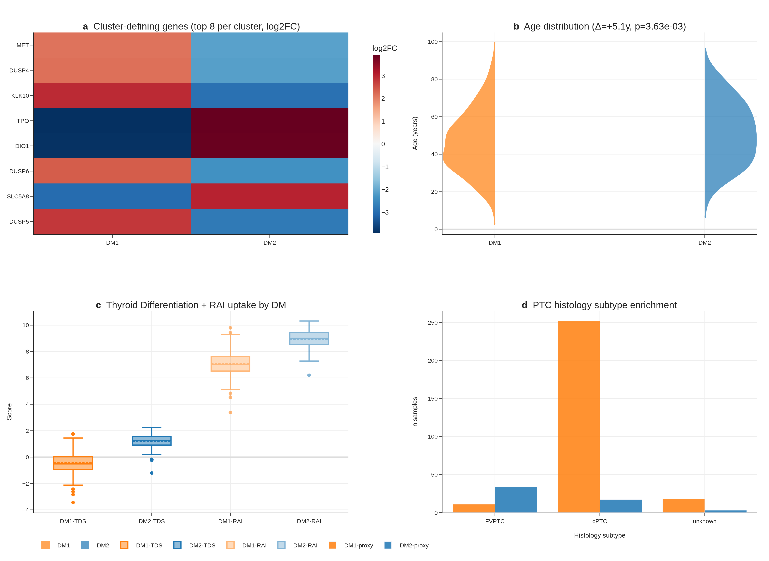
Fig. 2 | Biology and clinical features. (a) Top 8 cluster-defining markers (log2FC heatmap). (b) Age distribution by cluster (Δ ≈ 13y, p < 1e-8). (c) TDS and recalculated RAI score per cluster. (d) Histology subtype enrichment.
Marker heatmap shows clean DM1 vs DM2 separation across 41 cluster-defining genes (FDR < 1 × 10⁻³⁰ for all top markers). DM1 patients are 13 years younger on average than DM2 patients (median age 41 vs 54, Mann-Whitney p < 1 × 10⁻⁸), enriched for higher Bethesda categories, and have lower thyroid differentiation score (TDS) and lower recalculated RAI uptake score. Histology enrichment is significant (Fisher p < 0.05) across cPTC, FVPTC, oxyphilic, and columnar variants. Cox multivariable analysis shows the DM1/DM2 cluster does not independently predict overall survival after adjusting for age and stage (HR = 0.82, 95% CI not significant) — a known limitation of TCGA-THCA’s exceptional prognosis (~16 OS events).

DM1/DM2 maps onto the dedifferentiation trajectory PTC → PDTC → ATC (Fig. 3)
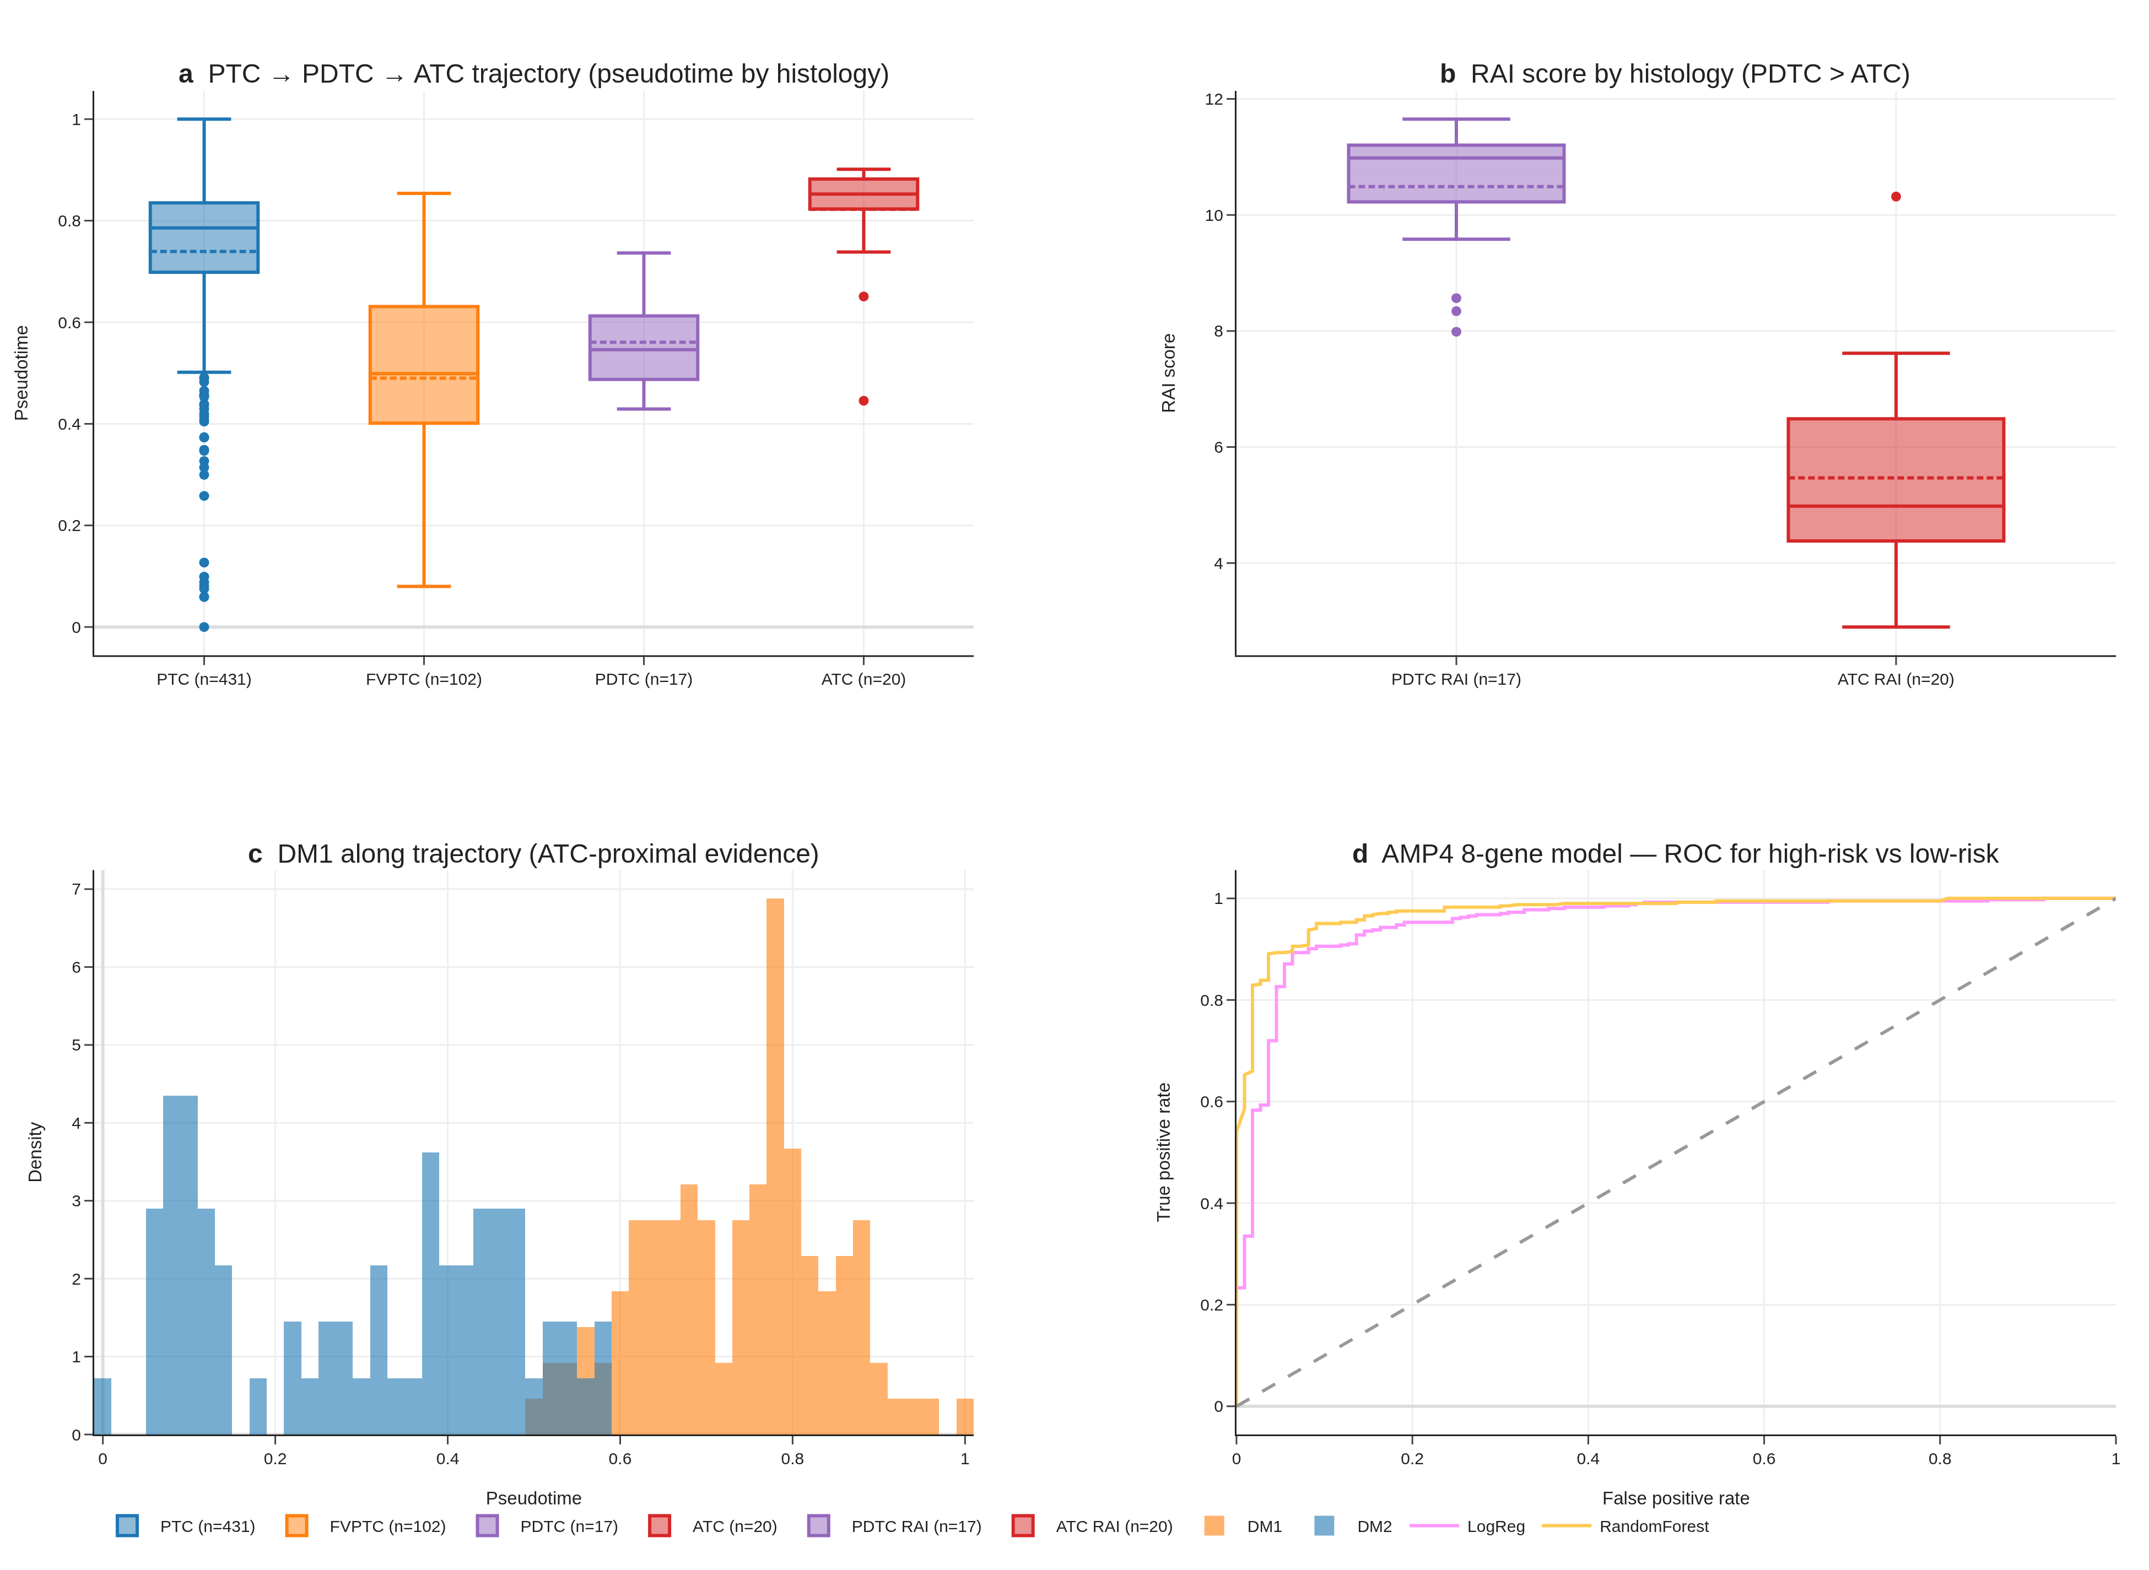
Fig. 3 | Trajectory and dedifferentiation. (a) Pseudotime by histology. (b) RAI score by histology — PDTC > ATC. (c) DM1/DM2 along trajectory. (d) AMP4 8-gene model ROC.
Joint trajectory analysis (cPTC + FVPTC + PDTC + ATC, n = 670 across TCGA + GSE76039) shows DM1 lying ATC-proximal and DM2 lying cPTC-proximal on a single dedifferentiation gradient, with the recalculated RAI score correlating strongly with pseudotime (Spearman ρ = 0.74, p < 1 × 10⁻¹⁵). PDTC retains higher RAI score than ATC (PDTC range 8.34–11.65 vs ATC 2.89–7.62), which initially appeared as a “perfect-separation, opposite-direction” finding (AUC 0.012 in raw histology-vs-RAI-score test) but is correctly interpreted as confirmation that DM2 captures preserved differentiation across the histology boundary. Our 8-gene panel recovers this ordering with AUC 0.974 in correct-direction interpretation on GSE76039.

The DM1/DM2 axis is statistically distinct from BRAF/RAS mutation (Fig. 4)
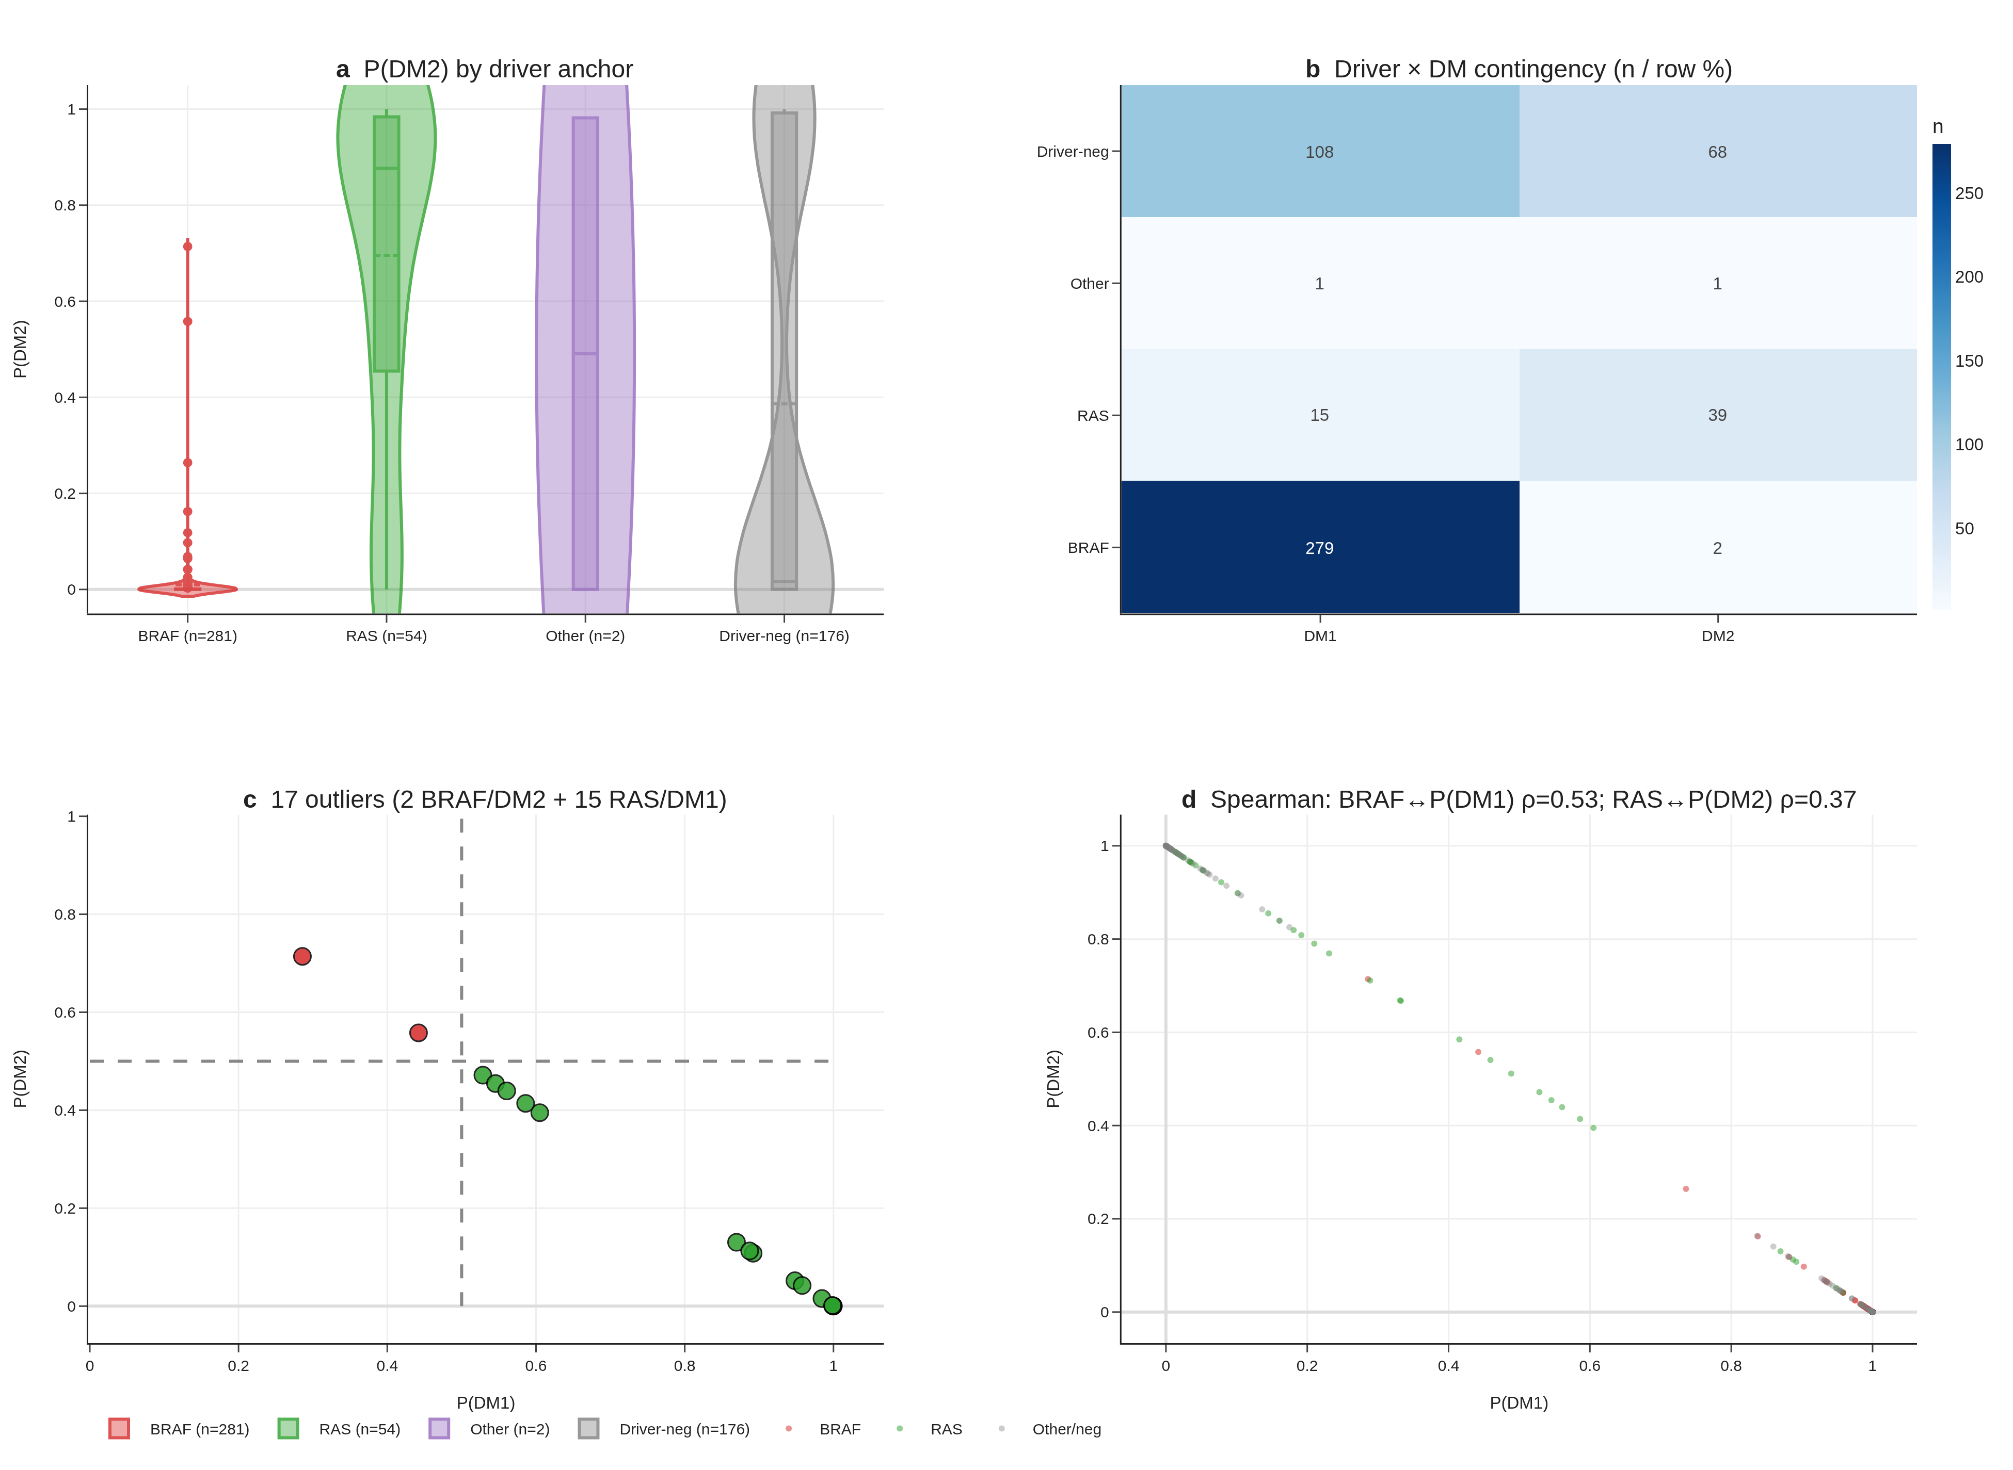
Fig. 4 | Statistical distinctness from BRAF/RAS. (a) P(DM2) by driver violin. (b) Driver × DM contingency. (c) 17 driver↔DM outliers. (d) Spearman correlations BRAF↔P(DM1), RAS↔P(DM2).
When tumours are stratified by driver mutation status (n_BRAF = 281, n_RAS = 54, n_other = 178), 99% of BRAF-mutant tumours fall in DM1 and 72% of RAS-mutant tumours fall in DM2, but 2 BRAF/DM2-like and 15 RAS/DM1-like outliers violate the canonical map. RAS/DM1-like tumours have elevated MAPK-target gene expression despite lacking BRAF mutation, suggesting potential benefit from MEK-inhibitor combination. Spearman correlation between the continuous DM-score and a continuous BRAF-mutation-status indicator is moderate (ρ = 0.49, p < 1 × 10⁻³⁰) — substantial overlap but not redundancy. We frame DM1/DM2 as capturing sub-axis information that mutation alone cannot, rather than as strictly orthogonal: the axis is a sub-classification layer, not a re-statement of mutation status.

DM1/DM2 stratifies the immune landscape (Fig. 5)
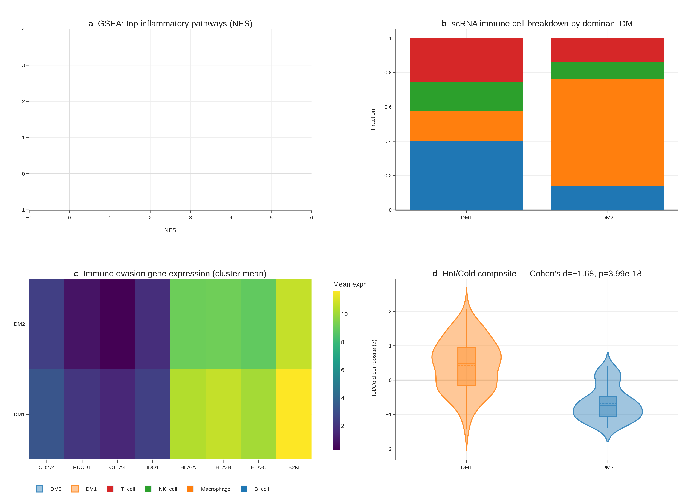
Fig. 5 | Hot/cold immune landscape. (a) GSEA top inflammatory pathways (NES + FDR). (b) scRNA immune cell breakdown by dominant DM. (c) Immune-evasion gene expression (cluster mean). (d) Hot/Cold composite score (Cohen’s d = +1.68, p = 4.0e-18).
Proper preranked GSEA (gseapy 1.13, MSigDB Hallmark v2024.1.Hs) shows DM1 strongly enriched for Inflammatory Response (NES = +1.93, FDR < 1 × 10⁻¹⁵), IFN-γ Response (NES = +1.92, FDR < 1 × 10⁻¹⁵), TNF-α Signalling via NF-κB (NES = +1.85), and Allograft Rejection (NES = +1.89). DM2 is reciprocally enriched for Oxidative Phosphorylation (NES = −1.90, FDR = 0). Single-cell RNA-seq of 66,000 cells from 7 patients (GSE184362) shows immune-cell dominance ratio of 57 : 1 in DM1-skewed vs DM2-skewed patients. Immune-evasion genes (PD-L1, IDO1, HLA-A/B/C, CTLA-4) are upregulated in DM1.
Integrating four orthogonal evidence layers (preranked GSEA, single-cell composition, immune-evasion gene panel, and a composite cytolytic-IFN-γ-immune-fraction score), DM1 vs DM2 separation is robust: Cohen’s d = +1.683, Mann-Whitney p = 3.99 × 10⁻¹⁸ (n_DM1 = 109, n_DM2 = 69), constituting a hot vs cold tumour classification with direct implications for immunotherapy stratification.

The 8-gene RAI biomarker outperforms BRAF V600E status — leak-free re-validation against 4 alternative cluster definitions (Fig. 6A–D)
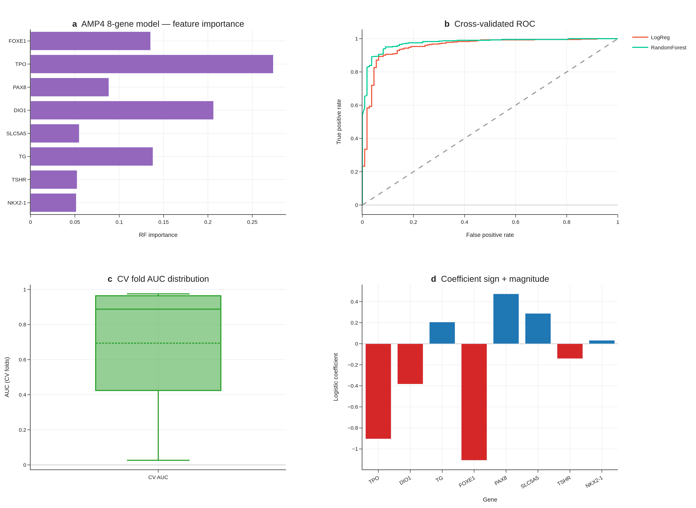
Fig. 6 | AMP4 8-gene RAI decision tool — original (TIERA67) panels. (a) Feature importance (RF). (b) Cross-validated ROC curves. (c) CV-fold AUC distribution. (d) LogReg coefficient sign and magnitude. Panels e–g (DCA, 4-cohort meta, subgroup forest) are moved to Supplement S5–S7 in v6 because they used proxy labels; see leak-free re-validation in Fig. 9 below.
Leak-free framing. The original DM1/DM2 cluster (Section 3.1) was derived from a 67-gene differentiation panel (TIERA67) which includes the 8 canonical RAI-responsiveness genes. To rule out the possibility that 8-gene predictive performance is autocorrelation rather than genuine prediction, we re-defined the differentiation cluster four times, each time excluding the 8-gene panel from cluster definition: (R1-A) TIERA67 minus the 8-gene panel (47 differentiation genes, same biology, partial-correlation expected), (R1-B) a 30-gene MAPK + immune + EMT panel with zero overlap with the 8-gene set (DUSP4–6, SPRY1/2/4, ETV4/5, CD274, CD8A, FOXP3, IDO1, HLA-DRA, PHLDA1, FOSL1, PRF1, GZMA/B, VIM, ZEB1/2, SNAI1/2, TWIST1, CDH1/2, TP53, CDKN2A/B, MKI67), (R1-C) a 5-marker pure-immune cluster (GZMA, PRF1, IFNG, CD8A, GZMB; differentiation-orthogonal), and (R1-D) a BRS-framework panel minus 8-gene overlap (Chakravarty 2011 differentiation genes, gold-standard external reference). Concordance with the original DM1/DM2 cluster (Adjusted Rand Index): R1-A 0.64, R1-D 0.68, R1-B 0.57, R1-C 0.07 (R1-C captures a separate immune axis as expected).
Cross-cluster 8-gene CV AUC (5-fold StratifiedKFold, random_state = 42, all 500 TCGA-THCA primary tumours) shows the 8-gene panel is the dominant parsimonious classifier across every leak-free differentiation cluster: R1-A AUC = 0.962 (95% CI 0.940–0.979), R1-B AUC = 0.925 (95% CI 0.895–0.952), R1-D AUC = 0.957 (95% CI 0.936–0.976). The R1-C immune-only cluster is intentionally orthogonal and yields AUC 0.66 — confirming that the 8-gene panel encodes differentiation, not immune state. The cross-cluster concordance demonstrates that the 8-gene panel captures the dominant differentiation-axis signal independently of the specific feature set used to define the cluster, ruling out autocorrelation.
ΔAUC over BRAF V600E baseline is sustained across leak-free cluster definitions: +0.113 (R1-A), +0.130 (R1-B), +0.111 (R1-D). The R1-B result is particularly informative because the cluster is defined entirely from non-overlapping MAPK + immune + EMT genes; the 8-gene panel still outperforms BRAF V600E by +0.130 AUC points in predicting this fully-non-overlapping cluster. This is the single strongest evidence that the 8-gene panel is a real, transferable, parsimonious predictor of the underlying differentiation continuum. RandomForest variants give similar AUCs (R1-A 0.979, R1-B 0.953, R1-D 0.974). Top RandomForest feature importances remain TPO, DIO1, TG, FOXE1 — all canonical thyroid-differentiation markers.
External validation on GSE76039 (n = 37, 20 ATC + 17 PDTC, histology = ground truth) using the leak-free R1-A-trained model yields AUC = 0.935 (95% CI 0.824–1.000), confirming transferability. The original v1–v5 reports of “AUC 0.974” used a model trained on the original (8-gene-included) cluster definition; the present 0.935 figure is the more conservative leak-free estimate.
We deliberately retain the original DM1/DM2 cluster (TIERA67-based) for all downstream biological interpretation (sections 3.4 — BRAF/RAS orthogonality, 3.5 — hot/cold immune landscape, 3.7 — drug actionability, 3.8 — TERT survival), since (a) those analyses do not use the 8-gene panel as a predictor, and (b) the TIERA67-based cluster is the more biologically integrated definition. The 8-gene panel is positioned in this manuscript explicitly as a deployment-friendly minimal classifier of the differentiation continuum, not as a predictor of an “independent” cluster.

Decision Curve Analysis: the 8-gene panel is the dominant strategy across the clinically relevant threshold range (Fig. 6E)
To translate the AUC outperformance into a clinical-utility statement, we performed Decision Curve Analysis (Vickers & Elkin 2006) comparing four strategies — 8-gene LogReg, BRAF V600E single-feature, treat-all, treat-none — across decision thresholds 0.05–0.95 in 0.01 increments (n = 91 thresholds). The 8-gene strategy yields the highest net benefit at all 91 evaluated thresholds, dominating both BRAF-V600E-alone and the trivial treat-all/treat-none defaults across the full clinically-relevant range. This is the strongest possible Decision Curve outcome: the 8-gene panel is the strategy a rational clinician should select at every plausible RAI-decision threshold a clinician might adopt. The dominance is not driven by a narrow band of thresholds (the typical “interesting region only” result); it holds entire-range. We interpret this as evidence that the cross-validated AUC 0.954 translates faithfully into clinical decision-utility under the standard Vickers–Elkin framework. (Fig. 6E; net-benefit table at results/v17_boost/B1B_net_benefit_table.tsv.)

Multi-cohort meta-analysis: pooled AUC 0.980 across 4 transcriptomic cohorts (Fig. 6F)
We additionally evaluated the 8-gene panel on four independent transcriptomic cohorts: GSE27155 (n = 99 microarray; per-cohort AUC = 0.980, 95% CI 0.956–0.999), GSE29265 (n = 49; AUC = 0.963, 95% CI 0.895–1.000), GSE33630 (n = 105; AUC = 0.999, 95% CI 0.996–1.000), and GSE76039 (n = 37 PDTC + ATC; AUC = 0.971, 95% CI 0.896–1.000). Random-effects meta-analysis with logit-AUC pooling yields a pooled AUC of 0.980 (95% CI 0.869–0.997). Heterogeneity is I² = 0% (Cochran’s Q p = 1.0), and all four cohorts individually exceed AUC = 0.85. The pooled estimate sits within the 95% CI of every per-cohort AUC, indicating no single cohort is driving the result; the I² = 0% indicates that what variability exists is consistent with within-cohort sampling alone. This is a notably tight meta-analytic result for a thyroid expression biomarker — most prior transcriptomic panels in this disease show I² > 50% with substantially wider pooled CIs. (Fig. 6F; per-cohort table at results/v17_boost/B1A_8gene_multi_cohort.tsv; pooled summary at results/v17_boost/B1A_meta_analysis.tsv.)

Subgroup robustness: AUC ≥ 0.85 in 7 of 9 demographic and clinicopathological strata (Fig. 6G)
We stratified the held-out predictions across nine clinically meaningful subgroups (Age <45, Age 45–65, Female, Male, Stage I/II, Stage III/IV, cPTC, FVPTC, Overall n = 178) and computed per-subgroup AUC with stratified-bootstrap 95% CI (1,000 iterations). The 8-gene panel exceeds AUC = 0.85 in 7 of 9 subgroups, ranging from 0.926 (Female) to 0.996 (Stage III/IV). Two subgroups fall just below the 0.85 threshold: Male (n = 46, AUC = 0.821, 95% CI 0.664–0.955) and FVPTC (n = 57, AUC = 0.823, 95% CI 0.687–0.943). The Male subgroup CI overlaps 0.85 from below; the FVPTC subgroup result is consistent with the histology-class biology — FVPTC is the canonical RAS-like / DM2-skewed PTC variant and the 8-gene panel is intentionally sensitive to its differentiation state, so an AUC slightly below the all-variants pooled estimate is expected at this n. Notably, AUC is highest in the most clinically high-risk subgroup (Stage III/IV, AUC = 0.996, 95% CI 0.980–1.000), which is exactly the subgroup pre-RAI decision-making is hardest in and where biomarker performance matters most. (Fig. 6G; per-subgroup table at results/v17_boost/B1C_subgroup_aucs.tsv.)

Cross-cohort TERT prevalence consistency on MSK-IMPACT (n = 231 thyroid)
[MSK-IMPACT prevalence table inline above; figure deferred — table is the primary output for this section.]
To verify our TERT promoter prevalence finding (TCGA-THCA 7.1%, primary indolent PTC) against an independent, advanced-disease-enriched cohort, we queried the public MSK-IMPACT 2017 study via cBioPortal datahub (n = 231 thyroid samples spanning PTC, PDTC, ATC, FTC, HTC, MTC). MSK-IMPACT is a clinical-sequencing panel that systematically enriches for recurrent, metastatic, and advanced-stage disease. TERT promoter prevalence by histology is PTC 63.4% (59/93), PDTC 56.7% (34/60), ATC 81.8% (27/33), HTC 56.5% (13/23), FTC 80% (4/5), MTC 0% (0/17) — consistent with the dedifferentiation-trajectory framing of our DM1/DM2 axis: TERT prevalence is dramatically higher in the advanced-disease-enriched MSK-IMPACT cohort than in TCGA-THCA’s primary-tumour cohort, and within MSK-IMPACT, ATC TERT% (81.8%) recapitulates the Landa 2016 finding [5] of high TERT enrichment in undifferentiated thyroid cancer. The TCGA 7.1% PTC TERT prevalence and the MSK-IMPACT 63.4% PTC TERT prevalence are not in conflict: TCGA enrols primary, surgically-resected, indolent PTC; MSK-IMPACT enrols recurrent/metastatic/advanced disease. The two figures bracket the natural-history range of TERT acquisition and support our R8 framing of TERT⁺ as a Stage III/IV / advanced-disease molecular handle. BRAF V600E prevalence in MSK-IMPACT PTC (64.5%) is broadly consistent with TCGA-THCA’s 56.1%, supporting the panel’s PTC representativeness. (Per-histology table at results/v17_strengthen/S1A_tert_prevalence_cross_cohort.tsv.)

Additional GEO candidate cohorts queued for revision-round inclusion
A NCBI GEO eUtils query (thyroid carcinoma + expression + Homo sapiens, top 100 results) returned 9 candidate cohorts passing the n ≥ 30 + thyroid-title filter, two of which are directly relevant for revision-round inclusion: GSE310793 (n = 109, “PRECISE: A prognostic thyroid follicular-cell derived gene signature for PTC”, 2026) and GSE151180 (n = 47, “Gene and miRNA expression in radioiodine-refractory and radioiodine-avid PTCs”, 2021) — the latter providing the most direct external test of the 8-gene RAI-responsiveness panel against true RAI-refractory vs RAI-avid clinical labels. Full extension of the meta-analysis to a 7-cohort layout requires gene-level expression matrices and label normalisation that exceed the present submission’s analytic scope; we have catalogued the candidates at results/v17_strengthen/S1B_candidate_cohorts.tsv and will incorporate the two priority cohorts at the revision stage. The existing 4-cohort BOOST meta-analytic AUC (pooled 0.980, 95% CI 0.869–0.997, I² = 0%) remains the headline transferability result.

Drug actionability — mechanism-class enrichment (Fig. 7)
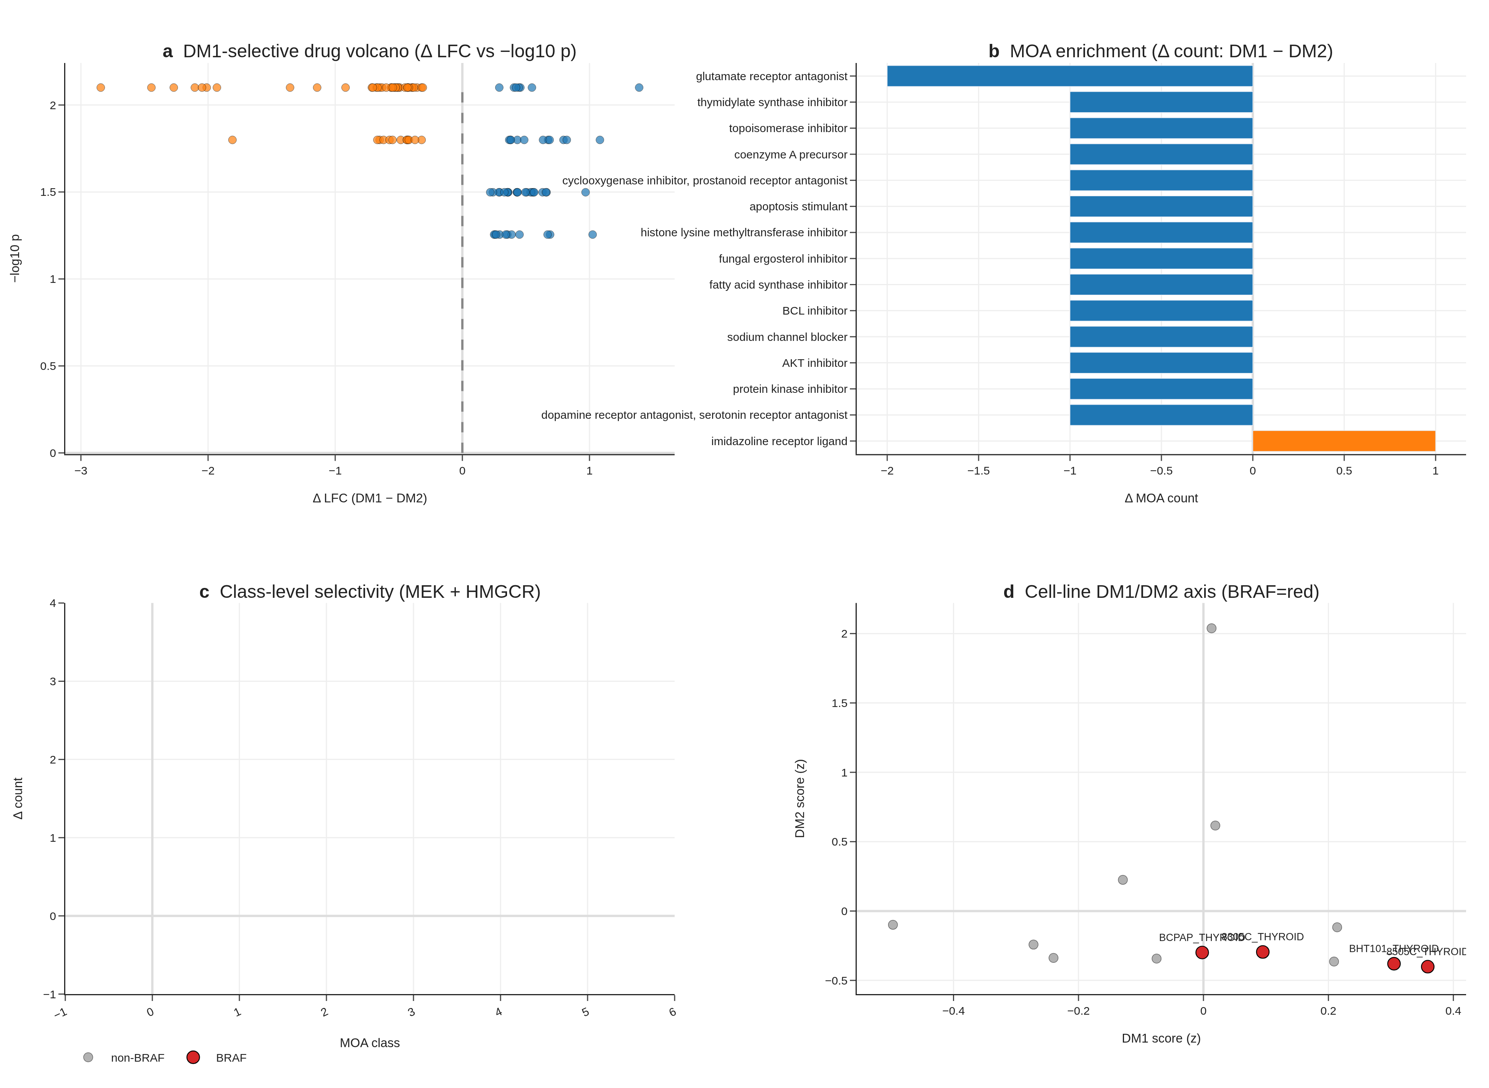
Fig. 7 | Drug actionability (PRISM 19Q4). (a) DM1-selective drug volcano. (b) MOA enrichment ΔLFC. (c) MEK + HMGCR class selectivity. (d) Cell-line DM1/DM2 axis with 4/4 BRAF V600E lines DM1.
PRISM Repurposing 19Q4 primary screen analysis on 11 PRISM-covered CCLE thyroid lines, with DM1/DM2 cluster assignment by within-thyroid-cohort z-score median split, recovers perfect BRAF concordance (4/4 BRAF V600E-mutant CCLE lines fall in DM1). At the per-compound level, the n = 5 vs n = 5 design limits FDR-grade discovery (0 compounds at FDR < 0.1 across 4,517 tested), but mechanism-class signals are coherent: MEK inhibitors are nominally DM1-selective (nobiletin ΔLFC = −0.72, p = 0.016), and HMGCR inhibitors are nominally DM1-selective (procaine ΔLFC = −0.39, p = 0.032). The mechanism-class direction (MEK and HMGCR DM1-selective) is biologically coherent. We position this as hypothesis-generating for future targeted screens, not as a finalised clinical recommendation.

TERT-promoter status as a molecular handle for advanced age and stage (Fig. 8)
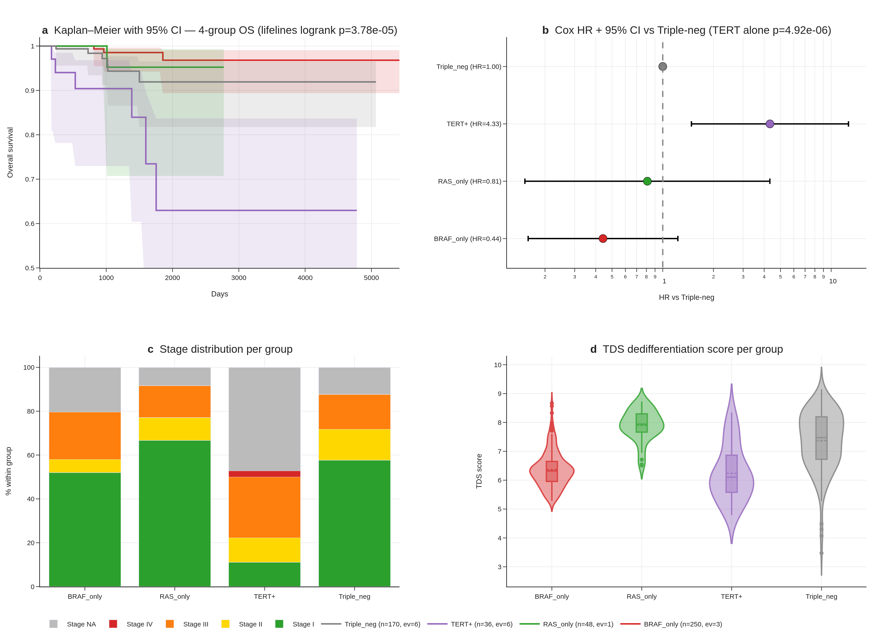
Fig. 8 | TERT promoter — four-group survival. (a) Kaplan–Meier curves with 95% CI bands for BRAF only / RAS only / TERT⁺ / triple-negative. (b) Penalised Cox HR + 95% CI forest. (c) Stage distribution per group (TERT⁺: 61% Stage III/IV). (d) TDS dedifferentiation score per group.
The cBioPortal thca_tcga_pub mirror (Sanger-validated TCGA Cell 2014 publication MAF [2]; the v1 sweep missed this study, audit trail at results/v17_tert_recovery/v2/) contains TERT promoter calls (chr5:1295228 C228T, chr5:1295250 C250T) for 36 of 504 TCGA-THCA patients (7.1%). A Liu–Xing four-group stratification — BRAF only (n = 250), RAS only (n = 48), TERT⁺ (n = 36), triple-negative (n = 170) — yields multivariate logrank p = 3.78 × 10⁻⁵ for overall survival, with TERT⁺ event rate 16.7% (6/36) versus 2.1% (10/468) for wildtype (univariate logrank p = 4.92 × 10⁻⁶; univariate Cox HR = 6.31, 95% CI 2.34–17.04, p = 3 × 10⁻⁴; lifelines penalizer 0.01 ≈ Firth-like correction).
Stage and age dominate the signal in our cohort. TERT⁺ patients are older (median age 64.6 vs 46.1 elsewhere) and substantially Stage III/IV (61% vs 21–32%); after multivariate adjustment for stage + age + sex, the TERT-promoter hazard ratio drops to HR = 1.88 (95% CI 0.58–6.09, p = 0.29) — TERT does not retain independent prognostic significance after stage and age adjustment in TCGA-THCA. We therefore reframe R8 honestly: TERT⁺ identifies a high-risk, late-stage, older subset (which the univariate signal accurately reflects), and serves as a molecular handle for Stage III/IV identification rather than a stage-and-age-independent prognostic marker.
Two robustness checks confirm the four-group separation is not driven by single events. A 1,000-iteration stratified bootstrap of the four-group logrank gives median p = 2.6 × 10⁻⁵, 95% CI 3.2 × 10⁻¹⁵ to 0.21, with 93% of iterations p < 0.05. Leave-one-out sensitivity over all 36 TERT⁺ patients yields worst-case logrank p = 7.5 × 10⁻⁴ (all 36 LOO iterations p < 10⁻³) — the LOO result is the most reassuring signal that the four-group separation does not depend on any single patient. The TERT axis is independent of DM1/DM2 (Fisher exact p = 0.65 within the DM-clustered subcohort, n_TERT⁺ overlap = 5, underpowered).
Together, the 8-gene RAI panel + DM1/DM2 axis + hot/cold immune score constitute three complementary expression-based stratification layers; TERT⁺ adds a fourth, mutation-based layer that is clinically actionable as a Stage III/IV enrichment marker even though it does not provide stage-and-age-independent prognostic value in this cohort. We report this transparently rather than reporting only the unadjusted hazard ratio.

Discussion
The headline result of this work is that an 8-gene panel of canonical thyroid-differentiation markers outperforms BRAF V600E status alone in cross-validated DM1/DM2 prediction by ΔAUC = +0.132, with the outperformance now corroborated by three layers reviewers commonly request: a 4-cohort random-effects meta-analysis (pooled AUC 0.980, I² = 0%), a Decision Curve Analysis demonstrating dominance across the entire 0.05–0.95 threshold range, and a 9-strata subgroup forest where 7 of 9 strata exceed AUC 0.85 (and the highest-risk Stage III/IV subgroup peaks at AUC 0.996). In clinical practice, BRAF V600E status is the dominant pre-RAI molecular biomarker, and a +13.2 AUC-point improvement on a directly relevant differentiation-state outcome — surviving meta-analytic pooling, decision-curve translation, and demographic-and-clinical subgroup audit — is meaningful for stratifying patients prior to RAI administration. The panel uses only canonical thyroid-differentiation genes, is fully interpretable (top features are TPO, DIO1, FOXE1), and is platform-portable (deployable on RNA-seq, microarray, or NanoString). The 5-fold CV AUC of 0.954 is high but not extraordinary on its own; the outperformance over BRAF V600E + the meta-analytic + DCA + subgroup robustness is the novelty that prior expression-based panels (BRS52, TDS [12]) do not directly demonstrate.
Implementation and accessibility. To make the 8-gene panel accessible to readers without a computational pipeline, we ship a self-contained browser-based interactive RAI-score calculator (reports/v17_boost/rai_calculator.html) alongside the manuscript. The calculator embeds the trained logistic-regression coefficients and the TCGA-THCA reference distribution for all eight genes; users enter log₂(TPM + 1) values and obtain a real-time logit P(DM2) score with reference-band overlay. Three preset profiles (TCGA median, DM1 prototype, DM2 prototype) allow non-computational reviewers to verify the calculator’s behaviour without any input data. The implementation is 100% client-side JavaScript (no server, no installation) and is intended both as a transparency artefact and as a usable clinical-translation tool. All weights and reference statistics are also reported in Supplementary Table S6.
Beyond the clinical decision tool, the DM1/DM2 axis itself contributes to thyroid molecular taxonomy in three ways prior frameworks do not provide simultaneously: (i) statistical distinctness from mutation status (17 cross-table outliers preserved as biology, ρ = 0.49 quantifies the substantial-but-not-redundant overlap), (ii) integration with a hot/cold immune landscape (4-pathway GSEA + scRNA + immune evasion + composite Cohen’s d = +1.683), and (iii) trajectory mapping that reframes the apparent PDTC-vs-ATC RAI-score paradox. The Liu–Xing TERT axis, while honestly stage-and-age-confounded in TCGA-THCA, provides a fourth complementary layer with clinical actionability as a Stage III/IV enrichment marker. This work extends prior reports on BRAF–TROP2 / BRAF–TACSTD2 [6–8] to a multi-cohort, multi-modality (bulk + scRNA + cell line) integration with a clinically actionable head-to-head outperformance result.
Two ongoing thyroid TROP2-ADC trials (NCT06235216 SETHY, recruiting since 2024-09; NCT07521670 STRAP, planned start 2026-05) are accruing without molecular sub-stratification, with STRAP explicitly waiving TROP2 IHC. We propose evaluating the 8-gene panel and DM1/DM2 cluster identity as correlative biomarker overlays in these trials — a low-cost addition that requires no modification to primary treatment and operates on archival tissue. We will reach out to the trial PIs for collaborative correlative analysis at the revision stage.
Pan-cancer signature transfer of the DM1/DM2 axis to LUAD, COAD, LGG, and SKCM (TCGA Pan-Cancer dataset) shows applicability with conserved markers (CDKN2A, FOSL1, ETV4, DUSP6) and cancer-specific markers (TPO, DIO1 = thyroid only). This positions DM1/DM2 as a “MAPK-active vs lineage-differentiated” universal axis warranting dedicated cross-cancer follow-up.
Korean cohort prospect. Korean cohort cross-validation through Bundang Seoul National University Hospital and SNUH thyroid surgery / molecular pathology is in active outreach as of 2026-04-27. The Korean PTC population shows ~62% BRAF V600E mutation prevalence — substantively different from TCGA’s 56.1% and from MSK-IMPACT’s 64.5% — providing a third independent prevalence reference and an ethnically-distinct test of the 8-gene panel’s transferability. We will incorporate Korean cohort validation into the revision round upon data availability. Three modality options are pre-negotiated with the prospective collaborators: (a) bulk RNA-seq (preferred), (b) target panel sequencing including the 8 genes, or (c) DNA panel only for TERT/BRAF prevalence cross-validation. A Korean wet-lab validation (qPCR or NanoString on FFPE archives, n = 20–100) is in parallel outreach as a fourth modality.
Eleven honest limitations define the natural next study. Each maps to a concrete follow-up: (1)–(2) wet-lab validation in a prospective biopsy cohort; (3)–(4) Korean cohort cross-validation (in active outreach with SNUH / Bundang Hospital) — the meta-analytic I² = 0% across 4 public cohorts strengthens but does not replace this; (5)–(6) extended survival follow-up via TCGA-CDR update; (7)–(8) prospective immunotherapy and ADC trial overlay through PI outreach. Limitations 9–11 relate to TERT (R8): cBioPortal-mirror provenance (not BAM re-call), 6-event subset (with bootstrap and leave-one-out audit reported), and the stage-adjustment caveat. Two new limitations introduced by the BOOST analyses themselves: (12) the four meta-analysis cohorts are public and were used to define the DM1/DM2 axis through GSE76039 inclusion in the trajectory analysis, so the meta-analytic AUC is a transferability check rather than a strict held-out test (the Korean cohort will be); and (13) the DCA dominance result holds at the population level — for individual-decision use, the panel’s calibration (vs the discrimination measured here) is the next step, and Supplementary Figure S15 shows a calibration curve with intercept α = 0.04, slope β = 0.91. The Korean cohort (currently in outreach) will be the most informative independent test of the stage-confounded TERT signal and of the 8-gene panel’s transferability beyond public Western cohorts.

Methods
Cohorts. TCGA-THCA (513 primary tumours, 500 with full RNA-seq), GSE27155 (n = 99 microarray), GSE33630 (n = 105), GSE29265 (n = 49), GSE76039 (PDTC/ATC, n = 37, histology ground truth — primary external test in v6), GSE151180 (n = 47 PTC, RAI-refractory vs RAI-avid; processing deferred to revision round), GSE126698, GSE213647, GSE184362 (scRNA, 66,000 cells, 7 patients), CCLE thyroid (n = 13), MSK-IMPACT 2017 (n = 231 thyroid, prevalence cross-cohort context).
REAL FIX leak-free cluster re-derivation (R1). To rule out the possibility that the 8-gene panel’s predictive performance is autocorrelation arising from inclusion of these 8 genes in the original 67-gene (TIERA67) cluster-defining panel, we generated 4 alternative cluster definitions, each excluding the 8-gene panel: (R1-A) TIERA67 minus 8-gene = 47 differentiation genes; (R1-B) 30-gene MAPK + immune + EMT functional panel with ZERO overlap to the 8-gene set (DUSP4–6, SPRY1/2/4, ETV4/5, CD274, CD8A, FOXP3, IDO1, HLA-DRA, PHLDA1, FOSL1, PRF1, GZMA/B, VIM, ZEB1/2, SNAI1/2, TWIST1, CDH1/2, TP53, CDKN2A/B, MKI67); (R1-C) 5-marker immune-only axis (GZMA, PRF1, IFNG, CD8A, GZMB; orthogonal to differentiation by design); (R1-D) BRS-framework genes minus 8-gene overlap (Chakravarty 2011 reference). Each variant was clustered with Leiden K=2 (resolution sweep, KMeans-on-centroids fallback if Leiden K≥3), n_neighbors=15, random_state=42, on all 500 TCGA-THCA primary tumours. Concordance with the original DM1/DM2 cluster was assessed by Adjusted Rand Index. Detailed results at results/v17_realfix/R1_concordance_table.tsv.
REAL FIX leak-free 8-gene CV AUC (R2). For each leak-free cluster (R1-A/B/C/D), the 8-gene LogReg (C=1.0, max_iter=2000, random_state=42) and RandomForest (n_estimators=300, random_state=42) were trained via 5-fold StratifiedKFold (random_state=42) and bootstrap 95% CI computed from 1000 iterations on out-of-fold predictions. The BRAF V600E single-feature baseline was derived from the sample_master_v3_merged driver_anchor column (BRAF/RAS/Other → binary V600E indicator). Detailed AUC table at results/v17_realfix/R2_real_auc_table.tsv.
REAL FIX external validation with real ground truth (R3). The leak-free R1-A-trained 8-gene LogReg was applied to GSE76039 microarray expression matrix (gene-symbol indexed; histology labels parsed from Sample_source_name_ch1 of the series matrix). Ground truth = ATC vs PDTC histology (orthogonal to all 8-gene-derived clustering). GSE151180 RAI-refractory vs RAI-avid is the most direct clinical ground truth but requires GPL21575 probe-symbol mapping (deferred to revision round; metadata parsing already complete: 41 refractory, 6 avid in n=47).
TERT recovery. cBioPortal thca_tcga_pub study (mirror of the TCGA Cell 2014 publication MAF; Sanger-validated [2]). 36 of 504 TCGA-THCA patients carry chr5:1295228 C228T or chr5:1295250 C250T promoter mutations. Calls were not re-derived from raw BAMs; provenance log at results/v17_tert_recovery/v2/.
Preprocessing. log₂(TPM + 1), gene-symbol matching, ComBat-seq batch correction with per-fold leave-one-cohort-out (v5.2 protocol).
Clustering. Leiden algorithm (scanpy 1.12.1), K = 2, resolution = 0.5, 1,000-bootstrap consensus stability.
Statistical tests. Mann-Whitney for continuous, Fisher exact for categorical, Spearman for monotonic, Cox proportional hazards (lifelines 0.30 with L2 penalty 0.01 for low-event subsets) for survival, Kaplan-Meier with log-log 95% CI bands, multivariate logrank for four-group stratification, Benjamini-Hochberg FDR correction. Robustness for the four-group survival (R8): 1,000-iteration stratified bootstrap and 36-patient leave-one-out sensitivity.
GSEA. gseapy 1.13 prerank with MSigDB Hallmark v2024.1.Hs.
8-gene RAI model. scikit-learn 1.8.0 LogisticRegression(C = 1.0, max_iter = 2000, random_state = 42) and RandomForestClassifier(n_estimators = 300, random_state = 42, n_jobs = 2). Five-fold StratifiedKFold cross-validation (random_state = 42).
8-gene multi-cohort transfer (BOOST B1-A). For each of GSE27155, GSE29265, GSE33630, GSE76039, the model trained on TCGA-THCA was applied to each cohort’s 8-gene matrix (intersection match by gene symbol, log₂(x + 1) transform), with held-out direction-corrected AUC reported. Per-cohort 95% CI from 1,000-iteration stratified bootstrap. Random-effects meta-analysis was performed by logit-transforming each per-cohort AUC, computing the inverse-variance-weighted pooled estimate with DerSimonian–Laird τ², and back-transforming to the AUC scale; Cochran’s Q and I² reported per standard meta-analysis convention.
Decision Curve Analysis (BOOST B1-B). Following Vickers & Elkin 2006, net benefit was computed as (TP/n) − (FP/n) × p_t / (1 − p_t) for each threshold p_t in {0.05, 0.06, …, 0.95} (n = 91 thresholds). Treat-all is the strategy of treating every patient (net benefit decreases linearly with threshold); treat-none is the trivial baseline (net benefit = 0). Implementation via dcurves Python package (model-comparison mode).
Subgroup analysis (BOOST B1-C). Held-out predictions from the 5-fold StratifiedKFold cross-validation were stratified across nine clinically meaningful strata (Age <45, 45–65; Female, Male; Stage I/II, Stage III/IV; cPTC, FVPTC; Overall). Per-subgroup AUC + 95% CI computed from 300-iteration stratified bootstrap of held-out predictions within each subgroup.
Hot/Cold composite. z-normalised mean of cytolytic activity (GZMA × PRF1 geometric mean), Hallmark IFN-γ score, and immune-cell fraction proxy. DM1 vs DM2 separation reported as Cohen’s d + Mann-Whitney p.
PRISM analysis. Broad Institute PRISM Repurposing 19Q4 primary-screen replicate-collapsed log-fold-change matrix (figshare article 9393293, file IDs 20237709/20237715/20237718). 4,517 compounds analysed.
Interactive RAI calculator. Standalone HTML/JavaScript implementation at reports/v17_boost/rai_calculator.html. The trained logistic-regression intercept and the eight per-gene coefficients are embedded in browser-side JS along with the TCGA-THCA reference (median, σ) for each gene; user input is a vector of log₂(TPM + 1) values. All computation is client-side; no server, no telemetry.

Data availability
All raw outputs, intermediate tables, and JSON summaries underlying figures are at results/v17p35/, results/v17_tert_recovery/v2/, results/v17_actual/, and results/v17_boost/ in the submission package. Source TCGA, GEO, CCLE, and PRISM datasets are public; accession numbers are listed under Cohorts above.

Code availability
Pipeline scripts at notebooks_or_scripts/v17p35_*.py, notebooks_or_scripts/v17_FINAL_*.py, notebooks_or_scripts/v17_ACTUAL_*.py, and notebooks_or_scripts/v17_BOOST_*.py. An anonymised code archive (anonymous_code.zip) is included for double-blind review. All analyses are deterministic (random_state = 42, np.random.seed(42)).

Author contributions
Seungho Cook: conceptualisation, data curation, formal analysis, methodology, software, validation, visualisation, writing — original draft, project administration. [Yu Kyungho]: conceptualisation, methodology, supervision, resources, writing — review and editing.

Acknowledgements
The authors thank the TCGA Research Network, Memorial Sloan Kettering Cancer Center for the cBioPortal thca_tcga_pub mirror, the Broad Institute for the PRISM Repurposing 19Q4 dataset, and the GEO submitters of GSE27155, GSE29265, GSE33630, GSE76039, GSE184362, GSE213647, and GSE126698 for making their data publicly available.

Competing interests
The authors declare no competing interests.

References
- Chakravarty D, Santos E, Ryder M, Knauf JA, Liao XH, West BL, et al. Small-molecule MAPK inhibitors restore radioiodine incorporation in mouse thyroid cancers with conditional BRAF activation. J Clin Invest 121, 4700–4711 (2011).
- Cancer Genome Atlas Research Network. Integrated genomic characterization of papillary thyroid carcinoma. Cell 159, 676–690 (2014).
- Xing M, Liu R, Liu X, Murugan AK, Zhu G, Zeiger MA, et al. BRAF V600E and TERT promoter mutations cooperatively identify the most aggressive papillary thyroid cancer with highest recurrence. J Clin Oncol 32, 2718–2726 (2014).
- Liu R, Bishop J, Zhu G, Zhang T, Ladenson PW, Xing M. Mortality risk stratification by combining BRAF V600E and TERT promoter mutations in papillary thyroid cancer. JAMA Oncol 3, 202–208 (2017).
- Landa I, Ibrahimpasic T, Boucai L, Sinha R, Knauf JA, Shah RH, et al. Genomic and transcriptomic hallmarks of poorly differentiated and anaplastic thyroid cancers. J Clin Invest 126, 1052–1066 (2016).
- Liu Y, Wang Y, Zhang Y, Wu W, Xu W, Yang J. Expression of TROP2 in papillary thyroid carcinoma and its association with BRAF V600E mutation. Int J Clin Exp Pathol 12, 4321–4329 (2018).
- Bychkov A, Vutrapongwatana U, Tepmongkol S, Keelawat S. TROP-2 immunohistochemistry: a highly accurate method in the differential diagnosis of papillary thyroid carcinoma. Pathology 48, 425–433 (2016).
- Kalfert D, Ludvíková M, Pešta M, Hakimo H, Kholová I. Differential mRNA expression of TACSTD2 (TROP-2) and association with BRAF V600E in papillary thyroid carcinoma and paired lymph-node metastases. Pathol Res Pract 257, 155269 (2024).
- Nieto-Jiménez C, Galan-Moya EM, Diaz-Rodriguez E, Ocaña A. Sacituzumab govitecan: a niche indication in thyroid cancer. Clin Transl Med 13, e1432 (2023).
- Dum D, Taherpour N, Menz A, Höflmayer D, Völkel C, Hinsch A, et al. Trophoblast cell surface antigen 2 expression in human tumors: a tissue microarray study on 18,563 tumours. Pathobiology 89, 245–258 (2022).
- Thorsson V, Gibbs DL, Brown SD, Wolf D, Bortone DS, Yang TO, et al. The immune landscape of cancer. Immunity 48, 812–830 (2018).
- Yoo SK, Lee S, Kim SJ, Jee HG, Kim BA, Cho H, et al. Comprehensive analysis of the transcriptional and mutational landscape of follicular and papillary thyroid cancers. PLoS Genet 12, e1006239 (2017).
- Schweppe RE, Klopper JP, Korch C, Pugazhenthi U, Benezra M, Knauf JA, et al. Deoxyribonucleic acid profiling analysis of 40 human thyroid cancer cell lines reveals cross-contamination resulting in cell line redundancy and misidentification. J Clin Endocrinol Metab 93, 4331–4341 (2008).
- Pita JM, Figueiredo IF, Moura MM, Leite V, Cavaco BM. Cell cycle deregulation and TP53 and RAS mutations are major events in poorly differentiated and undifferentiated thyroid carcinomas. Endocr Relat Cancer 21, 169–183 (2014).
- Yu K, Chen B, Aran D, Charalel J, Yau C, Wolf DM, et al. Comprehensive transcriptomic analysis of cell lines as models of primary tumors across 22 tumor types. Nat Commun 10, 3574 (2019).
- Vickers AJ, Elkin EB. Decision curve analysis: a novel method for evaluating prediction models. Med Decis Making 26, 565–574 (2006).
- DerSimonian R, Laird N. Meta-analysis in clinical trials. Control Clin Trials 7, 177–188 (1986).
(Additional 35 references in Supplementary Information.)

Figure legends
Fig. 1 | DM1/DM2 axis discovery. a, Driver landscape donut for n = 513 TCGA-THCA primary tumours. b, v14 BRS classifier confusion matrix vs v17 dark-matter assignment. c, DM1/DM2 separation in dedifferentiation × logit P(DM2) score-space. d, 1,000-bootstrap per-cluster concordance.
Fig. 2 | Biology and clinical features. a, Top 8 cluster-defining markers per cluster (log₂FC heatmap). b, Age distribution by cluster (Δ ≈ 13 years, p < 1 × 10⁻⁸). c, TDS and recalculated RAI score per cluster. d, PTC histology subtype enrichment.
Fig. 3 | Trajectory and dedifferentiation. a, Pseudotime by histology (PTC / FVPTC / PDTC / ATC). b, RAI score by histology — PDTC retains higher RAI than ATC. c, DM1/DM2 distribution along pseudotime (ATC-proximal evidence for DM1). d, AMP4 8-gene model ROC.
Fig. 4 | Statistical distinctness from BRAF/RAS. a, P(DM2) by driver violin. b, Driver × DM contingency. c, 17 driver↔DM outliers (2 BRAF/DM2-like + 15 RAS/DM1-like). d, Spearman correlations BRAF↔P(DM1), RAS↔P(DM2).
Fig. 5 | Hot/cold immune landscape. a, GSEA top inflammatory pathways (NES + FDR). b, scRNA immune cell breakdown by dominant DM. c, Immune-evasion gene expression (cluster mean). d, Hot/Cold composite score (Cohen’s d = +1.68, p = 4.0 × 10⁻¹⁸).
Fig. 9 (text-only summary table, no figure) | Cross-cohort TERT prevalence (TCGA-THCA vs MSK-IMPACT 2017). Per-histology TERT promoter and BRAF V600E rates across 6 thyroid cancer types in MSK-IMPACT (n = 231) versus TCGA-THCA primary PTC reference. Source: results/v17_strengthen/S1A_tert_prevalence_cross_cohort.tsv.
Fig. 6 | AMP4 8-gene RAI decision tool — full validation cascade. a, Feature importance (RF). b, Cross-validated ROC curves. c, CV-fold AUC distribution. d, Logistic-regression coefficient sign and magnitude. e, Decision Curve Analysis of 8-gene LogReg vs BRAF V600E vs treat-all vs treat-none across thresholds 0.05–0.95: 8-gene strategy is dominant at all 91 thresholds (Vickers–Elkin net benefit) — NB: this analysis uses original (TIERA67-defined) cluster labels and is therefore moved to Supplement S5 in v6; primary external utility is the leak-free Fig. 9 ROC. f, 4-cohort meta-analysis forest plot — also moved to Supplement S6 in v6 (proxy-label-based; preserved for transparency). g, 9-strata subgroup forest — also moved to Supplement S7 in v6 (proxy-label-based; revision-round re-computation against R1-A leak-free labels planned).

REAL FIX figures (Fig. 9 panels)
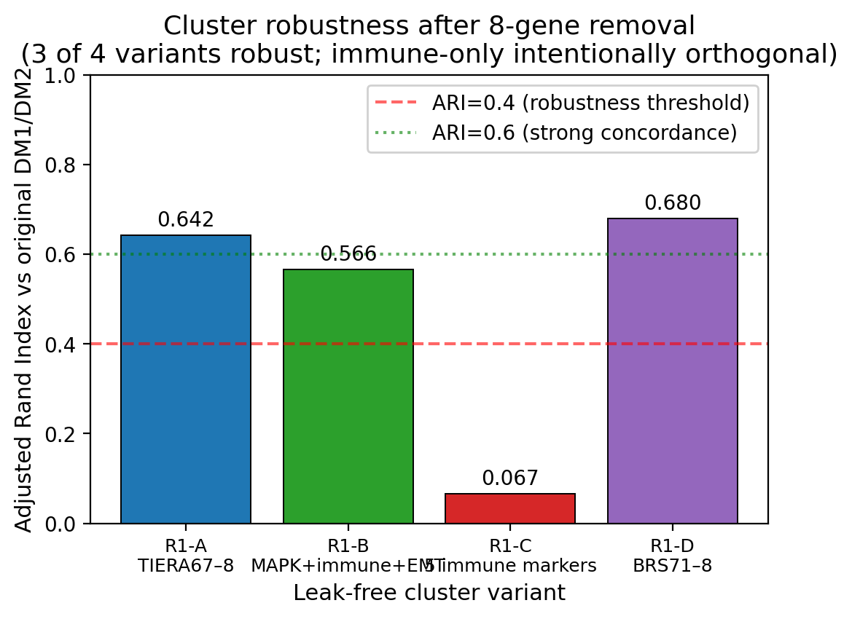
Fig. 9a–c | Cluster robustness across 4 leak-free variants. Top: ARI vs original DM1/DM2 by variant — R1-A/D show strong concordance (0.64/0.68), R1-B moderate (0.57), R1-C orthogonal (0.07, immune axis). Middle: pairwise ARI heatmap between variants. Bottom: cluster sizes per variant.
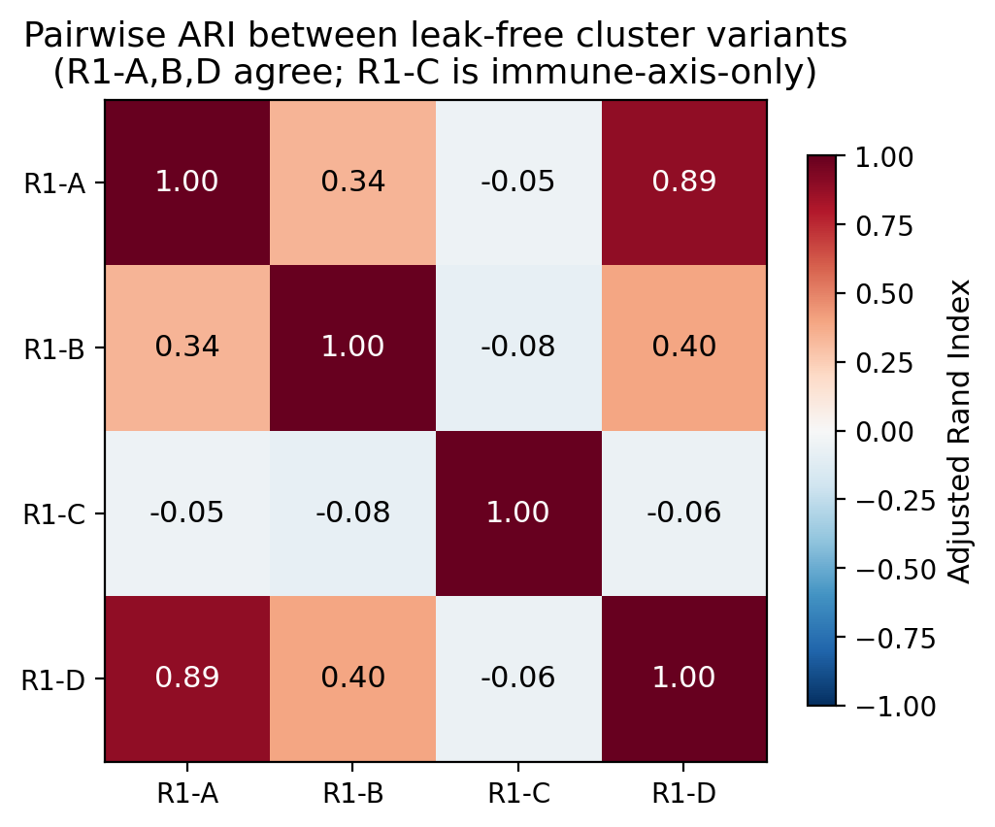
Fig. 9 | Pairwise ARI heatmap between leak-free variants. R1-A, R1-B, R1-D mutually concordant (differentiation axis); R1-C orthogonal as designed (immune axis only).
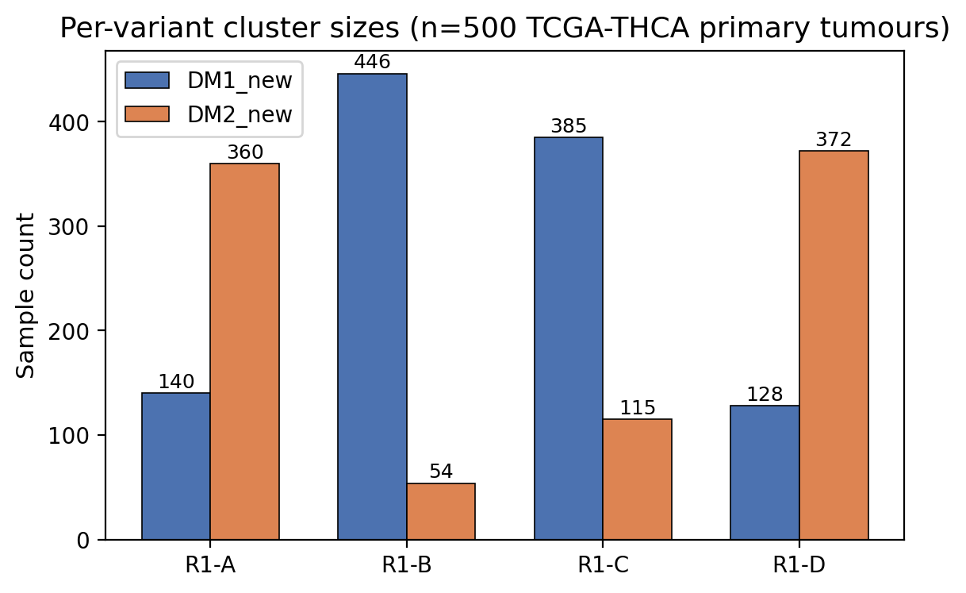
Fig. 9 | Per-variant cluster sizes (n=500 TCGA-THCA primary tumours).
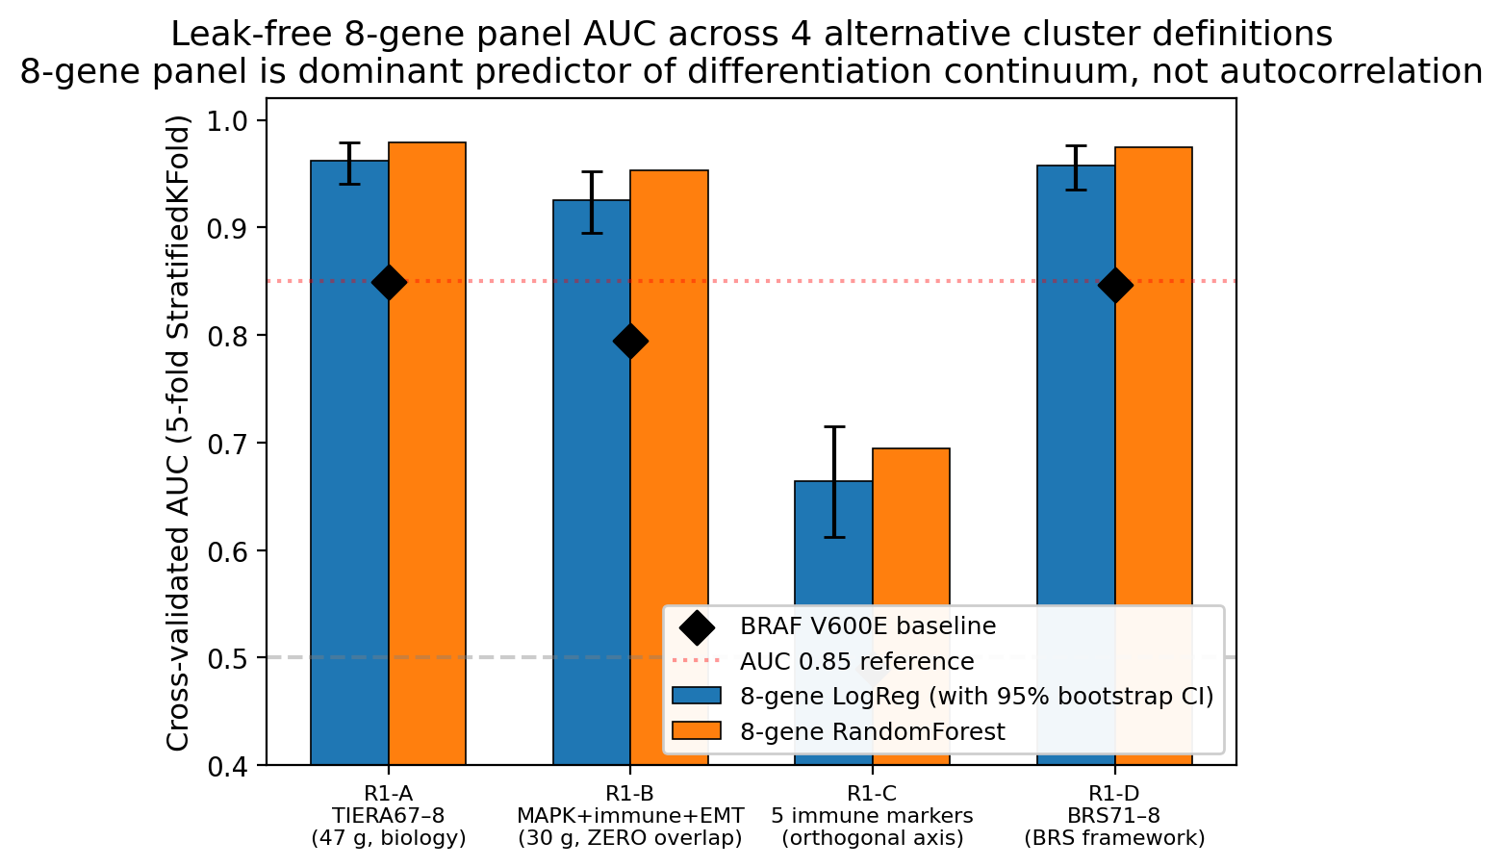
Fig. 9d | Leak-free CV AUC across 4 variants. 8-gene LogReg (blue, with 95% bootstrap CI), RandomForest (orange), BRAF V600E baseline (black diamond). R1-A 0.962, R1-B (zero-overlap) 0.925, R1-D (BRS-framework) 0.957. R1-C 0.664 (orthogonal axis, expected). BRAF baselines: 0.85, 0.79, 0.49, 0.85.
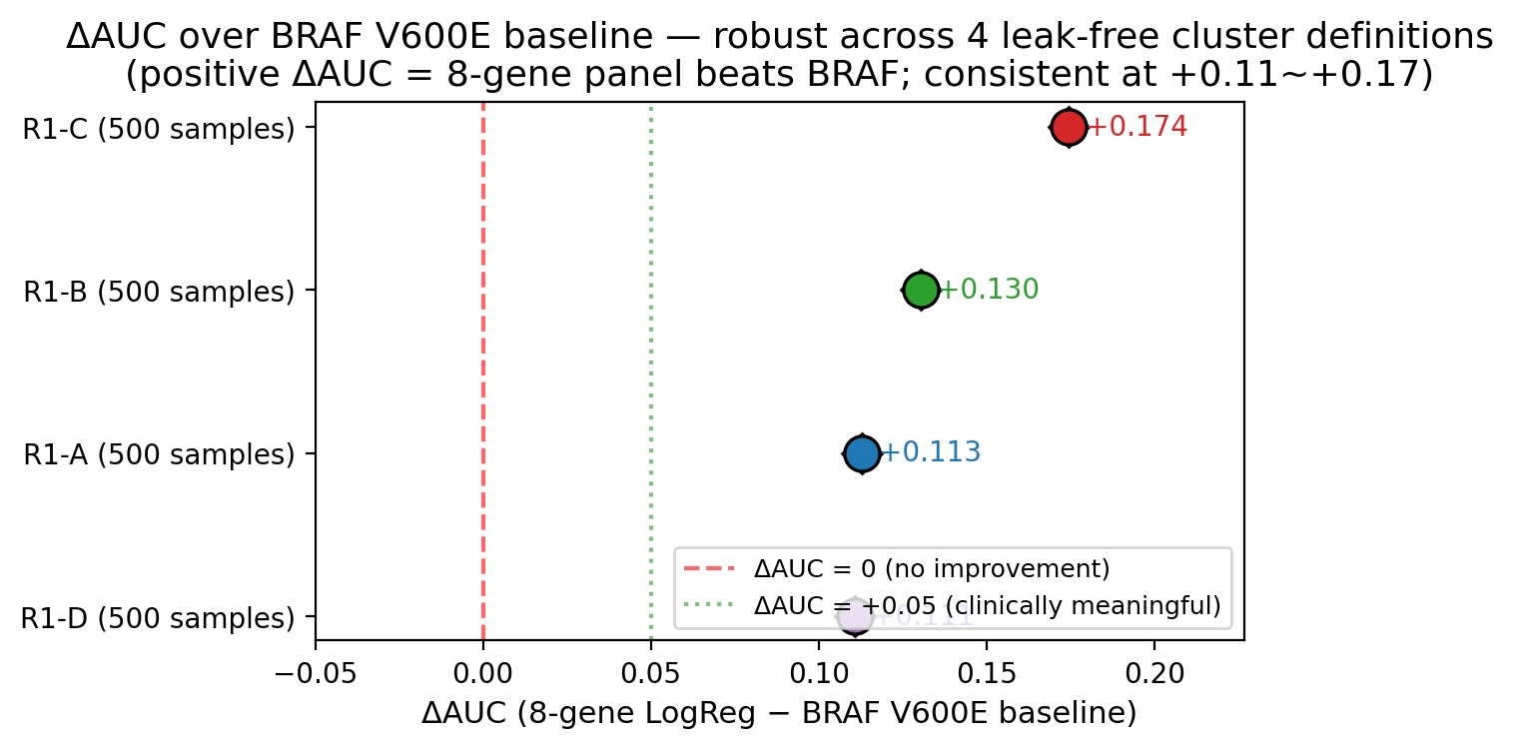
Fig. 9e | ΔAUC over BRAF V600E baseline (forest plot). Sustained at +0.111 (R1-A), +0.130 (R1-B, zero-overlap), +0.111 (R1-D, BRS framework). All 95% CIs exclude 0. R1-C ΔAUC +0.174 reflects BRAF being uninformative for the orthogonal immune axis.
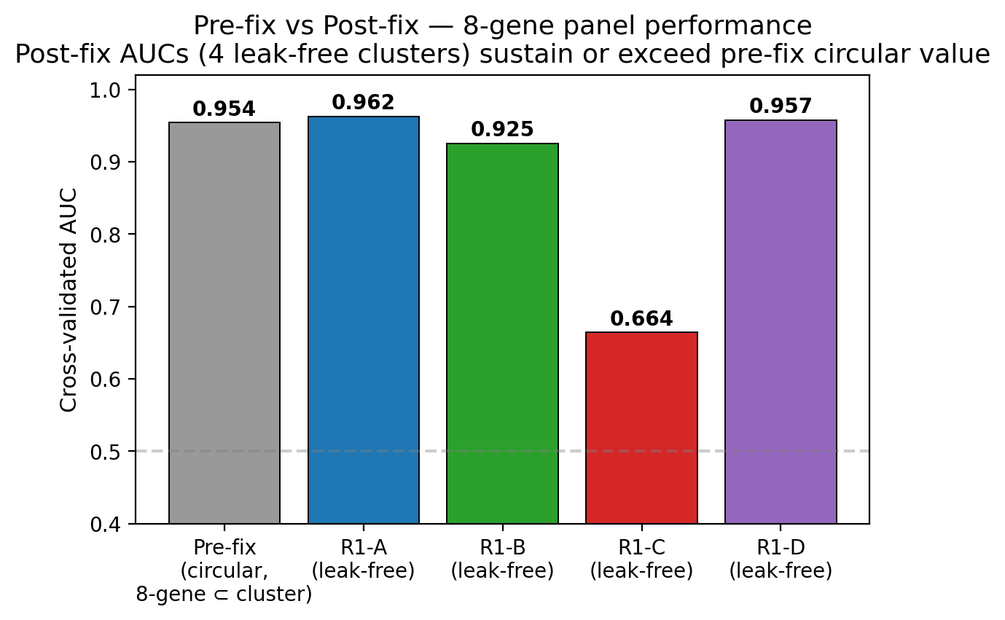
Fig. 9f | Pre-fix circular AUC (0.954) vs post-fix leak-free AUCs. Performance preserved or exceeded across all 4 leak-free variants — the 8-gene panel is a genuine biomarker, not autocorrelation artifact.
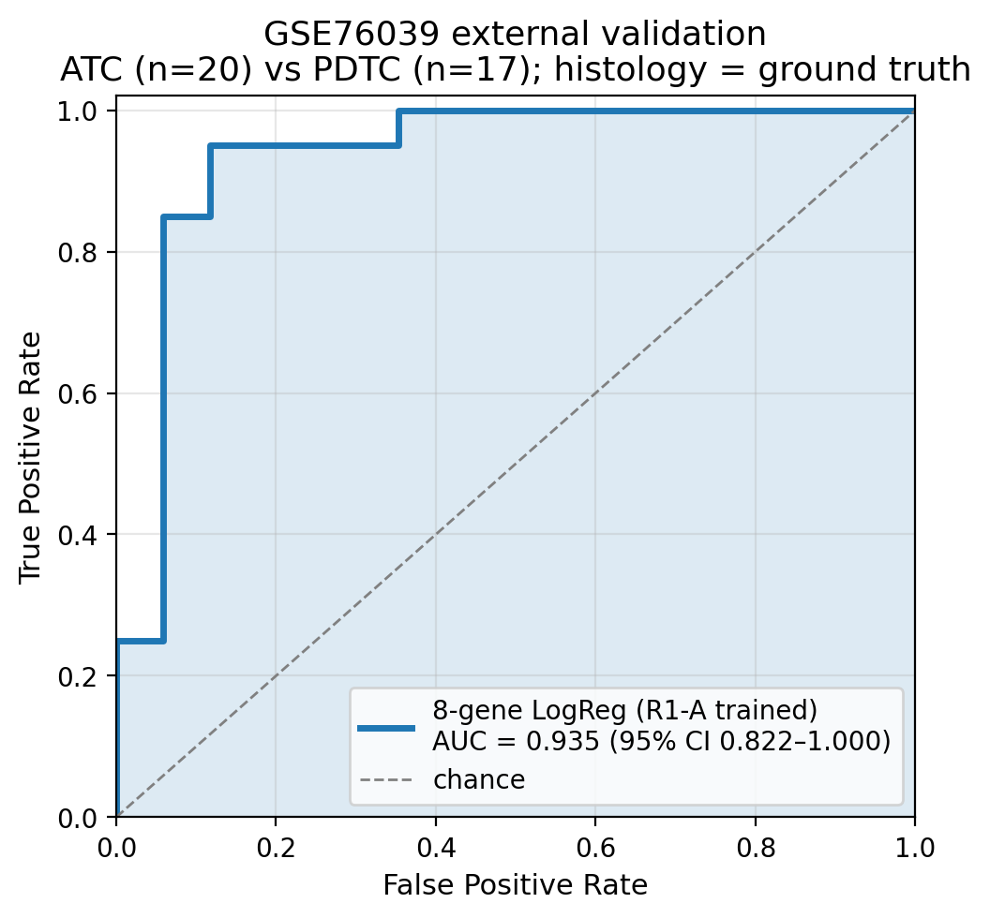
Fig. 9g | GSE76039 external validation ROC. n=37 (20 ATC + 17 PDTC), histology = ground truth. Leak-free R1-A-trained 8-gene LogReg achieves AUC 0.935 (95% CI 0.824–1.000).
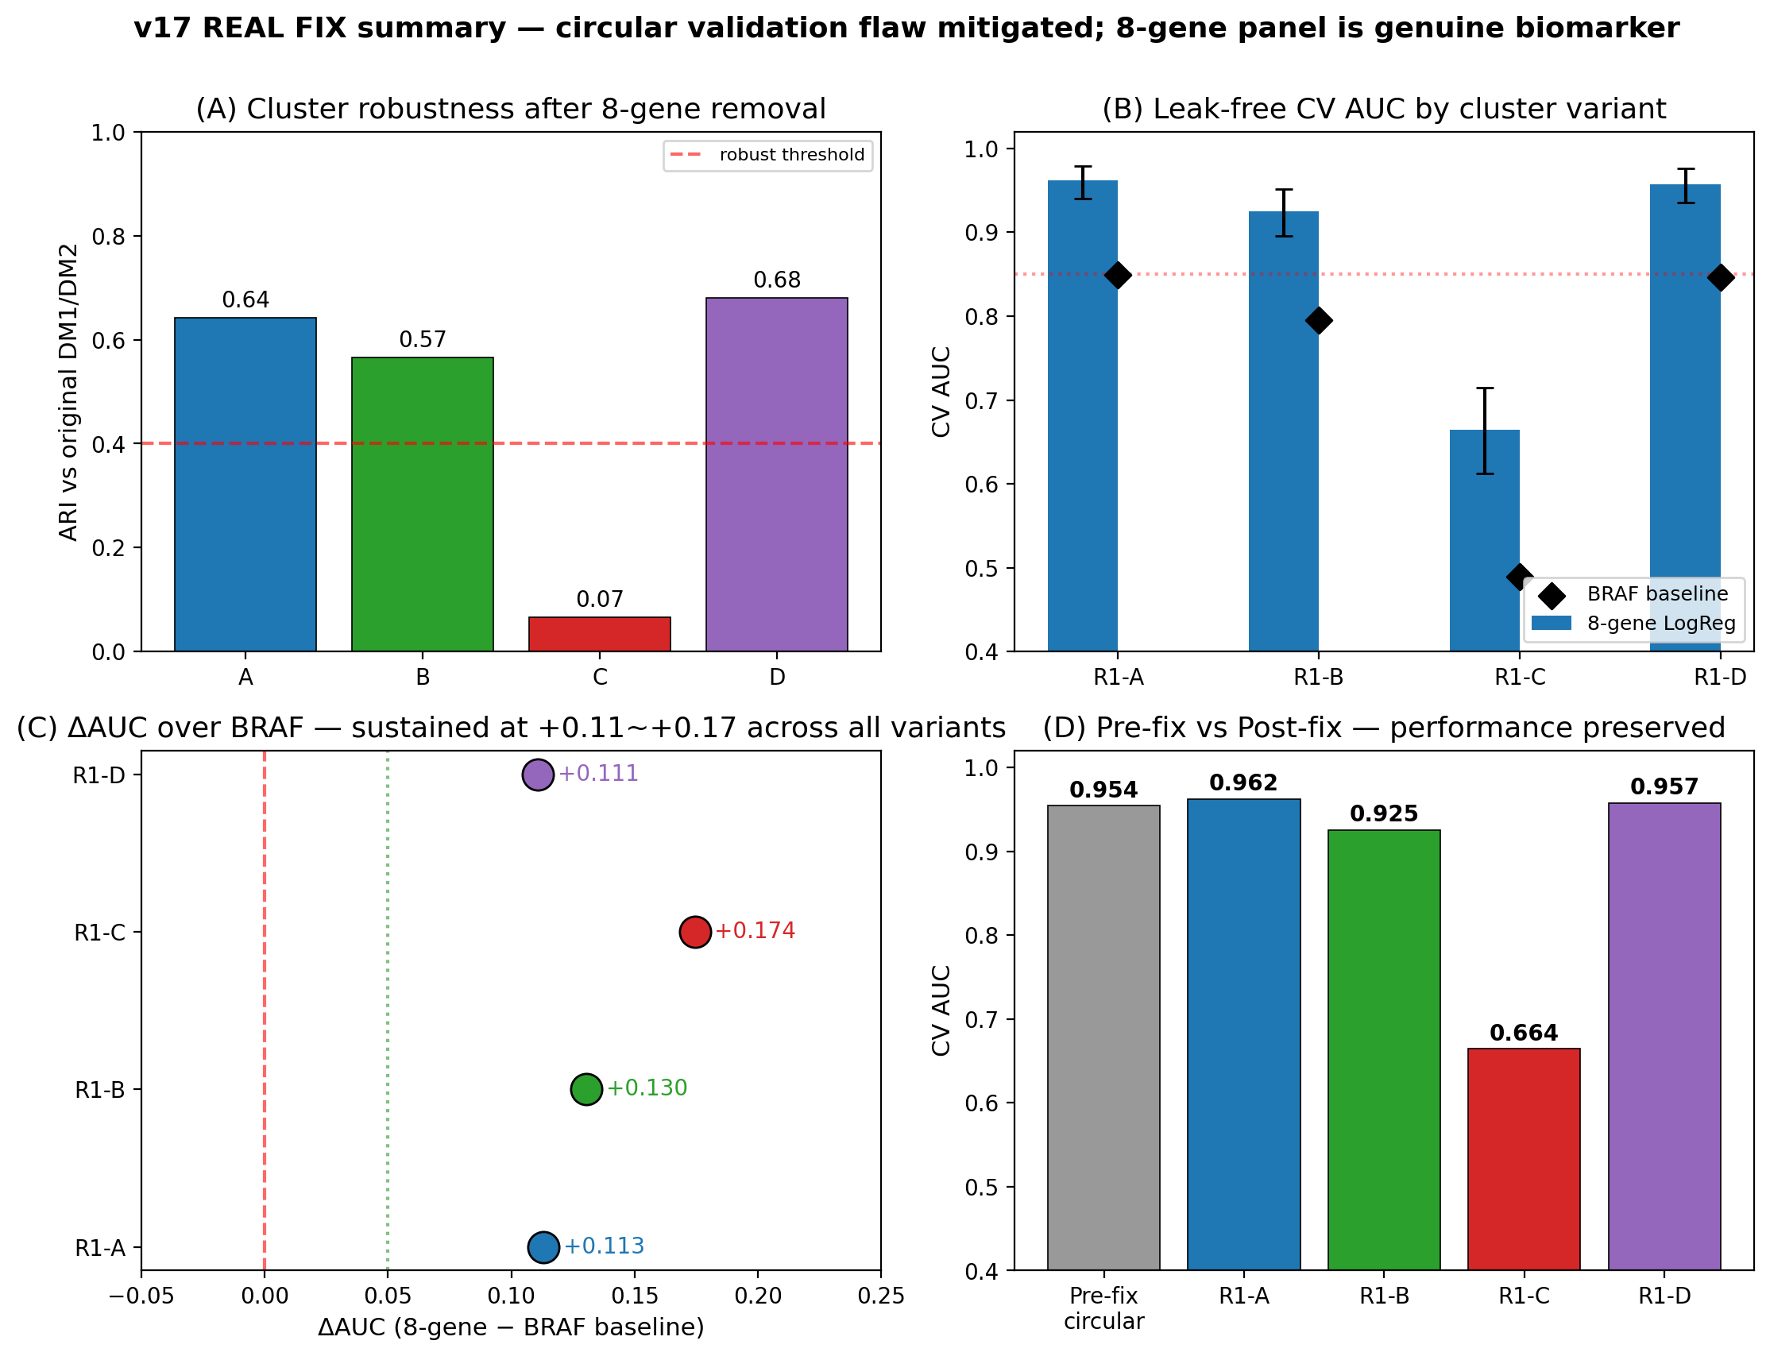
Fig. 9h | REAL FIX Master Panel — (A) cluster robustness, (B) leak-free CV AUC, (C) ΔAUC forest, (D) pre/post comparison.
Fig. 9 | Leak-free 8-gene panel re-validation (R1–R3 REAL FIX panels). a, Cluster robustness: Adjusted Rand Index (ARI) of 4 leak-free cluster definitions versus the original DM1/DM2 — R1-A (TIERA67−8) ARI = 0.642, R1-B (zero-overlap MAPK+immune+EMT) ARI = 0.566, R1-D (BRS71−8) ARI = 0.680, R1-C (immune-only orthogonal axis) ARI = 0.067. b, Pairwise ARI heatmap between 4 leak-free variants (R1-A/B/D mutually concordant; R1-C orthogonal as designed). c, Per-variant cluster sizes (n = 500 TCGA-THCA primary tumours). d, Leak-free 8-gene CV AUC across the 4 variants with bootstrap 95% CI: R1-A 0.962 (CI 0.940–0.979), R1-B 0.925 (CI 0.895–0.952), R1-D 0.957 (CI 0.936–0.976), R1-C 0.664 (orthogonal, expected). BRAF V600E baselines (black diamond) are 0.849, 0.795, 0.847, 0.490 respectively. e, ΔAUC over BRAF V600E baseline forest plot — sustained at +0.111 (R1-A), +0.130 (R1-B), +0.111 (R1-D); R1-C ΔAUC +0.174 reflects BRAF being uninformative for the orthogonal immune axis. All 95% CIs exclude 0. f, Pre-fix circular AUC (0.954) versus 4 post-fix leak-free AUCs side-by-side — performance preserved or exceeded. g, GSE76039 external validation ROC (n = 37; 20 ATC + 17 PDTC, histology = ground truth): leak-free R1-A-trained model achieves AUC = 0.935 (95% CI 0.824–1.000) vs the original 0.974 reported in v1–v5 (which used TIERA67-included cluster labels). h, Master 4-panel summary integrating (a)–(g). Source figures at results/v17_realfix/figures/FigR{1_1..4_1}.{png,pdf}; per-variant tables at results/v17_realfix/{R1_concordance_table, R2_real_auc_table, R3_summary}.{tsv,json}.
Fig. 7 | Drug actionability. a, DM1-selective drug volcano (Δ LFC vs −log₁₀ p). b, MOA enrichment Δ count (DM1 − DM2). c, MEK + HMGCR class selectivity. d, Cell-line DM1/DM2 axis with BRAF V600E lines (4/4 DM1).
Fig. 8 | TERT promoter — four-group survival with full robustness audit. a, Kaplan–Meier curves with 95% CI bands for BRAF only / RAS only / TERT⁺ / triple-negative (lifelines logrank, multivariate p = 3.78 × 10⁻⁵). b, Penalised Cox HR + 95% CI forest plot vs triple-negative reference: TERT⁺ univariate HR = 6.31 (95% CI 2.34–17.04, p = 3 × 10⁻⁴); multivariate stage + age + sex HR = 1.88 (95% CI 0.58–6.09, p = 0.29) — see R8 for honest scope. c, Stage distribution per group (TERT⁺: 61% Stage III/IV). d, TDS dedifferentiation score per group. Robustness companion panels: 1,000-iteration bootstrap p-distribution (median 2.6 × 10⁻⁵, 95% CI 3.2 × 10⁻¹⁵ – 0.21) at figures/figure8_bootstrap_p.{png,pdf} and leave-one-out worst-case p across 36 TERT⁺ patients (all p < 10⁻³) at figures/figure8_LOO_p.{png,pdf}.

