1. Link: <https://github.com/cook2298/csd-310>

2. GitHub Repo:

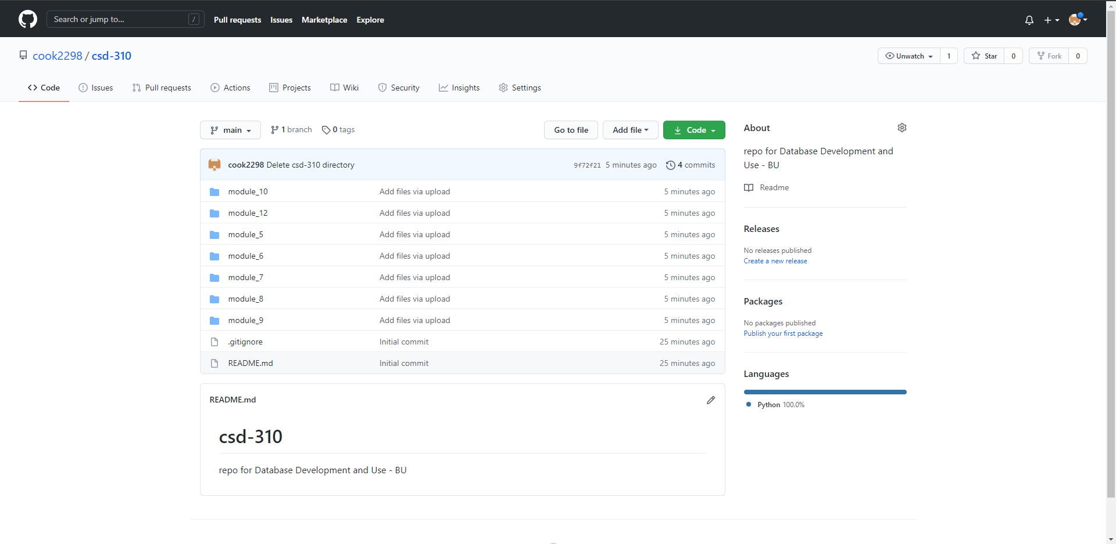

3. Local Directory:

