Player Roster Program
Project 1
CMSC 215
Lawrence Cooke
19 Jan 2026

Approach
To solve the given problem, my general approach was to design each class to encapsulate as much complexity as possible. In order to handle normalizing feet and inch inputs later on, I designed the constructor in the Height class to check the inches argument as such:
$$feet=feet+\left\lfloor \frac{inches}{12}\right\rfloor$$
$$inches=inches\text{\%}12$$
In addition to handling the normalization of the height input, I also chose for the height class handle the conversion of the measurement to inches and to handle the formatted string output with feet and inch symbols. This allowed for a much easier time designing the Player class and enabled me to simply call the previously defined height methods when needed. After I finished designing these classes, I chose to design a third class to handle storing the ArrayList, adding players to the list, automatically updating the average age, and automatically determining the tallest player who is below the average age. After designing and implementing each class, I created a static main method for each class to test the functionality of each method. Finally, I designed the class which contained the main method. The main purpose of this method is to handle the user input. I knew this would be the most challenging part, which was a big reason why wanted to encapsulate as much of the program’s functionality into seperate classes as possible. Each line of the data input is formatted as “name:String age:int feet:int inches:int” with each token seperated by a single whitespace character. To indicate that the input is complete, the user inputs a blank line. I chose to solve this by using two seperate Scanner objects: the first Scanner reads System.in , and the second Scanner reads a string variable. The first scanner reads the entire line from System.in and stores it into a declared String variable. If the first scanner stores a non-empty line, The second Scanner then reads it using single whitespace characters as delimiters and extracts the required data. To test the final program, I created *.txt files that contained input information and used the input redirect functionality of the JVM as such. This enabled me to run the tests much quicker and with a larger amount of inputs.

UML Diagram
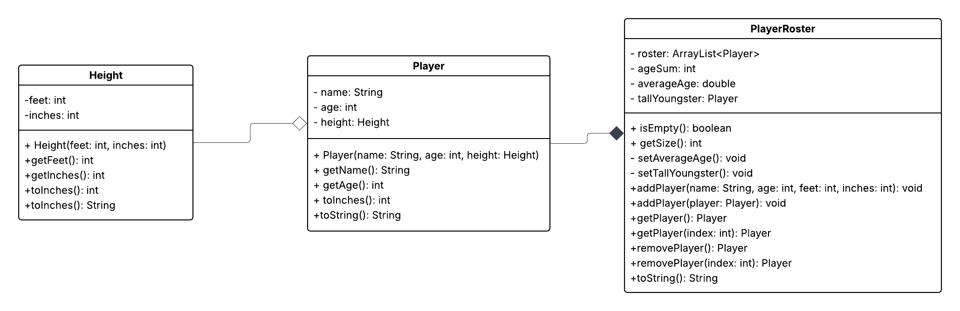

Test Case 1
The first test case will be conducted on the Project1 class, containing tha main method of the assignment. The user input functionality of this class will be the main subject of this test.
Input | Expected Output | Actual Output
Enter Player’s name, age, and height in feet and inches: | No player data entered | No player data entered
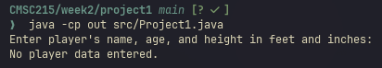

Test Case 2
The remaining three tests will be focused on testing the class methods. To accomplish this, I created a test class to quickly run seperate data samples to ensure each class method behaves as intended. Each test will initialize (6) Player objects and store them in a Player Roster Object. The test class will then display the average age, the tallest younger than average player, and print the information for each player. As the information for each player is displayed, the program will check the validity of the tallest youngster and display whether each player’s age is above or below average. Finally, each test case will remove the player at index 0 and recalculate the average age and tallest youngster.
Raw Input |  |  |  |  | Expected output
Index | Name | Age | Feet | Inches | toInches | height string | Tall Youngster | average age comparison  Before removal | average age comparison  After removal
0 | steve | 21 | 5 | 11 | 71 | 5’ 11” | before | at or below
1 | harry | 22 | 5 | 13 | 73 | 6’ 1” |  | above | at or below
2 | phil | 22 | 5 | 11 | 71 | 5’ 11” |  | above | at or below
3 | tom | 22 | 6 | 2 | 74 | 6’ 2” | after | above | at or below
4 | larry | 22 | 6 | 2 | 74 | 6’ 2” |  | above | at or below
5 | bill | 22 | 5 | 11 | 71 | 5’ 11” |  | above | at or below

Average Age: 21.83333333
Average Age after removal: 22

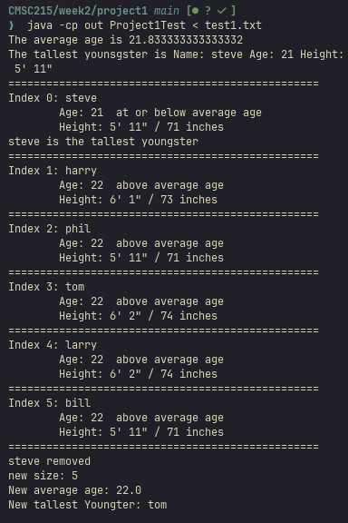
Test 2 Actual Output

Test Case 3
Where before the tall youngster changed after being recalculated, in this test case the tall youngster should remain the same.
Raw Input |  |  |  |  | Expected output
Index | Name | Age | Feet | Inches | toInches | height string | Tall Youngster | average age comparison  Before removal | average age comparison  After removal
0 | steve | 35 | 5 | 11 | 71 | 5’ 11” |  | at or below
1 | harry | 35 | 5 | 13 | 73 | 6’ 1” |  | at or below | at or below
2 | phil | 35 | 5 | 11 | 71 | 5’ 11” |  | at or below | at or below
3 | tom | 35 | 6 | 2 | 74 | 6’ 2” | before/after | at or below | at or below
4 | larry | 35 | 6 | 2 | 74 | 6’ 2” |  | at or below | at or below
5 | bill | 36 | 5 | 11 | 71 | 5’ 11” |  | above | above

Average Age: 35.16666667
Average Age after removal: 35.2

Actual Output
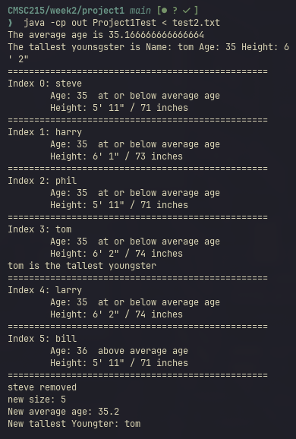

Test Case 4
In this test case, after the index 0 player is removed the new tallest youngster switches between two players of the same height but different ages
Raw Input |  |  |  |  | Expected output
Index | Name | Age | Feet | Inches | toInches | height string | Tall Youngster | average age comparison  Before removal | average age comparison  After removal
0 | steve | 99 | 5 | 11 | 71 | 5’ 11” |  | above
1 | harry | 40 | 5 | 13 | 73 | 6’ 1” |  | at or below | above
2 | phil | 35 | 5 | 11 | 71 | 5’ 11” |  | at or below | at or below
3 | tom | 48 | 6 | 2 | 74 | 6’ 2” | before | at or below | above
4 | larry | 30 | 6 | 2 | 74 | 6’ 2” | after | at or below | at or below
5 | bill | 36 | 5 | 11 | 71 | 5’ 11” |  | at or below | at or below

Average Age: 48
Average Age after removal: 37.8

Actual Output
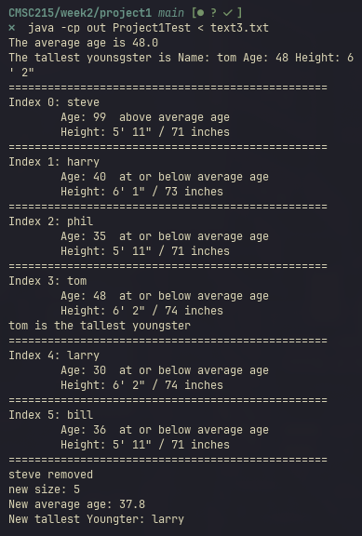

Lessons Learned
The main focus for me during this project was to stretch my understanding of what I can do with objects and what they can be. I think I am starting to move past the basic understanding of an object being a container with data fields. I think before, my instinct was to think of a class as a database schema since that is what I am more familiar with professionally working with geospatial information systems. I think now I am starting to grasp what objects are in an OOP sense. I was inspired to implement the PlayerRoster class in the way I did because of the Stack class case study from this week’s reading. I thoroughly enjoyed learning about ArrayLists during this project.

