Project Report for Project 2
Student：林瑋鴻、鍾昀倫
- Provider’s company information
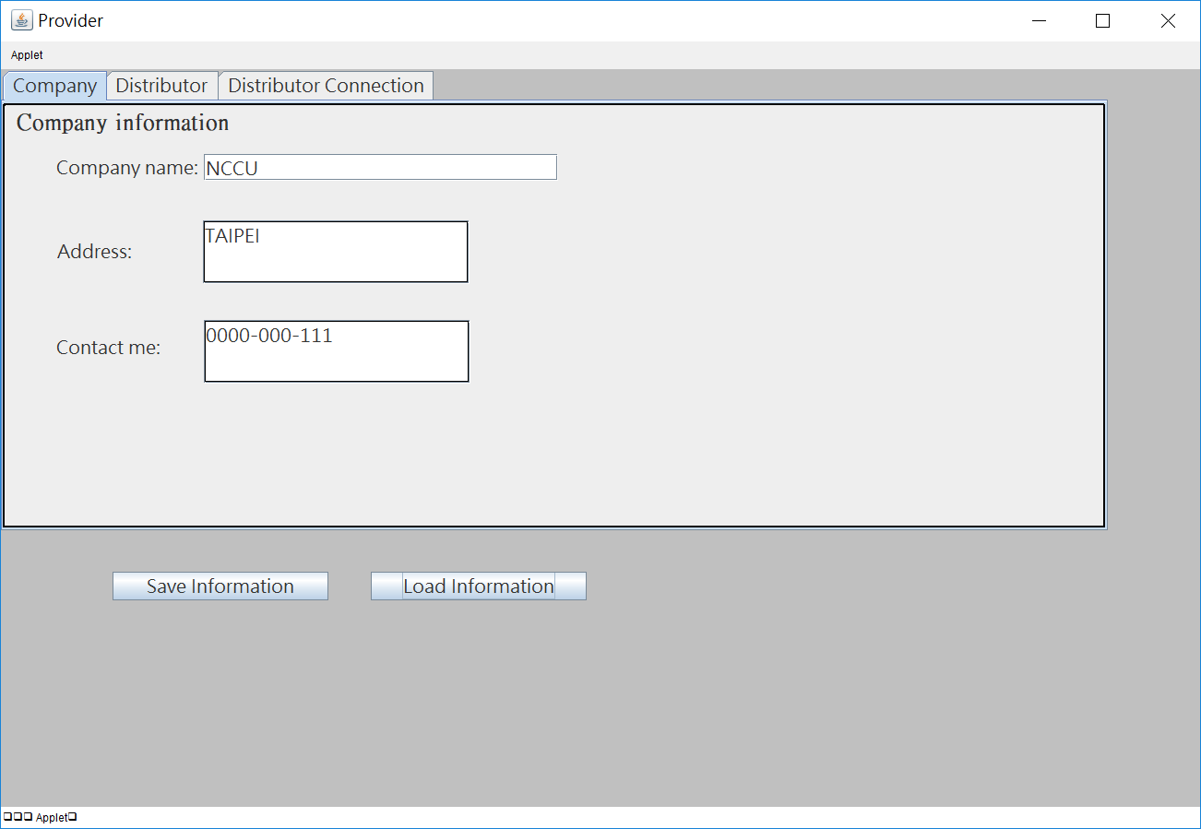
- Provider’s available commodities for distributor
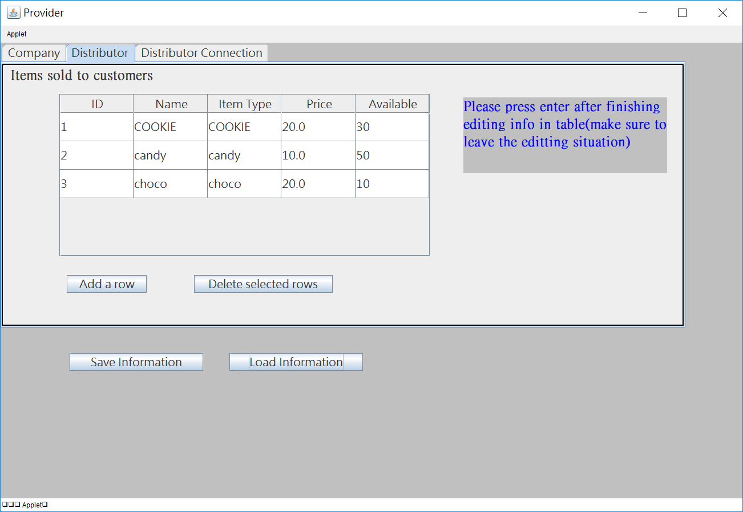
- Button for connecting to distributors and table showing distributor lists of name
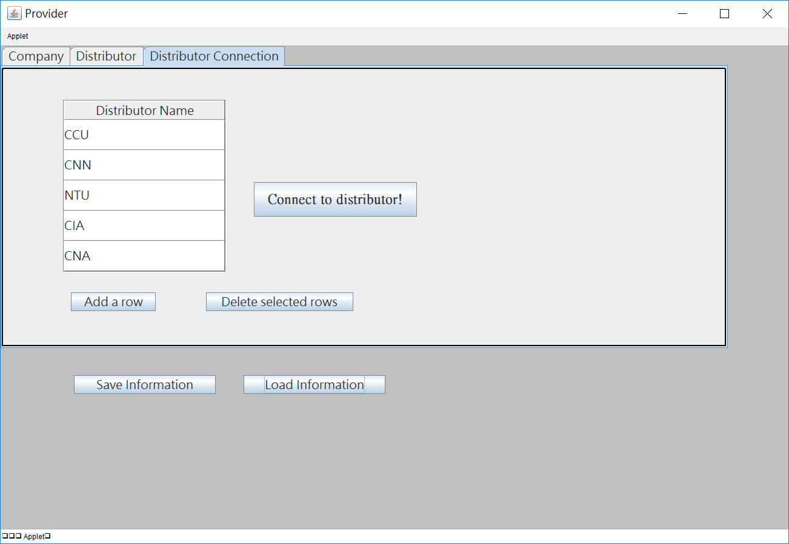
- Provider’s message box with an assigned port number
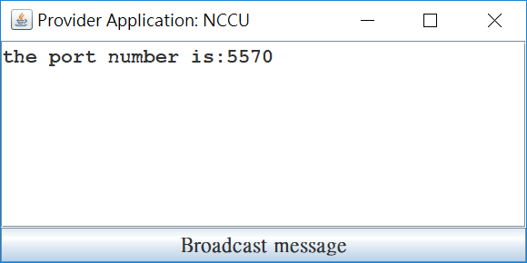
- Distributor’s company information
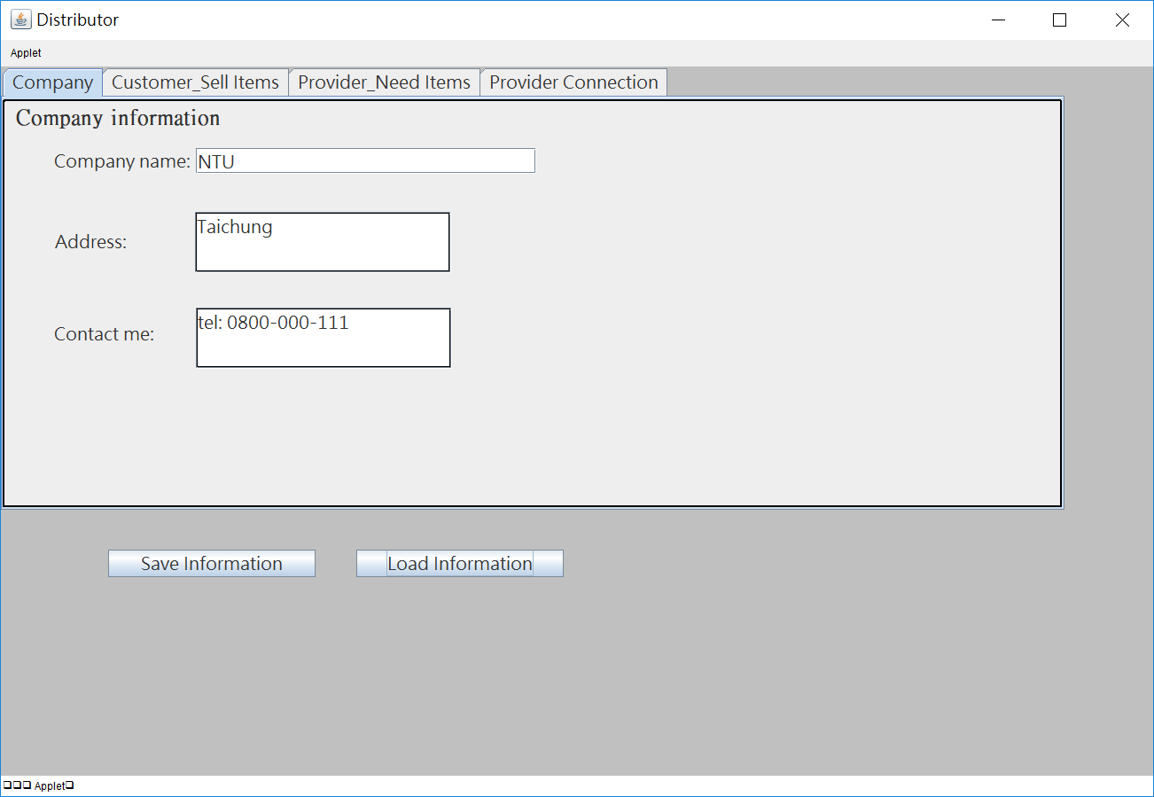
- Distributor’s items sold to customer
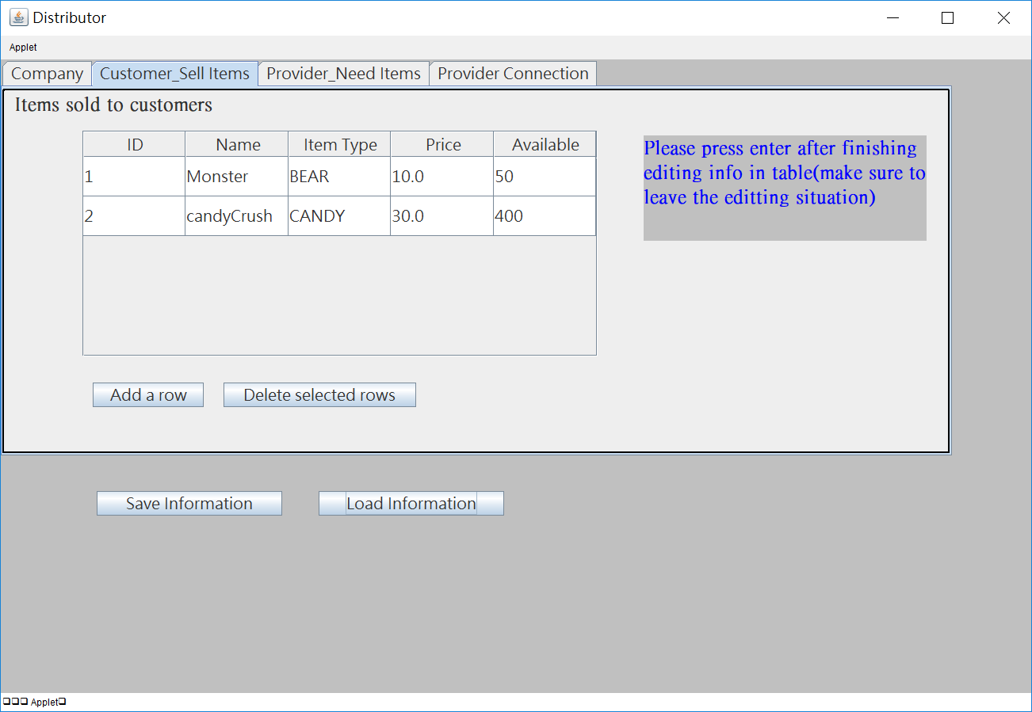
- Distributor’s items needed from providers
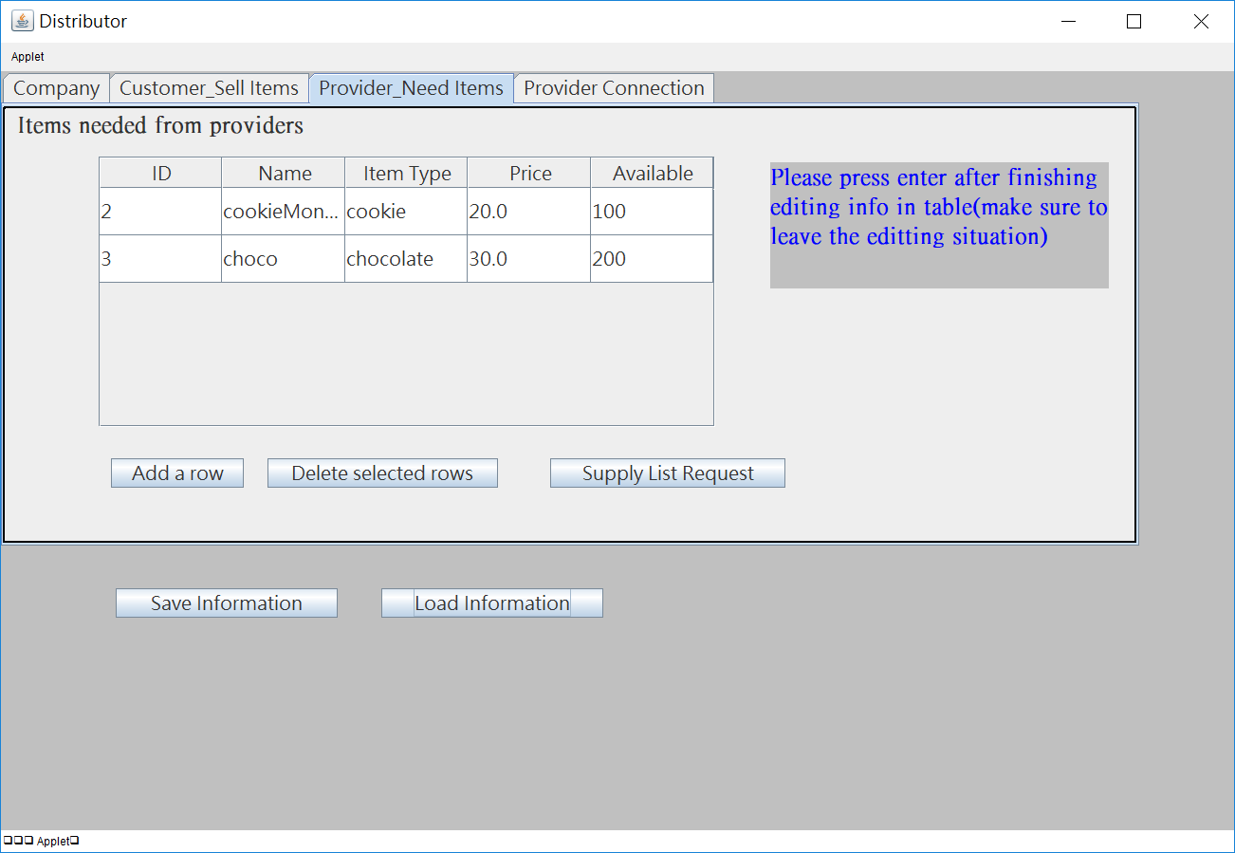
Request to providers for needed items.

- Button for connecting to provider
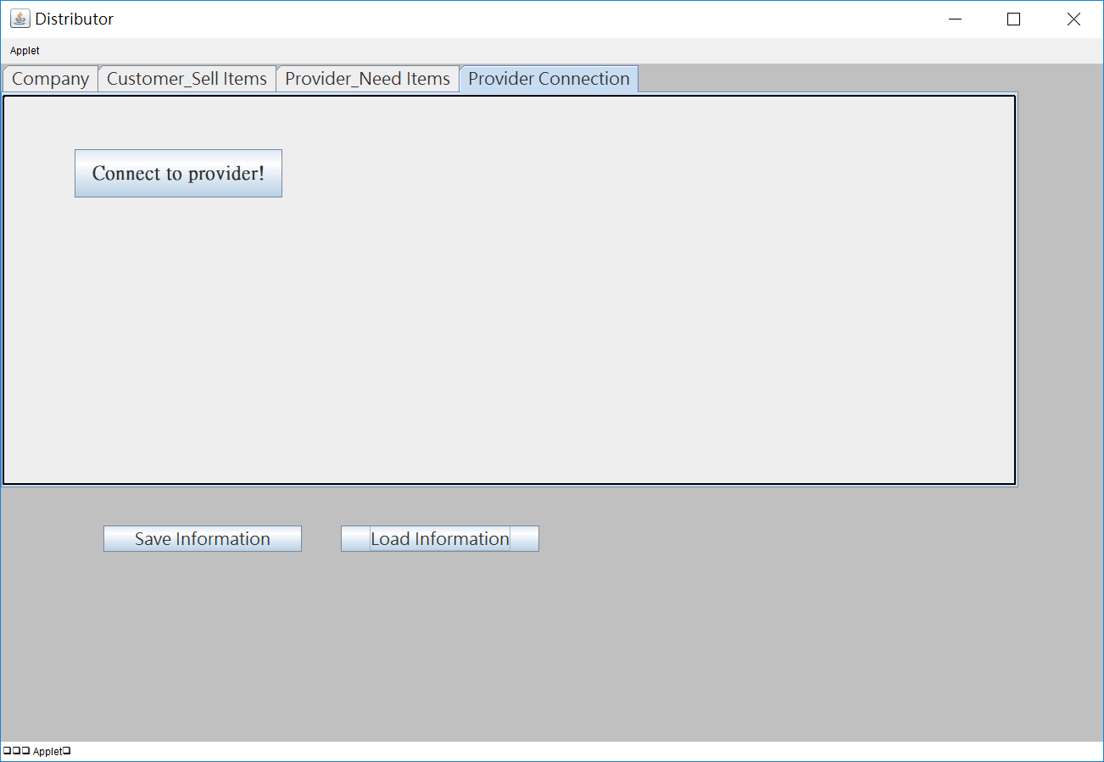
- Purchase list showing items requesting to providers
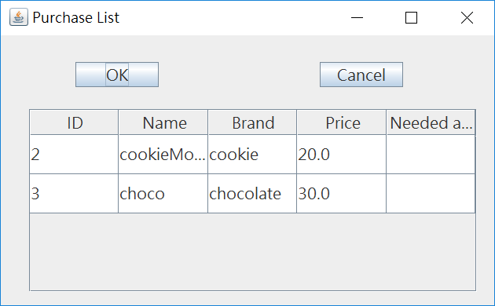
Type in needed amounts
- Distributor’s message box – sending authentication request
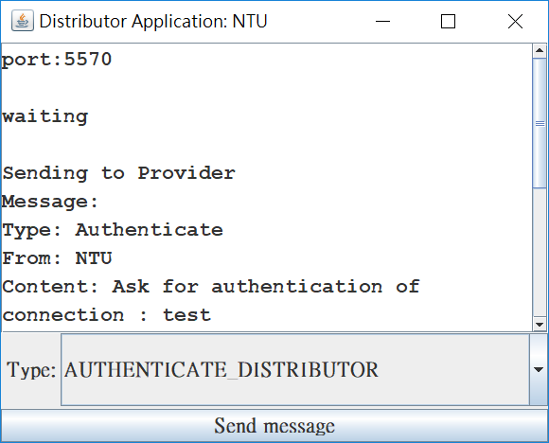
- Distributor’s message box – Reply message with Authentication from provider
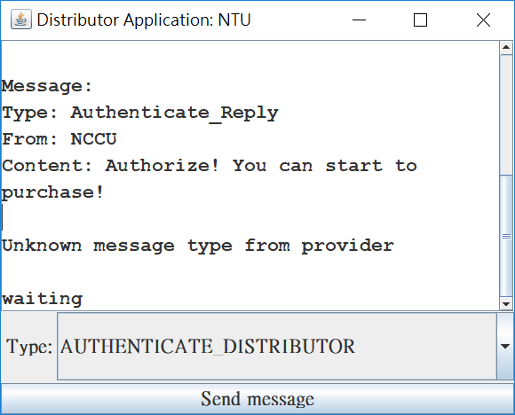

- Provider’s message box – receiving authentication message from providers
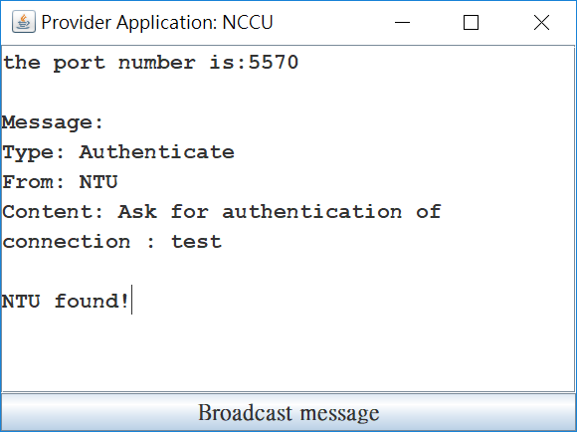
- Distributor’s message box – sending supply list request to provider
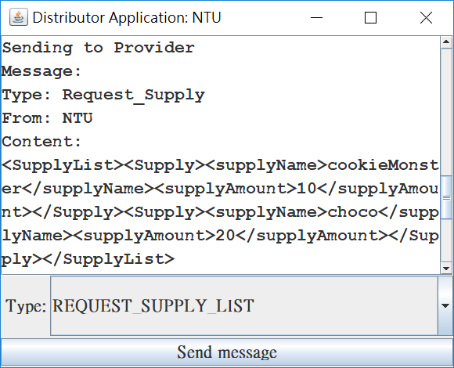
- Distributor’s message box – receiving request supply reply from providers
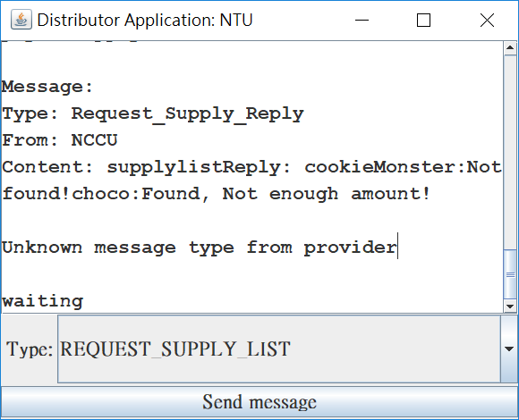
- Provider’s message box – receiving supply request from distributors
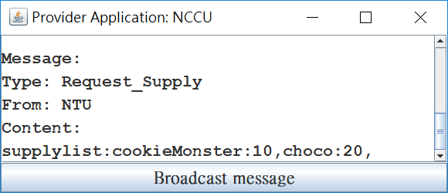
- Distributor’s message box – sending purchase request to providers
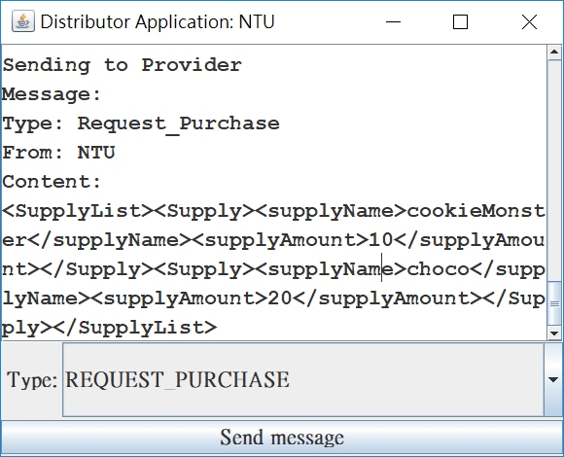
- Provider’s message box – receiving purchase request from distributors
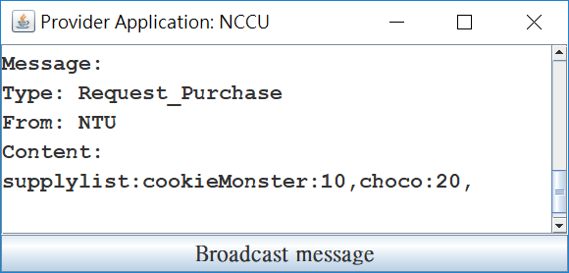
- Distributor’s message box – sending terminate message to providers
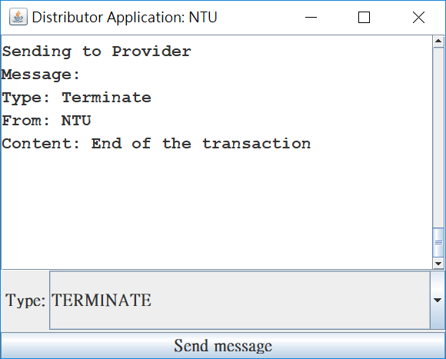
- Provider’s message box – receiving end of communication from distributors
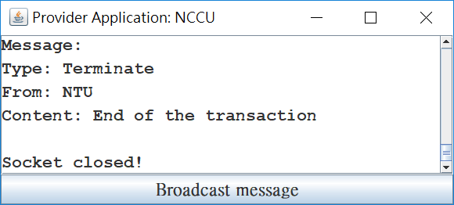
- Provider’s xml file
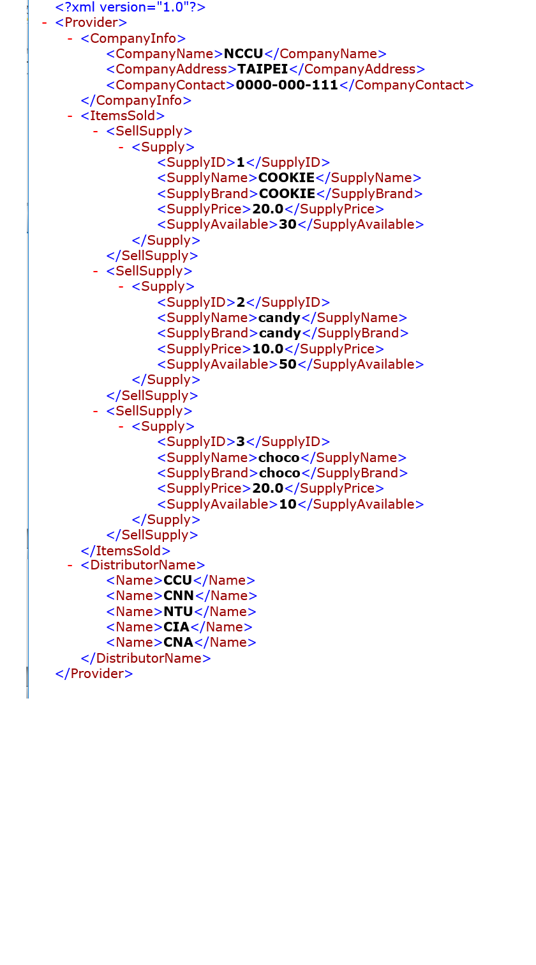
- Distributor’s xml file
