FRONTEND IMPLEMENTATION & VERIFICATION REPORT

ShopSmart Laboratory 1
Search, stock messaging, and reusable cart item counting
SUBMISSION DATE | 28 September 2026
PROJECT CHECK | PASS — lint, tests, and production build
EVIDENCE INCLUDED | Three browser screenshots and command output

Submission overview
This report documents three focused improvements to the existing ShopSmart frontend. Product search now includes descriptions, product cards show clearer stock messages, and cart quantities are counted by one reusable utility shared across the interface.
The existing API, database, routing, styling, cart operations, stock validation, and monetary total behavior remain unchanged.

1. Product data flow
The frontend calls api.getProducts() inside ProductsPage. The resolved API response supplies data.products, which is stored in the products React state variable. ProductsPage filters that array into visibleProducts, maps the matching objects into ProductCard components, and passes each product through the product prop. Each card renders the product name, description, price, stock, and cart action.
API response | products state | filter | visibleProducts | ProductCard

2. JavaScript and React concepts
Concept | Code location or name | What it does
Variable | products in ProductsPage | Stores the product array returned by the API and causes the page to rerender when it changes.
Array method | products.filter(...) | Creates visibleProducts by applying the search and category conditions.
Function | calculateCartItemCount(cart) | Adds every cart item's quantity and returns zero for an empty cart.
Condition | Stock if / else if / else | Selects the out-of-stock, low-stock, or regular-stock message.
Event handler | onClick={() => onAddToCart(product)} | Responds to Add to cart and sends the selected product to the cart action.

3. React events and state
Clicking Add to cart runs the product card's click handler, which calls the addToCart action supplied by CartContext. That action uses the functional form of setCart to derive the next cart from the current cart. React rerenders the provider, recalculates itemCount and total, and updates consumers such as the navigation and cart page.
The search input follows the same event-to-state pattern. Its onChange handler updates search, which rerenders ProductsPage. The normalized query is applied to the product name and description while the selected category remains a required condition.

4. Implemented improvements

Description-aware search
Search now trims and normalizes the query once, then checks both the product name and description case-insensitively. The category condition is still combined with the text match, so category selection continues to narrow the catalog.

Clear stock messaging
Product cards display Out of stock for zero stock, Only N left for quantities from 1 through 8, and N in stock for 9 or more. Existing unavailable styling and the disabled Add to cart behavior are preserved.

Reusable cart item count
Cart counting is implemented once in calculateCartItemCount(cart) using reduce(..., 0). CartContext exposes the result as itemCount, and both navigation and the order summary use that shared value. Price totals remain a separate price × quantity calculation.

5. Verification summary
- Description search: privacy cover displays the 1080p Webcam.
- Stock labels: quantities 6–8 show Only N left; quantities 9, 10, and 12 show N in stock.
- Cart count: navigation and the order summary remain synchronized after adding, increasing, and removing items.
- Project check: frontend and backend linting, all 10 tests, and the production build pass.

1. Description search result
The search query appears only in the product description, demonstrating that the broadened search behavior works without removing the category filter.
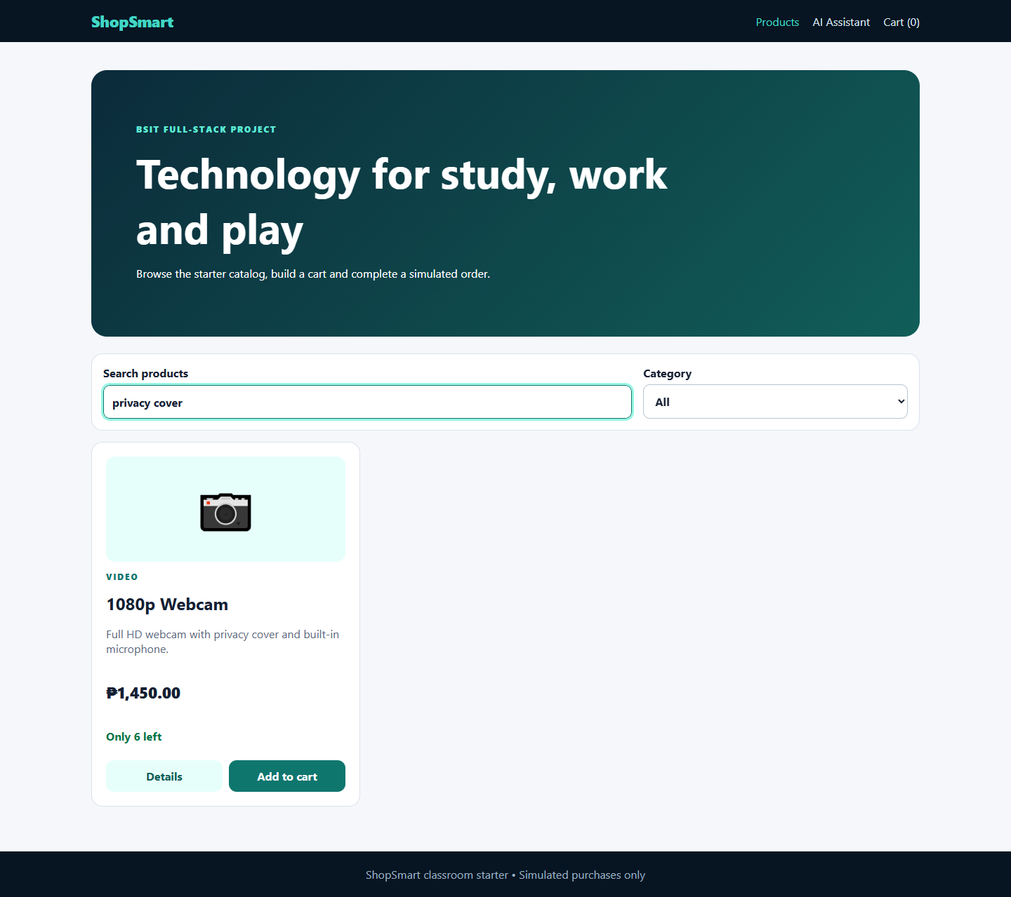
Figure 1. Searching for “privacy cover” returns the 1080p Webcam.

2. Low-stock message
Seeded low-stock products display the required “Only N left” message while regular-stock products retain the “N in stock” format.
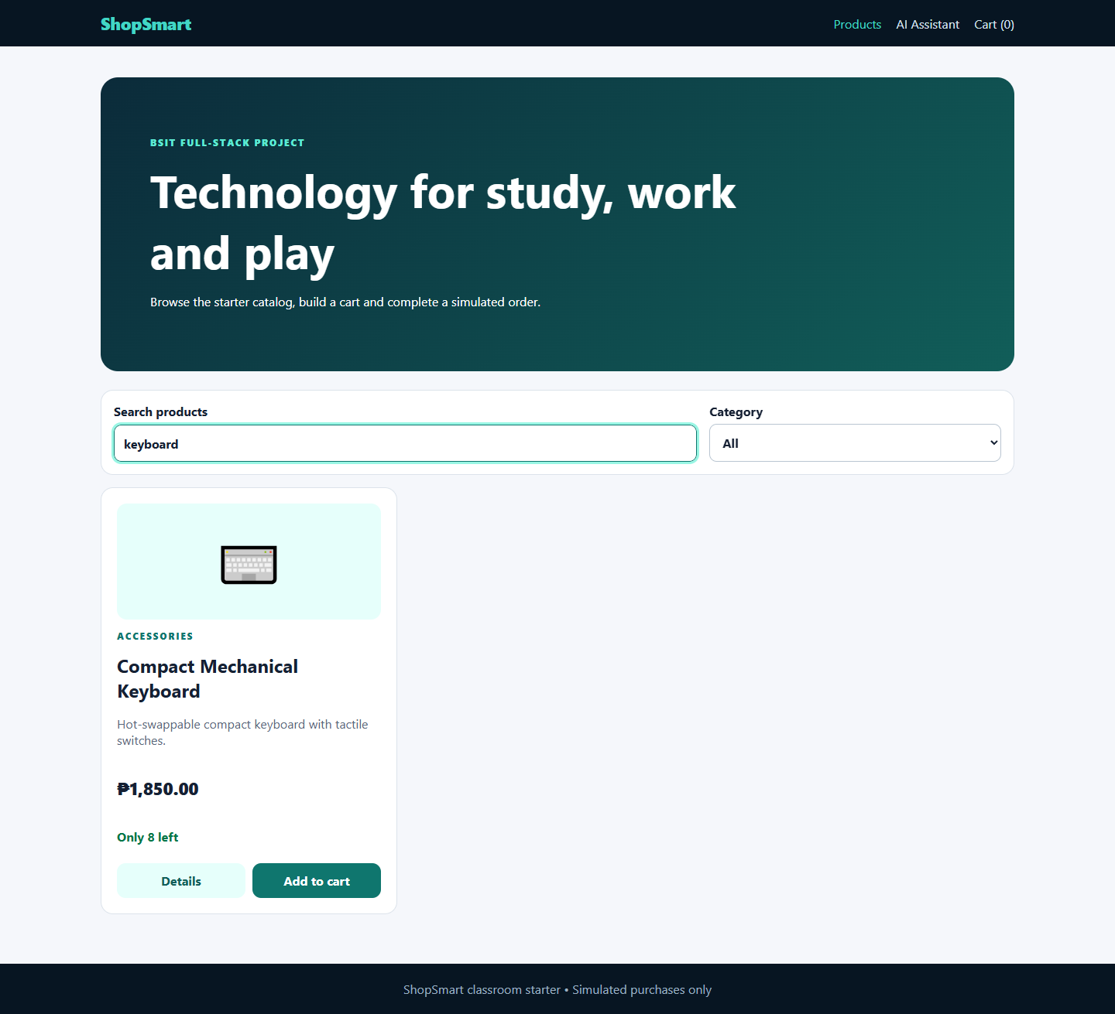
Figure 2. Product cards distinguish low stock from regular stock.

3. Synchronized cart item count
The navigation badge and order-summary Items value use the shared context count and remain synchronized as quantities change.
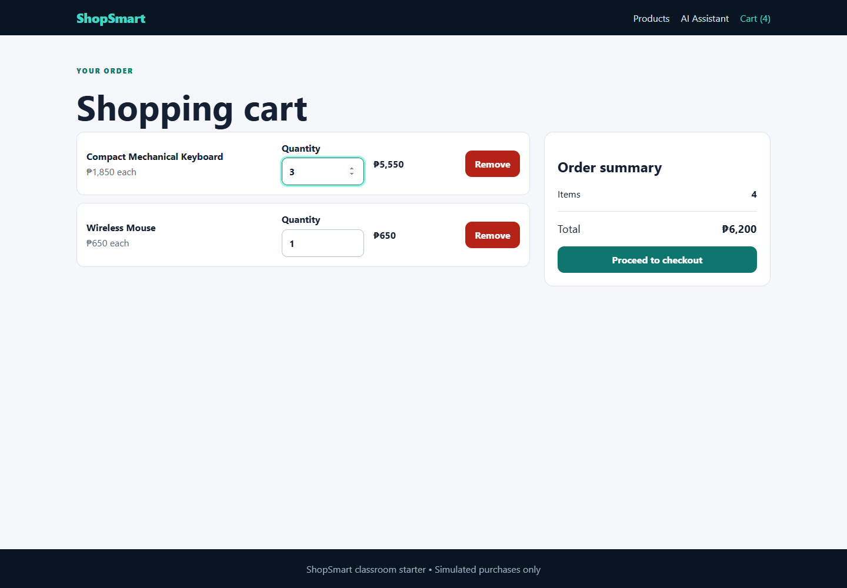
Figure 3. Navigation and order-summary item counts agree after quantity updates.

6. Final project check
The project check was rerun from the ShopSmart-Starter root on 28 September 2026. It completed successfully with exit code 0.
Stage | Result
Frontend ESLint | PASS
Backend ESLint | PASS
Frontend Vitest — 4 tests | PASS
Backend node:test — 6 tests | PASS
Frontend Vite production build — 52 modules | PASS

Command output
> shopsmart-starter@1.0.0 check
> npm run lint --workspace frontend && npm run lint --workspace backend && npm run test && npm run build
> shopsmart-frontend@1.0.0 lint
> eslint .
> shopsmart-backend@1.0.0 lint
> eslint .
> shopsmart-frontend@1.0.0 test
> vitest run
RUN v3.2.7 C:/xampp/htdocs/ShopSmart-Starter/frontend
PASS src/utils/cart.test.js (4 tests)
Test Files 1 passed (1)
Tests 4 passed (4)
> shopsmart-backend@1.0.0 test
> node --test
tests 6 | pass 6 | fail 0 | skipped 0
> shopsmart-frontend@1.0.0 build
> vite build
vite v7.3.6 building client environment for production...
52 modules transformed.
dist/index.html 0.49 kB | gzip: 0.30 kB
dist/assets/index-CoWcbNrj.css 4.30 kB | gzip: 1.48 kB
dist/assets/index-CHKwRV51.js 272.21 kB | gzip: 86.21 kB
built in 825ms

