四川大学期中考试试题（开卷）
（2015~2016学年第2学期）
课程号： 311082030 课程名称： 软件设计与体系结构（A卷） 任课教师：
适用专业年级： 软件工程 2014级 学号： 姓名：
考试须知
四川大学学生参加由学校组织或由学校承办的各级各类考试，必须严格执行《四川大学考试工作管理办法》和《四川大学考场规则》。有考试违纪作弊行为的，一律按照《四川大学学生考试违纪作弊处罚条例》进行处理。
四川大学各级各类考试的监考人员，必须严格执行《四川大学考试工作管理办法》、《四川大学考场规则》和《四川大学监考人员职责》。有违反学校有关规定的，严格按照《四川大学教学事故认定及处理办法》进行处理。
题 号 | 一(30%) | 二(20%) | 三(30%) | 四(20%) | 五(0%) | 六(0%) | 七(0%) | 八(0%) | 卷面  成绩
得 分
阅卷时间

注意事项：1. 请务必将本人所在学院、姓名、学号、任课教师姓名等信息准确填写在试题纸和添卷纸上；

2. 请将答案全部填写在本试题纸上；

3. 考试结束，请将试题纸、添卷纸和草稿纸一并交给监考老师。


一、Choice Questions（10 items，3points each，total 30points）
评阅教师
得分

提示：在每小题列出的四个备选项中只有一个是符合题目要求的，请将其代码填写在下表中。错选、多选或未选均无分。
1 | 2 | 3 | 4 | 5 | 6 | 7 | 8 | 9 | 10
D | B | A | ABC | ABCDE | ABCD | ADE | ABCDE | ABE | BC
1．What structure is used for project managing（ D ）
（A）Use structure （B）concurrency structure.
（C）Service structure （D）Working assignment structure
(E) Concurrency structure
2．Which quality attributes relate to the time（ B ）
（A）Modifiability （B）Performance
（C）Testability （D）Usability
（E）Availability
3．Which part of the system is easy to modify（ A ）
（A）Local part （B）Architectural part
（C）Nonlocal part （D）Framework
（E）Global part
4．Why does the software structure must be abstraction（ ABC ）
（A）It’s requirement of design （B）Easy to understand
（C）Reduce the complexity （D）It is written in book
（D）Nothing
5．Stakeholder of the system includes（ ABCDE ）
（A）Project manager （B）Tester
（C）Implementer （D）User
（E）Architect
6．Witch contexts influence on the architecture（ ABCD ）
（A）Technical （B）Project
（C）Business （D）Profession
（E）Hobby
7．What questions does the module structure answer（ ADE ）
（A）What is the primary function responsibility of each module
（B）What are the major executing components
（C）What processor does each software element execute on
（D）What other elements allowed to use
（E）What software does it use and depend on
8．Why an architecture is important from a technical perspective（ ABCDE ）
（A）It supports or inhibits the quality attributes
（B）It reduces design and system complexity by restricting design alternatives
（C）It can help project manager accurately estimate the cost and schedule
（D）It’s documents enhances communication among stakeholders
（E）It can be the foundation for training a new team member
9．What are the heart part of the quality attributes scenario（ ABE ）
（A）Stimulus source （B）Stimulus
（C）Artifact （D）Environment
（E）Response
10．What tactics do recover from attack（ BC ）
（A）Limit access （B）Maintain audit Trail
（C）Redundancy （D）Detect intrusion
（E）Verify message

二、Terms Explanation（5 items，4 points each，total 20points）
评阅教师
得分

1． Software architecture
The software architecture of a system is the set of structures needed to reason about the system, which comprise software elements, relations among them, and properties of both
软件构架是一组解释系统的结构，这些结构包含了软件元素及元素之间的关系和特性
2． Structures
A structures is a set of elements held together by a relation
3． Architecture Influence Cycle
The architecture and the environment, such as business goal, technical, project and architect’s profession influenced each other, the mechanism call Architecture Influence Cycle ( AIC )
4． Quality attribute
A quality attribute is a measurable or testable property of a system that is used to indicate how well the system satisfies the needs of its stakeholders
5. Tactic
A tactic is a design decision that influences the achievement of a quality attribute response

三、Short Answer Questions（3 items，10points each，total 30points）
评阅教师
得分

1. Do you care about the dynamic structure when you design a software system? Why?
When software is complex, we must represent it in various perspectives for reducing the complexity(2). Actually, there are three categories of structure for representing the software system, including module, C&C, allocation. C&C is the dynamic structure(3). C&C structures focus on the way the elements interact with each other at runtime to carry out the system’s functions. It helps analyze the performance and availability of the system.(5)
2. How various tactics to support qualities attributes of software do impact each other? Give two examples, one explains the positive impact, another explains negative impact.
The positive impact, the increase cohesion is a tactic to support modifiability, but it support the availability and testability.(5)
The negative impact, the intermediate tactic to support the modifiability, but it inhibit the performance (5)
3. Drawing a concrete quality attribute scenario (six parts) according to below description.
A hacker wants to get the military secrets from a remote location during normal operations, the system detected the attack, then inform the administrator and revoke the access immediately.
Source of stimulus: A hacker
Stimulus: Get the military secrets
Artifact: Data in the system
Environment: Normal operations
Response: detected the attack and informed the administrator
Response measure: Immediately detected attack and resist the attack successful

四、Analytical Questions（1items，20points each，total 20points）
评阅教师
得分
1．Analyze the below structure, and answer question.
1) Which structure does the below graph represent? (5)
2) Explain the structure, include: role (5), element, relation of the structure(5), and relative quality attributes(5)
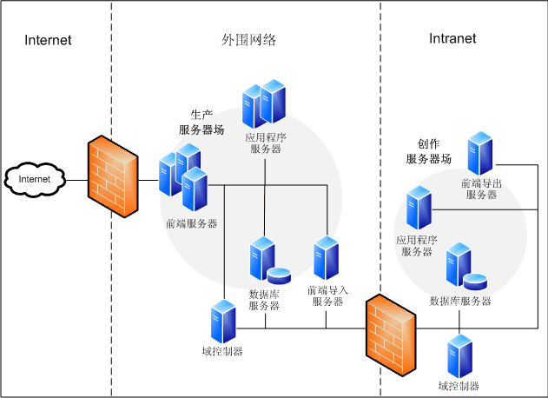
This is deployment structure(5); deployment structure shows how software is assigned to hardware(3).
Element: Components, hardware element(2)
Relation: Allocated to, migrates to(3)
Useful for: Performance, availability, security analysis(2)
Quality Attributes affected: Performance, security, availability(5)

