四川大学期末考试试题（开卷）
（2015~2016学年第2学期）
课程号： 311082030 课程名称： 软件设计与体系结构（A卷） 任课教师：
适用专业年级： 软件工程 2013级 学号： 姓名：
考试须知
四川大学学生参加由学校组织或由学校承办的各级各类考试，必须严格执行《四川大学考试工作管理办法》和《四川大学考场规则》。有考试违纪作弊行为的，一律按照《四川大学学生考试违纪作弊处罚条例》进行处理。
四川大学各级各类考试的监考人员，必须严格执行《四川大学考试工作管理办法》、《四川大学考场规则》和《四川大学监考人员职责》。有违反学校有关规定的，严格按照《四川大学教学事故认定及处理办法》进行处理。
题 号 | 一(40%) | 二(10%) | 三(30%) | 四(20%) | 五(0%) | 六(0%) | 七(0%) | 八(0%) | 卷面  成绩
得 分
阅卷时间

注意事项：1. 请务必将本人所在学院、姓名、学号、任课教师姓名等信息准确填写在试题纸和添卷纸上；

2. 请将答案全部填写在本试题纸上；

3. 考试结束，请将试题纸、添卷纸和草稿纸一并交给监考老师。


一、Single choice question（10 items，2points each，total 20points）
评阅教师
得分

提示：在每小题列出的四个备选项中只有一个是符合题目要求的，请将其代码填写在下表中。错选、多选或未选均无分。
1 | 2 | 3 | 4 | 5 | 6 | 7 | 8 | 9 | 10
1．What is heart of the architecture evaluation（ ）
（A）ATAM （B）CBAM
（C）Model analysis （D）Utility tree
2．How much phase does the ATAM evaluation have? （ ）
（A）3 （B）4
（C）5 （D）6
3．Which pattern does the context “All complex systems experience the need to develop and evolve portions of the system independently” belong to （ ）
（A）Layer pattern （B）Broker pattern
（C）MVC pattern （D）Map-reduce pattern

4．What architecture pattern is below graph? （ ）
in.txt
out.txt
grep
sort

（A） MVC pattern （B）Pipe-and-Filter patter
（C）Layer pattern （D）Map-Reduce pattern
5．What is mean of “REDUCE” in the MAP-REDUCE pattern （ ）
（A）Reduce process （B）Reduce output
（C）Reduce input （D）The output set is much smaller than the input set
6．What below tactics do belong to the testability（ ）
（A）Maintain audit trail （B）Detect Intrusion
（C）Lock computer （D）Limit structural complexity
7．Which pattern does used to transform stream of discrete data items from input to output（ ）
（A）Pipe-and-Filter pattern （B）Peer-to-Peer pattern
（C）Layered pattern （D）SOA pattern
8．When an examination score was inputted into the student management system, the system found the score is minus and tip the inputter. What tactic is this? （ ）
（A）Sanity checking （B）Reintroduction
（C）Active redundancy （D）Increase competence set
9．Which quality attribute does the “reduce overhead” tactic support（ ）
（A）Availability （B）Modifiability
（C）Performance （D）Security
10．Which quality attribute does the “increase semantic coherence” tactic support（ ）
（A）Availability （B）Modifiability
（C）Performance （D）Security

二、Multiple choice question（10 items，2points each，total 20points）
评阅教师
得分

提示：在每小题列出的四个备选项中只有一个是符合题目要求的，请将其代码填写在下表中。错选、多选或未选均无分。
1 | 2 | 3 | 4 | 5 | 6 | 7 | 8 | 9 | 10
1．Which forms may the architecture evaluation be taken（ ）
（A）By manager in the requirement analysis （B）By the designer within the design process
（C）By tester in the test process （D）By peers within the design process
（E）Analysis by outsiders once the architecture has been designed
2．Which responsibilities does the evaluation leader in ATAM evaluation take（ ）
（A）Set up the evaluation （B）Release final report
（C）Run evaluation （D）Facilitates onsite analysis
（E）Facilitates evaluation of scenarios against architecture
3．Who are the architecture stakeholders（ ABC DE ）
（A）Developer （B）User
（C）Integrator （D）Maintainer
（E）Performance engineer
4．What does the initial hypothesis of the generate-and-test design method include（ ）
（A）Existing systems （B）Known architecture patterns
（C）Design checklists （D）A domain decomposition
（E）Frameworks available to the project
5．Which pattern does a typical web-based system might include（ ）
（A）Layer pattern （B）Broker pattern
（C）MVC pattern （D）Client-server pattern
（E）Pipe-and-Filter pattern
6．Which quality attribute does the layer pattern support（ ）
（A）Portability （B）Modifiability
（C）Performance （D）Security
（E）Usability
7．Which element does the broker pattern might include（ ）
（A）Client （B）Server
（C）Client-side proxy （D）Broker
（E）Server-side proxy
8．What is the relationship between tactics and pattern （ ）
（A）Patterns comprise tactics （B）Using tactics to augment patterns
（C）Tactics hinder pattern （D）Most patterns consist of several different tactics
（E）Tactics are atoms and patterns are molecules
9．Which tactics does layer pattern contain（ ）
（A）Increase semantic coherence （B）Abstract common services
（C）Encapsulate （D）Restrict communication paths
（E）Intermediary
10．Which below quality attributes does relative to the modifiability? （ ）
（A）Variability （B）Portability
（C）Scalability （D）Mobility
（E）Monitorability

三、terms to explain（5 items，2 points each，total 10points）
评阅教师
得分

1．ATAM (Architecture tradeoff analysis method) (构架权衡分析方法)

2．Sensitivity point (敏感点)

3. Product lines (产品线)

4. Architecture pattern (构架模式)

5. Integrity (完整性)

四、Short Answer Questions（3 items，10points each，total 30points）
评阅教师
得分
1. Simply describe the evaluation process of ATAM.

2. There are two quality attribute response curves (a) and (b). Except to the slope of the curve, their other properties are same. You prefer to invest which curve more money for more utility, why?
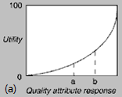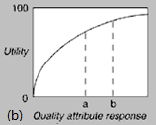

3. About broker pattern, it both supports and hinder (阻碍) the availability and performance quality attributes. How do you understand the contradiction phenomenon?

五、Analytical questions（1items，20points each，total 20points）
评阅教师
得分
1．Analyze the below structure, and answer the questions.
1) Which quality does the structure support? (5)
2) How does the structure support its quality attribute (15)
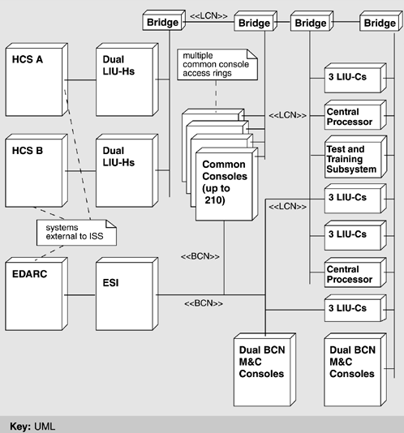
Annotation:
HCS: Host Computer System
LIU: Local Interface Unit
LCN: Local Communications Network
BCN: Backup Communications Network
EDARC: Enhanced Direct Access Radar Channel
M&C: Monitor-and-Control

