**四川大学期中考试试题（开卷）**

（2015~2016学年第2学期）

课程号： **311082030** 课程名称： **软件设计与体系结构（B卷）** 任课教师：

适用专业年级： **软件工程 2014级** 学号： 姓名：

|  |  |  |  |  |  |  |  |  |  |
| --- | --- | --- | --- | --- | --- | --- | --- | --- | --- |
| **考试须知**  四川大学学生参加由学校组织或由学校承办的各级各类考试，必须严格执行《四川大学考试工作管理办法》和《四川大学考场规则》。有考试违纪作弊行为的，一律按照《四川大学学生考试违纪作弊处罚条例》进行处理。  四川大学各级各类考试的监考人员，必须严格执行《四川大学考试工作管理办法》、《四川大学考场规则》和《四川大学监考人员职责》。有违反学校有关规定的，严格按照《四川大学教学事故认定及处理办法》进行处理。 | | | | | | | | | |
| **题 号** | **一(30%)** | **二(20%)** | **三(30%)** | **四(20%)** | **五(0%)** | **六(0%)** | **七(0%)** | **八(0%)** | **卷面**  **成绩** |
| **得 分** |  |  |  |  |  |  |  |  |  |
| **阅卷时间** |  |  |  |  |  |  |  |  |

##### 注意事项：1. 请务必将本人所在学院、姓名、学号、任课教师姓名等信息准确填写在试题纸和添卷纸上；

##### 2. 请将答案全部填写在本试题纸上；

##### 3. 考试结束，请将试题纸、添卷纸和草稿纸一并交给监考老师。

🕣🕣🕣🕣🕣🕣🕣🕣🕣🕣🕣🕣🕣🕣🕣🕣🕣🕣🕣🕣🕣🕣🕣🕣🕣🕣🕣🕣🕣🕣🕣🕣🕣🕣🕣🕣🕣🕣🕣🕣🕣🕣🕣🕣

##### 一、Choice Questions（10 items，3points each，total 30points）

**评阅教师**

**得分**

##### 提示：在每小题列出的四个备选项中至少有一个是符合题目要求的，请将其代码填写在下表中。错选、多选或未选均无分。

|  |  |  |  |  |  |  |  |  |  |
| --- | --- | --- | --- | --- | --- | --- | --- | --- | --- |
| **1** | **2** | **3** | **4** | **5** | **6** | **7** | **8** | **9** | **10** |
| B | B | C | ABC | BCE | ABE | ACDE | ABD | ABCDE | BC |

1．What structure is used for scheduling analysis（ B ）

（A）Class structure （B）Service structure

（C）Implementation structure （D）Working assignment structure

（E）Concurrency structure

2．Which quality attributes relate to the time（ B ）

（A）Modifiability （B）Performance

（C）Testability （D）Usability

（E）Availability

3．Adding a new business rule to a pricing logic module probably changes which part of the system

（ C ）

（A）Nonlocal part （B）Architectural part

（C）Local part （D）Framework

（E）Global part

4．Why does the software structure must be abstraction（ ABC ）

（A）It’s requirement of design （B）Easy to understand

（C）Reduce the complexity （D）It is written in book

（D）Nothing

5．Cost and schedule estimates help the project manager to（ BCE ）

（A）Define constraints on an implementation

（B）Acquire the necessary resources

（C）Monitor progress on the project

（D）Enhancing communication among stakeholders

（E）Know if and when a project is in trouble

6．Which kinds of stakeholder may concern about low cost（ ABE ）

（A）Developing organization’s management （B）Marketing

（C）End user （D）Maintenance organization

（E）Customer

7．Useful mapping among architectural elements include（ ACDE ）

（A）The mapping of modules and runtime elements to each other

（B）Choosing the major data abstractions

（C）The assignment of runtime elements to processors

（D）The assignment of items in the data model to data stores

（E）The mapping of modules and runtime elements to units of delivery

8．Availability tactics include（ ABD ）

（A）Fault detection （B）Fault recovery

（C）Increasing cohesion （D）Fault prevention

（E）Managing sampling rate

9．Which may be involved when considering environment in the modifiability scenario（ ABCDE ）

（A）Design time （B）Compile time （C）Build time

（D）Initiation time （E）Runtime

10．Performance can be measured in terms of（ BC ）

（A）Stability （B）Throughput （C）Latency

（D）Security （E）Expandability

##### 二、Terms Explanation（5 items，4 points each，total 20points）

**评阅教师**

**得分**

1． Software architecture

The software architecture of a system is the set of structures needed to reason about the system, which comprise software elements, relations among them, and properties of both

软件构架是一组解释系统的结构，这些结构包含了软件元素及元素之间的关系和特性

2． Architecture Influence Cycle

The architecture and the environment, such as business goal, technical, project and architect’s profession influenced each other, the mechanism call Architecture Influence Cycle ( AIC )

3． Stimulus

A condition that requires a response when it arrives at a system.

4． Dependability

Dependability is the ability to avoid failures that are more frequent and more severe than is acceptable.

5. Tactic

A tactic is a design decision that influences the achievement of a quality attribute response

##### 三、Short Answer Questions（3 items，10points each，total 30points）

**评阅教师**

**得分**

1. What do performance tactics consist of ? For each one, try to list some of its tactics.

Control resource demand, manage resources(4)

Control resource demand : manage Sampling Rate, limit event response, prioritize events, reduce overhead, bound execution times, increase resource efficiency(3)

Manage resources : increase resources, introduce concurrency, maintain multiple copies of computations, maintain multiple copies of data, bound queue sizes, schedule resources(3)

2. How various tactics to support qualities attributes of software do impact each other? Give two examples, one explains the positive impact, another explains negative impact.

The positive impact, the increase cohesion is a tactic to support modifiability, but it support the availability and testability.(5)

The negative impact, the intermediate tactic to support the modifiability, but it inhibit the performance (5)

3. Drawing a concrete quality attribute scenario (six parts) according to below description.

A sales manager wants to get the sales of a product from a remote location during normal operations, the system detected the order immediately, identified his information and returned the data to him.

Source of stimulus: A sales manager

Stimulus: Get the sales of a product

Artifact: Data in the system

Environment: Normal operations

Response: Detected the order, identified user information and returned the data to him

Response measure: Immediately detected the order, identified user information, returned the data successfully

##### 四、Analytical Questions（1items，20points each，total 20points）

**评阅教师**

**得分**

1．Analyze the below structure, and answer question.

1) Which structure does the below graph represent? (5)

2) Explain the structure, include: role (5), element, relation of the structure(5), and relative quality attributes(5)

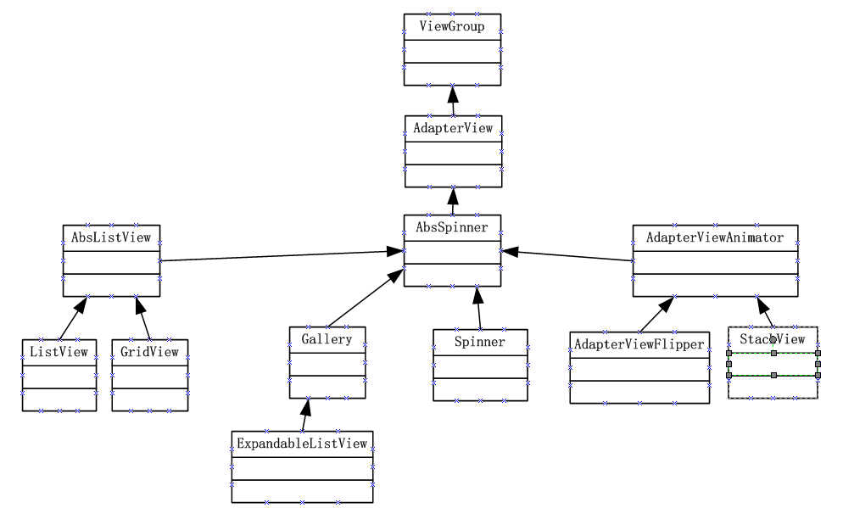

This is class structure(5); deployment structure allows one to reason about reuse and the incremental addition of functionality(3).

Element: Class, object(2)

Relation: Is an instance of, shares access methods of(3)

Useful for: In object-oriented design systems, factoring out commonality ; planning extensions of functionality(2)

Quality Attributes affected: Modifiability, extensibility(5)