**Interaction Diagrams**

**Team Members (C2_6):**

Neeraj Kumar– 57

Anish Sahu– 56

Aarav Bhandari– 47

Anup Pai– 45

**Newspaper Agency Automation Software**

1. Sequence Diagram 
2. Collaboration Diagram

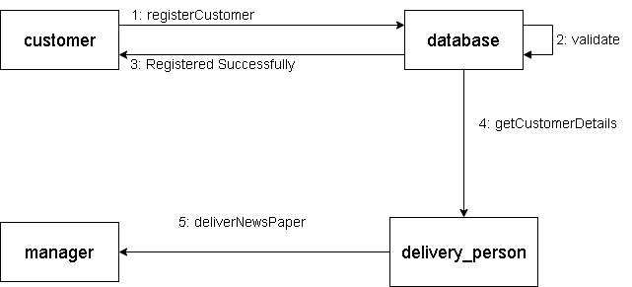

1. Activity Diagram



**Song Recommendation System**

1. Sequence Diagram:

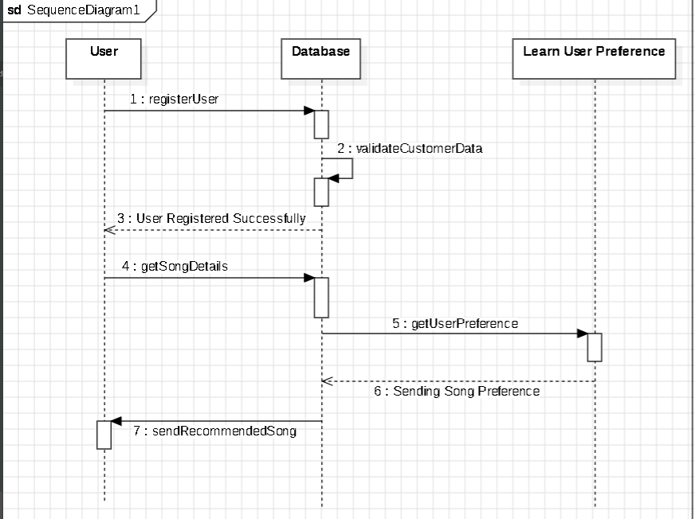

1. Collaboration Diagram:



1. Activity Diagram:

