Week1

Name : NEERJ KUMAR
Regno. : 220905536
Roll no. : 57
Title: BASIC FILE HANDLING OPERATIONS

- Source Code: To count the number of lines and characters in a file.
#include <stdio.h>
#include <stdlib.h>

void countChar_Lines(char *filename)
{
int charCount=0, lineCount=0;
FILE *file1 = fopen(filename,"r");
char c = fgetc(file1);
while (c!=EOF)
{
charCount++;
if (c=='\n')
{
lineCount++;
charCount--;
}
c = fgetc(file1);
}
printf("\nNumber of charcters is: %d",charCount);
printf("\nNumber of Lines in file is: %d\n",lineCount);
fclose(file1);
}

int main()
{
char filename[100];
printf("Enter the filename to open for reading: \n");
scanf("%s", filename);
countChar_Lines(filename);
return 0;
}

Output:
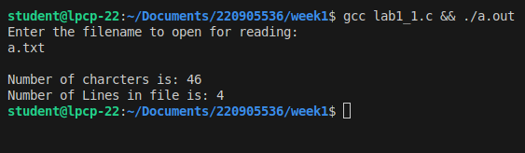
- Source Code: To reverse the file contents and store in another file. Also display the size of file using file handling function.
#include<stdio.h>

void reverseFile(FILE *file1, FILE *file2)
{
char c = fgetc(file1);
if (c==EOF)
{
return;
}
reverseFile(file1,file2);
fputc(c,file2);
}

int main()
{
char srcFile[128], destFile[128];
printf("\nEnter the source file : ");
scanf("%s",srcFile);
printf("\nEnter the destination file : ");
scanf("%s", destFile);
FILE *file1 = fopen(srcFile,"r");
FILE *file2 = fopen(destFile,"w+");
reverseFile(file1,file2);
printf("Reversed successfully, open file named %s to view",destFile);
fclose(file1);
fclose(file2);
return 0;
}

Output:

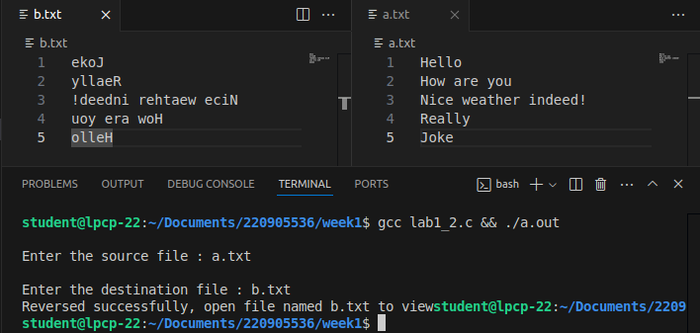

- Source Code: That merges lines alternatively from 2 files and stores it in a resultant file.
#include <stdio.h>

void readLinesAtsameTime(char *srcfile1, char *srcfile2, char *destFile)
{
char buffer[1024];
FILE *file1 = fopen(srcfile1, "r");
FILE *file2 = fopen(srcfile2, "r");
FILE *file3 = fopen(destFile, "w+");

// to read same lines from two files concurrently
while (1)
{
if (fgets(buffer, sizeof(buffer), file1))
{
fputs(buffer, file3);
}
else
{
break;
}
if (fgets(buffer, sizeof(buffer), file2))
{
fputs(buffer, file3);
}
else
{
break;
}
}

// if file2 is read but file1 not
while (fgets(buffer, sizeof(buffer), file1))
{
fputs(buffer, file3);
}

// if file1 is read but file2 not
while (fgets(buffer, sizeof(buffer), file2))
{
fputs(buffer, file3);
}

fclose(file1);
fclose(file2);
fclose(file3);
}

int main()
{
char file1[128], file2[128], destFile[128];
printf("\nEnter the source file1 : ");
scanf("%s", file1);
printf("\nEnter the source file2 : ");
scanf("%s", file2);
printf("\nEnter the destination file : ");
scanf("%s", destFile);
readLinesAtsameTime(file1, file2, destFile);
printf("Operation accomplished, open file named %s to view",destFile);
return 0;
}

Output:
