Week1

Name : NEERJ KUMAR
Regno. : 220905536
Roll no. : 57
Title: BASIC FILE HANDLING OPERATIONS

Sample Exercise:

Write a C program for removal of single and multiline comments
#include <stdio.h>

int main()
{
FILE *fa, *fb;
int ca, cb;
fa = fopen("q4in.c", "r");
if (fa == NULL)
{
printf("Cannot open file \n");
return 0;
}
fb = fopen("q4out.c", "w");
ca = getc(fa);
while (ca != EOF)
{
if (ca == ' ')
{
putc(ca, fb);
while (ca == ' ')
ca = getc(fa);
}
if (ca == '/')
{
cb = getc(fa);
if (cb == '/')
{
while (ca != '\n')
ca = getc(fa);
}
else if (cb == '*')
{
do
{
while (ca != '*')
ca = getc(fa);
ca = getc(fa);
} while (ca != '/');
}
else
{
putc(ca, fb);
putc(cb, fb);
}
}
else
putc(ca, fb);
ca = getc(fa);
}
fclose(fa);
fclose(fb);
return 0;
}

Output:

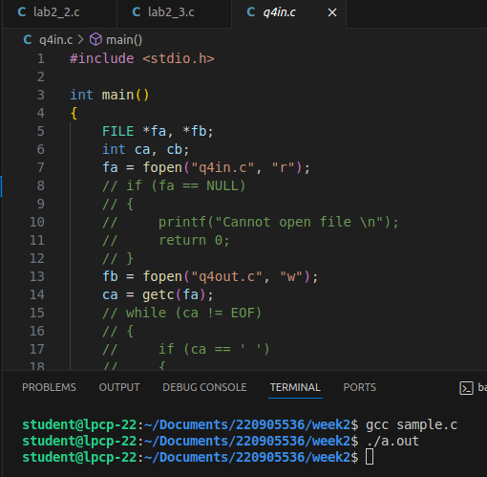

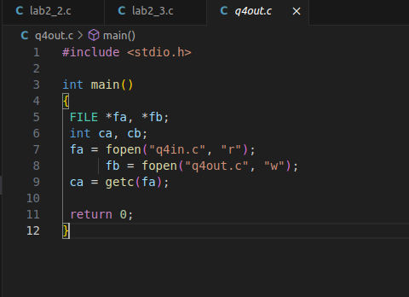

Lab Exercise:
- Source Code: That takes a file as input and replaces blank spaces and tabs by single space and writes the output to a file.
#include <stdio.h>
void removeSpace(char *srcFile, char *destFile)
{
FILE *file1 = fopen(srcFile, "r");
FILE *file2 = fopen(destFile, "w");
char c = fgetc(file1);
while (c != EOF)
{
if (c == ' ')
{
while (c == ' ')
{
c = fgetc(file1);
}
if (c != ' ')
{
fputc(' ', file2);
fputc(c, file2);
}
}
else
{
fputc(c, file2);
}
c = fgetc(file1);
}
fclose(file1);
fclose(file2);
}

int main()
{
char srcFile[1024], destFile[1024];
printf("\nEnter the srcFile: ");
scanf("%s", srcFile);
printf("\nEnter the destFile: ");
scanf("%s", destFile);
removeSpace(srcFile, destFile);
return 0;
}

Output:
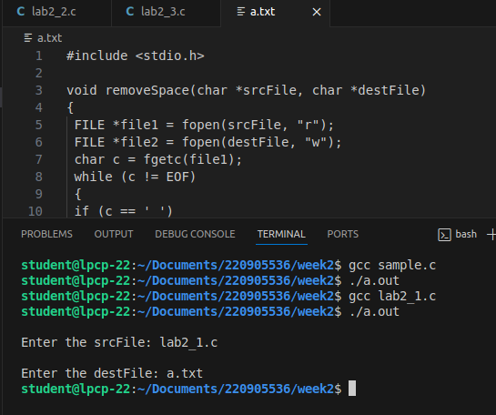

- Source Code: To discard preprocessor directives from the given input ‘C’ file.
#include<stdio.h>

#include <stdio.h>

#define size 1024

void discardPreproessor(char *srcFile, char *destFile)
{
FILE *file1 = fopen(srcFile, "r");
FILE *file2 = fopen(destFile, "w");
char c = fgetc(file1);
while (c != EOF)
{
// this is done here if string is include word preprocessor word exists in printf
statement
if (c == '\"')
{
fputc(c, file2);
c = fgetc(file1);
while (c != '\"' && c != EOF)
{
fputc(c, file2);
c = fgetc(file1);
}
if (c == '\"')
{
fputc(c, file2);
}
}
// logic to skip directives
else if (c == '#')
{
while (c != '\n' && c != EOF)
{
c = fgetc(file1);
}
}
// any other characters
else
{
fputc(c, file2);
}
c = fgetc(file1);
}
fclose(file1);
fclose(file2);
}

int main()
{
char srcFile[size], destFile[size];
printf("\nEnter the srcFile: ");
scanf("%s", srcFile);
printf("\nEnter the destFile: ");
scanf("%s", destFile);
discardPreproessor(srcFile, destFile);
return 0;
}

Output:

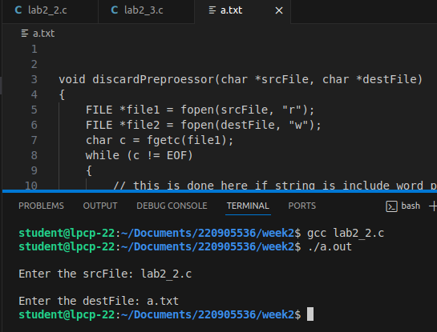

- Source Code: That takes C program as input, recognizes all the keywords and prints them in upper case.
#include <stdio.h>

#include <stdio.h>
#include <string.h>
#include <ctype.h>

#define SIZE 1024

void toUpperCase(char *word)
{
int i = 0;
while (word[i] != '\0')
{
if (word[i] >= 'a' && word[i] <= 'z')
{
word[i] -= 32;
}
i++;
}
}

int isKeyword(char *word, char **keywords, int num_keywords)
{
for (int i = 0; i < num_keywords; i++)
{
if (strcmp(word, keywords[i]) == 0)
{
return 1;
}
}
return 0;
}

void keyword_to_Uppercase(char **keywords, int num_keywords, char *srcFile, char *destFile)
{
char buffer[SIZE];
FILE *file1 = fopen(srcFile, "r");
FILE *file2 = fopen(destFile, "w");

if (!file1 || !file2) {
printf("Error opening files.\n");
return;
}

char c = fgetc(file1);
while (c != EOF)
{
int k = 0;
// Skip non-alphabetic characters and get the next word
while (c != EOF && !isalpha(c))
{
fputc(c, file2); // Write punctuation/space directly to the output file
c = fgetc(file1);
}

// Read the word into the buffer
while (c != EOF && isalpha(c))
{
buffer[k++] = c;
c = fgetc(file1);
}
buffer[k] = '\0';

if (k > 0 && isKeyword(buffer, keywords, num_keywords))
{
toUpperCase(buffer);
}

// Write the word (or uppercase word) to the output file
if (k > 0)
{
fprintf(file2, "%s", buffer);
}
}

fclose(file1);
fclose(file2);
}

int main()
{
char srcFile[SIZE], destFile[SIZE];
char *keywords[] = {"int", "if", "void", "char","return"};
printf("\nEnter the srcFile: ");
scanf("%s", srcFile);
printf("\nEnter the destFile: ");
scanf("%s", destFile);
int num_keywords = sizeof(keywords) / sizeof(keywords[0]);
keyword_to_Uppercase(keywords, num_keywords, srcFile, destFile);
return 0;
}

Output:

