Week6

Name: NEERAJ KUMAR
Regno.: 220905536
Roll no.: 57
Title: RECURSIVE DESCENT PARSER FOR SIMPLE GRAMMARS

Lab Exercise: Write a recursive descent parser for the following simple grammars.
- S→a | > | ( T )
T→T, S|S

Source Code:
#include <stdio.h>
#include <string.h>
#include <stdlib.h>

char wording[128];
int indx = 0;

/*
S→a | > | ( T )
T→T,S | S // has left recusrion so below 2 lines removes left recursion
T->S T'
T'->,ST' | null
*/

void S();
void T();
void Tprime();

void valid()
{
printf("\n===================SUCCESS!==================\n");
exit(0);
}

void invalid()
{
printf("\n===================ERROR!==================\n");
exit(0);
}

void Tprime()
{
if (wording[indx] == ',')
{
indx++;
S();
Tprime();
}
else if (wording[indx] == '$')
{
return ;
}
}

void T()
{
S();
Tprime();
}

void S()
{
if (wording[indx] == 'a' || wording[indx] == '>')
{
indx++;
}
else if (wording[indx] == '(')
{
indx++;
T();
if (wording[indx] == ')')
{
indx++;
return;
}
}
else
{
printf("\tError char in S: %c\t", wording[indx]);
invalid();
}
}

int main()
{
printf("Enter the message: ");
scanf("%s", wording);
S();
if (wording[indx] == '$')
{
valid();
}
else
{
invalid();
}
return 0;
}

Output:
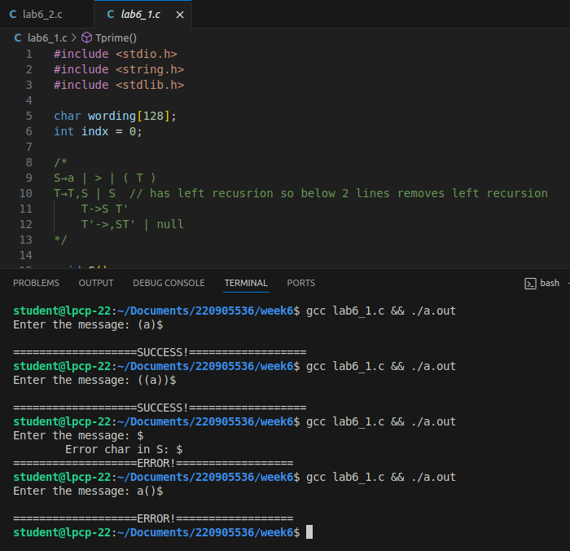

- S→UVW
U →(S) | aSb | d
V → aV | 𝜖
W → cW | 𝜖

Source Code:
#include <stdio.h>
#include <stdlib.h>
#include <string.h>

char wording[128];
int indx = 0;

/*
S→UVW
U →(S) | aSb | d
V → aV | null
W → cW | null
*/

void S();
void U();
void V();
void W();

void valid()
{
printf("\n===================SUCCESS!==================\n");
exit(0);
}

void invalid()
{
printf("\n===================ERROR!==================\n");
exit(0);
}

void W()
{
if (wording[indx] == 'c')
{
indx++;
W();
}
else if (wording[indx] == '$')
{
return;
}
}

void V()
{
if (wording[indx] == 'a')
{
indx++;
V();
}
else if (wording[indx] == '$')
{
return;
}
}

void U()
{
if (wording[indx] == '(')
{
indx++;
S();
if (wording[indx] == ')')
{
indx++;
return;
}
}
else if (wording[indx] == 'a')
{
indx++;
S();
if (wording[indx] == 'b')
{
indx++;
return;
}
}
else if (wording[indx] == 'd')
{
indx++;
return;
}
}

void S()
{
if (wording[indx] == '$')
{
return;
}
U();
V();
W();
}

int main()
{
printf("\nEnter the message: ");
scanf("%s", wording);
S();
if (wording[indx] == '$')
{
valid();
}
else
{
invalid();
}
return 0;
}

Output:
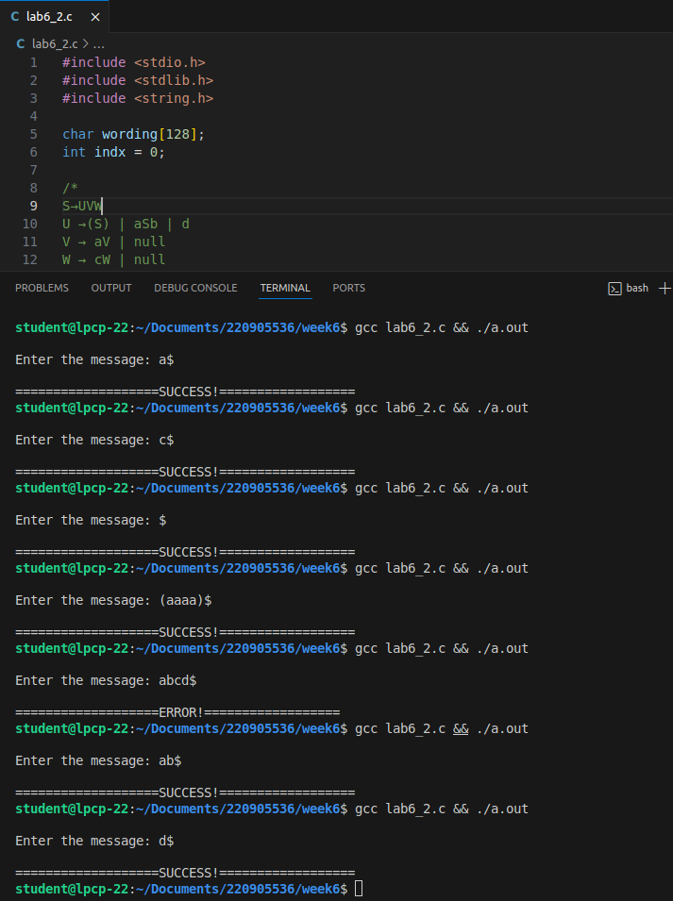

- S→aAcBe
A→Ab|b
B→d
Source Code:
#include <stdio.h>
#include <string.h>
#include <stdlib.h>

char wording[128];
int indx = 0;

/*
S → aAcBe
A → Ab|b //has left recusrion so below 2 lines removes left recursion
A -> bA'
A'-> bA' | null
B → d
*/

void S();
void A();
void Aprime();
void B();

void valid()
{
printf("\n===================SUCCESS!==================\n");
exit(0);
}

void invalid()
{
printf("\nError char : %c at index %d", wording[indx], indx);
printf("\n===================ERROR!==================\n");
exit(0);
}

void A()
{
if (wording[indx] == 'b')
{
indx++;
Aprime();
}
else if (wording[indx] == '$')
{
return;
}
}

void Aprime()
{
if (wording[indx] == 'b')
{
indx++;
Aprime();
}
else if (wording[indx] == '$')
{
return;
}
}

void B()
{
if (wording[indx] == 'd')
{
indx++;
return;
}
else
{
invalid();
}
}

void S()
{
if (wording[indx] == 'a')
{
indx++;
A();
if (wording[indx] == 'c')
{
indx++;
B();
if (wording[indx] == 'e')
{
indx++;
return;
}
}
else
{
invalid();
}
}
else
{
invalid();
}
}

int main()
{
printf("\nEner the message: ");
scanf("%s", wording);
S();
if (wording[indx] == '$')
{
valid();
}
else
{
invalid();
}
return 0;
}

Output:
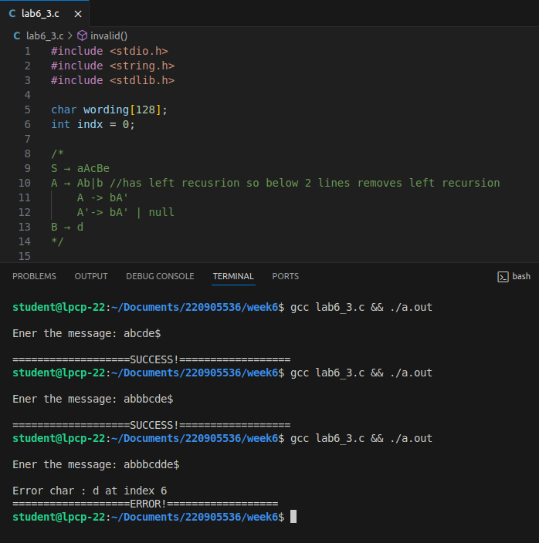

- S →(L) | a
L → L,S | S

Source Code:
#include <stdio.h>
#include <string.h>
#include <stdlib.h>

char wording[128];
int indx = 0;

/*
S →(L) | a
L → L,S | S //has left recusrion so below 2 lines removes left recursion

L -> SL'
L' -> ,SL' | null
*/

void S();
void L();
void Lprime();

void valid()
{
printf("\n===================SUCCESS!==================\n");
exit(0);
}

void invalid()
{
printf("\n===================ERROR!==================\n");
exit(0);
}

void Lprime()
{
if (wording[indx] == ',')
{
indx++;
S();
Lprime();
}
else if (wording[indx] == '$')
{
return;
}
}

void L()
{
S();
Lprime();
}

void S()
{
if (wording[indx] == 'a')
{
indx++;
}
else if (wording[indx] == '(')
{
indx++;
L();
if (wording[indx]==')')
{
indx++;
return;
}
}
else
{
printf("\tError char in S: %c\t", wording[indx]);
invalid();
}
}

int main()
{
printf("\nEnter the string input: ");
scanf("%s", wording);
S();
if (wording[indx] == '$')
{
valid();
}
else
{
invalid();
}
return 0;
}

Output:
