FORWARD DEPLOYED AI ENGINEERING
Capstone Project
Governance Framework
What must be true before this could speak to a real customer
Risk, fairness, decision logging and incident response. This is the part teams
leave until the end, which is precisely why it is usually shallow.
REFERENCE · USE IN WEEK THREE

What governance actually means here
You are building something that will send text to a paying customer without a human reading it first. Governance is the set of arrangements that make that defensible. It is not a document you produce at the end to satisfy a requirement; it is a series of design decisions taken early, which is why this framework asks you to make some of them in week one.
The test of whether your governance is real is simple. Pick a plausible way your system could harm a customer, and ask what in your design would stop it. If the answer describes a property of the model rather than a control you built, you have described a hope.
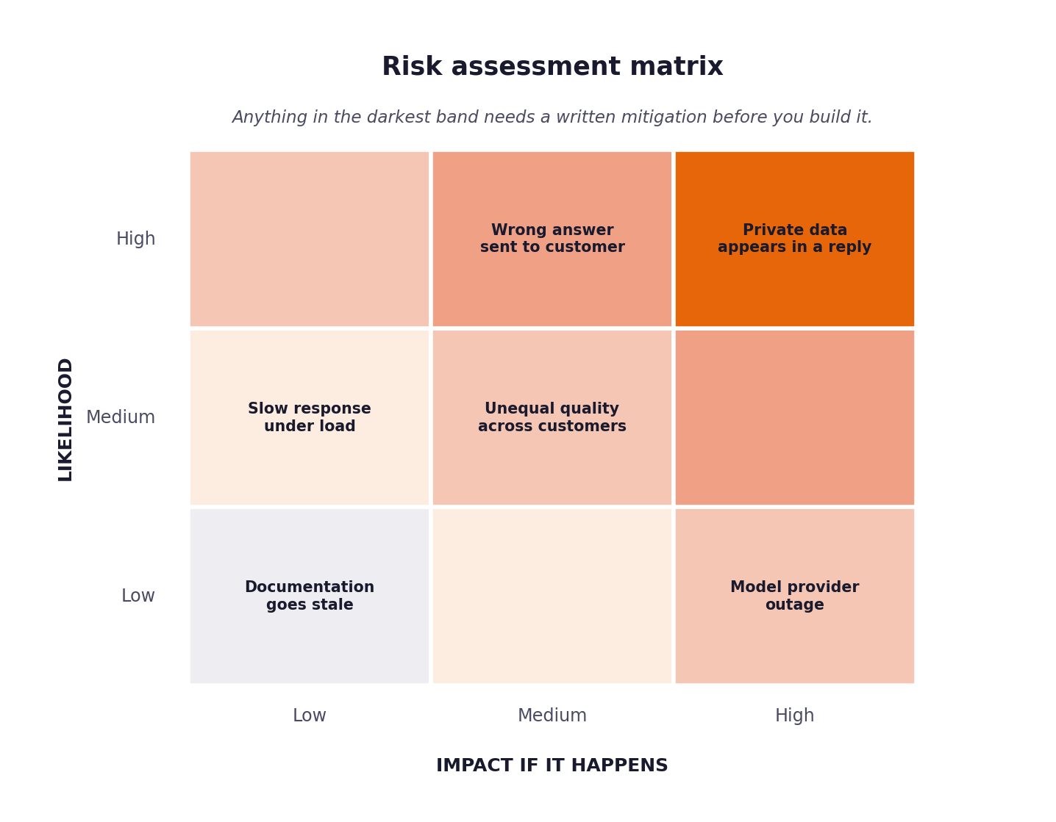
Figure 1. Anything in the darkest band requires a written mitigation before you build it.

1 Decision logging
Every automated decision must be reconstructable months later by someone who was not there. That means logging not only what was decided but why, with enough context that the decision could be audited or challenged.
The minimum record
{
"decision_id": "...",
"timestamp": "...",
"ticket_id": "...",
"stage": "classification | routing | generation | validation",
"input_summary": "...",
"model": { "name": "...", "version": "..." },
"prediction": { "value": "...", "confidence": 0.00 },
"alternatives": [ { "value": "...", "confidence": 0.00 } ],
"sources_used": [ { "doc_id": "...", "score": 0.00 } ],
"threshold_applied": 0.00,
"action_taken": "auto_respond | escalate | block",
"reason": "human readable explanation of why this action followed",
"guardrail_results": { "pii": "pass", "grounding": "pass", "tone": "pass" },
"prompt_version": "PR-02 v1.3",
"requirement_ids": ["FR-03", "FR-07"]
}

Note the last two fields. Recording which prompt version and which requirement produced a decision is what lets you answer the question that always comes up after a problem: was this behaviour intended?
Coverage check
Count your logged decisions against your processed tickets. They must reconcile exactly. A gap means some path through your system takes a decision without recording it, and that is the path where something will eventually go wrong unobserved.

2 Risk register
Complete this fully. Each risk needs a likelihood, an impact, a specific mitigation and a named person accountable for it. Mitigations phrased as we will be careful are not mitigations.
ID | Risk | Likelihood | Impact | Mitigation in your design | Owner
R-01 | The system answers confidently and incorrectly | Medium. Measured on the 20 Sep 80-ticket validation run (harness-20260920T173736Z-8eee28c5): 13 of the 32 tickets the labels say should be held were auto-sent (40.6%, 95% CI 26-58%). Substantially unchanged from the 15 Sep run's 14 of 32 (43.8%) — the intervals overlap almost entirely, so this is the same rate, not an improvement. | High. EV-M3 — Marcus's first fear, and a wrong public answer is screenshottable within the hour. | Grounding guardrail blocks any claim with no supporting span in a retrieved passage (FR-17); the generator may decline rather than guess (FR-14); confidence floor 0.85 (D-05b); D-07 policy list never auto-answers four intents. RESIDUAL: the 13 unsafe sends were tickets the corpus cannot answer, answered confidently — the guardrails check what was written, not whether the corpus could answer at all. The 20 Sep run attributes 12 of its 26 wrong decisions to answerability, the largest single stage. | Alok Kulkarni (author). Post-deployment: Head of Support (Marcus).
R-02 | Private data appears in an outbound response | Low. No PII detected in any draft on the 20 Sep 80-ticket run (pii_detections 0) or on the 15 Sep run, and the synthetic dataset carries none; the model could still fabricate one. | Very high. Regulatory and reputational; a single occurrence is a governance failure. | PII guardrail runs on every draft before routing and BLOCKS — it never redacts and sends (FR-16). Regex evidence plus a judge call; if the judge errors and no regex evidence exists, it fails safe and blocks (A7). | Alok Kulkarni (author). Post-deployment: Head of Support (Marcus).
R-03 | A customer's input is treated as an instruction | Medium, and now measurable. No injection attempt appears in the 500 dev tickets, and the input-side detector flagged none of the 80 validation tickets on the 20 Sep run (injection_suspected 0), so live frequency is unknown. Six crafted attacks were run through the live pipeline on 2026-09-20 (tests/fixtures/injection_probe.json): none succeeded — no draft carried the payload and every ticket was blocked — but the FR-18 guardrail fired on none of them; the blocks came from answer relevance and tone/scope. | High. A successful injection can redirect the reply or extract system text. | Four layers. (1) Input-side detection (src/injection.py, D-16): deterministic patterns on the raw ticket text; a match escalates at router rule 2b with trigger='injection_suspected', names the shape in the reason, and is counted in metrics_report.json and on /metrics. It never refuses the customer — a ticket quoting 'ignore previous instructions' may be an attack, a pasted error or a developer describing their own prompt. (2) Delimiter escaping (prompt_loader.escape_delimiters): <<MARKER>> sequences in customer text are neutralised to [[MARKER]] at render time, so a body cannot forge the data/instruction boundary; escaped rather than stripped, so the reviewer sees what was sent. (3) Every prompt wraps ticket text in delimiters and instructs the model to treat it as data. (4) FR-18 instruction-integrity blocks a draft showing persona-shift markers or fabricated citations. NOT MITIGATED: the heuristic is not a classifier and misses shapes it does not match — the probe's fabricated-citation attack (INJ-05) is not flagged by it and is caught downstream by grounding and citation resolution instead. | Alok Kulkarni (author). Post-deployment: Head of Support (Marcus).
R-04 | Some customer groups receive worse answers | High, and measured. Non-fluent English is 19.5 percentage points below fluent on decision correctness (52.6% n=19 against 72.1% n=61) on the 20 Sep 80-ticket run, narrowed from 24.8 points on 15 Sep but on the same 19 non-fluent tickets, so the change is two tickets rather than a fix. The unsafe-send rate is the sharper gap: 54.5% (6/11) against 33.3% (7/21) for fluent. | Medium. Commercial risk on renewals plus a fairness finding CloudServe would have to report. | NFR-05 sets a 15pp limit; evaluation/fairness_audit.py runs per segment on every run and is tabled in section 3 below. Verdict on the binding dimension is BREACH_NOT_SIGNIFICANT: the gap exceeds 15pp but the 95% intervals overlap at n=19, so it is neither cleared nor proven. Classifier never sees tier, region, name or fluency (PR-CLASSIFY-01). | Alok Kulkarni (author). Post-deployment: Head of Support (Marcus).
R-05 | The documentation the system relies on goes stale | Medium over a compliance-review horizon; not observed during the build — documentation.json was unchanged 26 Aug to 18 Sep. | Medium. A wrong-but-cited answer is worse than an uncited one, because the citation transfers authority to it. | The index is rebuilt from documentation.json by src/index_docs.py and every citation resolves to a retrieved doc_id (A6). NOT BUILT: no freshness monitor and no last_reviewed surfacing — PRD Table 6 records live re-indexing as out of scope, so this risk is accepted, not mitigated. | Ines (corpus owner) post-deployment. Alok Kulkarni during the build.
R-06 | The model provider becomes unavailable | High, and realised four times. The 13 Sep free-tier run lost 46 of 80 classifications and 47 of 80 drafts to connection errors; the 17 Sep free retry hit 429 on 7 of 8 classifications; on 20 Sep Gemini returned 402 'prepayment credits are depleted' on all 28 judge calls of a paid run, and Google's free models were rate-limited UPSTREAM (shared capacity, not our quota) for every call of a free run. The same day a free OpenRouter pairing (nvidia/nemotron-3-super-120b-a12b:free drafting, nex-agi/nex-n2.5-pro:free judging) completed a 5-ticket run, but 3 of its 16 calls returned HTTP 200 carrying no choices at all. | Medium for correctness, high for availability. A failed call delays a ticket rather than answering it wrongly, provided the system degrades rather than crashes — which it did every time above: 0 tickets degraded, A8 reconciled, each failure naming its cause in the decision log. The residual risk is that nothing gets answered at all: on the 20 Sep paid run an unavailable judge blocked all 10 tickets, and on the free run all 5 escalated. | Every call is bounded (MODEL_TIMEOUT_SECONDS, MODEL_MAX_RETRIES) so an unattended run terminates (A9); a failed classification returns unknown with the cause named (FR-05); a failed guardrail judge fails safe and blocks (A7); a degraded ticket escalates and the run continues at exit 0 (FR-23, A11). D-01a records the provider decision and leaves the free model open. | Alok Kulkarni (author). Post-deployment: Head of Support (Marcus).
R-07 | Latency degrades under load | High, and measured. p50 5.8s, p95 6.7s, max 7.0s on the 20 Sep 80-ticket run (n=71 live tickets), down from p50 18.7s, p95 30.3s, max 84s on the 15 Sep run once guardrails were made concurrent (D-12). | Medium. NFR-02 requires p95 at most 4.0s, so the requirement is still UNMET on every configuration measured, though the 20 Sep margin is 2.7s rather than 26s. For an asynchronous support queue this is a target missed, not a customer-facing outage. | Per-call timeout and retry cap bound the worst case; latency is reported in every metrics report (p50, p95, max). PARTLY MITIGATED: D-12 runs the guardrail judges concurrently, which is what took p95 from 30.3s to 6.7s. What remains is sequential — classification, then retrieval, then generation, then the guardrail fan-out — at p50 1.45s, 0.12s, 1.80s and 2.33s respectively on the 20 Sep run, a mean of 3.77 model calls per ticket. NOT MITIGATED: no batching across tickets. Recorded as a breach in the Stage 5 revision log. | Alok Kulkarni (author). Post-deployment: Head of Support (Marcus).
R-08 | Costs rise unexpectedly with volume | Medium. Volume here is fixed (80 validation, 120 hidden), so the exposure is a provider or model change rather than growth. | Medium. NFR-08 requires the run to fit the free tier; a billed model breaks the cost-nothing constraint the project is built on. | src/usage.py records prompt and completion tokens and a price for every call, and every metrics report carries cost_metrics by stage. D-01a keeps the graded configuration on a free tier. FOUND 18 SEP: the committed default model (meta-llama/llama-3.1-8b-instruct) is billed, so the documented configuration is not free; the free model is still open. | Alok Kulkarni (author). Post-deployment: Head of Support (Marcus).

3 Fairness audit
Your system will not treat all customers identically, and you need to know in which direction and by how much. Segment your test set and compare outcomes across segments.
Segment | Tickets in segment | Resolution rate | Quality score | Variation from best | Explanation
Enterprise customers | 8 | 67% (4/6; 95% CI 30-90%) | 75% (6/8; 95% CI 41-93%) | 1pp above best assessed | Best assessed tier is standard at 74%. n=8 — below the audit's minimum, so reported but never judged and it cannot be 'best'. One ticket moves this 12.5pp.
Small business customers | 30 | 67% (14/21; 95% CI 45-83%) | 57% (17/30; 95% CI 39-73%) | 17pp below best | The largest tier gap in the audit, narrowed from 29pp on 15 Sep. Best is standard at 74% (n=42). On auto_precision, which is the measure NFR-05 binds for tier, business is 70.0% against standard's 70.8% — within the 10pp limit.
Tickets in fluent English | 61 | 75% (30/40; 95% CI 60-86%) | 72% (44/61; 95% CI 60-82%) | Best segment | Binding dimension for NFR-05 (EV-DATA-09). Mean classifier confidence 0.8102. 40 tickets should auto-send; 17 are unanswerable.
Tickets in non-fluent English | 19 | 62% (5/8; 95% CI 31-86%) | 53% (10/19; 95% CI 32-73%) | 20pp below best | Verdict BREACH_NOT_SIGNIFICANT: past the 15pp limit, but the intervals overlap at n=19. Unsafe-send rate 54.5% (6/11) against 33.3% for fluent. 10 of the 19 are unanswerable, against 17 of 61 for fluent.
Short tickets | 28 | 53% (8/15; 95% CI 30-75%) | 61% (17/28; 95% CI 42-76%) | 11pp below best | Under 23 words. Within the 15pp limit. Mean confidence 0.7411, the lowest of the three length bands — the classifier is appropriately less certain on thin input. 13 of 28 are unanswerable, the highest share of any band.
Long or complex tickets | 24 | 87% (13/15; 95% CI 62-96%) | 71% (17/24; 95% CI 51-85%) | 1pp below best | Over 31 words. Best is medium-length at 71%. Resolution is highest here, but more of these tickets are unanswerable and get answered anyway.

The variation you are most likely to find
Systems built on retrieval tend to perform noticeably worse on tickets written in non-fluent English, because the retrieval step depends on the phrasing matching the documentation. This is a real and common fairness problem. Finding it and reporting it honestly is worth far more than a table showing no variation anywhere.

4 Guardrails
A guardrail is a check that runs on every response and can block it. Guardrails that only run in testing are not guardrails; they are tests.
Guardrail | What it checks | What happens when it fires
Private data | Names, addresses, keys, account numbers, anything identifying another customer. | Block and escalate. Never redact and send.
Grounding | Every factual claim traceable to a retrieved passage. | Block and escalate with the unsupported claim flagged.
Instruction integrity | The ticket content has not altered the system's instructions. | Block, escalate and record the input for review.
Tone and scope | The response stays within support scope and does not make commitments. | Block. Commitments about refunds or timelines are not the system's to make.
Confidence floor | The routing threshold was actually applied. | Escalate. A missing confidence score is not a high one.

5 Incident response
Write this so that someone unfamiliar with your system could follow it at two in the morning. That constraint is what forces the useful level of detail.
Step | What to do | Who does it | How long it should take
1. Detect | Three routes: a customer or agent reports a bad reply; a run's figures move (unsafe-send rate, guardrail fail-safe share, pii_detections above 0, reconciliation false); or decision-log review finds one. Nothing is automatic today — there is no alerting, so detection depends on someone reading the run. | Author during the build. Post-deployment: support duty manager, on the same rota that reads escalations. | Same working day for a report; within one run for a metric shift.
2. Contain | Export KILL_SWITCH=1 into the environment of the running process (D-15). route() reads it on the next call as rule 0 and escalates every ticket to a person, whatever its confidence, intent or guardrail verdicts; the drafts and retrieved passages still travel with each escalation. If a harness run is in progress, either set the variable for it or stop it; completed rows are already on disk and the metrics report records that the switch was on. | Author, or whoever holds the kill switch (section 7). No engineer required. | Seconds. Read at call time, so no restart and no deploy; the next ticket is already escalating.
3. Assess | Pull the ticket's decision-log row and its results.jsonl entry. Both carry the inbound request, the draft before guardrails, each guardrail verdict with its full reason and structured detail, the routing decision and reason, prompt_version and requirement_ids. Establish which layer failed: ungrounded claim, PII, provider failure, or a ticket the corpus cannot answer. | Author. A second reader for anything involving private data. | Under an hour per ticket; the record is designed so no re-run against the provider is needed.
4. Notify | Head of Support first, with the decision_id and the draft as sent. Private-data or compliance cases also go to the compliance contact named for the autumn review (EV-M5), and the affected customer's account owner. Record who was told and when. | Author to Head of Support; Head of Support to the customer. | Same day. Immediately, before any other step, for private data.
5. Remediate | Fix at the layer the assessment names: prompt version bump, guardrail rule, threshold, or a corpus article for a documentation gap. Re-run the affected tickets, then the full 80-ticket validation gate, before auto-send is re-enabled. Record the change as a Stage 5 revision-log row. | Author. | One to three days, depending on the layer. A corpus gap depends on Ines.
6. Review | Write the cause, the fix and the evidence into the Stage 5 revision log and update this risk register. Add a regression test in tests/ that fails on the old behaviour — every defect found during the build has one, and that is what stops it returning. | Author. | Within a week of the incident closing.

The kill switch
Every system of this kind needs a way to stop it answering automatically, immediately, without a deployment. State what yours is, who can operate it, and how long it takes to take effect. If you do not have one, that is your first governance finding.
Question | Your answer
What is the mechanism? | KILL_SWITCH=1 in the environment of any running process — the API service or a harness run. src/config.py.kill_switch_active() reads it on every routing call, and src/route.py applies it as rule 0, ahead of every other rule: the ticket escalates with trigger='kill_switch_active' and a reason naming the switch. Classification, retrieval, generation and all six guardrails still run, so the escalation bundle the reviewer receives (FR-11) is as complete as on a normal day; only automatic sending stops. It replaces the CONFIDENCE_THRESHOLD=1.01 mechanism documented here before 2026-09-20, which needed a restart and was indistinguishable in the log from a badly tuned threshold (D-15). A harder stop is still to stop the process.
Who is authorised to use it? | Alok Kulkarni during the build. In a deployment it must belong to the Head of Support and the support on-call rota rather than an engineer, because the people who see the harm first are the ones answering the tickets. Access to the process environment is access to the switch, so that access is what the rota needs — no code change, no deploy pipeline, no engineer in the loop.
How long until it takes effect? | The next ticket. The flag is read at call time on every route() call, so exporting KILL_SWITCH=1 on a running process halts it without a restart — sub-second in practice. This is the one thing the previous mechanism got wrong: it required a restart because configuration is read at import.
What happens to tickets in flight? | A ticket already past route() completes on the verdict it has, and its decision-log row and results row are written as usual; results stream to disk per ticket, so nothing already recorded is lost. Any ticket reaching route() after the switch is set escalates. No automatic reply is produced under the halt. Scope stated honestly: this project drafts and routes but has no live send path, so the switch stops auto-respond decisions, not an outbound mail server.
How is it tested? | tests/test_route.py: test_kill_switch_escalates_a_ticket_that_would_otherwise_be_sent (0.99 confidence, every rule clear, still escalate), test_kill_switch_outranks_every_other_rule (a PII block is still reported as the halt), test_kill_switch_still_hands_the_human_a_bundle, test_kill_switch_reads_the_environment_on_every_call (nine spellings), and test_service_resumes_when_the_switch_is_cleared (no restart). Reporting is covered by tests/test_api_smoke.py (/healthz shows the halt, status stays ok), tests/test_harness_smoke.py (every ticket escalates; metrics_report records kill_switch_active) and tests/test_results_table.py (the results table labels a halted run). All run in CI on every push. NOT YET DONE: a live drill on a running service, as opposed to the test suite.

6 The declaration
Complete this last. It is the summary an assessor reads first.
Statement | Your position
This system must never ... | send a customer a claim that no retrieved passage supports, or any private data, without a person having read it.
The mechanism that enforces that is ... | five blocking guardrails on every draft before routing — PII, grounding, instruction integrity, tone and scope, answer relevance — plus a confidence floor. Any block withholds the draft and escalates it; a guardrail that errors fails safe and blocks (A7). Every outcome is written to the decision log with the reason (FR-20).
The most likely way it could still cause harm is ... | a fluent, well-grounded-looking reply to a question the documentation cannot answer. Measured on the 20 Sep 80-ticket run: 13 of 32 tickets that should have been held were auto-sent, and the generator declined only 8 of 27 unanswerable tickets (recall 0.30) — the same recall as 15 Sep, so nothing since has addressed it. The guardrails verify the claims in a draft; nothing verifies that the corpus could answer the ticket in the first place. D-05b reached the same conclusion from the other direction: no confidence threshold meets the 0.95 precision floor, because answerability, not confidence, is the binding constraint.
We would not deploy this without first ... | (1) an answerability check that holds tickets the corpus cannot answer; (2) a completed gate run on the graded free-tier configuration (D-01a) — the 20 Sep 80-ticket gate ran on the paid pairing, at a cost of $0.80; (3) NFR-02 latency inside target — p95 is 6.7s against a 4.0s requirement, down from 30.3s but still short; (4) a tested kill switch and a rehearsed incident drill; (5) a human groundedness review of at least 50 replies by two assessors, as the Evaluation Framework requires, because the LLM judge failed calibration at Spearman 0.35 and cannot stand in for it.

