Configuring Secure Sockets Layer (SSL) support in a DB2 instance

- Before you begin the task
There are some of the environment variables that you need to change in commands according to your environment.
Eg:
db2instance - Replace this with environment DB2 instance.
CN=<Server Host> – Replace it with your server host name.
OU=<Organization Unit> – Replace it with your Organization.
L=<Server Location> – Replace it with Server physical Location.
ST=<Server State> – Replace it with Server state.
C=<Server Country> – Replace it with Server Country.
label – Replace it with label of your choice.
Password – Password of your choice.

- Pre-requisites –
- You should have IBM gskit installed on your system where you intend to install the certificate. By default, DB2 has a gskit installed in db2 installation path.
To verify, you can run the following
- Login to db2 server using putty.
- Switch to db2 instance and run db2profile
- Run “which gsk8capicmd_64”
It will show you the path from where system is using the gskit.
In case you it returns something like. Then you need to adjust the db2profile
which: no gsk8capicmd_64 in (/usr/local/bin:/usr/bin:/bin:/usr/bin/X11:/usr/X11R6/bin:/usr/games:/usr/lib64/jvm/jre/bin:/usr/lib/mit/bin:/usr/lib/mit/sbin:/opt/gnome/bin)

- Adjust the db2profile-
- First verify that you have gskit available in your db2 installation path. (Note you may have standalone gskit installed on your system as well)
- Goto db2 installation path
/home/<db2instance>/sqllib/gskit/bin
ls -l
if you have above path you will see gskit commands available there.
- If you find gskit from step 2, Modify the db2profile to add the following.
### Added to set the GSKIT PATH
PATH=/home/<db2instance>/sqllib/gskit/bin:$PATH; export PATH

- Run db2profile after the changes.
- Go through step 1 to make sure which gsk8capicmd_64 returns the path.
Note – If you do not find gskit installed on your system you need to install it from IBM Fixed Central here → http://www-01.ibm.com/support/docview.wss?uid=swg21631462

- Create Certificate KeyStores –
Step 1. Login to DB2 Server using the putty
Step 2. Create a separate folder structure to protect Signer Certificate, KeyStore and Stash file.
mkdir /home/db2instance/db2_ssl
cd /home/db2instance/db2_ssl
Step 3. Use the gsk8capicmd_64 command to create key database.
gsk8capicmd_64 -keydb -create -db "db2_ssl_keydb.kdb" -pw "<password>" -type cms -stash

Note – You should have 4 new files created in /home/<db2instance>/db2_ssl path.
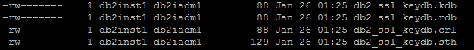

Step 4. Create a Certificate Signing Request (CSR) File
gsk8capicmd_64 -certreq -create -db "db2_ssl_keydb.kdb" -pw "<password>" -label "IBM_CA_signed" -dn "CN=<Server Host>, O=IBM, OU=<Org Unit>, L=Portsmouth, ST=Portsmouth, C=UK" -file db2_ssl_ibmca_certreq.csr -size 2048 -sigalg SHA512WithRSA

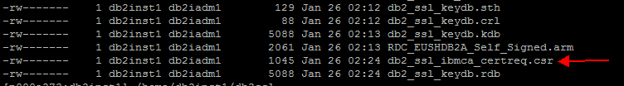
You will receive a new file with extension .csr
Step 5. Run command
cat sb2_ssl_ibmca_certreq.csr
You will see the request key.

- Request Certificate on IBM CA website-
- Go to IBM CA website
https://daymvs1.pok.ibm.com/ibmca/welcome.do?id=1685630
- Select Server Certificates
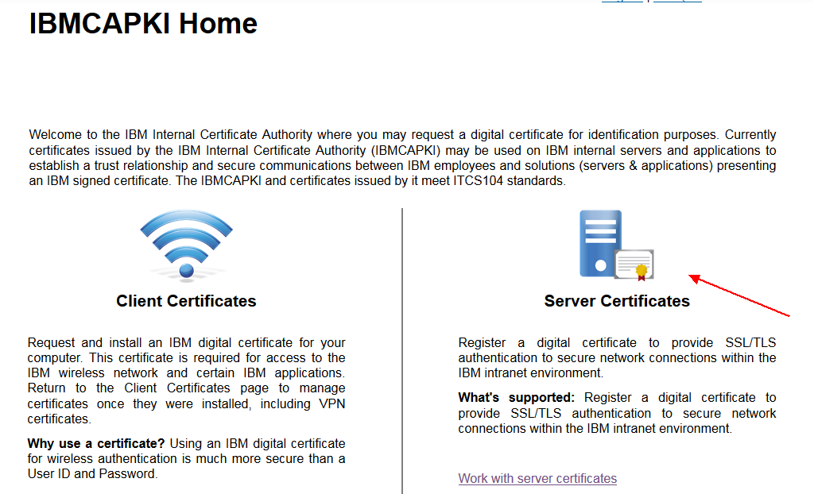

- Select Create Profile
Note – You can use your existing profile if you already have one.
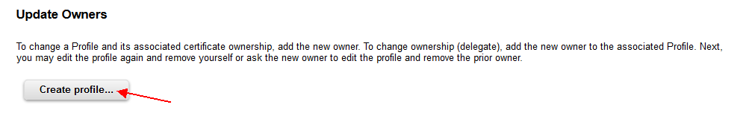
- Fill in the details – Profile Information
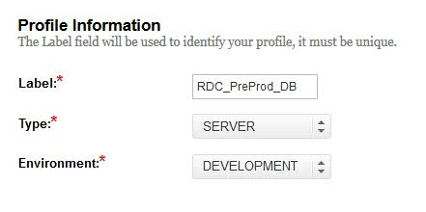
* Label is basically for you to identify your serve

- Fill in the details – Certificate Fields
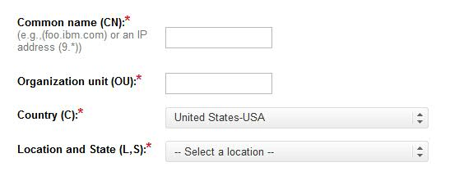
CN - Your server host name
OU – Fill in your organizational Unit
C - Country where the server is located
L, S – Server Location

Note – You can fill-in the same info that you have used in generating the request file in previous step.

- Fill in the details – Description
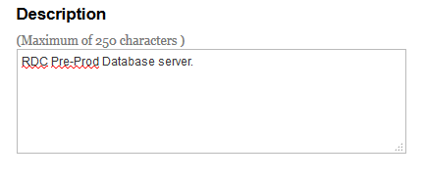
- Fill in the details – Owner and MAD Address.
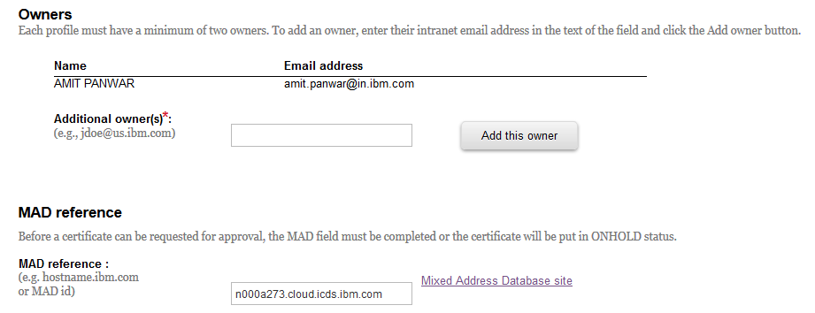
Add owner to the certificate, you can add your team member who can backup you and/or project manager. You may have multiple people added as owner.
MAD reference is you server host name or alias. You can search your server in MAD DB site. There is a link beside the input box.
- Click on Submit. It will create your profile
- On next screen you will see a button “Request Certificate” click on it.
- Select copy and paste option. And Paste the whole contents of your CSR file (generated from step D.5)
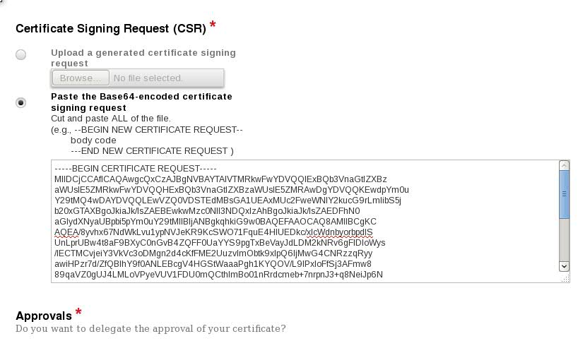
- Select your approving manager.
- Submit the request.
- Once you have your approval. Follow the next steps.

- Download Certificates from IBM CA-
Step 1. Once the approval is in place, you will receive an email from service machine.
It will have download links for the IBMRoot and IBMIntermediate certificates.
Download both the certificates (IBMRoot and IBMIntermediate)
Alternately you can download them from IBMCA website → Certificate tab → at the bottom of the page.
Step 2. Goto IBM CA website
Select Certificates tab → select Server label from the list.
On the next screen select “CRT File” from Action dropdown and click on arrow “>” to download it.
Now you will have 3rd file.
Step 3. Now you got total 3 files (2 .der files and 1 .crt file)
IBMRoot (carootcert.der), IBMIntermediate (caintermediatecert.der) and cert.crt file
Ftp all 3 files to DB2 server. You need to place them under the folder you have created. As per our eg db2_ssl.

- Install Certificates –
Now you need to install the certificates.
Run the following commands
Step 1. Add the root certificate to KeyStore
gsk8capicmd_64 -cert -add -db "db2_ssl_keydb.kdb" -pw "<password>" -label " IBMCA_Root" -file carootcert.der -format binary -fips
Step 2. Add the Intermediate certificate to KeyStore
gsk8capicmd_64 -cert -add -db "db2_ssl_keydb.kdb" -pw "<password>" -label " IBMCA_Intermediate" -file caintermediatecert.der -format binary -fips
Step 3. Receive the signer certificate to KeyStore
gsk8capicmd_64 -cert -receive -file cert.crt -db db2_ssl_keydb.kdb -pw "<password>" -format binary -default_cert yes
Step 4. Validate
Run the following command to list the certificates.
gsk8capicmd_64 -cert -list -db db2_ssl_keydb.kdb -stashed
You should see 3 certificates in your keystore.

- Configure the DBM configuration -
Step 1. Configure the DBM configuration. (for DB2 Server)
db2 update dbm cfg using SSL_SVR_KEYDB /home/db2inst1/db2_ssl/db2_ssl_keydb.kdb

db2 update dbm cfg using SSL_SVR_STASH /home/db2inst1/db2_ssl/db2_ssl_keydb.sth

db2 update dbm cfg using SSL_SVR_LABEL <Default Certificate Label>

Configure the DBM configuration. (for DB2 Client)
db2 update dbm cfg using SSL_CLNT_STASH /home/db2inst1/db2_ssl/db2_ssl_keydb.sth
db2 update dbm cfg using SSL_CLNT_KEYDB /home/db2inst1/db2_ssl/db2_ssl_keydb.kdb
db2set db2comm=tcpip,ssl

Note - Only set the Default Certificate Label. System will atomically use the reset of the certificate chain.
Step 2. Recycle the DB Instance.

Step 3. Re-catalog DB Node Entries with Security SSL
Eg: db2 catalog node <nodename> remote <hostname> server <sslport> security ssl
Note all the RDC SSL ports are listed on RDC GDPR Wiki.
Step 4. Now you can test the connections

RDC Server details -
RDC Pre-Prod (Test/UAT)
Host Name - b06acirdb005.portsmouth.uk.ibm.com
DB Name - EUSHDB2A
SSL Port - 3333

RDC Pre-Prod Mainshad/Shadow (Test/UAT)
Host Name - ibmrrcd0.portsmouth.uk.ibm.com
DB Name - MAINSHAD
SSL Port - 5913

RDC Production
Host Name - ibmrpcdb0.portsmouth.uk.ibm.com
DB Name - EUSIDB2B
SSL Port - 3202

RDC Production Mainshad/Shadow
Host Name - ibmrpcd0.portsmouth.uk.ibm.com
DB Name - MAINSHAD
SSL Port - 5918

I received a question from some of the partners that they have ibmkr2ez and ibmkr1ez on their side. So basically ibmkr2ez and ibmkr1ez are the aliases to ibmrrcd0 and ibmrpcd0 servers respectively.
here is the mapping
ibmkr2ez.portsmouth.uk.ibm.com --> ibmrrcd0.portsmouth.uk.ibm.com (RDC Pre-Prod MAINSHAD DB)
ibmkp1ez.portsmouth.uk.ibm.com --> ibmrpcd0.portsmouth.uk.ibm.com (RDC Production MAINSHAD DB)

As part of this SSL activity you would need to remove the old catalog entry and recreate it with SSL security. So we would recommend that you take this opportunity and use our latest host name to avoid any confusion in future.

