ICEditor

The graphic tool chain for ICMS

Final Report

Yang Hu, Lou Angelucci
Introduction:
A tool chain for component based software engineering.

Icdb.xml
ice
Ici.xml
Ice
ICMSV2
ICEditor
ICBuilder
ICEditor

A detailed description of ICEditor:
User Interface:

Original version:
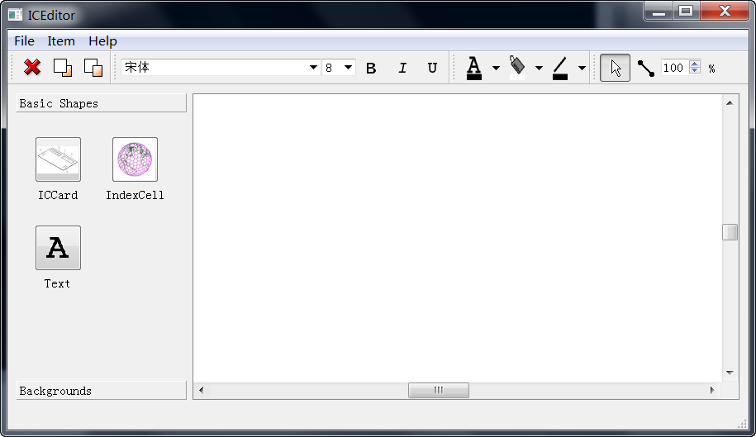
Graphic items
Drawing area

Current version:
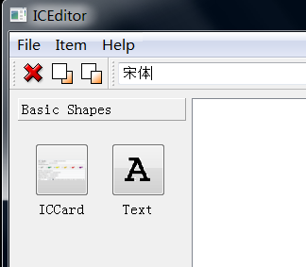
ICCard

ICCard tiny editor:
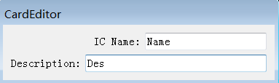

ICCard editor:
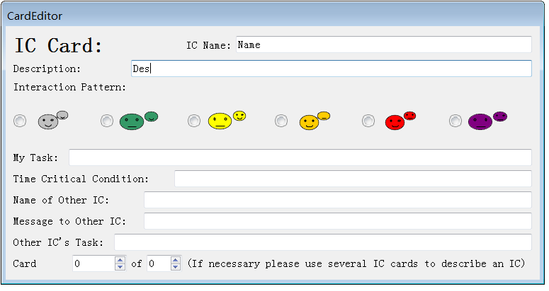

File Menu:
Open project
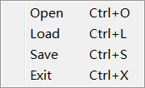
Now we can successfully save the whole graph into ICCard editor project file (*.ice).

Save project:
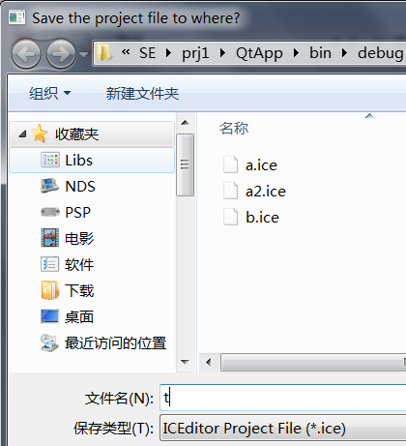

Open project file:
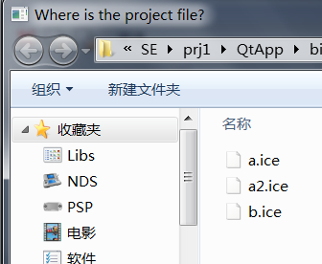

Item Menu:
Delete Item
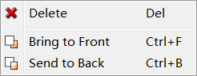
Help Menu:
About ICEditor
About Dialog:
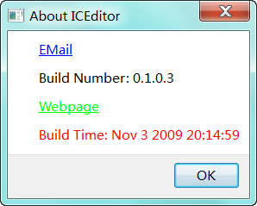
ICCard edit:

Original version:
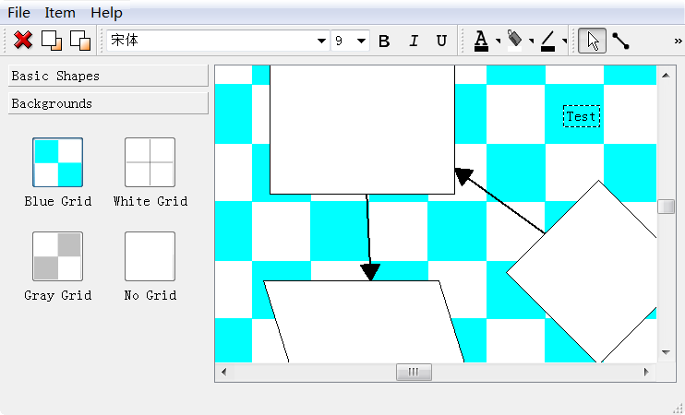
Rectangle
Text
Background

New version:
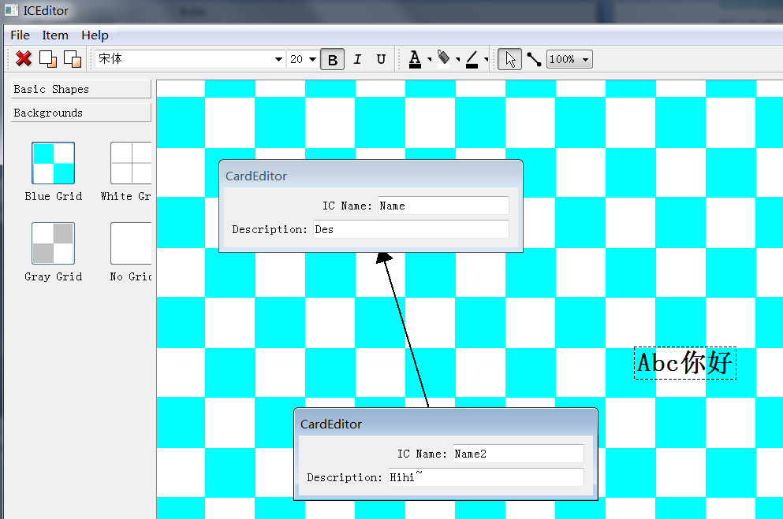
Relations
ICCard

Xml parser:

Using XQuery as a backend.

An introduction to XQuery:
XQuery is to XML what SQL is to database tables.

XQuery is designed to query XML data - not just XML files, but anything that can appear as XML, including databases.

What is XQuery?
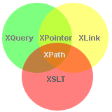 | - XQuery is the language for querying XML data  - XQuery for XML is like SQL for databases  - XQuery is built on XPath expressions  - XQuery is supported by all major databases  - XQuery is a W3C Recommendation

ICEditor use XQuery in loading xml data.
Icci.xq for icci.xml
Icdb.xq for icdb.xml

Load icms xml file:
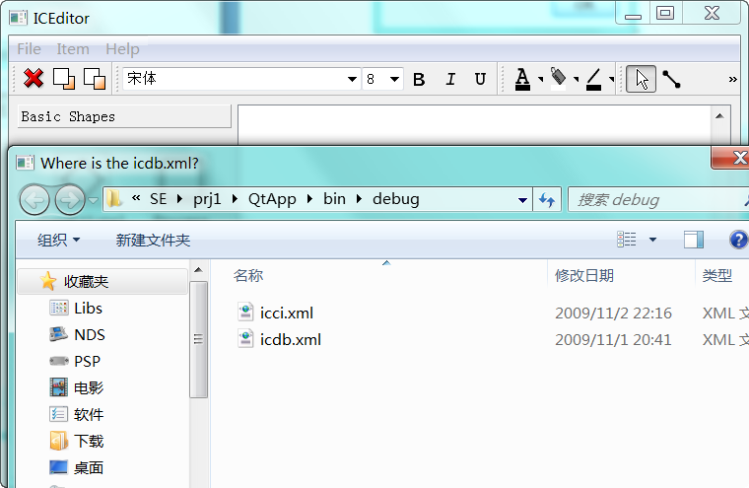

Sample icdb.xml:
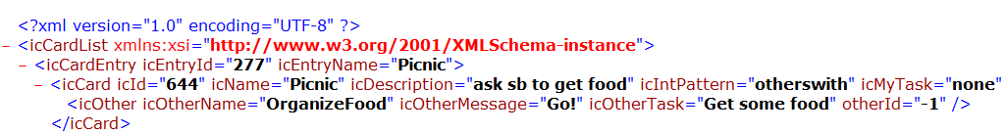

Sample icci.xml:

Sample icdb.xq:
Sample icci.xq:

Import Demonstrations:
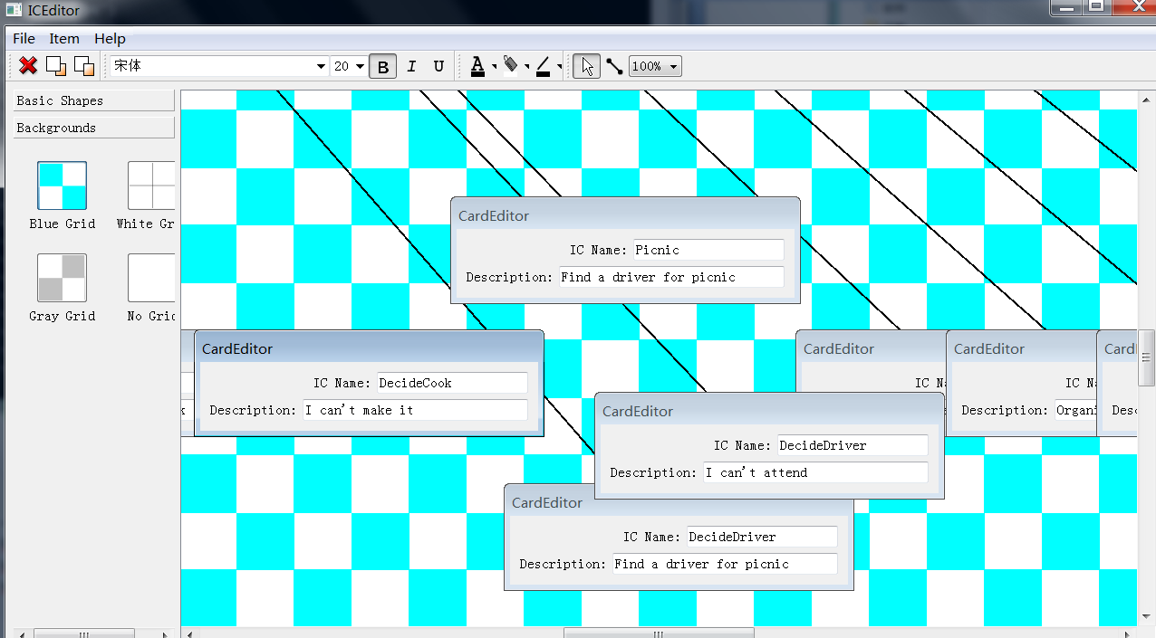

Auto tree structure:
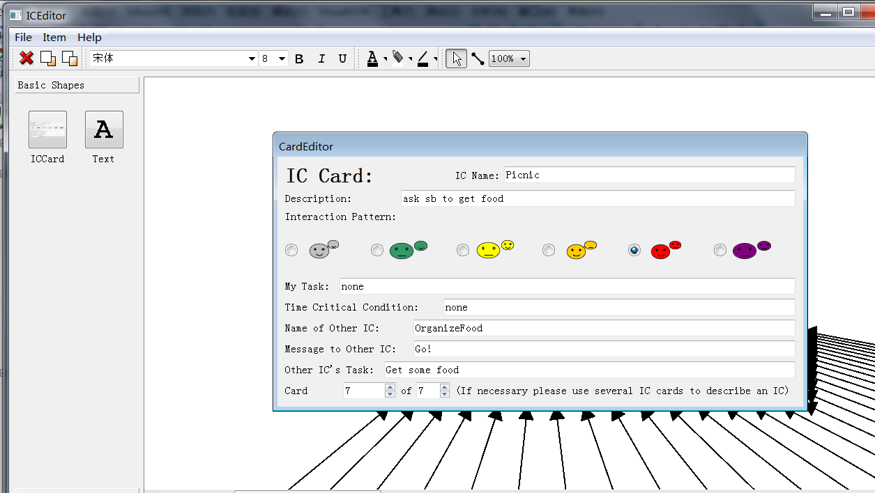

Zoom:
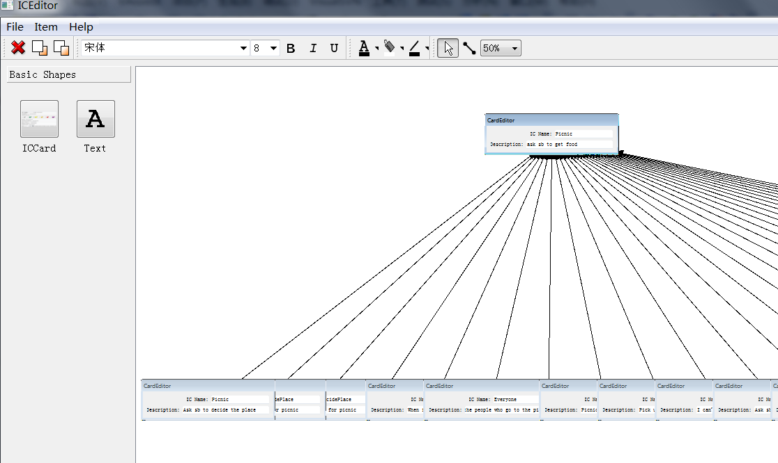

ICCard’s data structure:

class ICCard
{
public:
typedef QHash<int, ICCard> ICCards;

enum Pattern{
Undef,
QuietState,//quietstate
MyselfNone,//myselfnone
MyselfWith,//myselfwith
OthersNone,//othersnone
OthersWith,//otherswith
MixedState//mixedstate
};

public:
static ICCards Load(QStringList icdb, QStringList icci);

public:
ICCard(void);
~ICCard(void);

private:
int icId;
int parentId;
QString icName;
QString icDescription;
Pattern icIntPattern;
QString icMyTask;
QString icTimeCriticalCondition;
int icNumberCurrent;
int icNumberTotal;
//ic other
//QString icOtherName;
int otherId;
QString icOtherMessage;
QString icOtherTask;
};

Xml error handler:
When encounter an xml related loading error, a clear error output will show up:
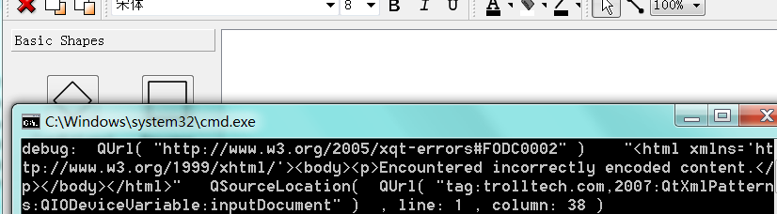

A detailed description of ICIndex:
TODO…

ICBuilder

Introduction:
ICBuilder is a java 1.6 based tool used to convert from the index card format, generated by ICMS or ICEditor to an index cell system specification. The general format for the index card system and the index cell system can be seen in appendix A, and is described in full detail in Transformations for Rapid Prototyping of Time-Critical Applications.

Requirements:
All of these requirements must be satisfied in order to compile and run ICBuilder.
To compile you must install:
-jdk(java development kit) 1.6 or higher
-Apache Ant 1.7 or higher
-Apache Log 4J 1.2.15 or higher.
To Run the tool you must install:
-JRE(Java Run Time Environment) 1.6 or higher
-Apache Log 4J 1.2.15 or higher.

Running the tool:

Configuration:
The ICBuilder tool is design to allow the user to change configurations manually via a properties file. The properties file must be defined before run time in order to run the tool successfully. Below is an example of the configuration file. When you have finished filling in all of your configuration data save the file as “config.properties” and place it in the “config” directory in the ICBuilder tool directory. (See appendix B)

Building the tool:
Once all requirement are satisfied it is time to build the tool. ICBuilder comes with a simple BAT (Batch Script File) for compilation and running on MS-DOS Systems. For those running in a linux environment simply run the included ant script to generate the ICBuilder.jar archive file using ant via the command line.

Running the Tool:
If compiling the tool via command line (Dos or linux) simply type:
ant -v -f build.xml jar-dev > build.log

If running the tool via command line (Dos or linux) simply type:
Java -jar ./lib/log4j-1.2.15.jar.jar -Dicbuilder.conf=./config/config.properties com.pitt.softengr.icbuilder.commandLine

Tool output:

The output of the tool will be generated in two directories, underneath the root of the tool directory, the logs and output directory(specified by the user). In the logs directory the ICBuilder tool will keep a running log of events that occur within the tool. In the output directory the ICSystem.xml file will be generated. An example of three different system configurations can be seen in appendix C.

APPENDIX A
IcCard System Files:

IcCard Database File format:
<icCardList >
<icCardEntry icEntryId="324" icEntryName="Food">
<icCard icId="758" icName="Food" icDescription="Problem: Organize food for a Picnic Context:A group of people Solution: Ask each person to preform seperate food preparation tasks" icIntPattern="mixedstate" icMyTask="help organize food preparation" icTimeCriticalCondition="must be ready by picnic DATE" icNumberCurrent="1" icNumberTotal="1">
<icOther icOtherName="" icOtherMessage="" icOtherTask="" otherId="-1" />
</icCard>
</icCardEntry>
<icCardEntry icEntryId="323" icEntryName="Picnic">
<icCard icId="757" icName="Picnic" icDescription="Problem: Organize A Picnic Context:A group of people Solution: Ask each person to prepare for picnic" icIntPattern="mixedstate" icMyTask="Organize picnic with others" icTimeCriticalCondition="must be ready by picnic DATE" icNumberCurrent="3" icNumberTotal="3">
<icOther icOtherName="schedular" icOtherMessage="Please organize a schedule for a) sunny day picnic or b) rainy day picnic" icOtherTask="Plan for two different types of days" otherId="785" />
</icCard>
<icCard icId="756" icName="Picnic" icDescription="Problem: Organize A Picnic Context:A group of people Solution: Ask each person to prepare for picnic" icIntPattern="mixedstate" icMyTask="Organize picnic with others" icTimeCriticalCondition="must be ready by picnic DATE" icNumberCurrent="2" icNumberTotal="3">
<icOther icOtherName="Games" icOtherMessage="please prepare games to be played at picnic" icOtherTask="prepare games" otherId="778" />
</icCard>
<icCard icId="754" icName="Picnic" icDescription="Problem: Organize A Picnic Context:A group of people Solution: Ask each person to prepare for picnic" icIntPattern="mixedstate" icMyTask="help organize food preparation" icTimeCriticalCondition="must be ready by picnic DATE" icNumberCurrent="1" icNumberTotal="3">
<icOther icOtherName="Food" icOtherMessage="please prepare food to be served at picnic" icOtherTask="prepare food" otherId="758" />
</icCard>
</icCardEntry>
<icCardEntry icEntryId="335" icEntryName="Games" icEntryParentId="" icEntryOther="">
<icCard icId="778" icName="Games" icDescription="Problem: need games for picnic Context:Prepare for game time Solution: Ask each person to help prepare for games" icIntPattern="mixedstate" icMyTask="Help organize games" icTimeCriticalCondition="must be ready by picnic DATE" icNumberCurrent="1" icNumberTotal="1">
<icOther icOtherName="" icOtherMessage="" icOtherTask="Buy the games" otherId="-1" />
</icCard>
</icCardEntry>
<icCardEntry icEntryId="340" icEntryName="Schedule">
<icCard icId="785" icName="Schedule" icDescription="Problem: need schedule for picnic Context:Prepare schedule for good and bad day Solution: Ask each person to think of alternative schedules" icIntPattern="mixedstate" icMyTask="Help provide alternative schedules" icTimeCriticalCondition="must be ready by picnic DATE" icNumberCurrent="1" icNumberTotal="1">
<icOther icOtherName="" icOtherMessage="" icOtherTask="" otherId="-1" />
</icCard>
</icCardEntry>
</icCardList>

IcCard Interactions File format:
<icInteractions xmlns:xsi="http://www.w3.org/2001/XMLSchema-instance" xsi:noNamespaceSchemaLocation="icCardInteractions.xsd">
<icInteraction scenario="http://www.cs.pitt.edu/~chang/231/cinder/scenario.htm" icSystem="http://www.cs.pitt.edu/~chang/231/cinder/ICSystemDesign.htm">
<icCard id="758" icName="Food" parentId="754" otherIcId="-1" scenario="Picnic" icSystem="icsystem1" icGroup="1" />
<icCard id="754" icName="Picnic" parentId="-1" otherIcId="758" scenario="Picnic" icSystem="icsystem1" icGroup="0" />
<icCard id="756" icName="Picnic" parentId="-1" otherIcId="778" scenario="Picnic" icSystem="icsystem1" icGroup="0" />
<icCard id="757" icName="Picnic" parentId="-1" otherIcId="785" scenario="Picnic" icSystem="icsystem1" icGroup="0" />
<icCard id="778" icName="Games" parentId="756" otherIcId="-1" scenario="Picnic" icSystem="icsystem1" icGroup="1" />
<icCard id="785" icName="Schedule" parentId="757" otherIcId="-1" scenario="Picnic" icSystem="icsystem1" icGroup="1" />
</icInteraction>
</icInteractions>

ICE File format:
<?xml version="1.0" encoding="UTF-8" standalone="yes" ?>
<!DOCTYPE boost_serialization>
<boost_serialization signature="serialization::archive" version="5">
<iceType>ICCard</iceType>
<scards class_id="0" tracking_level="0" version="0">
<count>6</count>
<item_version>0</item_version>
<item class_id="1" tracking_level="0" version="0">
<ic_ class_id="2" tracking_level="0" version="0">
<Id>756</Id>
<parentId>-1</parentId>
<Name class_id="3" tracking_level="0" version="0">
<str>Picnic</str>
</Name>
<Description>
<str>Problem: Organize A Picnic Context:A group of people Solution: Ask each person to prepare for picnic</str>
</Description>
<IntPattern>6</IntPattern>
<Task>
<str>Organize picnic with others</str>
</Task>
<TimeCriticalCondition>
<str>must be ready by picnic DATE</str>
</TimeCriticalCondition>
<NumberCurrent>2</NumberCurrent>
<NumberTotal>3</NumberTotal>
<OtherName>
<str>Games</str>
</OtherName>
<otherId>778</otherId>
<OtherMessage>
<str>please prepare games to be played at picnic</str>
</OtherMessage>
<OtherTask>
<str>prepare games</str>
</OtherTask>
<scenario>
<str>Picnic</str>
</scenario>
<icSystem>
<str>icsystem1</str>
</icSystem>
<icGroup>
<str>0</str>
</icGroup>
<icEntryId>
<str>323</str>
</icEntryId>
<icEntryName>
<str>Picnic</str>
</icEntryName>
</ic_>
<pos_ class_id="4" tracking_level="0" version="0">
<x>1666</x>
<y>20</y>
</pos_>
</item>
<item>
<ic_>
<Id>758</Id>
<parentId>754</parentId>
<Name>
<str>Food</str>
</Name>
<Description>
<str>Problem: Organize food for a Picnic Context:A group of people Solution: Ask each person to preform seperate food preparation tasks</str>
</Description>
<IntPattern>6</IntPattern>
<Task>
<str>help organize food preparation</str>
</Task>
<TimeCriticalCondition>
<str>must be ready by picnic DATE</str>
</TimeCriticalCondition>
<NumberCurrent>1</NumberCurrent>
<NumberTotal>1</NumberTotal>
<OtherName>
<str></str>
</OtherName>
<otherId>-1</otherId>
<OtherMessage>
<str></str>
</OtherMessage>
<OtherTask>
<str></str>
</OtherTask>
<scenario>
<str>Picnic</str>
</scenario>
<icSystem>
<str>icsystem1</str>
</icSystem>
<icGroup>
<str>1</str>
</icGroup>
<icEntryId>
<str>324</str>
</icEntryId>
<icEntryName>
<str>Food</str>
</icEntryName>
</ic_>
<pos_>
<x>-300</x>
<y>2560</y>
</pos_>
</item>
<item>
<ic_>
<Id>754</Id>
<parentId>-1</parentId>
<Name>
<str>Picnic</str>
</Name>
<Description>
<str>Problem: Organize A Picnic Context:A group of people Solution: Ask each person to prepare for picnic</str>
</Description>
<IntPattern>6</IntPattern>
<Task>
<str>help organize food preparation</str>
</Task>
<TimeCriticalCondition>
<str>must be ready by picnic DATE</str>
</TimeCriticalCondition>
<NumberCurrent>1</NumberCurrent>
<NumberTotal>3</NumberTotal>
<OtherName>
<str>Food</str>
</OtherName>
<otherId>758</otherId>
<OtherMessage>
<str>please prepare food to be served at picnic</str>
</OtherMessage>
<OtherTask>
<str>prepare food</str>
</OtherTask>
<scenario>
<str>Picnic</str>
</scenario>
<icSystem>
<str>icsystem1</str>
</icSystem>
<icGroup>
<str>0</str>
</icGroup>
<icEntryId>
<str>323</str>
</icEntryId>
<icEntryName>
<str>Picnic</str>
</icEntryName>
</ic_>
<pos_>
<x>1720</x>
<y>-50</y>
</pos_>
</item>
<item>
<ic_>
<Id>757</Id>
<parentId>-1</parentId>
<Name>
<str>Picnic</str>
</Name>
<Description>
<str>Problem: Organize A Picnic Context:A group of people Solution: Ask each person to prepare for picnic</str>
</Description>
<IntPattern>6</IntPattern>
<Task>
<str>Organize picnic with others</str>
</Task>
<TimeCriticalCondition>
<str>must be ready by picnic DATE</str>
</TimeCriticalCondition>
<NumberCurrent>3</NumberCurrent>
<NumberTotal>3</NumberTotal>
<OtherName>
<str>schedular</str>
</OtherName>
<otherId>785</otherId>
<OtherMessage>
<str>Please organize a schedule for a) sunny day picnic or b) rainy day picnic</str>
</OtherMessage>
<OtherTask>
<str>Plan for two different types of days</str>
</OtherTask>
<scenario>
<str>Picnic</str>
</scenario>
<icSystem>
<str>icsystem1</str>
</icSystem>
<icGroup>
<str>0</str>
</icGroup>
<icEntryId>
<str>323</str>
</icEntryId>
<icEntryName>
<str>Picnic</str>
</icEntryName>
</ic_>
<pos_>
<x>1832</x>
<y>-140</y>
</pos_>
</item>
<item>
<ic_>
<Id>785</Id>
<parentId>757</parentId>
<Name>
<str>Schedule</str>
</Name>
<Description>
<str>Problem: need schedule for picnic Context:Prepare schedule for good and bad day Solution: Ask each person to think of alternative schedules</str>
</Description>
<IntPattern>6</IntPattern>
<Task>
<str>Help provide alternative schedules</str>
</Task>
<TimeCriticalCondition>
<str>must be ready by picnic DATE</str>
</TimeCriticalCondition>
<NumberCurrent>1</NumberCurrent>
<NumberTotal>1</NumberTotal>
<OtherName>
<str></str>
</OtherName>
<otherId>-1</otherId>
<OtherMessage>
<str></str>
</OtherMessage>
<OtherTask>
<str></str>
</OtherTask>
<scenario>
<str>Picnic</str>
</scenario>
<icSystem>
<str>icsystem1</str>
</icSystem>
<icGroup>
<str>1</str>
</icGroup>
<icEntryId>
<str>340</str>
</icEntryId>
<icEntryName>
<str>Schedule</str>
</icEntryName>
</ic_>
<pos_>
<x>2207</x>
<y>2263.8888888888891</y>
</pos_>
</item>
<item>
<ic_>
<Id>778</Id>
<parentId>756</parentId>
<Name>
<str>Games</str>
</Name>
<Description>
<str>Problem: need games for picnic Context:Prepare for game time Solution: Ask each person to help prepare for games</str>
</Description>
<IntPattern>6</IntPattern>
<Task>
<str>Help organize games</str>
</Task>
<TimeCriticalCondition>
<str>must be ready by picnic DATE</str>
</TimeCriticalCondition>
<NumberCurrent>1</NumberCurrent>
<NumberTotal>1</NumberTotal>
<OtherName>
<str></str>
</OtherName>
<otherId>-1</otherId>
<OtherMessage>
<str></str>
</OtherMessage>
<OtherTask>
<str>Buy the games</str>
</OtherTask>
<scenario>
<str>Picnic</str>
</scenario>
<icSystem>
<str>icsystem1</str>
</icSystem>
<icGroup>
<str>1</str>
</icGroup>
<icEntryId>
<str>335</str>
</icEntryId>
<icEntryName>
<str>Games</str>
</icEntryName>
</ic_>
<pos_>
<x>1999.3333333333333</x>
<y>2022.2222222222222</y>
</pos_>
</item>
</scards>
<scells class_id="5" tracking_level="0" version="0">
<count>0</count>
<item_version>0</item_version>
</scells>
<stexts class_id="6" tracking_level="0" version="0">
<count>1</count>
<item_version>0</item_version>
<item class_id="7" tracking_level="0" version="0">
<content_>
<str>&lt;!DOCTYPE HTML PUBLIC &quot;-//W3C//DTD HTML 4.0//EN&quot; &quot;http://www.w3.org/TR/REC-html40/strict.dtd&quot;&gt;
&lt;html&gt;&lt;head&gt;&lt;meta name=&quot;qrichtext&quot; content=&quot;1&quot; /&gt;&lt;style type=&quot;text/css&quot;&gt;
p, li { white-space: pre-wrap; }
&lt;/style&gt;&lt;/head&gt;&lt;body style=&quot; font-family:&apos;MS Shell Dlg 2&apos;; font-size:28pt; font-weight:600; font-style:italic;&quot;&gt;
&lt;p style=&quot; margin-top:0px; margin-bottom:0px; margin-left:0px; margin-right:0px; -qt-block-indent:0; text-indent:0px;&quot;&gt;hyjjjjmhy&lt;/p&gt;&lt;/body&gt;&lt;/html&gt;</str>
</content_>
<pos_>
<x>1830.5555555555557</x>
<y>1788.8888888888885</y>
</pos_>
</item>
</stexts>
</boost_serialization>

APPENDIX B

ICBuilder Configuration Template File:

### WARNING THIS IS A TEMPLATE YOU MUST STILL FILL OUT ALL THE FIELDS!

## the location of the icCardInterations.xml file generated by icms
## Example: input.data.ic.interactions=./data/icCardInteractions.xml
input.data.ic.interactions=

## the location of the icdb.xml file generated by icms
## Example: input.data.ic.database=./data/icdb.xml
input.data.ic.database=

## the location of the ice file generated by ICEditor
## Example: input.data.ic.ice=./data/icdb.ice
input.data.ic.ice=

## The input file format you wish to use either "ice" or "standard"
input.data.ic.format=

## the type of index cell system you want to generate
## "custom" - means you specify in the interactions file how to generate a system
## "gross" - all ic cards form one index cell
## "fine" - all ic cards form their own index cell
system.indexcell.type=

## the directory to which you want the icsystem.xml file to be generated
## Example: output.dir=./output
output.dir=

APPENDIX C
ICIndex System File:

Custom System Specification:
<indexSystem id="323" name="Picnic" description="n/a">
<indexCell id="324" maxLifeTime="infinity" name="Food">
</indexCell>
<indexCell id="323" maxLifeTime="infinity" name="Picnic">
</indexCell>
<indexCell id="335" maxLifeTime="infinity" name="Games">
</indexCell>
<indexCell id="340" maxLifeTime="infinity" name="Schedule">
</indexCell>
<transition id="0" type="internal" source="323" target="340" >
</transition>
<transition id="1" type="internal" source="323" target="335" >
</transition>
<transition id="2" type="internal" source="323" target="324" >
</transition>
</indexSystem>

Gross System Specification:
<indexSystem id="323" name="Picnic" description="n/a">
<indexCell id="323" maxLifeTime="infinity" name="Picnic">
<state id="324" type="INTERNAL" name="Food" />
<state id="323" type="INTERNAL" name="Picnic" />
<state id="335" type="INTERNAL" name="Games" />
<state id="345" type="INTERNAL" name="Buy Games" />
<state id="340" type="INTERNAL" name="Schedule" />
<transition id="0" type="INTERNAL" source="323" target="340" >
<message type="input" id="0" name="Plan for two different types of days" >
<parameter dataType="time" dataValue="must be ready by picnic DATE" name="Tc" />
</message>
</transition>
<transition id="1" type="INTERNAL" source="323" target="335" >
<message type="input" id="1" name="prepare games" >
<parameter dataType="time" dataValue="must be ready by picnic DATE" name="Tc" />
</message>
</transition>
<transition id="2" type="INTERNAL" source="323" target="324" >
<message type="input" id="2" name="prepare food" >
<parameter dataType="time" dataValue="must be ready by picnic DATE" name="Tc" />
</message>
</transition>
<transition id="0" type="INTERNAL" source="323" target="345" >
<message type="input" id="0" name="Buy the games" >
<parameter dataType="time" dataValue="must be ready by picnic DATE" name="Tc" />
</message>
</transition>
</indexCell>
</indexSystem>

Fine System Specification:
<indexSystem id="323" name="Picnic" description="n/a">
<indexCell id="324" maxLifeTime="infinity" name="Food">
</indexCell>
<indexCell id="323" maxLifeTime="infinity" name="Picnic">
</indexCell>
<indexCell id="335" maxLifeTime="infinity" name="Games">
</indexCell>
<indexCell id="345" maxLifeTime="infinity" name="Buy Games">
</indexCell>
<indexCell id="340" maxLifeTime="infinity" name="Schedule">
</indexCell>
<transition id="0" type="INTERNAL" source="323" target="340" >
</transition>
<transition id="1" type="INTERNAL" source="323" target="335" >
</transition>
<transition id="2" type="INTERNAL" source="323" target="324" >
</transition>
<transition id="3" type="INTERNAL" source="323" target="345" >
</transition>
</indexSystem>

