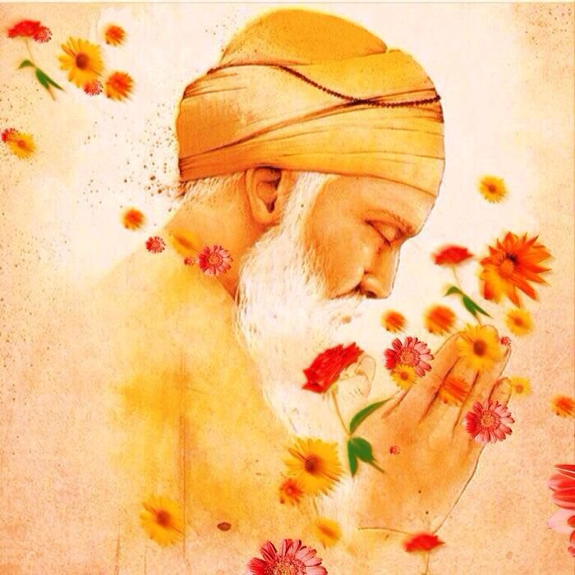

Sri Guru

Nanak DevJi